Solidarity and self-organisation as generators of change: The role of self-organised art initiatives in Macedonia
The links between identity and memory are, right from the start, subtle and intimate. Like history itself, memory is a fundamental matrix in building one’s identity. What does one remember?
One recalls the memory Western Europe had of the Balkans at the beginning of the twentieth century:
They found its geography too complicated, its ethnography too confused, its history too intricate and its politics too inexplicable. Although there were plenty of books dealing with these matters, each year that passed made room for more, as the situation continually changed, always introducing something new to record, a new subject to depict, a new problem to explain, a new complication to disentangle. (Jezernik, 2004:26)
Not much seems to have changed and the image of instability continues to be projected on the countries of Balkans or (South) Eastern Europe[i]. The Balkans, far from being only a neutral geographical or historical denomination, began to carry from the end of the nineteenth century “the negative connotations of filth, passivity, untrustworthiness, disregard for women, conspiracy, unscrupulousness, opportunism, indolence, superstition, sluggishness, unprincipled and overzealous bureaucracy, and so on” (Goldsworthy, 1998:ix).
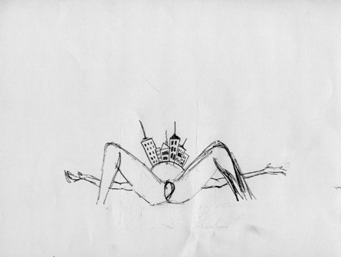
Ivana Dragsic, Eleven––drawings series for a poetry book.
The wars in Yugoslavia, unjustly generalised as ‘Balkan wars,’ have nevertheless generated a Balkan crisis. The region suddenly came to be perceived as a threat to the security of its Western neighbors and it brought back to the surface a concept that apparently had faded during Communism. Unlike the majority of East Europe, the Balkans had never been fully accepted as part of European Union, but always confined to its margins, somewhere close to the Orient. In the region itself the Balkans are always thought to be elsewhere, to the southeast of wherever one is.
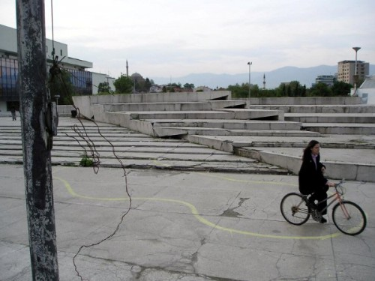
Igor Toshevski “Territories” (2004-2011).
In the heart of the Balkan, both geographically and politically, lies a small landlocked country: Macedonia. Its capital Skopje was described in many travelers book and journals since the 16th century as a summa of the Balkan’s multifaceted identity (West 2006, Celebi 2011). Divided with the river Vardar, the cities North side is historically more deprived and predominately Muslim, and the South side infrastructure is more developed and the population is predominately Christian. The country has undergone an enormous transition in the last 20 years: politically, socially and economically and it still remains on the fringes of Europe.
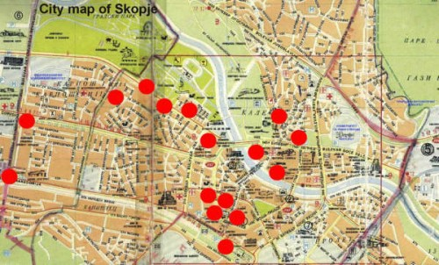
Igor Toshevski “Territories” (2004-2011).
In order to explain the activities of the self-organised art-initiatives, I need to first explain the complex problem of urban space planning in Skopje, Macedonia.
The centre of Skopje was largely destroyed by a catastrophic earthquake in 1963. This gave rise to the idea of rebuilding the city centre based on an international design competition. The competition, financed by the UN, was won by the Japanese modernist architect Kenzo Tange. However, the proposed design was never completely realized. This empty underdeveloped space in the central area of Skopje became a focus of the Macedonian ultra-nationalistic government in 2009. Their five-year plan called Skopje 2014 (SK014), sparked a public debate and numerous protests. The initial government idea was to re-connect the Macedonian capital with the European architectural legacy. The greatest challenge to this effort is the absolute need to invent this heritage that was never present in this city. The purpose of this infusion of historicism is to negate the oriental and modernist layers that dominated Skopje’s urban landscape.
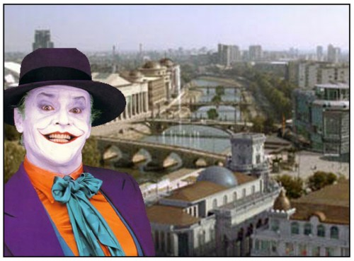
Matej Bogdanovski “Skopje Rados Ti Ke Bidesh” (2009).
Discussion and dialogue from a distance
Skopje is also the city where I was born and raised. When narrowing the subject of this post I dwell into an area subjective and problematic, difficult to navigate, but also so familiar and comforting at the same time, that I ostensibly knew I was on the right track. The past is not as separate from the present. The past is constantly broken down and reintegrated into the present. This process can surely be characterized by many as nostalgic, since I left the country in 2008 and I am currently based in UK. I am using reflective nostalgia as a method to position myself on a flexible historical trajectory and to challenge the erasure and falsification of unwanted heritage in the Macedonian capital Skopje through the government-funded project Skopje 2014.
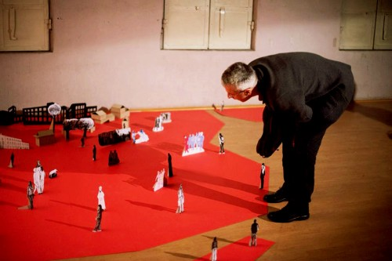
Gjorge Jovanovik “Silent night” 2014.
In order to do this I invited four artists/activists from Skopje to answer five questions about self-organisation as a principle of their work through Skype or email:

Ivana Dragsic (member of Raspeani Skopjani)
Gjorgje Jovanovik (member of KOOPERACIJA and associate member of Raspeani Skopjani)
Filip Jovanovski (member of KOOPERACIJA and associate member of Raspeani Skopjani)
Igor Toshevski (member of KOOPERACIJA)
These artists have been involved in a self-organised movement in Macedonia since 2009, and they are representing inter-generational perspective on the current situation in the Macedonian capital Skopje.
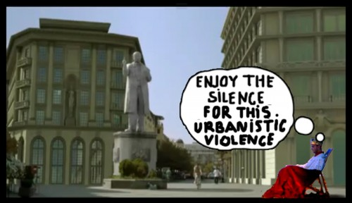
Matej Bogdanovski “Skopje Rados Ti Ke Bidesh” (2009).
The activists in Macedonia felt compelled to self-organise after a protest by students of The Ss. Cyril and Methodius University, Faculty of Architecture that they symbolically called First Architectural Uprising on 28th March 2009. The students were peacefully protesting and collecting signatures from the citizens on the city square “Macedonia,” when a significant group of counter-protestors violently attacked and physically injured many of them. This created a strong reaction in the public and many debates around the right to protest and the right to protect public space. Few self-organised initiatives were formed shortly after this incident, among them:
- Raspeani skopjani (Singing citizens of Skopje) is a self-organised group of activists which stream from the core group of those involved in the First Architectural Uprising. This city choir is composed of core group of 10 people, however significantly larger group of protestors are involved in certain actions, mobilized through social media. They use songs and urban singing as a performance tool to react to the urban and social upheavals in Skopje, including taking away the right to disagree.
- KOOPERACIJA is an initiative whose purpose is artistic activity outside the inert institutional frameworks, thus suggesting an exceptional approach to the creation and experience of contemporary art. KOOPERACIJA stands for shifting and redefining the borders between public and personal space. Its objective is to unlock questions concerning the dynamic role of art in the context of centralized cultural politics and social discourse. KOOPERACIJA strives to encourage the interaction between the artist and audience. KOOPERACIJA’s basic strategy is the occupation of temporarily free space dispersed throughout the urban landscape and exhibiting via a chain of blitzkrieg events.

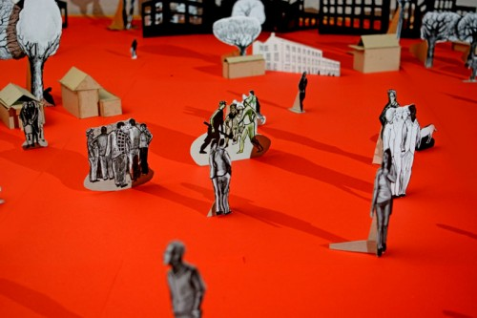
Gjorge Jovanovik “Silent night” 2014.
In the interview with Filip Jovanovski (video below), he clearly states that his life has significantly changed since the protests in 2009 and that his artwork and activism has a different purpose. He vividly remembers the moments when the Government published the plans for the project Skopje 2014 and the reaction it created among young activists and artists. Filip thinks that the ultimately this project created strong links between different communities and mobilized them to produce change.
Below are the answers to my questions from Ivana Dragsich and Igor Toshevski
Elena: Skopje went through a political and urban upheaval in the last five years since the start of the government led project Skopje 2014. Many artists have been vocal in their dissatisfaction with this transformation and with how the government falsifies the history through this project. What do you think is the role of artists in defining place and creating change in Skopje? What an artist can offer?
Igor: As a political construct, Skopje 2014 is a paradigm of the devastating consequences of populist neoliberalism reinforced by xenophobic nationalism, and hegemonic propaganda. When you add to this the ongoing ethnic divisions, which SK014 has only managed to increase, the picture looks pretty bleak. Still, this condition also helped define many artists’ views in relation to politics and critical art. A few of them have remained loyal to the idea of art as an instrument of truth, and continue to challenge the practically totalitarian narratives imposed by the current government. Although art does not posses the power to directly intervene and fundamentally alter a particular political condition, it can certainly inspire a social movement toward a better understanding of that same society. But, before it can do anything at all, art must first free itself from any conformism and establish a new front where it can act resourcefully, creating ultimately a new or different set of values.
Ivana: Artists have a major role in claiming and defining space. With their investigative, insightful and even acquisitive nature, they tend to deconstruct myths, claim forbidden territories and pose questions left aside. Unfortunately, in the case of Skopje 2014, some artists had a major role in constructing the ravaging, sexist and criminal myth about the past we never had. The common ground for both types of artists is their bigger access to public opinion, public space and media.
Our choir was created amidst a very polarized dialogue, run by the media, confronted with various types of repression, violence and threats. Anyone stating an attitude against the government policies and politics was marked a “traitor,” “a foreign collaborator,” or having tendencies for a political position/function. Our idea was to find another way of transmitting a message, claiming space and air, but also making a strong statement by repeatedly appearing in front of physical representations of the power: monuments, public institutions, squares. We were also hoping that people would hear what we sing about, since they were already indoctrinated to ignore our words, but look for our family relations, professional or political background, sexual orientation. After a period of practicing that approach to protesting and articulating political thought, we came to realization that choir (unison) singing IS power, of a different kind. Our performances grew, they were more complex, sometimes even with choreography. We were counting on transmitting a political message in a very censored and repressive state.
Elena: In “There is No Alternative: THE FUTURE IS SELF-ORGANISED” Davies, Dillemouth and Jakobsen proclaim that collaboration with institutions is should cease immediately and that the self-organised is the tool with which artists need to work in opposition to predominant systems. What was the role and the approach to the self-organised in the work of Raspeani Skopjani?
Igor: It is unfortunate that all of the institutions are now under total control of the state apparatus. But, this doesn’t necessarily mean KOOPERACIJA is a priori against the institutions as such. Frankly, if the circumstances were any different, KOOPERACIJA would probably not even have been established. What this initiative is trying to accomplish is to demonstrate that the art scene here has much more to offer than just formalist paintings, pseudo post-modernist art or the monstrous academic kitsch cherished by this government. In the process, we have also found a technique to achieve this and it is a successful model, which others can adopt freely through self-organized and self-financed engagements.
It is crucial that KOOPERACIJA remains unconnected with any political wing or NGO whatsoever, because both of these options still remain vulnerable to corruption and sluggishness, due to their bureaucratic mechanisms. When it comes down to developing new, authentic means of emancipatory initiatives, self-organized undertakings are indeed a much more effective tool. Our particular model is based on cooperation between artists, but also between the artists and the private business sector. Of course, it is not the perfect method, which is why we’re still searching for other modes in order to improve this strategy and its impact. But the main commitment remains the same: to stimulate and deliver critically charged works, actions or public events, which otherwise are not an acceptable standard within the framework of the political correctness of state institutions.
Ivana: “Self-organization,” as a term, is thrown around recently like some kind of social sanctity. It is also positioned as highly opposed to something institutional, or institutions themselves. Instead, we propose another looking at it. Self-organization appears even in centralized or regulated institutions and systems. It actually appears in spite of regulation. Such cases are the small market economies, such as the Macedonian, where the market, although regulated, has its own rules, coordination or unwritten social contracts.
Self-organization was not our primary goal when shaping our collective action into a choir. As a matter of fact, the institutional choirs in Macedonia are much more efficient and successful, with less social impact, though. We also came to realize that it is extremely difficult to self-organize, especially in a schizophrenic political state of our being (having to work and react on all topics of public interest being under attack by the regime), constant run/rush for basic living conditions and intense intimate relations between the individuals involved. It is a double-sided sword; it empowers the individual, but also demands serious commitment. Question is––how far does the given socio-political state allow or necessitate self-organization? We have had highs and lows, we are on the low now, given the fact that many of the core members are in their thirties, seriously working on figuring out their survival in a country with very poor living standards, with a completely destructed political system and institutions.
Elena: Did the urge to self-organise came from the struggle to survive in despite being daily faced with such a megalomaniac project as Skopje 2014?
Ivana: The urge to self-organize came after the urge to sing, or at least try to convey a political message in a different way. At the beginning, there is initiative, enthusiasm, spontaneous functioning and leisure. The urge to self-organize appears at a later point. As performances grew more complex, the production requirements increased, as well as the personal duties. So, in a way, self-organization needed to be institutionalized in order to be more efficient, perform more often and keep pace with the political turmoil. We settled for a more laid-back, but still internally structured mode of working. Self-organization inevitably leads to structure, hierarchy and ultimately systematization/institutionalization, in my opinion. They are not exclusive to each other, moreover, they might cause each other, or at least the need for the other.
Igor: Initially, KOOPERACIJA’s program developed from the pragmatic need for physical space as a communication platform. This, of course, implies public, as well as temporary gallery space. Since a method has been established, the rest depends on a liberal creative process based on teamwork. However, although KOOPERACIJA is mostly open to any form of collaboration, we do have one general principle: no artist who has contributed in SK014 is, or will be invited to participate. Naturally, this somehow explicitly defines this initiative as an opposition, there’s no way out of it. However, we live in times where being objective and speaking the truth almost automatically brands you as a traitor of “national values.” But, that’s something everyone has gotten used to dealing with here.
Nevertheless, KOOPERACIJA does not officially support any specific ideology, nor does it propagate one. It also does not offer any “instant solutions.” It does, however, embrace the right to question certain given values, to remain skeptical at times, explore alternatives in social networking and perhaps, propose new concepts of interaction.
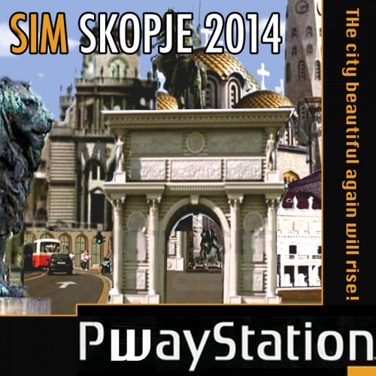
Matej Bogdanovski “Skopje Rados Ti Ke Bidesh” (2009).
Elena: Is it dangerous to claim that self-organization holds transformative potential in itself?
Igor: It’s not about claiming, as it is more about actually putting it into action. But here comes the paradox: precisely because this model can obviously function outside the institutions, it poses a threat not only to the institutions, but also to the ones who somehow see themselves as “legitimate” and accountable advocates for change. So, while it is important to remain independent, this still doesn’t make the job easier. For example, recently, I was surprised to learn that many still believe Soros or some other NGO is financing KOOPERACIJA. It goes to show how much people here have become weary of any form of ideological platform promoting social change for a “better tomorrow.” So, even if independent models like KOOPERACIJA can function successfully, in reality it is a difficult task to actually reassure people that purposeful alternatives indeed exist. It takes time…
True, in the last years, KOOPERACIJA has indirectly helped encourage other groups and individuals in establishing themselves as self-financed, autonomous culture centers, which is definitely a progress. Still, it’s not just the model that counts, but also its substance, which further defines its political role and the message it tries to convey. This, of course, comes with the price of not being so popular––a price which many in Macedonia are not willing to pay. Simply put, KOOPERACIJA is not here to entertain anybody.
Currently, we are working on developing new strategies based on practical collaborative projects, as well as publishing theoretical works regarding critical art theory.
Regardless of any radical social changes, which might occur in the geo-political region, Macedonia still remains far from attaining elementary democratic standards, including the much-needed boost regarding art and cultural identity altogether. This is why, for now, KOOPERACIJA continues to focus mainly on issues concerning art practice and its potentials within a troubled society from which it originally derives.
Matej Bogdanovski “Skopje Rados Ti Ke Bidesh” (2009).
Elena: Do your performances hold transformative potential in itself? What do you gain from singing?
Ivana: The performances are abounding with transformative power. Ranging from weirdness, self-awareness, empathy, to empowerment and uplifting energy that ultimately depends on having to listen to the other. In a philosophical and practical manner, it is a very cathartic personal and collective experience.
We have come so far: we initiated a regional network of self-organized choirs that meets biannually, we are being mentioned and referenced in various social/critical theory essays and books, various initiatives in need of public attention invite us to raise awareness about a certain topic of matter. Obviously, none of it is important or strong enough, as we are on a hiatus now, all absorbed in out public-private battle state in our country.
Elena: What are the next steps? Is change possible? And how the choir needs to get involved in propagating change? (Especially considering the recent elections in Greece and the return of the left.)
Ivana: Macedonia is in a state of institutional crisis at the moment. This is bigger than any small, grass-root or self-organized initiative, and change is only possible through international mediation combined with home independent expertise. The events in Greece mainly serve as an encouragement that change is possible, with no bigger impact on current politics.
The members of the choir are all individually dedicated to propagating change even before the choir, so I guess the involvement is more personal and/or with different collectives/groups/initiatives.

Link suggested by Ivana Dragsic:
http://globalvoicesonline.org/2009/11/23/macedonia-singing-skopjans/
http://mastazine.net/node/224
http://www.balcanicaucaso.org/bhs/layout/set/print/zone/Makedonija/Macedonia-He-who-sings-means-no-evil-55778
[i] Erhard Busek, the Austrian politician heading the Stability Pact for South-East Europe, recognised that in order to change the attitude towards the Balkans that sees it as a region of permanent instability, one has to start by changing the name: “We need to say farewell to the term ‘Balkans’ and call this part of the continent ‘southeast Europe.’ Why is that? The term ‘Balkans’ is associated with a psychological note of condescension which most certainly affects the people thus denominated.” (2003:online)
Bibliography:
Busek, E. (2003) ‘Austria and the Balkans’, in Blut und Honig: Zukunft ist am Balkan (Blood and Honey: the Future’s in the Balkans) Vienna: Sammlung Essl, Klosterneuburg.
Celebi, E. (2011) An Ottoman Traveller: Selections from the Book of Travels of Evliya Celebi. London: Eland Publishing.
Goldsworthy V. (1998) Inventing Ruritania: The Imperialism of the Imagination, New Haven: Yale University Press
Jezernik B. (2004), Wild Europe: The Balkans in the Gaze of Western Travellers, London: SAQI
West, R. (2006) Black Lamb and Grey Falcon: A Journey Through Yugoslavia. Edinburgh:Scottish Arts Council.

