Title: Developing the next generation of specialist cancer nurses.
Authors
Andrew Whittaker PhD
Associate Professor
London South Bank University, London SE1 0AA

Alison Hill MSc RGN
Lead cancer Nurse
University College Hospital, London NW1 2PG

Alison Leary PhD RN FRCN FQNI
Professor of Healthcare Modelling
London South Bank University, London SE1 0AA

Acknowledgements
The authors wish to thank Lesley Baillie, Kathryn Hair, Chris Caldwell and Julie Latimer.
Funding
This project was funded by Health Education North East Central and East London (HENCEL) but the evaluation was conducted by an independent group of researchers at London South Bank University.

Abstract 75-100 words
Recent work has highlighted concerns over the future supply of the specialist cancer nursing workforce and its ability to meet the growing need for cancer care. There are few opportunities to progress into specialist nursing roles that offer support & development and there is no national or strategic framework for this.
One group of acute trusts have addressed this by offering a development programme in partnership with a specialist cancer Trust. The development programme offered mentorship and learning opportunities to the participants.
The programme has been evaluated using a mixed method approach, and overall has been well evaluated. is the programme is being rolled out as a practical solution to developing specialist nursing in cancer care.
Introduction
Recent work over the last ten years in the UK has highlighted issues about the current cancer nursing workforce and its ability to meet the future needs of the increasing number of people living with cancer (Mcaddams et al 2014). Specialist cancer nursing is widely recognised as an essential part of cancer care, providing technical expertise, meeting information needs, and offering emotional support and coordination (Department of Health 2007). Clinical Nurse Specialists (CNSs) play a key role in the cancer patient pathway but there is concern that specialist nursing provision is insufficient, inconsistent and inequitable (Trevatt and Leary 2010, Macmillan Cancer Support 2014), and will be unable to meet increasing demand for specialist cancer nursing care across the UK as the number of people living with cancer increases. The clinical nurse specialist workforce is aging (PCUK 2014, Macmillan 2014, 2017) there arefew developmental posts that could fill the gap left.There is no national strategic workforce planning for specialist nursing,but this level of cancer nursing requires expertise and there is an increase drive for sub specialisation due to the increasing complexity of care (PCUK 2014, Macmillan Cancer Support 2014, 2017).
There are limited opportunities for progression or systems leadership with few consultant nurse posts currently in England (Macmillan Cancer Support 2014, 2017). Other options for progression could include lead clinical nurse specialist or lead cancer nurses posts but there is little national data on the number of these posts since the dissolution of the cancer network infrastructure. These workforce challenges must be seen in the wider context of NHS reforms, in particular with respect to tightened budgets and a move to provide more care in the community/primary care settings, rather than in secondary care.
Not all patients with cancer have access to a named specialist nurse and nurses appear to offer different service configurations at different levels of practice even within a speciality (PCUK 2014). For example findings from the National Cancer Patient Eexpereince Survey (NCPES) in England in 2014 identified that 88% of the 6,288 prostate cancer respondents had been given the name of a CNS who would be in charge of their care, with the poorest trust reporting only 32% (NHS England 2014). According to the National Prostate Cancer Audit, almost all (95%) of the 142 NHS trusts in England provide access to a urological CNS and 67 (47%) provide access to an oncological CNS. The National Cancer Director in England reported that the care provided by nurse specialists was ‘one of the most positive aspects of the survey’ (Richards 2010). The Welsh Cancer Patient Experience Survey reported that 54% of men in Wales with prostate cancer were given the name and contact details of their key worker (Welsh Government 2014). In Scotland, 76% of cancer patients were given the name of a specialist nurse (Prostate Cancer UK 2013). Taken as a whole, these challenges point to the need to develop CNS roles and individuals into the roles, development in the role in order that it meets current demands of the service and to provide a sustainable future caring for cancer patients.
In order to address this pipeline issue a new development programmes was introduced.
The Cancer Centre on behalf of all the local Trusts was given some funding through HEE to develop and evaluate a new programme to address some of these issues. Working in conjunction with Macmillan Cancer Support, a combination of e-learning modules and telephone mentorship was set up to support both aspirant CNS and newly appointed CNS. All local Trusts were invited to apply and participants were allocated an external mentor through a local Higher Education Institute and could access and work through the dedicated e-learning modules from Macmillan Cancer Support. Mentorship sessions were by telephone, every two weeks and could be fitted around the participants’ working day. In the initial year, over 40 CNS applied for the programme.
Aims
This study aimed to evaluate a development programme which contributes to the development of the next generations of CNSs in cancer. Participants were offered a six month programme of support, e learning and telephone mentorship by experienced cancer nurses either as a precursor or induction into the first year of CNS practice.
Method
The evaluation used a mixed method approach which recorded experiences and perceptions before and after the programme. Participants were asked to complete a before and after survey which has been tested and used in previous large national studies of workload and workforce complexity (Punshon et al 2017, PCUK 2014, Leary et al 2013, Leary et al 2012) . The sample was the whole population of particpants. The survey is essentialy a data collection tool that primarily used in larger studies for modelling however was used in this study to collect descriptive data only. Particpants also took part in depth interviews. Quantitative data was analysed using descriptive statistics in Excel. No inferential statistics or mathematical modelling took place due to sample size. Free text responses were analysed using thematic analysis. Interviews were analysed using NVivo qualitative data analysis software (QSR Software 2017) utilising a thematic analysis approach (Braun and Clarke, 2006).

Results
The programme was evaluated using the survey and interviews. There were 15 respondents to the “before” and 12 to the “after” survey. 12 people took part in the in depth interviews.
The survey collected mostly demographic information. There is an interesting spread in terms of years in nursing (Fig 1) as most of those participating (9) had been nurses for eleven years or more

Figure 1 The variation in years of experience in the profession before taking part in the programme (n=15)
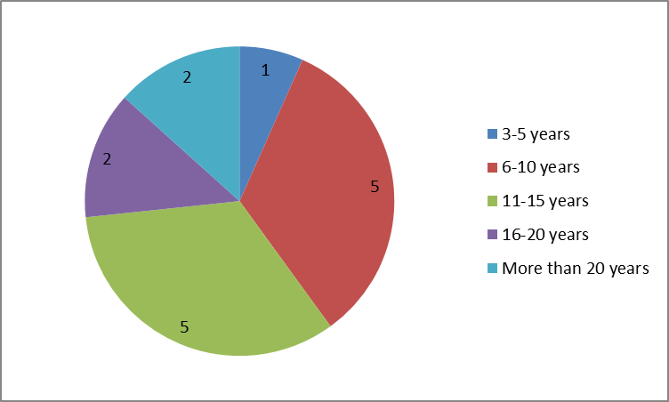

The majority were in a CNS or development post (10) on a band 6 salary (9). Four felt positively that there were prospects to develop into a CNS role within their workplace with the reminder (9) considering it a possibility. The majority (12) aspired to an advanced practice specialist role such as CNS or consultant.
The particpants came from a variety of educational backgrounds (Figure 2) and despite many years in practice did not declare many post registration qualifications
Figure 2 Declared educational background of the particpants (particpants could choose more than one answer)

Analysis of questionnaire free text in which respondents were asked to share their view on the purpose of the role many cited advice and support as the primary function. The focus was on psychological care and information giving. There was also a facilitative theme of supporting medicine and “being the link worker between the consultant and the patient” with one respondent explicitly comparing the role to that of a junior doctor. Only one respondent mentioned expertise in cancer nursing, co-ordination of care or advocacy. This might indicate a deficit in understanding of the more complex aspects of the role.
Motivation for undertaking the course (n=12) was primarily to build confidence, self-development and career progression.
There was an appetite for further development as shown in Fig 3. Respondents were asked what they would study if time and money were no object to which 12 responded. It is interesting to note that advanced practice was only chosen by four respondents as these are essentially advanced practice roles. However there was an appetite amongst the group for specialist study days.

Fig 3 Declared desired development activity (respondents could choose more than one option) n=12
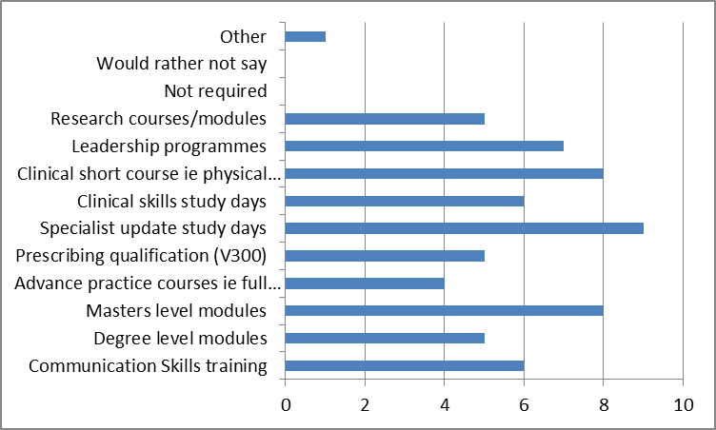
In terms of confidence around the role within the multidisciplinary team (MDT) some insight was gained from a specific question in which respondents were asked if they agreed with statements. These statements were drawn up by expert CNSs in previous studies such as 2015 Prostate Cancer UK. The results are shown in Fig 4 and 5 and show a range of perceptions about the role and function within the team particularly in regard to advocacy. Whilst participants enjoyed being part of the MDT around half felt they were not clear about their role and also had areas where they lacked confidence such as constructive challenge and case management.
Fig 4 Experiences in the "before” group of working within the MDT n=12
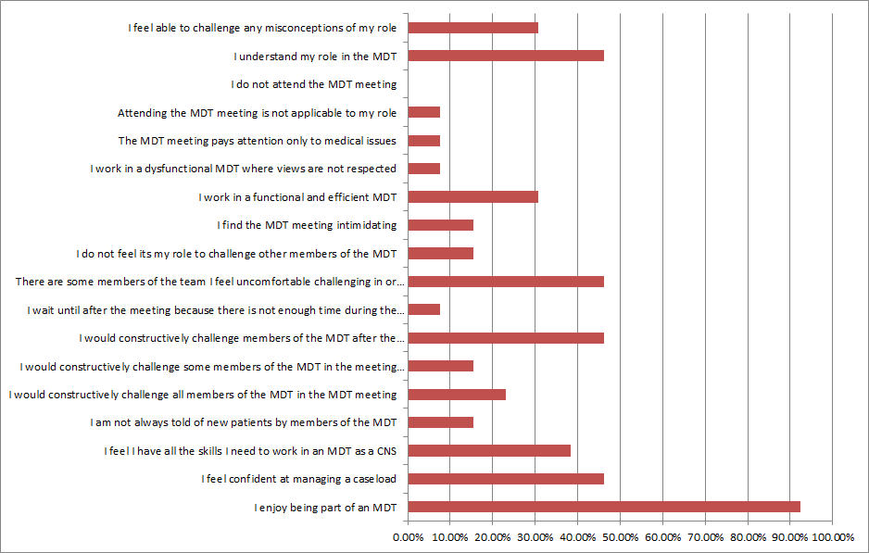

Fig 5 Experiences in the "after" group of working within the MDT n=6

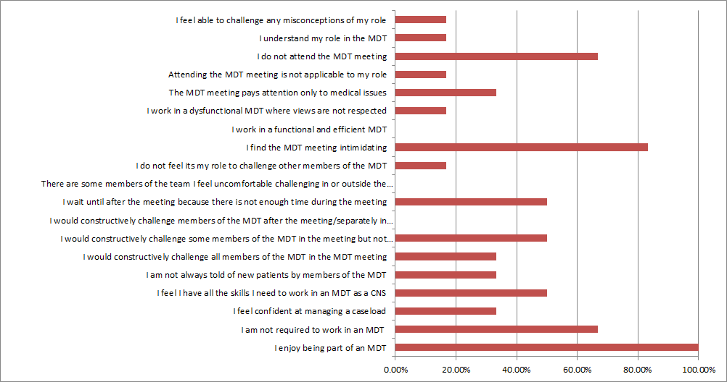

It is interesting to note that although all the participants enjoyed being part of the MDT there seemed to be no change (and even an increase) in negative perceptions of MDT working such as willingness to constructively challenge and feeling intimidated by the MDT which is at odds with the expressed perception of the role as one of advocacy.
The after survey was sent to the same participants during October-Dec 2016. Those that did respond found the course useful (5) and one was not sure and one found the course not useful. Four were from a large teaching centre and two from a district hospital. When asked what was useful in free text questions, mentorship and exposure to a cancer centre was useful although two respondents commented that the cancer centre worked in a very different way which might limit transferability of the learning.
Five out of six responded that their next desired career move would be to a CNS or developmental CNS role but two desired ward sister/manager as their next role.
Areas where the course could be improved upon included shadowing opportunities, incorporating e-learning into more of the module and more exposure to the CNS to learn. Other comments included the “basic” nature of the communication skills course and a desire for more information on research roles. Reasons for taking the course remained largely the same both in the before and after group. The primary motivator was to build confidence but in addition a theme emerged around finding out more about the role. In the after group six participants felt that the course had helped them by giving them an increased knowledge in cancer with one participant not sure.
Interestingly the freetext responses to the question of the purpose of the role changed in the after group-answered were more structured with the role and function of keyworker prominent whereas it was not mentioned in the before study. Expert care is also a theme with an emphasis on developing a skill set of being able to review patients independently, advocacy, ensuring patient safety and teaching others was also more prominent.
Discussion
Overall the course was well evaluated in that the majority of participants found it very useful, felt it improved knowledge and was useful preparation for the role. In particular participants valued the flexibility in delivery and felt motivated by taking part. Participants highly valued the mentorship offered, not only in terms of knowledge but also in terms of developing professional identity. Professional identity is important to nursing and many struggle in new roles such as specialist practice (Scholes 2008). The course and the mentorship offered allowed them the opportunity to understand the context of the role as part of the wider service and start to develop their professional identity as a specialist
Professionalization and increased role identity was apparent during and after participation-changes of language in terms of clarity of role were apparent such as increased use of the terms like keyworker and advocacy as being central to the purpose of the role. Although this was across all participants it is hard to know how much the course contributed to changes in language and self-perception. This would be an area for further study.

There were however significant challenges to participation. This is not unusual as currently there is pressure on specialist nurses work on wards (Read 2015), carry larger caseloads (PCUK 2014) and There is also decrease in continuing professional development funding in England. The particpants stated that during the programme there is no protected time, service demands are high and the development activity was given less priority than clinical work. Many of the participants felt that a fixed delivery period and expectation in terms of completion would give structure to the course. Overall the module content was good but some participants felt some aspects such as communications were too basic. The evaluation revealed other workplace issues such as lack of clarity around the role of the CNS within the MDT and a mixed picture in term of confidence building which is worth further study and echoes the recent publication by CRUK into MDT working (CRUK 2017). Overall the course was well evaluated despite the challenges in terms of time. It would be interesting to evaluate a larger fixed cohort, gain insight from those who are mentoring and also undertake more comparative work to understand impact on services. A number of suggestions were made by the participants which are shown in Box 1 and the team have already incorporated into the next iteration of the programme.

There is a worldwide shortage of nurses alongside issues of recruitment and retention in the profession. This has led to pipeline issues and development programmes such as this one might not only increase supply but also aid retention in the clinical workforce as a whole.
BOX1 Suggested further work & recommendations
Suggestions/recommendations
• Some of the challenges might be overcome by a fixed time period with a defined start & end point. This is now in place with an expectation of 6 months.
• Protected time for example 0.5 days per month (3 days in total) for participants and mentors. Two study days will be added for the next cohort on communication skills and MDT working
A Graduation Day has been introduced to mark completion of the programme• Participants valued contact time (real or virtual) and different methods of support such as action learning sets, communities of practice, forums and secure virtual space might be helpful.
• The e-learning module content was helpful but some participants felt it was pitched too low and that some elements could be added such as dealing with working relationships, understanding research, understanding the role and expectations and specialist specific learning for example tests & investigations. The modules have now been reviewed and new ones added e. g. MDT working
• Although the course appears to have impact attrition is high-this appeared to be a reflection of churn rather than the course per se but high turnover should be considered in terms of recruitment.
Conclusion
The development of the next generation of specialist nurses is essential in order to maintain quality in cancer services but challneges such as a nursing shortage, restrictions on funding and an ageing workforce mean a pragmatic approach is necessary.
Development programmes such as this might encourage more nurses into specialist practice and may even help retain nurses in the profession by offereing progression in a clinical role.
References
Braun, V. and Clarke, V. (2006) ‘Using thematic analysis in psychology’, Qualitative Research in Psychology, 3(2), pp. 77–101.
Cancer Research UK (2017) Meeting Patients Needs Accessed Jan 2017 http://www.cancerresearchuk.org/about-us/we-develop-policy/our-policy-on-nhs-cancer-services/improving-the-effectiveness-of-mdts-in-cancer-services?utm_source=twitter_crukpolicy&utm_medium=cruksocialmedia&utm_campaign=CRUKpolicytw
Department of Health (2007) The Cancer Reform Strategy http://webarchive.nationalarchives.gov.uk/+/www.dh.gov.uk/en/Healthcare/Cancer/DH_091120 Accessed 4th October 2015
Leary A Mackie D, Warren M (2012) The complexity of non face-to-face work with patients affected by metastatic breast cancer and their carers. The 'hidden consultations' of the clinical nurse specialist. Eur J Oncol Nurs. 2012 Dec;16(5):460-4. doi: 10.1016/j.ejon.2011.10.009. Epub 2011 Dec 9
Leary A White J, Yarnell L, (2013) The work left undone. Understanding the challenge of providing holistic lung cancer nursing care in the UK. Eur J Oncol Nurs. 2014 Feb;18(1):23-8. doi: 10.1016/j.ejon.2013.10.002. Epub 2013 Nov 15

Macmillan Cancer Support (2014) Census of the specialist cancer nursing workforce (England) http://www.macmillan.org.uk/Documents/AboutUs/Research/Researchandevaluationreports/Macmillan-Census-Report-England.pdf Accessed 4th October 2015
Maddams J, Utley M, Møller H (2014). Projections of cancer prevalence in the United Kingdom, 2010-2040. British Journal of Cancer, 107(7): 1195–202.
NHS England (2014). Cancer Patient Experience Survey 2014 National Report. http://tinyurl.com/oz96j68 Accessed 4th October 2015
PCUK (2014) The Prostate Cancer Specialist Nursing Workforce in the UK. Prostate Cancer UK
Punshon G, (2017) Endecott R, Aslett P et al The Experiences of Specialist Nurses Working Within the Uro-oncology Multidisciplinary Team in the United Kingdom. Clin Nurse Spec. 2017 Jul/Aug;31(4):210-218. doi: 10.1097/NUR.0000000000000308
QSR Software (2017) NVivio Software for qualitataive data analysis QRS Software http://www.qsrinternational.com/nvivo-product accessed July 2017Read, C. Workforce supplement: The Benefits of Specialist Nurses. HSJ, February 2015.Weblink: https://www.hsj.co.uk/hsj-knowledge/downloads/workforce-supplement-the-benefits-of-specialist-nurses/5082712.article Accessed July 2017
Richards M (2010) National Cancer Patients’ Experience Survey Programme 2010. http://tinyurl.com/68spyhm Accessed 4th October 2015
Scholes J (2008) Coping with the professional identity crisis: Is building resilience the answer? IJNS Volume 45, Issue 7, Pages 975–978
Trevatt P, Leary A (2010) A census of the advanced and specialist cancer nursing workforce in England, Northern Ireland and Wales. European Journal of Oncology Nursing 2010 Feb;14(1):68-73.
Welsh Government (2014). Wales Cancer Patient Experience Survey: National Report http://tinyurl.com/lvklbd5 Accessed 4th October 2015

