An investigation into the effect of acoustics on vocal strain of Opera singers
Gizem Okten
WSP | Parsons Brinckerhoff, London, UK
email: Gizem.Okten@wspgroup.com
Stephen Dance
London South Bank University, London, UK,
Objectives: This paper will report some of the final results of a doctoral study on the effect of acoustics on vocal strain of Opera singers. The research presents singers' objective voice dosimetry and subjective perception data together with the room acoustic parameters with the aim of establishing the preferred practice room conditions for Opera singers.
Methodology: For this purpose 117 Opera singers from the Royal Academy of Music participated in the research. The pilot stage of the research was undertaken at the acoustic laboratories of London South Bank University in order to validate the research methodology in controlled environment, and the field stage was undertaken at four practice rooms of Royal Academy of Music. Singers’ subjective data was collected via questionnaires validated during the pilot stage, and singers’ objective voice dosimetry data was collected via Ambulatory Phonation Monitor. Room acoustic measurements were undertaken separately for each practice room when the rooms were unoccupied. Statistical analysis were performed to establish the relationship between the room acoustics and the singers’ data.
Results: The students' subjective response to the different acoustic conditions of the practice rooms showed significant change and very strong correlations were observed with the measured T30 room acoustic parameter at the 4k octave band and C80 parameter at 500 Hz to 4 kHz. Using this information and the practice room geometries, Opera singers’ ideal practice room conditions were established.
Keywords: Ambulatory Phonation Monitor, practice room acoustics, opera singers, voice dosimetry, vocal loading

Introduction
Professional classical singing requires dedication and a significant amount of practice in order to properly sing the challenging pieces. Classical singers not only practice to become an expert in their techniques but also must understand the context, emotions and delivery of each musical piece. Acoustics of practice rooms are crucial as the singers spend most of their learning process in these rooms. According to Lamberty ^{[36]} weekly use of practice rooms in music schools by music students can reach 40 hours, which proves the importance of these spaces.
Previous research on singers’ voice focused on the voice and vocal health issues. This allowed improved treatments and techniques in the clinical practice for singers’ vocal health. However, little research has been undertaken on how room acoustics affect the voice dosimetry and perception of classical singers. The aim of this research was to understand the changes in Opera singers’ objective and subjective responses due to change in the acoustics of their practicing environment. This would allow the relationship between room parameters and the subject’s parameters to be determined so that a preferable practicing environment for the Opera singers could be designed.

Methodology
The research has been undertaken in two stages: the pilot and the field stage. The research methodology including the questionnaire and the equipment to be used for the field stage were validated in the pilot stage which was undertaken with a total of 62 Opera singers using extreme environments; a reverberant, semi-reverberant and an anechoic chamber.
The field stage was undertaken with a total of 55 Opera singers. Four acoustically different practice rooms at the Royal Academy of Music which are mainly used by the Opera singers were chosen. The data were collected in three steps: singers’ objective data collection, singers’ subjective data collection, and room data collection.

Singers’ Objective Data Collection
Vocal loading is known as the stress inflicted on the vocal folds during phonation. ^{[1, p125]} In order to track singers’ vocal loading and collect voice dosimetry data, two equipment were used: an Ambulatory Phonation Monitor (APM) and a Class 1, Norsonic 140 sound level meter.

Objective Voice Dosimetry collection via Ambulatory Phonation Monitor (APM)
APM is a portable device composed of an accelerometer which is attached to singers’ glottis. The accelerometer detects the vocal fold vibrations and provides voice dosimetry data including phonation time (P_{t}, sec), time-average sound pressure level (SPL, dB), frequency (F0_{average} and F0_{mode}, Hz), cycle dose (D_{c}) and distance dose (D_{d}, meters). These voice dosimetry parameters are known as vocal loading parameters, and the device is used in order to track the changes in each of these parameters due to change in the acoustics of the practice rooms.
Prior to measurements, the device needs to be calibrated for each singer in order to introduce the full range of the singer to the device. After calibration process, in order to collect singers’ voice dosimetry data, the singers were given two tasks: to sing “scales” and a “song” of their own choice for two minutes and to repeat the same tasks in each of the four practice rooms. As in their real practice environment, they were asked to sing the scales first as a warm-up and then the song. The total singing duration in each practice room were four minutes non-stop (two-minute scales, two-minute song) and the total voice dosimetry measurement duration was 16 minutes with each singer.

Objective Voice Dosimetry collection via Sound Level Meter
During pilot stage it is found out that APM only provides time-average unweighted sound pressure levels, in order to obtain frequency based data for a more detailed analysis, a Class 1 Nor140 sound level meter was fixed at 1.5 m away from the singers during monitoring. Sound power levels for each octave band were calculated from the measured sound pressure levels for each singer via Equation 1⁽³⁵⁾ where L_{TOTAL} is the sum of direct and reverberant sound pressure levels, L_{w} is the sound power level, r is the distance of receiver from the source and R_{c} is the room constant.

(1)
R_{c} for each room was calculated for each octave band frequency using Equation 2⁽³⁵⁾ where S is the total area of room surfaces, α is the average sound absorption of those surfaces at each octave band.

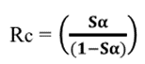 (2)
Sound absorption for each room at each octave band frequency was calculated via Sabine’s formula presented in Equation 3 using measured T30 values.
(3)

Singer’s Subjective Data Collection

Room Questionnaire
In order to collect singers’ subjective data regarding the rooms, a questionnaire was developed. The questionnaire was composed of nine questions of which the singers were asked to rate on a seven-point Likert-type scale. The first five questions were related to room acoustic parameters whereas the last four questions were about their perceived effort and overall impression of the rooms. The questions are presented below in Table 1.
Table 1: Room Questionnaire in order to collect singers’ subjective data with preferred values
 | Subjective Parameter | Preferred Value
1 | Loudness  How do you perceive your sound level in this room? | 4 (sufficient)
2 | Clarity  How would you rate the degree to which notes are distinctly separated and clearly heard? | 4 (balanced)
3 | Reverberance  How would you rate the persistence of sound in this room? | 4 (balanced)
4 | Background noise  How would you rate the background noise levels in this room? | 2 (very weak)
5 | Size of the room  How would you rate the size of this room? | 4 (sufficient)
6 | Pleasure of singing in this room  How would you rate your pleasure of singing in this room? | 5 (good)
7 | Voice feeling  How would you rate your voice feeling in this room? | 4 (as usual)
8 | Singing effort  How would you rate your effort singing in this room? | 4 (as usual)
9 | Overall Impression  How would you rate the acoustical quality of this room? | 5 (good)

The singers were asked to complete the questionnaire right after their voice dosimetry collection in each room.

Singers’ preferred ratings
In addition, after completion of the room questionnaire, regardless of the rooms they have sung in, the singers were also asked about what rating they would ideally prefer on the 7-point Likert type scale for each subjective parameter in order to find out Opera singers’ preferred ratings and their preferences were separately documented in an Excel sheet. In further analysis, these preferred ratings were targeted for each subjective parameter in order to find out ideal practice room conditions for the Opera singers.

Room Data Collection
Room acoustic measurements of each practice room were undertaken using the exponential swept sine (e-sweep) technique using the WINMLS software. A laptop connected to a Norsonic (Nor280) power amplifier linked to a Norsonic (Nor275) hemi-dodecahedron loudspeaker and an Earthworks M30BX class 1 microphone was used when the rooms were unoccupied at a minimum of six measurement positions, see Figure 1. Parameters including Clarity Index (C80), Reverberation Time (T30), Early Decay Time (EDT) were measured at each octave-band for each room. Due to small size of the rooms, Strength (G) parameter was calculated from the measured Reverberation Time using the following formula:

In addition, background noise measurements were undertaken using a NOR 140 sound level meter, again when the rooms were unoccupied. Here, the aim was to measure the background noise levels at the time when the singer’s voice dosimetry measurements were collected, pragmatic 2-minute representative background noise measurements were done immediately after the data collection of each subject when the room under measurement was unoccupied but adjacent practice rooms were in use. Hence the higher LAeq values in the four rooms, ranging from 40 to 45 dB. In order to find the representative noise levels during the time of singers’ measurements, the 2-minute background noise levels (L) collected after each singer (N=55) in each practice room were logarithmically averaged for each room.

Figure 1. The measured reverberation time, T30, in the four RAM practice rooms

Statistical Analysis
The measurement results were analysed using IBM SPSS Statistics 21. In order to find the difference of singer’s data between the practice rooms a One-Way Repeated Measures ANOVA test was conducted. According to the results of one-way repeated measures ANOVA tests conducted for singer’s data, the parameters that showed significant difference between RAM practice rooms further analysed together with Pearson Correlation Analysis in order to find the correlation between room data and the singers’ data. The parameters which have shown significant correlation were further analysed using regression analysis to predict the target values of these parameters which correspond to singers’ “preferred” ratings in practice rooms.

Results
According to the results of one-way repeated measures ANOVA test, the voice dosimetry data collected via APM and SLM in practice rooms for “scales” and for “song” exercise did not show any significant difference between rooms, but the subjective data showed significant change. Table 1 shows the relationship between the subjective responses and the objective room acoustic parameters where 5 of the 9 parameters shown agreement at the 95% level. The two parameters with consistent agreement were C80 and T30, interesting only the 4 kHz value should agreement for both parameters.

Table 2 Subjective parameters and the room parameters that show common correlation, + : parameters that show correlation, n/c : no correlation.
Room Parameters | Subjective Parameters
 | Reverberance | Voice  feeling | Singing  effort | Pleasure of singing | Overall  impression
C80 _{(500Hz)} | + | + | + | + | +
C80 _{(1kHz)} | + | + | + | + | +
C80 _{(2 kHz)} | + | + | + | + | +
C80 _{(4 kHz)} | + | + | + | + | +
C80 _{(1 kHz -2 kHz)} | + | + | + | + | +
C80 _{(500Hz-1kHz)} | + | + | + | + | +
C80 _{(mid)} | + | + | + | + | +
C80 _{(250-500 Hz)} | + | + | + | + | +
C80 _{(250-1 kHz)} | + | + | + | + | +
C80 _{(125Hz-1 kHz)} | + | + | + | + | +
T30 _{(4 kHz)} | + | + | + | + | +
C80 _{(125-500Hz)} | + | n/c | + | + | +
C80 _{(125-250Hz)} | n/c | n/c | n/c | + | +
C80 _{(low)} | n/c | n/c | n/c | + | +
EDT_{(4 kHz)} | n/c | n/c | + | + | +
EDT_{(1 kHz)} | n/c | n/c | + | + | +
EDT_{(500Hz-1k)} | n/c | n/c | n/c | + | +
EDT_{(1 kHz -2 kHz)} | n/c | n/c | n/c | + | +
EDT _{(mid)} | n/c | n/c | n/c | + | +
T30 _{(250-500Hz)} | n/c | n/c | n/c | + | +
T30 _{(250Hz-1 kHz)} | n/c | n/c | n/c | + | +

For example for the subjective response 'reverberance' the four RAM practice rooms showed a 99% relation with C80 4kHz which can be used to predict the preferred rating, see Figure 2 . The preferred value of 5 can also be found from Figure 3 giving a T30 4kHz value of 0.5 seconds.
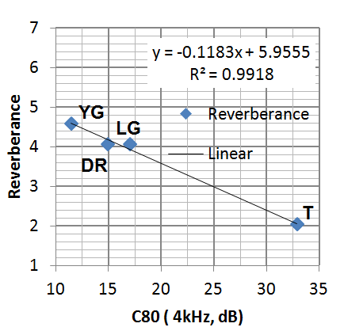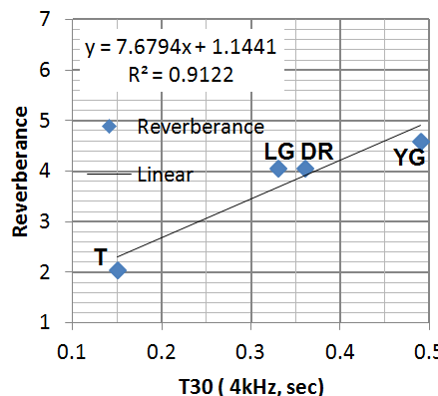
Figure 2 Reverberance and C80 4 kHz relation Figure 3. Reverberance and T30 4kHz relation

Another example is given for the 'Pleasure of Singing' response can be found with 99% relation from the C80 2 kHz value as 8 dB, and the T30 4kHz value of 0.53 seconds
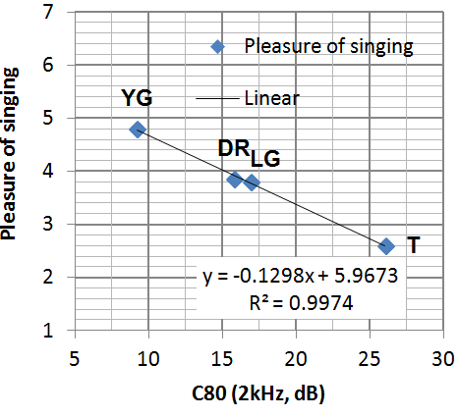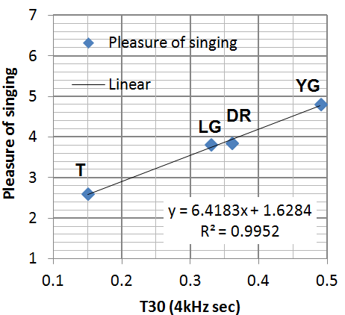

A comparison with standards and guidance was undertaken to establish if the research findings were consistent with the literature, based on NS8178 the reverberation time, Tm, is too great for all of the RAM practice rooms, see Table 3.

Table 3 Comparison of reverberation times measured in RAM practice room and NS8178

Rooms | Volume | T_{m} (measured) | T_{m} (minimum and maximum limits, NS8178)
YG | 35.12 | 0.72 | 0.3 sec≤ T_{m} ≤0.43 sec
LG | 14.53 | 0.37 | 0.15 sec≤ T_{m} ≤0.17sec
DR | 19.5 | 0.45 | 0.23 sec≤ T_{m} ≤0.27 sec
T | 13.94 | 0.22 | 0.13 sec≤ T_{m} ≤0.16 sec

However, when the results were compared to the BB93, Music Accommodations and ANSI 12.60 standards the values measured are compliant for Tmid, see Table 4.
Table 4 Required reverberation times (T30_{mid}, sec) of music practice rooms according to different standards/guidance and RAM values
Standard / Guidance | Room Volume | T30_{mid}
BB93:2015 ^{[40]}  (new built) | ≤ 30 m³ | ≤ 0.6
 | > 30 m³ | ≤ 0.8
BB93:2015^{[40]} (refurbished) | ≤ 30 m³ | ≤ 0.8
 | > 30 m³ | ≤1.0
Music accommodation in secondary schools, A design guide (2010) ^{[41]} | ≤ 30 m³ | ≤ 0.8
 | > 30 m³
ANSI/ASA S12.60^{[44]} | ≤ 283 m³ | ≤ 0.6
RAM Practice Rooms | Room Volume | T30_{mid}
YG | 35.12 | 0.67
LG | 14.53 | 0.35
DR | 19.5 | 0.41
T | 13.94 | 0.21

When compared to the standards for small practice rooms and the values preferred by the Opera singers it was determined that a 35m3 room was felt to be sufficient, where as a larger, 50m3 room was preferred. These were found to be inline with BB93, Music Accommodation and NS8178. see Table 5.
Table 5 Minimum dimensions of a small practice room recommended by the standards and singer’s preferred dimensions according to research results.
Standard / Guidance | Room volume |  | Room area |  |  | Room height
 | Small | Medium (ensemble) | Small | Medium (ensemble) |  | Small |  | Medium (ensemble)
BB93:2015^{[40]} | ≥ 30 m³ |  | 8 m² | 20 m² |  | ≥ 3 m
Music accommodation in secondary schools, A design guide (2010) ^{[41]} | ≥ 30 m³ |  | 8 m² | 12 - 15 m² |  | 2.7m - 3 m
NS8178^{[45]} | ≥ 40 m³ | ≥ 60 m³ | ≥ 15 m² |  |  | ≥ 2.7 m | ≥ 3.5 m
Research results | Room volume |  | Room area |  |  | Room height
Preferred Ratings | Sufficient | Large | Sufficient |  | Large | Sufficient |  | Large
Singer’s preferred dimensions | 35 m³ | 50 m³ | 13 m² |  | 18 m² | 2.67 m |  | 2.77 m

In terms of background noise levels (unoccupied) these are lower than that found in the music practice rooms. The reason was that the levels were measured unoccupied but the neighbouring practice rooms were occupied by musicians, and hence 42 dBA was found acceptable, 15 dB higher than that given in NS8178. but in line with AS/NZS 2107:2000, see Table 6.
Table 6 Recommended maximum background noise levels for practice rooms by standards/guidance and the recommended levels according to research results.
Standard / Guidance |  |  | L_{Aeq}
BB93:2015^{[40]} (new built) |  |  | 35 dBA
BB93:2015 ^{[40]}(refurbished) |  |  | 40 dBA
Music accommodation in secondary schools, A design guide (2010) ^{[41]} |  |  | 35 dBA
ANSI/ASA S12.60^{[44]} |  |  | 35 dBA
NS 8178^{[45]} |  |  | 27 - 30 dBA
AS/NZS 2107:2000^{[72]} |  |  | 40 dBA – satisfactory level
 |  |  | 45 dBA – maximum level
Research results
Ratings | Preferred ratings |  | Maximum tolerable rating
 | very weak | weak | acceptable
L_{Aeq} | 35.3 dBA | 38.8 dBA | 42.3 dBA

4. Conclusions
With the full cooperation of the Royal Academy of Music 117 Opera singers participated in the research project. The aim of the project was to provide design guidance for music practice rooms suitable for opera singers. It was found that vocal load did not correlate with the room acoustics data, however the subjective responses showed significant correlation at the >95% level. It was found that Reverberation time (T30) and Clarity Index (C80) were key room acoustic parameters that effect singers’ perception of the room as well as perception of their singing effort. The new findings was that the T30 in the 4 kHz octave band was found to play a key role on singers’ perception rather than the middle frequencies (T30_{mid}) as used in the guidance. For Clarity, C80, singers' perception agreed for all octaves bands, 500-4 kHz and combinations there of. In addition musician's did not mind higher levels of background noise, 42 dBA was acceptable, a higher value than all but one of the international standards. Finally, in terms of room size a practice room should be between 35-50m³ and be designed with one longer dimension and a flat reverberation time of between 0.4 and 0.5 seconds .

REFERENCES
- Crocker, M. J. Ed., Handbook of Noise and Vibration Control, John Wiley & Sons, Hoboken, NJ (2007).
- Migdalovici, M., Sireteanu, T. and Videa, E. M. Control of Vibration of Transmission Lines, International Journal of Acoustics and Vibration, 15 (2), 65–71, (2010).
- Každailis, P., Giriūnienė, R., Rimeika, R. and Čiplys, D. Application of leaky surface acoustic waves for investigation of thin film properties, Proceedings of the 18th International Congress on Sound and Vibration, Rio de Janeiro, Brazil, 10–14 July, (2011).
- Finks, K. (2003). Geometrical Acoustics. [Online.] available: http://www.fink.com/Kevin.html
- Yang, J. N., Akbarpour, A., and Ghaemmaghami, P. Technical Report NCEER-87-0007, Instantaneous Optimal Control Law for Tall Buildings Under Seismic Excitations, (1987).
- Poese, M. E., Performance Measurements on a Thermoacoustic Refrigerator Driven at High Amplitudes, Master of Science Thesis, Graduate Program in acoustics, Pensylvania State University, (1998).

