Two-Stage Stabiliser Addition Protocol as a Means to Reduce the Size and Improve the Uniformity of Polymer Beads
in Suspension Polymerisation

Fatemeh Jahanzad¹, Shahriar Sajjadi²
¹ Division of Chemical and Petroleum Engineering, School of Engineering, London South Bank University, 103 Borough Road, London SE10AA, UK.
² Faculty of Natural and Mathematical Sciences, King’s College London, Strand, London WC2R2LS, UK.
Correspondence to: Fatemeh Jahanzad (Email: jahanzaf@lsbu.ac.uk)

Abstract
A 2-stage stabiliser addition protocol is suggested for reducing the size and improving the uniformity of polymer beads resulting from conventional suspension polymerisation. The stabiliser load was divided into an initial charge and a secondary addition. The use of a low concentration of stabilizer in the initial charge served to assist drop rupture while avoiding significant reduction in drop size and production of too many satellite droplets. The secondary addition time of stabiliser occurred just before the onset of the growth stage when drops were vulnerable to coalescence but were robust against break up due to their high viscosity. The secondary addition of stabiliser served to provide stability to monomer drops during the growth stage and as a result the drops underwent limited coalescence. This resulted in the formation of smaller and more uniform polymer beads in comparison to beads obtained by conventional suspension polymerisation at the same overall concentration of stabiliser.

Introduction
Polymer beads are usually produced by suspension polymerisation. This process consists of an emulsification stage, where monomer droplets are formed, followed by a reaction stage, where the initial monomer drops transform into final polymer beads by polymerisation reactions occurring inside each drop. ,,, These two stages usually occur simultaneously in the same environment and are highly intermixed. Suspension polymerisation often produces polymer beads with a wide size distribution due to varying non-uniform shearing force applied onto drops during the emulsification stage. Drops interactions become more severe by the continuous increase in drop viscosity during the polymerisation stage, which can affect drop rupturing and coalescence in different ways. An increasing viscosity during polymerisation always enhances drop resistance to shearing forces and thus reduces the rate of drop break up while it only slightly decreases the rate of coalescence due to the concomitant increase in the film drainage time. The net effect results in a steep increase in the size of drops during the growth stage. These events add to the difficulties involved in producing uniform bead size distributions in conventional suspension polymerisation.
In recent years there has been significant research in decoupling emulsification and polymerisation stages in suspension polymerisation. Microfluidics, and membrane emulsification,, methods have been suggested as a substitute to the emulsification stage in a typical suspension polymerisation. While microfluidics enjoys unrivalled superiority in terms of drop uniformity, it suffers from a lack of scalability and high cost, which makes it an impossible choice for many commodity polymer beads. Membrane emulsification can deliver a more economically viable choice, but still requires large infrastructural investments, which makes it only economically viable for highly value-added materials.
Parallel with technologically advanced research, another approach has looked into designing new protocols for improving size distribution of polymer beads within the means of conventional suspension polymerisation. There are two lines of research in this category. One uses process variables, such as mixing type and pattern, in order to enhance bead uniformity by providing more uniform shear forces. The other one seeks formulation variables such as stabiliser type and concentration as a means to affect the surface properties of droplets and thereby improve droplets stability as well as uniformity. The latter approach highly emphasises the role of stabiliser in controlling drop size distribution in suspension polymerisation. The performance of a stabiliser in terms of its ability to stabilise drops is a function of surface coverage of drops, and diffusion and adsorption characteristics of the stabiliser, which are further determined by the molecular properties of the stabiliser.Error: Reference source not found,Error: Reference source not found Increasing the concentration of stabiliser in general, and polyvinyl alcohol (PVA) in particular, has been found to increase the ability to stabilise dispersions due to steric and Marangoni effects. A smaller mean size and sharper size distribution have often been obtained with increasing PVA concentration in suspension polymerisation as well as in simple liquid-liquid dispersions.
Drops fully protected by stabilisers are usually robust against coalescence due to the steric effect. These conditions are usually met at the critical micellar concentration (CMC) of stabiliser in the water phase; that is when the stabiliser concentration is sufficiently high to almost saturate the surface of droplets, but does not yet allow micelles to form. Under such conditions, a steady state in drop size is often achieved during which the rates of drop break up and coalescence are balanced. However, a high stabiliser concentration usually leads to small drops/beads with more associated smaller droplets/particles (satellite) due to a concomitant decrease in the interfacial tension or an increased chance of homogenous particle nucleation in the water phase. A high concentration of stabiliser often complicates the washing stage of polymer beads too. These drawbacks, together with unfavourable cost implication of using too much stabiliser, have caused the manufacturing units to adopt formulations based on a low concentration of stabilizer (< CMC). At such concentrations, however, drops cannot be fully covered and protected by the stabilizer and as a result a dynamic steady state in the average drop size is established, which cannot be easily controlled, leading to an increase in drop sizes during the growth stage.Error: Reference source not found
In this work we used an overall PVA concentration of 0.5 g/l which is much lower than the CMC value (around 1.0-1.5 g/l for PVA). The concept behind this research is that if the emulsification stage is conducted using a low stabiliser concentration, thus minimising the drops surface area developed, and the resulting drops are further stabilised by the addition of the remainder of stabiliser at some point during polymerisation when drops are sufficiently viscous and can resist break up induced by the lower interfacial tension, then such stabilised drops are more likely to avoid coalescence during the growth stage. As a result, this two-stage stabiliser addition protocol can provide finer beads with improved uniformity.

Experimental
All chemicals were obtained from Aldrich. Methylmethacrylate, MMA (analytical grade) was distilled before use. Lauryl peroxide, LPO (97%) and polyvinylchloride, PVA (M_{w} = 85000-146000, degree of hydrolysis = 87-89%) were used as initiator and stabiliser, respectively, without further purification. Deionised water was used throughout the work. Experiments were carried out using a 1-litre jacketed glass reactor with an internal diameter of 10 cm equipped with a four-bladed flat turbine-type impeller with a width of 5.0 cm, a standard four-baffle plate with the width of 1/10 of vessel diameter located at 90° intervals, an overhead reflux condenser, a thermocouple, a sampling device, a port for nitrogen purge, and an inlet for feeding ingredients. Nitrogen purging was carried out for 15 minutes before the monomer, containing 1.0 wt% initiator, was added to the continuous aqueous phase containing the required amount of PVA. The secondary addition of PVA (dissolved in 10 ml water) was made after 50 min from the start of the polymerisation reactions in most experiments. The monomer phase ratio of 20%, based on water, was used throughout this work. All experiments were carried out at 70 ± 1.0 °C using agitation speed of 500 rpm.
Samples were withdrawn at the desired time intervals from the reaction vessel for gravimetric measurements of conversion as well as size measurements. A laser diffraction particle sizer (Malvern, Coulter LS130), based on Fraunhofer diffraction, was used for drop/particle average size and distribution measurements. Interfacial tensions of MMA/aqueous PVA solutions were measured using a Du Nouy ring tensiometer.
The Coefficient of Variance (CV) for drop/bead volumee distributions was calculated using Equation 1.
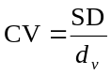
(1)

where SD is the standard deviation and d_{v} is the volume-average diameter of drops/particles. SD was calculated using Equation 2 where d is the drop/particle diameter in each size bin and n is the number of bins.
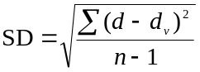
(2)

Results and Discussion
The experiments conducted are outlined in TABLE 1. Three experiments, runs 1, 2, and 3, were carried out using initial PVA concentrations [PVA]₀= 0.10, 0.15, and 0.25 g/l, respectively, while total PVA concentration was kept constant at [PVA]_{t} = 0.50 g/l. In other words, runs 1, 2, and 3 correspond to 20%, 30%, and 50% of the total PVA concentration in the initial reactor charge, respectively. The remainder of the PVA dissolved in 10 ml water was added to the reaction vessel in one shot at t = 50 min from the start of polymerisation. In another experiment, run 4, with [PVA]₀ = 0.25 g/l, the rest of the PVA was continuously added to the reactor using a dosing pump until t = 50 min. Two batch polymerisations with PVA concentrations of 0.50 and 0.25 g/l, runs 5 and 6, respectively, were also conducted for comparison.

TABLE 1. Recipes used in suspension polymerisations of MMA using two-stage PVA addition protocol. The total concentration of PVA was kept constant at [PVA]_{t} = 0.50 g/l for runs 1-5. The values given as added PVA are
based on total water content of the reactor.
Run | Initial PVA  charge (%) | Initial PVA  ([PVA]₀) (g/l) | Added PVA  ([PVA]_{a}) (g/l) | Mode of second  PVA addition
1 | 20 | 0.10 | 0.40 | One-shot
2 | 30 | 0.15 | 0.35 | One-shot
3 | 50 | 0.25 | 0.25 | One-shot
4 | 50 | 0.25 | 0.25 | Continuous
5 | 100 | 0.50 | 0 | N/A
6* | 100 | 0.25 | 0 | N/A
*[PVA]_{t} = 0.25 g/l

FIGURE 1a shows conversion vs time for runs with different initial charges of PVA. The overall rate of polymerisation was unaffected by the PVA addition policy, as was expected.Error: Reference source not found This figure also shows that the onset of the growth stage (the gel effect) occurs at t ≈ 60 min, beyond which the scale of particle growth becomes significant. This is the reason for t = 50 min being selected as the addition time of the remaining PVA.
FIGURE 1b shows the variations of the Sauter mean diameter (D₃₂) with time for this series, while FIGURE 1c illustrates the concept of this research for two representative runs. The average size of particles closely followed the common behaviour previously reported for suspension polymerisation.Error: Reference source not found The particle average size underwent four intervals; (i) transient stage during which drops were continuously reduced in size, (ii) steady state during which the average drop size remained almost constant, (iii) growth stage, and (iv) the identity point, which almost set the size of polymer beads.Error: Reference source not found

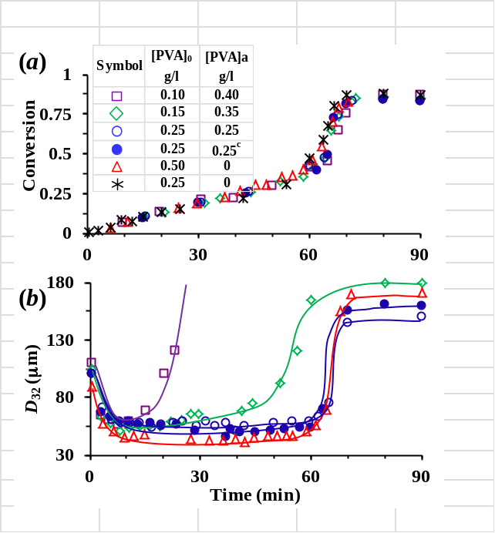
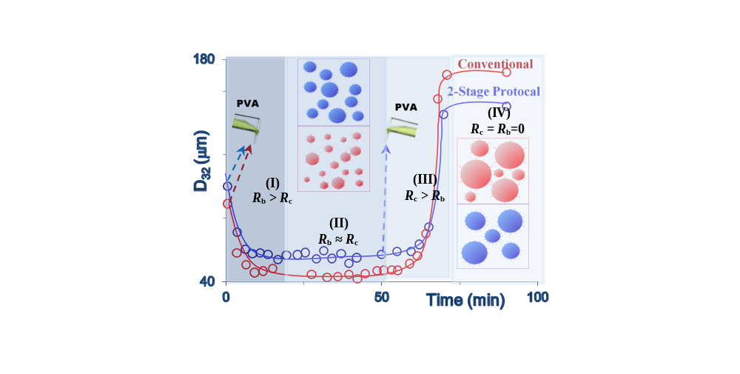
(c)
FIGURE 1. Time evolution of (a) conversion and (b) Sauter mean diameter (D₃₂) in suspension polymerisations of MMA with different initial PVA charges. Run 4 ([PVA]₀ = 0.25 g/l with continuous PVA addition) is shown with filled symbols and marked as ‘0.25^{c}’ in the legend of (a). The final particle size of run 1 ([PVA]₀ = 0.10 g/l) is 610 μm (not shown). (c) Illustrates the concept of the 2-stage stabiliser addition protocol for runs 3 and 5 .

Generally, the application of a higher initial concentration of PVA resulted in a longer transition period leading to a smaller average droplet size, as seen in FIGURE 1b, which is consistent with literature. This is in line with the interfacial data shown in FIGURE 2a; an increase in PVA concentration is associated with a decrease in the interfacial tension. A low interfacial tension assists in rupturing drops and making them smaller. The stability of drops against coalescence with increasing PVA concentration is mainly due to the increase in the resistance to film thinning. This may be achieved through two mechanisms. The first is related to the higher viscosity of the continuous phase with adding polymeric stabilisers. The other mechanism is what has been called Marangoni effect; when the intervening film thins, it sweeps along its path the stabiliser molecules adsorbed on the interface, creating a stabiliser concentration gradient and subsequent interfacial tension gradient that opposes the film thinning. The change in the viscosity of the medium was not significant in the range of PVA concentrations studied. Therefore, the improved stability can be attributed to the steric effect offered by the stabiliser and the Marangoni effect associated with it.

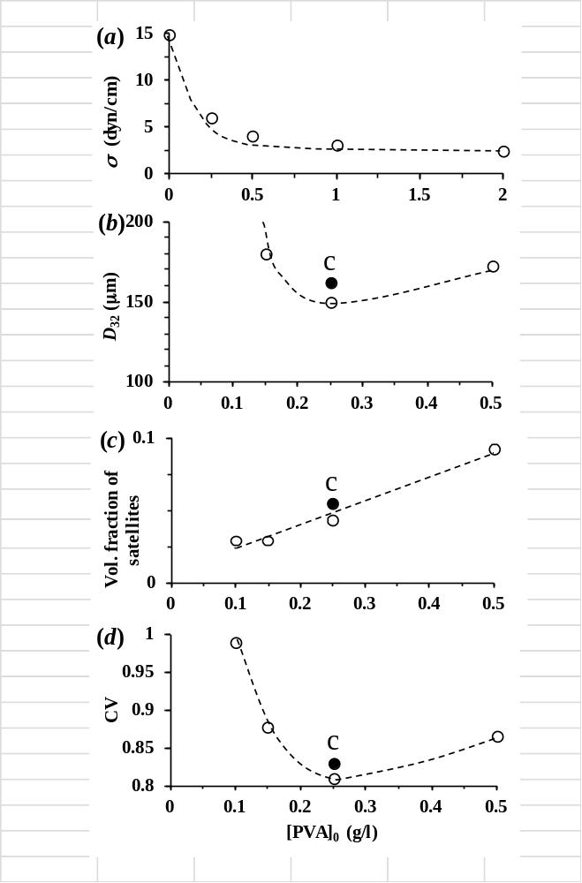

FIGURE 2. Variations in surface tension of PVA aqueous solutions (a), volume fraction of satellite (b), Sauter mean diameter (c), and coefficient of variance CV (d) against [PVA]₀ in suspension polymerisation of MMA with [PVA]_{t} = 0.50 g/l. The filled symbol marked with ‘c’ represents Run 4 ([PVA]₀ = 0.25 g/l with continuous PVA addition).

Overall, a higher concentration of stabiliser in the initial charge gave a longer steady-state period during which the size of drops could be maintained due to abundance of the stabiliser. For [PVA]₀ = 0.10 g/l, there was almost no steady-state period. Drops started growing via coalescence 10 min after the start of the polymerisation, due to the lack of stabiliser, as seen in FIGURES 1b. The addition of the remainder of PVA improved the stability of particles and controlled their size in the course of polymerisation. For this experiment, however, the size of particles exceeded the operational size range of the particle sizer after 45 min, so photographs were taken from the samples using an optical microscope and the particle size average was estimated by counting about 300 particles. For [PVA]₀ = 0.15 g/l, the growth stage started after 30 min. For the higher initial charge of PVA ([PVA]₀ = 0.25 g/l), drops showed a rather long steady-state period and the growth stage started after about 60 min from the start of the polymerisation, similar to that of conventional polymerisation using [PVA]₀ = 0.50 g/l.
FIGURE 2b shows the size of final particles vs [PVA]₀. A minimum in the Sauter mean diameter of drops was obtained when the two-stage PVA addition protocol was used with [PVA]₀ = 0.25 g/l, regardless of the secondary PVA addition mode (one-shot or continuous). Particles from the runs with [PVA]₀ > < 0.25 g/l were quite larger than that at the minimum. The interesting result is that by using the two-stage stabiliser addition protocol, it is possible to reduce the size of final particles using the same overall concentration of the stabiliser.
The rate of drop break up in a liquid-liquid dispersion, R_{b}, is a function of frequency of drops collision with eddies and efficiency of drop break up. The latter is the ratio of the required energy to overcome the surface tension and viscoelastic resistance to available energy.Error: Reference source not found The break up efficiency is therefore inversely proportional to the interfacial tension and drop viscosity; a drop with higher interfacial tension and viscosity can resist breakage more. The rate of drop coalescence, R_{c}, is a function of frequency of drops collision and efficiency of coalescence which depends on the drainage time of the film intervening colliding drops. The efficiency of coalescence decreases with increasing stabiliser concentration.
The average size of drops during the transition stage is governed by the rate of drop break up R_{b}, while it is governed by the rate of coalescence R_{c} during the growth stage,Error: Reference source not found with the equality in rates R_{b}≈ R_{c} held in the middle steady-state region. The use of a reduced amount of PVA in the initial charge serves to slow down the rate of break up R_{b} during the transition period, when compared with the whole PVA added initially, while the use of the remainder of PVA as a secondary stabiliser serves to reduce the coalescence rate R_{c} during the growth stage when R_{b} no longer dominates the size. The combined effects raise the steady-state drop size and reduce the extent by which drops undergo growth/coalescence during the growth stage, leading to smaller polymer beads, as seen in FIGURE 1b and illustrated in Figure 1C.
The secondary addition of stabiliser did not affect the rate of drop break up. This statement is verified by the fact that the secondary addition of PVA at t = 50 min did not lead to any reduction in drop size for all experiments carried out (see FIGURE 1b). This clarifies why the secondary PVA addition was delayed until t = 50 min, which is close to the onset of the growth stage (t ≈ 60 min). The duration of the steady-state stage and other intervals in suspension polymerisation depends on the stabiliser concentration as well as the reaction kinetics.Error: Reference source not found From FIGURE 2b, it is conjectured that there could be a critical concentration of PVA for any polymerisation condition, [PVA]₀ > 0.25 g/l for the current study, above which a two-stage addition of stabiliser will result in the formation of smaller particles in comparison with those from the corresponding batch process.
One of the technological drawbacks of conventional suspension polymerisation is the production of inferior satellite particles, which are usually treated as off-grade by-products and screened from the main polymer beads. The task of reducing the formation of satellite particles by using a lower concentration of stabiliser is often formidable due to a concomitant increase in the size of final polymer beads. While the use of inhibitors can eliminate the formation of small particles resulting from homogenous nucleation in the water phase, cannot eliminate the bulk of satellite particles formed via drop breakage mechanism.Error: Reference source not found FIGURE 2c shows that the volume fraction of satellite droplets increased with [PVA]₀. Not only satellite droplets/particles were produced at a lower rate at low initial PVA concentration, due to a high interfacial tension as observed in FIGURE 2a, they were also partly lost in the course of reaction by coalescence/coagulation due to the lack of stability of particles. The results clearly show the 2-stage stabiliser addition protocol can reduce the formation of satellite drops and thus improve uniformity of products. FIGURE 2d shows that the minimum in polymer bead size at [PVA]₀ = 0.25 g/l, as seen in FIGURE 2a, was accompanied by a minimum in the CV of polymer beads, confirming that the resulting polymer beads were the smallest with the sharpest distribution.

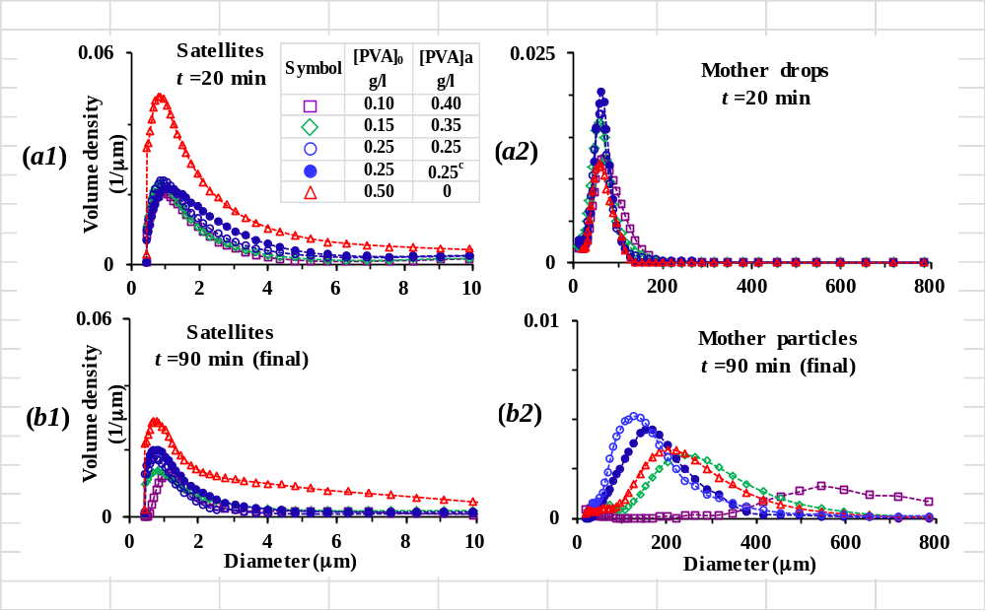
FIGURE 3. Drop/Particle size distributions of ((a1) and (b1)) satellites (<10 μm) and ((a2) and (b2)) mother drops/particles at t = 20 min and t = 90 min in suspension polymerisations of MMA with [PVA]_{t} = 0.50 g/l, respectively. Run 4 ([PVA]₀ = 0.25 g/l with continuous PVA addition) is shown with filled symbols and marked as ‘0.25^{c}’ in the legend of (a).
The time evolution of size distributions can be observed in FIGURE 3 for satellite droplets/microparticles as well as mother drops/particles at t = 20 and 90 min. The time 20 min represents the size distributions for steady-state stage while t = 90 min represents the final particle size distributions. FIGURES 3a1 and 3b1 clearly show that the volume density of satellite droplets is maximised at high PVA concentration in the initial batch,Error: Reference source not found an effect which was maintained until the end of reactions, as shown in FIGURES 3a2 and 3b2. At very low [PVA]₀ (e.g., 0.10 g/l), drops were not sufficiently stabilised and eventually very large polymer beads with broad distribution were resulted. The sharpest distribution for polymer beads was obtained at [PVA]₀ = 0.25 g/l, where the smallest polymer beads were also produced, as stated before. The size distributions of polymer particles broadened with decreasing PVA concentration in the initial charge, [PVA]₀, below the minimum. The conventional batch polymerisation produced sharper size distribution than the two-stage protocol using [PVA]₀ = 0.1 and 0.15 g/l, but could not match those produced at [PVA]₀ = 0.25 g/l.
It is quite well documented that the adsorption of PVA on drops is not instantaneous. It has been shown that it might take several minutes before stabiliser molecules, particularly PVA molecules, are completely adsorbed on the surface of droplets.,,, This was the reason that the PVA addition time was set at t = 50 min, 10 min prior to the onset of the growth stage that occurs around 60 min after the start of polymerisation. However, in order to ensure that PVA adsorption has progressed sufficiently before the onset of the growth stage, run 4, was conducted in which the remainder of the stabiliser was added over a course of time starting from time t = 0 to t = 50 min. In this run the added stabiliser molecules had sufficient time for adsorption on the surface of drops before the onset of the growth stage. However, the increased PVA concentration, because of the additional PVA added early during polymerization, enhanced the rate of drop break up and reduced drop sizes during the steady state stage, as seen in FIGURE 1b. This semi continuous addition policy resulted in larger particles with broader distribution than those produced via one-shot secondary addition policy at the same PVA concentration. It appears that the continuous stabiliser addition policy supresses the advantage of two-stage protocol and tends to approach conventional suspension polymerisation.
Furthermore, it has been reported that the stability of oil/water dispersions increases with increasing degree of grafting of hydrophobic branches of the water-soluble polymeric stabilisers such as PVA,, an effect which appears to intensify with reaction time. The early addition of PVA stabiliser should therefore theoretically enhance the possibility of grafting PVA molecules onto the surface of drops, and thereby increase their stability against coalescence. However, the results refute such possibility. In contrast, the early addition of PVA might result in the gradual burial of the stabiliser in the drops with time and the loss of stability, an effect which may be minimised in two-stage stabiliser addition protocol.
To the best of authors’ knowledge, there is only one report in the literature regarding delayed addition of stabiliser, which contrasts this work. In that work, Alvarez and coworkers briefly studied the effect of PVA addition policy in styrene suspension polymerisation via theoretical modelling. No initial stabiliser charge was considered, and the polymerisation reaction was modelled using no stabiliser until the later reaction time of 300 - 400 min, corresponding to conversions of 0.70 - 0.80, when the stabiliser was added. These conversions are very close to the identity point of drops by which the final sizes of beads have been already set. An over-delayed stabiliser addition, with no use of initial stabiliser charge, unleashes the particle growth, because of significantly enhanced drop coalescence. Therefore, this is not surprising that their theoretical study concluded that a delayed-stabiliser addition leads to a gross increase in the size and polydispersity of particles. However, we showed here that if the delayed addition of stabiliser occurs just prior to the onset of growth stage and is preceded by an initial addition of stabiliser (at constant total stabiliser concentration), smaller and less polydisperse beads are produced.
In order to show the effect of additional PVA on maintaining drop stability, we compared the results from the two-stage addition protocol, run 4, with those of run 6 which was conducted at the same initial stabiliser charge (0.25 g/l) but with no further stabiliser addition. This places the comparison on a sound basis as the initial size distribution of the dispersions was mainly dictated by the initial PVA charge, which was the same for both runs, making it possible to track the effect of PVA addition on the evolution of drop size distribution. FIGURE 4 clearly shows that the added stabiliser in the delayed PVA addition protocol served to maintain the size and uniformity of drops during growth, unlike a much worse case for run 6 which did not use additional stabiliser.

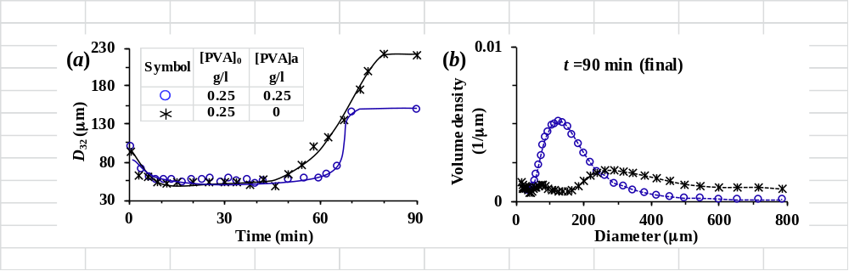
FIGURE 4 (a) Time evolution of Sauter mean diameter (D₃₂), and (b) mother particle size distributions in suspension polymerisations of MMA for Run 3 ([PVA]₀ = 0.25 g/l) and Run 6 ([PVA]₀ = 0.25 g/l with no further PVA addition).

Conclusions
We found that while the presence of stabiliser is essential during the early stages of suspension polymerisation, its concentration can be kept low. This is because in early reaction time drops are not viscous and can easily be ruptured. In fact, the polymer bead size in a typical suspension polymerisation is mainly dictated by the events occurring in the growth stage during which the rate of coalescence exceeds that of break up due to increasing drop viscosity. We showed that the growth stage can be dampened by the addition of stabiliser before the onset of this stage where drops are viscous and cannot be further ruptured. This policy reduced the formation of satellite particles, stabilised drops against coalescence, and produced finer and less polydisperse polymer beads. We can conclude that the success of the two stage stabiliser addition protocol in improving product quality is based on reducing the rate of drop break up during the transition period and reducing the rate of coalescence during the growth stage.

References

Brooks, B.W. Chem. Eng. Tech. 2010, 33, 1737-1744.
Vivaldo-Lima, E.; Wood, P.E.; Hamielec, A.E.; Penlidis, A. Ind. Eng. Chem. Res. 1997, 36, 939-965.
Cunningham, M.F. Polym. Reac. Eng. 1999, 7, 231-257.
Xie, G. M.; Pan, P. J. ; Bao, Y. Z. J. Appl. Polym. Sci. 2016, 133, Article No. 43632.
Jahanzad, F.; Sajjadi, S.; Brooks, B.W. Ind. & Eng. Chem. Res. 2005, 44 (11), 4112-4119.
Liu, S.; Li, D. Chem. Eng. Sci. 1999, 54, 5667-5675.
Chaurasia, A.S.; Sajjadi, S. Chem. Eng. Sci. 2015, 129, 260-270.
Xu, S.Q.; Nie, Z.H.; Seo, M.; Lewis, P.; Kumacheva, E.; Stone, H.A.; Garstecki, P.; Weibel D.B.; Gitlin, I.; Whitesides, G.M. Angew. Chem. Int. Ed. 2005, 44, 724–728.
Nuisin, R.; Omi, S.; Kiatkamjornwong, S., J. Appl. Polym. Sci. 2003. 90(11), 3037-3050.
Alroaithi, M; Sajjadi, S. RSC Adv. 2016, 6, 79745-79754.
Vladisavljevic, G.T; Williams, R.A. Adv. in Colloid and Interface Sci. 2007, 113(1), 1-20.
Yang, B.; Takahashi, K.; Takeishi, M. J. Appl. Polym. Sci. 2001, 82(8), 1873-1881.
Konno, M.; Arai, K.; Saito, S. J. Chem. Eng. Japan 1982, 15(2), 131-135.
Chatzi, E.G.; Kiparissides, C. Chem. Eng. Sci. 1994, 49(24B), 5039-5052.
Jahanzad, F.; Sajjadi, S.; Brooks, B.W. Chem. Eng. Sci. 2005, 60 (20), 5574-5589.
Jahanzad, F.; Sajjadi, S.; Brooks, B.W. Polymer 2013, 54(1), 16-23.
Jahanzad, F.; Sajjadi, S.; Brooks, B.W. Macromol. Symp. 2004, 206, 255-262.
He, Y.; Howes, T.; Litster, J.D.; Ko, G.H. Colloids and Surf. A: Physicochemical and Eng aspects 2002, 207, 89-104.
Lazrak, N.; Le Bolay, N.; Ricard, A. Eur. Polym. J. 1998, 34, 1637-1647.
Zerfa, M.; Brooks, B.W. Colloids and Surf. A: Physicochemical and Eng. Aspects 1998, 132(2-3), 267-273.
Ravera, F.; Ferrari, M.; Liggieri, L. Adv. in Colloid and Interface Sci. 2000, 88, 129-177.
Diamant, H.; Ariel, G.; Andeman, D. Colloids and Surf. 2001, 259, 183-185.
Okaya, T.; Suzuki, A.; Kikuchi, K. Colloids and Surf. A: Physicochemical and Eng. Aspects 1999, 153, 123-125.
Kim, N.; Sudol, E.D.; Dimonie, V.L.; El-Aasser, M.S. Macromol. 2003, 36(15), 5573-5579.
Alvarez, J.; Alvarez, J.J.; Hernandez, M. Chem. Eng. Sci. 1994, 49(1), 99-113.

