5-301-17 Gillich

A smarter way to electrify heat – The Balanced Energy Network approach to demand side response in the UK
Authors: Aaron Gillich¹, Csaba Zagoni², Andy Ford¹, Graham Oakes², Mark Hewitt³
1 London South Bank University, 103 Borough Road, London, SE1 0AA
2 Upside Energy, 1 Fore St, London, EC2Y 9DT
3 ICAX, 33 Greenwood Place, London NW5 1LB

Abstract
The Climate Change Committee states that the UK’s 2050 carbon targets are unachievable without a near complete decarbonisation of the heating sector. With heating at nearly half the UK’s energy use this represents a staggering challenge for the built environment; particularly the ageing existing stock. Any path to low carbon heating requires considerable electrification of heat, and meeting the electric demand through a greener grid.
This paper presents early results from a Balanced Energy Network (BEN) demonstration project at London South Bank University that offers a novel approach to electrifying heat.
BEN is a heat pump driven network that uses a low temperature heat network to link buildings together, and makes use of demand side response to communicate with the national grid and use electricity at optimal times. This essentially turns the heat pumps and the buildings themselves into distributed storage systems that provide a low cost balancing service for the national grid.
This paper is presented in two main parts: 1) A description of the two buildings in the LSBU campus where two heat pumps are installed in parallel to the existing gas boilers. And 2) Calculating/simulating the potential revenue of utilising the DSR potential from the heat pumps at a constant COP and the heat storage (a hot water storage tank) in three different flexibility markets: FFR, STOR and UoS. The implications of expanding BEN networks will be explored in the context of increased capacity for demand side response as a load shifting tool across the UK.

Introduction
The UK faces a considerable challenge in addressing the trilemma of a low cost, low carbon, and secure energy system by 2050. The Committee on Climate Change states that the UK’s 2050 carbon targets are unachievable without a near complete decarbonisation of the heating sector (CCC, 2016). With heating at 40 % the UK’s energy use (CCC, 2016), this represents a staggering challenge for the built environment. Any path to low carbon heating requires considerable electrification of heat, and then meeting the electric demand through a greener grid.
This paper addresses this problem using the Balanced Energy Network (BEN) case study demonstration project at London South Bank University. The BEN project is electrifying heat by retrofitting heat pumps to two buildings using the existing heat distribution system. It also makes use of distributed storage and demand side response (DSR) to operate the heat pumps at optimal times. This paper summarises the case study and early modelling results showing how the system can reduce heating costs by providing a balancing service to National Grid and making use of DSR revenue streams.
A study of 176 DSR sites found that only a small minority engaged in load shifting and demand turn-down, while the majority of demand response was provided by stand-by generators (Grunewald & Torriti, 2013). Exploiting the full potential of DSR as a grid balancing resource requires better understanding of the operating characteristics of demand side storage devices. The BEN case study and the present paper are a step towards addressing this gap by presenting early modelling results testing the capacity for BEN to capture DSR revenue assuming a constant COP. Throughout this study, Capacity Market revenues, changes in Renewable Heat Incentive income and energy costs are not included. The service costs for the DSR aggregator are also excluded.
The structure of the paper is as follows. First, a literature review of the issue of carbon-free heat will outline the scale of the challenge and the role for both heat networks and heat pumps, followed by a description of the DSR revenue streams investigated, which are Firm Frequency Response (FFR), Short Term Operational Reserve (STOR), and network Use of Service (UoS). The BEN case study is described in detail, before the method section outlines the assumptions used in the DSR model of the BEN system. The results section presents the potential revenue streams through FFR, STOR, and UoS services. Finally, the options and limitations in stacking different DSR revenue streams are discussed, and the paper closes with an assessment of the long term implications for BEN style systems to both electrify heat more efficiently, and also expand the available resources that can be exploited for DSR balancing services.

Background

Carbon-free heat and flexibility
This section briefly explores options for decarbonising the UK heating system. Studies considering pathways to decarbonising heat commonly include ambitious targets for reductions in demand through energy efficiency (e.g. 20-30% by 2030 in MacLean, et al., (2016)) The role of retrofits in reducing demand for carbon-free heat is uncontroversial, but outside the scope of this paper.
In terms of the provision of carbon-free heat, there are three core options: 1) electrification: typically using heat pumps in buildings, 2) heat networks: district heating with a carbon-free source, and 3) repurposed gas grids: using existing gas infrastructure with hyrogen or biogas (DECC, 2012)(MacLean, et al., 2016).
MacLean and others emphasise that a combination of strategies will be needed, and in the immediate decade there are low-risk steps that can be taken without precluding any future policy paths. One such set of strategic options is summarised in Figure 1 by the CCC (2016). Here the size of each box roughly corresponds to the quantity of carbon emissions savings available through each strategy.
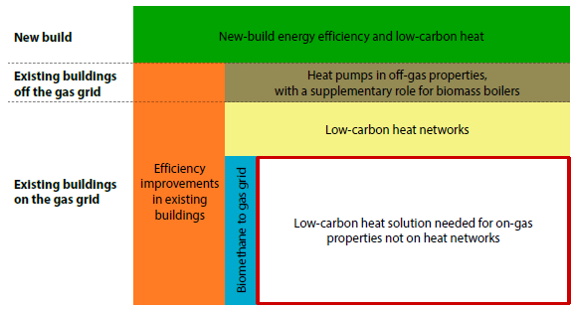
Figure 1: Strategic options for decarbonising heat (CCC, 2016).
Even if all properties currently on the gas grid are served with carbon-free gas, any path to carbon-free heat requires the extensive rollout of heat pumps. The details of each scenario differ, but there is an uncontroversial consensus that electrification of heat in buildings, facilitated primarily by heat pumps, is a critical component of decarbonising heat and meeting the 2050 target (National Grid, 2012). There are approximately 20,000 heat pumps installed each year in the UK compared to 1.6 million gas fired boilers. CCC’s ‘core decarbonisation’ scenarios call for over 600,000 heat pumps by 2020, increasing to 2.6 million by 2025, and over 7 million by 2030 (ElementEnergy, 2014).
Heat networks have the potential to increase heating efficiency but face considerable barriers in deployment (DECC, 2013). As the grid decarbonises heat pump driven networks will become increasingly appealing compared to gas driven CHP (DECC, 2016). The electricity demands of heat networks and standalone heat pumps will add substantially to peak generation and network requirements during extremely cold winter events (National Grid, 2012). The flexibility to shift these peak loads will be a critical aspect of future energy systems.
Traditional power grids are evolving to include distributed renewables generation, distributed storage, utility scale renewables, utility scale storage, and is also converting from radial networks to mesh networks. There is also a layer of communication networks that enable more intelligent control of these distributed resources (Gelazanskas & Gamag, 2014). All of these concepts drive a greater potential for flexibility. The availability of suitable thermal and electrical storage is the backbone of any strategy to increase system flexibility. Demand side measures currently represent a small but growing facet of the flexibility potential.

Demand side response services
There is a clear need for greater flexibility in the electricity system in order to balance increasing demand with the increasingly intermittent supply. There is a growing interest in Demand Side Response (DSR) solutions that allow shifting of electricity demand in real-time in response to changing price signals. Many demand side loads are too small to be individually significant, and so the DSR market is largely driven by aggregators that coordinate demand response from individual customers.
Ofgem notes that there is an incomplete picture in quantifying volumes of DSR, but estimates that there was 1.3-1.6 GW of DSR capacity in 2015/2016 (Ofgem, 2016). A breakdown of four common DSR revenue streams and their high end estimate is given in Table 1. Note that a number of other revenue streams have been introduced which are small in scale or for which data is not yet available (Power Responsive, 2016).
Table 1: Estimated Levels of Contracted DSR in the UK 2015/2016 (Ofgem, 2016)
Demand Side Response Revenue Streams | Definition | MW
Firm Frequency Response (FFR) | Keeping grid frequency at 50 ± 0.3 Hz | 25
Demand Side Balancing Reserve (DSBR) | Reduce large loads in winter from 4-8pm | 133
Short Term Operating Reserve (STOR) | When actual demand exceeds anticipated demand | 237
Transmission Network Use of System (TNUoS) | Avoiding peak events (triad) | 1,200
Total |  | 1,595

This paper will focus on Firm Frequency Response (FFR), Short Term Operating Reserve (STOR) and Transmission Network Use of System (TNUoS) and Distribution Network Use of System (DNUoS) and consider each in turn.
FFR comprises low and high frequency response. The grid operates at a frequency of 50Hz. If the frequency deviates from this, then a demand response event can be triggered to compensate. Details of the parameters for this scenario are given in Appendix A.
While FFR is a relatively small contributor to the total currently contracted DSR services in the UK, it is an expected area of growth and one that is of research interest due to its differences from other DSR revenue streams. It is very short term, requiring a response in the order of seconds, not hours. Because the grid must always remain at 50 Hz, it has the potential to be contracted for 24 hours per day, this means that not only can it be used in combination with other services; it offers a complementary DSR service that can operate when other DSR services are typically not available.
The term STOR is defined as a service for the provision of additional active power from generation or demand reduction (National Grid, 2016). The need for STOR occurs when actual demand on the grid exceeds anticipated demand. The STOR provider must be able to deliver 1) a minimum of 3MW or more of generation or steady demand reduction; 2) Deliver full MW within 240 minutes or less from receiving instructions from National Grid; 3) Provide full MW for at least 2 hours when instructed; and 4) Be able to deliver at least three times per week (National Grid, 2016). Critically, these conditions can be met by aggregating loads from more than one site, or multiple loads within a site.
There are two types of Use of Service (UoS) charges that can be used to generate DSR revenue. These are termed Transmission Network Use of Service (TNUoS) and Distribution Network Use of Service (DNUoS).
National Grid charges electricity suppliers (and hence, end consumers) for using the transmission network via a process referred to as the Triad. TNUoS are currently based on the three separately observed peaks of system demand across the year. These system demand peaks are measured over half hour intervals by National Grid, and typically occur between the months of November and February. The system peaks typically occur during the late afternoon, although recently the variability in system peak demand has become greater as more consumers attempt to use triad forecasting to avoid triad periods. This can have the effect of shifting the Triad to an atypical time. If a DSR provider can be active during the three settlement periods nominated as the Triad (only known after the event), then they can reduce their TNUoS charge in-line with the prevailing demand reduction at the time of the Triad. In order to access this benefit, the DSR provider must partner with an Energy Supplier (or an entity that has an electricity supply license). The rate of TNUoS charge is location specific and as such based on the transmission demand tariff in the region.
DNUoS charges occur at the level of the local Distribution Network Operator (DNO). These are billed each month based on the customer's maximum half-hour peak power and energy consumption. The observed maximum half- hourly peaks are subject to one of three time-of-use DUoS charges (red, amber, or green), or a single peak rate depending on the voltage level connected. The DNUoS charge maybe contained within an overall kWh rate, or maybe split out separately to the energy cost. In order to access the benefit, some negotiation maybe required between the provider and the relevant DNO. The DNUoS red-band runs from 4pm to 7pm on winter weekdays. This is the same time as the Triad avoidance scenario will operate. So it should be possible to capture both revenues concurrently.

Balanced Energy Network – Case Study
The Balanced Energy Network (BEN) is a demonstration project at London South Bank University that entails using heat pumps to shift peak loads and is running from May 2016-May 2018. BEN is a heating, cooling, and electricity network that balances the delivery of these three services in a way that minimise costs and carbon emissions.
At its core, BEN uses a ‘Cold Water Heat Network (CWHN)’ (Gillich, et al., 2016) to move and store energy between two buildings on the LSBU campus, as shown in Figure 2. Both the Tower Block and the EJM block are approximately 10,000 m² internal floor area of 1960s era construction. They are heavyweight concrete structures with a slow thermal response time. Both serve as offices/classroom buildings, they have no significant cooling loads, and the heating requirement is currently served by gas fired boilers operating in a cascade.

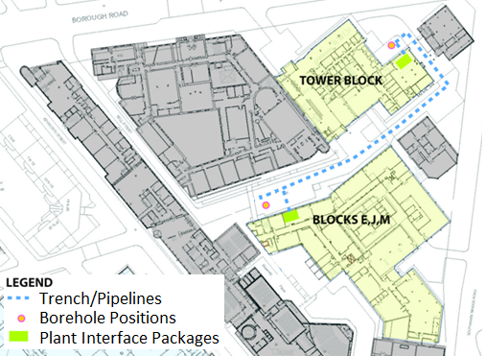
Figure 2: Layout of Balanced Energy Network linking Tower Block and EJB Block on LSBU campus.
The BEN project retrofits a high temperature heat pump in parallel to the existing gas fired boiler system of each building. This enables the new electrified heat to be distributed via the existing emitters (coils and radiators) working on a 70/60 degree flow return distribution circuit. The principle of a BEN style heat sharing network is to reject heat to the network from a place that needs cooling and recover the heat in those needing heating and domestic hot water. Exploiting asymmetric loads between buildings has the potential to increase the heat pump coefficients of performance (COPs), however, when the buildings share similar loading characteristics, the network requires a method of regulating the temperature of the ground water loop. In this case, BEN’s heat sharing network is linked to two boreholes, which use water from the chalk aquifer beneath London with an average temperature of 13⁰C.
BEN systems are managed by a cloud based aggregator linked to the network system controller, which together deliver ‘Virtual Energy Storage’ or DSR. The DSR aggregator communicates with hot water tanks specially designed to create a smart storage solution, and a controller which interfaces with the existing and new plant. Finally, BEN also links with a unique fuel cell calciner that creates carbon negative electricity by actively removing CO₂ from the atmosphere. The demonstration project can also expand to include future buildings and energy technologies.
This paper focuses on how the links between high temperature heat pumps, the hot water storage, and the DSR aggregator can electrify heat in a way that minimises costs and reduce peak load demand. The following sections will describe the modelling setups that were used to define this control strategy.

Method
This section explains the DSR modelling setup for the BEN system. Note that the model is deliberately created based upon some generalizable assumptions that will have flexible applications beyond the BEN project. The flexible modelling setup described in this section will be calibrated in future work into a more specific control strategy. All models were programmed in Octave.
The model considers one type of thermal storage in the building, a 10,000 litre well insulated storage tank for the service hot water (SHW). The hot water storage can either be served by the heat pump or by an electric immersion heater. The model requires a) the total electrical load that is available for providing DSR services, and b) the rate of charge/discharge characteristics of the thermal storage.
The initial configuration of the BEN system couples the following components together. The configuration is assumed to be identical in both the Tower Block and EJM Block test buildings:
- One x 95 kWe (300 kWth) Heat Pump
- One x 350 kWh hot water storage with a 95 kWe immersion heater
- Four x Gas boilers with a total capacity of 2 MWth
The aim of the early stage calculations presented in this paper was to create a flexible DSR revenue model based on generic assumptions that can inform BEN decision making but also be flexibly applied to other projects outside BEN. This early stage model will be refined in future work as recorded project data becomes available for the BEN case study buildings.
In order to determine how much revenue can be generated for each type of DSR revenue stream, the model needs to know for each hourly interval the amount of electricity (heat) that is available, and the rate at which that DSR service is charged. The individual calculations for each DSR revenue stream are given in Table 3 (FFR), Table 4 (STOR), and Table 5 (UoS). Each DSR revenue service is charged using a slightly different methodology, but can generally be expressed as follows:
$$DSR revenue \left(£\right)=Electricity available \left(kWh\right) ×Rate of DSR service (\frac{£}{kWh})$$
The potential DSR revenue for each hour is then summed throughout the year. In order to carry out this calculation, the model needs the building heating load (and hence the electricity) throughout the year. The specific heat load was found using a simplified ‘rule of thumb’ method based on CIBSE Guide A Equation 5.40 and 5.44 (CIBSE, 2006):
$$∅_{t}=h ∙(T_{int}-T_{ext})$$
$$∅_{i}= F_{3}∙∅_{t}$$
$$h= \frac{∅_{i}}{F_{3}(T_{int}-T_{ext})}$$
Where:
h = Specific heat loss (kW/K)
Ø_{t} = Design heat loss (MW)
Ø_{i} = Plant size = 2MW (from LSBU estates department)
T_{int} -T_{ext} = 20⁰C (design criteria)
F₃ = Plant uplift factor = 1.25 (to account for intermittent plant operation)
Solving for the specific heat load gives an assumed value of 80kW/K. This is a useful method for this type of modelling that allows an assumption to be made about the rate of combined fabric and ventilation heat losses in the building based on its installed plant characteristics when little other information is available about the building.
Using the specific heat loss rate of 80kW/K, the heating demand at half hourly intervals was calculated using 2014 NASA Merra weather data.
The resulting resource that is available for DSR services is thus dependent on the accuracy of the assumed specific heat loss rate. The sensitivity of the 80kW/K assumption was explored for the 40-120 kW/K range. The results of this sensitivity analysis are given in the Discussion in Figure 7.
The SHW demand is assumed to be 2000 litre per day, It is assumed that the power required to heat the water is constant during the day, and with a ∆T of 50˚C (10˚C mains and 60˚C SHW), this comes to 10 kWh/hr. The 10 kW for SHW includes approximately 50 % assumed system losses (as calorific heat of 2000 litres at 50˚C would be around 4.8 kW only).
Table 2: Summary of modelled heating strategy.
 | Heating | Hot Water | Notes
Summer  (June-August) | Off | On | Hot water consumption is too low (ca. 120kWh per day) to provide a useful DSR service in Summer. Heat pump (HP) availability is assumed to be zero.
Spring / Autumn  (April-May & Sept-Oct) | Heating is on if the external air temperature falls below 14⁰C | On | The short-term variability of the HP makes it unsuitable to offer a dedicated STOR service, although it would be possible to make use of the intermittent availability within a wider Upside asset portfolio. See details throughout cases below.
Winter  (Nov-March) | Heating always on. | On | It was assumed that the HP is only available in case there is a heat demand from the building.

BEN is eligible for Renewable Heat Incentive (RHI) payments. The RHI pays the end user for every kilowatt hour of renewable heat that they generate. In order to avoid incentivising higher consumption to keep receiving further payments, the RHI has divided their payment rates into two ‘Tiers’. The higher Tier 1 payments are given a upper threshold based on the installation size, for any heat that is generated above this threshold, the payment rate drops to the lower Tier 2. This is designed to avoid incentivising consumption to secure RHI payments. At the time of writing the rates are 8.95 p/kWh for Tier 1 and 2.67p/kWh for Tier 2. Throughout this study, changes in RHI income and energy costs are not included. Capacity Market revenues and service costs for the DSR aggregator are also excluded.

Results
The conditions above were used as the base inputs for the model to test three DSR revenue streams: FFR, STOR, UoS. This section presents the detailed inputs and results for each of these revenue streams individually, then discusses how they can be used in combination.

FFR – Firm Frequency Response
If the heating strategy allows, the heat pump will be fully loaded at all times (95 kWe) to provide a low FFR response. That is, on a low frequency event, the heat pump will be switched off for up to 30 minutes. The heat pump will respond within 10 seconds of an event and the response will last for 30 minutes. This means that the BEN heat network will contract for Primary, Secondary Static FFR. Before a Low FFR event the HP is operating at its rated output and the storage tank is in its normal state of charge (75˚C = 150kWh). When the Low FFR event is initiated, the HP output is reduced to zero and the storage begins to be discharged. The event lasts 30 minutes (from 400 seconds to 2200 seconds in Figure 3).
At the end of the event the storage tank state of charge is 62˚C (25 kWh). The HP output is increased to its original state (full rated output) and the storage tank is recharged by an increased output from the gas boilers.
FFR income is proportional to the power capacity offered per hour (£/MWh). The DSR revenue achievable for this type of event for both day and night-time rates are summarised in Table 3.
Table 3: Revenue from FFR
FFR Period | Available Power [kW] | Hours | FFR Rate [£/MWh/h] | Revenue
Day (07:00 to 22:59) - Full load | 95 | 3020 | 6.5 | £1,864.85
Night (23:00 to 06:59) - Full load | 95 | 1892 | 4 | £718.96
Day (07:00 to 22:59) - Part load | 50 | 245 | 6.5 | £79.63
Night (23:00 to 06:59) - Part load | 50 | 154 | 4 | £30.80
 |  |  |  | £2,694.24

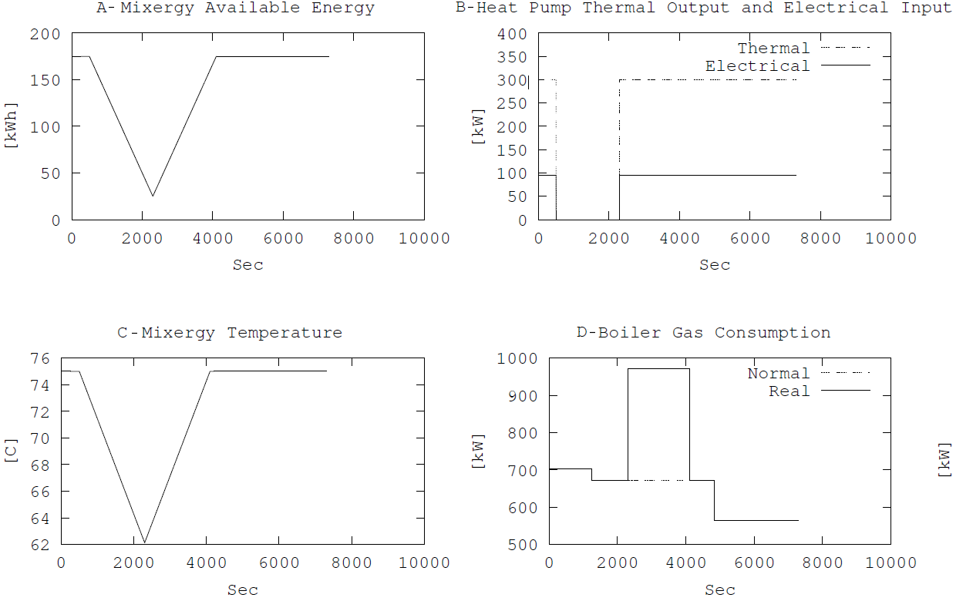
Figure 3: Profiles for a) state of charge of storage (SOC), b) HP thermal output and electric input, c) internal temperature of the storage and d) boiler gas consumption, during an FFR event (from 400 sec to 2200 sec).

STOR - Short Term Operating Reserve
The next scenario considers a case where the heat network is set to maximise revenue from a STOR contract during the winter months. This assumes that the heat pump will be fully loaded at all times (95kWe) to provide a demand response. That is, on instruction from National Grid, the heat pump can be switched off for up to 120 minutes. Figure 4 shows the BEN profile during a STOR event.
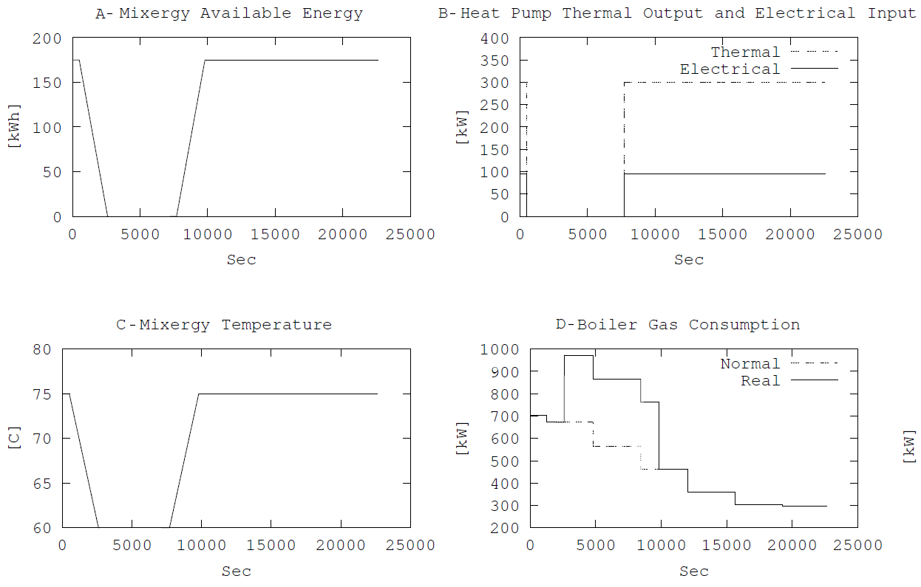
Figure 4: Profiles for a) state of charge of storage, b) HP thermal output and electric input, c) internal temperature of the storage, and d) boiler gas consumption, during an STOR event (from 300 sec to 7500 sec).

Figure 4 shows that a demand response for the minimum two hours can be generated without a significant impact to the building water temperature. The water storage tank discharges from 75˚C to 60˚C in 35 minutes, and the tank is fully discharged for the remaining 85 minutes of the STOR event. During this time, the gas boiler consumption increases by 300kW to compensate.
After the STOR event, the tank recharges to its original setpoint of 75˚C. This is achieved by boosting the gas boiler output by 300kW for 35 minutes, and through the addition of the heat-pump after the two demand response events have concluded. National Grid contracts two STOR rates, a lower availability payment for having the service there when needed, and a higher utilisation payment when the service is called upon (typically 10% of the available hours for a STOR asset high in the merit order). The rates for availability and utilisation payments for both winter and summer seasons are summarised in Table 4 along with the corresponding STOR revenue for this modelling setup.
Table 4: Revenue from STOR
Season | Payment type | Power Available [kW] | Hours Available [h] | Rate [£/MWh] | STOR Revenue  [£]
Winter | Availability payment - Full Power | 95 | 1495 | 6.31 | £896.18
Winter | Availability payment - Part Power | 50 | 89 | 6.31 | £28.08
Winter | Utilisation payment - Full Power | 95 | 149.5 | 162.92 | £2,313.87
Winter | Utilisation payment -Part Power | 50 | 8.9 | 162.92 | £72.50
Spring/Autumn | Availability payment - Full Power | 95 | 365 | 2.69 | £93.28
Spring/Autumn | Availability payment - Part Power | 50 | 92.5 | 2.69 | £12.44
Spring/Autumn | Utilisation payment - Full Power | 95 | 36.5 | 91.32 | £316.65
Spring/Autumn | Utilisation payment -Part Power | 50 | 9.25 | 91.32 | £42.24
Total Annual STOR revenue |  |  |  |  | £3,775.23

UoS – Network Use of System charges
For Triad avoidance, the BEN heat network must be able to drop the load of the heat pump during the winter when the load across the Transmission Network is at its highest. As with the STOR calculations, at this stage the aim is to model the likely total annual hours during which the BEN system can be available for capturing UoS revenue. To establish a high probability of capturing the TNUoS benefit, one simple strategy is to undertake demand response from 5.30pm to 7pm every week day from November to February. For DNUoS red-band avoidance we adopt the same approach as Triad avoidance, but use a period from 4pm to 7pm on winter weekdays. Therefore, both DNUoS and Triad avoidance are captured within the same three-hour window. The season for avoiding DNUoS was chosen as running from November to March, to align with the winter heating season.
This model assumes that at 4pm the heat-pump is switched from full load to off, then switched back to full load at 7pm. From the period of 4pm to 7pm the additional heat load from the building is met firstly by discharging the storage tank (hot water stored at 75 ⁰C). If the storage tank is exhausted, then any additional load is met by the gas boilers. After 7pm the gas boilers assist the heat pump to recharge the storage tank back to its nominal state of 75 ⁰C.
The modelling shows that for the 2014/2015 period from November to March, the Use of System charge window as discussed above covered 321 hours. The TNUoS charge for the year is based on a tariff ranging from c.£40 to c.£52 per kilowatt depending on location. This is multiplied by the average demand during the three Triad half-hours. Typically, the provider receives 85% of the benefit, the supplier retains 15%. The revenue summary for both the TNUoS and DNUoS service are given in Table 5. Note that TNUoS payments are based on capacity (kW), whereas DNUoS payments are based on consumption (kWh). Table 5 includes relevant calculation variables for each, namely the TNUoS network operator’s loss adjustment factor (line losses), while the DNUoS calculation includes the hours of provision of the service.
Table 5: Revenue from Use of System charges (UoS)
Payment type | Power Available [kW] | Rate [£/kW] | Line Loss Factor | Supplier retention factor | UoS Revenue  [£]
TNUoS | 95 | 51.87 | 1.088 | 15% | £4,557.09
Payment type | Power Available [kW] | Rate [p/kWh] | Hours | Supplier retention factor | UoS Revenue  [£]
DNUoS | 95 | 10.976 | 321 | 15% | £2,816.61
Total Annual STOR revenue |  |  |  |  | £7,373.70

Combining FFR, STOR and UoS services
The previous sections have shown how each DSR service can generate revenue for the BEN heat network individually. Because the FFR, STOR, and UoS events may occur at different times, there is potential to utilise more than one throughout the day. A stacking algorithm was used to determine the sequencing of the three DSR services in order to maximise revenue. For each half hourly interval, the stacking algorithm decided which of the three DSR services was available, and which would offer the highest value payment for that half hour. The cost of delivering the DSR service is constant across all scenarios and thus not included in the algorithm.
In order to determine which DSR revenue stream to utilise in a given half hourly interval, the model required detailed pricing information for the service windows offered by National Grid for each month. These vary for each type of DSR service.
The pricing methods for each individual DRS stream given in Tables 3, 4, and 5, were therefore placed alongside the National Grid service schedule for each half hourly interval throughout the year. UoS is always the highest of the three revenue services. Therefore, if UoS services were available, this was given priority, followed by STOR, and finally FFR.
Figure 5 shows how the different DSR schedules throughout the year. The x-axis gives days, and the y-axis gives half-hourly intervals through each individual day. White spaces show times in which the given DSR service is not provided and black shows times in which the DSR service is provided.
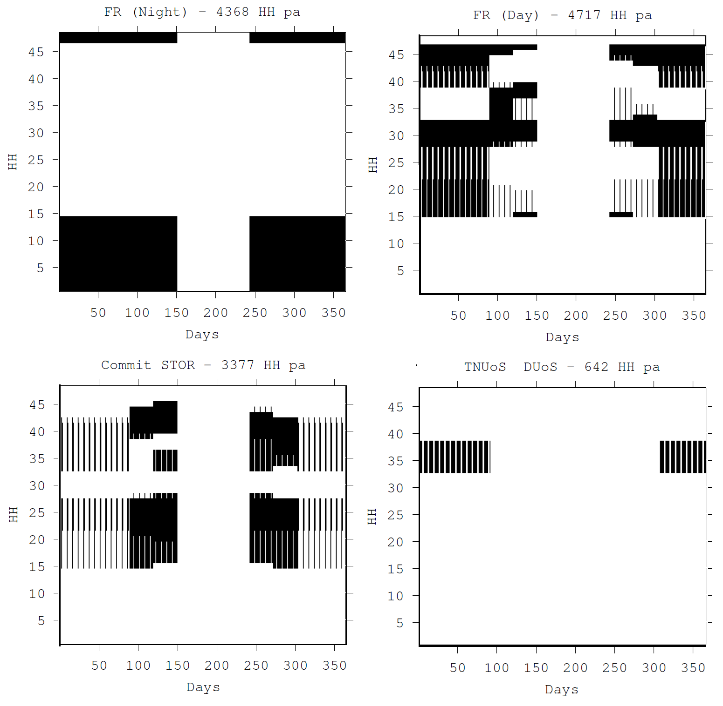
Figure 5: Individual annual sevice schedule for FFR, STOR and UoS services (black is DSR availability).
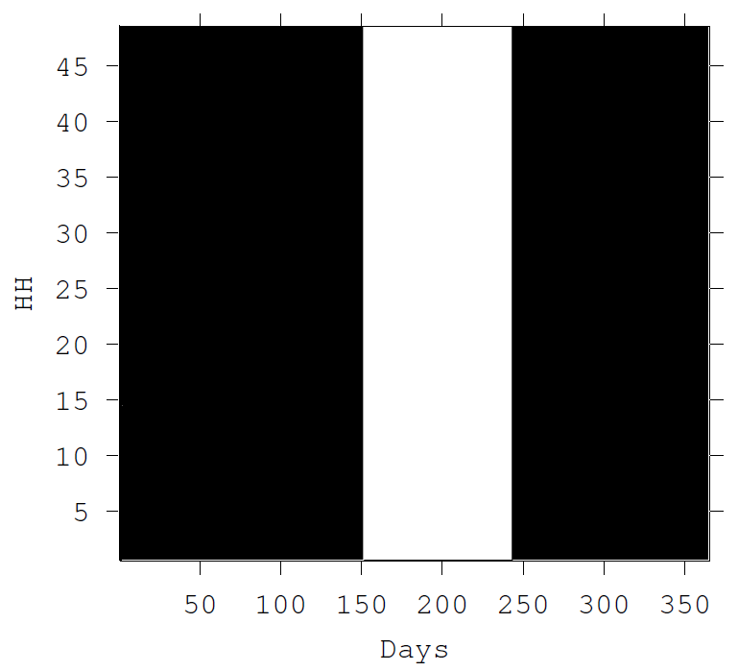
Figure 6: Combined FFR, STOR, and UoS revenue streams (black is DSR availability).
Figure 6 shows the four images in Figure 5 superimposed on one another. This gives the optimised stacked schedule for all three services in combination cover the entire year except for the summer period in which the heating system is turned off altogether.
The gross revenue from these stacked services is summarised in Table 6. However, note that this represents the gross total of the combined services.
Table 6: Gross results
 | Service Revenue
FR (night) | £788
FR (day) | £1,170
STOR | £1,600
UoS | £7,386
Total Gross DSR Revenue | £10,945

Heating costs and net DSR results
BEN changes the current heating arrangement for the LSBU buildings by utilising heat pumps and shifting part of the heating costs from gas to electricity. This means that BEN is eligible for RHI payments, currently at 8.95 p/kWh Tier 1 and 2.67p/kWh Tier 2. Utilising DSR on top of this electrification of heat impacts the heating costs in two critical ways 1) it moves some of the electrified heat back to the gas grid in order to charge the storage tank, and 2) this has the effect of reducing the amount of heat eligible for RHI payments. The three setups are summarised in Table 7.
Table 7: Heating costs and net DSR results
 | Heating Costs |  | Income |  | Total Heating Cost
 | Electricity | Gas | RHI | DSR
(1) Current Setup - Gas Only | £0 | £98,322 | £0 | £0 | £98,322
(2) Typical approach to electrifying heat (Heat pumps + Gas) | £49,095 | £60,828 | £66,515 | £0 | £43,408
(3) BEN approach to electrifying heat (Heat pumps + Gas + DSR) | £45,255 | £63,761 | £63,203 | £10,945 | £34,868
(2) - (3) Total Net DSR Revenue |  |  |  |  | £8,540

The results in Table 7 give the modelled fuel costs for the buildings assuming a boiler efficiency of 88%, constant COP of 3.16 (In practice this will vary with well temperature, supply temperature, and load throughout the year.), gas costs 0.021 £/kWh, and electricity costs at 0.098 £/kWh.

Current setup (1) in Table 7 is based on the specific heat loss for the building and hourly weather summed for year. No heating is provided by heat pumps.
The Heat Pumps and Gas setup (2) includes the heat pumps as described in this paper, but doesn’t include revenue from DSR. The heat pumps are used as much as possible, and the remaining heating load is met with gas.
The BEN approach (3) includes the same assumptions as setup (2) but also includes the revenue of DSR services. This results in shifting some of the heat pump load back to gas. The total heating load is identical in all three cases.
Comparing the typical approach to electrifying heat (2) to the BEN approach (3) shows net revenue of £8,540 for the DSR services under this setup. Note that the results summarised in Table 7 represent one building only, and that the total cost savings for utilising DSR across both buildings would be approximately doubled. A more detailed RHI calculation is given in Appendix A.

Discussion
The calculation in this paper used a building specific heat loss of 80 kW/K and its sensitivity was tested in the 40-120 kW/K range as shown in Figure 7. The results show that as the specific heat loss of the building decreases, the DRS revenue decreases, and that the rate of change is greater for lower building specific heat loss. Regardless of the true values for the BEN buildings, the results of Figure 7 show that a 50% change in the specific heat loss would only result in an approximate 10% change in the anticipated revenue from DSR, meaning that the calculations presented in this paper provide a useful indication of the benefits of DSR services.
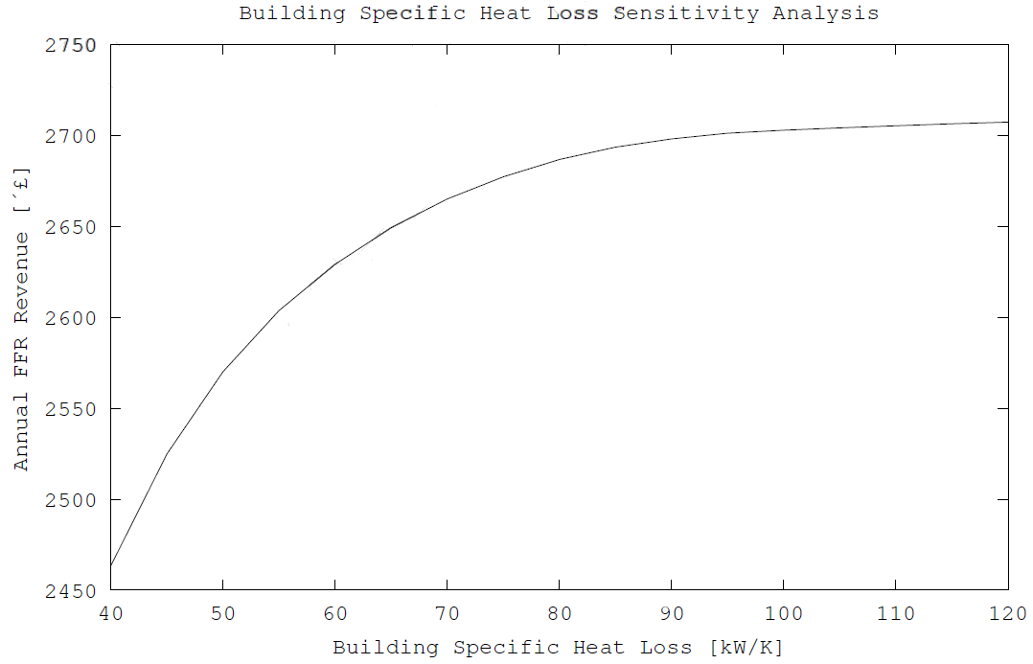
Figure 7: Building Specific Heat Loss Sensitivity Analysis.

Conclusions and outlook
This paper has summarised the issues facing the UK in decarbonising the heat supply by 2050. Recent studies show that electrifying heat through heat pumps is a critical element in this effort. Early modelling results from the BEN prototype heat network indicate that linking heat pumps to DSR services is a smarter way to electrify heat and reduce total heating costs.
The results presented in this paper represent a low-end estimate of these benefits through a BEN style network. Ongoing research is considering further DSR revenue streams which will be the subject of subsequent writing. Furthermore, the design of the heat network itself offers potential storage options that are not possible through conventional sources of DSR balancing services such as batteries and standby generators. This includes for example storing heat in the circulating fluid of the heat network itself, or diurnal storage, which is possible by utilising the heat pumps during demand turn up events to store water in the aquifer for retrieval the next day.
The BEN system is a platform for testing the extent to which DSR services can be integrated into building and heat network services. Further work will expand on the results shown in Table 7 and detail the changes in energy consumption as a result of DSR. Additionally, a sensitivity analysis will be carried out for a range of gas and electricity prices. Logged data will replace the assumed data used to calculate the total energy consumption for the base case (gas only). This will allow an investigation into the optimum heat pump size based on NPV and LCOE calculations. Current efforts are converting the heat model from static to dynamic, which will allow BEN to take into account the heating schedule of the buildings and make better control decisions over the use of the building itself as a thermal store.

Acknowledgements
The BEN project is supported by an Innovate UK Integrated Supply Chains for Energy Systems Grant, as well as by funding from each project partner in the consortium. Each component of the BEN system is an original design created specifically for the BEN project as the result of considerable research and innovation. The consortium consists of ICAX Ltd (project lead coordinators), who designed the Cold Water Heat Network (heat sharing) as well as the plant room interface strategies. Terra Firma Ground Investigations have created the borehole designs to link BEN to the chalk aquifer beneath London, Upside Energy created the DSR algorithms featured in this paper, Mixergy Ltd. created the hot water storage cylinders also described in this paper and finally Origen Power, and Cranfield University are creating a fuel cell calciner that uses natural gas to create electricity while actively removing CO₂ from the atmosphere. The authors are grateful for their support and input.

References
CCC, 2016. Next Steps for UK heat policy, London: Committee on Climate Change.
CIBSE, 2006. CIBSE Guide A, London, UK: Chartered Institution of Building Services Engineering.
DECC, 2012. The Future of Heating: A Strategic Framework for Low Carbon Heat in the UK, London: Department of Energy and Climate Change.
DECC, 2013. The Future of Heating: Meeting the Challenge, London: DECC.
DECC, 2016. Heat Pumps in District Heating - Final Report, London: Element Energy and Carbon Alternatives on behalf of DECC.
ElementEnergy, 2014. Incrastructure in a low carbon energy system in 2030: Transmission and distribution, London: Imperial College London and Element Energy on behalf of the Committee on Climate Change.
Gelazanskas, L. & Gamag, K., 2014. Demand side management in smart grid: A review and proposals for future direction. Suitable Cities and Society, Volume 11, pp. 22-30.
Gillich, A., Ford, A., Hewitt, M. & Thompson, E., 2016. Cold Water Heat Networks and the Thermal Storage Revolution. Aalbourg, Denmark, Proceedings from the CLIMA 2016 conference..
Grunewald, P. & Torriti, J., 2013. Demand response from the non-domestic sector: Early UK experiences and future opportunities. Energy Policy, Volume 61, pp. 423-429.
MacLean, K., Sansom, R., Watson, T. & Gross, R., 2016. Managing Heat System Decarbonisation - Comparing the impacts and costs of transitions in heat infrastructure, London: Imperial College London.
National Grid, 2012. Pathways for Decarbonising Heat, s.l.: Redpoint Energy Ltd on behalf of National Grid.
National Grid, 2016. National Grid - Short Term Operating Reserve. [Online]
Available at: http://www2.nationalgrid.com/uk/services/balancing-services/reserve-services/short-term-operating-reserve/
[Accessed 06 01 2017].
Ofgem, 2016. OFGEM - Aggregators - Barriers and External Impacts, London: OFGEM.
Palensky, P. & Dietrich, D., 2011. Demand Side Management: Demand Response, Intelligent Energy Systems, and Smart Loads. IEEE Transaction on Industrial Infomratics, 7(3), pp. 381-388.
Power Responsive, 2016. Power Responsive DSR Product Map Glossary, http://www2.nationalgrid.com/WorkArea/DownloadAsset.aspx?id=8589935075: National Grid.
REA, 2015. Energy Storage in the UK - An Overview, London: Renewable Energy Association.
Strbac, G. et al., 2015. Value of Flexibility in a Decarbonised Grid and System Externalities of Low-Carbon Generation Technologies, London: Imperial College London and Nera consulting on behalf of the Committee on Climate Change.

Appendix A

Should the grid frequency fall below 49.7Hz, a low frequency event is triggered. If the grid frequency rises above 50.3Hz, a high frequency event is triggered. A low frequency event requires a decrease in demand, while a high frequency event requires an increase in demand in order to help stabilise the grid. Low and High FFR is further characterised by response duration: Primary FFR must last 30 seconds and Secondary FFR 30 minutes. A primary FFR response time is 1 second, and spinning reserve is unable to respond that quickly.
Table A1 gives a more detailed calculation for the potential RHI revenue available for the BEN project. This was carried out as a separate calculation exercise to the DSR work in the body text and is given for illustration of how the RHI revenues increase with heat pump size.
Table A1: Supplementary Calculations for Renewable Heat Incentive for BEN project.
GSHP size (kW) | 1000 | 600
Total Annual Heating | 2,110,664 | 2,110,664
RHI Tier 1 (kWh) | 1,314,000 | 788,400
RHI Tier 2 (kWh) | 796,664 | 1,322,264
Total RHI income | £135,031 | £102,970

