Rethinking music geography through the mainstream:
a geographical analysis of Frank Sinatra, music and travel
Kevin Milburn

Department of Urban, Environment and Leisure Studies, London South Bank University, London, UK

This paper brings a new perspective to music geography by focusing on how a particular mainstream musician helped to construct, subvert and circulate meanings associated with travel. It asserts that Frank Sinatra, via his music and actions, engaged with travel in ways that frequently ran counter to how it has commonly been enacted in American music and popular culture. Particular attention is paid to the singer’s travel-themed album, Come Fly With Me. By the time of its release in 1958, Sinatra, via a public persona that encompassed performer, ‘playboy’ and businessman, was a central figure in promoting an alignment of leisured mobility with post-war economic success. The paper interrogates how Sinatra’s celebrity allowed him to embody travel in certain real and imagined ways. It also examines what the resulting representations revealed about performances of gender, ethnicity and status, and the expected modes of behaviour that were associated with them, in America’s post-war consumer-driven society.

Keywords: Frank Sinatra, music, travel, representation, mobility, celebrity

Introduction
i) Music and geography
For a short period in the mid-to-late 1990s, research on music carried out by the likes of Smith (1994) and Kong (1995a) provided a vibrant presence in cultural geography, which arguably reached a peak with the publication of The Place of Music (Leyshon et al, 1998). During this time, particular attention was paid to music’s role in processes of identity formation. Some studies examined how music shaped identity at the level of the nation, in places such as Singapore (Kong, 1995b) and Britain (Revill, 2000). Other work examined how certain types of music, such as rap (Smith, 1997) and northern soul (Hollows and Milestone, 1998), had become a central component in counter-hegemonic and predominantly sub-cultural identities. Meanwhile, another corpus of work interrogated output that was either recorded by ‘cult’ artists – for example, Valentine’s (1995) study of the circulation and consumption of kd lang’s music – or was performed within ‘cult’ scenes, such as Rycroft’s (1998) research on the underground music circuit in late 1960s Los Angeles. Even when the subjects of these studies enjoyed considerable commercial success, as was the case with lang, the focus tended to be on the ways that these musicians presented themselves – or were portrayed by critics and audiences – as being separate from the mainstream, as a result of their chosen lifestyle, political ideology, musical approach or stylistic preferences. Such studies helpfully extended our understanding of the roles that music can play in informing, and in giving focus to, counter-hegemonic movements and in providing a voice of resistance or protest.
Music has the capacity to confer inclusion upon those who may feel largely voiceless and marginalized as a result of their sexuality, gender, race or beliefs. This trait of music prompted geographers in the late 1990s to reframe their engagement with music and to examine more rigorously exactly what it is – socially, culturally, and economically – that music does. For example, is it correct to view music as a potentially transformative force capable of enacting social change? Or is it more accurate to consider music to be more of a reflector, or perhaps an accelerator, of social changes that are already in motion? Attention to such questions, coupled with a growing interest in the shifting power dynamics between musicians, audiences, and between different branches of the music and media industries, chimed with then new ways of approaching creative practice from within the social sciences.
This fresh vision articulated new ways for how geographic research could engage with music. Specifically, it promoted an approach that was attentive both to music’s role in the formation of social life and identity and to the music industry’s standing as a high profile and, at that time at least, highly profitable branch of the entertainment industry. Arguably, this broader understanding of music’s socio-economic significance was constitutive of a broader New Cultural Geography mode of thinking that was then coming to the fore in many geography departments, particularly in the UK. Studies that were said to come under the New Cultural Geography banner addressed such a breadth of topics and utilized such an array of methodologies that it is often difficult to discern a singular, identifiable style of thought running through work that had this label attached to it. Nonetheless, what it is less open to question is that there was a shift in disciplinary approaches to music in the mid to late 1990s which, in geography, was characterized by a more sustained and richer engagement with music’s relationship to currents affecting society and culture more generally. It was an engagement that still retained the spatial focus often lacking in other disciplines, which now additionally encouraged a critical engagement with the role of creative practice in helping to shape discourses on identity and notions of belonging. It produced research often characterized by an interrogation of the role played by factors such as race, class and gender in processes underpinning a ‘multiplicity of cultures and geographies’ (Cresswell, 1993: 250).
As valuable as the aforementioned studies were (e.g. Rycroft, 1998; Valentine, 1995), their valorization of artists and genres operating at tangents to the mainstream, as opposed to those operating within it, sometimes led to a surfeit of studies orientated around music that scholars appeared to wish people had listened to, at the expense of examinations of music and musicians that people actually had listened to. If one were to soundtrack, for example, the movement of agrarian workers in the 1930s and 1940s from the Dust Bowl states to California according to the amount of academic literature written on the subject, then the music undoubtedly would be provided by the protest singer, Woody Guthrie (Gold, 1998; Kaufman, 2011, Partington, 2011). However, if one were to base the soundtrack instead on music that the migrants actually did see live on their travels, or that they listened to on the radio – music that frequently addressed the places they were departing from, or heading towards – then the soundtrack would instead have been comprised of music by the likes of Bob Wills and the Texas Playboys, Spade Cooley & his Orchestra, the Light Crust Doughboys, and Tex Ritter. In other words, it would be comprised of the kind of commercially successful, populist acts that are routinely ignored by the academy.
However, some geographers have, albeit only very rarely, researched major figures in popular music. They have done so in order to examine a wide range of themes, including how music intersects with class and gender roles (Moss, 1992, 2011, in relation to Bruce Springsteen); with urban and pastoral focused modes of representation (Kruse, 2003 and Daniels, 2006, both in relation to The Beatles); and in relation to tourism (Alderman, 2009 on Elvis Presley, or, more accurately, on the fans of Elvis Presley). As welcome as this work has been, it is notable for its mid-1960s onwards focus. Even Alderman’s (2009) work concentrates on the present day, via Presley’s impact on Memphis’s tourist industry, rather than on the period during which Presley exerted his greatest cultural influence: the late 1950s. There has been virtually no geographic engagement with well-known performers who came to prominence before rock’n’roll’s emergence in the mid-to-late 1950s.
This absence of research focused on earlier decades is surprising since, for example, it was in the 1930s that a popular singer, Bing Crosby, first experienced a level of celebrity, fame and wealth comparable to that previously experienced by actors, such as Charlie Chaplin, Mary Pickford and Rudolph Valentino. Furthermore, it was during the 1940s that other popular music singers, such as Frank Sinatra in the first half of the decade and Dick Haymes in the second half of the decade, acquired equally large followings as that enjoyed by Crosby, by overtly choosing to pitch their act at younger audiences. As a result of artists such as Sinatra and Haymes, and their management, identifying the key role that teenagers were likely to have as music consumers from that point in time onwards, both became high profile and significant figures within America’s cultural landscape.
The celebrity status of America’s recording stars intensified and was extended still further throughout the 1950s, a period that witnessed a rapid acceleration in consumer spending throughout much of the United States. The latter part of the decade was also a time during when Frank Sinatra, the subject of this study, enjoyed – via a string of well-received releases for the Capitol record label – arguably his greatest critical successes, which unsurprisingly reinforced and extended his celebrity status. It was a status that the singer had experienced intermittently since being the most popular member of the successful group The Hoboken Four, at the start of his recording career, in the mid-1930s. However, it was in the mid to late 1950s that Sinatra worked most effectively with not only the music industry but also with the burgeoning TV, film, press and advertising industries and, in doing so, achieved not just mass sales but also global fame. Sinatra’s skill in recognizing and exploiting such opportunities impacted not just his own career but also influenced those of his peers, such as Nat King Cole and Frankie Laine, as well as, shortly afterwards, Elvis Presley and, later still, the career of The Beatles, along with many other acts up to the present day.
The absence of geographic work focused on music acts and the attendant rise of celebrity culture from the end of WWII until the end of the 1950s seems all the more remiss given the increasingly prominent – some might say invasive – role that celebrity plays within in our own society (Inglis, 2010; Rojek, 2012), which includes an ongoing fixation with celebrities such as Marilyn Monroe, James Dean and Frank Sinatra, who are all most associated with mid-twentieth century America. Sinatra, as with Monroe and Dean, continues to command in death a level of fame and interest far in excess of anything experienced by most living celebrities, as will be detailed later in this paper. Yet, despite this interest in Sinatra, and the volume of material produced about him, he has, until now, been entirely ignored by geographers. As noted earlier, it is a neglect that echoes a broader lack of studies by geographers of popular culture more generally, and of genuinely populist popular music in particular.
However, it is important to note that, despite the scarcity of geographic studies focused on high-profile commercially significant acts – and an attendant tendency to privilege niche acts and alternative scenes – New Cultural Geography orientated work on music during the 1990s was at least sporadically attentive to the distinctive significance of specific performers and composers. Examples demonstrating this awareness included Gold’s (1998) already noted research into the folk singer-songwriter, Woody Guthrie, and Revill’s (1998) work on the Croydon based black Edwardian composer, Samuel Coleridge-Taylor; both studies were included in the highly influential Place of Music collection (Leyshon et al, 1998).
By contrast, work on music by geographers in the early years of this century placed greater emphasis on the agency of those listening to music (Jones, 2005), and also on the physical and emotional aspects involved in such listening (Anderson, 2004; Wood and Smith, 2004), with less attention paid to those responsible for making the music. These practice orientated studies embraced music’s more than representational aspects and foregrounded the pronounced experiential qualities routinely ascribed to music. The focus here was on music as affect: on the emotional aspects associated with music and on the various corporeal responses triggered by music, such as those experienced when listening, singing, playing (Smith, 2000), and dancing (Revill, 2004; Cresswell, 2006a).
Daniels’ (2006) previously mentioned paper based around The Beatles stood out from this affect focused geographic work on music. Daniels analyzed how place and the English landscape tradition of pastoralism were enacted in two recordings by the band: ‘Penny Lane’ and ‘Strawberry Fields Forever’. Daniels contended these songs invoked different registers of memory: personal, collective and mediated, and went on to detail how this helped them to inform the nation’s sense of itself in the late 1960s. This largely archival based research also explored ideas concerning the band’s place-making relationship with the city of Liverpool, a theme also investigated by Kruse (2005) and Cohen (2007).
By the mid-2000s, the mere existence of these separate studies, together with journal special issues devoted to geography, music and sound (Anderson et al, 2005; Waterman, 2006) and the publication of Connell and Gibson’s (2003) monograph on popular music and geography, suggested that Smith’s (1994: 238) earlier call for a ‘more explicit incorporation of sound generally, and music in particular, into research in human geography, and especially into those aspects of the subject concerned with cultural politics’ had been answered. However, whilst this period possibly marked a high point for geographic engagement with music, it also signaled the beginning of a gradual – albeit temporary – retreat from it, as will be detailed.
More recent geographic scholarship on music (e.g. Johansson and Bell, 2009; Wood, 2012; Brandellero and Pfeffer, 2015) is notable, among its other qualities, for the attention it gives to matters of locality. As such, it acknowledges, but also theoretically significantly expands upon, early work on music carried out by geographers (Carney, 1978; Curtis and Rose, 1983). For example, Brandellero and Pfeffer (2015) examine the influence of gentrification and urban redevelopment on a particular local music ‘scene’ over a period of time. In doing so, they problematize progress driven assumptions of gentrification and urban development documented in a series of studies by Richard Florida (Stolarick and Florida, 2006; Florida, Mellander and Stolarick, 2010; Florida, 2013), which highlighted the evolving spatial distribution of music businesses, musicians and audiences, between and within North American cities.
Whilst Florida’s work prioritizes matters of place, geographers are currently also giving consideration to notions of placelessness in relation to music (Leyshon, 2014; Watson, 2014). This perspective is one that is largely being driven by the new realities of the more virtual, non-site specific way in which music is now recorded, distributed, shared, sold, consumed and experienced. These are changes, of course, brought about by technological advances – especially the downloading, streaming and sharing of sound files – but they are also driven by the increasingly transnational make-up of the media and content industries in an era of neo-liberal globalization. These changes produce effects on a wide range of different music geographies: from the changing ability of particular cities to support new music ‘scenes’, through to the (related) impacts upon specific facilities including, for example, recording studios, sites of production that were once a hugely significant part of the supply chain of the recording industry and of the everyday musical cultures of many towns and cities.

This paper, by contrast, seeks to advance geographical work on music by focusing less on music as an economic and industrial domain and more on the social and cultural space that music occupies. It calls for a reconsideration of the roles of, and the importance attached to, representation. It asserts that considerations of the representations, both aural and visual, generated in connection to Frank Sinatra, one of the most celebrated musical performers of the last century, can give fresh meaning and shape to conceptions of leisured mobility in late 1950s America. Additionally, the paper pays heed not just to the way that Sinatra represented mobility but also to how he performed mobility. His performances of mobility were both literal, namely in the sense of Sinatra’s actual movements relating to his relatively peripatetic lifestyle, and also metaphorical, through his performances of travel themed material expressed in a variety of texts,.
My assertion here is that Sinatra was a central figure in the promotion of an idealized view of travel in post-war America, both at the time and subsequently. He articulated the theme of travel, implicitly and explicitly, across a range of representative texts that included individual songs, albums, sleeve artwork, films, press photographs and advertisements. In addition, the nature of his core work, namely recording, touring, and filming, together with his geographically dispersed businesses and domestic arrangements – a multi-home existence and marriage to an international movie star, Ava Gardner – all meant that Sinatra was frequently a figure on the move. Consequently, he was an early embodiment of ‘the jet-set’. His texts and actions cemented in the popular imagination an association between wealth, celebrity and hyper-mobility, one that was highly exclusionary in terms of access, a trait that remains equally applicable to today’s most privileged and mobile class. This paper will go on to address this alignment of wealth, celebrity and mobility, exploring how Sinatra used travel, and especially flight, as a signifier for success. But, additionally, it will identify how the singer demonstrated an awareness of travel’s transgressive potential and used this to subvert, at least partially, overly neat alignments between travel, display and material success.
Through a focus on Sinatra, the paper also seeks to illustrate how particular meanings become ascribed to mobility. As Divall and Revill (2005: 99) observed, ‘terms such as “travel”, “mobility”… “frontier”… “dislocation”, have become central to thinking about the nature of subjectivity and hence the formation of identity, both personal and social’. By focusing on the United States in the late 1950s, a period when the social phenomena of travel and mobility began to play an increasingly important role in the lives of many Americans, this study interrogates the interplay between travel, mobility, subjectivity and identity within a culturally significant socio-historical context.

ii) Music and mobility
Concepts relating to mobility were central to early geographical work on music. Studies of diffusion in the 1970s looked at the adoption of musical styles across time and space (Carney, 1978). This was followed by work that focused on the recurrence of mobility as a lyrical concern in popular music (Jarvis, 1985) and on how mobility was enrolled in the work and mythology of a specific artist, Woody Guthrie (Gold, 1998). Subsequently, some geographers undertook research into a form of movement intimately connected to music, namely dance (Revill, 2004; Saldanha, 2005; Cresswell, 2006a; McCormack, 2008). However, in recent years, with very few exceptions, notably Johansson and Bell (2014), there has been an absence of work published on the intersection of mobility and music. This neglect is all the more surprising given the continuing interest in mobility within the social sciences (Sheller and Urry, 2016). Also, this scarcity is peculiar not just because of the aforementioned expansion in mobility related studies more generally but because of the frequency with which mobility appears as a lyrical theme and rhythmic motif within popular music. Furthermore, the scant attention paid to the relationship between music and mobility by geographers is surprising when one considers the centrality of mobility to the experience of being a musician (Johansson and Bell, 2014), something that, in recent years, has been reinforced, with musicians having to tour more in order to compensate for the collapse in their recorded music revenues.
A songwriter such as Woody Guthrie, who, as mentioned earlier, depicted and was a part of the Dust Bowl migration in the 1930s, is but one example in a long tradition of musicians that have sung about life on the road in its different guises. Given the mobile lifestyle of many professional musicians, the tendency for movement and travel to appear as a lyrical theme and/or a rhythmic motif in the music is perhaps unsurprising. Many songs that incorporate such tropes serve as apparent paeans to personal liberation (Jarvis, 1985), with notable examples including ‘(Get Your Kicks on) Route 66’ (1946), recorded by Nat King Cole (among others), Steppenwolf’s ‘Born to be Wild’ (1968) and ‘Wide Open Road’ (1986) by the Australian band, The Triffids. Although all stylistically different, each of these songs eulogizes a certain carefree attitude that many music fans appear to value and want their favourite artists to embody.
However, Greil Marcus (2000: 26-7), in his analysis of the 1930s black blues performer Robert Johnson – another artist closely associated with musical mythologies of ‘the road’ – reminds us that historically there has also been a more complicated and threatening relationship regarding links between music and mobility:
There is the nightmare of “Cross Road”, where Johnson is sure to be caught by whites after dark and does not know which way to run… there is the last word of “Hellhound on My Trail”: I got to keep moving, I got to keep moving ... Hellhound on my trail, hellhound on my trail. It wasn’t the open road, to say the least.
Similarly, Jarvis (1985: 101) notes that in many blues songs ‘travel and its heartaches are a matter of economic or psychological necessity, hard and grueling’. He contrasts this with ‘many rock lyrics, which celebrated mobility, especially in the mid-1960s’ (Ibid). In another 1960s focused analysis, Crang (1998: 90) contends that
the celebration of the highway stretches forward through Guthrie’s influence on Bob Dylan, who in turn reproduced the fixation with the highway as a symbol for America – in albums such as Highway 59 Revisited and songs such as ‘Desolation Row’ and ‘Highway 61’.
Dylan’s output, along with material produced later by numerous other artists, including Bruce Springsteen, Paul Simon, Joni Mitchell, Rickie Lee Jones, Tom Waits, Jonathan Richman, and Talking Heads, all served to epitomize what Leyshon et al (1998: 22) described as
the freedom and escape of the road song… speeding in postwar affluence out of suburban confinement, modeling… movement in part on a hobo culture moving out of the necessities of poverty.
As strongly alluded to here by Leyshon et al, this music, by Dylan, Waits, Richman and so on, was socially-cultural specific in terms of: place (America, and more specifically, its suburbs, and the desire to escape from them); time (the extended postwar period); and class (affluent). Also, although not mentioned by Leyshon et al, it was racially inscripted: all these musicians were white. Other than when they were occasionally touring, none of these artists were on the road because they especially needed to be, instead, it was because they wanted to be. They were not on the road to in order to avoid being caught by a mob, but were chiefly trying to stave off boredom, as well as to position themselves, to some extent, with hobo culture and, more pertinently, with an emergent boho culture. In doing so, they consciously drew on the persistent and powerful mythology associated with the cross-country trips undertaken in the late 1940s and early 1950s by Jack Kerouac and fellow writers of the Beat movement.
The vast majority of cultural products – including songs, poems, novel, films – that have celebrated movement in the USA, and certainly those produced from the end of WWII until the 1990s, have tended to be highly gendered, characterized by a pronounced male focused outlook. Within these texts, little attention was given to who did and did not have access to freedoms and opportunities supposedly associated with the open road, a situation belatedly addressed in the academy in studies by, among others, Aitken and Lukinbeal (1997) and McDowell (1996).

Frank Sinatra: enduring symbol of the high life
In contrast to many of the musicians already mentioned in this paper, such as Guthrie, Dylan and Springsteen, Frank Sinatra was a singer who, by nature, liked to stay in one place, with that one place usually being home. However, despite this preference, Sinatra ironically became an instrumental figure in representing to fellow Americans and to the world a particular iteration of American mobility. In the music he produced movement was invariably portrayed as a marker of the good life, a symbol of success and as a signifier for his celebrity lifestyle. From the mid-1950s onwards, through his actions, performances and representations, Sinatra was able to him to give voice to, circulate and (re-)construct a unique web of meanings connected to movement.
To best comprehend how this was achieved it is instructive to reflect for a moment upon the magnitude of his standing in public life. Frank Sinatra was undoubtedly one of the defining figures in twentieth century popular culture. He was, and remains, indelibly associated with the United States, a fact demonstrated by the existence and naming of ‘Sinatra: An American Icon’, New York Public Library’s major 2015 touring exhibition, which commemorated the centenary of the singer’s birth. Also in 2015, the appropriately named US National Public Radio programme, ‘This American Life’, broadcast an acclaimed special on Sinatra, again in commemoration of his birth, but which specifically examined his continuing cultural significance. The scale and longevity of Sinatra’s celebrity was also demonstrated in other ways in 2015, including the ‘Sinatra: The Man and his Music’ run of shows at the London Palladium and filmed tribute concerts to him at major concert venues in Los Angeles and London. The same year also saw a whole season of special programming dedicated to Sinatra on BBC Radio 2, and a new four hour documentary about him broadcast on BBC TV, a programme that was inserted into schedules already containing numerous older Sinatra documentaries, concerts and films.
Although this upsurge in Sinatra related activity was timed to coincide with the 100th anniversary of the singer’s birth, it merely followed a trend that had been gathering momentum throughout the 21st century; examples of this included the release in 2001 of Robbie Williams’ successful Vegas era Sinatra / Rat Pack themed album, Swing When You Are Winning album and, in 2003, of Amy Winehouse’s debut album, Frank, which was named, in part, in honour of Sinatra. Huge levels of interest continue to be shown by the public, or by newspaper editors at least, in Sinatra’s private life. This was vividly indicated on 2nd October 2013 when nearly all of the British press (both broadsheets and tabloids) prominently featured Sinatra on their front pages in response to rumours regarding the singer’s supposed paternity of Mia Farrow and Woody Allen’s son, Ronan. The attention devoted to the latter story provided a vivid illustration of Sinatra’s continuing newsstand appeal, fifteen years after his death. Furthermore, since his passing in 1998, Sinatra’s life, work and career has continued to fascinate not only journalists and fellow artists, but also academics (Fuchs and Prigozy, 2007; Pearson, 2014) and biographers (Summers and Swan, 2006; Kaplan, 2010). Clearly then, Sinatra’s influence and fame have survived him, and his critical standing is now higher than it was at many times during his career.

One particular aspect of a distinctively mid-century American mythology that Sinatra was central in articulating was travel and, more specifically, high-end luxury travel, especially travel involving flight. It is a mythology that, in relation to Sinatra in particular, continues to circulate via books (Stadiem, 2014a; Stadiem, 2014b), newspaper travel articles (McClure, 2015; Millar, 2015) and advertising strategies (Newhouse, 2015). Such outputs suggest that the Sinatra travel mythology still has considerable purchase, appealing most perhaps to those with a longing for an apparently more innocent (although, in actuality, far more dangerous) time for air travel, one unencumbered by contemporary security considerations, and who also have an interest in the 1950s Hollywood jet-set and in visiting sites, such as Sinatra’s Palm Springs holiday home, that are most closely identified with that lifestyle and era.
From the early 1950s to the present day then, and despite the singer not being a keen traveler, a persuasive image emerged of ‘Sinatra the globetrotter’. It was an image born partly out of necessity. The late 1940s and early 1950s marked the nadir of Sinatra’s career in the U.S. It was a period that saw him dropped by his long-term record label (Columbia), his film company (MGM) and his management company. With his popularity in North America in steep decline, he resorted to touring overseas for the first time. Prior to this, the majority of the travelling that Sinatra had undertaken was within the US, with most of it related to his live work. Before becoming a solo performer, in 1942, Sinatra had travelled a great deal within the country as lead singer of two big bands, the first led by Harry James, and the second, more successfully, by Tommy Dorsey. Additionally, before joining either of these outfits, Sinatra had also toured extensively across the USA, in 1935, as a member of the aforementioned four-piece vocal troupe, The Hoboken Four.
It was not until later in his career, in the mid-1950s, that Sinatra’s traveling acquired a more ‘exotic’ image. Part of this new image related to a shift in his mode of travel, from the road to the air, and part of it related to the new destinations he was going to, and his reasons for doing so, which often related to film work undertaken either by himself, or by actress Ava Gardner, his second-wife, with whom he had an on-off marriage which played out very publicly throughout much of the decade. The unexpected upturn in fortunes that Sinatra experienced in the early 1950s was due, initially, to the film work he undertook after his departure from the MGM studio, which was cemented at the 1953 Academy Awards, where he won the best supporting actor award for his role in the film, From Here to Eternity.
Similarly, Sinatra’s change of record labels, from Columbia to Capitol in the early 1950s, helped to resurrect his music career. Some aspects of this more internationally peripatetic lifestyle he was now experiencing was reflected in the material Sinatra produced for his new label. The first songs that he recorded for Capitol Records, in 1952, were the travel-themed ‘South of the Border (Down Mexico Way)’ and ‘World on a String’. Both songs made the Top 20 of the US charts and were well received critically. The success of these early Capitol releases contributed to a vital turnaround in his career; appropriately the mobile subject matter of the songs demonstrated, in relation to Sinatra himself, ‘the meaning that mobility has in the USA: the chance to start afresh, to make yourself over’ (Crang 1998: 90).
Stylistically the new releases marked a change in direction. This was largely due to the fact that they were the first records that Sinatra worked on with the veteran bandleader, Billy May, with whom Sinatra re-united six years later to record the travel themed album, Come Fly With Me. Musicologist Will Friedwald (1995: 284-285) has stressed the importance of May as an arranger to Sinatra, noting that it was only with May that the singer chose to
really delve into the realm of exotica. These cheap and potent songs of the 1920s and ’30s invariably depict affairs between American (read: Caucasian) men and the variously colored women of faraway places… In other words, ‘Let’s go ‘South of the Border’ and get laid’.
With their often brazen lyrics and driving sound, these records – together with other exotica themed material that Sinatra and May produced for Come Fly With Me, such as ‘On the Road to Mandalay’ and ‘Brazil’ – generated vinyl inscripted meanings of mobility that were ‘frequently ideological. Thus ... the fact of getting from A to B becomes synonymous with freedom, with transgression, with creativity’ (Cresswell, 2006b: 8).
Throughout Sinatra’s long career, his overseas trips, most of which were for places further afield than the other side of the Mexican border, all fed into his ‘star-image’ which helped him to become synonymous with America’s newly emerging ‘jet-set’. This was a highly mediated perception, one that was promoted and circulated in newsreels, via celebrity magazines such as LIFE and in specialist music magazines, both in the US and abroad. It was also a perception that was supported and enhanced by his film work, by his own brand sponsored TV series and by his endorsement of various lifestyle products, such as Timex watches, Chesterfield cigarettes, and Chrysler and Lincoln cars. Additionally, this consumption celebrating lifestyle was enacted, of course, via his music recordings and by the distinctive way that many of his records were visually marketed. One example of this is London by Night, a 1962 compilation album, the sleeve for which features a globetrotting, camera-touting Sinatra, superimposed on to the Palace of Westminster (Figure 1).

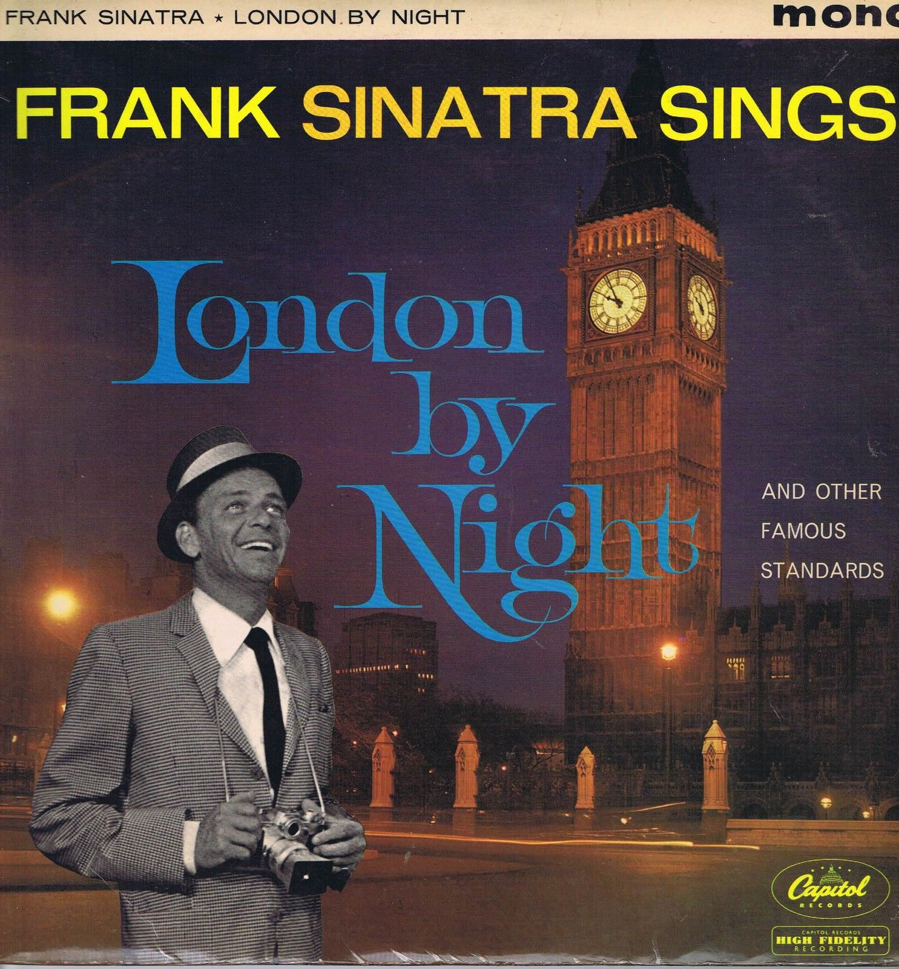

[Figure 1 near here]
Figure 1: Frank Sinatra album, London By Night. Capitol Records, 1962.

London By Night, described by the British music British music newspaper, Melody Maker, as ‘a Capitol memento of Sinatra’s recent trip here’ (uncredited, 1962: 9), demonstrates how Sinatra’s promotional and live work fed into the way his recordings were packaged and sold with the record company capitalizing on the fact that, for the first time, Sinatra was starting to perform more regularly outside the USA. Despite having been a star since the early 1940s, Sinatra did undertook his first tour of Europe until 1953, and, even then, he only performed in Scandinavia, Belgium, Italy and the UK. Meanwhile, his first world tour did not take place until 1962. George Jacobs, who for more than a decade was Sinatra’s valet and close aide, identifies this World Tour as being the set of engagements that finally
made him [Sinatra] worldly... [and] cured him of his reluctance to trot the globe. Like many glamorous people with the advent of the 707 plane, Mr. S. began to look at Europe as another playground with infinite possibilities. (Jacobs and Stadiem, 2003: 196)
Jacobs contends that prior to this tour his boss had displayed ‘a total lack of curiosity about the outside world. He was a homebody, not an explorer... He vastly preferred Little Italy to the Big One, Hoboken to Hong Kong, Las Vegas to Monte Carlo, Palm Springs to Marrakech’ (ibid: 179). Perhaps one reason for this outlook was the far from glamorous nature of Sinatra’s early exposure to travel: those arduous cross-country coach journeys with The Hoboken Four, The Harry James Orchestra and The Tommy Dorsey Band.
Sinatra’s relative disinterest in travel was also coupled to his life-long fear of flying. It was a fear that was exacerbated by the singer narrowly avoiding boarding a plane in 1958 that subsequently crashed, and, much later, by his mother dying in a plane crash while en route to see her son perform in Las Vegas in January 1977. Yet despite these factors, travel and especially flight were periodically presented throughout Sinatra’s long career as a key component of a particular lifestyle that he was viewed as embodying, one that signaled power, glamour and wealth.
This particular image was perhaps best exemplified by Sinatra’s ownership of a succession of private planes. It was the first of these, a powerful, propeller driven Martin 4-0-4 purchased in 1959, that was the best known, not least because of the name he gave it: El Dago (Figure 2). Given Sinatra’s Italian heritage, this choice of name was clearly provocative; indeed, it was later rechristened Tina (named after Sinatra’s second daughter) to allay fears of upsetting Italian fans during the singer’s 1962 world tour. Sinatra’s original name for this plane suggests that, in his mind at least, the principal image he felt many people still had of him was not one of power, wealth and glamour, but instead was one that could most succinctly be summed up by this derogatory and ethnically charged epithet. In naming his own plane El Dago Sinatra was making a clear attempt to re-appropriate the offensive term, a strategy that later was similarly adopted by numerous hip hop artists in relation to the word “nigger”.

[Figure 2 near here]

Figure 2. Sandra Paul, wife of Sinatra biographer Robin Douglas-Home, in front of El Dago, 1961. Rex Features.
Recalling time spent on the plane, George Jacobs stated that it
had a terrific sound system and all his [Sinatra’s] records, a projector for most of his films, as well as … a great bar, I was the barman of the skies ... The flights were a true movable feast. It was a flying cocktail party. (Jacobs and Stadiem, 2003: 190)

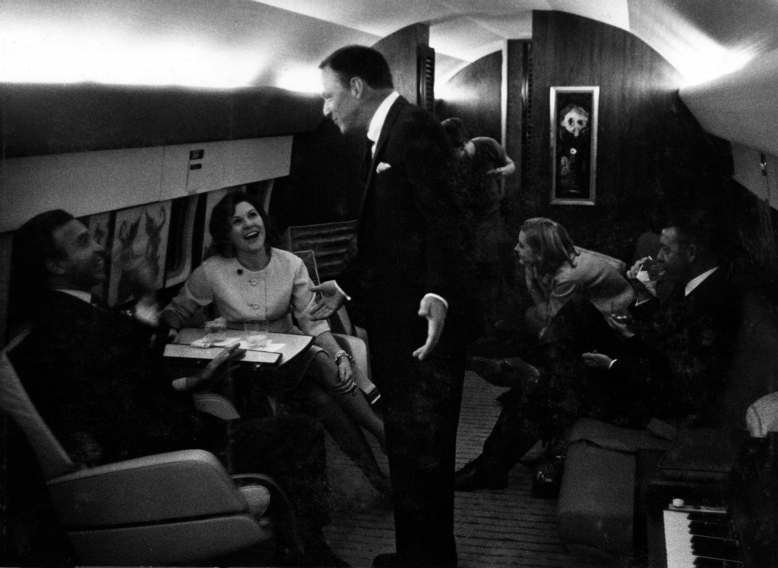

[Figure 3 near here]

Figure 3. Frank Sinatra with friends and piano on board El Dago. Rex Features.
On one level, such reminiscences, and associated images (Figures 2 and 3) that were distributed at the time, reinforced this image of Sinatra as being a standard bearer for projecting not just wealth but also a specific mid-twentieth century American assuredness. Additionally, Sinatra at this time was performing a certain form of masculinity, one associated ‘with taste, lifestyle, with gadgets, with penthouses, with clothes’ (Angela McRobbie, interviewed in Taylor, 2011). The codes of this masculinity were similar to those Mort (1996) identified as having driven a later iteration of male style culture in 1990s Britain. Just as that latter culture was most clearly articulated in the pages of men’s magazines (Jackson et al, 2001), so the late 1950s and early 1960s variant of this ‘ideal’ was often also principally presented via the pages of new and much talked about magazines, such as Playboy. Following Sinatra’s death in 1998, The New York Times obituary observed that:
except perhaps for [Playboy publisher] Hugh Hefner ... probably nobody did more [than Sinatra] to create a male ideal in the 1950s. For years, Sinatra seemed the embodiment of the hard-drinking, hedonistic swinger who could have his pick of women and who was the leader of a party-loving entourage. (Holden: 1998)
Sinatra’s private plane, which he later replaced with a succession of jet powered aircraft, provided a mobile party venue for the Hollywood elite. Every time it took to the skies the singer was making a none too subtle statement about his considerable earnings and, as such, was situating himself within a long lineage of high status figures who have used mobility – and displays of mobility – as a means of publicly performing, and thus of reinforcing, their power, wealth and celebrity, as geographers have identified in both historic (Daniels, 1996) and contemporary (Beaverstock et al, 2010) settings. However, the significance of Sinatra’s private plane extended beyond it being a site, or perhaps more accurately a phallocentric space, for articulating authority. By naming it El Dago, Sinatra explicitly used the plane to draw attention to discrimination resulting from his Italian ancestry that he claimed he had experienced since childhood, in the working class New Jersey dock town of Hoboken, and which he said continued even after he became perhaps the most famous singer in America. In a 1958 interview with Melody Maker Sinatra stated:
I’ve been up and down America a lot since I first started singing and I’ve seen and heard a lot to make me feel both proud and ashamed of being an American. In my own experience I’ve known prejudice ... A lot of people look down on Italians. Not long ago a woman, slightly drunk, sat at my table in a night club near Carmel, California and told me: “You know what we call you in our house? We call you the wop singer.” This wasn’t the last time I’ve been called a wop and it probably won’t be the last. But I intend to go on doing what I can to eliminate this sickness. (uncredited, 1958: 2-3)
Sinatra’s anger towards such comments manifested itself in various ways. He wanted to raise the issue and was unusual among his peers in choosing to discuss such matters openly with journalists. Similarly, in an attempt to try and educate audiences, in the immediate aftermath of WWII Sinatra produced and appeared in a short film, The House I Live In – for which he received a special Oscar at the 1946 Academy Awards – that called for racial and religious tolerance, especially amongst the young. Additionally, he sought to counter discrimination within the music industry by standing up to those who wanted him to downplay his Italian identity. Early in Sinatra’s career, his bandleader boss, Harry James, asked him to change his name to the more Anglicized sounding ‘Frankie Satin’. Sinatra resisted such pressure, unlike Dean Martin (Dino Crocetti), Tony Bennett (Anthony Benedetto), Frankie Laine (Francesco LoVecchio) and Frankie Valli (Francesco Castelluccio).
Despite his wealth, fame and periodic connections to those in positions of political power, Sinatra, a Catholic son of Italian immigrants, never felt himself to be entirely welcome at the top table of America’s social elite. His ownership and use of the plane, and the name he gave to it, can be read as a demonstration of how mobility, and performances of mobility, can be constitutive of ‘the play of power and meaning within social and cultural networks of signification’ (Cresswell and Dixon, 2002: 4), networks that are not always as stable and secure as they may initially appear. whether Sinatra’s decision to call his plane El Dago was the best way to help to tackle the ‘sickness’ he described is debatable. But his naming of the plane does demonstrate that even after he became a worldwide celebrity and was enjoying enormous, almost unprecedented fame and fortune, Sinatra still felt that his ethnicity, as well as other factors, including his religion, his relatively non-conformist lifestyle – certainly with regard to his attitude towards monogamy – and, at that time, his left leaning political beliefs, were all held against him.
One event that crystalized this for Sinatra occurred in March 1962. Sinatra viewed President John F Kennedy as a close friend; he had very publicly supported him during the 1960 presidential election, even re-recording one of his best known songs, ‘High Hopes’, as an official Kennedy campaign song and organizing, along with actor Peter Lawford, Kennedy’s pre-inaugural ball in Washington D.C. Furthermore, it is rumoured that during the tight presidential campaign against Nixon, Sinatra successfully leant on the Chicago Mob boss, Sam Giancana, with whom he had a close relationship, to facilitate a win for Kennedy, via voting irregularities, in the crucial swing state of Illinois. As thanks for such support (both public and clandestine) it was agreed that after Kennedy took office he would spend a vacation at Sinatra’s Palm Springs home. However, on the eve of that long-planned stay, and to Sinatra’s fury, Kennedy went back on his word and chose instead to stay at the home of Sinatra’s great rival, Bing Crosby. Worse still for Sinatra, a lifelong Democrat supporter up until this time, was the fact that Crosby was a renowned Republican. Tellingly though, in contrast to Sinatra, Crosby was widely viewed, albeit not entirely accurately, as a clean-living beacon of the WASP establishment.
Sinatra believed it could only have been his ethnicity that led to the snub by Kennedy. He chose to ignore the fact that it was his fraternization with known Mob bosses which was the principal reason for US Attorney General, Robert Kennedy, insisting his brother stay with Crosby rather than Sinatra. Sinatra’s Mafia connections, and the electoral outcomes they helped to influence, had indirectly led him to being given the honour of hosting the President, as an expression of thanks. However, it was ironically the very toxicity of these connections, and the later fear the Kennedy administration had of being in any way associated with them, that then led to the visit being rescinded. At various times throughout his career, Sinatra’s fraternization with leading figures from the world of organized crime unsurprisingly hampered his ambitions to be accepted into the very highest strata of American public life. But, more beneficially, the notoriety Sinatra gained as a result of frequently hosting senior Mafia bosses in his homes and clubs provided him with a more risqué, dangerous and ultimately more commercially potent public image than any of his peers possessed.

The post-war bachelor on the move: Frank Sinatra’s Come Fly With Me
The equation of travel with Sinatra occurred throughout his career and, as has been outlined here, after it as well. Nonetheless, it was unquestionably at its most persuasive in the 1950s, a time when representations of mobility in the USA developed a special resonance. During that decade, rising levels of disposable income among many, though by no means all, Americans, found expression, amongst other ways, in increasing car ownership. This, together with road and other infrastructure improvements and leaps in transport technology, many of which were facilitated by the war, allowed for an increasing proportion of the public to move purely for leisure. As the novelist Vladimir Nabokov poetically stated, ‘voraciously we consumed those long highways, in rapt silence we glided over their glossy black dance floors’ (Barter, 2007: 220). The boom was evident not just in leisure travel by road, but also by air. In April 1949 the first production commercial jet airliner, the de Havilland Comet 1, made its maiden flight and, within a decade, in 1958, Boeing launched its first long-range civilian airliner, the 707. Music, along with much of the literature, film and painting produced in the US in the post-war period, reflected and promoted the central role of travel in enacting, reflecting and reproducing rapid shifts in lifestyle patterns. One such text that foregrounded the pronounced connection between music and mobility to considerable effect was Frank Sinatra’s 1958 travel themed album, Come Fly With Me.
Come Fly With Me was made in Capitol Records studios, Hollywood over the course of just three days in October 1957. In the US the record topped the Billboard chart on its release in January 1958 (Friedwald, 1995: 285); in the UK it was the first Sinatra album to make the newly launched album chart, reaching number two. As well as being a commercial hit, Come Fly With Me was also a critical success. In 1959 it received Grammy Award nominations for best album, best album cover, and – for its title track – best arrangement. The album was released at the start of Sinatra’s sixth year with Capitol Records, a period that had seen him successfully target an older, more adult audience. As Stan Cornyn’s sleeve notes to a 1965 compilation, Sinatra: A Man and his Music, put it, ‘his public was no longer lonely girls. You had to be old enough to buy booze to buy Sinatra’. Although this was a conscious shift by Sinatra and Capitol Records, followed by Reprise Records, it was also one that was forced on them to some extent by the sudden emergence of rock’n’roll in the late 1950s. Rock’n’roll created a generational gap in music and culture, one that had not previously existed to anything like the same extent; Sinatra, once a teen hero, now found himself firmly on the adult ‘side’ of the divide. But it was a shift the singer embraced. Sonically and thematically his material began to move well away from his previous output. Increasingly he became associated with the new long-player album format, one which, unlike the cheaper 7-inch single, was aimed at an older, wealthier and predominantly male market.
Unlike other albums that Sinatra released in the mid to late 1950s, Come Fly With Me’s unity came about not by immersion in a particular mood, as was the case with, for example, In the Wee Small Hours, nor from the cohesion of one musical style, as demonstrated by Songs for Swinging Lovers but, instead, via the exploration of a single theme, travel, which spanned the album’s twelve songs. As already mentioned, Come Fly With Me was not the first time that the singer had engaged with the topic of travel for Capitol. Furthermore, even prior to signing with Capitol and recording ‘World on a String’ and ‘South of the Border’, Sinatra had already travelled extensively on record with his previous label, Columbia Records (1942 to 1952), including to Asia (‘On a Little Street in Singapore’), the American South (‘I Went Down to Virginia’, ‘Tennessee Newsboy’ and ‘Peach Tree Street’), and Europe, in pursuit both of vicarious military conflict (‘There’ll be a Hot Time in the Town of Berlin’), and romance (‘London By Night’ and ‘April In Paris’). Meanwhile, later in his career, on his own Reprise label (1961 to 1984), Sinatra once more took to the skies with ‘Leaving on a Jet Plane’, and went higher still on ‘Fly Me To The Moon’.
However, Come Fly With Me was the only time in his career that Sinatra devoted an entire album to travel. The record presented Sinatra as a debonair playboy, radiating cosmopolitan sheen. Previously, he had projected a confident display of bachelorhood across a range of music and film projects, with examples of the latter including The Tender Trap (1955) and Pal Joey (1957). But even the ebullience and panache displayed by Sinatra in those performances does not match what was delivered on Come Fly With Me. The album, and the persona Sinatra adopted throughout it, was timely; it chimed with the entertainment industry’s broader vision of the post-war white American male as a figure who was both physically and socially mobile and explicitly expressed and promoted notions that are still commonly associated with mobility, namely those of ‘progress… freedom… opportunity, and … modernity’ (Cresswell, 2006b: 1-2).
The album contains some of Sinatra’s memorable string based ballads, including ‘Moonlight in Vermont’, ‘Autumn in New York’, and ‘London by Night’, but arguably a more lasting impression is that generated by the newly assertive, brash, incarnation of Sinatra that the listener encounters. This fresh, strutting persona, one that saw Sinatra consolidate and extend his increasingly male following, was achieved through a combination of elements, which included: Billy May’s rhythmically strong, dynamic brass arrangements; memorable melodies; smart lyrics; and Sinatra’s frequently more strident vocal delivery. The latter built on an approach he had adopted on the acclaimed Songs for Swinging Lovers album, released two years earlier, on which Sinatra’s vocal delivery was virtually unrecognizable from the crooning style that he had been so associated with throughout the 1930s and 1940s.
Equally noteworthy, regarding the overall character of Come Fly With Me, were the contributions made by the only two songwriters specifically commissioned to produce material for the album: composer Jimmy Van Heusen and lyricist Sammy Cahn. For the sociologist Chris Rojek (2004: 30), the output of this songwriting duo – who wrote, or co-wrote, 43 songs recorded by Sinatra, including many of his best known numbers, such as ‘(Love is) The Tender Trap’, ‘My Kind of Town’ and ‘Love and Marriage’ – constituted ‘the poetry of American consumer culture in the 1950s’. On Come Fly With Me (as on Sinatra’s next LP, Only The Lonely), the singer came up with the title of the album, then commissioned Cahn and Van Heusen to compose an opening song based around it. The songwriters responded with a suitably ‘lofty affair … the perfect vehicle for Sinatra’s languid, breathy vocals, so evocative of the feeling of flight’ (Granata, 2004: 136). The song’s ‘intro’ immediately establishes an exhilarating sense of being swept along, of taking-off, thanks largely to ‘anticipatory off-kilter riffs and giddy, ascending strings’ (Ingham, 2005: 255), and thus provides a fine aural representation of the phenomenological affects of flight (Adey, 2010). As such, a full three decades after it was recorded, the song still remained an entirely choice for inclusion on the entertainment system of British Airways Concorde flights going to and from New York, a city, of course, closely identified with Frank Sinatra. Prior even to hearing the travel fantasies depicted on Come Fly With Me, Sinatra fans had a very good indication of what to expect courtesy of seeing the album’s arresting sleeve (Figure 4).
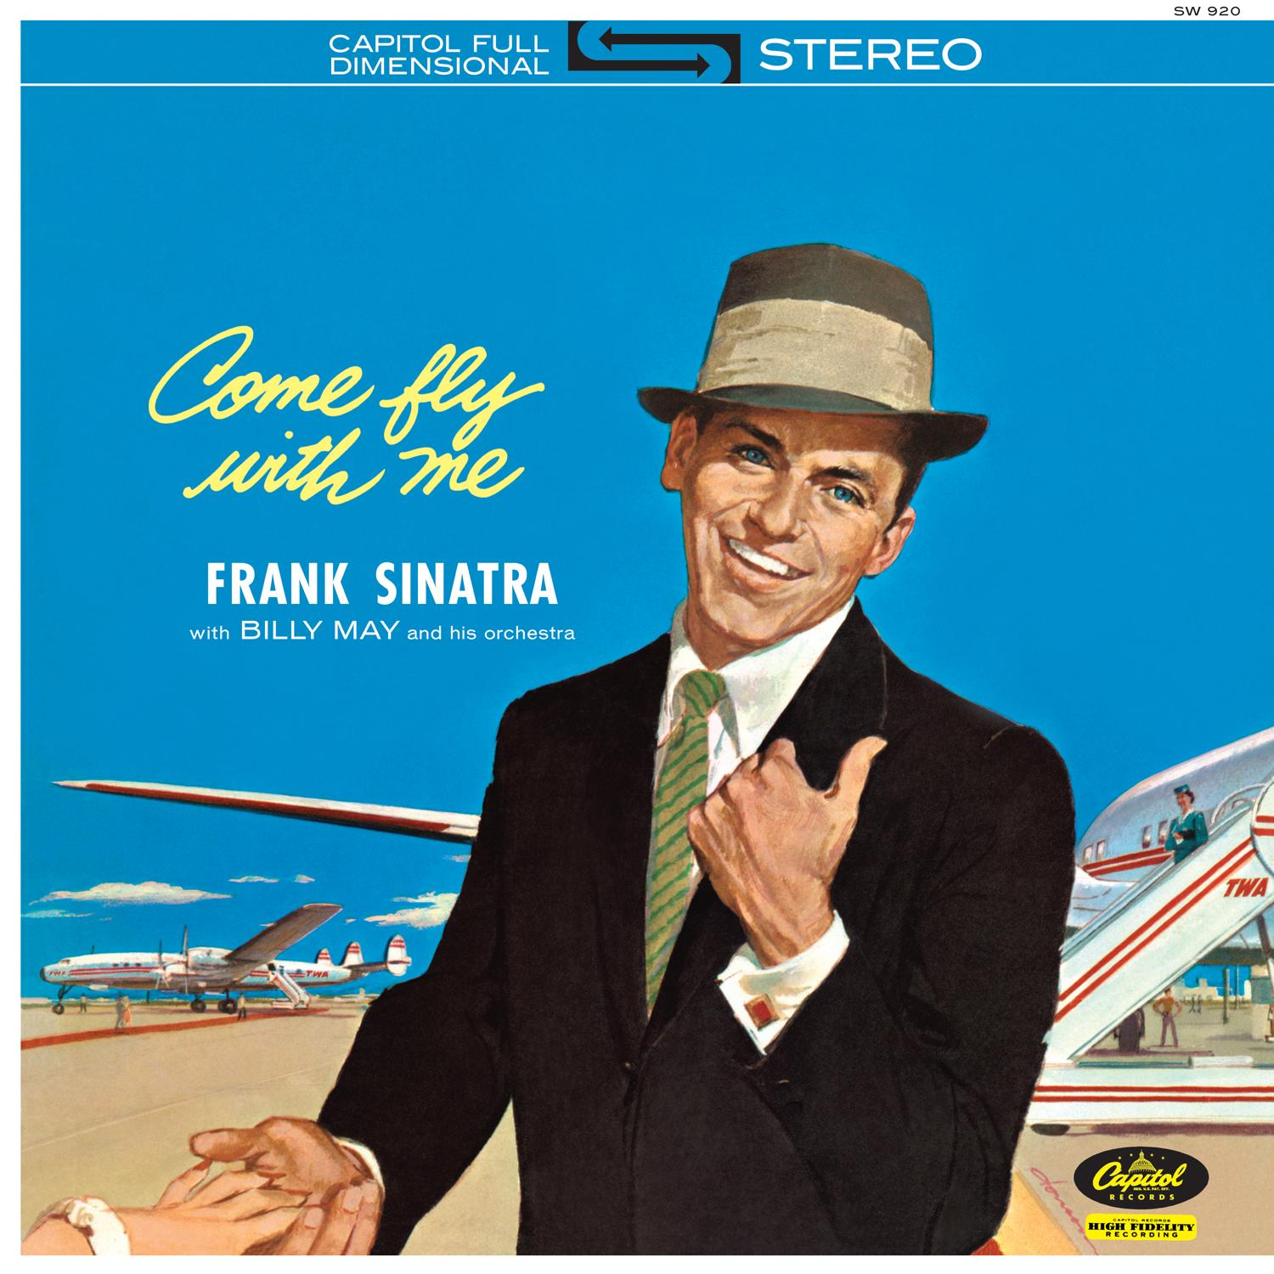
[Figure 4 near here]

Figure 4. Frank Sinatra album, Come Fly With Me. Capitol Records, 1958.
The central portrait of Sinatra on the cover of Come Fly With Me recalls an earlier painterly ‘realistic’ style, but the overall impression is colourful, playful and contemporary. The font used for the album title is suggestive of a jet vapour trail and contrasts with the bold upper case letters that spell out the performer’s name. In the centre of the image Sinatra smiles broadly, fixing his gaze on whoever holds the record. His appearance is striking. The singer’s teeth are impossibly white, perfectly offsetting the famed blueness of his eyes and the sky behind him; those teeth celebrate good-health, vigour and personal and national well-being. In addition, Sinatra is, as ever, impeccably well dressed. His stance invites us to think that he is thumbing a lift on what look like his own pair of Trans World Airways jets lined up on the runway behind him. A regal red carpet leads to one of these jets, a potent symbol of the technological glamour of American modernity. Tantalizingly, and almost out of shot, a woman stretches out a manicured hand towards Frank. Frank looks decidedly pleased with the situation, and with himself; the cocky personification of his first Capitol single, ‘I’ve Got the World on a String’, a tanned figurehead for an apparently contented and seemingly impregnable USA.
This carefree, street-smart Sinatra persona presented on Come Fly With Me speaks to the notion of travel as presenting an opportunity for a literal flight away from accepted societal mores and responsibilities. Significantly, it was recorded at the end of 1957, the year Frank Sinatra divorced Ava Gardner, four years after they separated. Ingham, (2005: 54) asserts that this split ‘hardened him, leaving him less guilty than before about taking pleasure where it could be found’. Such behaviour is strongly suggested, both visually and aurally, on Come Fly With Me. As such, the album is emblematic of what Toop (1999: 151) has described as ‘the masculine den of the fifties, stocked with [Martin] Denny, [Les] Baxter, [Frank] Sinatra, [Stan] Kenton … flushed with the imminence of sexual freedom, dimly aware that the domination… may soon be under threat’. As such, it exposes the different modes of sexual behavior considered permissible for men and women at the time, reflecting the double standards that underpinned the era’s highly gendered culture and providing a stark illustration of Wolff’s (1993: 235) belief that ‘the suggestion of free and equal mobility is… a deception since we don’t all have the same access to the road’.
The imagery and playfulness conveyed by the Come Fly With Me sleeve, and by the record itself, may appear to be oblivious to America’s then deteriorating Cold War relationship with the Soviet Union. But, conversely, it is possible to argue that the relentless positivity of much of the album is fundamentally informed by the geopolitical context in which it was made. In the post-war period the Hearst press did their best to depict Sinatra as a ‘Red’ (McNally, 2005). This was due to his enthusiastic support of the Democratic Party up until the early-1960s, his endorsement of blacklisted writers in Hollywood, such as Albert Maltz, and his funding of and starring in the aforementioned short film, The House I Live In, which called for greater equality and racial harmony. As Travis Elborough (2008: 135) notes, ‘throughout the 1940s, Sinatra’s progressive politics and his highly principled and unparalleled public stance on racial equality were radical and not without controversy’. But despite attempts to ‘Red’ smear Sinatra, orchestrated by some of the leading columnists of the time, such as Lee Mortimer and Dorothy Kilgallen, it is difficult to think of a more powerful advertisement for the capitalist lifestyle than that provided by Come Fly With Me. As presented on the record’s sleeve, on the title track, and on other songs on the album, such as ‘Isle of Capri’, ‘Brazil’, and ‘It’s Nice to Go Trav’ling’ (another Cahn and Van Heusen composition), Sinatra seems determined to enjoy the possibilities the ‘jet age’ appears to offer, at least to multi-millionaire, white male divorcees. By the time of the album’s release, in 1958, he was a metonym for a nationally self-confident vision of the good life, one that was being promoted with ever more zeal and sophistication on Madison Avenue by America’s increasingly influential advertising industry.
In an era of Cold War tensions, Sinatra was a globally recognized figure who many Americans could proudly point to as being an embodiment of physical vitality, material success and personal freedom, freedom that found expression in the range of work he undertook and in how he chose to conduct his private life. But, at the same time, many other Americans were wary of Sinatra. They considered that his public indulgence of the freedoms afforded to him by his fame, wealth and charisma posed a threat to the stability and sanctity of American family life. In sections of the mass media, which was assuming greater significance, Sinatra was repeatedly condemned for appearing to deliberately flout widely circulated ideals of cultural conformity. This pressure for conformity gained momentum with the construction across the country of vast suburbs, spaces specifically designed to encourage social obedience. Major real estate developers, such as William Levitt, helped to ensure that 83% of all population growth in America in the 1950s took place in the suburbs (Patterson, 1997: 333). The people who moved into these new homes included many who had previously accounted for Sinatra’s original, largely female fan base, in the late 1930s and early 1940s. Having now reached adulthood, this constituency was largely unimpressed by Sinatra’s openly promiscuous activities. Via his indiscreet philandering when married, his apparent abandonment of his young family and his unwillingness to remain faithful to girlfriends when a bachelor, the singer pushed well beyond what many of his fans, and those in the press – including, again, the extremely influential journalist, Kilgallen – deemed to be morally acceptable behaviour. As Elborough (2008: 137) sums it up, ‘Sinatra’s adultery was looked upon as a personal act of betrayal, a dream-trampling affront to their [his fans’] collective values, or at least that was how the newspaper columnists chose to report it’.
Conclusion
Through an engagement with Sinatra’s texts, actions and performances, this paper has demonstrated that the singer was a powerful embodiment for a romanticized, carefree vision of mid-century America. At the same time, this commonly circulated image obfuscates contradictions that were played out through Sinatra’s experience of and representations of mobility. These contradictions include the fact that he became emblematic of the jet set despite not being a keen traveller, and that one of the defining indications of having achieved the so-called American Dream, owning one’s own private plane, was rather counterbalanced by him choosing to name it with a racially charged epithet that spoke to ongoing social tensions in mid-century America. By contextualizing such issues, the paper has attempted to be attentive to concerns raised by Shurmer-Smith and Hannam (1994, cited in Bowler 1999: 168), who criticized ‘many studies of travel behaviour for ignoring the gender of travellers, the significance of life-course stage and issues of gendered power in accounting for travel patterns’, a concern that, despite being made twenty years ago, all too often remains valid today.
Frank Sinatra’s legacy continues to inform creative practice, while his strong alignment with mobility and the high life is such that books and articles are still regularly commissioned on the topic, all of which contribute to the long afterlife of his global celebrity. The extent of this ongoing interest should come as little surprise, given that Sinatra, as he was in numerous realms, was a fascinating character in relation to mobility. He embodied the notion of travel as a luxury activity whilst also sometimes, and sometimes simultaneously, using travel to push against and transgress societal norms and expectations. In doing so, he vividly demonstrated the means by which ‘mobilities are ... articulated in particular ways to reproduce and/or challenge social relations’ (Cresswell and Dixon, 2002: 4). By addressing how these reproductions and challenges occur in specific contexts this paper has sought to present a fuller, more rounded approach to the issue of movement and, in particular, to its intersection with notions of prestige as well as rebellion, as represented in American popular culture texts and actions in the late 1950s and early 1960s.
In the final part of the analysis, the particular importance of Sinatra’s Come Fly With Me has been stressed. This record was significant in numerous ways, including its role in: the commercial and critical arc of Sinatra’s career; the changing demographic trajectory of the US music industry; and the promotion of rapidly evolving cultures of travel, leisure and celebrity. In addition, the album was important for its depiction of a particular form of American bachelordom. More than any other LP by Sinatra – or by anyone else, at that time – it explicitly spoke to conjoined discourses of mobility and masculinity. The breezy optimism presented on the album by Sinatra can be interpreted, in part, as a reaction to the class, race, gender and geopolitical stresses that were becoming increasingly pronounced at the time of its release. Sinatra’s take on mobility was aimed at adults rather than youths. This alone distinguished him from other artists, such as Jack Kerouac, who also engaged with mobility related themes in post-war America, but whose eventual audience tended to be more youthful and much more closely aligned with an incipient counter-culture.
By engaging with one of the most famous singers of the twentieth century, this paper has also sought to re-shape and broaden the scope of geography’s existing engagement with popular culture. More specifically, it has sought to re-animate geographical enquiry focused around the deep reading of, and sustained engagement with, particular historic case-studies, in this instance the work produced by a mainstream musical performer. I have attempted to counter a frustrating tendency sometimes evident in studies of popular culture, including music, namely one which suggests ‘that questions of culture and identity are frivolous diversions compared to the ‘real’ tasks of examining music’s function as a nucleus of economic growth’. (Connell and Gibson, 2003: 7). Instead, by focusing on Sinatra and his career, I have adopted an approach that is attentive to music as culture and music as commerce as being in near constant dialogue with one another.
The paper also mapped out ways in which another unfortunate academic binary dualism can and should be overcome, namely that between representation and text versus performativity and corporeality. It took the latter seriously whilst also consciously foregrounding questions of ‘representation… positionality, and the politics of identity’ (Merriman and Revill, 2008: 209). I have attempted to show how Frank Sinatra performed mobility through his mobile lifestyle but also addressed how he represented it through his musical texts – including the visual imagery attached to them – texts that came into being via the embodied performances that Sinatra and his fellow musicians delivered in the studio. The paper has drawn attention to how, within these texts, the combined actions of singer, arranger and musicians successfully allowed ugh the music to convey sensations associated with traveling, including flying, as viscerally felt experiences.
I have sought to reactivate the study of music from a cultural geography perspective by adopting an approach that melds performative dimensions – incorporating practices such as song-writing, singing, arranging, playing and designing – with detailed analysis of texts, contexts and representations. Additionally, I have highlighted that a close reading of popular music’s material culture and its situatedness can tell geographers a great deal not just about the invention, production, consumption and influence of specific products, but also about the societies and cultures that brought them into being. Via the tangibility of the discs, the music contained within them, the accompanying artwork and so forth, records provide a means through which fans and researchers can engage with multiple, complex cultural processes. In the first decade of the 21st century, the depth of engagement with such processes arguably weakened when, to the dismay of some music fans, recorded music become increasingly intangible due to the growing popularity of downloads and streams as delivery formats. However, in recent years, there is evidence of a growing enthusiasm, including among some younger fans, for more tangible and visible formats. This has been demonstrated by a renewed, although still niche, interest in the music cassette (Evangelho, 2016) and, more significantly, by a notable rise in sales of vinyl records, admittedly from a very low base (Stanley, 2015).
If one agrees with the contention of Neil Tennant, former journalist and lead singer of the Pet Shop Boys, that ‘pop music is a diary of contemporary culture ... rooted in time’ (Brusasco, 2011),_ then one can claim that, for decades, discs – first shellac, then vinyl and finally compact – provided people with aural diary entries that frequently encompassed a multitude of pressing cultural geography themes, including those of place and performance, identity and belonging, and mobility and representation. Geography stands to benefit by engaging with popular music more frequently in order to examine such themes. Music – including, and perhaps especially, commercially popular, mainstream music – offers a rich and compelling resource for cultural geographers, one that, for too long, has been largely neglected.

Acknowledgements
I would like to thank David Atkinson, Andrew Leyshon and Alex Vasudevan for their helpful comments on earlier versions of this work, Nicola Thomas for her general encouragement and advice, and Jackie Bishop, at the EMI Archive, Hayes, for facilitating valuable access to materials.

Disclosure statement
No potential conflict of interest was reported by the author.

Funding
This article relates to my doctoral research, which was undertaken in the School of Geography at the University of Nottingham with the support of an ESRC Quota Studentship Award.

References
Adey, P. (2010). Aerial Life: spaces, mobilities, affects. London: Wiley-Blackwell.
Aitken, S., & Lukinbeal, C. (1997). Disassociated Masculinities and Geographies of the Road. In I. Hark, & S. Cohan (Eds.), The Road Movies Book (pp. 349-370). New York: Routledge.
Alderman, D.H. (2009). Writing on the Graceland Wall: On the Importance of Authorship in Pilgrimage Landscapes. In O. Johansson & T.L. Bell (Eds.), Sound, Society and the Geography of Popular Music (pp. 53-65). Farnham: Ashgate.
Anderson, B. (2004). Recorded music and practices of remembering. Social & Cultural Geography, 5, 3-20.
Anderson, B., Morton, F., & Revill, G. (2005). Editorial: Practices of music and sound. Social & Cultural Geography, 6, 639-644.
Barter, J.A. (2007). Travels and Travails: Hopper’s Late Pictures. In S. M. Tremblay & M. Polizzotti (Eds.), Edward Hopper: Carol Troyen, Judith A. Barter, Janet L. Comey, Elliot Bostwick Davis, Ellen R. Roberts (pp. 211-225). London: Thames and Hudson.
Brusasco, L. (Producer). (2011). Breakthrough Single [Television series episode]. In Secrets of the Pop Song. London: Renegade Pictures.
Beaverstock, J., Deudder, B., Faulconbridge, J., & Witlox, F. (Eds.). (2010). International Business Travel in the Global Economy. Farnham: Ashgate Publishing.
Bowler, S. (1999). Mobility. In L. McDowell & J. Sharp (Eds.), A Feminist Glossary of Human Geography, (p. 168). London: Arnold.
Brandellero, A., & Pfeffer, K. (2015). Making a scene: exploring the dimensions of place through Dutch popular music, 1960-2010. Environment and Planning A, 47, 1574-1591.
Carney, G. (Ed.). (1978). The sounds of people and places: a geography of American music from country to classical and blues to bop. Washington: University Press of America.
Cohen, S. (2007). Decline, Renewal and the City in Popular Music Culture: Beyond the Beatles. Aldershot: Ashgate.
Connell, J., & Gibson, C. (2003). Soundtracks: popular music, identity and place. Abingdon: Routledge.
Crang, M. (1998). Cultural Geography. London: Routledge.
Cresswell, T. (1993). Mobility as Resistance: A Geographical Reading of Kerouac’s ‘On the Road’. Transactions of the Institute of British Geographers, 18, 249-262.
Cresswell, T. (2006a). ‘You cannot shake that shimmie here’: producing mobility on the dance floor. Cultural Geographies, 13, 55-77.
Cresswell, T. (2006b). On the Move: Mobility in the Modern Western World. London: Routledge.
Cresswell, T., & Dixon, D. (2002). Introduction. In T. Cresswell, & D. Dixon (Eds.), Engaging Film: Geographies of Mobility and Identity (pp. 1-10). Oxford: Rowman and Littlefield.
Curtis, J.R. & Rose, R.F. (1983). “The Miami Sound”: A Contemporary Latin Form of Place- Specific Music. Journal of Cultural Geography, 4, 110-118.
Daniels, S. (1996). On the Road with Humphry Repton. Journal of Garden History, 16, 170-90.
Daniels, S. (2006). Suburban pastoral: Strawberry Fields forever and Sixties memory. Cultural Geographies, 13, 28-54.
Divall, C., & Revill, G. (2005). Cultures of Transport: Representation, practice and technology. Journal of Transport Studies, 26, 99-111.
Elborough, T. (2008). The Long-Player Record Goodbye. London: Sceptre.
Evangelho, J. (2016, March 3). Forget Vinyl, Let’s Talk About the Cassette Comeback. Forbes. Retrieved from http://www.forbes.com/sites/jasonevangelho/2016/03/24/forget-vinyl-lets-talk-about-the-cassette-comeback/#263cf5051723
Florida, R. (2013, May 28). The Geography of America’s Pop Music/Entertainment Complex. CITYLAB. Retrieved from http://www.citylab.com/design/2013/05/geography-americas-pop-musicentertainment-complex/5219/
Florida, R., Mellander, C., & Stolarick, K. (2010). Music scenes to music clusters: the economic geography of music in the US, 1970-2000. Environment and Planning A, 42, 785-804.
Friedwald, W. (1995). Sinatra! The Song is You. A Singer’s Art. New York: Scribner.
Fuchs, J., & Prigozy, R. (Eds.). (2007). Frank Sinatra: The Man, The Music, The Legend. Rochester: University of Rochester Press.
Gold, J. R. (1998). From “Dust Storm Disaster” to “Pastures of Plenty” – Woody Guthrie and Landscapes of the American Depression. In A. Leyshon, D. Matless, & G. Revill (Eds.), The Place of Music (pp. 249-268). New York: Guilford.
Granata, C. (2004). Sessions with Sinatra: Frank Sinatra and the Art of Recording. Chicago: A Cappella Books.
Holden, S. (1998, May 16). Frank Sinatra Dies at 82; Matchless Stylist of Pop. The New York Times. Retrieved from http://www.nytimes.com/1998/05/16/movies/frank-sinatra-dies-at-82-matchless-stylist-of-pop.html
Hollows, J., & Milestone, K. (1998). Welcome to Dreamsville: A History and Geography of Northern Soul. In A. Leyshon, D. Matless, & G. Revill (Eds.), The Place of Music (pp. 83-103). New York: The Guilford Press.
Ingham, C. (2005). The Rough Guide to Frank Sinatra. London: Rough Guides.
Inglis, F. (2010). A Short History of Celebrity. Princeton: Princeton University Press.
Jackson, P., Stevenson, N., & Brooks, K. (2001). Making Sense of Men’s Magazines. Cambridge: Polity Press.
Jacobs, G., & Stadiem, W. (2003). Mr S: The Last Word on Frank Sinatra. London: Harper Collins.
Jarvis, B. (1985). The truth is only known by guttersnipes. In J. Burgess & J.R. Gold (Eds.), Geography, The Media and Popular Culture (pp. 96-122). London: Croom Helm.
Johansson, O., & Bell, T.L. (Eds.). (2009). Sound, Society and the Geography of Popular Music. Farnham: Ashgate.
Johansson, O., & Bell, T.L. (2014). Touring Circuits and the Geography of Rock Music Performance. Popular Music and Society, 37, 331-337.
Jones, K. (2005). Music in factories: a twentieth-century technique for control of the productive self. Social & Cultural Geography, 6, 723-744.
Kaplan, J. (2010). Frank: The Making of a Legend. London: Sphere.
Kaufman, W. (2011). Woody Guthrie, American Radical. Urbana: University of Illinois Press.
Kong, L. (1995a). Popular music in geographical analyses. Progress in Human Geography, 19, 183-198.
Kong, L. (1995b). Music and cultural politics: ideology and resistance in Singapore. Transactions of the Institute of British Geographers, 20, 447-59.
Kruse, R. (2003). Imagining Strawberry Fields as a Place of Pilgrimage. Area, 35, 154-162.
Kruse, R. J. (2005). A Cultural Geography of the Beatles: Representing Landscapes as Musical Texts. Lewiston, NY: Edwin Mellen Press.
Leyshon, A. (2014). Reformatted: Code, Networks, and the Transformation of the Music Industry. Oxford: Oxford University Press.
Leyshon, A., Matless, D., & Revill, G. (1998). Introduction. In A. Leyshon, D. Matless, & G. Revill (Eds.), The Place of Music (pp. 1-30). New York: Guilford.
Marcus, G. (2000). Mystery Train: Images of America in Rock ‘n’ Roll Music. London: Faber and Faber.
McClure, R. (2015, November 27). Follow in Frank Sinatra’s footsteps as Palm Springs toasts Ol’ Blue Eyes’ 100th birthday. LA Times. Retrieved from http://www.latimes.com/travel/la-tr-d-frank-sinatra-main-20151129-story.html
McCormack, D.P. (2008). Geographies for moving bodies: thinking, dancing, spaces. Geography Compass, 2, 1822-1836.
McDowell, L. (1996). Writing, Reading and the Problem of Resistance: Alternative Views of Rebellion, Resistance and ‘The Beats’. Transactions of the Institute of British Geographers, 21, 412-419.
McNally, K. (2005). ‘Sinatra, Commie Playboy’: Frank Sinatra, Postwar Liberalism and Press Paranoia. Film Studies, 7, 43-53.
Merriman, P., & Revill, G. (2008). Afterword (208-209). In Merriman, P., Revill, G., Lorimer, H., Matless, D., Rose, G., Wylie, J., & Cresswell, T. Landscape, mobility, practice. Social & Cultural Geography, 9, 191-212.
Millar, L. (2015, December 3). Follow in Frank Sinatra’s footsteps with a trip to desert oasis Palm Springs. Daily Mirror. Retrieved from http://www.mirror.co.uk/lifestyle/travel/usa-long-haul/follow-frank-sinatras-footsteps-trip-6948926
Mort, F. (1996). Cultures of Consumption: Masculinities and Social Space in Late Twentieth-Century Britain. London: Routledge.
Moss, P. (1992). Where is the ‘Promised Land’? Class and Gender in Bruce Springsteen’s Rock Lyrics. Geografiska Annaler: Series B, Human Geography, 74, 167-187.
Moss, P. (2011). Still searching for the Promised Land: placing women in Bruce Springsteen’s lyrical landscapes. Cultural Geographies, 18, 343-362.
Newhouse, D. (2015, December 11). Brown-Forman and Sinatra do it their way. Travel Retail Business. Retrieved from http://www.trbusiness.com/regional-news/international/brown-forman-and-sinatra-do-it-their-way/98935
Partington, J.S. (2011). The Life, Music and Thought of Woody Guthrie: A Critical Appraisal. Farnham: Ashgate.
Patterson, J. (1997). Grand Expectations: The United States, 1945-1974. Oxford: Oxford University Press.
Pearson, R. (2014) Remembering Frank Sinatra: Celebrity Studies Meets Memory Studies. In B. Thomas and J. Round (Eds.), Real Lives, Celebrity Stories: Narratives of Ordinary and Extraordinary People Across Media (pp. 187-209). London: Bloomsbury.
Revill, G. (1998). Samuel Coleridge-Taylor’s Geography of Disappointment: Hybridity, Identity, and Networks of Musical Meaning. In A. Leyshon, D. Matless, & G. Revill (Eds.), The Place of Music (pp. 197-221). New York: Guilford Press.
Revill, G. (2000). English pastoral: music, landscape, history and politics. In I. Cook, D. Crouch, S. Naylor & J.R. Ryan (Eds.), Cultural Turns/Geographical Turns (pp. 140-158). Harlow: Pearson Education.
Revill, G. (2004). Cultural geographies in practice: Performing French folk music: dance, authenticity and nonrepresentational theory. Cultural Geographies, 11, 199-209.
Rojek, C. (2004). Frank Sinatra. Cambridge: Polity Press.
Rojek, C. (2012). Fame Attack: The Inflation of Celebrity and Its Consequences. London: Bloomsbury Academic.
Rycroft, S. (1998). Global Undergrounds: The Cultural Politics of Sound and Light in Los Angeles, 1965-1975. In A. Leyshon, D. Matless, & G. Revill (Eds.), The Place of Music (pp. 222-248). New York: Guilford.
Saldanha, A. (2005). Trance and visibility at dawn: racial dynamics in Goa’s rave scene. Social & Cultural Geography, 6, 707-721.
Sheller, M., & Urry, J. (2016). Mobilizing the new mobilities paradigm. Applied Mobilities, 1, 10-25.
Smith, S. (1994). Soundscape. Area, 26, 232-240.
Smith, S. (1997). Beyond geography’s visible worlds: a cultural politics of music. Progress in Human Geography, 21, 502-529.
Smith, S. (2000). Performing the (Sound)World. Environment and Planning D: Society and Space, 18, 615-637.
Stadiem, W. (2014a). Jet Set: The People, the Planes, the Glamour, and the Sex in Aviation’s Glory Years. New York: Ballantine Books.
Stadiem, W. (2014b, August 2). Frank Sinatra and the Birth of the Jet Set. The Daily Beast. Retrieved from http://www.thedailybeast.com/articles/2014/08/02/frank-sinatra-and-the-birth-of-the-jet-set.html
Stanley, B. (2015, April 14). Vinyl revival: is it back for good? The Guardian. Retrieved from https://www.theguardian.com/commentisfree/2015/apr/14/vinyl-revival-music-here-to-stay
Stolarick, K., & Florida, R. (2006). Creativity, Connections and Innovation: A Study of Linkages in the Montréal Region. Environment and Planning A, 38, 1799-1817.
Summers, A., & Swan, R. (2006). Sinatra: The Life. London: Corgi Books.
Taylor, C. (Producer). (2011, May 25). BBC Radio 4 Thinking Aloud: Playboy – Celebrity Politics [Audio Podcast]. Retrieved from
https://itunes.apple.com/gb/podcast/playboy-celebrity-politics/id261548752?i=1000377916249&mt=2
Toop, D. (1999). Exotica – Fabricated Soundscapes in a Real World. London: Serpent’s Tail.
Uncredited (1958, October 18). Frank Sinatra Says Jazz Has No Colour Bar. Melody Maker, pp. 2-3.
Uncredited (1962, August 11). Untitled article. Melody Maker, p. 9.
Valentine, G. (1995). Creating transgressive space: the music of kd lang. Transactions of the Institute of British Geographers, 20, 474-485.
Waterman, S. (2006). Geography and music: some introductory remarks. GeoJournal, 65, 1-2.
Watson, A. (2014). Cultural Production in and Beyond the Recording Studio. London: Routledge.
Wolff, J. (1993). On the Road Again: Metaphors of Travel in Cultural Criticism. Cultural Studies, 7, 224-237.
Wood, N. (2012). Playing with ‘Scottishness’: Musical performance, non-representational thinking and the ‘doings’ of national identity. Cultural Geographies, 19, 195-215.
Wood, N., & Smith, S. (2004). Instrumental routes to emotional geographies, Social & Cultural Geography, 5, 533-548.

