Zhining Liao 5-175-15

Human Behaviour Model Combining Multiple Sensors

Zhining Liao  Engineering and Design Department  London South Bank University  London, SE1 0AA  United Kingdom  liaoz@lsbu.ac.uk | Kathryn Buchanan  Department of Psychology,  University of Essex  Colchester CO4 3SQ  United Kingdom  kbucha@essex.ac.uk
Navid Ghavami  Engineering and Design Department  London South Bank University  London, SE1 0AA  United Kingdom  ghavamin@lsbu.ac.uk | Nikolaos Vastardis  School of Computer Science & Electronics Engineering  University of Essex  Colchester CO4 3SQ  United Kingdom  nvasta@essex.ac.uk
Mounir Adjrad  Faculty of Engineering Sciences  University College London  London, WC1E 6BT  United Kingdom  mounir.adjrad@ucl.ac.uk | Christian Koch  Engineering and Design Department  London South Bank University  London, SE1 0AA  United Kingdom  christk3lsbu@gmail.com
Mohammad Ghavami  Engineering and Design Department  London South Bank University  London, SE1 0AA  United Kingdom  ghavamim@lsbu.ac.uk | Ben Anderson  Engineering and the Environment  University of Southampton,  Southampton  United Kingdom, SO17 1BJ  b.anderson@soton.ac.uk
Kun Yang  School of Computer Science & Electronics Engineering  University of Essex  Colchester, CO4 3SQ  United Kingdom  kunyang@essex.ac.uk | Riccardo Russo  Department of Psychology,  University of Essex  Colchester, CO4 3SQ  United Kingdom  kbucha@essex.ac.uk
Sandra Dudley
Engineering and Design Department
London South Bank University
London, SE1 0AA
United Kingdom
dudleyms@lsbu.ac.uk

Keywords
Home Energy Management System; Human Behaviour; Ultra wideband; Energy Demand & Consumption.

Abstract
Occupant behaviour accounts for a considerable proportion of variation in the energy efficiency profile of domestic buildings. As such it is vital that any “smart system” that is designed to reduce energy consumption takes into consideration human behaviour. In the proposed paper we introduce an innovative system currently under development known as DANCER (Digital Agent Networking for Customer Energy Reduction), which aims to reduce energy consumption in domestic dwellings while still retaining desirable levels of occupants’ comfort. One of the ways in which the system aspires to achieve this is by inferring a model of human behaviour from multiple channels of information obtained from different wireless sensors: ultra wideband (UWB) radar and energy consumption sensors – all time stamped to a reference clock (the wireless gateway clock). In the proposed paper we illustrate how information from these multiple channels can be drawn together to infer human behaviour and generate policies that if desired by the end-user can be implemented to reduce consumption via automation. We consider the next steps for DANCER and what success might look like for a smart system from a multidisciplinary perspective.

Introduction

“Buildings don’t use energy, people do” is an undeniable truism (Janda, 2011, p.15) and one that has been demonstrated in findings that reveal considerable variation in energy demand and consumption between virtually identical apartments (Morley & Hazaz, 2011). Similarly, time use survey data shows that there are no “average” days or “average” consumer profiles that can reliably predict energy demand and consumption (Anderson, 2014). Yet, surprisingly human behaviour has not been factored into existing building legislations that have been designed to predict and improve energy consumption (e.g., Part L, the Code for Sustainable homes and the Energy Performance Certificates). Consequently, there is a gap between predicted energy consumption and actual energy consumption (Monahan & Gemmell, 2011; Gill, Tierney, Pegg, & Allan, 2010). For example, a paper by the Carbon Trust (Closing the Gap, 2012) compared the modelling for Part L and the EPC to actual energy using a series of case studies. In one instance, actual energy use was underestimated by five times in the first year alone. Moreover, even when more detailed modelling and benchmarking was done for other case studies, the gap between actual use and estimated use still averaged 16%. Such findings lead the report to conclude that, “although designers can influence many aspects of the building that determine low carbon outcomes, there are still important areas that only the occupiers can influence”. Indeed, research has shown that even in buildings designed to be energy efficient, an occupant’s actions account for up to 51% of the variance in heating, and 37% in electricity consumption (Morley & Hazas, 2011). Often, occupants form energy habits that are less than optimal resulting in “over” consumption, though this may occur either intentionally (for comfort reasons) or unintentionally (due to absent mindedness). For instance, according to the Energy Saving Trust’s report, The Habits of a Lifetime, 71% of consumers left appliances on standby, 67% boiled more water than needed in the kettle, and 63% forgot to turn lights off in unoccupied rooms.

At present, most residential energy-monitoring research projects, as well as energy providers, are simply interested in acquiring usage data and behavioural patterns. Even though in some cases this information is made available to the respective users, to the best of our knowledge, it has never been used to optimize the energy consumption in an automated way. Some methods adopting behavioural interventions, including feedback on energy consumption, have been devised to induce more conservative energy related behaviours (Abrahamse, 2005), however one study showed either daily or monthly feedback was given to induce changes in users’ gas consumption. Although consumption fell in the short term, it increased above pre-test levels twelve months after intervention, a phenomenon referred to as the fallback effect (Van Houwelingen, 1989). As such if an energy saving initiative is to be successful it is vital for it to consider “the human factor”. This is especially true when the initiative involves technological advancements, as long-term reductions in energy consumption that take place without forcing users to change their habits are unlikely to be achieved, unless the end user welcomes the new system into their home and engages with it when required.

Accordingly, in the following paper we first introduce the DANCER system, a smart energy management system designed from a user centred perspective to curb consumption without compromising consumers’ comfort. We then illustrate how a human behaviour model can be derived using the information gathered from the multiple sensors before considering what success might looks like for a smart system using a multidisciplinary framework.

Introducing the DANCER System

The basic premise behind the DANCER system is that it will monitor and reduce energy consumption with minimal user input through an innovative combination of (i) feedback (i.e. providing users with information about their consumption) and (ii) automation. The DANCER system is designed to be a “plug in and play” product that avoids invasive installation (e.g., drilling, re-wiring) and allows various components to be added/removed, to alter the systems operations and/or extend its capabilities. The home network design for instance, is technology agnostic and can accommodate a variety of diverse devices such as smart and legacy appliances, sensor nodes, user interface and heating, ventilating, and air-conditioning (HVAC) devices.

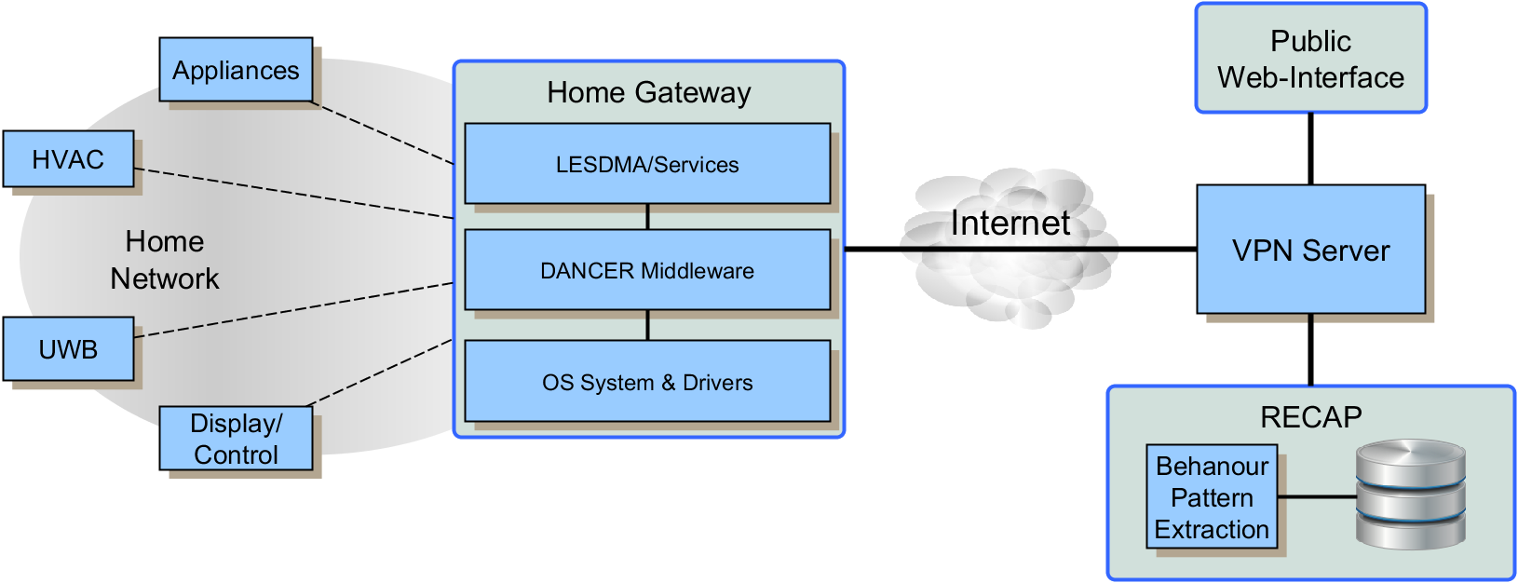
Figure 1: The Architecture of the DANCER System.

Figure 1 describes the architecture of the DANCER system. At the core, is the local energy saving decision maker (LESDMA), located inside the Home Gateway (HG). The LESDMA receives multiple streams of information via the home network about the occupants’ energy consumption behaviours and end-users energy-related preferences. Specifically, Zigbee enabled sensors are utilized to measure gas and electricity consumption, smart plugs are used to capture data about appliance use, ultra-wideband (UWB) records occupancy and activity data (i.e., whose home and which rooms they predominantly occupy at various time intervals) and the in-home-display and controls generate reports about the actions a user has taken.
These multiple streams of information are used by the LESDMA to perform the reasoning required to implement automated energy saving actions This automation functionality is based on a set of policy rules that follow the format: IF {conditions} THEN {action}. For instance, it might be apparent from the data that some rooms are rarely used, accordingly the following energy saving policy could be implemented: IF {a room is unoccupied for more than 60 minutes} THEN {reduce heating via the Thermostatic Radiator Valve}. However, should end users consistently opt to override such an action then this information will be fed back to the LESDMA and this policy would be deleted to avoid the end-user rejecting the system. It is anticipated that this automated aspect of DANCER may help consumers effortlessly save money on their energy bills by performing energy saving actions for them.
The LESDMA also uses the multiple streams of information to provide feedback to users about their total and historical consumption in both energy (kWh) and monetary (£) terms, as well as the disaggregated cost of each monitored appliance. Such information can be accessed via a visualized information display placed in the home and/or a smart phone application and/or an internet browser. This will equip the end user with the information they need to more readily understand their households’ energy profile, so that if desired, they can make informed decisions about how to reduce their consumption.
The HG distributes the information collected via a public UDP Virtual Private Network (VPN Connection to a central storage component named Remote Energy Consumption Amalgamation Point (RECAP).The HG is able to connect over the internet to a public UDP-based Virtual Private Network (VPN) connection, which allows people to securely access local Zigbee network while outside home. This VPN connection allows access to a central storage component named Remote Energy Consumption Amalgamation Point (RECAP), which has two major functions in the DANCER system. Firstly, it collects data on energy-related behaviours of occupants and saves the data into a secure database. These are collected by the various sensing modules deployed around the residence (e.g when the user performs an action on each specific monitored device and what are the environment parameters at that point). Additionally, by using advance data mining techniques, RECAP can provide occupants' energy use habits and predict long term/short term gas and electricity consumption. Furthermore, through real-time analysis of the data from different wireless sensors: UWB radar and energy consumption sensors, occupants' behaviour and the operation of households’ appliances can be specified. The latter is performed within LESDMA that will enable automatic decision making to take actions, such as turning on/off radiator valves, lights, TV, etc. In order to be able to carry out real-time processing of big sensor data, RECAP applies a Hadoop, Spark, Non_SQL database (RRDtool), and SQL database (Oracle) architecture, which is shown below in Figure 2.

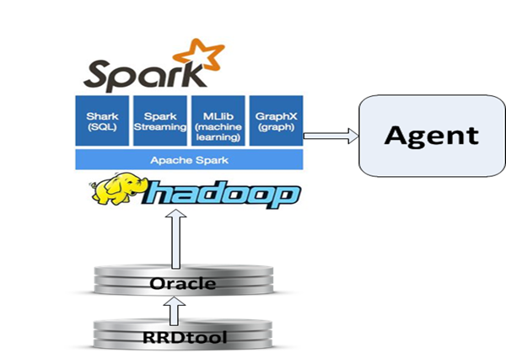
Fig. 2. Architecture and working flow of RECAP

At London South Bank University, a mini Hadoop computer cluster is constructed with 5 computers for parallel computing to deal with big sensor data. Spark is applied for machine learning and provides the agent with real-time analysis results for Energy-saving decision making.

Inferring Behaviour from Multiple Sensors

To achieve the aim of saving energy without change users’ habits, the DANCER system needs to automatically control appliances in houses and predict users’ behaviour. One problem is that it is very difficult to infer users’ energy consumption behaviour from meter data. Figure 4 (shown below) illustrates an example of an electricity and gas demand profile from an individual household where the data was recorded every 5 minutes. As is evident from Figure 4, it is clear that energy consumption is transient and that rates of energy use vary dramatically throughout the day. Although one domestic appliance may use less than 1 kWh per day, if demands from several appliances occur at the same time, they can produce a peak demand of several kilowatts. For example, the peak electricity consumption is 4.3kw at 14:20. Thus, from the meter data alone, it is not possible to decipher which appliances are being used. This is problematic because without knowledge about past appliances used (what & when) it becomes impossible to predict future behaviour.
To enable a more detailed understanding of the occupants energy use from the meter data, we designed a data appliance matching experiment (referred to as DAME), whereby residents recorded their use of household appliances using a time-use diary. Such methodology is typically utilized for gathering information about activities (when, what) and their durations (Gershuny, 2011). Evidently, it is not realistic to expect residents to indefinitely record their appliance usage. However, by matching occupants self-reported use with the consumption data we were able to (a) derive appliance signatures and (b) gain a more detailed understanding of occupants energy consumption behaviours that could be utilized to inform the development of DANCER. Accordingly, we asked two sets of households to record their appliance use over 48 hours, once in the winter and once in the summer. The appliances we asked residents to complete time use diaries for, were those that residents reported were used most frequently.
Figure 4, depicts this information using a Gantt chart to show which appliances were used at any one time in house A. Figure 5 shows the daily electricity and gas demand profiles in the same house. From these two figures, we can establish the relation between the households' activities and their energy demand and consumption.
For example, the data from the activities diary shows that at 14:20 occupants were using the washing machine, tumble dryer, and television. This activity is visible in the consumption profiles where we can observe a high demand of electricity is required for the washing machine or tumble dryer (about 2kw for each, from 13:00 to 15:40) and if these two appliances are used at same time a peak demand occurs (4.3kw at 14:20 on 13 January 2014). From both the activities’ diary and electricity meter data, we also know the duration of washing is about 1 hour and 10 minutes. Therefore, by using these two sources of data together, we are able to derive what users are doing and what they will do.

6am ----------------------------Midday------------------------------6pm-------------------------11pm
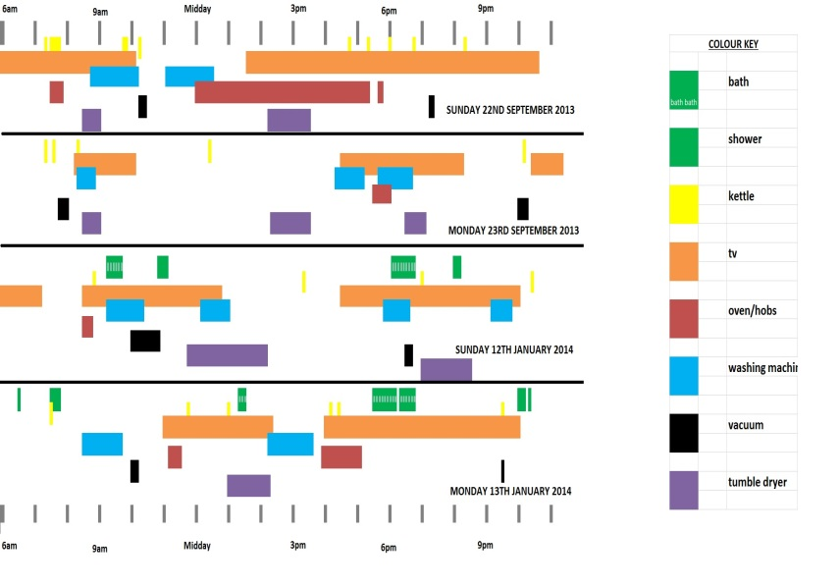
Colour Key
Monday 13/01/14
Sunday 12/01/14
Monday 23/09/13
Sunday 22/09/13
Tumble Dryer
Vacuum
Washing machine
Oven
TV
Kettle
Shower
Bath
Fig. 3. Example of diaries of activities
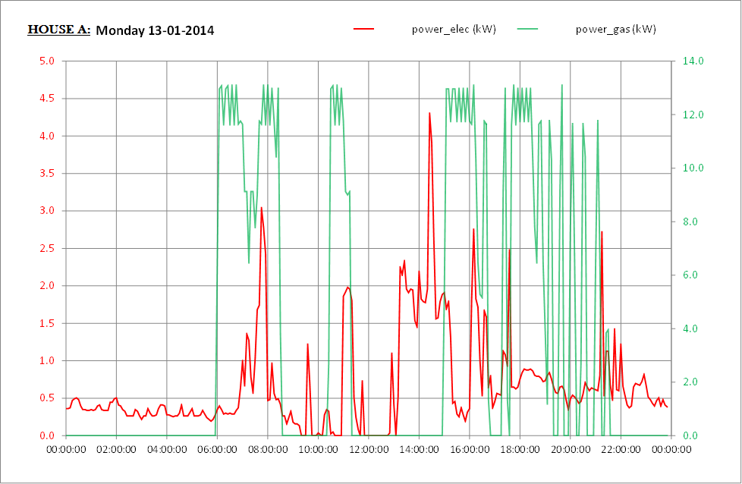

Fig. 4. Daily electricity and gas demand profiles

However, as noted earlier, it is neither realistic nor practical to expect residents to indefinitely record their appliance usage. To overcome this problem, we infer a model of human behaviour from multiple channels of information obtained from different wireless sensors: UWB radar and energy consumption sensors and it will be integrated into DANCER system in the future. There are four major steps in our model.

- Define set of activities and build a knowledge repository of activities.
- Data acquisition (occupants’ positional information, energy consumption data).
- Appliance feature extraction.
- Inference and learning.

Step 1. Define set of activities and build a knowledge repository of activities.
In order to define a set of activities, it is first necessary to capture historical data from each household before assigning these an activity code. Our activity codes are derived from UK’s national time-use studies (ONS, 2000), which has used time use studies from the UK to generate a comprehensive list of energy orientated activities that are clearly defined (see Table 1). Through gathering the energy consumption related data and assigning it a code, we are essentially building a knowledge repository which contains statistical information about the likelihood of an activity occurring at a certain time for each household with a DANCER system. For example, for X household there is 5% possibility for the cooking activity for main dinner happening between 4pm to 5pm and a 55% possibility between 6:30pm to 7:30pm. The average cooking time is 1 hour.

Table 1: part of an energy-oriented set of activities
Activity | Definition | ONS codes
cooking | cooking, preparing food & drink, washing up | 31
washing | showering, bath | 03
laundry | laundry and drying | 33
cleaning | cleaning, vacuum | 31
watching TV | watching TV | 82
playing games | playing games on console, computer, tablet, smartphone | 733
computing | using computer, | 372

Step 2. Data acquisition (occupants’ positional information, energy consumption data).

Within the DANCER system, RECAP collects real-time data, obtained from multiple sensors (temperature, smart thermostat smart plug, meter reading) and radar data through VPN. The current DANCER system is comprised of three temperature sensors, one humidity sensor, five smart plugs, one boiler detecting sensor, one electricity power meter sensor and one gas meter reading sensor. The data from the sensors is collected at 30 second intervals. Smart plugs are used to measure the power consumption from the most commonly used appliances, for example TV, fridge, washing machine, kettle, etc. The radar data is collected with 1 second resolution and is used to track people’s movements.

Step 3. Appliance feature extraction

Energy disaggregation is used to distinguish individual appliances from the aggregated electricity signal. For this to occur, the DANCER system employs pattern recognition approaches (Hagras, 2004) whereby the extracted information is compared to appliance signatures to identify an event associated with the operation of an appliance.

Step 4. Inference and learning

The final step is to infer occupant’s behaviour and predict what he/she will do. With real-time occupants’ positional information, energy consumption data, and time stamping, DANCER will be able to understand and identify occupants’ behaviours and ultimately predict future actions using historical data analysis. Further details of how this will be achieved are presented below.

Ultra-wideband (UWB) adapted sensors

UWB has emerged as one of the most promising technologies for indoor locating and sensing, making use of its distinctive properties including extremely low power transmission levels, large channel capacity, low complexity, low cost and high range resolution capability (Gezici, 2005; Yang, 2004). Impulse Radio UWB communication systems transmit very short duration pulses, resulting in the production of very high bandwidth signals. The short duration of the pulses allows a high level of accuracy with centimetre-level ranging resolution and unmatched performance in multipath environments (Ghavami, 2004). Multiple studies can be found in the literature focussing on ranging (Yang, 2004), location and tracking algorithms (Gezici, 2005; Seco, 2009).
In project DANCER, UWB will be used to identify real-time occupancy and activity, i.e., the number of people in a particular house/room and the movements of them at each time point.

Our setup employs a commercially available hardware. The UWB radar module, with a bandwidth of 3.1-5.3 GHz, comprises one TimeDomain PulsON P410 module board and two Broadspec antennas, one for transmission and one for reception. The received signal is sent to a host PC for data processing. The nominal pulse repetition frequency for the system is 10 MHz and the default gain of the system corresponds to the peak emission power permitted under the US Federal Communications Commission (FCC) rules.

The developed UWB system has recently been undergoing a case study trial in a one bedroom flat. The flat includes a large living room, a kitchen, bathroom and a bedroom (Figure 5). In order to cover the movement in the entire house, the radar module has been placed in the corner of the living room, shown with a red circle in the below figure.

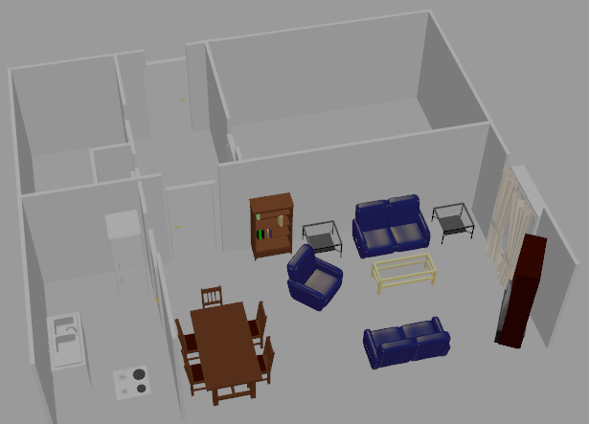

Fig. 5. Radar set-up sketch and house plan. The red circle indicates the position of UWB radar module.
The optional parameters of the radar module, such as the required distance range to be covered can be adjusted depending on the size of the building. In this case study, a distance range of 10 meters was set. Figure 6 shows an example of movement detected inside the house, indicating a moving person walking away from the living room towards the kitchen during the evening.
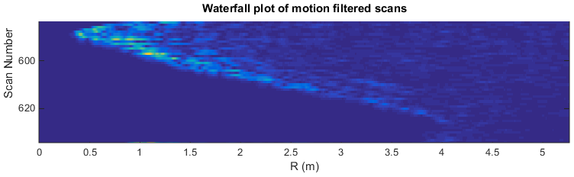

Fig. 6. Example of movement detection through UWB scan, red and green circles indicate the position of the user in the living room and kitchen, respectively.

An Illustrative example of human behaviour:
Let us consider an example of a person moving from their living room to the kitchen at 7 pm. The DANCER system recognises the movement and notifies the system of the person’s new location and the time stamp is recorded. The smart system then makes a decision depending on whether or not a change in the gas meter reading is recorded and by referring to the usage history data of the consumer. If the users past activity (stored in the knowledge repository) indicates that they often start cooking at this time of day, and an increase in the gas meter reading is viewed, the system would infer that the consumer has started cooking for dinner. Past activities indicate that the person spends an average of 1 hour preparing the dinner, hence the system sends this information to the decision making agent (LESDMA) to make a decision. LESDMA would then reach a decision about turning off the lights and the heater in the bedroom.

What does success look like for a smart system?
But what does success look like for a smart energy management system? Clearly, the main evaluative criterion is that DANCER should fulfil its primary objective of reducing domestic energy consumption. However, as this is a multidisciplinary research the evaluative criteria vary according to discipline. In what follows we provide details about the criteria that are important from each perspective.

The Social Scientist Perspective

User acceptance and engagement

From a social science perspective, if DANCER is to operate as intended, then it is vital that people welcome DANCER into their homes. For this to be achieved, users need to perceive that they could benefit from one or more of the concepts embedded in the system. Indeed, survey findings suggest that people are open to the opportunities afforded by DANCER. Specifically, 89.4% of participants (where the total sample size was 179) responded positively to the concept of disaggregated feedback, 79.9% liked the idea of unused appliances being automatically turned off, and 82.7% welcomed the idea of being able to turn appliances off remotely (Buchanan, 2014). A series of focus groups revealed similar findings with people responding positively to both the ideas of feedback and automation (Buchanan et al., in prep). For example, one respondent commented, “Give me the information, let me analyse it myself, I can see which appliances are consuming the most power…”, while another said in reference to the concept board that centred around automation, “I think it’s quite good for when you’re not at home, holidays or at work…”. Of course, aside from liking the concepts people must also be willing to engage with the system itself. To avoid end users rejecting DANCER, it should be both appealing and intuitive to use. This is important to ensure that end users are capable of operating the system so that they can benefit from the features that it offers. In particular, if the feedback component is to help users reduce their consumption then it is vital that they engage with the information provided (see also Buchanan, Russo & Anderson, 2015). Moreover, if users do not feel that they can confidently use DANCER then they may not be willing to entrust the system to manage their energy use. While people are open to the idea of automation it is important for them to feel that they are still in control and can override the system should they want or need to (Buchanan et al., in prep).

Rigorously testing the energy reduction aspiration
It is important to demonstrate, beyond reasonable doubt, that DANCER can significantly reduce energy consumption. To ascertain whether this is the case, it is necessary to conduct a robust experiment. Whist extensive guidelines have been published about how this can best be achieved (e.g., Cappers et al., 2014), there are time and budget constraints that prevent us from achieving the ultimate gold standard of evaluation - a large scale (1000 or more), long-term (spanning several years), randomized control trial (RCT). Thus, given the available resources, in the long-term we plan to recruit a relatively moderately sized sample to participate in a short term (spanning several months) randomized control trial. Evidently, before such a trial is undertaken, it is important to pilot the system on a smaller scale using case studies to ensure that any issues with the system are identified and resolved before deploying the system to a larger number of households. Piloting the system in this way will also enable us to derive an initial estimate of the effect size of the system (i.e., whether it will reduce energy substantially or moderately). This effect size can then be used to identify the sample size needed for the RCT.

To minimize some of the variation in energy consumption we will recruit UK participants from a pool of flats that were all built within the last 20 years, and thus are relatively homogenous in terms of building materials and lay-out. Of the homes we recruit, we will randomly assign households to one of three conditions, whereby they will either receive the fully functioning DANCER system (feedback, enhanced controls, and automation), or a partial version of the DANCER system (which will not include the automation aspect) or a basic version of the system whereby occupants will simply receive feedback about their consumption. The last condition described is equivalent to the UK governments’ smart metering initiative whereby 53 million domestic properties will be offered an in-home-display which will provide householders with information about their energy consumption. As such, this condition constitutes our control condition. Regardless of the condition that households are assigned to, we will start the experiment by monitoring occupants’ energy use for approximately one month in order to establish a “normal” baseline. After this initial monitoring period, regardless of the condition to which they have been assigned, all households will be provided with some energy saving advice and set the challenge of trying to reduce their energy use by 20%. After 2 months, we will then change the condition to which participants have been assigned. For instance, those with the fully functioning system will be assigned to the control condition, while those in the control condition will receive the partial system and those that previously had the partial system will receive the full system. Variations in seasonality (i.e., external temperatures) will be taken into account to ensure that reductions in consumption are a function of the condition that homes have been assigned to.

Throughout the trial we will monitor the households’ consumption and will select a subset of homes to participate in interviews in order to gather more detailed information about end users experiences. All respondents will receive short surveys both before and after participating in the trial(s). This will allow us to measure key variables that may change as a result of participating in the trial and/or may have a bearing on the effectiveness of DANCER (e.g., financial and environmental motives, technology readiness, energy consumption habits, awareness and knowledge of cost and consumption of energy use). By supplementing our objective consumption statistics with the richer data gleaned from surveys and interviews we may be able to ascertain not only if DANCER reduced consumption but also if it did, how it achieved this and if it did not, what the barriers were.

Such a design will ultimately enable us to establish what extent DANCER may reduce energy consumption by, but also if the fully functioning DANCER system is superior to either a partially functioning system or to a control condition (i.e., the normal household energy management set up). The use of an adequate control condition is particularly important in the context of domestic energy consumption for two reasons. First, researchers have found that Hawthorne effects, whereby participants change their behaviour simply as a result of being involved in a research study, can reduce electricity use by 2.7% (Schwartz et al., 2013). Second, we need to ascertain whether DANCER really is a cost effective solution. If either the partially functioning system condition or the control condition results in significantly larger energy savings, then this would suggest that the system in its entirety may not be the most cost effective home energy management solution.

The Engineering Perspective

Computer Science & Electronic Engineering

Drawing on existing literature from the Information and Communications Technology research community, we were able to identify four evaluative characteristics that are deemed important for the success of a Home Energy Management System (HEMS). First and foremost, the HEMS should be effective, meaning that it should be able to perform its tasks in accordance to the goal and requirements requested of it (Weiss & Kleiminger, 2011). Second, it should be designed from an ecological perspective. According to Saito (2013) this entails the following: (i) Minimizing the cost of the software and hardware, without compromising the systems soundness and service function. (ii) Ensuring that the HEMS helps consumers manage their energy consumption via the use of visualized displays, and controls for switching appliances on and off, without the HEMS requiring a high level of power to operate. (iii) Considering maintainability and ease of use to ensure that end-users can use the HEMS. (iv) Effectively managing the big data generated by the multiple sensors and actuators that comprise the HEMS. Third, the interoperability and modularity of the HEMS should also be considered. In other words, the components of the system should be capable of working both in isolation and together without the need for extensive configuration processes. According to Arnold et al. (2013), interoperability should be defined not only in terms of home network devices and the compatible technologies, but also in terms of external connectivity and manageability. Moreover, modularity should characterize the overall system architecture and allow components to be deployed flexibly in a centralized or distributed manner, without the requirement of updating the core system functionality. Finally, multiple sources note that it is vital for HEMS to have context-awareness (e.g., Iksan, Supangkat, & Nugraha, 2013; Raja Vara Prasad & Rajalakshmi, 2013). In other words, the system should have the ability to adjust the actions and decisions it executes on the basis of the information it has received.

Beyond the evaluative criteria that have emerged from the ICT literature, there are some additional criteria that are specific to the DANCER project. At the outset, one of the first criteria, we decided upon was that DANCER should be flexible in its capabilities so that we were not restricted by the type of data that could be collected and the energy saving features we could implement. This led us to develop our own prototype rather than utilizing a combination of existing HEM products. While there are obvious advantages to such an approach, including the accumulation of knowledge that may be of interest to academics and industry, a disadvantage is that it increases the chance of encountering deployment issues. Accordingly, some additional evaluative criteria must also be taken into consideration.

Firstly, the system must be robust, i.e., it should be resilient against failures and should have the ability to resolve issues should they arise. Not only, will this ensure end users place trust in the system but may prevent the project’s progress from stalling indefinitely due to wasted man hours spent troubleshooting. Secondly, the system should be scalabale, in terms being able to handle a larger number of home network devices in more complicated scenarios. Such a feature is important as it enables the system to be deployed and tested in different locations with different requirements. For example, the advanced functionalities can be removed to allow examination of a placebo effect of DANCER, where only the equipment needed for monitoring consumption is deployed. Thirdly, the DANCER system should exhibit operational efficiency. While the system involves multiple operations (e.g., user requests, behavioural pattern extraction, monitoring from multiple sensors) these should run smoothly to ensure the system does not become unresponsive and thus degrade the user-experience.

The Signal/Communications Engineering Perspective

Within the DANCER project, the specialists working on the UWB aspect of DANCER also have their own evaluative framework. These criteria are related to two systems that work together to help reduce energy consumption. These systems are energy consumption sensing and human sensing.

For energy consumption sensing it is important that the hardware that is deployed is compatible with the environment. For instance, monitoring the outside temperature may involve ensuring equipment has the necessary waterproofing requirements. Such hardware, should also be relatively autonomous. In other words, it should use collocated batteries that can last for months without needing to being charged and/or replaced.
Moreover, given the trend towards wireless solutions in the latest technological products, it is important that DANCER uses a wireless system, hence the interference from and to existing communications system needs to be assessed and to comply with existing regulations.

For human sensing, the system should be capable of extracting information about whether people are present or absent and what they are doing. Accordingly, the system needs the following spatio-temporal properties: presence, count, location, track and identity, as well as the capability to overcome a variety of obstacles that may prevent human sensing. Common obstacles can be grouped into five broad classes: 1. Sensing noise, such as thermal noise, that may be alleviated through well-known hardware- and sensor-design considerations. 2. Environmental variations - unexpected or sudden changes in environmental conditions are some of the most common sources of errors that occur in real-world scenarios; example of a room where furniture has been removed, added or re-arranged. 3. Similarity to background signal - clearly, separating a person from the background signal is a core requirement for human-sensing. However, this is often not possible outside a laboratory setting, as background signals in the real world can grow arbitrarily complex. In domains, such as with ranging sensors like radars, the presence of unwanted signals with the correct frequency spectrum or timing characteristics (due to multipath, for instance) can often fool the system into producing phantom detections. 4. Appearance variability and unpredictability - people have non-rigid bodies which can be arranged in any number of poses (Zatsiorsky, 1997). To further complicate matters, this appearance-space greatly increases as we consider different types of clothing. Finally, people can also behave unpredictably, moving in paths that may change on a whim, and thus present an enormous challenge to localisation and tracking systems. 5. Similarity to other people - in performing some tasks, such as tracking or person identification, the main challenge to be overcome is the high degree of similarity amongst people. Moreover, physical limitations of the sensors themselves often lead to a further loss of personally-identifying information in the acquired signal.

Testing the DANCER system
To develop the DANCER system as a product and to ensure that its characteristics are supported by the system, we have been adopting the software release life cycle methodology for testing and developing. This includes the pre-alpha, alpha and beta stages of software release. The pre-alpha stage includes the initial design and implementation, while during the alpha stage the initial testing of the software takes place. Once the alpha stage is over, no additional features are added, thus not endangering the stability of the forth-coming release. Finally, in the beta stage further bug fixing and testing takes place, before the software is finally released.
By following the development cycle and using tools such as the Debian package-repositories, a more flexible administration is made possible. This involves remote access in the deployed gateways, version control of the installed software, remote update operations in order to make sure that all components are always up to date, as well as logging and debugging operations. The prototype system has already been deployed in the lab environment, as well as in a single one bedroom flat, and all major components are currently operational and stable. Various tests have been performed to evaluate the smooth operation of the system, measure its response times and resource utilization (Vastardis et. al, 2014) and finally to ensure that the user interface platforms provide the necessary functionality for controlling it.

Summarizing Success
While each discipline has its own perspective in what success looks like for a smart system, it is not hard to find common ground, as collectively the research team aspires to deliver a sustainable and cost-effective system that has the capability to reduce energy consumption. Moreover, the evaluative criteria from one perspective can be seen as complimenting the evaluative criteria of another approach. For example, the social scientist’s requirement to compare a fully functioning version of the DANCER system to a partially functioning and placebo system, is clearly compatible with the engineers’ requirement that the system must be scalable (i.e., aspects of the system can be added or removed as required). Moreover, given the shared goal perhaps inevitably some of the evaluative criteria overlap. In particular, both the engineering and social science perspective recognise how important it is for the end users to have positive experiences when using the DANCER system. Of course, there are differences in considerations of how this might be achieved. For example, the social science perspective stresses that DANCER should be appealing and intuitive to use, while the engineering perspective contends that batteries should not require frequent recharging and that the system should be capable of running multiple operations so that end users requests can be met without delay. Nonetheless, through bringing these different but compatible perspectives, each discipline contributes to helping deliver a more carefully thought through product.

Conclusion
The innovative smart system presented in this paper attempts to promote smart metering and intelligent agent applications to help understand customer energy consumption patterns, and ultimately reduce their energy consumption. Indeed, the main goal is to motivate users towards an active engagement with their energy management. The key to achieving these reductions may be to limit the user interaction requirements with the system, through an intelligent automated energy management mechanism. As we have demonstrated in this paper, this may be achieved by synthesizing information from different sensors to infer a model of human behaviour. However, the success of our system in its energy reduction aspirations remain to be seen until the system is first piloted in a small number of households and then tested in a larger scale trial. Here, we presented an overall introduction to the DANCER system and described some examples of inferring behaviours from multiple sensors.

Acknowledgements

This research was supported by the Engineering and Physical Sciences Research Council UK (Grants: EP/K002643/1 and EP/K002473/1).

References

Abrahamse, W., Steg, L., Vlek, C., & Rothengatter, T. (2007). The effect of tailored information, goal setting, and tailored feedback on household energy use, energy-related behaviors, and behavioral antecedents. Journal of Environmental Psychology, 27(4), 265-276.

Anderson, B. (2014) The Time and Timing of UK Domestic Energy DEMAND. Keynote paper presented at the 2014 Otago Energy Research Centre Symposium, University of Otago, Dunedin, New Zealand, 28/11/2014. Avaliable from: http://www.slideshare.net/ben_anderson/the-time-and-timing-of-uk-domestic-energy-demand

Arnold, D., Sankur, M, Auslander, D.M. (2013). The next generation energy information gateway for use in residential and commercial environments. Power and Energy Society General Meeting (PES), 2013 IEEE , vol., no., pp.1,5, 21-25 July 2013. doi: 10.1109/PESMG.2013.6672625

Buchanan, K., Russo, R., & Anderson, B. (2015). The question of energy reduction: The problem (s) with feedback. Energy Policy, 77, 89-96.

Buchanan, K. (2014). Will People Like DANCER? Internal talk, University of Essex, UK.

Buchanan, K.E., Banks, N., Preston, I., Russo, R., & Anderson, B (in prep). The Public’s Perception of Smart Meters: Threats and Opportunities.

Cappers, P. (2014). Quantifying the Impacts of Timebased Rates, Enabling Technology, and Other Treatments in Consumer Behavior Studies: Protocols and Guidelines. Lawrence Berkeley National Laboratory: Lawrence Berkeley National Laboratory. LBNL Paper LBNL-6301E. Retrieved from: http://escholarship.org/uc/item/9wr4t18

Carbon Trust (2012). Technology Innovation Needs Assesment. Non Domestic Buildings Summary Report. Retrieved on 17/01/2015 from http://www.carbontrust.com/media/218006/tina-non-domestic-buildings-energy-efficiency-summary-report.pdf

Gershuny, J. (2011). Time-Use Surveys and the Measurement of National Well-Being. Oxford, UK, Centre for Time-use Research, Department of Sociology, University of Oxford.

Gezici, S., Tian, Z., Giannakis, G. B., Kobayashi, H., Molisch, A. F., Poor, H. V., & Sahinoglu, Z. (2005). Localization via ultra-wideband radios: a look at positioning aspects for future sensor networks. Signal Processing Magazine, IEEE, 22(4), 70-84.

Ghavami, M., Michael, L. B., & Kohno, R. (2004). Ultra wideband signals and systems in communication engineering. John Wiley&Sons Ltd.

Gill, Z. M., Tierney, M. J., Pegg, I. M., & Allan, N. (2010). Low-energy dwellings: the contribution of behaviours to actual performance. Building Research & Information, 38(5), 491-508.

Hagras H., V. Callaghan, M. Colley, G. Clarke, A. Pounds-Cornish, H. Duman. (2004) Creating an ambient-intelligence environment using embedded and agents, intelligent systems, IEEE, 19 (6)

Iksan, N.; Supangkat, S.H.; Nugraha, I.G.B.B. (2013). Home energy management system: A framework through context awareness. ICT for Smart Society (ICISS), 2013 International Conference on , vol., no., pp.1,4, 13-14 June 2013 doi: 10.1109/ICTSS.2013.6588118

Janda, K. B. (2011). Buildings don't use energy: people do. Architectural Science Review, 54(1), 15-22.

Morley, J., & Hazas, M. (2011). The significance of difference: Understanding variation in household energy consumption. Proceedings of the ECEEE 2011 Summer Study. Retrieved from http://www.comp.lancs.ac.uk/~hazas/Morley11_SignificanceofDifference-ECEEE.pdf

Monahan, S., & Gemmell, A. (2011) How Occupants Behave and Interact with Their Homes, NHBC Foundation NF35, retrieved 15/12/2014 from: http://www.nhbcfoundation.org/Publications/Research-and-Report/Improving-sound-insulation-measurements-in-homes-and-other-buildings-RR1

ONS (2000). Survey on Time Use: Activity Coding List. London, UK, Office of National Statistics (ONS) & Eurostat.

Power Table, retrieved 21/01/2015 from http://www.wholesalesolar.com/StartHere/HowtoSaveEnergy/PowerTable.html

Raja Vara Prasad, Y.; Rajalakshmi, P. (2013). Context aware building energy management system with heterogeneous wireless network architecture. Wireless and Mobile Networking Conference (WMNC), 2013 6th Joint IFIP , vol., no., pp.1,8, 23-25 April 2013. doi: 10.1109/WMNC.2013.6548976

Saito, N. (2013). Ecological Home Network: An Overview. Proceedings of the IEEE , vol.101, no.11, pp.2428,2435, Nov. 2013. doi: 10.1109/JPROC.2013.2277782

Schwartz, D., Fischhoff, B., Krishnamurti, T., & Sowell, F. (2013). The Hawthorne effect and energy awareness. Proceedings of the National Academy of Sciences, 110(38), 15242-15246.

Seco, F., Jimenez, A., Prieto, C., Roa, J., & Koutsou, K. (2009). A survey of mathematical methods for indoor localization in Intelligent Signal Processing, WISP 2009. IEEE International Symposium on, Aug 2009, pp. 9 - 14.
Vastardis, N., Adjrad, M., Buchanan, K., Liao, Z., Koch, C., Russo, R., Yang, K., Ghavami, M., Anderson, B., Dudley, S. (2014). A User-Centric System Architecture for Residential Energy Consumption Reduction, IEEE Online Conference on Green Communications (Online GreenComm'14).
Van Houwelingen, J. H., & Van Raaij, W. F. (1989). The effect of goal-setting and daily electronic feedback on in-home energy use. Journal of Consumer Research, 98-105.
Weiss, M., & Kleiminger, W. Smart Residential Energy Systems – How Pervasive Computing can be used to conserve energy. Proceedings of Smart Energy Strategies Conference 2011, Zurich, Switzerland, September 2011.
Yang, L., & Giannakis, G. B. (2004). Ultra-wideband communications: an idea whose time has come. Signal Processing Magazine, IEEE, 21(6), 26-54.

Zatsiorsky, V. M. (1997). Kinematics of Human Motion. Human Kinetics Publishers.

