**Title**  
[Innovating and evaluating education for people with kidney disease](http://researchopen.lsbu.ac.uk/cgi/users/home?screen=EPrint::View&eprintid=1647)

**Abstract**

A Community Kidney Service has been running since 2016 in four Clinical Commissioning Groups in East London. The service aims to improve primary care identification, coding and management of CKD, identification of progressive CKD from monthly surveillance of estimated glomerular filtration rate (eGFR) results, development of a single pathway from primary to secondary care with rapid access to specialist advice provided by e-clinics and promotion of patient self-management. A long term anticipated outcome of the service will be a reduction in incident end-stage kidney disease (ESKD) growth in East London.

This paper focuses on the patient education and self-management aspects of the service and describes how these have been developed, implemented and evaluated. Almost 350 patients with mild-to-moderate (category G3a/G3b) CKD have attended either one-to-one or group education sessions since 2016 and there has been positive patient feedback. However there remains a paucity of evidence that supports self-management for CKD in terms of changing health behaviours, so further evaluation and research is necessary.

**Key words**  
Chronic Kidney Disease; Education; Self-management; Conversation map

**INTRODUCTION**The prevalence of Chronic Kidney Disease (CKD) categories G1-G5 has been estimated to be between 11 to 13% of the adult population, with the majority of people having category G3a or G3b CKD which is usually asymptomatic (Erkardt 2013). Most people with category G3a/G3b CKD are managed in primary care although up to 1/3 of people with CKD are unknown, with results of the national CKD audit showing that 30% of 256 000 patients in primary care with biochemical CKD did not have a CKD code (Kim et al 2017).

Improving the identification and management of CKD is an important objective for CCGs and hospital Trusts. In East London, there are high rates of hypertension and diabetes, and also high levels of social deprivation often within diverse communities. These populations risk higher than average progression to end-stage kidney disease (ESKD), and higher rates of mortality and morbidity due to associated cardiovascular disease.

A new service, the East London Community Kidney Service aims to improve care, understanding and experience for patients with CKD in East London. The components of the service are shown in Box 1.

Box 1. Components of East London Community Kidney Service

a) Implementation of bespoke IT tools to improve primary care identification, coding and management of CKD, using cluster based review alongside performance dashboards

b) Use of trigger tool alerts to identify progressive CKD from monthly surveillance of estimated glomerular filtration rate (eGFR) results across East London

More detail about a) and b) at <http://www.qmul.ac.uk/blizard/ceg/resource-library/the-renal-health-service>

c) Development of a single pathway from primary to secondary care with rapid access to specialist advice provided by e-clinics within a shared primary care record. Nephrologists triage patients into specialist out-patient renal clinics where necessary.

More detail at <https://bartshealth.nhs.uk/renal/> vCKD for clinicians

d) Provision of patient education about mild-to-moderate CKD to promote patient self-management

A long term anticipated outcome of the service will be a reduction in incident ESKD growth in East London. The project became live in Tower Hamlets during March 2016, and has since been rolled out to City and Hackney, Newham and Waltham Forest Clinical Commissioning Groups (CCGs). These four CCGs provide care for almost 1 million adults in East London.

This paper focuses on the patient education aspects of the service and describes how the education service that focuses on patient self-management has been developed, implemented and evaluated.

**LITERATURE REVIEW**Self-management of chronic disease involves an individual taking responsibility for the day-to-day care of their illness. In mild-to-moderate CKD (category G3a/G3b), there is the potential to slow the progression of the disease, by individuals being supported to make changes to their lifestyle (Novak et al. 2013). However, knowledge of CKD among those with the disease, is low (Finkelstein et al. 2008), with people reporting a lack of understanding of the importance of self-management (Thomas 2012). A recent Think Kidneys survey (2014) showed that knowledge of kidney disease within the general population is also low. They found that approximately half of the population in Great Britain did not think their kidneys made urine (Think Kidneys/IPSOS Mori 2014).

An integrative review of self-management interventions for category G1–G4 CKD could not draw conclusions on the efficacy of CKD self-management interventions (Welch et al., 2015), mostly because of the lack of well-designed trials with appropriately powered sample sizes, well-tested instruments, and clear and consistent reporting of results. A meta-analysis (Lin et al 2017) of randomised-controlled trials only included one study (Blakeham et al 2014) on self-management in category G3 CKD, whilst only another three systematic reviews of self-management in CKD have been published. Mason et al.’s (2008) systematic review of educational interventions included only randomised controlled trial (RCT) up until 2007 and only one study in this review involved people who did not require dialysis, whilst Reid et al. (2011) only focused on interventions for people receiving haemodialysis. Bonner et al’s review (2014) focussed on critically appraising self-management interventions for adults with CKD categories G1–G4. The review assessed whether these interventions improved adherence, knowledge, CKD progression, health literacy, self-efficacy, health-related quality of life and/or hospitalisations.

Bonner et al (2014) found only five studies that met the inclusion criteria for the review and found variation in the design of these studies with regard to: study length; interventions delivered; outcomes assessed; assessment instruments used and results obtained. All interventions included a face-to-face educational component and some also included telephone sessions. The intensity of the interventions delivered also varied widely, ranging from sessions several times a week to one session with six-monthly follow-ups. A wide range of professionals were employed to deliver the interventions, the most common element being that four of the studies included a nurse on their delivery team. They concluded that although the effectiveness of self-management programmes in CKD (categories G1–G4) cannot be conclusively ascertained, it is desirable that individuals with CKD are supported to effectively self-manage day-to-day aspects of their health.

There are several ways in which self-management for long-term conditions can be supported, including leaflets, films, one-to-one consultations and group education sessions, however Havas et al (2016) has asserted that there is almost no literature regarding how patients with CKD would like self-management programmes to be delivered. More work has been in diabetes care, where programmes such as X-PERT <https://www.xperthealth.org.uk/> have been developed. In diabetes education, one of the most recent education tools is the set of Diabetes Conversation Maps™, which were developed by Healthy Interactions of Chicago, Illinois, USA for use in 1-1 and group education sessions. The maps are a series of pic­torial guides through which people are engaged in discussion, sharing beliefs and experiences about their lives with diabetes. Ghafoor (2015) concluded that conversation maps are effective for diabetes self**-**managementeducation and facilitating behaviour change in people with type 2 diabetes. A systematic review (Srulovici 2017) found that although the Diabetes ConversationMap**™** holds the potential to improve patient behaviours and outcomes, current research studies have provided limited evidence for positive patient outcomes.

With regards learning and teaching styles within educational sessions, motivational interviewing (MI) uses a guiding style of consultation to promote behaviour change. MI has been shown to be more effective than simply giving advice, with an emphasis on listening to the patient’s concerns and goals (Lundahl 2010).

**METHODS  
Nursing team**The nursing team in the East London Community Kidney Service consists of one full-time clinical nurse specialist (CNS)(HR), with wide-ranging experience in delivering patient education. She is supported one day per week by a nurse consultant with an honorary contract (NT), who has extensive experience of developing and evaluating patient education programmes.

**Referral to the nursing team from the e-clinic**A weekly virtual e-clinicis delivered by consultant nephrologists who each work with a single CCG. Patients do not attend the e-clinic. With patient consent, GP referrals are reviewed in the patient’s primary care record and the nephrologist details a management plan within this record. A GP letter is generated which is also uploaded to the hospital electronic patient record. After review, patients are either referred back to the GP with advice, called for consultation with the nephrologist in the hospital or referred to the nursing team for educational input. The nursing team referral may be via an e-mail directly to the CKD CNS or by direct booking into the CNS clinic. The CNS also reviews all GP letters to ensure consistency of access to the education service. At present referral to the education service is only via the e-clinic to ensure that patients receive appropriately tailored education.

**Development of the educational approach**The educational approach aimed to build on the health messages that patients already receive in primary care. One of the authors of this paper (HR) attended four community diabetes patient education sessions to gain a better understanding of these. The other author (NT) has previously been involved in a number of projects aimed at educating patients about CKD, including the ENABLE programme <https://www.kidneyresearchuk.org/packageofinnovation>

A Patient Advisory Group was planned, but was difficult to recruit to, despite advertising both in the renal outpatients and also on-line. It is possible that recruitment was difficult, partly because we wanted to include people who were not receiving dialysis and perhaps many people with CKD do not see themselves as having a long-term condition or being a ‘kidney patient.’ On reflection, it might have been more beneficial if we had tried to recruit via primary care contacts. However, one patient from the local community did volunteer, and she was recruited to help inform the educational approach and develop educational tools. The team were confident however, that despite the little patient engagement locally, previous work (Thomas and Bryar 2012; Thomas et al 2014) had included patients and families in educational resource development.

The educational approach aims to combine fact-based teaching with motivational interviewing techniques. Content of the sessions includes the teaching of facts about kidney health/kidney disease to address an expected knowledge deficit. In addition, motivational interviewing skills were used to promote and facilitate self-management. For many patients, CKD is positioned as a complication of diabetes, hypertension or other vascular disease to reassure patients that they had not developed a separate illness and to emphasise the importance of good diabetes and blood pressure management.

The education sessions are delivered either in one-to-one consultations with the CNS in a hospital out-patient setting, or through group education sessions held in GP surgeries. The one-to-one sessions are aimed at those who are high risk of progressive CKD to ensure that such patients receive individualised information and advice. The group education sessions are aimed at those with stable CKD because they provide general information and advice. A group education session aimed at those with progressive CKD has been considered but not held as yet due to lower numbers of referrals with progressive disease. One-to-one sessions are also offered to those with stable CKD who require interpreter support.

**Development of educational tools – How to look after your kidneys***Patient Information Leaflets*An internet search did not find any resources suitable for patients with low health literacy or non-English speakers so a short leaflet was devised based on simple images. The leaflet focuses on kidney health rather than disease with the focus on lifestyle modifications that promote kidney health. Suggestions from the patient advisor were incorporated, for example the title was changed from ‘Looking after your kidneys’ to ‘How to look after your kidneys’.

The leaflet was piloted in the one-to-one consultations. It was used to structure the consultations and seemed to be well-understood by patients and families.  
 *Conversation Map*A Conversation Map was felt to be an appropriate model for CKD group education as it had the potential to promote engagement and discussion. The idea was piloted using the simple images from the Patient Information Leaflet. Both HR and NT facilitated the pilot sessions allowing observation of the interactions, and sought informal feedback at the end of the session. The group session is designed to be deliverable by one nurse and some subsequent sessions have been delivered by HR or NT alone. Patients seemed well engaged, contributing questions and sharing their experiences. Many said they had enjoyed the session and others that they were grateful for the opportunity to learn more about how they could self-manage.

*Graphics*After piloting the Information Leaflet and Conversation Map a graphic designer was commissioned to develop the illustrations further, ensuring that the resources met NHS Trust branding guidelines. The final simple patient information leaflet (Figure 1) and Conversation Map (Figure 2) are shown below.

Figure 1: The small information booklet for CKD



Subsequently a longer booklet has been written (32 pages). This incorporates the same images but includes more detail for those who want in depth information.

Figure 2: The Conversation Map for CKD



*Film*With support from a local charity (the Friends of the Royal London Hospital) a short patient film was commissioned (Figure 3). This incorporates simple health messages with a powerful patient testimony about the benefits of lifestyle modification. This is currently being translated into four local languages.

Figure 3: The ‘How to look after your kidneys’ film. Available at https://bartshealth.nhs.uk/renal

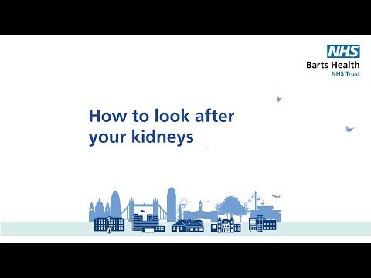

**Early evaluation**  
In November 2016 a short survey was sent to all 51 patients who had attended CKD education between April 2016 and September 2016.

The survey asked questions about usefulness of the session and also potential behaviour change as a result of attending the 1-1 or group session. The questions are shown in Figure 4.

Figure 4: Evaluation questionnaire

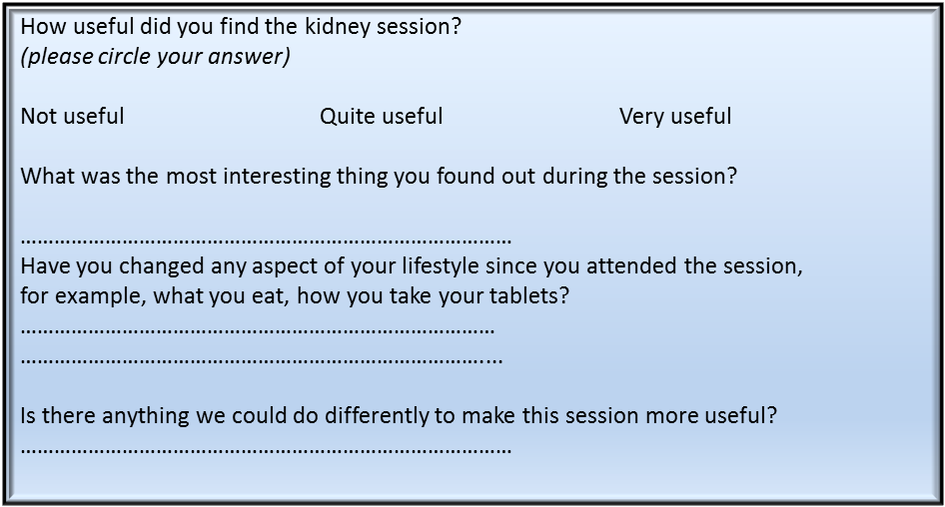

**RESULTS**

**Attendance**267 patients (74% of those invited) received education about CKD in a one-to-one consultation and a further 74 in group sessions (46% of those invited) during the 18 months from April 2016 to September 2017 (Figure 5).

Figure 5: Attendance at education sessions April 2016-September 2017



Numbers of referrals to the e-clinic have increased since the service start, as GPs become more familiar with the service. This increase led to a subsequent increase in referrals for patient education.

29% of the surveys were returned (One-to-one education sessions: 6/24 returned; group sessions: 9/27 returned). The results of the question about usefulness are shown in Box 2.   
Two patients said that they had not found the session useful with one reporting increased anxiety because he had not been aware of his CKD diagnosis. This was followed up by his GP.

Box 2: Results of survey

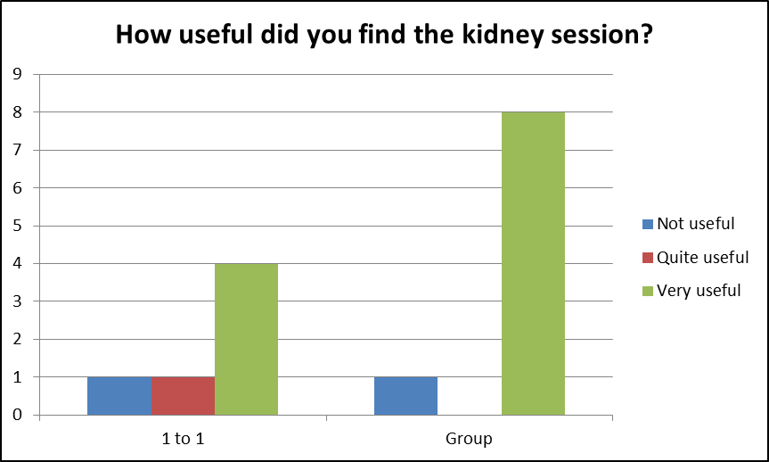

In answer to the questions, patients said:

Most replied that they found the session very useful. Other answers to questions were

What was the most interesting thing?   
*“different levels of experience on course”*

Have you changed any aspect of your lifestyle?   
*“I eliminated the foods high in salt. I stopped taking NSAID”*

Anything we could do differently?   
*“found the whole session informative and helpful”*

Additional comments suggested that people could recall relevant lifestyle factors such as reducing salt, increasing exercise and stopping smoking. Many patients stated that they had modified their lifestyle but this was not objectively measured.

**DISCUSSION**Effective self-management is essential for those with long-term conditions but there is little evidence about how best to empower people with CKD to achieve this. Access to the right kind of information is crucial, with the opportunity for discussion with others with the same condition (Patient Information Forum, 2015).

It is vital that patients are aware of their diagnosis of CKD if they are to engage in self-management but previous research has shown that GPs may be reluctant to inform patients because of fears of causing anxiety. Our experience has confirmed that not all patients are aware of their diagnosis, despite having been referred to the e-clinic. We now ensure that all education sessions open with a discussion about diagnosis and the implications of this.

The East London Community Kidney Service has developed new Patient Information Resources to try to deliver this. The service has found that many people do want more information about CKD, with good attendance at one-to-one sessions (including by those with English as a second language who often bring a relative to interpret).

Group sessions are less well attended, but we hope that attendance rates will improve as primary care providers become more familiar with, and promote, the service. A systematic review of education in diabetes care found that

*“group-based education interventions are more effective than usual care, waiting list control and individual education at improving clinical, lifestyle and psychosocial outcomes in people with Type 2 diabetes”* (Odgers et al 2017).

In our service, we have yet to measure outcomes, only attendance and self-reported benefits in a small sample. Attendance rates for group education sessions for diabetes can be used as a comparison: the National Diabetes Audit 2016-2017 found that attendance at structured education sessions for type 2 diabetes in the UK in 2015 was only 7% of all patients, despite over 70% being invited (NHS Digital 2017). However low rates of attendance may be due to incomplete recording of attendance data in GP electronic records.

Coates et al (2017) undertook a study on the reasons for low attendance at structured education in diabetes (including DESMOND and X-PERT programmes) and common reasons cited by over 350 patients were *'The course was too long*' (47.2%), *'I have other health problems*' (41.2%), ‘*I could not get to the venue’* (29%) and ‘*education sounds like school*’ (15%). In our service, we have tried to overcome some barriers to attendance by keeping the session to 1.5 hours maximum, holding it in a community venue (not at the acute hospital) and using language in the invitation that does not make it sound like school.

In the same study over 20% said they did not think they would gain anything from a group. As the number of referrals of patients with progressive CKD increases, bespoke group education sessions to cater specifically for people with progressive disease are planned.

Early self-reported evaluation has been positive with most people who replied finding the session useful and recalling relevant lifestyle information. However, evaluation is limited as has relied on self-reporting of behaviour change rather than measuring changes in markers such as blood pressure.

Our team has recognised the importance of including a variety of patient information materials suitable for a variety of leaning needs. A systematic review by Kim (2016) identified that in diabetes care, a range of self-management strategies for those with low health literacy, including written and verbal interventions that are empowering and have language/cultural considerations can lead to positive cognitive/psychological, **self**-care and health outcomes.

However, there is still a lack of evidence about effectiveness and patient experience of self-management in CKD. Qualitative research into patient experience of self-management is planned, with a purposive sample of 8-10 patients being interviewed about their experience of attending 1-1 or group education sessions. In the longer term, a larger study into the effectiveness of the intervention (behaviour change) requires funding.

Most mild-to-moderate (category G3a/G3b) CKD is managed in primary care and the next phase of the project includes a plan to disseminate these resources to GPs and Practice Nurses. All our copyrighted materials are freely available to download <https://bartshealth.nhs.uk/patient-information-leaflets> (scroll down to Renal Services).

We have also used the resources in community events such as World Kidney Day and the Trust Open Day where the Conversation Map has facilitated conversations about kidneys with the general public.

**CONCLUSION**The education programme within the East London Community Kidney Service is now well-established. Almost 350 patients with category G3a/G3b CKD have attended either one-to-one or group education sessions showing that this is a practical way to deliver health education about CKD. We would not do anything differently if starting again, although we recognise that more work is needed to understand the demographics of those who decline the invitation to attend for education - we then need to work harder to reach them. Although attendance rates are good compared with structured education programmes for diabetes, the impact on patient empowerment and ability to self-manage is not clear. There remains a paucity of evidence that supports self-management for CKD, so further evaluation is necessary.

**Key point sentences**

* Few renal units in the UK employ specialist nurses for chronic kidney disease
* Specialist nurses for CKD have a crucial role within the nephrology MDT, especially if the focus is patient education
* Educational resources for CKD need to be developed with patients and need to be suitable for a diverse population who have a variety of learning needs
* Conversation maps for CKD are one way in which education can be delivered in 1-1 and group education
* Further evaluation and research into educational programmes for CKD is required

**REFERENCES**

Blakeman T., Blickem C., Kennedy A., et al (2014) Effect of information and telephone-guided access to community support for people with chronic kidney disease: randomised controlled trial *PLoS One* p. e109135

Bonner A., Havas K., Douglas C., Thepha T., Bennett P., Clark R. (2014) Self-management programmes in Stages 1–4 chronic kidney disease: A literature review. *Journal of Renal Care*40(3): 194–204.

Eckardt K-U., Coresh J., Devuyst O., *et al*. (2013). Evolving importance of kidney disease: from subspecialty to global health burden. *The Lancet* **382**, 158-169.

Finkelstein F.O., Story K., Firanek C. *et al.* (2008). Perceived knowledge among patients cared for by nephrologists about chronic kidney disease and end-stage renal disease therapies. *Kidney International* **74,** 1178-1184.

Ghafoor, E; et al. Evaluation of Diabetes Conversation Map™ Education Tools for Diabetes Self-Management Education. *Diabetes Spectrum*. 28, 4, 230-235

Havas, K., Bonner, A., & Douglas, C. (2016) Self-management support for people with chronic kidney disease: Patient perspectives. *Journal of Renal Care*, 42(1), 7-14.

# Kim LG., Cleary F., Wheeler, D., Caplin B et al (2017) How do primary care doctors in England and Wales code and manage people with chronic kidney disease? Results from the National Chronic Kidney Disease Audit. *Nephrol Dial Transplant*. doi: 10.1093/ndt/gfx280

#### Kim S, Lee A. Health-Literacy-Sensitive Diabetes Self-Management Interventions: A Systematic Review and Meta-Analysis. Worldviews on Evidence-Based Nursing 13(4):324-333.

#### Lin, Mei-Yu et al. (2017) Effects of self-management on chronic kidney disease: A meta-analysis. International Journal of Nursing Studies, 74, 128 - 137

Lundahl BW, Kunz C, Brownell C, Tollefson D, Burke BL (2010) A meta-analysis of motivational interviewing: twenty-five years of empirical studies. *Research on Social Work Practice* 20(2): 137–60

Mason J., Khunti K., Stone M. et al. (2008) Educational interventions in kidney disease care: A systematic review of randomized trials. *American Journal of Kidney Diseases* 51, 933-951.

NHS Digital (2017) National Diabetes Audit, 2016-17 Care Processes and Treatment Targets: short report <https://digital.nhs.uk/catalogue/PUB30142>

Novak M., Constantini L., Schneider S. *et al.* (2013). Approaches to self-management in chronic illness. *Seminars in Dialysis* 26, 188-194.

Odgers-Jewell K, Ball L, Kelly J, Isenring E, Reidlinger D, Thomas R. (2017) Effectiveness of group-based self-management education for individuals with Type 2 diabetes: a systematic review with meta-analyses and meta-regression. *Diabetic Medicine* 34(8):1027-1039.

Patient Information Forum (2015) Is knowledge power? Using information and support to empower patients. https://www.pifonline.org.uk

Reid C., Hall J., Boys J. et al. (2011) Self-management of haemodialysis for end stage renal disease: A systematic review. *JBI Library of Systematic Reviews* 9, 69-103.

Srulovici E., Key C., Rotem M., Golfenshtein N. et al (2017) Diabetes Conversation Map™ and health outcomes: A systematic literature review. *International Journal of Nursing Studies* 70:99-109.

Think Kidneys/IPSOS Mori (2014) <https://www.thinkkidneys.nhs.uk/wp-content/uploads/2015/01/Think-Kidneys-Report-Understanding-what-the-public-know-Jan-2015-12.pdf>

Thomas N., and Bryar R. (2012). An evaluation of a self-management package for people with diabetes at risk of chronic kidney disease. *Primary Health Care Research and Development*, *14*(3), 270-280.

Thomas, N, Jain, N and Gallagher, H (2014) A quality improvement project to improve the effectiveness and patient-centredness of management of people with mild-to-moderate kidney disease in primary care. BMJ Quality Improvement Reports doi:10.1136/bmjquality.u201337.w825

Welch JL., Johnson M., Zimmerman L., Russell CL. Et al (2015) Self-management interventions in stages 1 to 4 chronic kidney disease: an integrative review

*West. J. Nurs. Res*., 37 (5) pp. 652-678