Adaptable cooling coil performance during part loads in the tropics—A computational evaluation

Chandra Sekhar a , Prashant Anand a,∗ , Stefano Schiavon b , Kwok Wai Tham a ,
David Cheong a , Esmail M. Saber a,c,d

a Department of Building, School of Design and Environment, National University of Singapore, Singapore
b Center for the Built Environment, University of California Berkeley, Berkeley, CA, United States
c Department of Civil and Structural Engineering, University of Shefﬁeld, Shefﬁeld, UK
d School of the Built Environment and Architecture, London South Bank University, 103 Borough Road, London SE10AA, UK
* Corresponding author. E-mail address: a0135589@u.nus.edu (P. Anand).

Abstract
Air conditioning and mechanical ventilation systems may be oversized in commercial buildings in the Tropics. Oversized cooling coils may lead to reduced dehumidifying performance, indoor air quality and thermal comfort and increased energy consumption. In this paper, an adaptable cooling coil design is assessed with a general-purpose coil selection software tool, in which the number of active rows changes as a function of the load. For a 100% oversized coil, it is shown that the adaptable cooling coil is able to provide small but relevant improved humidity control down to 25% of the design load. This was obtained without affecting energy performance in typical variable air volume design and control. For speciﬁc applications, where variable air volume systems mainly control space humidity, there are also energy savings. The adaptable cooling coil could be seen as providing additional ﬂexibility in the operation of HVAC systems, particularly in the tropics.

Keywords: Oversized cooling coils, Part load operational issues, Adaptable cooling coil, Dehumidification performance, Energy Saving

Introduction

  - Issues with oversized coil design

    - Humidity issues
HVAC systems in buildings are sized based on peak load con- ditions to provide comfortable indoor space for occupants under relatively extreme conditions. ASHRAE 90.1 ([1]) recommends oversizing the equipment capacities by 15% for cooling and 25% for heating. Nevertheless, in actual scenarios the building HVAC systems could be oversized by designers/contractors due to poor thumb rule calculations or to avoid customer complaints [2]. Stud- ies show that 89% of designers in Hong-Kong [3] and 51% of designers in California use manufacturing software and 17% use rules of thumb (e.g., 28–32.5 m2 per ton for general ofﬁce) and previous experiences to design HVAC systems [4]. Another study from northern California concluded that more than 40% of the com- mercial building HVAC systems are oversized with a degree more than 25% and about 10% are oversized with a degree more than 50% [5].

These design considerations signiﬁcantly reduce the ability of HVAC system to control humidity at part load, which could cause poor indoor air quality (IAQ) and likely consequence of mold growth and bad odor. This could further lead to adverse health and comfort related issues of occupants. Indoor air quality (IAQ) issues due to poor dehumidifying performance of an oversized coil is a serious concern for the Tropics where a high latent cooling demand prevails for most of the time [6]. The amount of cooling provided to a space is usually controlled based on dry-bulb temperature measured with a thermostat in the space. Nevertheless, the amount of dehumidiﬁ- cation provided by the cooling system may not be enough to satisfy the latent load of the space without having to resort to overcooling. In smaller direct expansion air conditioning units, such as the win- dow unit or the split system unit, the fan operates continuously and the compressor cycles on and off depending on the thermo- stat set points (sensible control). Therefore, in part-load conditions, the continuous fan operation with a shut compressor elevates the evaporator temperature. This scenario is created when the com- pressor is cycled to the shut-off stage until the thermostat triggers its operation as a result of the indoor temperature rising above the set point. This causes an increased evaporation of moisture content with an increased temperature difference between coil sur- face and entering air wet-bulb temperature. This further leads to a higher humidity at zone level [7]. The source of this moisture

Nomenclature

ACC Adaptable cooling coil AHU Air handling unit
CAV Constant air volume
DCV Demand control ventilation
HVAC Heating ventilating and air-Conditioning IAQ Indoor air quality
RR Reduced rows
LVF Low face velocity HCV High coolant velocity
COP Coefﬁcient of performance DBT Dry-Bulb temperature
SEER Seasonal energy efﬁciency ratio SHR Sensible heat ratio
SHRcc Sensible heat ratio of cooling coil SHRcz Sensible heat ratio of cooling zone
and elsewhere in the tropics, automatic outdoor air dampers are not commonly installed, and therefore, the VAV system is forced to operate like a CAV system at part load, which results in high indoor humidity. Therefore, overcooling may be necessary to bring the humidity level within an acceptable range, which requires addi- tional energy to operate the system. VAV strategy is commonly used in large ofﬁce spaces due to its superior efﬁciency, while CAV design has been chosen in some applications because of its simplicity and lower initial cost.
Strategies aimed to boost energy-efﬁciency (e.g., window and wall insulation, external shading, etc.) may lead to reduced sensible load in a space without affecting the latent load. This may cause more challenging humidity control issues [14].

  - Importance of the tube-ﬁn interface temperature for dehumidiﬁcation

The term sensible heat ratio (SHR) is deﬁned as the ratio between

VAV Variable air volume
L100 Actual peak load
sensible and total cooling load or capacity. The SHRcc
(SHR of the

L75 75% of L100
L50 50% of L100
L25 25% of L100
FEG Fan efﬁciency grade

content could be internal latent loads of the building and highly humid ventilation/inﬁltration air. The mixed air consisting of room air and ventilation air needs to go through the coil as part of the air-conditioning process and would encounter a coil with elevated evaporator temperature that would result in less dehumidiﬁcation. Earlier studies related to on-site part-load scenarios have shown that the moisture removal capacity of a cooling coil decreases with a decrease in space-load [8]. This happens even in a case when the supply air fan operates uninterruptedly [9]. Therefore, varying the capacity of the cooling coil during part-load periods may not be sufﬁcient to counter the moisture content in an indoor space.

    - Ventilation issues
In the VAV system, the amount of supply air varies from peak load to part load while off coil air temperature may remain constant if supply air temperature reset is not used. However, due to venti- lation demand of space, the supply air volume cannot be reduced below a minimum requirement set by various standards (ASHRAE Standard 62.1, [10]; Singapore Standard 553, [11]). It is a common practice in ofﬁce buildings in Singapore to size the air handling unit supply air fan to provide 8–10 L/s·m2 of air to the conditioned space at peak load. However, outdoor air only constitutes 10–20% of this supply air volume and it is a general practice to not reduce supply air volume below 50% of peak design during part load operation. This limit can be overcome with outdoor air damper control and modern VFD fan controls.

    - Energy issues
cooling coil) and SHRcz (SHR of the conditioned zone) are required to
be compatible for an adequate humidity control under full load and part load scenarios. However, at part load conditions, when SHRcz decreases, the SHRcc increases. This mismatch has been evident for residential HVAC systems [15–17]. Although this mismatch has not been calculated and reported for commercial buildings, this heat and mass transfer principle will be applicable for all HVAC systems. Coils with higher SHR could reduce temperature too quickly for adequate moisture removal to occur, while coils with low SHR may dry out the air too much and indoor air may become too dry [18]. A simulation study by [6], found that operating a coil at half its design capacity (from 200 to 100 kW) increases the SHRcc by 10%. This 10% increase in SHR can increase the indoor space humidity.

1.2.1. Low face velocity/high coolant velocity
An oversized coil can perform better in dehumidiﬁcation at part loads with Low Face airﬂow Velocity (LFV) and High Coolant Velocity (HCV). When air approaches the cooling coil at a lower velocity, the ratio of latent heat exchange between moist air and chilled water across the coil increases, and hence SHRcc decreases. This LFV results in better moisture control due to a smaller exter- nal heat transfer coefﬁcient (ho). Additionally, HCV improves the internal heat transfer coefﬁcient (hi ). The LFV along with HCV pro- vides a coil-surface temperature as close as possible to the chilled water temperature. These phenomena can be seen through one- dimensional heat transfer analysis. The sensible heat transfer rate between air and water, Q, can be expressed as:

Q = h0 · A · (Ta − Ts) (1)

And

Q = hi · A · (Ts − Tw ) (2)

From Eq. (1) and Eq. (2)
hi Ts − Tw 1

Other consequences of over sizing are increased capital cost of the equipment and, with time, additional maintenance and energy use costs [12]. A study had predicted 0.2% reduction in Sensible Energy Efﬁciency Ratio (SEER) value for every 1% over-sizing of an
(Ta − Ts) =
0
h

Where,
(Ts − Tw ) =>
a − Tw
T
= 1+hi/hoh (3)

air conditioning unit. That is equal to an estimated energy saving of 10% for correcting an average over sizing of 50% [13]. However, correcting equipment-sizing problem with existing system is not a common practice and in most cases, replacing the whole system has been seen to overcome these issues [5]. VAV systems provide better humidity control at part load as compared to Constant Air Volume (CAV) systems as most of the air passes through the cool- ing coil. However, in existing commercial buildings in Singapore
Ts − Coil interface temperature (◦C)
ho − Heat transfer coefﬁcients on the air side (W/m2K)
hi − Heat transfer coefﬁcients on the chilled water side (W/m2K) Ta − Air temperature (◦C)
Tw − Chilled water temperature (◦C)
The coil-surface temperature decreases as hi increases (See Eq.
h0
(3)). The difference between the dew-point temperature of the air
and the surface temperature of the coil causes condensation. Hence,

a low ho and a high hi can lower the coil-surface temperature which in turn provides a larger condensation for a given dew point tem- perature. A lower ho can be achieved through LFV and a higher hi can be obtained through HCV [19].

1.3. Adaptable coils

This study assesses an adaptable cooling coil in which the num- ber of active cooling rows varies as a function of the cooling load. This strategy is based on the work of ([20] and [6]). They found that changing the effective surface area of the coil could improve the SHRcc of cooling coil at part load [6]. They concluded that with reduction of coil rows from 6 to 3, there would be a signiﬁcant decrease in SHRcc. This study aims to further develop the pro- posed adaptable cooling coil concept by assessing its interaction with the VAV system design and control. This simulation has been performed for two oversized cooling coils (200 kW and 150 kW) for two scenarios (Fixed/varying outdoor air percentage) and two possible cases (Fixed/Varying space absolute humidity). Simulation results have been assessed based on the ability to maintain indoor humidity levels and energy consumption.

Methodology

A three-step method is employed to assess the performance of the adaptable cooling coil. In the ﬁrst step, two oversized coils have been designed. The design condition was arbitrarily assumed to be 100 kW. One coil was designed to be 100% oversized (200 kW), the other to 50% oversizing (150 kW). The extent of the oversize is an assumption based on anecdotal evidence where 50% oversizing is assumed to be quite typical of conventional designs in Singapore in the past and 100% is an example of an extreme oversizing, both of which are not uncommon in existing buildings. High oversizing could result in existing buildings when energy conserving opera- tional strategies are employed. Oversized space cooling loads are 126 kW and 95 kW for the oversized cooling coil of capacity 200 kW and 150 kW respectively, whereas, the “actual peak” cooling capac- ity is 100 kW (for an actual space load of 63 kW). The method by which actual space loads are obtained is described in Section 2.1 of this paper.
In the second step, a hydraulic system and sensors are proposed to be integrated with the oversized coils. This integration enables

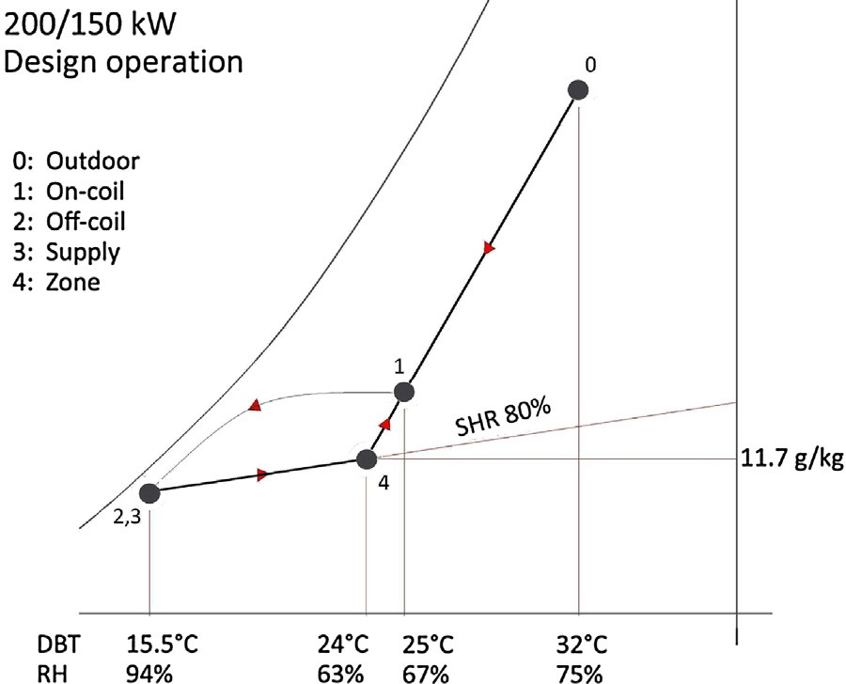

Fig. 1. On/off-coil and space conditions for oversized designed coils.

simulation data as done by [6]. The main operational design inputs for SPC are on-coil conditions and airﬂow rate.
On-coil condition: the design indoor condition of space is con- sidered as 24 ◦C and 63% RH. A slightly more stringent conditions than design day conditions outdoor parameters (32 ◦C and 75%) has
been used in this study. Based on these constrains, on-coil condi- tion of air has been obtained using psychrometric chart (“ASHRAE Psychrometric Chart No.1, [23] ”) which is 25 ◦C/67% RH. It has been assumed that at full load, on-coil air is a mixture of hot and humid outdoor air (10%) and conditioned re-circulated indoor air (90%).
Airﬂow rate: While deciding airﬂow rate (m3/s) based on typical cooling load estimation and conventional operation of HVAC sys- tem, it has been assumed that the SHRcz of oversized space load is up to 80% and difference between zone and off-coil temperature (�T) is below 12 ◦C. Based on these assumptions, numerous sim- ulations have been performed to obtain an adequate design. The same has been veriﬁed using a psychrometric chart (See Fig. 1) and Eq. (4) and (5).

Sensible Heat Load = 1.213 · (Air flow rate) · ΔT (4)

(Room Load) · SHRcz

the control of active coil row numbers. Four active row conﬁgu-
rations are assessed: 6 (base case), 4, 3 and 2. In the third step,
Sensible Heat Load =
100
(5)

performance assessment of adaptable cooling coil design is per- formed. For each coil size (150 kW and 200 kW), two VAV controls strategies (dry-bulb control and absolute humidity control), two VAV conﬁgurations (with and without motorized outdoor damper) and four possible active rows (6, 4, 3 and 2) were simulated; 32 cases in total. Each case is simulated for four different part-load operations of oversized coil (100%, 75%, 50% and 25% of actual room load). So, a total of 128 (32 × 4) simulations were performed.

  - Design of oversized coils (base designs)

The oversized cooling coils (200 kW and 150 kW) are designed using a free access cooling coil selection software (SPC2000 version 8.2, by S & P Coil Products Limited, [21]). SPC2000 is a coil rating and selection program. This software has been selected as it was used previously in similar investigations to explore the performance of coils for different operational scenarios and provided good results [22]. It calculates the optimum speciﬁcations of a heat exchanger based on the design input data. The input/output data could include airside data, ﬂuid side data and physical data related to the geom- etry of the heat exchanger. The conﬁguration of this coil and its operational condition for Singapore climate were selected based on
(Where ΔT is the temperature difference of air between off-coil and space)
In all the simulated scenarios, chilled water supply tempera- ture or on-coil water temperature was ﬁxed at 6 ◦C which is a typical value. The full circuiting (number of circuits is equal to the number of tubes in the height of the coil) has been chosen as cir- cuiting scheme. This also determines the ﬁn height. This implies that every tube in the ﬁrst row of the coil that is most downstream in the airﬂow direction is supplied with chilled water at the sup- ply temperature of 6 ◦C. This is to ensure that a true counter ﬂow arrangement of chilled water ﬂow and airﬂow is achieved, which would lead to a uniform log-mean temperature difference in the heat and mass transfer process occurring in the cooling coil.
Detailed information regarding other types of circuits e.g. half circuiting can be found in coil design handbooks and guidelines (ASHRAE, [24]). The sizes for ﬁn height (H) and ﬁn length (L) deter- mine the face area of the coil, which is inversely correlated with the face velocity (Vf ). The average air velocity passing through the coil is deﬁned as the face velocity, which can be calculated as airﬂow rate (Q) divided by the face area of the coil (H•L).
A typical face velocity threshold of 2.5 m/s has been used [24]. In addition, ﬁn material type of aluminum with ripple proﬁle and den-

Table 1
Conﬁguration of the simulated cooling coil including geometrical speciﬁcation and typical operational condition of coil in the tropics.
which water loops are to be opened or closed. Dry-bulb and wet- bulb temperatures could provide information regarding the real

time SHRcz of the space and the necessary loops of water could

Coil parameter Value Unit 200 kW 150 kW
On-coil air temperature 25 25 ◦ C
On-coil air relative humidity 67 67 % On-coil water temperature 6 6 ◦ C Fin material type Aluminium 0.15 rippled
Tube diameter | 16 | 16 | mm
Tubes high (no of tubes) | 44 | 36 | No.
Finned height | 1785 | 1461 | mm
Finned length | 2500 | 2250 | mm
Fin density | 9 | 9 | FPI (ﬁns per inch)
Inlet/Outlet connection | 76.2 | 76.2 | mm

Circulate type F − Full circuiting

Table 2
Design parameters for 200 kW and 150 kW oversized coils.

Design parameters | Values
Coil Duty, (kW) | 150 | 200
Rows | 6 | 6
Airﬂow rate, m3 /s | 8.0 | 11.1
Outdoor air% | 10 | 10
Face velocity, m/s | 2.4 | 2.5
SHRCC , % | 59 | 59
Air pressure drop, Pa | 187.4 | 194.2
Fluid on temperature, ◦ C | 6 | 6
Fluid off temperature, ◦ C | 14.7 | 15.2
Fluid ﬂow rate, L/s | 3.8 | 5.2
Actual pressure drop (Pa) | 8000 | 10900
Air on DB, ◦ C | 25 | 25
Air on RH, % | 67 | 67
Air off DB, ◦ C | 16.1 | 16.3
Air off WB, ◦ C | 15.5 | 15.7
Air off RH, % | 94 | 94
Supply Air temp, ◦ C | 16.2 | 16.2
Supply Air humidity, % | 93 | 93
SHRCZ , % | 80 | 80
Space absolute humidity, g/kg | 11.7 | 11.7
Space Load (kW) (Latent + Sensible) | 94.7 | 131.4
�T | 7.8 | 7.8
Zone DB, ◦ C | 24 | 24
Zone RH, % 63 63
then be deactivated to maintain the SHRcz in the acceptable range. A hydraulic system can control the number of rows in operation. A detailed control strategy of hydraulic systems for the practical application is discussed in Section 4 of this paper.

2.2.2. Control of outdoor air supply
Some of the existing VAV systems in Singapore do not employ controllable/motorized/variable outdoor air damper that results in proportional reduction of outdoor air quantity with reducing fan speed. This is quite common in other places, such as the United States. This is the major reason that forces a VAV system to func- tion like a CAV to maintain the minimum outdoor air requirement at part loads. In this study, both the cases of “without” and “with” outdoor air motorized damper (cases A and B) are assessed to eval- uate the applicability of adaptable cooling coil in existing and new buildings. To maintain the absolute humidity level of the space at lowest possible airﬂow rate, the amount of outdoor air supply to AHU space is decreased from 0.52 m3/s to 0.08 m3/s. The minimum ventilation requirement for an ofﬁce space in Singapore is 0.6 L/sm2 [11]. To maintain the balance between outdoor air and re-circulated air with minimum airﬂow rate, an automated return air exhaust needs to be introduced.

2.3. Performance assessment of adaptable coil

The performance of the adaptable cooling coil has been assessed through simulation and psychrometric analysis for four possible part loads, i.e. 100%, 75%, 50% and 25%. 100% space load is actual peak load = 63 kW (L100), 75% space load is = 47.4 kW (L75), 50% space load is = 31.6 kW (L50) and 25% space load is = 15.8 kW (L25). The design space load was obtained using a psychrometric anal- ysis as per Eq. (6). These part loads for space were obtained as a percentage of design coil duty using Eq. (7).

RLOversized = 1.184 · Voversized · (Δh) (6)
RLOversized

RLPartloads =
CD
oversized
- %RLactualpeak (7)

sity of 9 ﬁns per inch (fpi) has been selected in these simulations, which is a common ﬁn material and density supplied in Singapore.
The details of selected coil geometry and information on airside and waterside of the coil are provided in Table 1 and other design parameters are provided in Table 2. The schematic of this full cir- cuiting cooling coil including its design parameters are illustrated in (Fig. 2a).

  - Design and operative strategies for adaptable cooling coil

Two operational strategies are considered: a) control of coil rows and b) control of outdoor air supply.

    - Control of coil rows
A reduction in rows of coil may improve the SHRcc of cooling coil at part load. This improvement in coil SHRcc will further result in improvement of humidity at the zone level. The hydraulic sys- tem connection of chilled water ﬂow to cooling coil is required to be redesigned in order to activate each part of the coil separately on demand. The schematics of hydraulic system design for the pro- posed adaptable cooling coil conﬁguration are shown in Fig. 2b. Three-way control valves and modulating valves would be installed at different parts of the hydraulic system to modify chilled water ﬂow loop based on the cooling load. The on/off coil dry-bulb and wet-bulb temperatures could be measured and used to determine

Where
RLOversized : Space load for oversized coil
Voversized : Design airﬂow rate for oversized coil
�h : Difference in enthalpy of on-coil and off-coil air (obtained
from psychrometric chart)
RLPartloads : Space load at part loads
CDoversized : Duty of oversized coil
%RLactualpeak : Space load as a percentage of actual peak
The off-coil conditions and energy performance analysis for
these part loads are done using the results of the SPC simula- tions. These simulations are performed for base coil design (6 rows in operation) as well as for adaptable coil design (4, 3, and 2 rows in operation). To obtain the on-coil conditions, which are one of the main inputs for SPC simulation, SHRcz of part-loads has been assumed to be 75, 70, 65 and 60 for L100, L75, L50 and L25 respectively. These assumptions are based on a hypothesis that with decrease in space loads, predominantly the sensible loads, the SHRcz also decreases. Several simulations have been performed and the outcome of these simulations along with the psychromet- ric chart is used to obtain optimum space and on-coil conditions for various cases. These simulations have been performed for two oversized cooling coils (200 kW and 150 kW) for two cases and two possible scenarios for each case:
Scenario A (VAVv − Variable outdoor air): the amount of out- door air is reduced proportionally to the speed of the fan, therefore

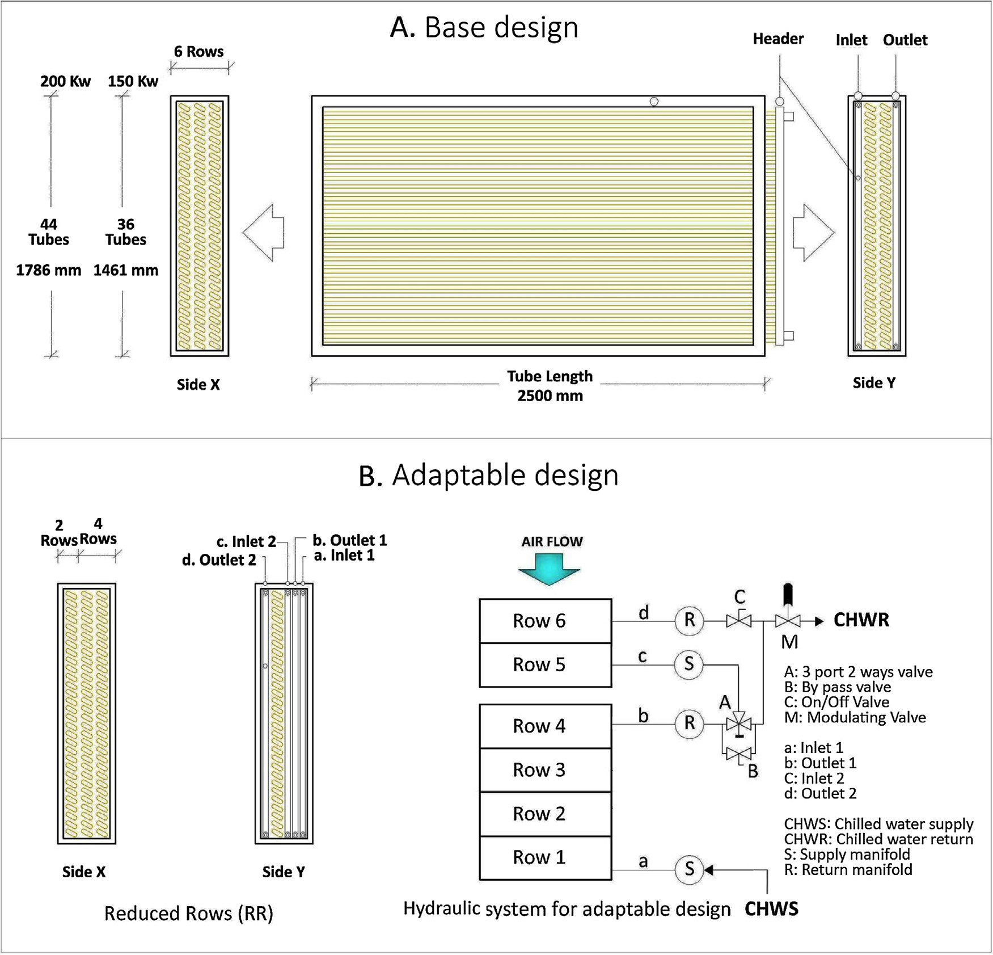

Fig. 2. Conﬁguration of a typical full circuiting cooling coil a) base design and b) adaptable design.

the minimum outdoor air may not be provided at low load condi- tions and this may cause IAQ problems. This is the operation of a VAV system that has a ﬁxed position outdoor air damper.
Scenario B (VAVf − Fixed outdoor air): The amount of outdoor
air provided to the occupant is constant. This is the operation of a
state of the art VAV system with variable outdoor air damper. In this case, the occupant always receives the design outdoor airﬂow rate.
Both Scenarios A and B have been simulated for two different cases. So, a total of four scenarios have been simulated for each
oversized cooling coil. The detailed steps for these simulations are
conﬁgurations. Hence, adaptable coil here is the coil that gives off- coil condition closest to design condition (i.e. absolute humidity close to 11.7 g/kg). Secondly, the same airﬂow rate is used for the analysis of remaining coil conﬁguration of the loads individually. Finally, optimum on-coil, off-coil and space conditions have been obtained using repetitive SPC simulations for various part loads. These simulations have been performed along with psychrometric analysis where ﬁxed SHRcz line is moved upward over the psychro- metric chart and �T was ﬁxed (See Fig. 3a).

VDO · PL

discussed below.
CASE 1: Fixed dry-bulb air temperature
In this case, dry-bulb temperature of space is ﬁxed at 24 ◦C (like
Vpl =

Where,
DLo
(8)

design space condition) and absolute humidity is allowed to vary.
This type of control is the most commonly used control in commer-
VPL : Airﬂow rate at part load
VDO : Design airﬂow rate (Oversized)

cial and residential buildings. In this case, the airﬂow rate (m3/s)
DLO
: Design Load (Oversized)

was obtained for various part loads as a proportion of oversized
design load using Eq. (8).
CASE 1A: Fixed dry-bulb air temperature and variable outdoor air ﬂowrate (VAVv)
This case represents an existing building without any advanced
HVAC control for the outdoor air damper. This case only compares the dehumidiﬁcation capacity of base and various adaptable coil
PL : Part Load
CASE 1B: Fixed dry-bulb air temperature and ﬁxed outdoor air ﬂowrate (VAVf)
This case represents a new building with a state of the art VAV
system employing outdoor air damper control. The steps of simu- lation and analysis are similar to CASE 1A.
CASE 2: Fixed space absolute humidity

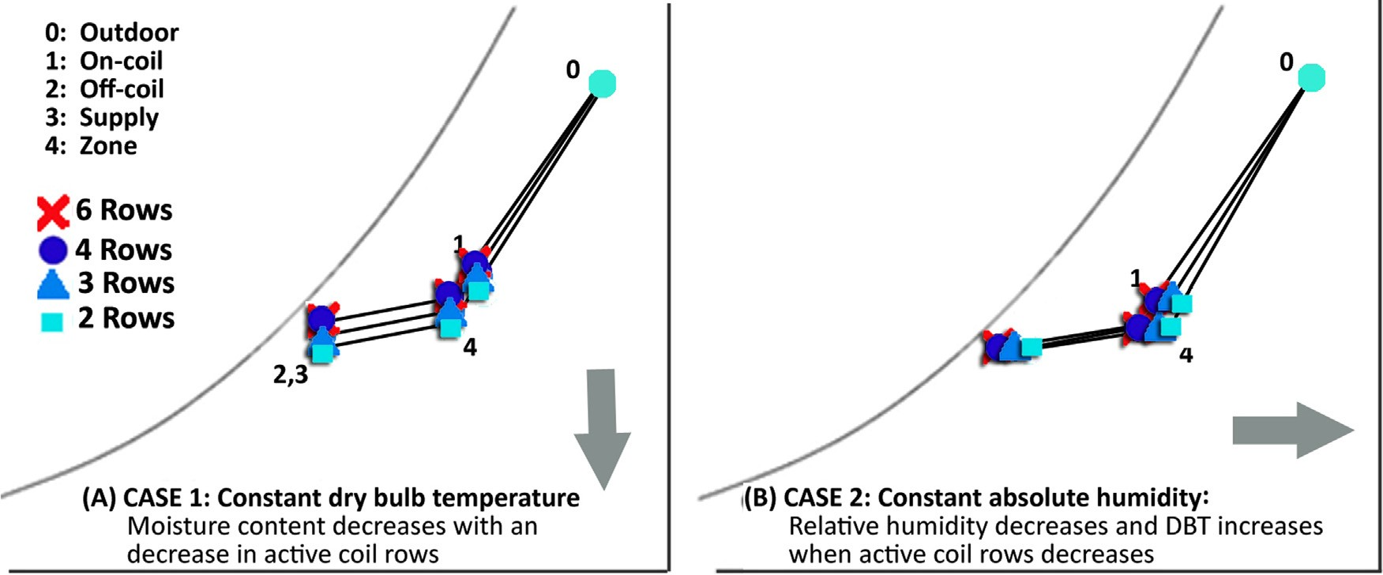

Fig. 3. Typical psychrometric analysis for Case 1 & Case 2.

In this case, absolute humidity (moisture content) of the space is ﬁxed to be 11.7 g/kg (design space condition) and dry-bulb tem- perature (DBT) is allowed to vary. The variation in DBT is such that
overcooling energy saving potential, which could be applied addi- tionally to obtain desired space temperature. These savings in terms of percentages can be obtained through Eq. (10).

the space condition and off-coil condition lie on the same assumed
SHRcz line on the corresponding psychrometric plots for any load.

% Potential overcooling energy saving =
PLV −

PLf

· 100 (10)

Fixed absolute humidity is representative of spaces where there is a need to control humidity like in some museums, part of libraries, operating theaters, etc. These types of building represent a rela- tively small fraction of the built environment.
CASE 2A: Fixed space absolute humidity and variable outdoor air ﬂowrate (VAVv)
In this case ﬁrstly, a minimum airﬂow rate (m3/s) was obtained
for the adaptable coil for various part loads. This has been done through Eq. (4). Here, adaptable coil is one, which gives an off- coil condition closest to design condition (i.e. DBT close to 24 ◦C). Secondly, the same airﬂow rate is used for the analysis of all coil conﬁgurations (6, 4, 3, 2 rows) at each load. Finally, optimum on-coil, off-coil and space conditions have been obtained using
L100F
Where L100F = Adaptable Coil duty at part load
PLv = Coil duty at part load with varying DBT
PLF = Coil duty at part load with ﬁxed DBT (DBT like Adaptable Coil)
Similarly, the airﬂow rate (Vf ) and actual pressure drop (dP) obtained from simulation is used to calculate the Fan energy (Fe) using Eq. (11). Further, to calculate pump energy (Pe), ﬂuid ﬂow rate (q) in (l/s) obtained from simulation has been used with Eq. (12).
Fe (kW ) = dP · Vf /J (11)
q · p · h · g

repetitive SPC simulations for various part loads. These simulations
have been performed along with psychrometric analysis where ﬁxed SHRcz line is moved laterally on the psychrometric chart and
Pe (kW ) =

Where,
3.6 · 106
/J (12)

�T was ﬁxed (See Fig. 3b). In this case, base case and various
adaptable coil conﬁgurations are compared for energy as well as dehumidiﬁcation performances.

2.4. Energy saving through adaptable coil operation

Three types of energy consumption are considered for energy saving calculation a) Oe- Overcooling energy, b) Fe − Fan Energy (to regulate airﬂow) and c) Pe − Pump energy (to regulate chilled water supply). All energy uses are calculated in kWh. The energy savings are calculated using the adaptable cooling coil best conﬁguration as reference point. This can be calculated using Eq. (9).
Total Additional Energy = Oe + Additional Fe + Additional Pe (9) Where, AdditionalF e = F ce−Face (9a)
andAdditionalPe = Pce−Pace (9b)

where, Fce & Pce are the fan and pump energy of that conﬁguration for which this additional energy is calculated and Face & Pace are the fan and pump energy of adaptable cooling coil.
To obtain the energy saving by adaptable coil conﬁgurations, additional set of simulations is performed to obtain coil duty where off-coil temperature is similar to the off-coil temperature obtained for adaptable coil. Further, the difference between adaptable coil duty and the duty of the remaining coils is considered as an
J : Fan efﬁciency/Pump efﬁciency (0.85 assumed in this study is
within the range of the Fan Efﬁciency Grade (FEG) given in draft stan- dard AMCA 205 (Movement, 2012)
p : Fluid density (here ﬂuid is water so density taken is 1gm/cm3)
h : Differential head of pump (2 m is assumed in this case) and g : gravity (9.81 m/s2)
CASE 2B: Fixed space absolute humidity and ﬁxed outdoor air ﬂow (VAVf)
In this case, the absolute humidity is constant and the outdoor
air ﬂow rate is ﬁxed. The steps of simulation are identical to CASE 2A.
Overall, 16 scenarios of base coil design and 48 scenarios of adaptable design scenarios have been simulated for various part- loads using the coil selection software for 200 kW and 150 kw coil individually. So, a total of 128 simulations have been performed. The summary of simulated scenario can be seen in Table 3.

Results

Out of 128 Simulation cases, 116 were successfully applicable to practical operation scenarios. However, in the remaining 12 cases, the coil was either unable to perform or the coil adaptation for that conﬁguration was not required. This implies that, in some cases, 3 rows conﬁguration was sufﬁcient to maintain space conditions and so the conﬁguration of 2 rows adaptation was not required.

Table 3
Summary of simulated scenarios.

Sl. No (A) Control Design/Cases Operation Scenario
(Absolute Humidity)

Oversized Coils (B) Active Rows
(Maximum 4 cases) (◦C)

150 kW design 200 kW design

 |  |  |  | % of actual peak | Airﬂow rate (m3 /s) | % of actual peak | Airﬂow rate (m3 /s)
 | VAV | Base | NA | 150% | 8.00 | 200% | 11.1 | 6
1 | VAV + FOA | RR/2 | Fixed | 100% | 5.20 | 100% | 5.20 | 6, 4, 3, 2
2 | VAV + FOA | RR/2 | Fixed | 75% | 3.60 | 75% | 3.60 | 6, 4, 3, 2
3 | VAV + FOA | RR/2 | Fixed | 50% | 2.00 | 50% | 2.00 | 6, 4, 3, 2
4 | VAV + FOA | RR/2 | Fixed | 25% | 0.80 | 25% | 0.80 | 6, 4, 3, 2
5 | VAV + FOA | RR/1 | Varying | 100% | 5.33 | 100% | 5.33 | 6, 4, 3, 2
6 | VAV + FOA | RR/1 | Varying | 75% | 4.00 | 75% | 4.00 | 6, 4, 3, 2
7 | VAV + FOA | RR/1 | Varying | 50% | 2.67 | 50% | 2.67 | 6, 4, 3, 2
8 | VAV + FOA | RR/1 | Varying | 25% | 1.33 | 25% | 1.33 | 6, 4, 3, 2
9 | VAV + VOA | RR/2 | Fixed | 100% | 4.80 | 100% | 4.80 | 6, 4, 3, 2
10 | VAV + VOA | RR/2 | Fixed | 75% | 3.20 | 75% | 3.20 | 6, 4, 3, 2
11 | VAV + VOA | RR/2 | Fixed | 50% | 1.56 | 50% | 1.56 | 6, 4, 3, 2
12 | VAV + VOA | RR/2 | Fixed | 25% | 0.62 | 25% | 0.62 | 6, 4, 3, 2
13 | VAV + VOA | RR/1 | Varying | 100% | 5.33 | 100% | 5.33 | 6, 4, 3, 2
14 | VAV + VOA | RR/1 | Varying | 75% | 4.00 | 75% | 4.00 | 6, 4, 3, 2
15 | VAV + VOA | RR/1 | Varying | 50% | 2.67 | 50% | 2.67 | 6, 4, 3, 2
16 | VAV + VOA | RR/1 | Varying | 25% | 1.33 | 25% | 1.33 | 6, 4, 3, 2
Total Simulation = A x B x C = 16 × 2 x 4 128
(RR- reduced rows adaptable design, FOA- Fixed outdoor air, VOA − Variable outdoor air).

These results are also categorized in four groups based on four operational scenarios for 150 kW and 200 kW individually. The out- come of each case is discussed for dehumidiﬁcation performance and energy saving potential in the subsequent sections.

  - CASE 1–ﬁxed space dry-bulb temperature

    - CASE 1A ﬁxed dry-bulb temperature and variable outdoor air ﬂowrate (VAVv)
Performance at all four loads has been studied for a system in
which the supply air varies from peak load to part-loads, while the percentage of outdoor air out of supply air remains constant. The calculated airﬂow rate and corresponding chilled water ﬂow rate is presented in Table 4.

    - Adaptable coil performance: room conditions
In the base conﬁguration (6-rows) of VAV operation at L100 and part-loads, the off-coil moisture content increases through a decrease in airﬂow rate. Although the zone level temperature is maintained, the zone level absolute humidity slightly increases (max increase is 1.5 g/kg (from 12.75 to 14.3 g/kg) that correspond to a 10% RH increase (from 67% to 77%). We can conclude that in the extreme conditions selected in this simulation involving a VAV system without motorized damper, the humidity increases but not excessively. In all the cases, the adaptable coil slightly reduces the absolute humidity (maximum reduction is 1.9 g/kg − from 13.8 to
11.9 g/kg). This corresponds to a 10% RH reduction (from 74 to 64%). The minimum variation with desired room condition is seen for L100 and the maximum variation is seen for L25. However, from Fig. 4a, it can be seen that with increase in ﬂuid ﬂow rate and reduction in active coil rows, the zone level humidity improves. For L100, reduc- tion of active coil rows up to 3 has been found to be adequate to maintain room conditions and for L75, L50 and L25, whereas the adaptable coil conﬁguration is the operation of 2 coil rows. The adaptable coils for L100, L75 and L50 can maintain zonal absolute humidity as close as design (11.7 g/kg). However, for L25, although adaptable coil is able to provide better humidity control as com- pared to other conﬁgurations, the zonal absolute humidity is found to be slightly higher (13.1 g/kg). It is to be noted that the dehumid-

iﬁcation capacity of adaptable coil conﬁguration decreases with decrease in zone load and airﬂow rate. This result is clearly seen with psychrometric analysis as presented in Appendix A (Fig. A1).

    - Adaptable coil performance: energy savings
The calculated amounts of pump energy by Eq. (12) shows insigniﬁcant additional energy required for operating the coil dur- ing adaptation as compared to base operation. For the various cases, the difference in energy use between cases is always less than 0.3% of overall energy required. It can, therefore, be concluded that the VAV system without outdoor damper has slightly increased abso- lute humidity when working in part-load conditions and that the adaptable coils can slightly reduce the absolute humidity in all load conditions without an energy penalty.

    - CASE 1B ﬁxed dry-bulb temperature and ﬁxed outdoor air ﬂowrate (VAVf)
This case investigates the performance of coils with ﬁxed dry-
bulb temperature. However, in this case, a ﬁxed amount of outdoor air 0.8 m3/s and 1.1 m3/s (10% of design loads for Coil150 and Coil200 respectively) is considered for all part-loads. This is the case of a properly designed VAV system.
This case works for all part-loads as there is ﬂexibility to oper- ate at higher absolute humidity levels. Calculated airﬂow rate and corresponding simulated ﬂuid ﬂow rate for different part-loads are presented in Table 5.

    - Adaptable coil performance: room conditions
From Fig. 4b, it can be easily seen that the off-coil humidity slightly increases with a decrease in airﬂow rate. The zone level absolute humidity increases by 1.9 g/kg (from 12.75 to 14.6 g/kg) and 11 RH% (from 67% up to 78%). As seen in earlier cases, the minimum variation with desired room condition is seen for L100 and maximum is seen for L25. With an increase in ﬂuid ﬂow rate and reduction in active coil rows, the zone level absolute humidity slightly improves. The maximum reduction is 1.2 g/kg (from 13.5 to
12.3 g/kg), which corresponds to a maximum RH reduction of 5.5% (from 72 to 66.5%). The improvement is less than in the case with ﬁx outdoor damper. Similar to Case 1A, for L100, reduction of active

 | L100 |  | L75 |  | L50 |  | L25
Coil Conﬁguration | Base | Adaptable | Base | Adaptable | Base | Adaptable | Base | Adaptable
Rows | 6 | 3 | 6 | 2 | 6 | 2 | 6 | 2
Coil 150 F (l/s) | 2.00 | 3.30 | 1.70 | 3.70 | 1.30 | 3.80 | 0.30 | 1.90
Coil 200 F (l/s) | 2.10 | 3.50 | 1.82 | 4.20 | 0.90 | 3.47 | 0.30 | 1.97
V (m3 /s) | 5.3 |  | 4.0 |  | 2.6 |  | 1.3
Coil 150 V% | 67 |  | 50 |  | 33 |  | 17
Coil 200 V% | 50 |  | 37 |  | 25 |  | 13
V − Airﬂow rate, V% − Percentage of actual design, F − Fluid (chilled water) ﬂow rate, Coil 150 : 150 kW, Coil 200 : 200 kW.

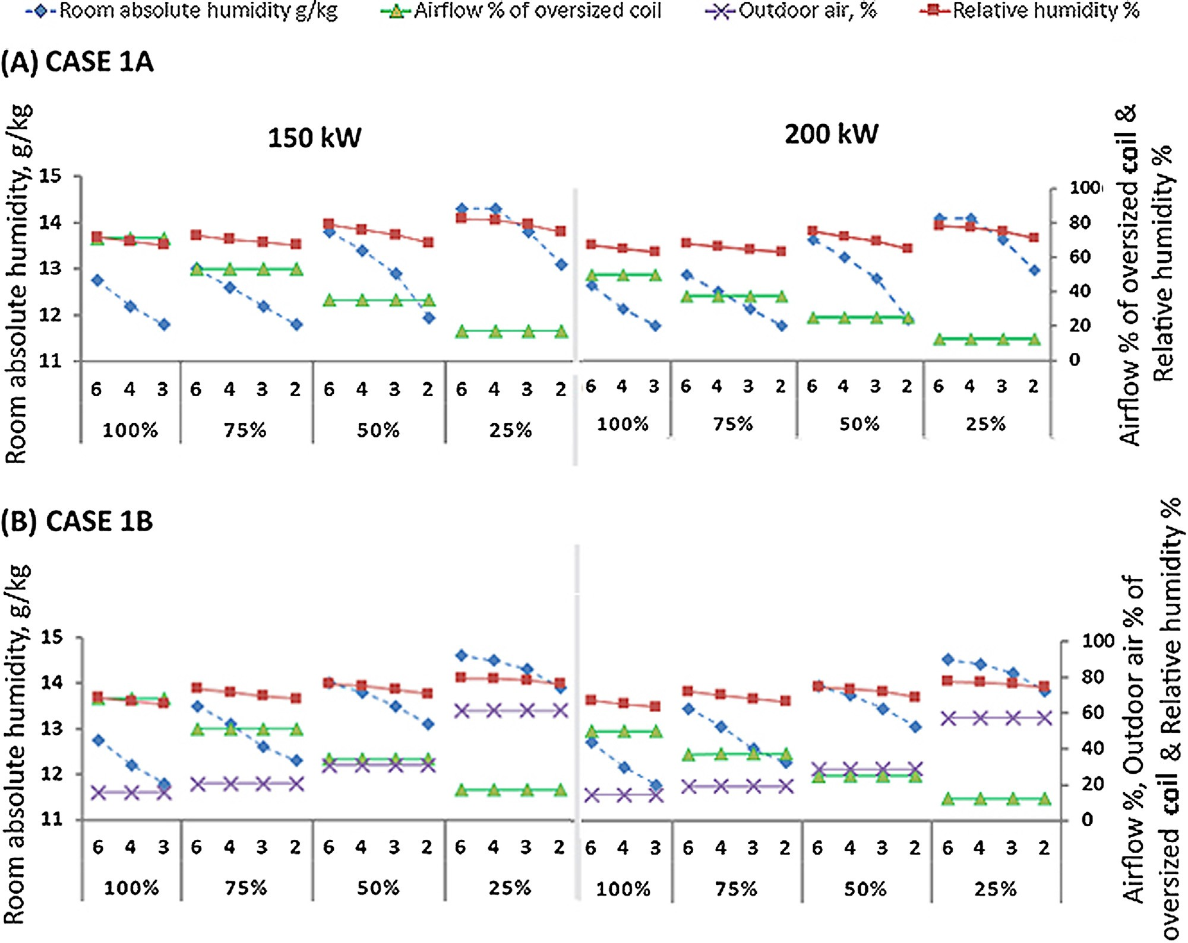

Fig. 4. CASE 1A and 1B Results: Comparison of dehumidiﬁcation performance of coil conﬁgurations at various part-loads.

Table 5
CASE 1B: Airﬂow rate and ﬂuid ﬂow rate.

 | L100 |  | L75 |  | L50 |  | L25
Coil Conﬁguration | Base | Adaptable | Base | Adaptable | Base | Adaptable | Base | Adaptable
Rows | 6 | 3 | 6 | 2 | 6 | 2 | 6 | 2
Coil 150 F (l/s) | 2.2 | 3.8 | 1.75 | 3.8 | 1.5 | 3.8 | 0.7 | 3.1
Coil 200 F (l/s) | 2.2 | 3.7 | 1.9 | 4 | 1.7 | 5.0 | 1.2 | 2.9
V (m3 /s) | 5.30 |  | 4.00 |  | 2.67 |  | 1.30
Coil 150 V% | 67 |  | 50 |  | 33 |  | 17
Coil 200 V% | 50 |  | 37 |  | 25 |  | 13
V − Airﬂow rate, V% − Percentage of actual design, F − Fluid (chilled water) ﬂow rate, Coil 150 : 150 kW, Coil 200 : 200 kW.

coil rows up to 3 has been found to be adequate to maintain room conditions and for L75, L50 and L25, the adaptable coil conﬁgura- tion is the operation of 2 rows coil. In this case, the adaptable coil
for L100 can maintain zonal absolute humidity as close as design
(11.7 g/kg). The dehumidiﬁcation capacity of adaptable coil con- ﬁguration decreases with decrease in zone load and airﬂow rate.

These results are presented in the form of psychrometric analysis as shown in (Appendix A, Fig. A2).

    - Adaptable coil performance: energy savings
Like Case 1A, the energy saving potential is insigniﬁcant here. Overall, it can be concluded that for a state of the art VAV system with outdoor air damper control, there is a slight increase in abso- lute humidity when working in part-load and that the adaptable coil only marginally reduces the absolute humidity, in particular in part-load conditions. There is no energy beneﬁt in using the adaptable coil.

  - CASE 2–ﬁxed room condition analysis

    - CASE 2A ﬁxed space absolute humidity and variable outdoor air ﬂowrate (VAVv)
To maintain the zone level absolute humidity of 11.7 (g/kg) as
per design load, the airﬂow rate is calculated using Eq. (4). Similarly, the airﬂow rate as a percentage of actual design is calculated using Eq. (13) for various part-loads. These calculated airﬂow rates and corresponding ﬂuid (chilled water) ﬂow rates for various part-loads are presented in Table 6.

    - Adaptable coil performance: room conditions
Calculated airﬂow rate is used for SPC simulation to ﬁnd the adaptable coil conﬁguration with varying rows number (6, 4, 3 and 2). An adaptable coil conﬁguration is identiﬁed as one, which provides the zone condition at part-loads closest to the design con- dition of full load. The outcomes of simulation for Coil150 and Coil200 are presented in Fig. 5. Using the adaptable cooling coil slightly reduces the relative humidity (max reduction is 5%, from 68 to 63%) and the temperature is increased (max increase is 1.4 ◦C from 22.7 to 24 ◦C). In the base case of VAV operation when 6 rows were active, the off-coil air condition gets cooler through reduction of airﬂow. The least variation with desired space condition is seen for L100 and maximum variation is seen for L25. These results can be seen in the psychrometric analysis (Appendix A, Fig. A3).
For L100, reduction of active coil rows up to 3 rows has been found to be adequate to maintain room conditions for both Coil150 and Coil200. So, there is no need to explore 2 row coil operation here. However, for L75, L50 and L25, the adaptable coil is a conﬁgu- ration of 2 rows. It is to be noted that the required amount of ﬂuid ﬂow rate varies as per the variation in airﬂow rate for both the coils.

    - Adaptable coil performance: energy savings
The energy saving potential by adaptable coil can be seen from Fig. 5. Between 1.5-11.8% and 7–18% of energy saving has been calculated for Coil150 and Coil200. The performance of these adaptation strategies (reduction in coil rows) in terms of energy saving is seen higher for the higher oversized coil (Coil200). How- ever, the energy saving potential by adaptable coil conﬁguration decreases with decrease in zone load (highest energy saving at L100 and lowest at L25). For Coil150 and Coil200, highest energy saving possible are 12 and 18% and the lowest are 1.5 and 2%.
leads to ﬁxed outdoor airﬂow rate at part-load conditions. The vari- able OA damper control allows for a ﬁxed amount of outdoor air
0.8 m3/s and 1.1 m3/s (10% of design loads for Coil150 and Coil200
respectively) for all part-load operation. So, the percentage of out- door air to supply air changes with the ventilation requirement for spaces. The results of this case are presented in Fig. 6.
The ﬁrst noticeable outcome is that the coils studied need out- door air percentage (ratio of outdoor air to airﬂow rate) more than 100% to maintain the absolute humidity at L25, which is practically impossible. This is due to ﬁxed and higher outdoor air supply at L25.
In the case of L25, the required airﬂow rate is 0.62 m3/s and much
lower than the ﬁxed outdoor air supply amount of 0.80 m3/s. So,
these coils are unable to maintain absolute humidity for L25 even in case of 100% outdoor air for ventilation. These are the cases when excess overcooling could be seen in the real operation of HVAC systems with an increased airﬂow rate.
In this case, airﬂow rate and ﬂuid ﬂow rates are obtained like Case-1A for various part-loads and presented in Table 7. Like Case- 1A, it can be seen from (Appendix A, Fig. A4) that the off-coil air condition gets cooler through reduction of airﬂow. From Fig. 6, a minimum variation is noticed between desired zonal DBT and absolute humidity for various part-loads. However, there is a slight
decrease in zonal temperature up to 0.9 ◦C and an increase in RH%
up to 5% is noticed for L100 and L75.

    - Adaptable coil performance: room conditions
From Fig. 6, it can be easily seen that with increase in ﬂuid ﬂow rate and reduction in active coil rows, the zone level temperature and relative humidity slightly improves. For L100 and L75, reduc- tion of active coil rows up to 3 has been found to be adequate to maintain room conditions for both the coils and so there is no need for 2-row coil operation here. However, it has been seen that at L50, adaptation does not give any better zone condition than actual base design of 6-Row coil operation. This occurs as the off-coil air condition reaches the saturation line for all cases (6, 4 and 3 rows in operation). This can be easily seen from the psychrometric analysis as presented in (Appendix A, Fig. A4).

    - Adaptable coil performance: energy savings
The potential of energy saving using adaptation for Coil150 and Coil200 is seen to be between 2 and 5.2% and 5.5-8.8% for L100 and L75. Like Case-1, the energy saving potential by adaptable coil con- ﬁguration decreases with decrease in zone load. Highest energy saving potential through adaptable coil is seen in the case of L100 and lowest is seen for L75 for both Coil150 and Coil200.
Adaptation is found insigniﬁcant for L50 for both cases of
enhancing the room condition as well as for saving energy. So, it can be concluded that with ﬁxed amount of outdoor air supply, the percentage of outdoor to supply air increases with decrease in space load. With this increase in ratio of outdoor to supply air, the per- formance of adaptation decreases and vice versa in case of airﬂow rate.

Adaptable coil control strategy for the practical application

Overall, we can conclude that in this speciﬁc application, where absolute humidity has to stay constant (e.g., conservation of art pieces), the adaptable coil is able to slightly reduce the relative humidity and increase the dry-bulb temperature, leading to up to 18% energy savings.

3.2.4. CASE 2B ﬁxed space absolute humidity and ﬁxed outdoor air ﬂow (VAVf)
This case investigates the performance of coils with ﬁxed space
absolute humidity and variable outdoor air damper control that
The control strategy of an adaptable coil would be based on the continuous measurement of �Tchw (Temperature difference between on-coil chilled water and off-coil chilled water) and Qchw [Fluid (water) ﬂow rate ( l ) inside the coil]. From Eq. (13), Qcoil(Coil load) would be measured. Further, the measured Qcoiland Fig. 7 (sample graph) would be used together to identify the required
adaptation in the coil conﬁguration for the various part loads. For illustration, the graph in Fig. 7 is prepared from the simulation out- comes of 200 kW coil and Case 2A. In the case of the 200-kW coil which is 100% oversized, if the actual or measured Qcoilis in the
s

 | L100 |  | L75 |  | L50 |  | L25
Coil Conﬁguration | Base | Adaptable | Base | Adaptable | Base | Adaptable | Base | Adaptable
Rows | 6 | 3 | 6 | 2 | 6 | 2 | 6 | 2
Coil 150 F (l/s) | 2.3 | 3.8 | 1.8 | 3.8 | 1.4 | 3.0 | 0.4 | 2.4
Coil 200 F (l/s) | 2.5 | 3.5 | 1.8 | 3.5 | 1.3 | 3.3 | 0.4 | 2.2
V (m3 /s) | 5.2 |  | 3.6 |  | 2 |  | 0.8
Coil 150 V% | 65 |  | 45 |  | 25 |  | 10
Coil 200 V% | 47 |  | 33 |  | 18 |  | 7
V − Airﬂow rate, V% − Percentage of actual design, F − Fluid (chilled water) ﬂow rate, Coil 150 : 150 kW, Coil 200 : 200 kW.

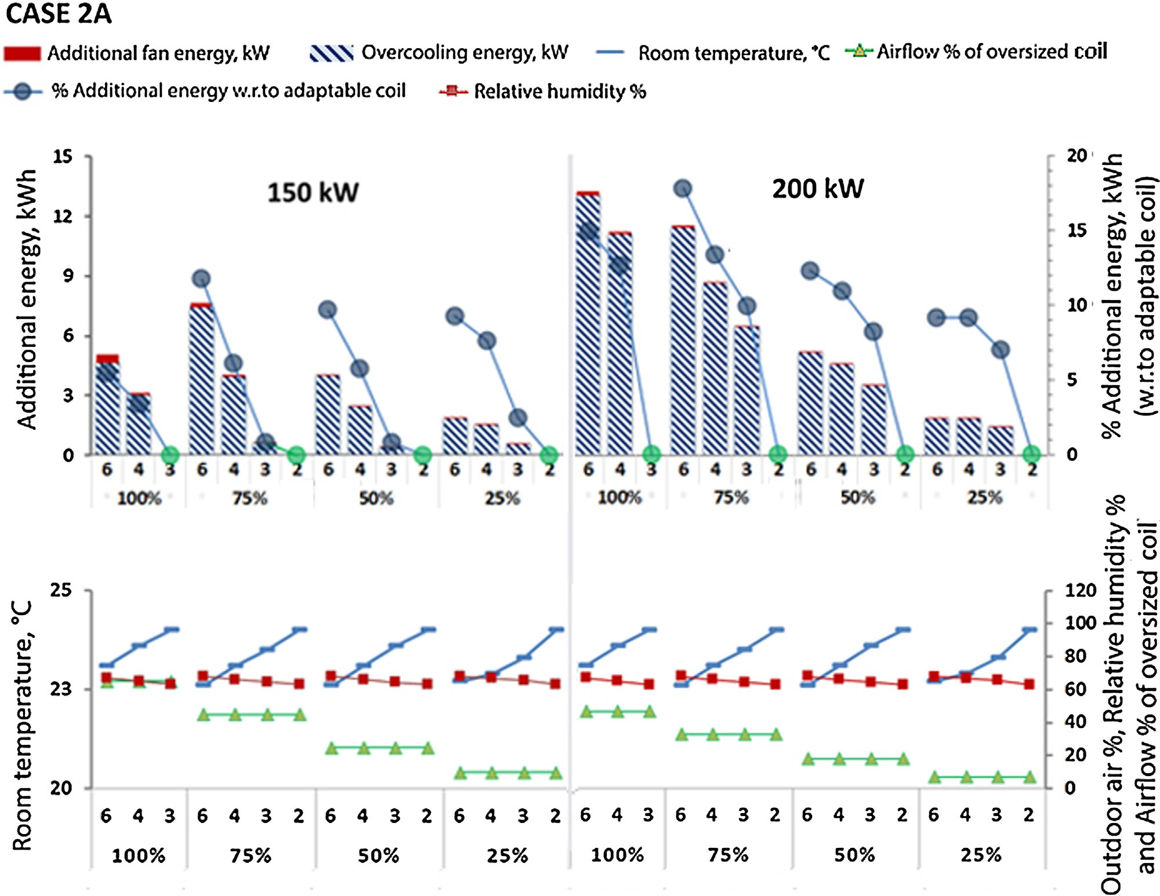

Fig. 5. CASE 2A Results: Comparison of energy and dehumidiﬁcation performance of coil conﬁgurations at various part-loads.

Table 7
CASE 2B: Airﬂow rate and ﬂuid ﬂow rate.

L100 L75 L50 L25

Coil Conﬁguration | Base | Adaptable | Base | Adaptable | Base | Adaptable | Unable to operate
Rows | 6 | 3 | 6 | 3 | 6 | 3
Coil 150 F (l/s) | 2.5 | 3.8 | 2.0 | 3.1 | 1.7 | 2.4
Coil 200 F (l/s) | 2.3 | 3.4 | 2.0 | 3.2 | 1.8 | 2.4
V (m3 /s) | 4.8 |  | 3.2 |  | 1.56
Coil 150 V% | 60 |  | 40 |  | 20
Coil 200 V% | 43 |  | 29 |  | 14
V − Airﬂow rate, V% − Percentage of actual design, F − Fluid (chilled water) ﬂow rate, Coil 150 : 150 kW, Coil 200 : 200 kW.

range of A (100% of coil load) and B (50% of coil load), there is no adaptation required and the coil will function normally with 6-rows in operation. However, at coil load B, which also corre-
sponds with the actual room load in this study, a change in coil conﬁguration is preferred. A key criterion in the A-B stage of a 6- row coil operation would be the association of the coil load with

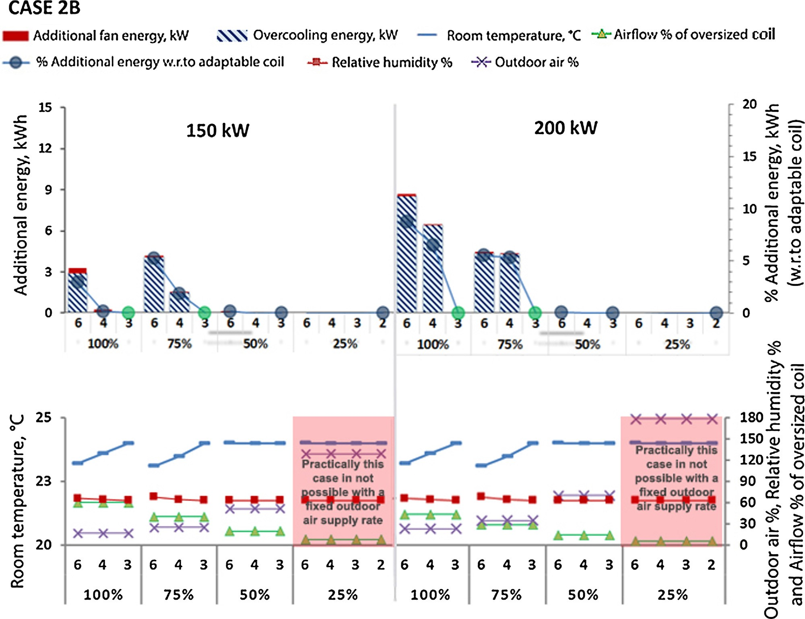

Fig. 6. CASE 2B Results: Comparison of energy and dehumidiﬁcation performance of coil conﬁgurations at various part-loads.

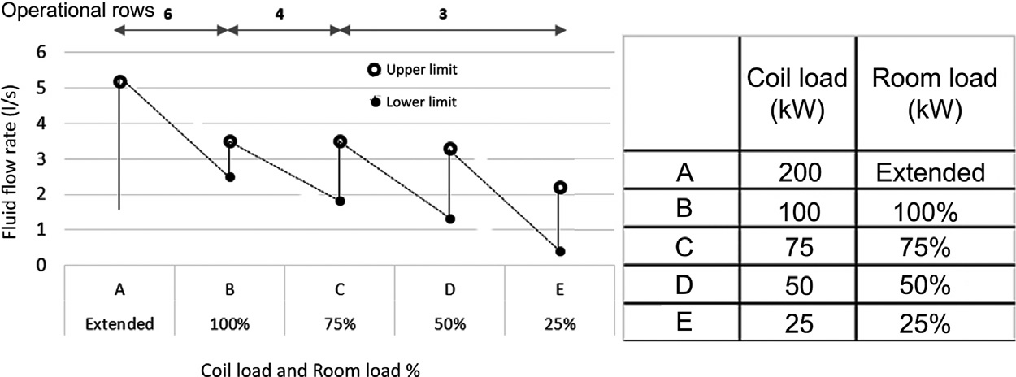

Fig. 7. Adaptable coil control strategy − Desirable coil conﬁgurations at extended and various part loads for Case 2A.

both Qchwand �Tchw and it is important to ensure that Qchw does not go below a stipulated (or pre-determined) minimum ﬂow rate. Between B and C, adaptation is made from 6-rows to 4-rows and this is accompanied by an increase of Qchw at the start of the 4-row coil operation, which is desirable from the perspective of enhanc- ing dehumidiﬁcation. During this operation of B-C, the adapted coil functions as a 4-row coil with Qchw progressively being modulated or reduced with decreasing coil load. Again, the criterion adopted for further adaptation would be further reduction of coil loads asso- ciated with reducing Qchw and�Tchw. A change-over to a 3-row coil would be made if Qchw falls below minimum stipulated ﬂow rate during the B-C stage. The adapted coil functions as a 3-row coil during the C-D stage of operation. Following similar logic, a fur- ther adaptation is made from 3-rows to 2-rows at the change-over
point of D. The scenario described above is for scenarios corre- sponding to decreasing loads. In the reverse scenario of increasing loads, the adaptation would move from 2-rows to 3-rows to 4- rows to 6-rows. At every change-over point, a control band of ± 5% of Qcoil is to be considered to prevent cycling and determine a clear “change-over” or adaptation from one coil conﬁguration to another. A similar control strategy can be adopted for 150 kW (50% oversized) coil and other operational scenarios. This control strat- egy of coil provides adaptation at various parts loads and also gives the ﬂexibility of harnessing the full potential of the coil perfor- mance, including that of future expansion in terms of room/space loads.

Qcoil = Qchw × L\Tchw (13)

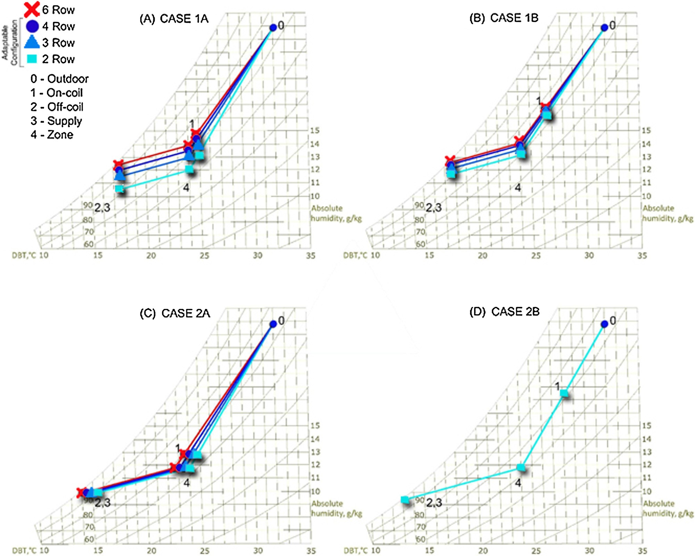

Fig. 8. Comparison between various cases for L50 using psychrometric analysis.

Table 8
Adaptable Coil Impact Matrix:.
 | CASE 1A | CASE 1B |  | CASE 2A | CASE 2B
 | INDOOR − Fixed DBT,  Varying Absolute | INDOOR − Fixed DBT,  Varying Absolute |  | INDOOR − Fixed Absolute Humidity, Varying DBT; | INDOOR − Fixed Absolute Humidity, Varying DBT;
 | Humidity; OUTDOOR AIR%  − Fixed | Humidity; OUTDOOR AIR%  − Variable with damper control |  | OUTDOOR AIR% − Fixed | OUTDOOR AIR% − Variable  with damper control
Load (%) | 100 75 50 25 | 100 75 50 | 25 | 100 75 50 25 | 100 75 50 25
Adaptability (Active coil rows) | 3 2 2 2 | 3 2 2 | 2 | 3 2 2 2 | 3 3 3 NA
Energy saving (%) OS (50%) | Ins Ins Ins Ins | Ins Ins Ins | Ins | 5.5 12 9.7 9.3 | 3 5.3 0 NA
OS (100%) | Ins Ins Ins Ins | Ins Ins Ins | Ins | 15 18 12.3 9.2 | 8.8 5.5 0 NA
Absolute humidity OS (50%) | 1 1.2 1.9 1.2 | 1 1.2 0.9 | 0.7 | NA NA NA NA | NA NA NA NA
reduction (g/kg) & RH% | 4% 5% 10% 7% | 3.5% 5.5% 5.5% | 3.3% | 4% 5% 5% 4.8% | 3% 5% 0% NA
Reduction OS (100%) | 1 1.2 0.9 0.7 | 1 1.2 0.9 | 0.7 | NA NA NA NA | NA NA NA NA
 | 4% 5% 10% 7% | 3.5% 5.5% 5.5% | 3.3% | 4% 5% 5% 4.8% | 3% 5% 0 NA
*Ins − Insigniﬁcant, NA − Not Applicable, OS − Oversized.

Limitations of the study

The cooling coil operational scenarios have been simulated under steady state scenarios where input data on air and water sides of coil do not change over time. However, in real condi- tions, chilled water supply temperature or on-coil air condition may change or ﬂuctuate over time. The humidity buffer effect of build- ing material was not considered. Another limitation of this study is
to consider a certain value for operational conditions of the cool- ing coil investigated. These assumptions have been made based on typical design conditions of cooling coils for the tropical climate of Singapore but there was not much measured data, therefore several assumptions (intensity of the oversize, SHR and how they change in part load, etc.) were based on our professional judgment. We did not explore how the active row control would look like and how it should be implemented.

Discussion and conclusions

The outcomes of simulations revealed that in part-load condi- tions, there is a small increase in absolute humidity (max 1.9 g/kg
− from 12.7 to 14.6 g/kg, 11% RH − from 67 to 78%) when we have
a heavily oversized cooling coil (50 and 100% oversize and room load conditions are at 25%). This is not a large increase but if the starting conditions were already in the high humidity range, then the value could be a concern. One possible approach would be to design for lower humidity targets to start from and a better-sized coil. Another approach is the one proposed in this paper. Using the adaptable coil would slightly reduce the absolute humidity (max reduction 0.9 g/kg) but its effectiveness is reduced at lower part- load conditions where is most needed. For illustration, L50 (lower part-load condition) is represented over a Psychrometric chart for different cases (see Fig. 8). It can be easily seen that the adaptation is effective for all cases except for the case of ﬁxed absolute humid- ity with ﬁxed outdoor airﬂow. This happens as the performance of
adaptation decreases with an increase in ratio of outdoor to supply air. In typical applications (temperature control) there is no energy beneﬁt of using the adaptable coil but in special applications (abso- lute humidity control) there is a substantial energy beneﬁt (up to 18%). All the conditions are summarized below (see Table 8).
It is apparent from this study that the reduction of active coil sur- face area could be an attractive option for the designer and operator to deal with an oversized coil. Although an evaluation of the cost- effectiveness is not presented in this paper and was beyond the scope of this study, it is envisaged that the capital cost premium would not be high. It is also further envisaged that manufacturer adoption could be quite reasonable, as the strategy does not have signiﬁcant drawbacks.

Appendix A.

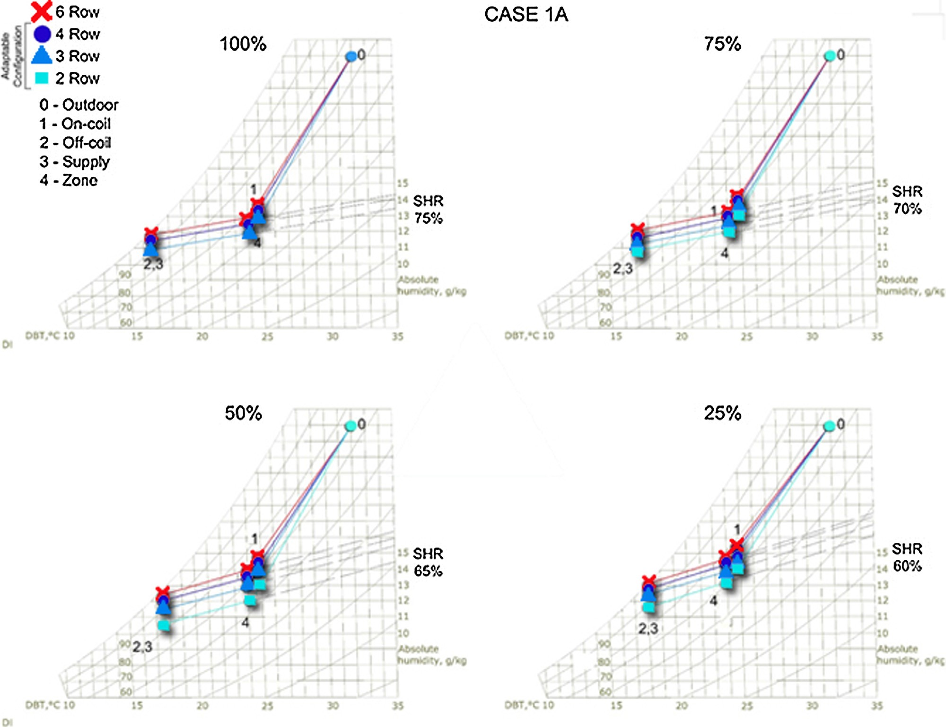

Fig. A1. Psychrometric analysis for CASE 1A.

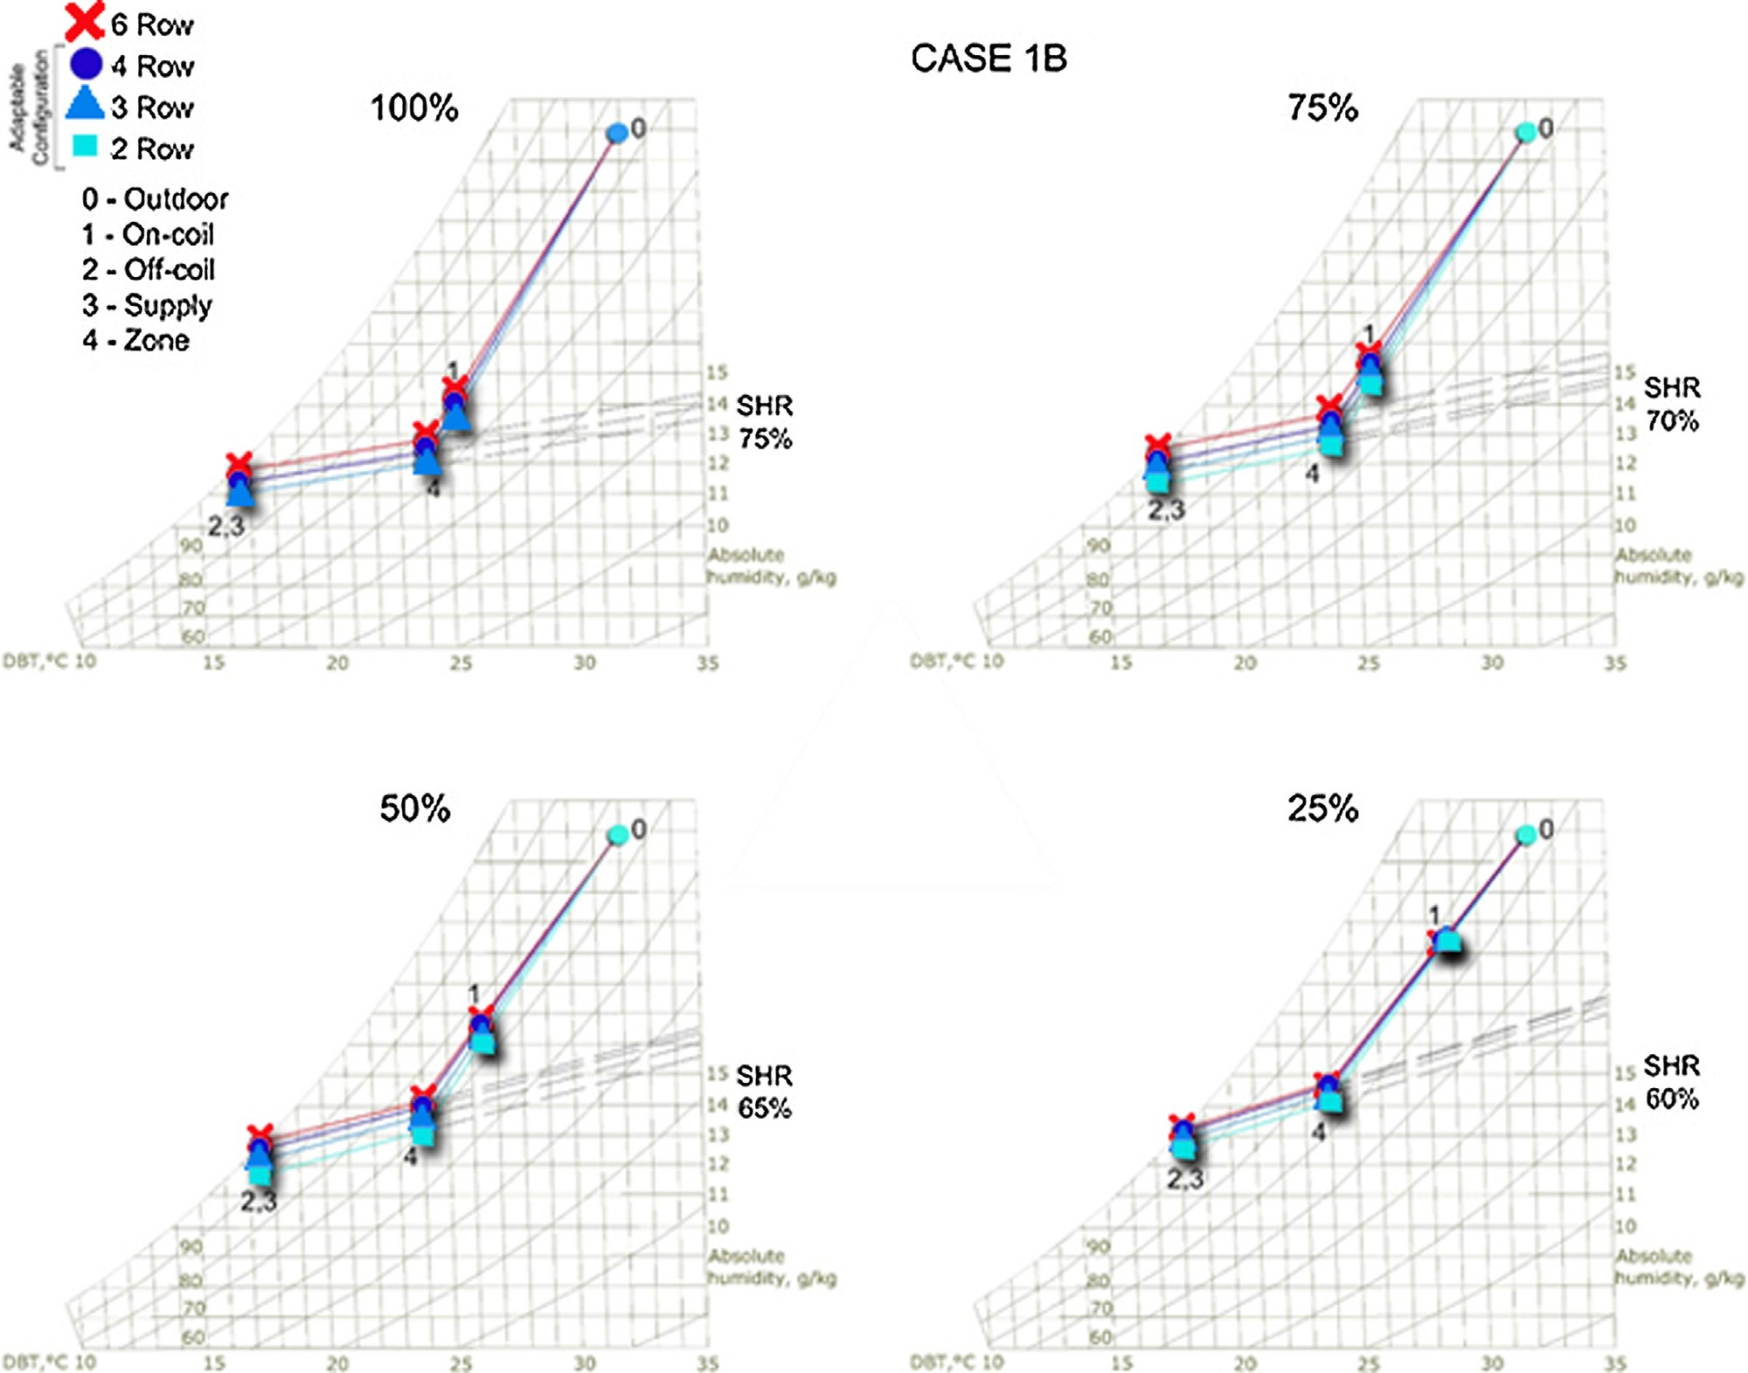

Fig. A2. Psychrometric analysis for CASE 1B.

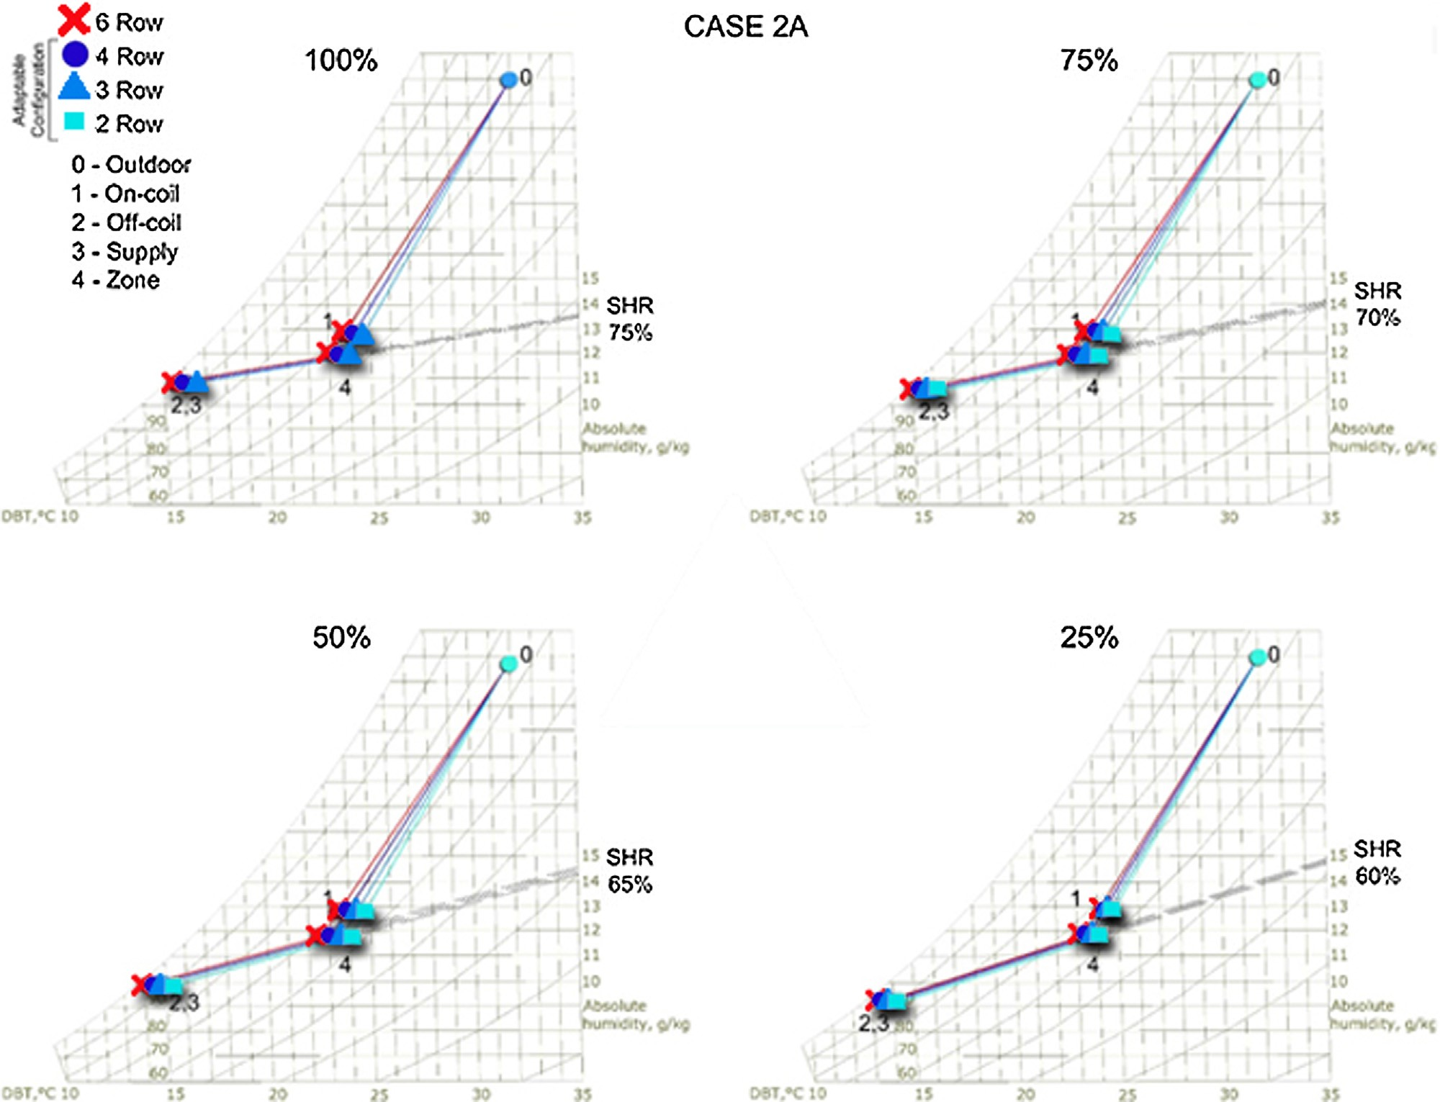

Fig. A3. Psychrometric analysis for CASE 2A.

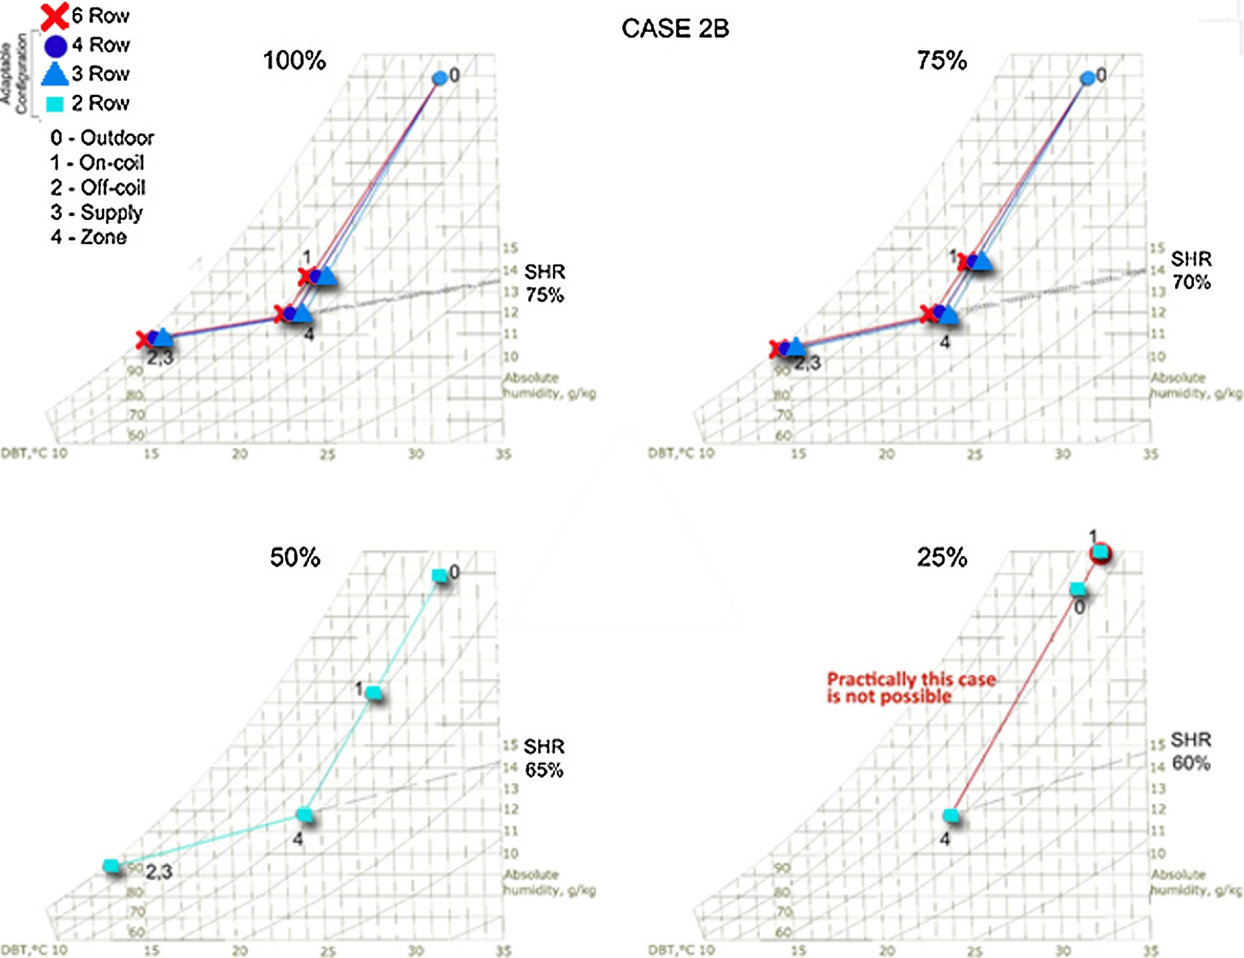

Fig. A4. Psychrometric analysis for CASE 2B.

References

[1] ASHRAE 90.1, Energy Standard for Buildings Except Low-Rise Residential Buildings, Atlanta,G, 2013.
[2] G.C. Hourahan, How to properly size unitary equipment, ASHRAE J. 46 (2) (2004) 15–18.
[3] W.K.C. Philip, C.H. Yu, Sizing of air-conditioning plant for commercial buildings in Hong Kong, Appl. Energy. 66 (2000) 91–103.
[4] H.H.P. Jacobs, State-of-the-Art Review Whole Building, Building Envelope and HVAC Component and System Simulation and Design Tools, Air-Conditioning Refrig. Technol. Institute, Arlington, VA, USA, 2002.
[5] P.B. Don, R. Felts, The State of Affairs-Packaged Cooling Equipment in California, 2000 (accessed June 15, 2016) http://cgec.ucdavis.edu/ACEEE/ 2000/PDFS/PANEL03/233.pdf.
[6] S.C. Sekhar, L.T. Tan, Optimization of cooling coil performance during operation stages for improved humidity control, Energy Build. 41 (2009) 229–233, http://dx.doi.org/10.1016/j.enbuild.2008.09.005.
[7] G. Amrane, K. Hourahan, G.C. Potts, Latent performance of unitary equipment, ASHRAE J. 45 (2003) 28–31.
[8] M. Khattar, M. Ramanan, N. Swami, Fan cycling effects on air conditioner moisture removal performance in warm, humid climates, in: Int. Symp. Moisture Humidity, Washingt. DC,April., 1995.
[9] H.I. Henderson, The impact of part-load air-conditioner operation on dehumidiﬁcation performance: validating a latent capacity degradation model, Proc. IAQ Energy (1998) 115–122.
[10] ASHRAE, Standard 62. 1- Ventilation for Acceptable Indoor Air Quality, American Society of Heating, 2016, 2016.
[11] BCA, SS 553: Code of Practice for Air-conditioning and Mechanical Ventilation in Buildings, SPRING, Singapore, Singapore, 2016.
[12] E. Djunaedy, K. van den Wymelenberg, B. Acker, H. Thimmana, Oversizing of HVAC system: signatures and penalties, Energy Build. 43 (2011) 468–475, http://dx.doi.org/10.1016/j.enbuild.2010.10.011.
[13] H. Mclain, D. Goldenberg, Beneﬁts of Replacing Residential Central Air Conditioning Systems: Beneﬁts of Replacing Residential Central Air

Conditioning Systems, Oak Ridge Natl. Lab., Knoxville, TN, USA, 1985 (accessed June 15, 2016) http://www.osti.gov/scitech/biblio/5866949.
[14] Z. Li, W. Chen, S. Deng, Z. Lin, The characteristics of space cooling load and indoor humidity control for residences in the subtropics, Build. Environ. 41 (2006) 1137–1147, http://dx.doi.org/10.1016/j.buildenv.2005.05.016.
[15] D.J. Worthington, Air Conditioning Apparatus Having Variable Sensible Heat Ratio, US4984433A, 1991 http://www.google.com/patents/ US4984433#backward-citations.
[16] X. Xu, L. Xia, M. Chan, S. Deng, Inherent correlation between the total output cooling capacity and equipment sensible heat ratio of a direct expansion air conditioning system under variable-speed operation (XXG SMD SHR DX AC unit), Appl. Therm. Eng. 30 (2010) 1601–1607, http://dx.doi.org/10.1016/j. applthermaleng.2010.03.016.
[17] Q. Qi, S. Deng, Multivariable control of indoor air temperature and humidity in a direct expansion (DX) air conditioning (A/C) system, Build. Environ. 44 (2009) 1659–1667, http://dx.doi.org/10.1016/j.buildenv.2008.11.001.
[18] P. Stephen, Kavanaugh, HVAC simpliﬁed, american society of heating, in: Refrigerating and Air-Conditioning Engineers, ASHRAE, 2017 (n.d.).
[19] K.J. Chua, S.K. Chou, J.C. Ho, A model to study the effects of different control strategies on space humidity during part-load conditions, Build. Environ. 43 (2008) 2074–2089, http://dx.doi.org/10.1016/j.buildenv.2007.12.005.
[20] A. Shaw, R.E. Luxton, Air Conditioner and Method of Dehumidiﬁer Control, Russell Estcourt Luxton and Luminis Pty. Ltd., 1989.
[21] Coil Selection and Rating Software, S.C.P. Limited, 2015 www.spcoils.com.
[22] C. Sekhar, U. Maheswaran, Cooling coil optimisation in hot and humid climates for IAQ and energy considerations, in: 10th Int. Conf. Heal. Build., Brisbane, Australia, 2012 http://scholarbank.nus.edu.sg/handle/10635/ 114049.
[23] ASHRAE Psychrometric Chart No.1, ASHRAE, 2016 (accessed June 16, 2016)
http://www.handsdownsoftware.com/ashrae-chart.pdf.
[24] ASHRAE, air-Cooling and dehumidifying coils, in: Ashrae Handbook-HVAC Syst. Equip, ASHRAE, Atlanta, GA, USA, 2012.

