Live Music Exchange Blog
Gig Going on London’s Periphery: Charting the Mainstream in the Margins – Dr Kevin Milburn
Posted on December 17, 2015

Dr Kevin Milburn’s post charts the shift of live activity in London from the early 1960s to the present day from the west to the east and southeast, highlighting the closure of significant venues along the way, including the Lewisham Odeon, played by The Beatles in 1963. The post shows that such sites were not threatened by lack of use or decline but instead because of being based in areas newly attractive to investors, alongside other external factors, a story very pertinent at a time when, according to one report, London lost 30% of its venues between 2007 and 2015.

As with musicians being generally hopeless at knowing what their best songs are, perhaps it’s hard to predict when posting social media updates which ones will take flight and which will remain resolutely earthbound. One such example was a Facebook update I posted in the summer relating to when The Beatles twice played in Lewisham (the borough where I live) in the early 1960s. I thought this might garner a couple of sympathetic ‘likes’ but it sparked a good deal more interest among friends than I anticipated. One reason may be that the scale of the Fab Four’s mythology is such that there seems something glorious and slightly ludicrous about the notion of George, Paul, John and Ringo ever having sprinkled their fairy dust on such local and reassuring quotidian places as the now disused old Ladywell police station, a site used by the band as a haven from fans ahead of their gigs just up the road in Lewisham.

When I think about The Beatles I think of the clips that are endlessly recycled, of the band struggling to be heard at Shea Stadium, or of Paul failing to keep his hair under control atop their Apple HQ in Savile Row. I don’t think of them playing in a site adjacent to what is now a DLR station in London SE13. Similarly, I struggle to comprehend, despite having watched the evidence, that Tina Turner, at the height of her mid-1980s pomp, really did film her ‘Private Dancer’ video in the Rivoli Ballroom, located, like the aforementioned police station, in a suburb (Crofton Park) of what is now a suburb (Lewisham).
Yet, in the early 1960s, there was nothing unusual about The Beatles playing in such a place. Indeed, in1963, The Fabs played in Lewisham twice, first in March and again in December, both times at the same location: the Lewisham Odeon. The venue had become part of the Oscar Deutsch Entertains Our Nation franchise the previous year. Prior to that it had been the Gaumont Theatre. When the 3,050 seat venue first opened, in 1932, it was the Gaumont Palace, its most fitting name, and one that it shared with what later became the Hammersmith Odeon, and which opened the same year as its south London cousin. There was nothing strange about The Beatles playing the Lewisham Odeon venue because it was merely a regular stop on the touring circuit for major acts. Other performers that played there included: The Rolling Stones, The Supremes, Johnny Cash, Ray Charles, Nat King Cole, and the Faces with Rod Stewart, a show that took place in November 1974, and which saw a Beatle once again on that stage, with Paul McCartney (and Linda), joining Rod and co. for a guest spot:
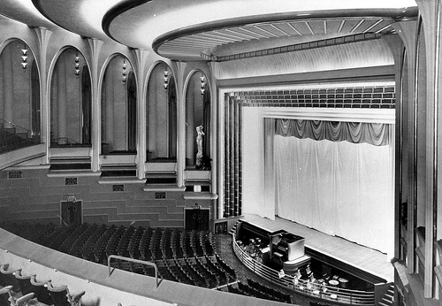
Lewisham Gaumont, later Lewisham Odeon, 1932.
Source: https://www.flickr.com/photos/oldcinemaphotos/2324602772

The point I’m trying to make here, in a roundabout way – perhaps appropriately, given that that a roundabout is tragically what the Lewisham Odeon eventually became – is that not only was it not peculiar at one time to see acts of that calibre in Lewisham, but that the same applied to other suburbs that encircled the capital. Most attention on musical London in the 1960s has been focused on more obviously ‘swinging’ sites, such as Carnaby Street and the King’s Road, but for much of the decade the halo of picture-places around the perimeter of the city remained the main places where people went to watch live music by ‘name’ acts. To get one’s musical kicks there was not always a need to go ‘up town’ or ‘Downtown’, to cite a key song of the era, written by the none more suburban Tony Hatch, born in Pinner, like Reg Dwight, in the far north west of the city, and then educated in Bexley, in the far south east.
An example of the significance of the giant suburban picture palaces to London’s postwar gig going life can be gleamed from the fact that Frank Sinatra, in his entire career, never once performed in cities of the standing of Leeds, Sheffield or Newcastle. But in 1953, on his only UK tour, he did perform in Elephant and Castle. And in Kilburn. And in Tooting. And in Edmonton. And in Hammersmith. Out of that suburban roll call the only of those venues that still hosts shows of course is, of course, Hammersmith. Like Lewisham, Hammersmith’s cinema went from being a Gaumont to being an Odeon. Unlike Lewisham it survived long enough to become, in 1990, a listed building. This guaranteed it an ongoing level of protection, one that was never accorded to its counterpart in SE13.
As late as February 1980 the 3,050 capacity Lewisham Odeon was still hosting shows by acts of the stature of The Clash. A year later, on 14 February 1981, it opened and closed its doors for the last time. Valentines stepping out on that Saturday for a final film night were presented with one last double-bill: ‘Prom Night’, starring Leslie Neilson, and the even less promising sounding ‘Love at First Bite’, featuring George Hamilton. The huge building then lay empty for more than a decade. Finally, in June 1991, the wrecking ball was moved into place and, in a matter of hours, the building was demolished. Unlike in many comparable instances, attempts to convert the cinema/concert venue into a bingo hall failed. The former palace, having lain empty for a decade, was then cut from the landscape. A road widening scheme was swiftly pasted over its footprint. A road widening scheme that Lewisham Council and the Highways Agency have, most frustratingly of all, spent all of 2015 undoing.
Meanwhile, the 1990s and beyond saw the more fortunate former Gaumont Palace in Hammersmith provide a timeline of sorts for the British live music industry, the ownership of that Odeon turned Apollo passing, in the last decade alone, from Clear Channel Entertainment to the MAMA Group, to HMV Group to AEG Live and CTS Eventim. Hammersmith survived as a major music venue, in part, because none of the other major suburban venues did. Acts too popular for the central London theatres but too small for, or not appropriate for, the sheds of Wembley and Earls Court had to play somewhere. But it also outlasted the other large cinemas in which, for example, Sinatra had played, by having the sheer good fortune to be located ‘in the right place’. With the exception of Elephant and Castle, it was closer than all the others to Central London, and thus benefitted from the glamour and relative convenience attendant with that. Hammersmith was also close to the largely West London based music industry, as well as to the BBC Television Centre, and is near to Heathrow and the motorways, all of which gave it a clear competitive advantage over comparable large, seated, non West End venues.
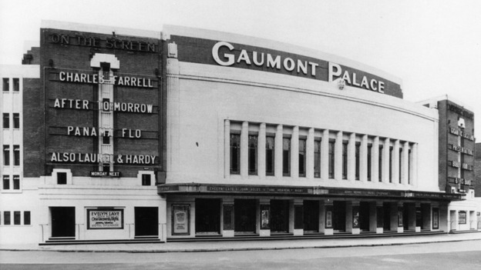
Hammersmith Gaumont, later Odeon/Apollo, 1930s.
Source: http://www.itv.com/news/london/story/2013-09-04/hammersmith-apollo-restoration/
However, one could argue that, increasingly, Hammersmith, and other smaller venues in that part of London, such as the Empire and Bush Hall in nearby Shepherd’s Bush, are themselves at risk of becoming somewhat geographically adrift, although clearly not to the same extent that, say, the Edmonton Regal or Tooting Granada had become by the late 1960s, when both stopped hosting concerts. For example, there is still evidence of cultural bodies choosing to move intowest London, as highlighted by the upcoming move of the Design Museum, from long-term home, a former banana warehouse by Tower Bridge, to its new one, the erstwhile Commonwealth Institute in Kensington. But such a move now feels the like the exception rather than the norm. Certainly since the start of this century, and arguably for a good time before then if one includes the development of London’s docklands in the early 1980s, the capital’s economic and cultural centre of gravity has shifted progressively eastwards. More recently it has also begun to creep southwards.
As has been well documented, the city’s music scene has mirrored this shift, and, at times, has perhaps even pre-empted it. Over the last fifteen years or so, the needle on London’s musical compass has twitched with increasing frequency towards the east. First, more and more musicians and music fans began to live in the east of the city. Soon afterwards, live venues opened to cater to them. Not long after that, small labels, independent music PR and the like began to move into the same neighbourhoods: Hackney, Dalston, Hoxton and the like. And now, lastly, even the big guns are on the move, as signaled by Universal Music’s decision to relocated in 2017 to a canal side location next to King’s Cross station, and perhaps just as significantly, next to the rights and collection agency PRS for Music’s, evidently as far east as both organisations dare brave. Being based in this watery location in a now vibrant cultural quarter – made so thanks to existing tenants such as Central Saint Martins and the Kings Place concert hall and home of The Guardian –means Universal’s next base in London will in some ways mirror its offices in Berlin, based as the latter is on the banks of the River Spree, just across from the rapidly evolving but still culturally distinctive district of Kreuzberg, i.e. it similarly is not located in a space traditionally associated with multinationals’ HQs.
In the same week that Universal announced they were leaving their current home in Kensington – also the location of the HQs of the other two major record labels, Sony and Warners – the main cultural focus for that area, the Odeon cinema, closed down, despite a great deal of well publicized local opposition. Taken together, the upcoming move of universal and the closure of the Odeon, perhaps suggest a lessening of the importance of creative industries and culture to west London life. A view strengthened considerably by the BBC’s move out of the area in 2013, one that saw the main music programme produced there, ‘Later… with Jools’, depart south-eastwards to Maidstone’.
Some of the challenges relating to the location of such organisations, which are major creative planks of west London life, whose presence shapes the character of the area, are also being felt, at a smaller but no less significant scale, by music venues, in that part of the capital. Of course there has been a lot of coverage on the Live Music Exchange forum and elsewhere in recent years about the closure of music related spaces in cities across the UK. When this debate has turned to London it has tended to focus on the decline of venues in the centre of the city as detailed here, and here and here and here. And it is certainly true that in central London’s Soho district, live music venues and associated businesses – such as night clubs, instrument shops, publishers, record shops, rights agencies, and so on – have closed due to being hit by multiple foes, these include: changing consumer habits, rapidly escalating business rates and rents, the temptation to cash in on rocketing land values, the tightening of local authority licensing regulations, the growing power of resident groupings, and the ravenous appetites of Phyllis and Ada, the Crossrail boring machines that greedily gouged on central London’s substrata between 2012 and 2014. But has been written about much less has been the threat to west London’s once vibrant cultural scene, a threat I contend is real if the closure of key entertainment consumption spaces is allowed to continue unabated, whether they be cinemas, as with the Kensington Odeon; nightclubs, such as the long since vanquished Hammersmith Palais, or live music venues, ranging in size from the huge – Earl’s Court – to the tiny, the Troubadour club in Old Brompton Road, currently up for sale and unlikely to host live music following any sale.
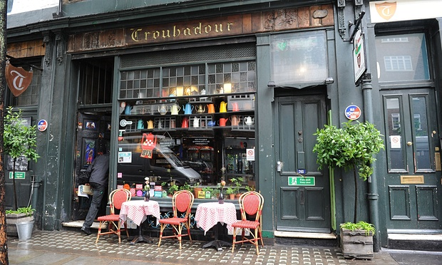
The Troubadour Club, Old Brompton Road, west London.
Source: http://www.theguardian.com/cities/2015/sep/09/the-slow-death-of-music-venues-in-cities
Nationwide there is a marked and worrying decline in the total number of music venues. In London the headline story has concerned threats, many of which have already come to pass, to venues in the city’s historic entertainment districts, such as Soho and St. Giles (especially Denmark Street), meanwhile, as just detailed, similar issues are being faced in the west of the city. However, much less commented upon has been the fact that in certain parts of the city, particularly the east and south-east, access to live music of a high standard is arguably more viable now than it has been for decades. In the same week that I was reposting and flagging up the Transpontine blog about The Beatles performing in Lewisham, I clicked on a link inviting me to read about London’s top 10 venues. Out of the 10, nine were located in east, south or south east London; none were located in the centre or the north of the city, two areas traditionally most associated with the city’s live music scene, and one only one, the Hammersmith Apollo, was in the west.
Irrespective of scenesters’ recurring tendency to champion their own backyards, the key point of such a survey is that if had been published a decade ago the geography of it would have looked profoundly different. I moved to south east London in 2004. By doing so, it was, at that time, effectively an acknowledgement that going to gigs would no longer be central to my life, so sparse were the opportunities to see live music in the area, coupled with the lengthy journeys that travelling from the south to the west or north of the city in pursuit of gigs involved before the recent development of the TFL Overground rail network. According to the most recent figures, provided by the Office for National Statistics in 2013, 1.4 million people live in the five most south-easterly boroughs of London (Southwark, Lewisham, Greenwich, Bexley, and Bromley). However, with the exception of Blackheath Halls, until recently there was not a single venue that served this population, one almost equal in size to that of the cities of Liverpool and Birmingham combined. The experience of Lewisham here is instructive. Over time, the amount of live shows in the borough declined due to a range of factors affecting venues: some were demolished, as with the Odeon; others were converted into nightclubs, such as the Venue in New Cross; some experienced a decline due to changes in the wider touring economy, Goldsmiths College Students Union being a notable example; whilst some were repurposed, as with the Albany in Deptford, a venue that went from hosting, in the late 1970s, early gigs by local acts such as Squeeze and Dire Straits, to being burnt to the ground, to then being rebuilt and reopened with a more explicit focus on local community events.
Of course, one geographical portion of the capital not having terribly easy access to live music of a certain scale (and there always remained a strong grass roots scene across multiple genres) is hardly one of the great social issues of our time. Nonetheless, it is interesting to note that this decline in gig going opportunities for local youth in the area from the early 1980s onwards coincided with a downtown in the previously notable role that this part of London had played in shaping popular music more widely. From the late 1950s until the late 1970s this corner of the capital was responsible for the emergence of numerous distinctive, and, in their different ways, important acts. These included: Tommy Steele (Southwark) David Bowie, Peter Frampton, Siouxsie Sioux, Billy Idol (Bromley), Kate Bush and Boy George (Bexley), Japan (Lewisham) and Squeeze (Greenwich), and, a little further east, Mick Jagger and Keith Richards (Dartford). By contrast, from the 1980s until the 2000s, with the exception of an ongoing strong soul and lovers rock scene in Lewisham, one highlighted by Mica Paris’s success, south east London largely lost its musical voice, one which, not long before, could be heard on radios and in clubs and venues in much of the world.
Now, finally, distinctive and varied musical output is again emanating from the area. Glancing at recent Mercury Prize shortlists is not always the most accurate guide to discerning possible trends but I think in this instance a look at these ‘album of the year’ shortlists is useful. There is always a danger of over stressing the importance of geography to music but I believe it is significant that, after a near total absence of any artists from south east London making the Mercury shortlist during the first two decades of the Prize – with the odd exception, such as Deptford’s Athlete, Crystal Palace’s Speech Debelle and Croydon’s Burial – the last five years have seen an apparently disproportionate number of musicians from this part of the capital make the shortlist, these include: Tinie Tempah (Plumstead then Peckham), Florence Welch (Camberwell), Eska (Lewisham), Kate Tempest (Brockley), James Blake (New Cross) and Katy B (Peckham), the last two having moved into the area to study music at the area’s most prominent higher education provider, Goldsmiths College.
Equally significantly, and quite possibly connected to this, this new generation of performers based in SE London districts have been forging careers at precisely the same time that new small venues in the area have been opening and garnering excellent reputations, as listed in the previously mentioned Fader survey. These include: Canavan’s and Rye Wax in Peckham, Warehouse space in Bermondsey and Corsica’s Studios in Elephant and Castle. However, the area is currently demonstrating just how worryingly short the time frame now is between a district experiencing a rapid flowering of its cultural scene and thus being ‘discovered’, (estate agent talk that disregards who and what was there before, akin to earlier New World ‘discoveries’) and the seemingly inevitable resultant threats then brought about by gentrification processes which often slipstream in behind, or frequently, drive such changes.
No sooner it seems, does a previously neglected area begin, finally, to get back on its feet than key cultural sites in that district find themselves under threat from rarely sympathetic redevelopments, irrespective of whether they are well established: as with the 136 year old Coronet venue in Elephant and Castle, an old stomping ground for local boy Charlie Chaplin, which is facing closure in 2017, or relatively new: the Bussey Building in Peckham, home to the ‘nightlife hotspot’ CLF Art Café and the aforementioned Rye Wax). These are sites threatened not through lack of use and the continuing decline of the area (factors that finally ‘did for’ the Lewisham Odeon). Instead, they are victims of the opposite: of being based in areas newly attractive to investors. The unfortunate irony is that the presence of vibrant cultural sites such as these is initially key to attracting capital, and thus people and businesses, into these areas. But despite having been central to stimulating activity and triggering migration into previously run down inner-urban districts, local artists and entrepreneurs (such as venue owners) invariably then find it difficult, if not impossible, to survive once new arrivals start moving into an area en masse. Though the latter may bring with them new ideas, energy and funds, just as often their presence results in a rapid escalation of property prices, rents and rates, and a general reshaping of the character of the area – not always for the better in terms of its creative vibrancy – as new moral geographies emerge with regard to issues such as licensing and noise levels.
The opening of an extension to the Overground rail network between south east London and east London in April 2010, a stretch that was soon labelled as ‘the culture line’, helped to transform both areas, but its positive effect was particularly keenly felt south of the Thames. Nonetheless, as just mentioned, many of the challenges of gentrification faced, for some time, by residents and business with a postcode starting with an ‘E ‘, have now come down the tracks and are similarly affecting those with an ‘SE’ in the last line of their address.
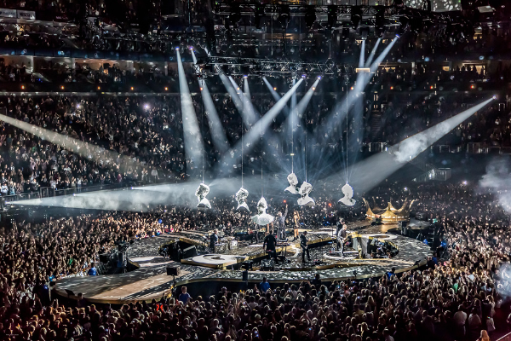
The O2, North Greenwich.
Source: http://www.theo2.co.uk/about-us/careers
During the last decade, and particularly since the opening of the AEG-run O2 in the south east of the city in June 2007 – an event christened with a concert by the not so local Bon Jovi – the surprise at seeing musical stars in this part of the capital has declined. The shock of bumping into the modern day equivalent of The Beatles in Ladywell or Tina Turner in Brockley, has lessened, although as highlighted below, is can still cause a slight stir. In other words, things are changing with regard to the local music geography of that global music industry hub: London. For many years – unless performing at the Brixton Academy, a venue located further west and closer to ‘town’ – musicians, like cabbies, rarely ventured across the river. Not unless, that is, they were migrating from south to north in order to further their careers. That situation is now reversing, at speed and at different scales: from pupils studying at the BRITS school in Selhurst; to musicians just starting out and keen to take advantage of the (relatively) cheaper spaces of south east London in which to live and learn, and rehearse and record; through to the BRIT Awards, which now has a permanent home in se London of all places, a situation unthinkable a decade ago. But perhaps it would be wrong to suggest that it is merely the presence of a venue like the O2 that now tempts musicians and music execs to do battle with the Blackwell Tunnel and to head south, there is also the not inconsiderable pull of the area’s local cuisine … http://www.thesun.co.uk/sol/homepage/showbiz/bizarre/4387678/Jay-Z-and-Beyonce-visit-Forest-Hill-cafe.html
By Dr Kevin Milburn
The title of this blog, and its double meaning, is a reference to the poem ‘Church Going’ (1955) by Philip Larkin (Faber & Faber). Thanks to Robert Chandler for introducing me to the work of Larkin and to the story of the Lewisham Odeon. The latter is one that Robert has recounted to me with admirable passion, whether reflecting on that venue’s glories or else railing against its grisly end.

