Risk Assessment Activity
Step 1: Identify your projects and audiences who might care about the data from your projects

Project Name | Audiences who might care about data from this project  (E.g. boss, funders, journalists, peer reviewers, ethics committee, research office…)

Step 2: Calculate your risk score
Write in the project names and audiences from Step One. Write one project and one audience per cell, you can repeat projects in multiple rows |  | What if someone from this audience requested your data for this project and you could not locate or interpret it?  Rate your risks and concerns for each group using the scales below. Then use those ratings to compute your risk score for that project.  (Emotional Distress + Reputational Impact) x Likelihood = Risk Score
Project | Audience | Emotional Distress | Reputational Impact | Likelihood | Risk Score
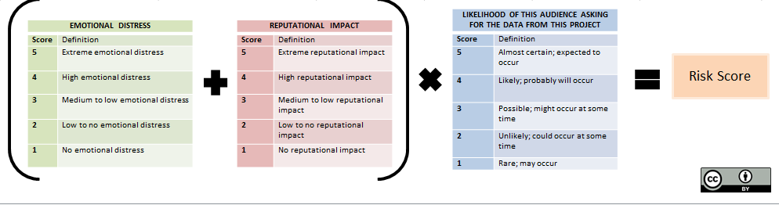
Step 3: Find out what to do
Risk Score | What to Do
Very High Risk (41-50) | Prioritise data management and data documentation above all other activities. Establish and implement a plan immediately
High Risk (31-40) | Setting aside time to address data management and data documentation is a priority. Establish and implement a plan as soon as possible.
Moderate Risk (21-30) | Setting aside time to address data management and data documentation needs is desirable. Risk should be monitored.
Low Risk (11-20) | Generally does not require action, but should be reviewed periodically.
Very Low Risk (1-10) | No action required.

Step 4: Personal Action Plan
Issue

What to do:

Who to contact/action:

Scheduled for: | Completed on:
Issue

What to do:

Who to contact/action:

Scheduled for: | Completed on:

Contacts
Ruth MacLeod, Data Curator and Archivist | Ext 6656  researchdata@lsbu.ac.uk
ICT Service Desk (for staff ICT issues) | Ext 6500  ictservicedesk@lsbu.ac.uk
LRC Helpdesk (for student ICT issues) | Ext 6678  llr-ithelpdesl@lsbu.ac.uk
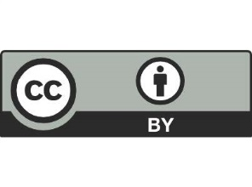
Adapted from Research Data Service, University of Illinois at Urbana-Champaign. “Making Data Management Manageable: A Risk Assessment Activity for Managing Research Data.” March 2017. http://hdl.handle.net/2142/95768.

