UniverCity: Images of Success and Structures of Risk.
Adam Brown, London South Bank University, London, United Kingdom.
103 Borough Road, London, SE1 0AA, United Kingdom
email: browna46@lsbu.ac.uk

Abstract:
The project UniverCity poses one key question: How can a representation that determines each element with absolute precision represent a space which, according to some definitions, is intended to contain absolute uncertainty? This research project takes various forms: a (more-or-less) conventional academic paper, a series of blog posts about CGI renderings of new universities or university buildings, a series of visual elements, and a web forum. This project is conceived and produced in the understanding that it will function as an element of construction in both a real and an imaginary new university building. Each different form is intended as an experiment with the literal meaning of this idea. Each is intended to possess the potential to be architectural, maybe sculptural - something like a brick, a block, an I-beam – part of an existing or future structure, yet able to be reclaimed, recycled, or recombined in structures produced by others.

Keywords:
Architecture, photography, digital, rendering, imaging, economics.

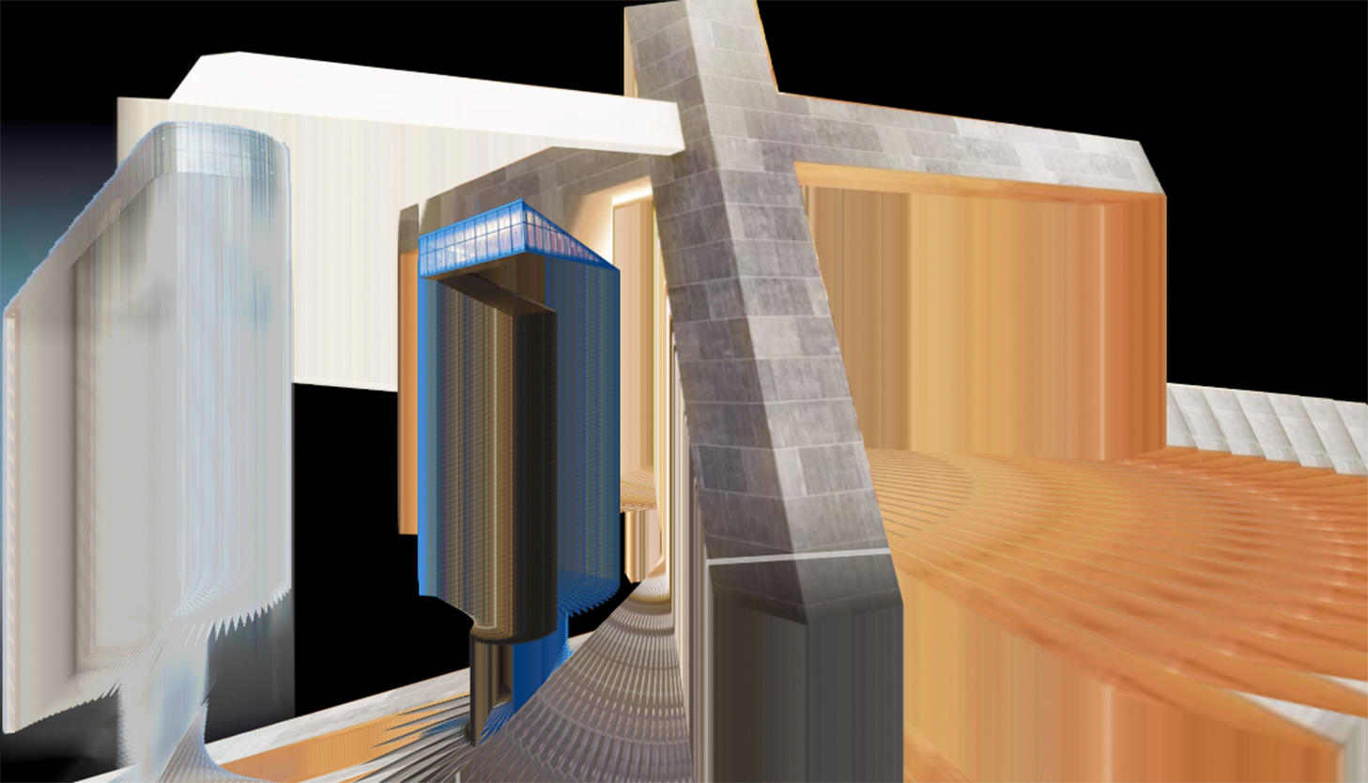
(Image: UniForm 1, the author, 2017)

Representing the Future University: Unfinished Business.

It is impossible to separate the digital representation of architectural space from notions of control. Pelletier and Perez Gomez claim that ‘architectural conception and realization usually assume a one-to-one correspondence between the represented idea and the final building. Absolute control is essential in our technological world’ (Gomez and Pelletier 1997, 3). In previous papers, I have written about how computer generated (CGI) images of future buildings co-opt tropes of photographic representation – excess of detail, compositional spontaneity, and synthesised or collaged traces of future events – in order to sell commercial and residential space ‘off plan’ to investors seeking as much certainty as a representation can provide (Brown 2013). This is problematic in the field of commercial real estate, yet possibly even more so when attempting to visualise universities yet to be built. It could be argued that a space for the production of knowledge must be unrepresentable – a location in which something intangible and unpredictable is intended to emerge via a process by which groups of human (and nonhuman) agents, from students to academics and technologies, engage in processes of collective exploration and/or structured disagreement.

Though I might call on various constructivist or radical pedagogical traditions to support this statement – for example Ron Barnett’s description of the critical role of the university in a ‘rational … (and) self-transforming society,’ (Barnett 1997, 7), a process of transformation which is by nature indefinite – a key paradox arises when confronted with digital architectural renderings of university architecture, inhabited by what James Bridle terms ‘render ghosts’, collaged or computer-generated images of students, academics and (very rarely) support staff (Bridle 2013). One could claim that such images of human forms are intended to represent subjects engaged in the dreaming or production of economic, cultural, historical, technological or political realities, but also possibly involved in the reimaging of such categories, in accord with Barnett’s notion of critical societal- and self-transformation. What kinds of speculation on their history or future might be taking place? It is possible – and necessary – to imagine these digital ciphers engaged in critical reflection about their journey to the space in which they find themselves, as political beings capable of reflecting upon their own choices, circumstances and possible privileges. It might be that some of them are engaged in consideration of the critical and political role of images: a perverse and provocatively reflexive proposition.

Bill Readings, in The University in Ruins, describes the university as a space irreducible to various forms of representation, from PowerPoint or spreadsheets to descriptions of past, present and future realities to potential investors and funders in meetings, corridor conversations, or social situations (Readings 1996). However, the assault of what Readings identifies as bureaucratisation and a culture of ‘excellence’, constructs the modern university as a ruin of a previous form, one in which the maintenance of processes of speculative enquiry was a core ethos:

It is imperative to accept that the University cannot be understood as the natural or historically necessary receptacle for such activities, that we need to recognize the University as a ruined institution, one that has lost its historical raison d'etre. At the same time, the University has, in its modern form, shared modernity's paradoxical attraction to the idea of the ruin, which means that considerable vigilance is required in disentangling this ruined status from a tradition of metaphysics that seeks to re-unify those ruins, either practically or aesthetically (Readings 1996, 19).

Thinkers in many fields, including philosophy, pedagogical theory, and indeed architecture, have challenged the containment of knowledge production and exchange within built structures, which mirror institutional and political formations (Hickey-Moody, Savage, and Windle 2010). However, in identifying the university as a place in which speculative or critical activities are deemed proper, Readings’ analogy of the ruin poses key questions regarding the perfected digital rendering of the institution: is the gleaming CGI structure in fact a representation of a ruin of the university itself? The rendering could certainly be said to represent an example of the aestheticising force of the metaphysics to which Readings refers. In its very perfection, the rendering can only represent an imperfect state of indeterminacy.

Pelletier and Perez Gomez’s longitudinal field study of architectural projections explores how the domain of projection is far from value free, indeed, it is fiercely contested. Taking a cue from their work, examination of digital images of future universities – as a quite specific (not to say specialist) subset – reveals that these representations precisely attempt to project ideas related to both forms of knowledge, and methods of knowledge production – which ordinarily include, amongst other methods, disagreement, opposition, friction, and indeterminacy. Despite a plethora of attempts to render in a predictive way spaces of indeterminacy, interdisciplinary mixing, free social association, or innovative turmoil – some of which are catalogued on my web forum UniverCity (Brown 2016) – no representational technologies can be considered entirely transparent or value free, as they are deployed in the service of a spectrum of ideological positions. Such technologies are universally rolled out in an attempt to seize control of the future – epistemologically, ideologically and financially. That for Pelletier and Perez Gomez the mechanism of representation is ‘value laden’ should come as no surprise to anyone interested in critical process, such as Barnett. Significantly for Benjamin, in ‘Author as Producer’, production of the means of production is itself the site of struggle (Benjamin 1935).

My research project for the disrupted Journal of Media Practice, has included the establishment of a web forum, which takes the form of a semi-parodic version of SkyscraperCity, but solely for images of universities, as well as for critical perspectives and interjections on academic architecture. The online community SkyscraperCity was initially founded by Economist Jan Kleerks in order to share and solicit comment on urban development in Rotterdam. Since its inception in 2002 it has grown into what arguably is the largest online bulletin board in the world, with close to a million members. Devoted to the global sharing of images of architectural megaprojects in proposal and development, the extent of SkyscraperCity’s membership parallels the content it hosts: discussions on scale, cost, and expense, but also on aesthetics, and occasionally on the social and political impact of the architecture the forum frames. As a pipeline that funnels image to audience, SkyscraperCity’s simple structure and intention has allowed for the massive accumulation of a bank of architectural images and commentary, a repository of images of the unbuilt, the built, and reactions to both. As John Gravois remarks, comments are usually ‘variations on that most human of utterances, "Wow". On SkyscraperCity, every forthcoming apartment complex, luxury hotel, and shopping emporium - indeed, virtually every tower crane in the developing world - seems to have a cheering section’ (Gravois 2010).

Amongst images of unbuilt towerblocks and city districts, the occasional university development can be found, subject to the same kind of critique as other featured projects: how big is it? How expensive? And, of course, ‘wow’ (though occasionally more critical comments are volunteered). If it could be argued that part of the purpose of the contemporary university is to produce buildings, then for me it seemed like a good idea to juxtapose this aspect of academic work – that which is directed towards the sustainability of the institution, growth or the production of capital – to the kind of labour in which I was engaged at ground level: that of research and pedagogy. The various fora for evaluation of academic research outputs, from the exchange of spreadsheets in preparation in advance of the REF, to the showcasing of staff successes in the context of school or staff meetings, seem to be similarly staged to produce or elicit various kinds of ‘wow.’ At least in SkyscraperCity, a ‘wow’ is considered appropriate, and not a debasement of some higher form of critique. But ultimately a wow is a wow: it is a qualitative judgement. An accumulation of such ‘wows’ could be considered quantitative data.

The rendering or flythrough gives the student, academic or investor the vertiginous experience of standing on the 25th floor of a new university block, gazing down on the campus beneath. As academics, we write and work between thrill and despair, like gamblers, or speculators. What can the image persuade us to do, by the push of fear or the pull of hope?

At this point in time, as I join one institution (a university) after leaving another (an FE/adult/workers’ education institution, in which my role involved the production of future undergraduates), at a time of rapid and unpredictable change in both the education sector and society in general, it is very necessary for me to ask this question. Tasked with assisting in the emergence of agents both critical and speculative (in relation to an aggressive market) in my previous educational role, I found that in the advice I was giving to students, I was increasingly working with ideas of affect, spectacle and ‘dreamwork,’ to use Mark Fisher’s phrase (Fisher 2009). For Fisher, one has to acknowledge a number of inconsistent ideas at the same time in order to make sense of a rapidly changing, apparently diversifying, yet increasingly bureaucratic and homogenised environment – a condition which, like Readings, he considers as characteristic of institutional and social structures under late capitalism (Fisher 2013, 60). The effort to overcome this problem of inconsistency involves ‘dreaming’ that such problems are solved, as if the only tool capable of overcoming such cognitive dissonance is the unconscious (Fisher 2013, 61). Here, Fisher echoes Stuart Hall’s concept of Dreamwork, which Hall identifies as a key function of colonial societies (for Hall specifically the UK) (Hall 1978). For Hall ‘dreamwork’ expresses a form of ‘collective forgetting’ in relation to inequalities of power, colonial histories and economic and political networks. It could be claimed that the network, as it is currently produced and reproduced, encompasses specific technologies the purpose of which is to elide ‘difficult’ relationships of production: colonialist for Hall, but ostensibly broader. In my experience, I found myself in the double bind of encouraging critical acuity in relation to image reception and production on the part of the students on the one hand, yet on the other hand, at the point of imagining the students’ possible future, being utterly beholden to images of gleaming campuses, high-production value websites, and representations of academic life which seemed in every sense simulacral. Academic institutions appeared to be morphing into a global University as dreamed by Baudrillard – and like Baudrillard’s Disneyland, these heterotopic theme parks seemed to exist to support the illusion that what is outside is unreal – not by setting forth a manifest unreality, but by collectively representing the unreal production of more reality, all the time, all together, at increasing speed (Baudrillard 1987).

It is a curious kind of economic crisis that, as it produces so much debt, gives rise to so many buildings, and such phenomenally accelerated production. In turn, it is a curious kind of architecture that gives rise to so many images of itself – before, during and after the building has been completed. Derrida, in his text from 1983 ‘The University in the Eyes of its Pupils,’ explores what the university sees (Derrida 1983). Here, after Fisher, the question is what does it dream, now that dreaming has the status of a means of production?

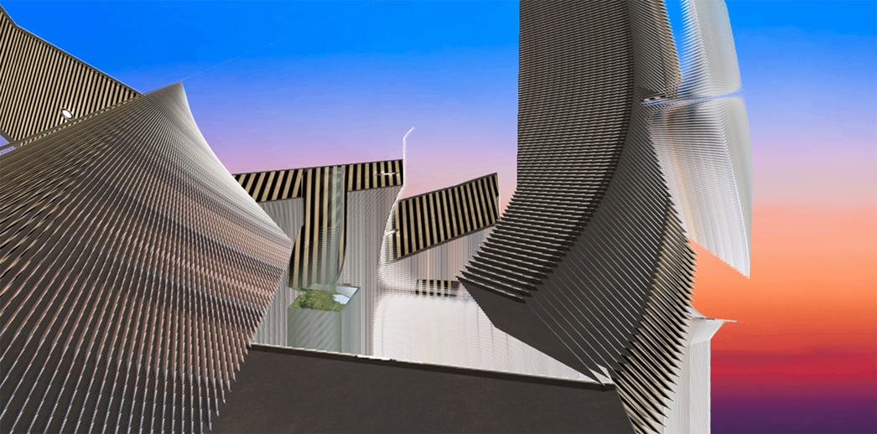
(Image 2: UniForm 2, the author, 2017)

Problem 1: Under_mine

Here’s one of my dreams: I am trying to imagine that by the very fact of my labour in writing this paper/posting my content online, a digital building will begin to become visible – a representation of a space yet to be constructed. As I write, the institution that employs me is in the process of commissioning a new facility for the Department of Arts and Creative Industries, within which I work to produce new knowledge. This work includes efforts to empower existing but previously unrepresented knowledges, including the ideas, positions, and shared/communal knowledges of undergraduates, postgraduates and academics, and advances itself through acknowledgement of the history and context of the creative subject at all levels. To enable such empowerment, an upgrade of facilities is necessary and welcome. Eventually, if enough assent and political will is marshalled by the institution, this digital building will become a physical artefact – construction will occur, foundations will be laid, and a structure will emerge, replacing other structures which occupy the north-western edge of the LSBU campus. In trying to understand the link between my writing and our building as causal, to find a way to describe my very actions now (fingers hitting the keys, the fabulation of sentences from thought, the work undertaken to imagine the responses of a reader, or respond to those of a reviewer) I can use various structures to map the connections between here/now and there/then. If I so choose, I can draw on economic and bureaucratic functions, for example: Fisher identifies the culture of auditing (class inspections, or research assessment and evaluation) as very much part of this moment, and representative of a kind of ‘glitch’ which implies that some degree of resistance to bureaucracy and absolute subjection to its imperatives (a condition that is internalised to some degree by anyone crossing the threshold of the institution) can be reconciled seamlessly – this dreamwork is part of the function of the institution at this moment (Fisher 2013, 54-55).

It should be said here that I am not writing against the spreadsheet, nor am I making a simplistic opposition between a technologically enabled bureaucracy and a glorious condition – past or future – of liberated academic production (in olive groves, factory canteens, flexispaces and the like). However, considering the spreadsheet as an intervention between writing/thinking and building means I can (maybe creatively) describe the whole process as linked, causal, connected, and machinic. It could also be that the intervention of the spreadsheet, the index by which my production is measured, has become perceptible as a means by which space is produced.

Following this argument, it could be said that, as I write now (with acknowledgements to Derrida), on one level I am working to produce capital, which down the line could be deployed in the service of the production of space. I want to imagine – or dream – a state in which my keystrokes are in a very real sense architectural. However, it is not the quality of the facilities but how they will come to be occupied which will determine the nature of the knowledge produced. Such occupation is difficult to represent – CGI renderings of universities are packed with CGI students, their shadows, images or outlines, but struggle to represent intangibles such as discourse, association, or agonistic processes. What I have chosen to problematise in this project is not what is necessary, as much as it is the representation of what is perceived to be necessary. The fact that images are involved – as well as the way in which they are deployed - matters to me as someone who teaches students to be reflective and critical producers, consumers and manipulators of images.

…and photography?

Within the University, as much as in the global real estate market, it appears that the work of construction is secured against measures of confidence and calculations of risk, some element of which will (for sure) be factored against my small contribution to the research output of the University. It could be argued that my ability to generate capital is predicated upon my ability to produce confidence. The existence of such bureaucratic structures to which I (and Fisher) have referred, allow me to suggest, as I have argued earlier, that there could exist an indexical, causal link between every word I commit to file, and the production of a physical space. My labour is measurable via machinic processes, and as such it begins to resemble photography – in the sense of what Flusser intends when he claims that ‘technical images are the indirect products of scientific texts’ (Flusser 2001). The relationship between texts, images and production is interlinked and complex due to the intervention – and the idea – of mechanisation.

Writing from within the field of photography, the index and the trace both interest me: I have written before about how the digital image of a building in advance of its construction reverses the causal chain upon which indexicality depends: the digital architectural rendering precedes the fact (the building, the space), rather than tracing an image of a pre-existent reality. Beyond this, the rendering purports to represent space in a way that is arguably causal, quantifiable and measurable, and not merely projective, due to the agency of information technology: convergent technologies increasingly bring methods of visualisation, structural calculations, and costing together on the same platform (Brown 2013). The work that goes in to making the rendering realistic, arguably contributes to its becoming real. It is likewise possible to argue that the act of writing – this file, this paper, this project – is similarly linked (via a reverse causal chain) to such developments thanks in part to the kinds of bureaucratic monitoring of academic labour critiqued by Fisher, Readings and others, which could be argued to be equally subject to the effects of technological convergence (Fisher 2009, 40; Rolfe 2013; Readings 1997). The production of academic output is part of a network which produces buildings: first digital models, then images, then bricks and mortar. I wish to suggest that within such a network, it becomes problematic to identify an order of succession in the causal chain – yet this problem is a productive one.

These issues of convergence and causality intrigue me at an epistemological level. Properly functioning, the university could be described as one of many mechanisms for the production of realities. To consider the university in the abstract is to imagine or project the necessary mechanisms for such production. Images of universities always already attempt to predetermine a deferred reality, or a hope or dream for new realities as yet unthought, unproduced, or undreamt. Whether digital or traditionally photographic, the visual image of the university can only ever be an abstraction – but as Lefebvre has argued, the work of abstraction can also be considered a form of violence (as quoted in Neary and Amsler 2012) – the friction-free user-navigable flythrough of the digital campus-to-be, represents not only a metaphor for immediacy, efficiency and futurity, but in some cases represents the removal of resistance. I would argue that images of buildings are representations of the spaces of future collectivities – literally in some cases if we include the aforementioned crowds of CGI students or ‘render ghosts’.

How, where and why is reality produced, and can its means of production be represented in the form of an image? A close and critical examination of images of spaces intended for the production of future realities can help address this question, or at least illustrate the complexity of the problem. Apart from the obvious fact that the events these images of spaces depict, occur in a possible future, it is possible to trace a causal mechanism linking the image to the thing represented. The fact that time appears to run backwards is not unusual at all, when placed in the context of contemporary economics. Debt, according to Betancourt, represents capital secured against future labour (2010). Debt can be generated against a future building as much as against an already extant tangible, physical asset.
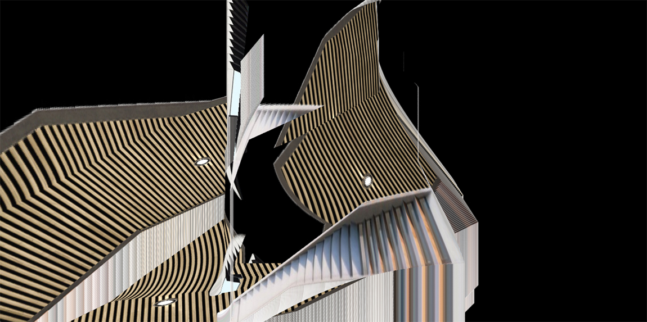
(Image 3: UniForm 3, the author, 2017)

Problem 2: Finance

The advent of what Michael Betancourt terms ‘digital capitalism’ reconfigures widely accepted understandings of causality (2010). Describing a ‘shift … from a physically productive economy to one based on semiotic manipulation,’ Betancourt describes how value systems based on labour, physical processes, limiting factors and scarcity, have been superseded by circumstances in which present wealth depends on future events: capital is generated via ‘the extension of credit: the creation of liens against future productivity encapsulated in the iteration and exchange of immaterial 'commodities' within the marketplace’ (Betancourt 2010). In the realm of higher education, capital in the form of ‘title to future labour’, manifests itself not only in the increasing role of finance – bonds issued by universities, students accumulating debt in the hope of future prosperity – but also in the efficacy of digital representations to undertake acts of semiotic manipulation in order to promote the University to students, political agencies and investors (Betancourt 2010). The representation, both in the form of the spreadsheet and the architectural rendering, becomes implicated in the ability of the institution to sustain itself in the kind of economic and social system described by theorists such as Betancourt. Images, spreadsheets and financial products, amongst other things, all become sites of contestation, in an ongoing discussion of what is to be.

Using the spreadsheet, amongst other technologies and mechanisms, academic research outcomes (such as this one) are quantified and given a value in relation to politically determined performance indicators. Via the rendering, a calculation of intellectual capital (scope, ambition, contribution to new knowledge) is converted into a visualisation of a possible future for the institution. Via the rendering, allies are recruited and political will is generated which increase the possibility that the building will become ‘real.’ Gillian Rose and Claire Melhuish, in their rich and thorough study of the affective role of digital renderings in the development of Doha, in Qatar, remark on how the rendering serves as an agent with the ability to recruit large numbers of allies from the technical, financial and political spheres, supervening the expert knowledge needed to interpret architects’ drawings or data.

At one level, it was vital for the architects to produce effective imagery to communicate with the client body, because it involved a hierarchy of different people, not all of whom could understand architectural drawings well. They therefore relied upon 3D images to generate design decisions, sign-offs of consecutive work stages, and payment of fees. But at another level, images had to be ‘affective’, to mobilise belief in the project, not just as another real estate development, but as a flagship for distinct ideas of Qatari culture and heritage. As a Msheireb marketing manager pointed out, the project required an enormous amount of political will and commitment. [my italics] (Melhuish, Degeen and Rose 2013, 10).

The recruitment of allies and the generation of political will – roles played by an image possessed of agency – are mobilised to produce a future. The agency of the CGI image manifests itself as a part of what Thomas Hughes describes as a ‘seamless web’ – a network of social and economic factors which contribute to the status of technology as social agent (Hughes 1983). If there is no seamless web, there can be no technology, from which it can be implied that the other elements of the web (i.e. financial, political) can be read off the surface of the image itself by both observing their presence or absence. The image’s style, form, or aesthetic are not separable from the context of its production. And, I would argue, images take part in exactly the kind of ‘dreamwork’ that Fisher describes as necessary to reconcile the many inconsistencies presented to those who experience various journeys through the institution. The renderings on which I choose to focus can be analysed for signs of the work involved in their own production: they make this work visible, under certain critical viewing conditions: such conditions also reveal key mechanisms which lead to the concealment and elision of labour of certain kinds.

In Betancourt’s model, the digital functions as an enabler of the ‘financialisation of everything,’ by fostering illusions of ‘accumulation without production’ and infinitude, amongst other by-products of semiotic manipulation (Betancourt, 2010). There is a particular stylistic feel to this digital moment, not just in terms of the images the digital produces – which seem to reproduce and reify metaphors of weightlessness, friction-free movement, and liberated geometries – but also in its writing. The digital demands that we write about the digital: it produces writing about itself – not merely due to the imperative to tackle what is seen as a contemporary moment or crisis, but because the mechanisms of critical production (i.e. research activity, academic labour, publication, visualisations) are now mediated by practices and technologies which suspend our realities somewhere between present and future. The ‘digital revolution’ and the ‘financialisation of everything’, can be seen as two elements of one cultural moment: what some commentators argue to be the apotheosis of the very forms of colonialism that can be found at the outset of the project that brings into being the modern University as institution and idea (Foucault 1966; Ghosh 2016). Echoing Hall, the future itself has been colonised by the digital: via the popular uptake of infrastructures, the very purpose of which is to create or pre-empt futures (pun intended) (Hall 1978). In this moment, debt as financial instrument, as acknowledgment, as influence, or as reference, all meld as parts of a contiguous field.

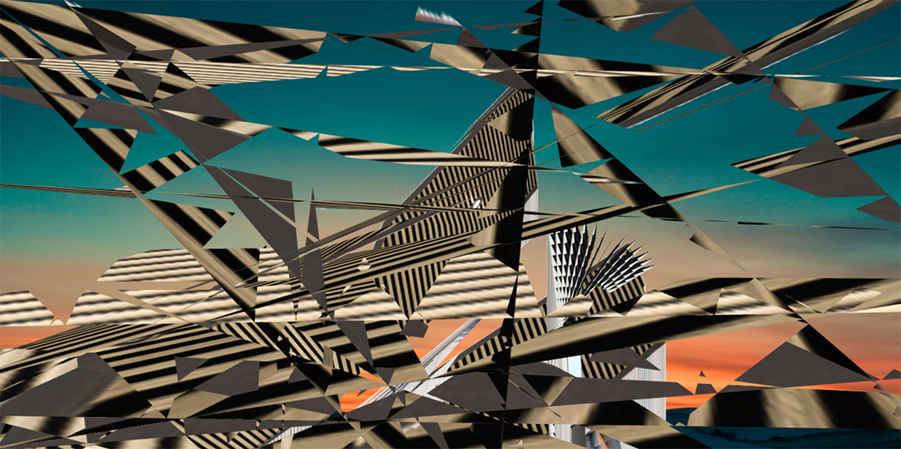
(Image 4: UniForm 4, the author, 2017)

Problem 3: Knowledge and its others

Rose & Melhuish, exploring the affective role of CGI images in the context of the redevelopment of Doha, write:

CGIs may be seen not simply as representations, but as inscriptions, or crafted objects, which have affect and agency in the production of architecture and design. This agency derives from a process of making which engages many different actors and a wide range of technical and artistic expertise, in a complex network of distributed craft practice, and intensive interaction and negotiation. They are then, affective and effective inscriptions which result in the construction of facts (Melhuish, Degeen and Rose 2013).

Creating CGI universities could be described as the construction of facts about the future location of the production of facts. However, a university is, of course, much more than this, and facts are very curious beings – after Latour, facts seem to exist to be worshipped: their fact-ish status depends upon their ability to generate faithlike adoration (Latour 2009). Even in the case of facts, the degree of agency they can muster, depends upon the context and manner in which they are deployed. In a well-argued defence of the role of critical practice within academia, Ron Barnett writes:

… what counts as knowledge is more open, being more subject to definition by others. … Academics have to become practising epistemologists, but in a radical sense. They have to go on continually legitimising themselves. They have to demonstrate that their definitions of knowledge matter. They cannot demonstrate that their definitions of knowledge are the only true way; there are too many other claimants now. … they demonstrate their competence in metaknowledge, that they really know about knowledge. … The academics give us plausible stories about the stories (Barnett 1997, 151).

Such a concept of the university as a place for debate, rather than a factory for facts, can be found at its origin. In Mochlos, Derrida returns to Kant’s 1798 text, the Conflict of the Faculties (in Derrida 2004). Predating the establishment of the fully-fledged Enlightenment institution, Derrida describes how Kant’s writing-in-advance-of-the-fact sets out a vision of an ideal university constitution characterised by a ‘division of labour’ between instrumentalist (state-serving) faculties (law, medicine, theology) and philosophy. The latter is able to articulate problems in order to ask difficult questions about truth itself, and by so doing temper the former, which have tendencies to absolutism due to their institutional relationship to the will of the State. In such an ideal university institution, reality is produced within a predetermined divisional structure. Yet the university itself is founded as a state institution, and exists to moderate, modify and produce knowledge for certain key enlightenment purposes – notably the expansion of technology and its deployment, which, Derrida writes, are for Kant necessarily tempered by notions of reason and democratic justice. Progress is a given. It is this enlightenment rationale that Derrida calls into question, both because it confers status upon itself and because it is based on a core irrationality. Derrida demands that intellectual and critical enquiry should always critique the institutional basis for its production:

We argue or acknowledge that an institutional concept is at play, a type of contract signed, an image of the ideal seminar constructed (my italics), a socius implied, repeated or displaced, invented, transformed, menaced or destroyed. An institution – this is not merely a few walls or some outer structures surrounding, protecting, guaranteeing or restricting the freedom of our work; it is also and already the structure of our interpretation (Derrida 2004).

Any institution (recalling Berger and Luckman’s use of this term in The Social Construction of Reality (Berger and Luckman 1966)), is a social formation or an idea of a social formation before it occupies a building. The building is an index, or in Derrida’s terms a ‘theatre’: ‘a representation by delegation and a theatrical representation’ of the site of the production of knowledge (2004).

The university, in both its built and ideal state, stages the production of knowledge: this theatrical role underscores its very origin. It is not the entire site for the production of knowledge, but it places the responsibility on critical thinkers to continually rethink the means of its own production; the institutional contexts (in the broadest sense) that give rise to the possibility of knowledge production. In this respect, any social representation which associates knowledge and its production with such a site in a non-theatrical way, is not a true representation of a university at all, at least in the sense that Kant or Derrida would have it. How can a representation produced to determine a future depict the university’s productive conflict, or in other terms, its processes of formation, rather than its form?

Henri Giroux’s concept of public pedagogy represents one contemporary perspective from which to tackle the challenges and possibilities of the production of knowledge through, outside of, and within the University. Giroux’s ideas oppose dispersed, extra-institutional processes of knowledge production and acquisition in a heavily mediated society against institutional structures, as well as activist pedagogies and means of knowledge transmission (Giroux 2004). For Giroux, the dispersed university already exists, only it exists via dominant and mediated social formations (under the umbrella term ‘culture’), which have sufficient powers to potentially overwhelm any critical challenge. Dominant or emerging formations of power have already produced the ‘institution without walls’ – in the form of certain forms of popular media, online fora, and the market-led disruption of established pedagogical practices, for example. Though the Occupy movement and its educational activities stand for Giroux as one example of the kinds of progressive and democratic possibilities enabled by an escape from architecture, other extra-mural practices exist which reinforce dominant or (increasingly) libertarian strands of practice: it is not architecture itself that makes the difference. For Giroux, power has already dreamed, thought and produced the anti-university.

In relation to architecture, forms of flexibility, mobility and dispersion such as those deployed by activist pedagogies, represent an attempt to recapture the means of the production of knowledge through occupation, as opposed to architectural construction. Giroux posits that collective knowledge creation in everyday action, and everyday space, is not in itself a radical phenomenon. Architectural production itself can construct spaces which position themselves outside the free-flowing, chaotic, accelerated world of powerful public pedagogies. Here, Michel de Certeau, maybe Bourdieu, and certainly Lefebvre, are similarly useful in articulating both the idea of the public/social construction of knowledge in everyday life from the perspective of the end-user, and the philosophical ramifications of such an idea for institutional forms of knowledge production within society at large (De Certeau 1984; Bourdieu 1984; Lefebvre 1991). In this light, mapping any kind of opposition between ‘architectural’ and ‘extra-architectural’ sites of learning/knowledge production, is problematised: architectural structures are not necessarily ‘conservative’ and neither is extra-mural pedagogy always ‘progressive.’

Knowledge production overflows the university as institution both in the sense of socially determined /delimited practice and of location/place. If Kant sets out the historical machinic/industrial origins of the establishment of a formalised institution for the production of knowledge, for Giroux, forms of activist knowledge production and sharing represent a challenge not only to institutions but to a culture of knowledge production and sharing which is already dispersed, and which a commodified, spectacular architecture is powerless to challenge in and of itself.

On the subject of foundations, Derrida writes:

If there can be no pure concept of the university, if, within the university, there can be no pure or purely rational concept of the university, this — to speak somewhat elliptically, given the hour, and before the doors are shut or the meeting dismissed — is due very simply to the fact that the university is founded. An event of foundation can never be comprehended merely within the logic that it founds. The foundation of a law is not a juridical event. The origin of the principle of reason, which is also implicated in the origin of the university, is not rational. The foundation of a university institution is not a university event (Derrida 2004).

For Derrida, then, the CGI image of the university must be something very different from the university itself, and functions as an act of foundation, not a university event. It is a trace of the university as seen from the outside, intended to signify something unsignifiable – something continually undertaking a process of self-definition.

Challenge: The de-architecture of antiuniversities

In order to field-test these ideas, we might look to structures or associations that cannot be represented using CGI technologies. The recent work of the revived Antiuniversity of London, frees itself from architectural constraint, and thus escapes the reach of totalising imagery. Geographically dispersed, crowdsourced, management-free and fee-free, the idea of the Antiuniversity commissioning a building is incongruous. The Antiuniversity is intended to emerge from the lived experience of an empowered and critical public.

Certain similar ventures are able to achieve productive momentum by repurposing the existing spaces of institutions themselves. The University of Lincoln’s project Student as Producer, initiated by Mike Neary and Sarah Amsler (2012) and rolled out campus-wide, responded to changes in government funding which privileged research over teaching by redefining students as not passive consumers, but active researchers, agents in the production of knowledge. The project demanded that ‘academics … design into their curriculum … student research and research-like activity at all levels of undergraduate programmes, for the production of new knowledge and not simply as a pedagogical device’ (Neary and Amsler 2012, 122). Claiming that ‘the modern university is fundamentally dysfunctional, with its two core activities – research and teaching – working against each other,’ the project explicitly challenges the ‘commodification of intellectual and social work’ (Neary and Amsler 2012, 122). Deploying the language and ideas of critical pedagogy and social constructivism, the project represented an experiment in what was possible if such ideas were taken at their word. In their own words, the project has involved ‘the development of critical pedagogies in existing educational spaces and situations, the building of cultural resistance to the logic of capital in academic institutions’ (Neary and Amsler 2012).

Taking a cue from the Occupy movement, as does Giroux, the Student as Producer project occupies the space of the existing university – and in this sense is unrepresentable. Such a project can have no architecture, no totalising vision. In this light CGI architecture can only produce digital analogues of sites that have the potential to be occupied in the future. Some sites already are occupied, if we take into consideration the recent wave of rent strikes protesting against the commodification of student accommodation (Ratcliffe 2016). Such events admit knowledges into the institution which were formerly considered to be improper – issues of labour, finance and debt are not customarily supposed to impinge on academic debate or seminar time. However, just as of the principal conceptual driving forces of Student as Producer is a resistance to what Lefebvre defines as the violence of abstraction, not to have this discussion – or to assume that it has been brought to a conclusion – can be said to represent a form of this violence (Neary and Amsler 2012, 108). Across a range of writings about academia and its discontents, it is possible to discern the awakenings of a realisation that this is a subject that the university cannot escape, for example in research by McClanahan and Graeber into cultures and epistemologies of debt, which admits subjects previously restricted to the field of economics into realms such as cultural studies, creative practice, and certainly architecture (McClanahan 2016; Graeber 2011).

The political formations of dominant public pedagogy as described by Giroux are more than incidental effects of the spread of neoliberalism, as they are part of an intentional progression away from older and established institutional forms of knowledge transmission. One sign of this is the increasing uptake of humanities graduates by financial institutions, just as humanities as a discipline is under attack in the university sector (Kraeger 2013). It is clear that a sophisticated critical and theoretical skills base is being harnessed by such multinational institutions. Furthermore, emerging globalised private institutions are now seen as key drivers of state educational policy – see the involvement of Ernst and Young, a global organisation controversial for signalling confidence in the bank Lehman Brothers in immediate advance of the financial crash of 2008 – in discussions regarding the development of higher education policy in Australia (Ernst and Young 2010).

(Image 5: UniForm 5, the author, 2017)

Problem 4: Career advice

Here I must return to the origin of this project: having published critically about the politics of CGI architecture, a point arose in my teaching career at which I found myself advising students on progression to higher education, surrounded by glossy brochures and high quality renderings of campuses yet-to-be, and talking about commitment, confidence and future prosperity. In some ways, my role had become that of a financial advisor. It did not seem unreasonable to blame images for this, to some extent.

A student looking at an image of a university, trying to decide which institution matches her aspirations and guarantees the best chance of prosperity, will be reading such an image very differently to a Pro Vice Chancellor measuring the viability of his or her institution in a marketplace teeming with competitors, or a real estate investor looking for up and coming zones with potential for growth. Images of gleaming new campuses hosted on institutional websites generate student recruitment, and in some instances impact on retention when the building is promised to existing students. Exactly the same images are on display at conferences such as those organised by the Henry Stewart Group, a company dedicated to educating investors on maximising income from property via conferences and events. Very much an educational organisation, their remit is somewhat different from mine, as is their demographic, but significantly both myself and the keynote speakers at conferences organised by such organisations now deal with ideas about how to secure future prosperity, in different ways. In London in 2016, the Henry Stewart Group organised a conference on the subject of ‘University and University Related Property,’ which included sessions on such matters as ‘Attracting Student Accommodation Investment’ and analysis of HESA estate management statistics from the perspective of asset generation and wealth management (Henry Stewart Group 2016). One of the keynote speakers at this event, from the University of Huddersfield, was given prominence as having presided over the wholesale transfer of University accommodation to the private sector. If concerned activists against the financialisation of the education sector refer explicitly to ‘real estate companies dressed up as higher education’, it is not without some justification (Guerrilla Girls 2016).

Considering the production of the means of production, academics, and students, when they make the choice to research or study, are placing their faith in an economic model driven by old certainties – that wealth derives from labour, that property is security, that ownership/possession dictates value, and that individual effort is paramount. This is the security – or dream – of what economist Michael Hudson terms the ‘real’ economy (Hudson 2016). However, students and academics would appear now to be appealing to such old-fashioned principles, deep within institutions which depend for their continued existence on a very different, financialised, model of reality. Committed to a market system, the viability of the institution depends upon continual economic growth. If Hudson defines a rentier economy as one in which capital derives from the ability to charge rent on a commodity, to licence it, then the impingement of the real estate sector on the university marks a plunge headlong into financialisation. Universities (beginning with De Montfort in the UK, in 2011) are now issuers of bonds, as much as degrees (McGettigan 2011).

One of the intentions of this project is to begin to map a process of convergence between the bond, the image, the degree and debt, amongst other products such as academic papers. All such products are mediated digitally, and the worth of each is determined by a relationship to future events. The web is seamless, the structure self-supporting, and time travel is the new normal. The CGI building is more valuable for its exchange value than its use value: though such technologies assist in the completion of building projects at a local level, only by prefiguring the continual restless redevelopment of the space beyond the frame are they ever productive of capital. In such images, a referent is chasing a real, which is always in motion: completion is not the goal. Within a rentier economy, any projection of a building – and most certainly a hyper-real CGI one – contributes not to a longed-for future reality as to the reality of an endless future. Growth is not a fixed state and digital representations do not give rise to monumental edifices, intended to endure. Such images celebrate endless, repetitive, speedy, friction-free development – the world, never mind the campus, as perpetual building site. Even spectacular edifices themselves (such as the Bilbao Guggenheim) are only valuable in as much as they give rise to other edifices. If this process of ceaseless, restless construction were ever to halt, if all the buildings represented in the current torrent of renderings, sketches, plans and visualisations were miraculously completed and occupied, money would cease to flow and the bubble would burst. Yet for certain, learning and innovation would still take place.

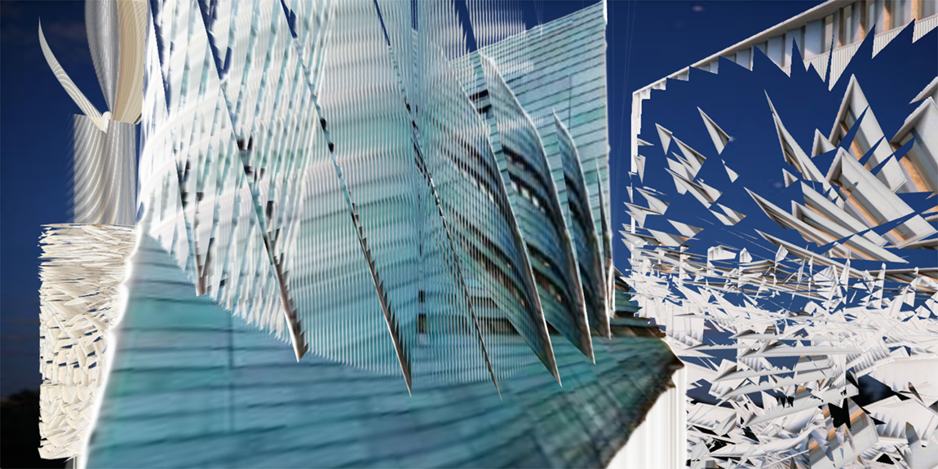
(Image 6: UniForm 6, the author, 2017)

Problem 5: education in a bubble

Ultimately, the effect of financialisation is to limit the very opportunities sought by students committing to study in higher education. As Hudson notes, within a financialised economy ‘a rising share of employee income, real estate rent, business revenue and even government tax revenue is diverted to pay debt service. By leaving less to spend on goods and services, the effect is to reduce new investment and employment’ (Hudson 2016). A financialised society is characterised not by expansion but by diminution of opportunity, in spite of the prevalent rhetoric of progress, modernisation and futurity. By embracing financialisation, the university actively diminishes the very thing it markets to prospective students – prosperity, employability, and security.

Ironically, the CGI industry is one of the sectors affected by this. Job insecurity is high, but so is the uptake of courses, both public and private, by students willing to commit to debt in order to pursue a career in what is seen as an attractive sector (Squires 2013). The industry that creates the spectacle is also a spectacle in its own right, and Squires, reflecting on the experience of his peer group, has a particular issue with ‘for profit’ providers who exploit this – there are echoes of Fisher here in the use of the word ‘dream’:

For-profit schools are multiplying at an incredible rate and being funded by money machines … to sell dreams to people, young and old. The problem is those dreams don't exist. These schools are churning out thousands of graduates to an industry without jobs. The only selection process at these types of schools is can you pay or can you sign this student loan from the government. Your aptitude and your potential talent is never evaluated. Guidance counselors (sic) never reveal the reality of the industry you're getting into or your odds. In most cases these diploma mill types of schools teach very little of value and even those that do now have cranked out so many others it doesn't matter (Squires 2013).

Above and beyond the actions of rogue education providers, the potential for this kind of disruption is programmed into the technology itself. In the example of defaulting VFX students at private US colleges, fleeced for a promise of glory, one can see quite clearly how a spectacular technology is not separable from a wider network of financial, cultural and social actors that replicates itself by feeding on those who most fervently believe in it. By trading in representations of magical, friction-free and weightless motion, the myth of action without resistance is reinforced: a dream of total command of production, one’s wishes fulfilled at a sweep of the hand. Digital technologies are a form of magic – they allow labour to be controlled instantaneously, by mysterious forces far away in space and time, without ever having to consider the local effects of alienated actions.

Here one can see where critical thought – and action – needs to be applied: at the level of the production of the means of production, exactly where Benjamin suggests in Author as Producer (Benjamin 1934). Squires’ blames a deregulated and exploitative market for what he perceives as the dire state of the VFX industry – and promotes worker organisation as the cure – in resistance to the friction free, unregulated market which produces such effects (Squires 2013). As education becomes spectacle, the production of the production of the spectacle is where critical action needs to be applied. However, solidarity at the location where work happens is only one solution: work towards technologies that think things very differently, maybe more slowly, and that factor in a necessary brake on disruption, is also crucial. Automation as a weapon against worker autonomy has a long and complex history, from the Spinning Jenny to (in a UK context) Murdoch’s victory over the print unions at Wapping in the implementation of digital printing technologies, facilitated by the evisceration of workers’ rights. The victory of automation, too, can be read from the surface of the spectacle: in order to dream differently, it is necessary to rethink (not necessarily to reject) the seduction of weightlessness and frictionlessness, which finds its expression in CGI dreams of total control – and how such seduction does its work on both student and producer. Discussions such as those set out by Squires need to become central to academic discourse, especially within what are now called the creative industries. Financialisation has epistemological effects.

The end / endless insecurity

What do the problems I have outlined at length above mean for images, buildings, pedagogy, research and ideas? I hesitate to write ‘at this point in time,’ as I am well aware how categorising financialisation as a kind of hypermodern ‘present,’ and the old world of gold-standard certainties as the ‘past,’ plays into exactly those kinds of positions that Betancourt’s ‘digital capitalism’ attempts to promote. Time is as much produced as space. Indeed, expressions of time (past, present, future) are often deployed exactly to express a metaphor between powerful and powerless – bearing in mind that the most powerful actor may well be a technology, network or image, and not necessarily any human actor who could be represented, satirically, by an overweight cat in a pinstripe suit. If enough people did not wholeheartedly believe (against all the evidence) that they were living in the world of valuable stuff, use value and unalienated labour – doing the ‘dreamwork’ of capital in Fisher’s terms – the whole edifice would collapse, though maybe not institutions, which could be argued to exist before, during and after architecture. The forms of time travel expressed in the CGI university are important to think through: even though the production of a building might be well intentioned, how does the use of CGI technologies avoid overstepping resistance, the slow thinking through of difficult problems, or the agonistic processes of collective decision-making? It could be claimed that CGI architectures previsualise a future in which these aspects are consigned to a ‘past,’ or more accurately enclosed within a private space, with the opposition of public to private mapped point-for-point onto an ideologically loaded and produced timeline known colloquially as ‘modernisation.’ Other solutions are possible.

Ultimately, the promise of security which the CGI image sells to students is increasingly divergent from the mission of the institutional network delivering their education, which generates capital from promises of future earnings in a deregulated (and further deregulating) market which is dependent on insecurity. Such paradoxes are directly legible from both the surface and production methods of the kinds of spectacular images encountered when negotiating the global institutional landscape.

The spectacle of the university does its work simultaneously on academics, speculators and students. For those who hold the firm belief that academics and students collaborate in the production of knowledge, and that, topologically and epistemologically, such production overflows the institution, the deployment of rendering technologies to previsualise a place for the production of critical individuals, collectives and knowledges, is to some degree problematic.

What allows me to speculate on the notion of reverse indexicality in relation to both images and writing, is the emergence of technological networks that link representation, subject, and the means by which they are produced. As the rendering appears to become more sophisticated as a self-contained entity – increasingly complex in content, form, and in its immersive and animated capabilities – it differs from the conventional architectural image in that its relationships to systems of production and reproduction appear to be increasingly mechanised. Likewise, with the academic paper: one can trace parallels with the way in which publishing now mechanically links different iterations of discreet products to networks which in themselves represent sites for the production of economic value, though critical attention is increasingly being brought to bear on the marketization of academic publishing, or even the conference ((Blommaert 2016; Nicholson 2017).

A ‘disrupted journal’ or a ‘parodic forum’ could be said to represent experiments with technological innovation at the level of distribution. However, in my experiments with soliciting user-generated content, I need to acknowledge how the value of such work is related to the reach of the network or the metrification of the content it solicits: which in both cases could be viewed as labour contributed based upon a promise of future gain (Hesmondhalgh 2010). For the academic, student or investor, the value of anything that can be identified as discreet content is increasingly projected into the future. As forms of online distribution proliferate in direct parallel to increasing precarity at the site of production, relationships of cause to effect are revealed to be shifting, messy and paradoxical.

Notes on the Illustrations:

Illustrations for this article are generated by the app UniForm. This app generates images of future academic architectures by modifying existing CGI renderings of university redevelopment projects. Drawn from images posted on the UniverCity forum, selected elements are subjected to simple processes of rotation, extrusion and collage in order for the machine to dream up dynamic images of future spaces for knowledge exchange, the production of facts and new institutional formations, amongst other things. Spaces for the production of future realities are created from images of universities which have yet to come into existence. A secondary intention for this creative outcome to the UniverCity project is to provoke considerations of the advantages in terms of cost, time and labour which could be gained by fully automating all processes of campus redevelopment..
References:

Balkan, S. 2016. “Anthropocene and Empire.” In e-flux, October 2016. http://conversations.e-flux.com/t/anthropocene-and-empire/5062

Barnett, Ronald. 1997. Higher Education: A Critical Business. Buckingham: Society for Research into Higher Education / Open University Press.

Baudrillard, Jean. 2012. The Ecstasy of Communication. Cambridge, MA: MIT Press

Benjamin, W. 1970. “The Author as Producer.” In Walter Benjamin: Selected Writings. Translated by E. Jephcott. Cambridge, MA: Harvard University Press.

Berger and Luckman. 1991. The Social Construction of Reality. London: Penguin

Betancourt, M. 2010. “Immateriality and Scarcity in Digital Capitalism, Theory Beyond the Codes.” ctheory, October 2010.
www.ctheory.net/articles.aspx?id=652

Blommaert, Jan. 2016. “Academic Publishing and Money.” Diggit, September 2016. https://www.diggitmagazine.com/articles/academic-publishing-and-money

Bourdieu, P. 1984. Distinction: a social critique of the judgement of taste. Cambridge: MA. Harvard University Press.

Bridle, James. 2013. “The Render Ghosts,” Electronic Voice Phenomena, 14th November 2013.
http://www.electronicvoicephenomena.net/index.php/the-render-ghosts-james-bridle/

Brown, Adam. 2013. “The Spinning Index: architectural images and the reversal of causality.” in Rubinstein D. Andy Fisher and Johnny Golding. (eds) The Verge of the Image: Critical Introduction to New Photography. Birmingham, UK, Birmingham Institute of Art and Design / ARTicle Press.

Brown, Adam. 2016. UniverCity. September 2016, accessed 4th January 2016. http://journal.disruptivemedia.org.uk/forum/index.php

De Certeau, M. 1984. The Practice of Everyday Life. Berkeley: University of California Press.

Derrida, Jacques. 2004. “The Principle of Reason: The University in the Eyes of its Pupils.” In Eyes of the University. Stanford, CA.: Stanford University Press.

Derrida, Jacques. 2004. “Mochlos: or the Conflict of the Faculties.” In Eyes of the University. Stanford, CA.: Stanford University Press.

Ernst and Young. 2012. University of the Future: A thousand year old industry on the cusp of profound change. Sydney, Ernst and Young Australia.

Fisher, Mark. 2009. Capitalist Realism. London: Zero Books

Foucault, Michel. 2002. The Order of Things: an archaeology of the human sciences, London: Routledge

Flusser, Vilem. 2000. Towards a Philosophy of Photography. Reaktion: London.

Giroux, Henri. 2004. “Cultural Studies, Public Pedagogy, and the Responsibility of Intellectuals.” Communication and Critical/Cultural Studies, 1 (1): 59–79.

Graeber, David. 2011. Debt: The First Five Thousand Years. New York: Melville House.

Gravois, 2010. “The urban dreamscape: Abu Dhabi's imaginary image.” The National, April 22, 2010.

http://www.thenational.ae/arts-culture/the-urban-dreamscape-abu-dhabis-imaginary-image

Guerrilla Girls. 2016. October 2016.

https://www.facebook.com/antiuniversityofeastlondon/photos/pcb.1667583946890424/1667572613558224/?type=3&theater

Hall, Stuart. 1978. “Racism and Reaction.” In Five Views on Multi Racial Britain. London: Commission for Racial Equality.

Henry Stewart Group. 2016. “University and University Related Real Estate.” October 2016.
http://www.henrystewartconferences.com/UniversityRealEstate2016/

Hesmondhalgh, David. 2010. “User-generated content, free labour and the cultural industries.” Ephemera, 2010. Accessed 1st March 2017 www.ephemerajournal.org/contribution/user-generated-content-free-labour-and-cultural-industries

Hickey-Moody, Anna, Glenn Savage, and Joel Windle. 2010. “Pedagogy Writ Large.” In Critical Studies in Education. 51, (3): London, Routledge.

Hudson, Michael. 2016. “Finance is Not the Economy.” August 2016, accessed 1st October 2016. http://michael-hudson.com/2016/08/finance-is-not-the-economy

Hughes, Thomas. 1993. Networks of Power. Baltimore: JHU Press.

Kraeger, Dr. Philip. 2013. Humanities Graduates and the British Economy: The Hidden Impact. Oxford: Oxford University Press.

Latour, Bruno. 2010. On the Modern Cult of the Factish Gods. London: Duke University

Lefebvre, H. 1991. The Production of Space. Trans Donald Nicholson Smith. Oxford: Blackwell Publishing.
McClanahan, Annie. 2016. Dead Pledges; Debt, Crisis and 21st Century Culture. Stanford: Stanford University Press.

McGettigan, A. 2011. ‘Demand would be Enormous.’ In Research Fortnight, supplement to issue no. 375, 21st September 2011.

Melhuish, Claire, Gillian Rose and Monica Degen. 2014. “Architectural atmospheres: affect and agency of mobile digital images in the material transformation of the urban landscape in Doha.” Tasmeem. 2014 (1). 4

Neary, Mike and Sara Amsler. 2012. “Occupy; A New Pedagogy of Space and Time.” Journal for Critical Education Policy Studies, 10, (2)

Nicolson, Donald J. 2017. Academic Conferences as Neoliberal Commodities., London: Palgrave Macmillan.

Perez-Gomez, Alberto and Louise Pelletier. 1997 Architectural Representation and the Perspective Hinge. Cambridge, MA.: MIT Press.

Ratcliffe, Rebecca. 2017. “University Students Across the UK Prepare for Wave of Rent Strikes.” 17th September 2016. Manchester: the Guardian.

Readings, Bill. 1996 The University in Ruins. Cambridge, MA: Harvard University Press.

Squires, Scott. 2013 “The Sad State of the VFX Industry,” in Effects Corner, 10th June 2013.
http://effectscorner.blogspot.co.uk/2013/06/sad-state-of-visual-effects-industry.html#.WBoEhJOLR-U

The web form UniverCity is available at http://journal.disruptivemedia.org.uk/forum/index.php

