Modelling of Fault detection in Electrical Wiring

G H Shirkoohi
School of Engineering
London South Bank University, London, UK
Direct line: +44 (0) 207815 7562

email: maziar.shirkoohi@lsbu.ac.uk

Keywords: Electrical wiring faults, cable insulation, cable shielding, TDR, Modelling of wires

Abstract
Electrical wiring and cables in many cases buried deep in many systems and environments suffer damage. In some cases the damage only affects wire insulation and is not usually detected under normal operating conditions. This paper discusses computer modelling of electrical wires based on TDR using trains of successive pulses which were used in order to develop techniques and test procedures that would lead to identification of these types of fault. The paper shows detailed simulations of defects in insulation of electrical wires and cable shields, using dedicated electromagnetic modelling computation software. The results of simulations were compared with those obtained in experimental measurement for wires and cables of several metres in length, with very good verification.

1 Introduction
Time Domain Reflectometry (TDR) technique has for many years been used to find faults in electrical wiring. Faults in electrical wires can arise in many environments including residential and corporate structures, road vehicles, surface and underground trains, ships, power plants and mines. Although TDR is well known, and is frequently used in many fields, ranging from ecology to detection of faults in microelectronic circuits, the systems developed so far are mostly incapable of detecting minor faults resulting from insulation damage and partial degradation of electrical wires. In aircraft, insulation damage may be caused for example, by over-tightened fasteners and clips holding aircraft wire harnesses in place against the airframe, or to the rubbing of harnesses against sharp metal edges. On the other hand, cable degradation frequently occurs in aircraft as a result of exposure of the wires to moisture, hydraulic fluids or temperature cycling. These types of fault in wiring harnesses are not detectable by standard TDR techniques. Other techniques have been investigated for finding faults in aircraft harnesses [1, 2], communication lines [3] and power cables [4]. More advanced techniques and elaborate models were also developed in order to detect and characterise defects in cables [5 - 10]. Previous work on similar type of defects were reported for much shorter lengths of cables, using ultrawide-band signals [11, 12], and similar comparative work using Broadband Impedance Spectroscopy [13] has been reported. Complex wire networks have also been investigated using reflectometry techniques [14, 15]. In most cases, the main problems are degradation of wires and cables due to aging, resulting in the need for assessing electrical discharge from the cables [16,17], and those related to intermittent faults [18]. Analysis of the results obtained from TDR based measurements would usually require particular care, especially when considering intermittent faults [19].
With the soaring increase in computing power it has become much easier to predict solutions for engineering problems by carrying out more accurate and appropriate computer simulations with a good degree of precision. This paper shows detailed simulations of defects in insulated electrical wires, of several metres in length, using electromagnetic modelling computation package, Concerto [20], which was initially developed for rf and microwave applications [21]. The results of simulations were compared with some of the experimental measurement reported in [22].

2 Wires investigated
One of the wires used in the simulation study was a low current electrical cable constructed from a pair of parallel wires, which are joined together through the insulation, forming the so called figure of eight configuration. The conductors are constructed from copper wire with a nominal diameter or 1 mm and an insulation thickness of 0.77 mm.
Several defects were simulated by removing small sections of the insulation on one of the wires. Initially a 1 cm section, and then a smaller 1 mm section of the insulation were removed from 10 metre long samples of this type of cable. Although these defects were rather large in comparison with the types of flaw which would be of interest in practise, the study of their effects is of importance prior to those of small cracks and minute insulation damage which are of more significant interest. The other important factor is that since the length of the cables of interest are usually in excess of twenty or thirty metres, the low energy TDR pulse frequencies need to be limited to around 200 to 350 MHz. This means that the wavelengths of the pulses are generally much larger than the size of the faults and would not initially give rise to characterisation of the defects. The model was created using the 3D geometric modeller facility provided within Concerto. This is an approximation of the wire pair consisting of two concentric cylinders forming the copper conductor and insulation sleeve for each of the wires, and a small separation distance between them, see figures 1-3, which also shows a box having the properties of a perfect conductor (PEC) constructed around the wires, which forms the boundary conditions for the problem. A smaller box with finer mesh is also used close to the wires, in order to increase the accuracy of calculations near the wires. A set of two other boundary conditions associated with the source port (where the incident wave enters the wire) and the load port (at the other end) were used to drive the model. The Concerto integrated FDTD solver, QuickWave was used to solve the models.

Figure 1. Sketch of the physical dimensions and actual figure of eight power cable used for modelling and measurements, with copper core of 1.00 mm diameter and insulation thickness of 0.77 mm.

Figure 2. Model of the 10 metre long twin power cable showing the input port surface (light grey) and mesh geometry, with the inner box providing finer mesh for increased accuracy of computation.

Figure 3. Model of the 10-metre twin cable, showing interior of the model, the meshed geometry and the boundary condition (shown in orange) of the solution domain. The four sides of the outer box (apart from the ports at either end) form the boundary condition, which was set to PEC.

Figures 4 and 5 shows the actual and model of the 10 metre twin cable with a simulated 10 mm flaw, where a section of insulation is removed from one of the wires. The purpose of this paper is to use the modelling software, which is to be exploited in order to perform predictions for more complex testing procedures than that of basic TDR. Pulse duration of 4 ns was considered with a moderate rise and fall times of around 2.5 ns, corresponding to a pulse of around 120 MHz. This is of a relatively low frequency, but it needs to be compatible to the round trip time travel of the pulse along very long wires.

Figure 4. The 10 mm defect created in the insulation on one side of the twin conductor (figure of eight) power cable, showing the section of insulation removed from one of the wires.

Figure 5. Model of 10 metre twin insulated wires showing a 10 mm simulated flaw where a section of insulation was removed from one of the wires, representing partial defect in the insulation.

3 Modelling of figure of eight wires
The model of the twin cable mentioned is an approximation of the wire pair, see figures 1 and 2. As mentioned previously a box having the properties of a perfect conductor (PEC) was constructed around the wires, which forms the boundary conditions for the problem, see figure 3. There are usually a set of two other boundary conditions associated with the ports that define the source port and the load port for this type of problem.
Also as stated above, figures 2 and 3 show smaller box, used close to the wires for increased accuracy of calculations near the wires. Some of the front and side faces of these two boxes have been removed in order to show the subdivision of the model into cells, which is done automatically by the software's mesh generator, depending on the material properties of the modelled components and the operating frequency range within which the solutions are required.

3.1 Modelling of straight wires with defect
In order to test for insulation defects, a small section of the insulation was removed from one of the wires. This section was 1 cm long, which is relatively large in comparison with the dimensions of typical frays and chafes that are of interest [23], but it demonstrates the prediction of the reflection from this type of impedance discontinuity.
Figure 5 shows the model of the 10 metre twin cable with a simulated flaw where a section of insulation is removed from one of the wires.
Models having a 1mm cut in insulation were also investigated, but are not fully discussed here. The purpose of this paper is to use the modelling software, which will be exploited in order to perform predictions for more complex testing procedures than that of basic TDR.
For this particular model, the pulse of duration 4 ns was considered with rise and fall times of around 2.5 ns, corresponding to a pulse of around 120 MHz. This, as mentioned is relatively low, but it needs to be suitable for long wires, and higher frequencies would require much higher energies, which are also not desirable in some of the applications. As is the norm in modelling of flaws, two sets of identical models, one with, and one without the flaw were solved and the results were compared with one another.

3.2 Simulation of the straight wires with fault
Once the model is created in the Concerto geometric modeller, it is then submitted to the integrated FDTD solver, known as QuickWave. Figure 6 shows the graphical representation of an incident pulse of 4.0 ns duration, and of a magnitude of around 2.4 Vpp, as it propagates down the cable. The QuickWave software runs in real-time, providing the facility for the propagation of the pulse to be observed while it propagates along the wire; an example is shown in figure 6(a), where the 4.0 ns pulse is just entering the wires from the source port. This pulse is seen to propagate to the end of the wire and usually dissipated into a matched load. However, for the purpose of the identification of the wire end, the load port boundary condition was set to be a short circuit, in order to observe an inverted reflected signal, which indicates the end of the wire. Figure 6(b) shows a different representation; here, the display shows a selected component, at one position in space, vs. time. In this case, the component is E_{Y}, recorded close to the input end of the cable. When running in TDR mode, the results can be displayed as the raw component, or can be processed in real time to show the impedance change and reflection coefficient vs the time of flight along the line. In figure 6(a) the full length of the cable is shown at an angle to fit the field of view. The very large size of the 4 ns (first) trapezoidal pulse used in this case could be appreciated against the small 1 cm defect which is located close to the centre of the cable (not visible in the diagram).

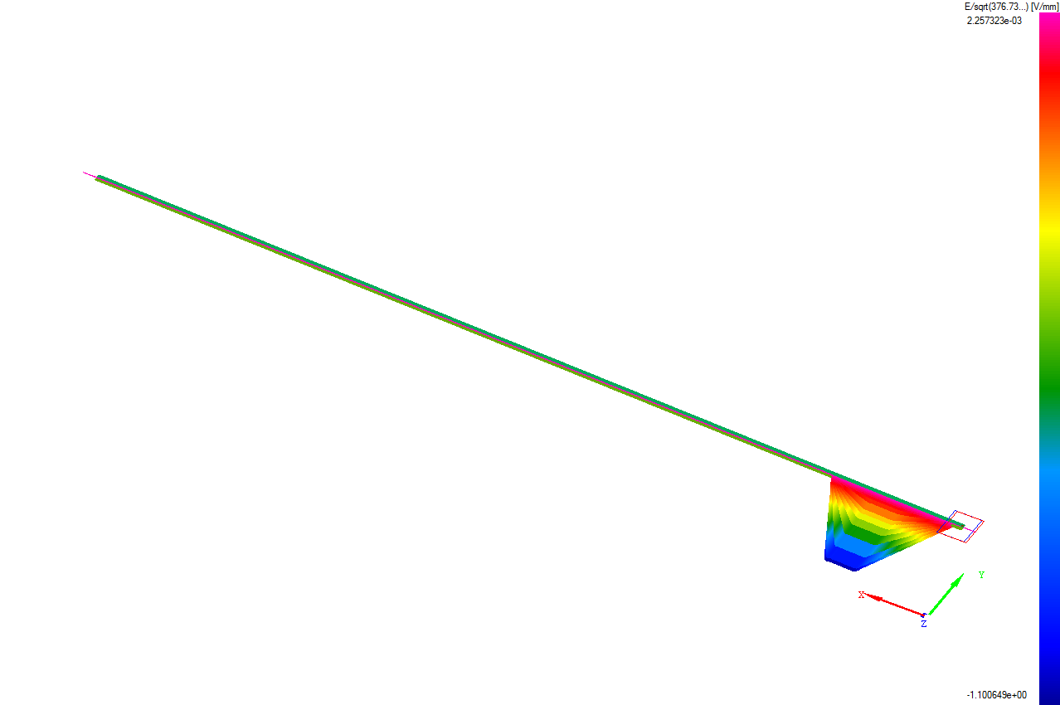
- (b)
Figure 6. Graphical representation of an incident of a wide pulse into the wire pair in QuickWave simulator module of Vector Fields’ Concerto software; a) propagation of the pulse is seen in real-time along the wire, b) the results (trace of E_{Y} in this case), as they are stored in real-time.

QuickWave was used in order to analyse the wires modelled with the 1 cm fault described above, and the results obtained were recorded by the programme for duration of around 120 nanoseconds. The results for these are shown in figure 7. The bottom trace in this figure shows the analysed results for some 120 sets of variable pulse measurements, and those shown in the above trace analysis of responses for up to 120 consecutive pulses simulated in Quickwave for a defect of 1 mm in the centre of a 10 metre long wire pair. The results for the 1 mm total cut and 1 cm half cut in the insulation of one of the wires were found to be remarkably similar.
Figure 7. Analysed response for the Twin Conductor Cable (F8) for the simulated fault on one conductor insulation, compared to the corresponding measurement.

4 Modelling of coaxial cable
The model of the coaxial cable was created using the 3D geometric modeller facility provided within Concerto. This is an approximation of the wire pair consisting of four concentric cylinders forming the copper core conductor, dielectric, shield screen and insulation sleeve for the cable, see figure 8. In this model there is no need to assign perfect conductor (PEC) properties to the outer box, since the cable screen acts as the required boundary condition for the simulation. A set of two other boundary conditions associated with the ports were also defined. The input port surface can be seen in figure 8, which should lie inside the screen, including the core conductor. The figure also shows a smaller box around the cable, again used close to the cable, in order to increase the accuracy of calculations. Again, the subdivision of the model into cells is generated automatically by the software's mesh generator. The automatic mesh generator generates the mesh for each model taking into account properties of the materials used in the model and the operating frequency range (defining the injected pulses). Localised refinements for sections of the models, such as the defect, were made after this automated process.

Figure 8. Model of the 500 mm long RG59 coaxial cable showing the geometry of the solution domain, input port (shown in red, just inside the cable screen).

4.1 Modelling of coaxial cable with defect
In order to test for insulation defects, a small 1 cm section of the sleeve insulation and the braided shield was removed, with the main dielectric and core conductor remaining unaffected, as shown in figure 9. Figure 10 shows the model of the cable with this simulated flaw. For this particular model, smaller pulse duration starting from 0.2 ns was considered. This is again relatively low in frequency, but it allows assessment of long wires. Once more as is the norm in modelling of flaws, two sets of identical models, one with, and one without the flaw were solved and the results were compared with one another.

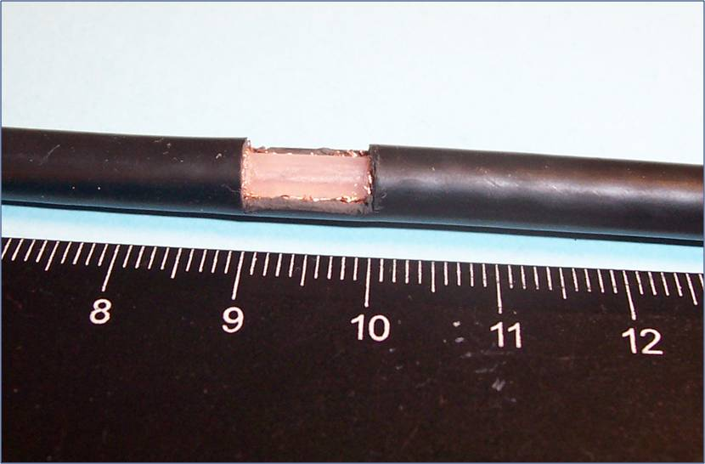
Figure 9. The actual 10 mm defect created in the coaxial cable, at a 4 metre distance from the start of the six metre long cable. The defect includes cut in the PVC sleeve and the braided shield of the cable.

Figure 10. Model of RG59 coaxial cable showing the 10 mm simulated flaw, where a section of insulation and shield is removed.

4.2 Simulation of coaxial cable with fault
Once the models were created in the Concerto geometric modeller, they were then submitted to the integrated FDTD solver, QuickWave and similar simulation procedure, as mentioned above, was carried out for the two sets of models.
The source port was injected with predetermined pulses, and again for the purpose of the identification of the wire end, the load port boundary condition was set to be a short circuit, in order to observe an inverted reflected signal, which indicates the end of the cable. QuickWave was used in order to analyse the wires modelled with the 1 cm defect described above, and the results obtained were recorded. The results for these are shown in figure 11.

Figure 11. Analysed response for the coaxial Cable for the simulated fault on sleeve and shield (upper trace), compared to those obtained by analysed measurement results.

5 Results and discussions
Figure 7 shows analysis of responses for up to 120 consecutive pulses simulated in Quickwave for a defect of 1 mm in the centre of a 10 metre long wire pair. The results in this figure show small but prominent change in the cumulated voltage values resulting from small change in the impedance of the cable due to the flaw which increases in value with rising number of incremental pulses used. Similar pattern is also observed in the actual measurements carried out on similar wire pair presented in the same figure (shown in the lower trace). The cable usually suffers from small changes in localised impedances due to small kinks and is unevenness resulting in ripple effect seen in the measurement results. Measurement noise is also clearly present in the figure which could perhaps be reduced, to some extent, by using filtering. The distinctive change in the voltage pattern is observed in the centre of the cable very similar to the pattern observed in the modelling results, even though much smaller defect was modelled. Although measurement results do suffer from excessive noise, the pattern is clearly indicated by the results obtained from modelling the wires. It was also noted that modelling results for 1 mm complete cut in the insulation gave the very similar indications to those for half of the insulation cut for 1 cm. the former results are shown for comparison, since the results for these were more numerous that the latter.
Figure 11 shows analysis of responses for consecutive pulses simulated in Quickwave for a defect of 1 cm in the sleeve and shield screen of RG 59 coaxial cable at a position 4 metres away from the start of the cable, and 2 metres away from the end of the cable. The position away from the centre was deliberately chosen to ensure that fault identification was not affected by possible symmetrical echoes from either end of the cable. The results in this figure are much more prominent change in the cumulated voltage values resulting from the change in the impedance of the cable due to the flaw. The larger change observed in measurement results (the lower trace in the figure), is expected for the coaxial cable, since in this case the capacitive component of the impedance is more dominant in coaxial cables. As the result of this change the cumulative incremental response due to the absence of the small proportion of the shield is clearly visible. This signal also increases in value with rising number of incremental pulses used. Similar pattern is also observed in the simulation results presented in the same Figure, shown in the upper trace. It should be noted here that due to the complexity of the coaxial model, and the necessity for higher resolution for the discretisation in the required, slightly higher frequency mesh, the model constructed for the coaxial cable was much smaller than the actual 6 metre long cable. For this reason the analysed result from modelling (the upper trace) is much smaller in length than that shown for the measurement.
However, positioning the trace from the modelling results in correct proportion within the length of the cable, the predicted fault location matches exactly with that of the location identified by the measurement results. It should also be noted that the defect in the model was positioned in a similar position, away from the centre of the model. This was also considered when matching the two traces.
The coaxial cables also suffer from small changes in localised impedances due to small kinks and uneven form, in the longitudinal direction, resulting in ripple effect also seen in these measurement results. Measurement noise is clearly present in this figure also, which could again be reduced to some extent, by filtering. The distinctive change in the voltage pattern is observed at the fault location, in this case, is clearly a good indication of success of the modelling results for the coaxial cable model.

6 Conclusions
Models of electrical wires with insulation flaws were constructed, and were subjected to simulated TDR tests in the QuickWave FDTD solver. The outcome of the simulations shows significant similarity in the comparative results, even though the TDR pulse width was much larger than the size of the flaw, and the modelled flaw was much smaller. The paper shows that modelling results obtained can be used in order to develop similar non-standard experimental techniques (in this case based on TDR method), in order to detect small faults in wire insulation. This technique can clearly be used to predict defects in wires and cables. Furthermore it is clearly shown that computational modelling can be used to endorse measurement techniques by confirmation of the results and vice versa.

References
- Furse, C., Chung, Y.C., Dangol, R., Nielsen, M., Mabey, G., and Woodward, R., "Frequency-Domain Reflectometry for on-Board Testing of Aging Aircraft Wiring," IEEE Transactions on Electromagnetic Compatibility, Vol. 45, No.2, pp. 306-315, May 2003.
- Smith, P., Furse, C., and Gunther, J.,"Analysis of Spread Spectrum Time Domain Reflectometry for Wire Fault Location," IEEE Sensors Journal, Vol. 5, No. 6, pp. 1469-1478, December 2005.
- Dodds, D.E., "Single-Ended FDR to Locate and Specifically Identify DSL Loop Impairments", IEEE International Conference on Communications 2007 (ICC '07), pp. 6413 - 6418, June 2007.
- Navaneethan, S., Soraghan, J.J., Siew, W.H., McPherson, F., and Gale, P.F. "Automatic fault location for underground low voltage distribution networks," IEEE Trans. Power Del., vol. 16, no. 2, pp. 346–351, April 2001.
- Wang, J., Stone, P.E.C., Shin, Y.-J., Dougal, R.A., "Application of joint time-frequency domain reflectometry for electric power cable diagnostics," Signal Processing, IET, Vol. 4, No. 4, pp. 395 - 405, September 2009.
- Schuet, S., "Wiring Diagnostics Via l₁ -Regularized Least Squares," IEEE Sensors Journal, Vol.10 , No. 7, pp. 1218 - 1225, July 2010.
- Smail, M.K., Pichon, L., Olivas, M., Auzanneau, F.,Lambert, M., “Detection of Defects in Wiring Networks Using Time Domain Reflectometry”, IEEE Transactions on Magnetics, Vol. 46, No. 8, pp. 2998-3001, August 2010.

Smail, M.K., Hacib, T., Pichon, L., Loete, F., “Detection and Location of Defects in Wiring Networks Using Time-Domain Reflectometry and Neural Networks”, IEEE Transactions on Magnetics, Vol. 47, No. 5, pp. 1502 – 1505, May 2011.
- Qinghai Shi , Kanoun, O., “A New Algorithm for Wire Fault Location Using Time-Domain Reflectometry”, IEEE Sensors Journal, Vol. 14 , No. 4, pp. 1171-1178, April 2014.

Kim, S.M., et al., “Development of a Monitoring System for Multichannel Cables Using TDR”, IEEE Transactions on Instrumentation & Measurement, Vol. PP, No. 99, pp. 1, 2014.
- Buccella, C., Feliziani, M., Manzi, G., "Detection and localization of defects in shielded cables by time-domain measurements with UWB pulse injection and clean algorithm post-processing," IEEE Transactions on Electromagnetic Compatibility, Vol. 46 , No. 4, pp. 597 - 605, November 2004.
- Buccella, C., Feliziani, M., Manzi, G., "Identification and localization of defects in shielded cables by a numerical/ experimental procedure," IEEE International Symposium on Electromagnetic Compatibility 2003, Vol. 1, pp. 213 - 218, August 2003.
- Hirai, N., Yamada, T., Ohki, Y., “Comparison of Broadband Impedance Spectroscopy and Time Domain Reflectometry for Locating Cable Degradation”, 2012 International Conference on Condition Monitoring and Diagnosis (CMD), pp. 229 – 232, 23-27 September 2012, Bali, Indonesia.
- Lelong, A., Sommervogel, L., Ravot, N., Carrion, M.O., "Distributed Reflectometry Method for Wire Fault Location Using Selective Average, "Sensors Journal, IEEE, Vol. 10, pp. 300 - 310, February 2010.
- Smail, M.K., Pichon, L., Olivas, M., Auzanneau, F., Lambert, M., "Detection of Defects in Wiring Networks Using Time Domain Reflectometry," IEEE Transactions on Magnetics, Vol. 46, , pp. 2998 - 3001, August 2010.
- Herold, C., Leibfried, T., “Signal processing tools for evaluation of Partial Discharge Measurement Data of Power Cables”, 2008 Annual Report Conference on Electrical Insulation Dielectric Phenomena (CEIDP), pp. 525-527, 26-29 October 2008, Quebec, QC, Canada.
- Herold, C., Leibfried, T., “Advanced Signal Processing and Modeling for Partial Discharge Diagnosis on Mixed Power Cable Systems”, IEEE Transactions on Dielectrics and Electrical Insulation Vol. 20, No. 3, pp. 791-800, June 2013.
- Ballas, M., Locken, N., Parkey, C., Hughes, C., “A Non-Destructive High-Voltage Low-Energy Intermittent Fault Location System” 2011 IEEE AUTOTESTCON, pp. 78 – 86, 12-15September 2011, Baltimore, MD, USA.

Parkey, C., Hughes, C., Locken, N., “Analyzing artifacts in the time domain waveform to locate wire faults” IEEE Instrumentation & Measurement Magazine, vol15 No. 4, pp. 16-21, August 2012.
- CONCERTO 7.5 Reference Manual, Vector Fields Ltd, Cobham Technical Services Ltd, Oxford, UK, 2008.
- Suidong Yang, Michaelides, A., Riley, C., Archer, J., Hook, M., Simkin, J, "Optimizing the design examples of wide-band antennas," Wideband and Multi-band Antennas and Arrays, IEE (Ref. No. 2005/11059) 2005.
- Shirkoohi, G.H., Hasan, K., "Enhanced TDR Technique for Fault Detection in Electrical Wires and Cables," 2nd Interational Symposium on NDT in Aerospace, Hamburg, Germany, November 2010.
- Griffiths, L.A., Parakh, R., Furse, C., and Baker, B.,"The Invisible Fray: A Critical Analysis of the Use of Reflectometry for Fray Location," IEEE Sensors Journal, Vol. 6, No. 3, pp. 697-706, June 2006.

