**FINANCIAL VIABILITY OF LIQUID AIR ENERGY STORAGE   
APPLIED TO COLD STORAGE WAREHOUSES**

A Foster(a), D Negro(a), L Varga(b), Y Hu(b), K Fikiin(c) and J Evans(a)

(a) London South Bank University, Langford, BS40 5DU, UK,

[alan.foster@lsbu.ac.uk](mailto:alan.foster@lsbu.ac.uk), Fax: +44(1117) 92892314

(b) Complex Systems Research Centre, Cranfield University, Bedford, UK

(c) Technical University of Sofia, Bulgaria

# ABSTRACT

Cold storage warehouses (CSWs) are large energy consumers and account for a significant portion of the global energy demand. CSWs are ideally suited for solar renewable energy, as they generally have large flat roofs and their peak demand can coincide with the sun shining. A challenge with fluctuating renewables is their variability, which means generation may not coincide with demand. Liquid air energy storage (LAES) is a technology that stores electrical energy as a cryogenic liquid. This paper presents two strategies for using LAES at CSWs, firstly to shift the import of energy from peak to off-peak tariffs and secondly to store on site renewable energy when there is a surplus and use when not. The financial viability of these strategies is then investigated taking into account the capital cost of the LAES and the money that can be saved due to the differences in tariffs at different times.

Key words: Liquid air energy storage, renewable energy, cold storage, finance.

# INTRODUCTION

Renewable energy sources (RES) have a much lower carbon footprint than conventional electrical energy generating fuels (coal, gas, oil) and so have the potential to reduce carbon emissions if used effectively. The EU aims to generate 20% of the energy used in Europe from renewable sources by 2020 (Renewable Energy Directive, 2009). As the EU and the rest of the world moves toward renewable energy, supply becomes more dependent on factors outside the control of the energy supplier, e.g. weather variations. This provides an issue for grid balancing, as electricity generation is not easily controllable.

One method to balance supply and demand in power generation is to store energy during periods of low demand and reuse it at high demand. Lehmann et al. (2016) stated that *“The UK can realise significant cost savings if market arrangements for the electricity system allow for an efficient deployment and use of energy storage…”*

Demand and supply fluctuations leads to electricity prices which change in response. This incentivises large energy consumers to vary their consumption and energy producers to vary the time they export energy, keeping the grid balanced.

Cold storage warehouses (CSWs) are typical large energy consumers, while industrial refrigeration accounts for about 8% of the global electrical demand (Fikiin and Stankov, 2015). Due to the substantial thermal capacity of frozen CSWs, it is common for CSW operators to vary CSW electrical energy consumption to avoid using energy when the price is high, thereby inevitably introducing some temperature fluctuations. However, the strict temperature control of the refrigerated product is critical and therefore there is a limit to the extent that such *‘passive storage’* strategy can be implemented (Fikiin and Stankov, 2015).

Storage of energy is a technology that can make money from arbitrage (buy at one price and sell at a higher price). The difference in energy price between the time energy is bought, stored and then discharged provides the income.

CSWs are ideally suited for solar renewable energy, as they generally have large flat roofs and their peak demand can coincide with the sun shining. However, it is not possible to be grid independent using only RES from solar and/or wind to power the CSW, due to its intermittent nature. Large-scale energy storage that has low losses over several days is needed alongside the RES, while conventional battery storage at this scale is not commercially viable.

Cryogenic energy storage (CES) makes use of low-temperature liquids as an energy storage and transfer medium. CES can provide large-scale, long-duration energy storage of 5-1000 MWh (Brett and Barnett, 2014) and can operate synergistically with a CSW (Fikiin et al., 2016), which is the focus of the EU CryoHub project (CryoHub, 2016).

The use of liquid air to store energy, which can then be recovered as mechanical work, dates back to 1900, when the Tripler Liquid Air Company developed a liquid air car. One of the current issues with CES is its low round trip efficiency (RTE is the ratio of energy retrieved to what was put in) as compared with pumped hydro electrical storage, compressed air energy storage and Li-ion batteries. A system has been demonstrated by Highview Power Storage (Morgan et al., 2015). They showed that RTE could be greatly increased by recycling more of the cold from the expansion to the liquefier. Morgan et al. (2015) stated that an over 50% RTE would be achievable if the percentage of cold recycling increases from 51% to 91%. RTEs are also greatly enhanced by air pre-heating using waste heat and pumping the liquid air to high pressures.

Energy storage systems need to provide a return on investment. The main capital expenditure (CAPEX) of liquid air energy storage (LAES) is the liquefaction plant which accounts for about 60% of the total cost. The cost of the liquefied air and high grade cold energy store is only about 10% of the total system (Brett and Barnett (2014). This means that the cost of LAES is non-linear, with storage capacity.

This paper investigates the financial viability of LAES for CSWs operators as actors on the electricity market (based on power import and export scenarios, without considering, at this stage, other possible off-grid applications of the cryogenic cold).

# Method

In order to assess the financial viability of LAES for CSWs, an understanding of electrical energy consumption and RES generation in CSWs is required. For that purpose, energy data from a CSW located in Belgium was gathered. This CSW has RES from solar PV on the roof (1 MWp).Electricity consumption and generation tariff prices for CSWs in Belgium, the UK and Hungary were also obtained to allow the results to be extrapolated to other locations.

The round trip efficiency (RTE) is defined as:

$RTE = \frac{Energy Recovered}{Energy Used in Liquefaction}$ Eq. (1)

RTE is perhaps one of the most critical parameters in energy storage as it reveals the energy which is lost in storage and is therefore critical in the financial analysis. Expected RTE from literature were investigated. Possible revenue from arbitrage was calculated for two scenarios: (a) with typical amount of RES (load shift scenario), and (b) RES increased to equal on average the CSW energy consumption (avoiding ‘feed in’ scenario). Capital cost of equipment was estimated using data from Highview (2012) and payback periods were calculated for each scenario. Further possibilities to enhance financial viability were considered.

# Results

## Typical cold storage warehouse electricity consumption and generation

The energy consumption of the CSW (every 15 min) was recorded over the period of a year. The electrical consumption was very erratic, rising and falling in the range between 100 and 800 kW approximately. When the energy demand was averaged over a whole day (Figure 1) the energy consumption was much less variable and more clearly shows the increase in consumption from winter (~500 kW) to summer (~700 kW).

To evaluate the applicability of an energy storage system, the electrical consumption over shorter time intervals needs to be known for a better match of the likely storage duration. As an example, Figure 2 shows average daily consumption (mean day) and on Spring equinox (a typical day).



Figure . Energy consumption of a cold storage warehouse in Belgium in 2015 averaged over a day.

Figure 2 shows that energy consumption for the mean day is lowest at 06:00 and in day-time hours, while it is greatest at 22:00 and over-night. This coincides with a change between peak and off-peak tariff. The reason for this is that the CSW reduces its consumption for refrigeration at peak tariff times (by allowing the set-point of the refrigerated rooms to increase) and increases the consumption at off-peak times (by reducing the set-point). It can be seen that the typical day chosen was similar to the mean day, but there was a greater level of variance.

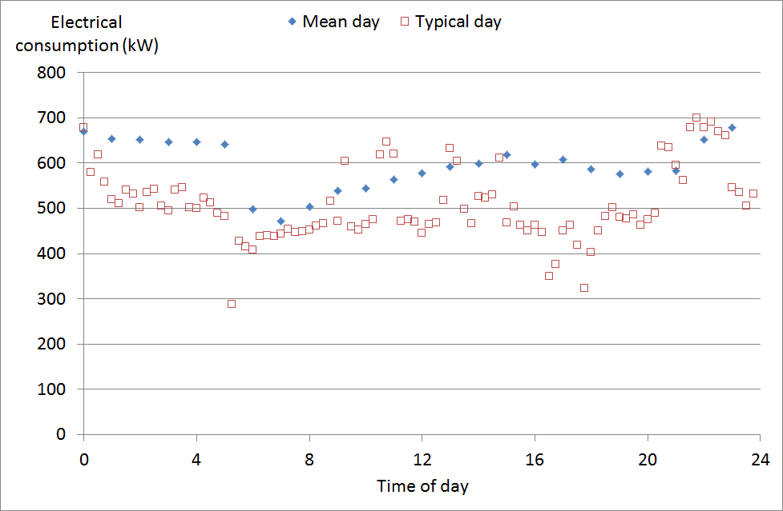

Figure . Energy consumption of a cold storage warehouse over 1 day.

Figure 3 shows mean daily power output from the photovoltaic (PV) panels on a typical day (same day as Figure 2). Obviously, PV output is zero at night and highest at midday. The typical day shown here is a cloudy day which does not match the mean day, unlike the next day (not shown) which matches it quite well. For this CSW, on average the PV output is lower than the electrical consumption even at mid-day. In fact, the PV power provided was only higher than the electrical consumption for 339 hours (3.9%) of the year.

## Round trip efficiency

As no storage system can be 100% efficient, not all of the energy consumed and stored is available for release at a later time. The RTE is therefore an important factor in energy storage systems, as it is directly related to the potential to generate revenue. There are a number of factors which affect RTEs reported in the literature (e.g. charging pressure, cold/hot energy recycle, turbine inlet temperature, size of system, etc.)

Table 1 shows RTEs of LAESs reported in scientific literature.There are two practical demonstrations of LAES technology found in the literature. Mitsubishi built a system (Kishimoto et al., 1998) based on liquid rocket engine technology and with no RTE reported. The Highview system reported a low RTE of 8% (Morgan et al., 2015), which is a consequence of the small-scale design, low level of cold recycle and no input from waste heat. However, Highview Power Storage is building a new demonstrator at a larger scale where they expect to recover up to 60% of all the waste heat energy input.

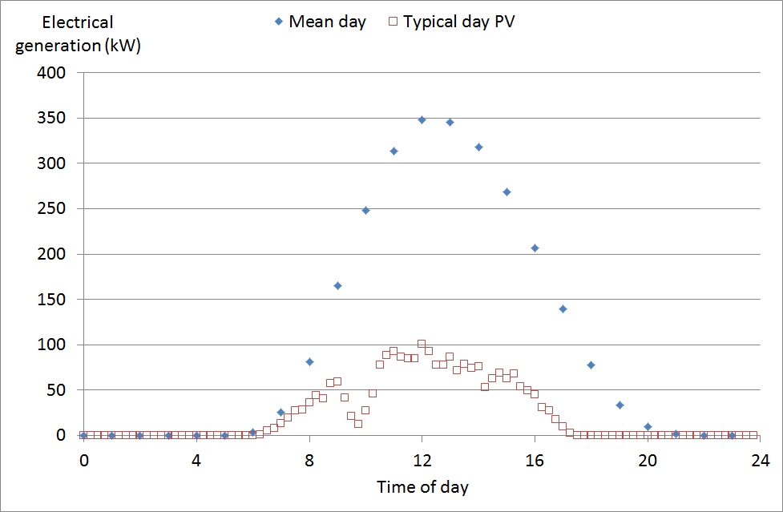

Figure . Energy generation of the PV panels of a cold storage warehouse over 1 day.

Table . RTEs reported in scientific literature.

|  |  |  |  |
| --- | --- | --- | --- |
| **Reference** | **RTE (%)** | **Basis** | **Information** |
| Morgan et al. (2015) | 8 | Demonstrator | Highview power storage system pilot plant. Cold recycle 51%. Small size plant (10 times smaller than commercial scale liquefier). No waste heat. |
| Morgan et al. (2015) | 49 | Theory | Peak discharge pressure 200 bar. Warm recycle 373 K. Liquefier size ~1000 tonnes per day. |
| Morgan et al. (2015) | Up to 60 | Theory | Peak discharge pressure 200 bar. Warm recycle 448 K. Liquefier size ~1000 tonnes per day. |
| Sciacovelli et al. (2017) | 48 | Theory | Charging pressure of 185 bar and 623 K turbine inlet temperature. Waste heat from liquefaction compressors used and stored. |

Sciacovelli et al. (2017) modelled a LAES system with a predicted RTE of 48%. They modelled the dynamic cycling of the cold/hot energy storage. The hot storage used heat from the compressors, rather than waste heat from an external process.

## Potential energy generation scenarios for a cold storage warehouse

Two scenarios were considered viable for any CSW operator who purchases and sells energy using off-peak and peak tariffs.

1. Load shift scenario – This scenario is for the CSW operator who has no RES or the RES is so small that they rarely export. This appeared typical in the CSWs studied to date. The storage system is designed to shift the electricity import from peak to off-peak times, thereby saving money.

The avoided costs (called revenue) per unit of electrical energy stored is the difference between the costs of the energy imported at peak and off-peak tariffs (taking into account the storage losses):

$R= E∙T_{p}-\frac{E}{RTE}∙T_{o}$ Eq. (2)

The minimum value of RTE to provide revenue is thus the ratio of off peak to peak tariffs:

Eq. (3)

2. Avoiding ‘feed in’ scenario – This scenario applies where the CSW has a large amount of RES and regularly exports electricity. For this scenario the CSW would store renewable energy and use it later, when required, rather than export energy, as the export tariff is generally much lower than the import tariff.

Without storage, energy would normally be both imported and exported but at different times, dependent on whether there is a deficit or surplus in RES respectively. When $P_{CSW}{>P}_{RES}$, the CSW would import energy. When $P_{CSW}{<P}_{RES}$, the CSW would export energy.

The purpose of storage would be to use as much as possible of the RES generated energy on site, instead of selling or purchasing it. The revenue generated by energy storage is the instantaneous difference between the costs of imported and exported energy when there is no storage, integrated over time:

$R= \int_{0}^{t}{ [T_{i}\left(t\right)∙ P_{i}\left(t\right)}- T_{e}\left(t\right) ∙\frac{P_{i}}{RTE}(t)] dt$ Eq. (4)

## Tariffs

Electricity import and export tariffs were gathered for selected CSWs in 3 countries - Belgium, UK and Hungary (Table 2). Two of the three CSWs investigated had two energy tariff periods. Typically, off-peak tariff was between 10 p.m. and 6 a.m. The one in Hungary had a single tariff. Only the Belgium site had a variable export tariff. The export tariff was always lower than the import tariff.

**Table 2. Electrical energy tariffs for the 3 regions.**

|  |  |  |  |
| --- | --- | --- | --- |
| **Price per (€.kWh-1)** | **Belgium** | **UK** | **Hungary** |
| Import off peak | 0.0861 | 0.0741912 | 0.074778 |
| Import peak | 0.10545 | 0.1176936 | 0.074778 |
| Export night | 0.01865 | 0.04332 | 0.049852 |
| Export day | 0.03195 | 0.04332 | 0.049852 |

## Potential revenue from two scenarios

For the Belgium store, which is typical of many CSWs, the warehouse is generally always importing electricity. Therefore, the load-shift strategy is currently the most appropriate method to reduce energy costs.

Table 3. Minimum RTE and revenue generated for different scenarios for the 3 regions.

|  |  |  |  |
| --- | --- | --- | --- |
|  | **Belgium** | **UK** | **Hungary** |
| ***Load-shift scenario*** | | | |
| **Minimum RTE** | 0.817 | 0.630 | 1 |
| **Revenue* (€.kWh-1)** | -0.002 | 0.025 | -0.019 |
| ***Avoiding ‘feed in’ scenario*** | | | |
| **Revenue* (€.kWh-1)** | 0.043 | 0.025 | 0.020 |
| * assuming an RTE of 0.8 |  |  |  |

As the RTE of the storage system is less than one, the energy released from storage would be less than that imported from the grid. The minimum RTE of a profitable CES system should be equal to the ratio of the tariffs between peak and off peak (see Eq. (3) and Table 3).

For Belgium, the minimum RTE needs to be 0.82 and for the UK, 0.63. The minimum RTE for the UK is of a similar order to that which Morgan et al. (2015) suggest for a commercial system with waste cold and recovery and high temperature waste heat (0.6). The figure for Belgium is higher than is realistically possible. For Hungary, there is no difference between the tariffs, so there is no benefit for this scenario.

The revenue generated (Eq. 2 and Table 3) for Belgium and Hungary, would be negative, but for the UK 0.025 €.kWh-1 revenue could be generated, assuming an RTE of 0.8.

The largest differences and ratios are between exporting and importing tariffs. Export tariffs are lower than import tariffs. Energy storage creates the potential to over-generate electricity, store and then utilise it when RES is in deficit. Table 3 also shows the annual revenue which could be generated by storing RES and using this energy when RES is not being generated at an RTE of 0.8. For solar panels, this would require storing energy during the day (peak times) and releasing at night (off-peak times). For this scenario all warehouses can potentially generate revenue. The largest revenue appears for the Belgium warehouse   
(0.043 €.kWh-1). However, this requires much more powerful RES than commonly available on a typical CSW.

## Capital costs and payback of LAES

While the previous evaluations were based solely on revenue, the following assessment includes capital cost and payback. The capital costs (CAPEX) were based on the Highview system (Highview, 2012). They assume a 4 MW liquefaction system, a 10 MW power recovery unit (PRU) and 4 hours of storage. The unit is assumed to charge in 10 hours and discharge in 4 hours every day. This provides a 40 MWh capacity. This is a larger system than needed for the CSW mentioned here, but it is of the same order of magnitude, thereby offering an appropriate size for some very large CSWs. The CAPEX of the LAES system for the 10 MW PRU and larger versions is given in Table 4 as well as the cost for 1st of kind (FoK), 10th of kind (OK) and 100th OK. A factor of 0.6 was used to scale the systems (meaning a 20 MW unit would cost (20/10)0.6 as much as the 10 MW unit. A learning rate of 17.5% was used (Highview, 2012), meaning costs reduced by 17.5% each time the number of units was doubled.

Table 4. CAPEX for different size and number of LAES systems (Highview, 2012)

|  |  |  |  |
| --- | --- | --- | --- |
| PRU (MW) | FoK | 10th OK | 100th OK |
|  | CAPEX (M€) | | |
| 10 | 25.4 | 13.4 | 7.1 |
| 50 | 70.7 | 37.3 | 19.7 |
| 200 | 174.4 | 92.1 | 48.6 |
|  | Revenue per year (M€) | | |
| 10 | 0.63 | | |
| 50 | 3.16 | | |
| 200 | 12.65 | | |
|  | Payback (years) | | |
| 10 | 40.2 | 21.2 | 11.2 |
| 50 | 22.4 | 11.8 | 6.2 |
| 200 | 13.8 | 7.3 | 3.8 |

The revenue for these systems for the best strategy (Net zero import and export, Belgium) is shown in   
Table 4. It is based on storing 40 MWh of energy, every day and an RTE of 0.8. A simple payback period has been calculated by dividing the CAPEX by the yearly revenue (Table 4). It should be noted that a 40 MWh.day-1 PV system at an average load factor of 10% is 17 MWp, this would amount to about 85 acres of space. It should also be noted that the liquefaction system would therefore need to be larger to capture the energy in summer and would be oversized in winter.

Previous assessments were overoptimistic as they ignored the difference in the value of cash with time. When considering a net present value (NPV) assessment on a 10th OK system at 10 MW PRU, assuming an absence of operational and maintenance costs and a 4% discount rate, the result is a payback period of 49 years and for 100th OK of 15 years. Therefore the economic justification of the smaller (10 MW PRU) system is challenging, unless the number of units is very large. Whereas a FoK system at the large scale (200 MW) would payback in 21 years (NPV). This indicates that, in the current situation, LAES is still economically much more feasible for large grid-scale systems or large numbers of systems.

## Grid services

There are benefits to the electrical grid (grid services) for which the grid operator pays the consumer. These mechanisms or services are designed to balance differences between supply and demand of the energy supply grid over a range of timescales from seconds to hours. Due to the thermal capacity and inertia of an LAES system, fast grid services are better carried out by electronic storage (e.g. batteries).

Services such as the UK national grid Short Term Operating Reserve (STOR) are relevant to LAES. STOR is required to provide reserve power in the form of either generation or demand reduction to deal with actual demand being greater than forecast demand and/or plant unavailability. The minimum power required for STOR is 3 MW to be delivered within 4 hours or less, for at least 2 hours. This service is ideal for LAES and provides a payment for both services being available and used.

## Cryogenic hub

Today, the high capital cost of a liquefaction system makes it difficult to financially justify a LAES for a common CSW. However, if this capital cost could be shared in a way that the liquid air or liquid nitrogen from LAES are used in areas outside the electrical grid, the price of the energy storage could be reduced.

When a CSW employs cryogenic fast food freezing processes, as an alternative to purchasing the cryogen from an external supplier, liquid air or liquid nitrogen from LAES could be used instead. A surplus of liquid air or liquid nitrogen could be generated to supply both the electricity generation and fast food freezing. Thus the high CAPEX of the liquefaction plant would be offset by ‘free’ cryogen for the fast freezing technologies.

Furthermore, CSWs form part of the continuous and ubiquitous cold chain which commonly uses food transport vehicles to transport refrigerated products. If cryogenically refrigerated food transport vehicles are used, the liquid air or liquid nitrogen from LAES can be harnessed to reduce the cost of cooling these vehicles. Cryogenic transport vehicles offer many benefits over diesel powered conventional systems. For example, zero emissions at point of use, quiet running, fast pull down and no need to run engines for maintaining low temperatures.

Surplus liquid air or liquid nitrogen could also be used to power automobiles (Knowlen et al., 1998). Dearman (2015) are developing this technology for both engine propulsion and container refrigeration.

# CONCLUSIONS AND RECOMMENDATIONS

Using LAES to load shift between peak and off-peak electricity tariffs was not economically viable for the CSWs studied, because the ratio between off-peak and peak tariffs was higher than RTE.

Employing CES to avoid exporting energy is currently much more economically viable. However, due to the large capital cost of a liquefaction system at small scale, LAES is only likely to provide an acceptable payback at large scale (~200 MW) and at reasonably large economies of scale (10 to 100 units per year). It is unlikely that any CSW can have the electrical consumption or RES production at a large enough scale to make LAES cost effective at the moment. The lack of a competitive market for small scale liquefaction systems makes them prohibitively expensive. This is somewhat of a ‘chicken and egg’ situation, as LAES may successfully provide the market if the technology was cheaper.

Sharing the cost of the liquefaction system by using it for cryogenic cooling, transport or sharing with other sites makes LAES more financially viable and this is the focus of further research of the authors.

Increased volatility in the electricity market, driving a larger difference in energy prices, could improve financial viability. Furthermore, government incentives for energy storage (such as the feed in tariffs for renewable power generation) could drive down costs and increase efficiency (as it previously happened with the solar panels), thereby making LAES for CSWs potentially viable in the near future.

# ACKNOWLEDGEMENTS

The CryoHub project has received funding from the European Union’s Horizon 2020 Research and Innovation Programme under Grant Agreement No 691761.

# Nomenclature

E Electrical Energy (kWh)

P Electrical Power (kW)

R Revenue (€.kWh-1)

RTE Round Trip Efficiency (dimensionless)

t Time (hours)

T Tariff (€)

**Subscripts**

e export

i import

min minumum

o off peak

p peak

**Acronyms**

CAPEX Capital Expenditure

CES Cryogenic Energy Storage

CSW Cold Storage Warehouse

FoK 1st Of Kind

LAES Liquid Air Energy Storage

NPV Net Present Value

OK Of Kind

PRU Power Recovery Unit

PV PhotoVoltaic

RES Renewable Energy Source

STOR Short Term Operating Reserve

# References

CryoHub (2016). Horizon 2020 Project No. 691761 “Developing Cryogenic Energy Storage at Refrigerated Warehouses as an Interactive Hub to Integrate Renewable Energy in Industrial Food Refrigeration and to Enhance Power Grid Sustainability – CryoHub”. www.cryohub.eu

Dearman, 2015. Liquid Air on the European Highway - The economic and environmental impact of zero-emission transport refrigeration. Dearman.

Fikiin K.A., Stankov B.N., 2015. Integration of renewable energy in refrigerated warehouses. Chapter 22, In Handbook of Research on Advances and Applications in Refrigeration Systems and Technologies. Eds: Gaspar P.D. and da Silva P.D., 1st edition, Engineering Books, IGI Global, Pennsylvania, USA, pp. 803-853.

Fikiin, K., Stankov, B., Evans, J., Maidment G., Foster, A., Brown, T., Radcliffe, J., Youbi-Idrissi, M., Alford, A., Varga, L., Alvarez, G., Ivanov, I. Evg., Bond, C., Colombo, I., Garcia-Naveda, G., Ivanov, I., Hattori, K., Umeki, D., Bojkov, Ts., Kaloyanov, N. (2017). Refrigerated warehouses as intelligent hubs to integrate renewable energy in industrial food refrigeration and to enhance power grid sustainability. Trends Food Sci. Tech., 60, 96-103

Highview, 2012. Technology and performance review. Highview Power Storage.

Kishimoto, K., Hasegawa, K, Asano, T., 1998. Development of generator of liquid air storage energy system. Mitsubishi Heavy Industries Ltd. Technical Review 35(3).

Knowlen, C., Mattick, A., Bruckner, A., Hertzberg, A., 1998. High efficiency energy conversion systems for liquid nitrogen automobiles (No. 981898). SAE Technical Paper.

Lehmann, N., Lever, A., Sanders, D., Ravishankar, M, Ashcroft, M., 2016. Can storage help reduce the cost of a future UK electricity system. The Carbon Trust.

Morgan, R., Nelmes, S., Gibson, E., Brett, G., 2015. Liquid air energy storage–analysis and first results from a pilot scale demonstration plant. Appl. Energ., 137, 845-853.

Renewable Energy Directive, 2009. Directive 2009/28/EC of the European parliament and of the council of 23 April 2009 on the promotion of the use of energy from renewable sources and amending and subsequently repealing Directives 2001/77/EC and 2003/30/EC. Official Journal of the European Union.

Sciacovelli, A, Vecchi, A, Ding, Y., 2017. Liquid air energy storage (LAES) with packed bed cold thermal storage - From component to system level performance through dynamic modelling, Appl. Energ., 190, P84-98.