Investigation on the Plastic Buckling Paradox for Metal Cylinders
R. Shamass ¹, G. Alfano ¹, F. Guarracino ²
1 - College of Engineering, Design and Physical Sciences, Brunel University, UB8 3PH Uxbridge, UK
2 – University of Naples ‘Federico II’, Via Claudio 21, 80125 Napoli, Italy

- Introduction and Some Historical Notes on the Problem of the Compressed Column
Inelastic stability of structures has attracted the attention of many researchers since the end of the nineteenth century and controversies arose almost immediately.
In order to study the stability of a simple metal column in the plastic range, Engesser¹ in 1889 suggested the use of a variable tangent modulus in the classic Euler’s equation. As pointed out by Gerard², two years later Considère³ indicated that a correct stability analysis in the plastic range would require the concept of strain-reversal on one side of the bent section. As a result of this observation, Engesser⁴ in 1895 presented the reduced-modulus theory, which was immediately validated by a series of tests conducted by von Karman on mild-steel columns².
However, in the following years it became evident from carefully conducted column tests on aluminium alloys that the difference between the tangent-modulus and reduced-modulus theory can be considerably greater than for mild steel on account of the differing stress-strain curves for the two materials. In fact, it was found² that the results from experiments on aluminium-alloy columns were generally in better accordance with the tangent-modulus theory.
In a well-known paper published in 1947⁵, Shanley re-examined the basic assumptions of the analysis of the stability of columns in the plastic range and suggested that, if axial and bending strain proceed simultaneously at the buckling load, as it is the case even for a minimum level of geometric imperfection, no strain reversal occurs and the tangent modulus is to be taken as the effective modulus for buckling in the plastic range. von Karman, however, commented that from a purely theoretical standpoint the use of reduced modulus is correct when the stability analysis is based on the requirement that the axial load remains fixed at the exchange of equilibrium configurations. Shanley replied that the tangent modulus stress can be considered the lowest value at which a bent configuration remains stable and it should be therefore considered as the buckling stress
von Karman concluded that it was then necessary to revise the definition of the buckling load as “the smallest value of the axial load at which bifurcation of the equilibrium positions can occur, regardless of whether or not the transition to the bent position requires an increase of the axial load”⁶.
Following the conclusion of this controversy, most of the work done thereafter in the inelastic stability of compressed metal struts has utilised Shanley’s concept that axial straining and bending proceed simultaneously with no strain reversal. In this respect the tangent-modulus theory can be seen as providing the critical stress of a strut with vanishingly small initial imperfections.
However, inelastic buckling is a complex phenomenon which can occur not only in a simply compressed column, but also in a variety of other structures when the deformed configuration, under a load for which the structural response is no longer elastic, undergoes a relatively sudden variation in shape. For these problems, buckling is a nonlinear problem from both a geometrical and a material point of view and the material nonlinearity requires the definition of appropriate stress-strain relationships, which for many cases of structural interest go beyond the results of a simple tensile test.
In this chapter, focus will remain on metal structures, whose inelastic response during buckling and the initial post-buckling phase, can be satisfactorily described by elastic-plastic models based on the assumption of small elastic strains (but with moderately large displacements and rotations).

- Flow and Deformation Theory of Plasticity and the Plastic Buckling Paradox
Generally speaking, the plasticity models that have been proposed for metals can be divided into two groups: the deformation and the flow theory of plasticity. In both of these theories the plastic deformations do not allow volume changes as plastic yielding is governed only by the second invariant $J_{2}$ of the deviatoric part of the stress tensor.
The flow theory of plasticity assumes that the current stress depends not only on the current value of the total strain but also on how this strain value has been attained, thus making the constitutive relationship path-dependent.
The deformation theory of plasticity is based on the assumption that, at any point on the loading path, the stress is uniquely determined by the current state of strain only and, therefore, it is a special class of path-independent non-linear elastic constitutive laws. According to this assumption, after a strain reversal in the plastic range, rather than recovering the initial elastic stiffness, as it is found experimentally, the initial loading curve is followed.
As such, the $J_{2}$ flow theory of plasticity is an incremental strain-hardening relationship and the $J_{2}$ deformation theory of plasticity is a total strain theory.
The following incremental strain-stress relationship holds in the $J_{2}$ flow theory:
$${dε}_{ij}=\frac{1}{E}\left[\left(1+ν\right) {dσ}_{ij}-ν dσ_{kk} δ_{ij}+h_{1}\left(J_{2}\right) s_{ij} dJ_{2}\right]$$ | (2.1)
where $E$ is the Young’s modulus, $ν$ is the Poisson’s ratio, $s_{ij}=σ_{ij}-σ_{kk}δ_{ij}/3$ is the stress deviator, $J_{2}=s_{ij}s_{ij}/2$ and $δ_{ij}$ is the Kronecker symbol, equal to one for $i=j$ and zero otherwise. The classical convention implying summation on the repeated index (the index varying between 1 and 3) is assumed here and throughout this chapter. Coefficient $h_{1}\left(J_{2}\right)$ is a hardening-related parameter, which is obtained from the one-dimensional stress-strain curve in terms of the tangent modulus,${ E}_{t}$:
$$h_{1}\left(J_{2}\right)=\frac{3}{4J_{2}}\left(\frac{E}{E_{t}}-1\right)$$ | (2.2)
The following total strain-stress relationship holds in the $J_{2}$ deformation theory:
$$ε_{ij}=\frac{1}{E}\left[\left(1+ν\right) σ_{ij}-ν σ_{kk} δ_{ij}+h_{2}\left(J_{2}\right) s_{ij}\right]$$ | (2.3)
where
$$h_{2}\left(J_{2}\right)=\frac{3}{2}\left(\frac{E}{E_{s}}-1\right)$$ | (2.4)
$E_{s}=σ/ε$ being the secant modulus in a simple one-dimensional test.
Tangent,${ E}_{t}$, and secant, $E_{s}$, moduli, are shown in Fig. 1.

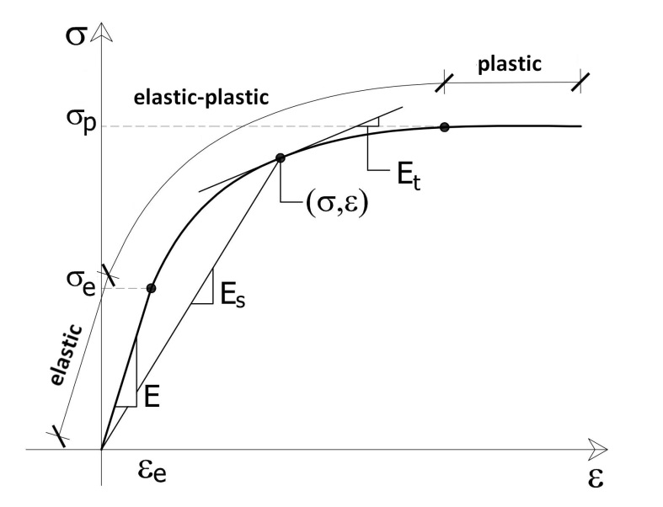
Figure 1: Tangent,${ E}_{t}$, and secant, $E_{s}$, moduli in a simple tension test.
As stated before, unloading in the $J_{2}$ flow theory of plasticity takes place according to the initial Young’s modulus, as it is experimentally found for most metals (see Fig. 2), while in the $J_{2}$ deformation theory it follows the same strain-stress path followed during loading.
There is general agreement among engineers and researchers that the deformation theory of plasticity lacks physical rigor in comparison to the flow theory. However, it has been repeatedly found by many authors that the deformation theory predicts buckling loads that are often in better agreement with experiments than those predicted by the flow theory of plasticity. This is generally known as the ‘plastic buckling paradox’. One of the simplest examples of this paradox is found in the study of the torsional buckling of a cruciform column under axial compression.

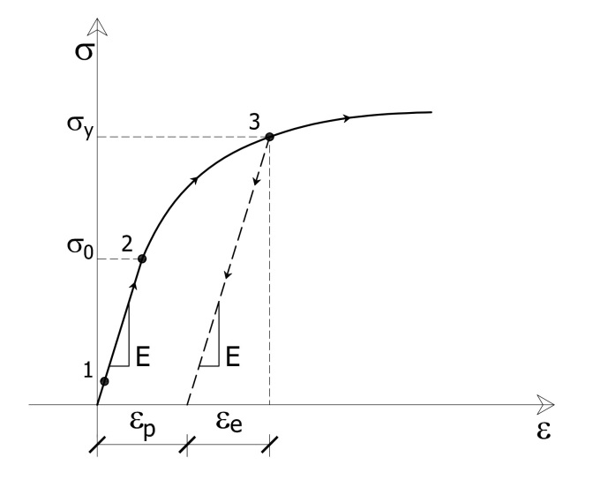
Figure 2: Unloading in the $J_{2}$ flow theory of plasticity.
- The Torsional Buckling of a Cruciform Column
The torsional buckling of a cruciform column under axial compression was originally studied by Stowell⁷ and is shown in Figs. 3 and 4. As it is the case for other more complex thin-walled open structures, a cruciform column tends to buckle in the torsion mode under applied compressive loads. When the applied load exceeds the yield load, the twisted structure remains in the plastic state in the whole cross-section.
In the torsion mode the ﬂanges of the cruciform column show twisting in addition to compression and thus change from simple compression to a combination of compression and shear. Therefore, the plastic buckling of the cruciform column is one of the simplest examples for a comparison of the $J_{2}$ ﬂow and deformation theories in their prediction of buckling loads of perfect structures. In other words, it is an ideal example to investigate the root causes of the plastic buckling paradox.
For cruciform columns made of 2024-T4 aluminum alloy, Gerard and Becker⁸ compared experimental results with those provided by different analytical approaches. Various ratios of ﬂange width and thickness were tested and the results appeared to favour the deformation theory. These results gave experimental evidence for certain shortcomings of the $J_{2}$ ﬂow theory in the calculation of buckling loads, for the ﬁrst time.

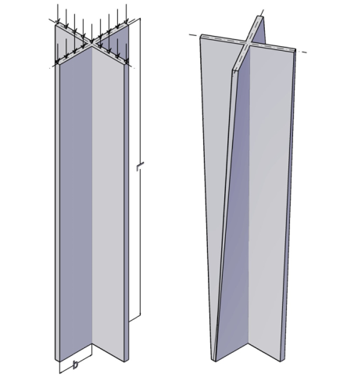
Figure 3: Torsional buckling of a cruciform column.
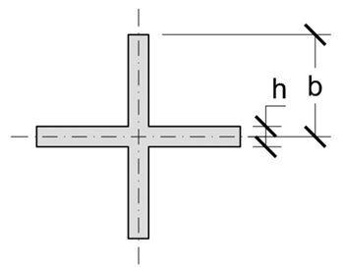
Figure 4: Cross section of a cruciform column.
Let us denote by $b$ and $h$ the width and thickness of the four flanges of the section, respectively (see Fig. 4), and by $G$ the elastic shear modulus, i.e.
$$G=\frac{E}{2\left(1+ν\right)}$$ | (3.1)
In the elastic range, under the assumptions that the length $L$ is not enough to trigger Euler buckling, and that $b≫h$, the stress at bifurcation is expressed by the following classic formula⁹:
$$σ_{cr}=G\frac{h^{2}}{b^{2}}$$ | (3.2)
In the plastic range, according to the $J_{2}$ flow theory of plasticity, any increment in the plastic strain is normal to the yield surface. As a consequence, since the pre-buckling state of stress is that of simple compression, it follows that, given the smoothness of the yield surface$f\left(σ,τ\right)=0$, see Fig. 5, the plastic strain increment has the same direction of the compressive stress $σ$ and the shear stress $τ$ is linked to the shear strain $γ$ by the elastic shear modulus, $G$. Therefore Eq. (3.2) holds true unchanged at buckling
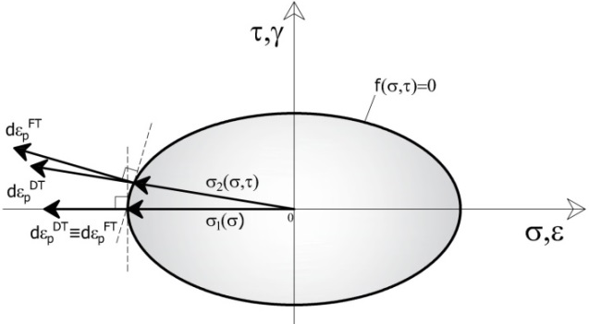
Figure 5: Plastic strain increments according to the flow (FT) and deformation theory (DT) of plasticity.
This does not happen in the case of the deformation theory of plasticity, for which it is
$$σ_{cr}=G_{s}\frac{h^{2}}{b^{2}}$$ | (3.3)
where
$$G_{s}=\frac{E_{s}}{3+\left(2ν-1\right)\frac{E_{s}}{E}}$$ | (3.4)
Eq. (3.4) can be easily derived from Eq. (2.3) by taking into consideration a state of pure shear stress. In fact, since $ε_{ij}=γ_{ij}/2$, it is
$$\frac{1}{2}γ_{ij}=\frac{1+ν}{E}τ+\frac{3}{2}\left(\frac{1}{E_{s}}-\frac{1}{E}\right)τ$$ | (3.5)
so that
$$γ_{ij}=\left[\frac{2\left(1+ν\right)}{E}+\frac{3\left(E-E_{s}\right)}{E_{s}E}\right]τ=\left(\frac{3+\left(2ν-1\right)\frac{E_{s}}{E}}{E_{s}}\right)τ=\frac{1}{G_{s}}τ$$ | (3.6)
which yields Eq. (3.4).
In order to overcome the problem, Hutchinson and Budiansky¹⁰ used a nonlinear von Kármán shell theory with an inelastic incremental law and showed that, by introducing an imperfection of the column so that the initial state of stress already accounts for some amount of shear stress, more accurate results can be obtained in the case of the flow theory.
However, additional studies (see, for example Giezen’s PhD thesis³⁰) have shown that, in general, the plastic buckling paradox cannot be entirely ascribed to a simple difference in the value of the shear stiffness. For this reason, in the following sections the attention will be focused on the kinematics of the problem and it will be shown that some assumptions regarding the buckling shapes are likely to be other important reasons for the systematic discrepancies between the results from the flow and the deformation theories of plasticity.
Additionally, it can be observed that the buckling of structures in the plastic regime often exhibits a strong imperfection-sensitivity¹¹. Again, Hutchinson and Budiansky¹⁰ showed that the reason for the high predicted buckling load of the $J_{2}$ flow theory of plasticity lies in the overestimation of the shear stiffness of a compressed cruciform column. Therefore, by introducing an imperfection of the column, more accurate results can be obtained also in the case of the flow theory.
- The Plastic Buckling Paradox in the Case of Shell Structures: A Brief Literature Review and Current Advances
The plastic buckling paradox has been observed in a wide range of shell structures, such as plate assemblies, torispherical domes and circular cylinders under different loading conditions and using different boundary conditions. Among these, the problem of relatively thick cylindrical shell structures subject to either axial compression or combined axial tension and external pressure has attracted substantial interest due to their importance in engineering applications, which has led to a vast literature with many benchmark tests and results. As a matter of fact, when comparing $J_{2}$ ﬂow and deformation theory for the prediction of buckling loads, experimental and analytical work continue to favour the deformation theory¹²⁻¹⁵.
In the early and mid-90s, the plastic buckling paradox was considered still “unresolved” by Yun and Kyriakides¹⁶ and proposed explanations judged still “inconclusive” by Teng¹⁷, who quoted results, recent at the time, “which once again confirm the better agreement between deformation theory and experiment”.
Wang and Huang¹⁸ concluded that the possible reason for the large discrepancy in the results between the flow and the deformation theories is the small deformation assumption used to establish the governing differential equation. Zhang and Wang¹⁹ provided another explanation of the results obtained by both theories, suggesting that the deformation theory, similarly to the case of the cruciform column, predicts an increasingly lower in-plane shear modulus as the level of plasticity increases, which results in lower calculated buckling-stress values.
Overall, there seems to be no definitive conclusion about the matter.
For such a reason, very recently the present authors²⁰⁻²² conducted an extensive investigation into the plastic buckling of cylinders subject to proportional and non-proportional loading. They used analytical and numerical tools and concluded that, if accurate geometrically non-linear FE analyses are conducted using both the flow and the deformation theories of plasticity, the flow theory of plasticity leads to predictions of buckling load and pressure that are in better agreement with the corresponding experimental results than those provided by the deformation theory. Moreover, in these analyses, the flow theory of plasticity succeeded in predicting buckling with physically acceptable plastic strains and the discrepancies between the flow and deformation theories results in terms of plastic buckling stress for both perfect and imperfect cylinders were quite small for both thick and thin cylinders.
The root of the discrepancy can be attributed to the over-constrained kinematics which is at the basis of a large number of analyses. This fact leads to overestimate the buckling pressures when the flow theory of plasticity is used, while the deformation theory counterbalances the excessive kinematic stiffness and provides critical loads which are much lower than those from the flow theory.
The non-linear finite-element (FE) analyses were conducted by the present authors^{20,22} using version 6.11-1 of ABAQUS software²³ and included an investigation of the imperfection sensitivity of the cylinders as they buckle in the plastic domain. The FE results were compared with experimental, numerical and analytical results available in the literature.
Analytical approaches for the considered case studies were also pursued in order to provide a possible explanation of the plastic buckling paradox and investigate the effect of the simplified assumptions used in many analytical treatments on the discrepancy between the flow and deformation theories. The obtained analytical results were compared with experimental and numerical results obtained by other authors using the code BOSOR5²⁴ and with the FE results presented in this thesis.
A semi-analytical model was also developed²⁰ using a simplified formulation proposed by Hutchinson²⁵ to qualitatively investigate the effect of the imperfections and of the unloading law in the constitutive relationships on the calculated plastic buckling load and on the post-buckling behaviour, using the flow and deformation theories.
The work done is summarised in the next sections.
- Implementation of the Flow and Deformation Theories of Plasticity in the Nonlinear FEA
The deformation theory is numerically implemented in ABAQUS by extending the classic Ramberg-Osgood formula to a general 3D model based on the von Mises yield criterion and the assumption of small strains, so that the general Eq. (2.3) specializes as follows:
$$ε_{ij}=\frac{1}{E}\left[\left(1+ν\right) s_{ij}-\frac{1+2ν}{3} σ_{kk}δ_{ij}+\frac{3}{2}α{\left(\frac{\sqrt{\frac{3}{2}s_{hk}s_{hk}}}{σ_{y}}\right)}^{n-1}s_{ij}\right]$$ | (5.1)
in which the material constants are Young’s modulus, $E$, Poisson’s ratio, $ν$, the offset strain,$α$, the proof stress, $σ_{y}$, and the exponent,$n$. Again, it is evident that Eq. (5.1) relates the current stress and strain tensors without any consideration of the previous deformation history.
For simulations based on the flow theory, the von Mises stress criterion was considered, too, with nonlinear isotropic hardening. Adopting the usual additive decomposition of the total strain tensor into an elastic and plastic part, as well as an associative-type flow rule, the governing equations can be summarized as follows:

$$\left\{\begin{matrix}{\dot{σ}}_{ij}=2G\left({\dot{ε}}_{ij}-{\dot{ε}}_{ij}^{p}\right)+μ \left({\dot{ε}}_{kk}-{\dot{ε}}_{kk}^{p}\right)δ_{ij} \\ {\dot{ε}}_{ij}^{p}=\dot{λ}\frac{∂f}{∂σ_{ij}} \\ \dot{λ}≥0 f\left(σ_{ij},ε_{p}^{eq}\right)≤0 \dot{λ} f\left(σ_{ij},ε_{p}^{eq}\right)=0 \\ ε_{p}^{eq}\left(t\right)=\int_{-∞}^{t}{\left\|{\dot{ε}}_{ij}^{p}\left(τ\right){\dot{ε}}_{ij}^{p}\left(τ\right)\right\| dτ} \\ f\left(σ_{ij},ε_{p}^{eq}\right)=\sqrt{\left(σ_{ij}-\frac{σ_{kk}δ_{ij}}{3}\right)\left(σ_{ij}-\frac{σ_{kk}δ_{ij}}{3}\right)}-\sqrt{\frac{2}{3}}k\left(ε_{p}^{eq}\right) \\ k\left(0\right)=k_{0}\end{matrix}\right.$$ | (5.2)
where $G=0.5E/\left(1+ν\right)$ and $μ=2G ν/\left(1-2ν\right)$ are the elastic Lamé constants, ${\dot{ε}}_{ij}^{p}$ denotes the plastic strain tensor, $ε_{p}^{eq}$ is the equivalent plastic strain, $f$ indicates the von Mises yield function and $k$ is the nonlinear isotropic hardening function, starting at the initial yield strength, $k_{0}$.
For both theories, the FE simulations accounted for large displacements and rotations by using co-rotational stress and strain measures²³. This implies the use of hypo-elasticity based plasticity formulations, which is acceptable in this case because elastic strains are indeed very small, and rotations are moderate.
A key aspect considered in the analysis was to ensure that the stress-strain curves provide the same results in the case of monotonic and proportional material loading, as well as resulting in a good approximation of the material behaviour in the experimental tests.
In addition to the elastic constants, $E$ and $ν$, or, equivalently $G$ and $μ$, which are needed in both formulations, for the deformation theory, use of (5.1) only requires the Ramberg-Osgood parameters $α,$ $σ_{y}$ and $n$. Instead, for the flow theory, the isotropic hardening function $k$ is needed to characterize the plastic behaviour.
Since the definition of the material parameters makes reference to uniaxial tensile or compression tests, the one-dimensional version of the Ramberg-Osgood formula was considered:
$$ε=\frac{σ}{E}+α{\left(\frac{σ}{σ_{y}}\right)}^{n-1}\frac{σ}{E}$$ | (5.3)
where $ε$ and $σ$ denote stress and strain in the axial direction of the specimen. First, the formula was used to fit the experimental data, when available, or to match the material specifications, so that parameters $α,$ $σ_{y}$ and $n$ needed for the deformation theory could be obtained.
Formula (5.3) is obviously based on the deformation theory and decomposes the total strain into an elastic part and a plastic part. In order to relate Eq. (5.3) to the use of the flow theory, it will be recalled that, in case of uniaxial stress and monotonic loading, the plastic strain in the axial direction of the specimen is equal to the equivalent plastic strain $ε_{p}^{eq}$ introduced in Eq. (5.2). Additionally, when the stress, $σ$, exceeds the initial yield strength,${ k}_{0}$, $σ$ is equal to $k\left(ε_{p}^{eq}\right)$. Therefore, once $α,$ $σ_{y}$ and $n$ are determined, the second term at the right-hand side of (5.3) provides the value of $ε_{p}^{eq}$ corresponding to each value of the stress $σ=k\left(ε_{p}^{eq}\right)$. In other words, it provides the isotropic hardening function $k$ that is required in ABAQUS in tabular form.
It is clear that the plastic strain in Eq. (5.3) is nonzero for any nonzero values of the stress. Instead, for the flow theory, the plastic strain is zero for as long as $\left|σ\right|≤k_{0}$. Therefore, in order to make the stress-strain curves exactly the same for the two theories in the case of monotonic and proportional material loading, a value $k_{0}=0$ should be considered.
This apparent difference can be explained because the actual value of the plastic strain provided by Eq. (5.3) for typical metals is found to be non-negligible only for values of the stress close to the proof stress $σ_{y}$. Nevertheless, in order to make the two monotonic stress-strain curves provided by the two theories as close as possible, a value $k_{0}={10}^{-5}$ MPa was used, because $k_{0}=0$ is not allowed by the software as it would result in a singularity.
The perfect agreement between the numerical results provided by the two theories in the case of simple problems with proportional and monotonic loading was checked and details are reported in²⁰.
- Axially Compressed Cylinders
A first investigation conducted by Shamass et al.²⁰ focused on axially compressed cylinders (Fig. 6) experimentally tested by Lee²⁶ and Batterman²⁷, for which analytical results were provided by Mao and Lu ²⁸ and Ore and Durban²⁹. The eight specimens selected for the investigation spanned a range of outer-radius-to-thickness ratios, $R/t$, from 9 to 120.
Both perfect and imperfect specimens were considered in the simulations.
The specimens were made of Aluminium 3003-0 and found to be without residual stresses. Lee²⁶ pointed out that the imperfections in general were irregular in a way that the cross sections had somewhat oval shapes. Details of their geometry and measured imperfection ratios $δ/t,$ are shown in Table 1.
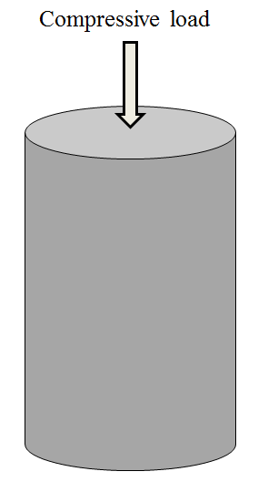
Figure 6: Axially compressed cylinder
Table 1: Details of geometry and imperfection ratio for the specimens tested by Lee²⁶.
Specimen | A330 | A230 | A130 | A320 | A220 | A310 | A110 | A300
$$R/t$$ | 9.36 | 9.38 | 9.39 | 19.38 | 19.4 | 29.16 | 29.22 | 46.06
$$L/R$$ | 4.21 | 6.32 | 10.5 | 4.1 | 6.15 | 4.06 | 10.16 | 4.04
$t$ (mm) | 5.43 | 5.42 | 5.41 | 2.62 | 2.62 | 1.74 | 1.74 | 1.1
$L$ (mm) | 213.87 | 321.01 | 533.40 | 208.28 | 321.10 | 206.25 | 516.13 | 205.23
$$δ/t$$ | 0.012 | 0.012 | 0.012 | 0.03 | 0.05 | 0.045 | 0.033 | 0.105
$R$ (mm) | 50.8

Fully integrated 4-noded shell elements with 6 degrees of freedom for each node were used for the simulations (elements S4 in ABAQUS²³). The material parameters were taken from those reported by Lee²⁶ and are reported in Table 2.
To account for the presence of imperfections, the perfect geometry was altered by adding the scaled first eigenmode computed with a linear buckling analysis under the assumptions of elastic behaviour and small displacements. The scaling parameter was computed to achieve the desired imperfection ratio, $δ/t$.
Table 2: Material parameters for Lee’s tests.
$$E \left(GPa\right)$$ | $$σ_{y} \left(MPa\right)$$ | $$ν$$ | $$n$$ | $$α$$
70 | 23.62 | 0.32 | 4.1 | 0.4286

Since the actual constraints to the end sections in the tests appeared to be intermediate between clamped and hinged boundary conditions, both these conditions were considered first. The results with clamped boundary conditions were found to be in much closer agreement with the experimental ones²⁰ not only in terms of buckling loads but also because the buckling mode appeared more similar to the one shown in Lee’s article. Therefore, the results presented here are those obtained with clamped edges, and are summarised in Fig. 7 in terms of buckling stress $σ_{c}$. They clearly show that not only do the flow and deformation theory provide similar results, unlike the findings by most authors in the literature, but also that the predictions of the flow theory are actually in better agreement with the experimental results than those provided by the deformation theory. In particular, the deformation theory tends to under-predict the experimental results.
For all specimens, except specimen A300, the buckling mode was axial-symmetric or nearly axial-symmetric. For specimen A300 the buckling mode was characterized by axial-symmetric bending near the edges and with a diamond-shaped pattern in the central region.

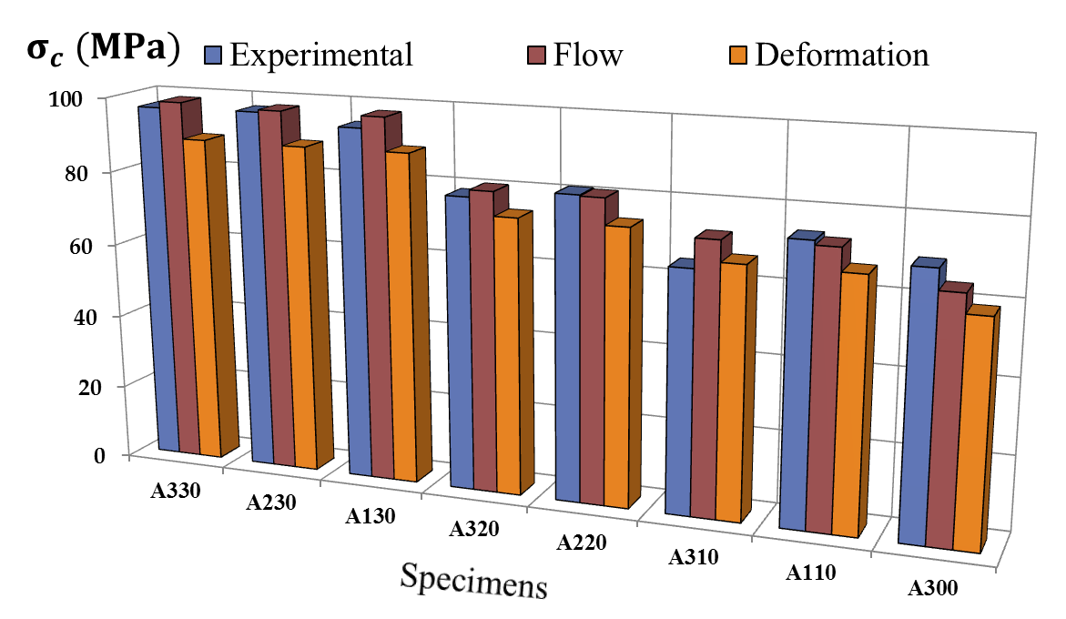
Figure 7: Comparison between buckling stresses experimentally measured by Lee²⁶ and the FE prediction with the flow and deformation theories.
The sensitivity to imperfections was studied, with ranges of imperfection ratios between 0 (perfect cylinders) and 20%. The sensitivity was found to be extremely small, and therefore does not explain why the results do not agree with the findings of other authors reported in the literature.
Fig. 8 shows a representative load-displacement curve obtained for Lee’s tests. Other curves for other tests show results which are qualitatively very similar to those in Fig. 8.
For brevity, the results of the nonlinear FE simulations of the experimental tests conducted by Batterman²⁷ are not reported here but can be found in an article by the authors²⁰. For some of the specimens tested by Batterman a greater sensitivity to the imperfections was found and, for some of them, a diamond-shaped buckling mode was found, with results that are in better agreement with experiments if imperfections are considered.

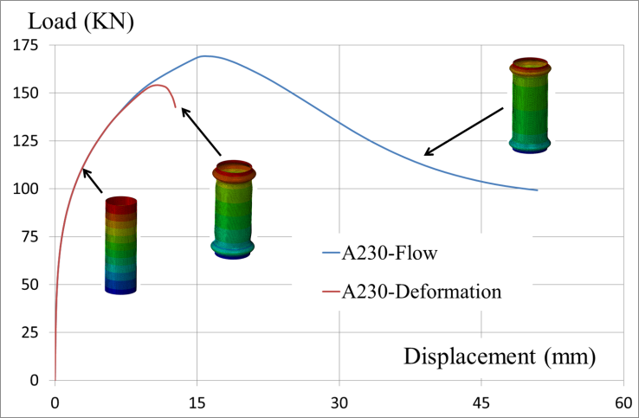
Figure 8: Load-displacement curve for specimen A230, also showing some details of the buckling mode.
The results confirm the two key findings with respect to Lee’s tests, i.e. (a) the difference in results provided by the deformation and the flow theories is very small (always less than 3% for Batterman’s specimens), (b) the buckling loads predicted by the flow theory are higher than those given by the deformation theory and (c) the flow theory results are in closer agreement with the experiments.
It is also worth noting that a mesh convergence analysis and a sensitivity analysis of the effect of the small initial yield strength $k_{0}$ led to changes in the FE results which were absolutely negligible.
- A semi-analytical model
To understand the role played by the different unloading response that one has in the numerical implementation of deformation and flow theories of plasticity, the simplified model, similar to the one used by Hutchinson²⁵, was studied with a semi-analytical approach. The model is depicted in Fig. 9 and is made of two rigid bars, with rectangular cross section, connected by two pin-ended short struts that are governed by the uniaxial stress-strain laws shown in Fig. 10 for the flow and deformation theories, respectively.

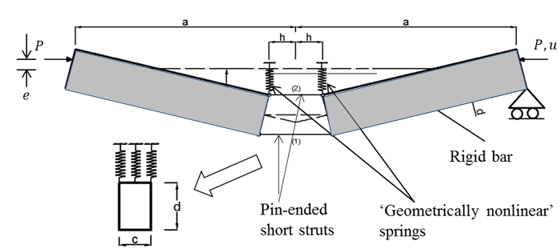
Figure 9: Hutchinson model²⁵.
The ‘geometrically nonlinear’ springs in Fig. 9 are characterized by the following force-displacement law:
$$Q=cβv^{2}sign\left(v\right)$$ | (6.1)
where $Q$ is the force exchanged by each spring, $c$ is the width of the cross section, $β$ is a positive coefficient and $v$ is the lateral deflection, as shown in the figure. These springs are added to simulate the geometrical nonlinearity leading to an unstable post-buckling response, typical of imperfection-sensitive structures such as cylinders in compression, for which the buckling load on an imperfect structure is lower and possibly significantly lower than that calculated for the perfect structure. The advantage of using these springs is that the imperfection sensitivity induced by the geometrical nonlinearity of the problem can actually be studied by adding some nonlinear and unstable material response, because Eq. (6.1) defines a force that is compressive when the spring is elongated and tensile when the spring is shrunk.
The geometric and material parameters for the problem are reported in Table 3.

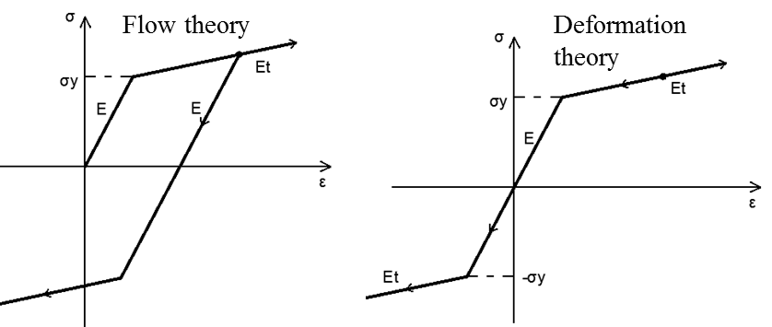
Figure 10: One-dimensional stress-strain curves used for the pin-ended short struts for the flow and deformation theories of plasticity.
Table 3: Parameters for Hutchinson’s model.
$$a \left(mm\right)$$ | $$c \left(mm\right)$$ | $$d \left(mm\right)$$ | $$h \left(mm\right)$$ | $$E \left(GPa\right)$$ | $$E_{t} \left(GPa\right)$$ | $$β \left(N{mm}^{-3}\right)$$ | $$σ_{y} \left(MPa\right)$$
250 | 15 | 15 | 5 | 70 | 35 | 10 | 100

Referring to Shamass et al.²⁰ for the details of the semi-analytical solution scheme used, Fig. 11 shows the load-displacement curve obtained for the case of an eccentricity of the load equal to 0.5 mm. It can be observed that, until the strut at the bottom starts unloading, the responses provided by the deformation and the flow theories are the same. Then, upon unloading of the bottom strut, the flow theory provides a curve which is constantly above the curve given by the deformation theory, as in the nonlinear FE analyses of the compressed cylinders. This suggests that the different material unloading can partially explain why the flow theory may tend to provide buckling loads larger than the deformation theory.

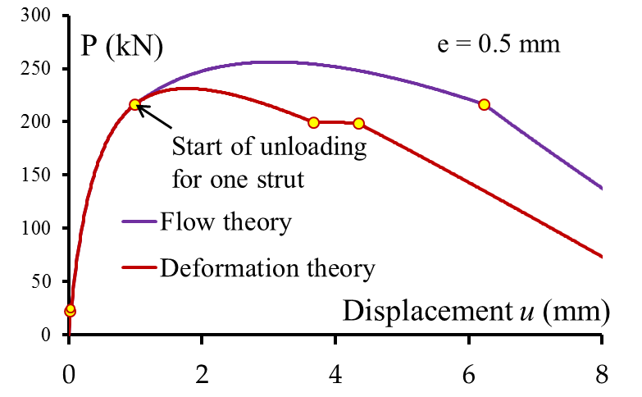
Figure 11: Load-displacement curves for the flow and deformation theories of plasticity for the simple two-bar model of Figure 9.
- Analytical methods
Although the different unloading responses in the deformation and in the flow theory of plasticity can partially explain why the numerical simulations with the flow theory provide larger buckling loads than for the deformation theory, the differences found in the FE results are relatively small, and much smaller than those reported in the literature. Furthermore, as already pointed out, results in the literature show that the best agreement with experiments is found with the deformation theory.
To shed light on this paradox, and why the paradox is not confirmed by the FE numerical results, the analytical models used in the literature were revisited by the authors²⁰. It was confirmed that the results are in favour of the deformation theory and that the flow theory tends to over-predict the buckling loads and, in some cases, cannot predict buckling at all.
One key assumption made in these models for the study of axially compressed cylinders, see e.g. the articles by Batterman²⁷ and by Ore and Durban²⁹, is that the buckling mode is axial-symmetric and that the radial displacement $v_{n}$ has a harmonic variation along the longitudinal axis, $x$, of the cylinder, with a number $m$ of half waves:
$$v_{n}=A sin\left(\frac{πmx}{L}\right)$$ | (6.2)
Using the same analytical approach as that adopted by Batterman²⁷, which is based on Eqs. (2.1) and (2.3) specialised to the case of a von Mises yield criterion, the results summarized in Fig. 12 were obtained. It is worth noting that the actual number $m$ of half waves was not specified a priori and was found from the analytical procedure as the one that provided the minimum buckling load.
The results are extremely close to those independently calculated again with the same analytical approach by Ore and Durban²⁹ and confirm the findings from most authors.
To investigate whether the kinematic assumption (6.2) might be the main reason of the significant difference between the numerical results in Fig. 7 and the analytical ones in Fig. 12, an axial-symmetric FE model was developed by the authors²⁰ with the addition of kinematic constraints that impose a deformed shape close to a harmonic function. To this end, 2-node axisymmetric shell elements were used and linear constraint equations were applied to the radial displacements of a suitable set of nodes, as shown in Fig. 13, to reproduce the same number of half waves as those in the analytical solution, for each case.
The results are summarized in Fig. 14 and show that there is a clear and strong correlation between the results of either theory obtained via the analytical approach or via a nonlinear incremental FE analysis under these kinematic constraints. It is worth noting that further analyses²⁰ show that, by removing the kinematic constraints, the axial-symmetric model essentially provides the same results as those in Fig. 7.
It is also worth noting that another assumption made in the analytical approach is that no material unloading occurs. This assumption is actually not even necessary for the deformation theory, based on Eq. (2.3), because unloading or loading is characterised by the same tangent stiffness. The assumption is implicit for the flow theory, because Eq. (2.1) is derived in the hypothesis that an increase in plastic strain occurs, which is equivalent to assuming that no elastic unloading occurs.
Therefore, the main difference in the results between the deformation and flow theory can be attributed to the difference in dealing with non-proportional loading. As discussed in Section 3, in relation to a simple problem, the flow theory considers a stiffer material tangent stiffness than that used in the deformation theory. The actual meaning of ‘stiffer’ can be seen for simple problems, such as in the cruciform column, as for that case it implies increments of shear stress and strains to be related through the elastic shear modulus in the flow theory, which is larger than the tangent shear modulus used in the deformation theory.

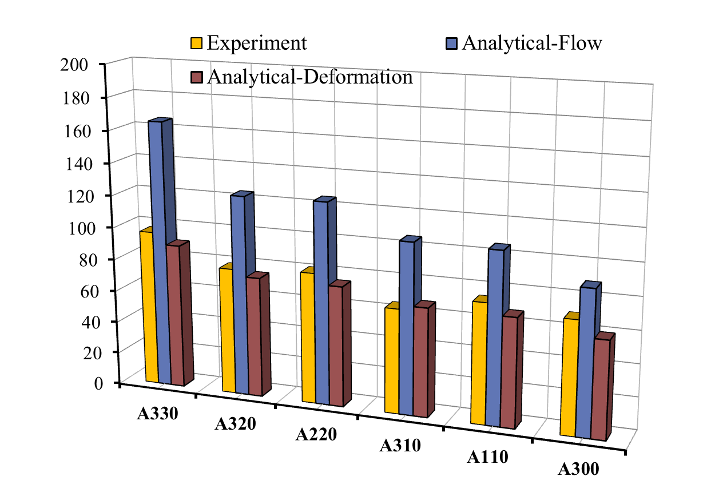
Figure 12: Comparison between experimental buckling stresses measured by Lee²⁶ and the analytical predictions with the flow and deformation theories²⁰.

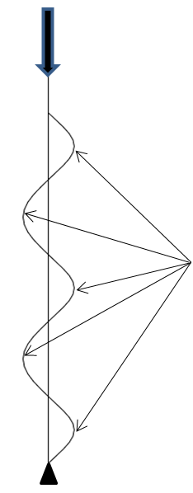
Linear constraint equations used on these nodes to reproduce the same number of half waves provided by the analytical solution
Load
Figure 13: Axial-symmetric FE model with kinematic constraints²⁰.

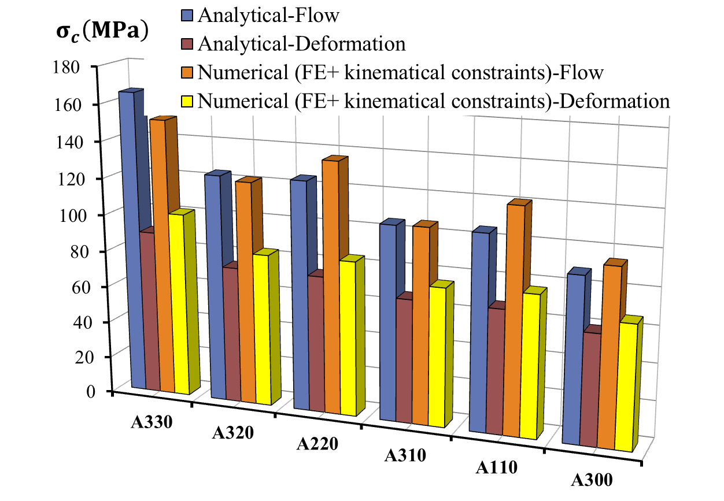
Figure 14: Numerical FE results obtained with an axial-symmetric model with kinematic constraints²⁰ vs experimental results²⁶.
- Conclusions of the investigation on axially compressed cylinders
The main conclusions that can be drawn by the investigation by the authors²⁰ can be summarised in two main points:
- When the flow and deformation theories are used in a nonlinear FE incremental analysis, with a sufficiently refined mesh and with carefully calibrated material models, no plastic paradox is found: the flow and deformation theories provide results that are relatively close, and those obtained with flow theory are in closer agreement with the experiments.
- All results combined together suggest that the plastic paradox is due to the kinematic assumptions which are made in the analytical solutions used in the literature. These assumptions are stronger than expected and produce a stiffer structure when the otherwise correct flow theory is used, ultimately resulting in over-prediction of the buckling load and the plastic strains. Instead, when the deformation theory is used, this excessive stiffness is compensated for a tangent material stiffness that is in general softer than the correct one, and this compensation leads to results in better agreement with experiments.

- Cylinders Subject to Non-Proportional Loading
The case of cylinders subject to axial tension and external pressure is of significant practical importance, for example in offshore engineering as it applies to underwater pipes at intermediate depths where the weight of the rest of the pipe at lower depths results in significant axial tension acting in combination with external hydrostatic pressure.
Within the context of this chapter, which investigates the plastic buckling paradox, this case is of significant interest also because it represents a situation where the actual external load is non-proportional.
It was discussed in Section 3 that, also for the simple case of a compressed column, the buckling phenomenon itself results in non-proportional material loading even if the external load increases monotonically and proportionally. On the other hand, one can expect that when the external action itself is non-proportional, the difference in results obtained using the flow and the deformation theory of plasticity might be amplified.
Indeed, this case has been investigated by a number of authors who once again found a marked difference between the results of the flow and deformation theory, the latter providing predictions of the buckling pressure which are in closer agreement with experiments.
Furthermore, buckling occurs in this case always with buckling modes that are not axial-symmetric, as is shown by a representative deformed shape in Fig. 15, which adds an element of complexity to the analysis. If a nonlinear FE simulation is conducted on the perfect structure, a linearized eigenvalue analysis at each increment is needed to determine the possibility of bifurcations. In the plastic range, this linearized analysis should however consider the current tangent stiffness, which is not possible in many commercial codes.
An alternative option is to directly study an imperfect cylinder, and perform a sensitivity study on the size and shape of the imperfection. Bifurcations loads on the perfect structures can be found with this methodology using an asymptotic approach in which the size of the imperfection is made to tend to zero.
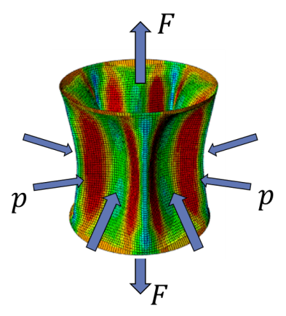
Figure 15: Representative buckling shape for cylinders subject to axial force and external pressure.
The case of cylinders subject to axial tension and external pressure was investigated by the authors²² to further validate their earlier conclusions²⁰ for the case of axially compressed cylinders. To this end, the experimental tests reported by Blachut et al.¹⁴ and by Giezen³⁰ and Giezen et al.³¹ were numerically simulated with nonlinear incremental FE analyses using both the deformation and the flow theory of plasticity, with the methodology described in Section 5. The analyses accounted for imperfections and initially the imperfection shape was based on the buckling modes reported in the experiments.
For brevity, results are summarized here for the 12 tests selected from those made by Blachut et al.¹⁴ on thirty mild-steel cylinders with different radius-to-thickness $R/t$ and length-to-diameter $L/D$ ratios, and with imperfections that were estimated to be approximately 1% of the thickness. The constraints at the end sections applied in the experimental setup were found to be accurately approximated by clamped boundary conditions in the FE analyses. The geometries of the specimens and the applied tensile loads are given in Table 3, while the material properties used in the analyses are given in Table 4.
In the FE analyses, an elastic-perfectly plastic law was implemented for the deformation theory with adequate approximation, by using a very high exponent n in order to approximate the stress plateau typical of mild steel. Furthermore, results of preliminary simulations, in which the yield strength was taken equal to either the upper or the lower yield limit, suggested the use of the upper yield in subsequent simulations constituted the best option. The reader is referred to the article by the authors²² for these details, as they are not crucial in the context of this investigation into the plastic buckling paradox.
Table 3: Geometry and applied load for the specimens tested by Blachut et al. ¹⁴.
Specimen | $$L/D$$ | $$R \left(mm\right)$$ | $$t \left(mm\right)$$ | Applied axial tension (N)
S1 | 0.982 | 17.00 | 0.685 | 17960
S2 | 0.983 | 16.99 | 0.688 | 0
S3 | 0.982 | 17.02 | 0.667 | 18000
S4 | 0.982 | 17.03 | 0.667 | 3990
S5 | 0.981 | 16.99 | 0.679 | 12010
S6 | 0.979 | 17.03 | 0.704 | 15030
S7 | 0.982 | 16.98 | 0.675 | 7970
M2 | 1.47 | 17.00 | 0.616 | 10670
M7 | 1.473 | 16.98 | 0.63 | 15060
M12 | 1.474 | 16.79 | 0.669 | 18530
L4 | 1.961 | 17.00 | 0.669 | 8210
L8 | 1.964 | 16.98 | 0.693 | 16490
Table 4: Material parameters.
$$E \left(GPa\right)$$ | $$σ_{y} \left(MPa\right)$$ | $$ν$$ | $$n$$ | $$α$$
212 | 328 | 0.31 | 300 | 0.428

Fig. 16 shows a summary of the results of the numerical simulations in terms of buckling pressure for the twelve chosen specimens, which provide a significant range of $R/t$ and $L/D$ ratios, compared to the experimental ones.
Unlike the case of axially compressed cylinders, studied in Section 6, it is not possible here to clearly say which theory provides results in closer agreement with the experiments. On the other hand, an extensive sensitivity analysis on the size and shape of the initial imperfections shows that imperfections can account for differences of up to 10%. Since the correct choice of the initial imperfection to use is an open issue for this type of problem, it is likely that, while the effect of imperfection does not dramatically affect the correlation between numerical and experimental results, it may have sufficient influence to make it not possible to judge which theory provides the closest agreement with experiments. Using the upper or the lower yield limit, or possibly a more sophisticated law that captures the yield phenomenon more precisely, is also something that may affect the comparison between the results obtained with the two theories.
Ultimately, these results confirm once again that the flow and deformation theories provide very similar results, all of them in relatively good correlation with the experimental results, and therefore that the plastic buckling paradox does not really exist when accurate nonlinear FE analyses are conducted.
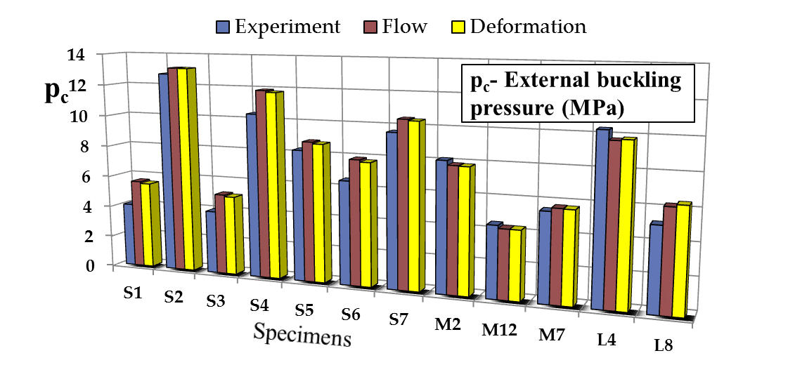
Figure 16: Buckling pressures predicted by FE simulations with the flow and deformation theories²² vs experimentally measured values¹⁴.

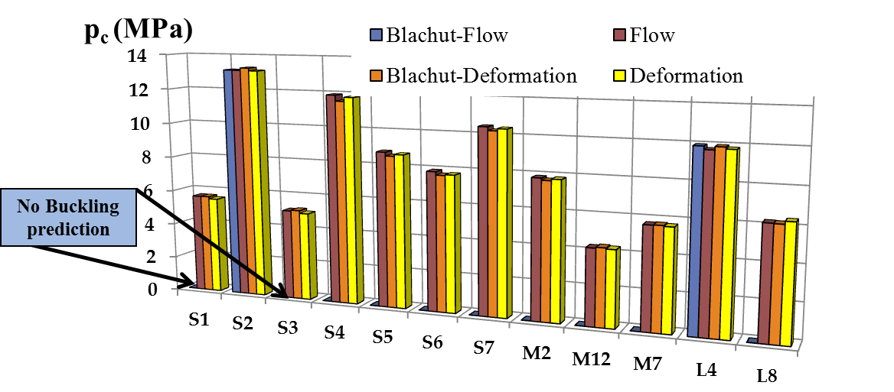
Figure 17: Comparison between numerical results by the authors²² with the numerical results by Blachut et al.¹⁴ using the code BOSOR5.
Fig. 17 shows a comparison between the numerical FE results by the authors²² and the results obtained by Blachut et al.¹⁴ using the code BOSOR5. It can be observed that the only specimens for which BOSOR5 was able to predict the buckling load on the basis of the flow theory are specimens S2 and S4. On the contrary, the nonlinear FE simulations based on the flow theory were able to predict buckling in all cases, with acceptable values of the plastic strains and with computed buckling pressures very close to those predicted by the FE analyses based on the deformation theory. In turn, the latter are very close to those found by Blachut et al.¹⁴.
- Conclusions.
The present review chapter has presented some problems in the inelastic buckling of structures and in particular has focused the attention on the so-called ‘plastic buckling paradox’, i.e. the fact, reported by many studies, that the more physically sound flow theory of plasticity tends to provide values of the buckling loads which are very different from the deformation theory of plasticity and not in agreement with experimental findings.
However, the authors²⁰⁻²² have recently suggested that, when an accurate and consistent FE model is set up, both the flow and deformation theories can predict buckling loads within acceptable plastic strains, and that buckling pressures calculated numerically by means of the flow theory are in better agreement with the experimental data.
Analytical formulations provide results which are very similar to those obtained by Blachut et al.¹⁴ and Giezen et al.³¹ using the code BOSOR5 for both the flow and deformation theory of plasticity²¹. Such results lead to analogous conclusions as those by Blachut et al.¹⁴ and Giezen et al.³¹, that is the flow theory tends to over-predict buckling pressure for high value of tensile load while the deformation theory provides more accurate results.
For a long time it has been believed that the difference in buckling predictions between the flow and the deformation theory of plasticity was mainly caused by the difference in the effective shear modulus used for the bifurcation buckling phase of the analysis, see for example Onat and Drucker¹¹. However, Giezen³⁰ showed, using the code BOSOR5, that in the case of cylinders under non-proportional loading the adoption of the effective shear modulus predicted by the deformation theory,$\overline{ G}$, instead of the elastic one, $G$, in the flow theory does lead to a certain reduction in the value of the buckling load but not as much as to make it comparable with the predictions from the deformation theory, based on the secant modulus in shear.
It is therefore likely that the difference in buckling predictions between the flow and the deformation theory can only be partially attributed to the difference in the effective shear modulus used for the bifurcation buckling phase of the analysis.
The authors²⁰ first showed in the case of proportional loading that the simplifying assumptions on the buckling shape made in several analytical treatments, which result in a kinematic constraint on the model, lead to an excessive stiffness of the cylinders and, consequently, to an overestimation of the buckling stress for both the flow and deformation theories. The deformation theory tends to compensate this excessive stiffness and provides results that are more in line with the experimental ones. This fact seem confirmed also in the case of non-proportional loading by the comparison between FE results and those obtained by Blachut et al.¹⁴ and Giezen et al.³¹ using BOSOR5. In fact, BOSOR5 assumes that the buckling shapes vary harmonically in the circumferential direction. In conclusion, this assumption regarding the kinematics of the problem seems to be the main reason for the systematic discrepancies between the results based on the flow theory of plasticity and those from the numerical analyses performed in the present study.
References
[1] Engesser, F. Die Knickfestigkeit gerader Stäbe . Z., 1889. Architektur Ingenieurw, 455
[2] Gerard, G. (1962). Introduction to Structural Stability Theory. McGraw-Hill, New York.
[3] Considère, A. (1891). Résistance des pièces comprimées, Congr. intern. proceédés construct., Paris, vol.3, 371.
[4] Engesser, F. (1895). Über Knickfragen, Schweizerische Bauzeitung, vol. 26, 24-26.
[5] Shanley, F.R. (1947). Inelastic Column Theory. J. Aeronaut. Sci., 14 (5), 261-267.
[6] Bushnell, D. (1974). Bifurcation buckling of shells of revolution including large deflections, plasticity and creep. Int J Solids Struct; 10, 1287-1305.
[7] Stowell, E. (1948). A Uniﬁed Theory of Plastic Buckling of Columns and Plates. NACA Technical Note 1556, NACA, Washington.
[8] Gerard, G., Becker, H. (1957). Handbook of Structural Stability – Part I – Buckling of Flat Plates. NACA Technical Note 3781, National Advisory Commitee for Aeronautics, Washington.
[9] Lubliner, J. (1990). Plasticity theory. Macmillan Publishing Company-US.
[10] Hutchinson, J., Budiansky, B. (1976). Analytical and numerical study of the effects of initial imperfections on the inelastic buckling of a cruciform column. In: Budiansky, B. (Ed.), Proc of IUTAM Symposium on Buckling of Structures. Springer, PP. 98-105.
[11] Onat, E. and Drucker, D. (1953). Inelastic Instability and Incremental Theories of Plasticity. J. Aeronaut. Sci. 20 (3), 181–186.
[12] Bushnell, D. (1982). Plastic buckling of various shells. ASME J. Press. Vessel Technol.104, 51.
[13] Tugcu, P. (1991). Plate buckling in the plastic range. Int. J. Mech. Sci. 33 (1), 1–11.
[14] Blachut, J., Galletly, G. and James, S. (1996). On the plastic buckling paradox for cylindrical shells. Proc. Inst. Mech Eng C- J Eng, 210 (5), 477–488.
[15] Wang, C., Xiang, Y. and Chakrabarty, J. (2001). Elastic/plastic buckling of thick plates. Int. J. Solids Struct. 38 (48–49), 8617–8640.
[16] Yun, H. and Kyriakides, S. (1990). On the beam and shell modes of buckling of buried pipelines. Soil Dyn Earthq Eng, 9(4), 179-193.
[17] Teng, J. G. (1996). Buckling of thin shells: recent advances and trends. Applied Mech Rev, 49(4), 263-274.
[18] Wang, X. and Huang, J. (2009). Elastoplastic buckling analyses of rectangular plates under biaxial loadings by the differential quadrature method. Thin Wall Struct, 47(1), 14-20.
[19] Zhang, W. and Wang, X., 2011. Elastoplastic buckling analysis of thick rectangular plates by using the differential quadrature method. Comput Math Appl, 61(1), 44-61.
[20] Shamass, R., Alfano, G. and Guarracino, F. (2014). A numerical investigation into the plastic buckling paradox for circular cylindrical shells under axial compression. Eng Struct, 75, 429-447.
[21] Shamass, R., Alfano, G. and Guarracino, F. (2015). An analytical insight into the buckling paradox for circular cylindrical shells under axial and lateral loading. Math Probl Eng, ID 514267, 1-11.
[22] Shamass, R., Alfano, G. and Guarracino, F. (2015). An investigation into the plastic buckling paradox for circular cylindrical shells under non-proportional loading. Thin Wall Struct, 95, 347-362.
[23] Simulia (2011). ABAQUS Theory Manual. Version 6.11-1. Dassault Systems.
[24] Bushnell, D. (1986). BOSOR5 – Program for Buckling of Complex, Branched Shells of Revolution Including Large Deflections, Plasticity and Creep. In Structural Analysis Systems – 2, edited by Niku-Lari, A. Pergamon, 25-54.
[25] Hutchinson, J.W. (1972). On the postbuckling behavior of imperfection-sensitive structures in the plastic range. J Appl Mech- T ASME, 39, 155–162.
[26] Lee, L. (1962). Inelastic buckling of initially imperfect cylindrical shells subjected to axial compression. J Aero Sci, 29, 87-95.
[27] Batterman, S.C. (1965). Plastic buckling of axially compressed cylindrical shells. AIAA Journal, 3(2), 316-325.
[28] Mao, R. and Lu, G. (2001). A study of the plastic buckling of axially compressed cylindrical shells with a thick-shell theory. Int J Mech Sci, 43(10), 2319-2330.
[29] Ore, E. and Durban, D. (1992). Elastoplastic buckling of axially compressed circular cylindrical shells. Int J Mech Sci, 34(9), 727-742.
[30] Giezen, J.J. (1988). Plastic buckling of cylinders under biaxial loading. (Ph.D. thesis), California Institute of Technology, Pasadena, CA, February.
[31] Giezen, J.J, Babcock, C. D. and Singer, J. (1991). Plastic buckling of cylindrical shells under biaxial loading. Exp Mech J, 31(4), 337-343

