Figure 7. Forest-plot for Affective/NT Outcome Post-intervention (Lee et al., 2008)

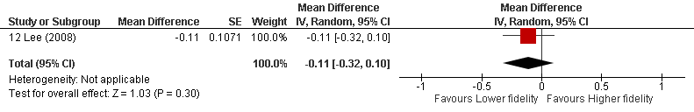

Statistical Package: Review Manager (RevMan-5.3).The Cochrane Collaboration (2014).

