Figure 8. Forest-plot Affective/NT Outcome at 2-Weeks and 2-Months (King and Reising, 2011)

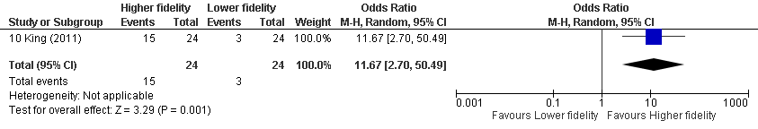
Statistical Package: Review Manager (RevMan-5.3).The Cochrane Collaboration (2014).

