Figure 2. Risk-of-Bias Summary

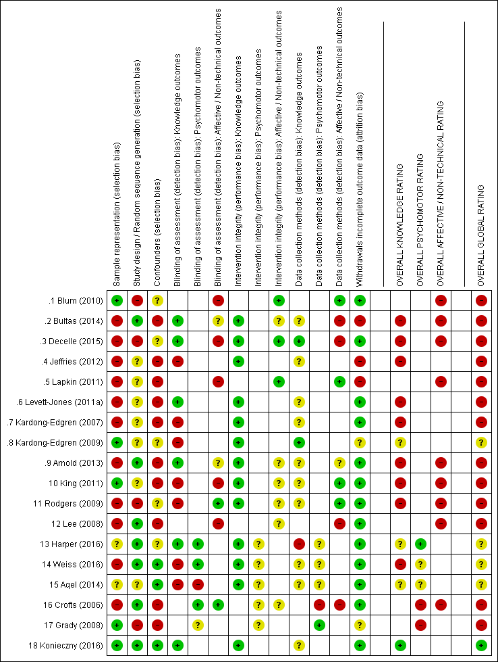
=low risk | =moderate risk | =high risk

Created and adapted from Review Manager (RevMan-5.3), The Cochrane Collaboration (2014).

