Figure 3. Forest-plot for Knowledge Outcome

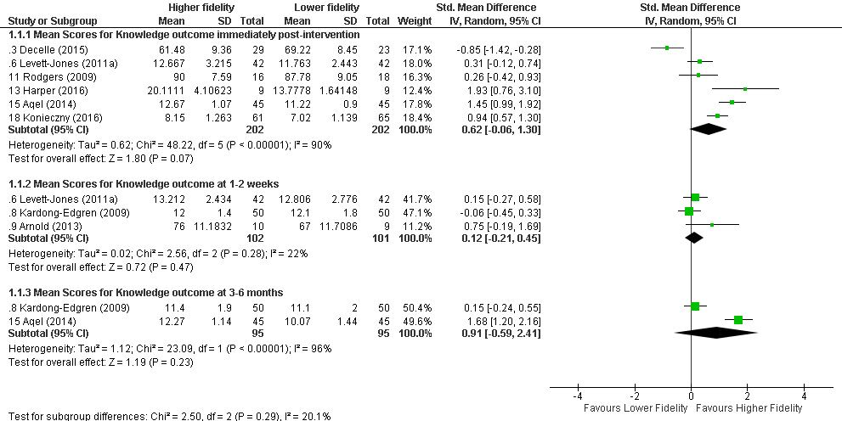

Statistical Package: Review Manager (RevMan-5.3).The Cochrane Collaboration (2014).

