Title Page
Modelling the Inflammatory Bowel Disease Specialist Nurse Workforce standards by determination of optimum caseloads in the United Kingdom.
Authors
Alison Leary¹, Isobel Mason^{2, 3} and Geoffrey Punshon¹
¹ London South Bank University, School of Health and Social Care, London SE1 0AA
² Crohn’s and Colitis UK, St. Alban’s, Herts AL1 3AW
³ Royal Free Hospital NHS Trust, London NW3 2QG
Contact details
Alison Leary email: alisonleary@yahoo.com.
Isobel Mason email: Isobel.Mason@CrohnsandColitis.org,uk
Geoffrey Punshon email: punshongeoff@yahoo.co.uk
Short Title
Modelling the IBD Specialist Nursing Workforce
Abbreviations
Full Time Equivalent (FTE); Inflammatory Bowel Disease (IBD); Multi-Disciplinary Team (MDT); Nurse Specialists (NS); Registered Nurse (RN); Royal College of Nursing (RCN)
Address for correspondence
Geoffrey Punshon. Address: London South Bank University, School of Health and Social Care, 103 Borough Road, London SE1 0AA UK. Email: punshongeoff@yahoo.co.uk. Telephone/Fax: +44 (0)207 928 8989.

Abstract
Background and Aims
Crohn’s disease and ulcerative colitis are the most common forms of inflammatory bowel disease affecting 1 in 250 of the population in the UK. It is accepted that access to a specialist nurse service improves patient experience and outcome. National Standards for inflammatory bowel disease care (2013) defined the number of nurse specialists required at 1.5 full time equivalent per 250,000 population. The aim of this study was to determine if these standards were being met and to publish a new, robust validated standard optimising the UK nursing workforce model.
Methods
Existing national data and specific workload and service data was collected from 164 IBD specialist nurses who completed a questionnaire designed to collect information on activity and complexity of work both done and undone.
Results
Data was received from all of the UK. Thirty-six percent of respondents were specialist nurses in the field for 3 years or less. A higher caseload than the recommended level was reported by 63% of respondents. Unpaid overtime was regularly carried out by 84%of respondents. The IBD specialist nurse was involved in all areas of the patient pathway. Areas of work left undone were psychological interventions, prescribing medicines and physical assessments.
Conclusions
Compared to other specialties IBD specialist nurses are less experienced. It is recommended that the current standard be increased to 2.5 full time equivalent specialist nurses per 250,000. patients to mitigate for the increasing complexity of the role, care and the “rookie” factor.
Keywords: Inflammatory Bowel Disease, Specialist Nurse, Workforce Modelling
Title: Modelling the Inflammatory Bowel Disease Specialist Nurse Workforce standards by determination of optimum caseloads in the United Kingdom.

Introduction
One of the most important challenges for the NHS in the UK and healthcare worldwide is to accurately calculate both the expertise and amount of time nurses require to care for different patient groups in a variety of environments. It is difficult to do this because nursing, in common with most human activities, is complex^{1,2} and dynamic. As a result, clarity over which information is even relevant to a proposed model may be challenging³.
Despite the complexity of nursing work most approaches to examining the issue of nursing resource are deterministic in nature and involve variations of time and motion models in which time is filled with a linear series of tasks⁴.
The two most common forms of Inflammatory Bowel Disease (IBD) in the UK are Crohn’s Disease and Ulcerative Colitis which taken together affect around 1 in 250 of the population⁵. IBD is currently a lifelong condition as there is currently no cure. Half of all newly diagnosed patients will be in their teens and twenties⁵.
It is widely accepted that access to effective IBD nurse specialist (NS) services improves experience and clinical outcomes for patients⁶. Patients often describe their IBD NS service as a lifeline. The National Standards for IBD Care⁷ first defined the numbers of NS required as 1.5 full time equivalent (FTE) per 250,000 population.
The current national standards have been influential in increasing nursing numbers⁷ however, they were a result of consensus rather than evidence, and don’t reflect the complexity of NS work.
Specialist nursing work varies in the UK. The level of practice and job title for example are not a reliable proxy for complexity of practice⁸. This means that NS in the UK tend to work at a range of levels of complexity, offer a different range of interventions and do so within many different service arrangements. These factors can affect workload burden. Other factors include complexity of patient needs⁹ and access to members of the multidisciplinary team¹⁰ (MDT).
In the UK the role of specialist IBD nurses was described by the Royal College of Nursing in 2007 providing guidance to developing best practice and for local service organisation. The report outlines a number of knowledge and skills frameworks in a number of areas such as specialist knowledge, education, service development, management and leadership. The scope of practice of the role includes areas such as telephone advice lines, rapid access clinics, follow-up clinics, in-patient care, managing an immunotherapy service and administering and monitoring therapies⁶.
In countries outside the UK, the role of nurses in caring for patients with IBD varies across Europe and the rest of the world. A variety of systems of delivering care and differing levels of responsibility for nurses exist¹¹. In 2018 N-ECCO produced a second consensus statements on the European Nursing Roles in Caring for Patients with Crohn’s Disease or Ulcerative Colitis which made a number of statements regarding the role of the IBD nurse based on ‘ideal’ standards of care¹².
As in many areas of healthcare the workforce is modelled from the supply side rather than demand. Very little demand modelling can be found. In order to model a future UK IBD nursing workforce, demand modelling was needed to understand the need for the IBD nursing interventions. This includes understanding how the current workforce meets demand, what work is left undone, how much overtime (paid and unpaid) is required to meet demand and the available skill mix in terms of complexity.
The aim of this study was to determine if the National IBD Standards for IBD NS were being met and to model the UK IBD nursing workforce.
Methods and Data Collection
A priori dataset- complexity and factors that affect workload
A curated dataset of around seventy million hours of advanced practice specialist work (n=18,000) since 2009 was accessed to look at patterns and workload of other specialists working in long term conditions. These data reflect varying levels of complexity of work and have generated indicators of workload in order to use stochastic approaches to optimum caseload calculation. From this curated data set a number of common factors which typically influence NS workload were determined. Examples of such factors included relationships with other members of the multidisciplinary team¹⁰, complexity of caseload¹³, access to administrative assistance¹⁴,access to other services¹⁵ and education and experience¹⁶. To enable NS to make independent decisions rather than “door hang” for the decisions of others issues such as access to non-medical prescribing¹⁷ and the ability to independently request investigations were also significant factors.
Consensus workshop of expert opinion-checking the assumptions
In order to use the existing a priori dataset and the on-line data collection tool it was necessary to check the assumptions made regarding the workload and activity of this group.
A consensus workshop of 15 IBD NS from across the UK was convened to check and challenge assumptions drawn from the dataset. The nurses were asked to explain their work in detail. Areas examined included the work environment, physical and psychological domains, social issues, case management, administration and work left undone. The IBD NS had a similar work pattern to those in other long-term conditions such as multiple sclerosis and rheumatology.
Data collection specific to IBD
National data from the IBD audit⁶ regional data from Crohn’s and Colitis UK on current workforce¹⁸ and population data on the incidence of IBD¹⁹ was used to model demand initially.
A 24-item questionnaire, exploring demographic data, caseload and workload was developed for this population by consensus using clinical, patient and academic experts based on a previously employed national study¹⁰. The questionnaire was designed to gather data on activity and complexity of specialist nursing services provided including work left undone and used a format similar to the national optimum caseload modelling project¹⁵. This was transferred to an online survey tool (administered using a Survey Monkey secure account). The survey link was distributed through the Royal College of Nursing (RCN) IBD Nursing Network and other professional mailing lists during February 2017. One hundred and sixty-four participants responded to the questionnaire. A single response could only be submitted from each computer. Analysis of the survey took place in March 2017.
Data analysis
Data were exported into Excel and modelled using descriptive statistics for example demographics, pay band and length of service, workload, interventions delivered, work left undone and educational background. Free text comments were analysed using thematic content analysis²⁰. Thematic content analysis is the approach best suited to free text questions in an otherwise quantitative questionnaire as it does not rely on interpretation of data but instead reflects a ‘low hovering over the data’.
Caseload calculations
Responses to the Survey Monkey workload questionnaire were received from 164 nurses who completed the questionnaire in whole or in part. The total population of NS in the UK is around 300 by headcount (FTE is unknown) so this equates to a 55% response rate.
Results
Respondent’s Demographic Data and Epidemiology of IBD in the UK
The country of practice, number of hospital sites covered, length of time working with IBD patients, patient population, area of IBD practice and educational qualifications are summarised in Table 1.
Insert Table 1 here
Time Spent Providing Care for IBD Patients
To determine how much of their time was spent caring for IBD patients’ respondents were asked to estimate the percentage of time they spent providing care for IBD patients. Thirty-one percent (51/164) respondents spent 100% of their time caring for IBD patients. Fifty-one percent (83/164) spent 80% of their time, 14% (23/164) 50% of their time and 4% (7/164) 30% of their time. No respondents spent less than 30% of their time working with IBD patients.
Contracted Hours of Work
Respondents were asked to state their contracted hours of work. Seventy-two percent of respondents were contracted to work 36 to 37.5 hours per week. Nine percent worked 26 to 30 hours, 6% worked 21 to 25 hours, 6% more than 37.5 hours, 4% 31 to 35 hours, 2% 7.5 to 15 hours and 1% 16 to 20 hours. In total this represents approximately 149 FTE for the 161 respondents to this question.

Unpaid Overtime Worked per Week
To ascertain how much unpaid overtime (including working through meal breaks) respondents carried out regularly per week they were given five options to choose from. Sixteen percent (25/160) of respondents reported that they carried out no regular unpaid overtime. Thirty-two percent (51/160) carried out between 1 and 3 hours’ unpaid work, 36% (57/160) 4 to 7 hours, 10% (16/160) 7 to 10 hours and 7% (11/160) more than 10 hours. . This equates to approximately 661 hours of unpaid overtime worked per week in total by respondents as a whole (assuming median values of 2, 5.5, 8.5 and 10 hours extra for the four categories reporting unpaid overtime) or 4.13 hours each which is equivalent to approximately 17.6 FTE unpaid overtime being worked per week in total.
Administrative Support Provided to Respondents
Respondents were asked how much administrative support (help with typing letters or doing routine non-clinical administration) they received each week.
Sixteen percent responded that they received no admin support at all. A further 45% responded that they only received admin support for clinic letters.
Of the respondents who did receive admin support to use as they wished 4% received between 1 and 5 hours’ support, 9% between 6 and 12 hours, 7% 13 to 20 hours and 19% more than 20 hours per week.
Unfilled and Frozen Vacancies
To ascertain the level of unfilled and frozen posts respondents were asked how many, if any, posts were unfilled in their speciality. Seventy-seven percent of respondents had no unfilled posts. 5% of respondents had less than one FTE unfilled while 15% had one FTE unfilled. Finally, 3% of respondents had two FTE unfilled. No respondents reported any frozen posts.
This equates to approximately 24.5 FTE posts unfilled in total from this population.
Respondents Estimated Caseload
Respondents were asked to estimate their individual caseload. 63% of respondents had caseloads over 700 patients while only 25% had caseloads of 500 or less (Figure 1). Taken as a whole this represents an approximate total caseload of 146,150 patients for all 148 respondents.
Insert Figure 1 here

Respondents Work Done
Respondents were asked if they carried out certain tasks at each level of the treatment pathway (Pre-diagnosis, diagnosis, post-diagnosis, treatment and end of treatment/follow up).
It can be seen that as a group IBD NS are involved in all stages of the treatment pathway. The actual level of involvement in pre-diagnosis was not anticipated by the focus group with only 55 respondents (41%) stating that they did not see patients at the pre-diagnosis stage. The highest period of activity was at the post-diagnosis stage. The responses are summarised in Figure 2.
Insert Figure 2 here
The six most common interventions at each treatment stage are shown in Figure 3 with meeting information needs, symptom control, requesting imaging and recommending medication being the most common interventions.
Insert Figure 3 here
Respondent’s Sessional Work
The respondents’ work done by session is summarised in Table 2. Provision of an advice line was the most common single use of working time with 85% of respondents spending at least three sessions a week on the advice line and a total of 560 (31% of the total reported sessions) sessions being spent by all respondents. Nurse lead outpatient clinics accounted for a further 290 sessions, more than twice the number of Consultant lead outpatient clinics at 121 sessions. Endoscopy does not appear to be common with only 36 sessions being reported.
Insert Table 2 here

Respondent’s Work Left Undone
Across all stages of treatment psychological interventions (emotional support, referring to counselling and/or psychiatric services) feature highly in respondents work undone and are the most common work undone at each stage after pre-diagnosis. Prescribing medication is another area where respondents felt much was left undone, perhaps because the nurses who gave this response did not have a prescribing qualification or were not able to prescribe independently. Work left undone is summarised in Figure 4.
Insert Figure 4 here

Discussion
Specialist disease specific nurses are known to enhance the quality of care and patient experience^{21, 22} and can be productive not only in terms of quality but also in terms of efficiency such as the avoidance of unnecessary admission to an acute inpatient unit^{14, 23}. The value of an IBD NS was investigated by Leach et al (2014) who examined 4920 recorded episodes of care in Australia involving 566 patients. IBD nurse intervention led to avoidance of 27 hospital admissions (representing a saving of 171 occupied bed days), 32 Emergency Department presentations and 163 outpatient reviews. After deducting salary and on-costs related to the IBD nurse there was a net direct saving to the hospital of AUD $136,535²⁴. Another study looked at the financial impact of a nurse-lead telemedicine service for IBD in a UK hospital and estimated that over a 5-month period the net saving on the avoidance of general practitioner consultations, of a consultant appointment and of either accident and emergency or hospital admission was £42, 890²⁵. The value of such telemedicine services or helplines has been demonstrated by a number of studies. For example, a survey of 1143 people with IBD (46% response rate) in Canada found that 77% of respondents were likely or very likely if acutely symptomatic to use a phone contact service with an IBD NS²⁶. As with any supply model there is likely to be a point of saturation whereby the quality of the service is at least partly driven by the distributed workload which can result in work being left undone²⁴.
Given that the total population of IBD patients in the UK is estimated at 250,000 to 300,000 the estimated 146,150 case load covered by the respondents in this study equates to between 49% and 58% of the total IBD patient population. This is supported by the estimate that the total IBD NS population in the UK is around 300 so 148 responses to the caseload question would represent around 50% of the IBD NS population. The distribution of respondents in the UK also reflects the distribution of IBD NS posts reported in the IBD nursing audit³.
The IBD Standards⁷ recommended that 1.5 FTE NS with a special interest and competency within IBD should be provided per 250,000 of population for a five-day service. Assuming that 1 in 250 of the population has IBD this would give a caseload of 666 per FTE IBD NS.
Crohn’s and Colitis UK⁵ states that the current number of patients with IBD in the UK is 300,000. To achieve a caseload of 666 patients per full time IBD NS would therefore require 450 full-time IBD NS based on current demand. There appears to be a considerable shortfall on this number in the UK. In this group, of the 148 nurses who responded to this workload analysis, over half (63%) have much higher caseloads than the current recommended standard. Caseloads as high as 2000 patients plus were reported.
There are number of potential reasons for these high caseloads. One potential issue is unfilled IBD NS posts. In this study the number of unfilled posts reported by respondents is estimated to be equivalent to 24.5 FTE. Another factor which is apparent from the study is the amount of unpaid overtime currently being carried out by IBD NS. In 2012 the RCN estimated that IBD NS carried out an average of 2.75 hours unpaid overtime per week⁶ suggesting on the basis of an estimated average of 4.13 hours in this study the amount of unpaid overtime carried out by IBD NS is increasing. Only 16% of respondents regularly carried out no unpaid overtime. The amount of unpaid overtime carried out by the remaining respondents equalled an estimated 17.6 FTE.
The 2012 RCN IBD Nursing Audit⁶ found that 79% (150/202) sites surveyed failed to meet the standard of 1.5 IBD NS per 250,000 population and the data presented in this study would appear to suggest there has not been significant improvement since 2012.
It is clear from the workload analysis that there is much variability and different levels of service provision. Of the 1,800 available sessions in the group 1,744 (97%) were taken up with programmed clinical activity. The majority of this time was a telephone advice line (560, 31%) and only 290 sessions (16%) were taken up with nurse led clinics. The IBD Standards Report⁷ found that only 24% of patients had access to a psychologist with an IBD interest which may explain why this work is often left undone.
It is also apparent that because of the variability of service provision local circumstances should be taken into account such as the availability of administrative help which remains a burden for some IBD NS. In other specialisms the provision of administration and support workers has increased productivity for example administrative workers allowed multiple sclerosis specialist nurses to proactively manage their case load resulting in reduced emergency admission²⁸. Another local factor which can influence caseload is the complexity of patients.
Conclusion
The current standard 1.5 FTE IBD NS per 250,000 population if filled is likely to mitigate for the rates of unpaid overtime and annual leave. However, there is a clear direction of travel for increasing complexity of care, activity at pre-diagnosis, support to community services and a “rookie” workforce (including a rookie factor uplift of 20%). This is because this workforce compared to other groups of specialist nurses^{8, 11} IBD NS have a much higher proportion who have been in specialist practice for less time (61, (36%) had been working as specialist nurses for less than 3 years). Only 51 (32%) had been working the role for 10 years or more. A study looking at research priorities for IBD nursing in 13 European countries found that 23.8% of respondents had worked in IBD for 3 years or less with 28.4% having worked for over 10 years¹¹. In prostate cancer CNS, for example, 55% of NS had been in post for ten years or more⁸. To mitigate this, it would be prudent to increase the standard to 2.5 FTE per 250,000 of the population. This would give a static caseload of 500 per FTE.
Author Contributions
AL and GP contributed to study design, data collection, data analysis and manuscript preparation. IM contributed to study design, data collection and manuscript preparation.
The authors confirm that the manuscript, including related data, figures and tables has not been previously published nor is the manuscript under consideration elsewhere.
Funding
This work was supported by Crohn’s and Colitis U.K. and carried out by an independent research team.

Conflict of Interest Statement
IM is head of Service Development for IBD nurses at Crohn’s and Colitis U.K. No other conflicts of interest are reported.
Acknowledgements
We would like to thank those who took part in data collection and in the consensus building process which led to the production of the study: Maxine Rawle, Allan Boal, Seth Squires, Madoor Ramdeen, Rodica Nedescu, Charlotte Bowman, Helen Thompson-Jones, Pearl Avery, Sarah Moody, Theresa Tindall, Sarah York, Allyson Lewis, Lisa Younge, Diane Hall, Jane Healey, Tracey Shaul, Lucy Metcalf and Marion Bettey.
References
- Hall L. Nursing: what is it? The Canadian Nurse 1964; 60(2), 150-154
- Pitkaaho T, Partanen P, Miettinen, M, Vehvilainen-Julkunen, K. Non-linear relationships between nurse staffing and patients’ length of stay in acute care units: Bayesian dependence modelling. Journal of Advanced Nursing 2014; Vol 71(2) 458-473.
- Ebright PR, Patterson ES, Chalko BA. Understanding the complexity of registered nurse work in acute care settings. J Nurs Adm 2003; 33: 630-8
- Raiborn CA. Managerial accounting. Melbourne, Australia: Nelson Thomson Learning, 2004.
- Inflammatory Bowel Disease Toolkit. Royal College of General Practitioners. (Accessed April 2017 at http://www.rcgp.org.uk/ibd)
- Inflammatory Bowel Disease Nursing: Results of an audit exploring the roles, responsibilities and activity of nurses with specialist/advanced roles. Royal College of Nursing 2012. (Accessed December 2016 at https://www.rcn.org.uk/professional-development/publications/pub-004197https://www2.rcn.org.uk/__data/assets/pdf_file/0008/433736/004197.pdf)
- Standards for the Healthcare of People who have Inflammatory Bowel Disease (IBD): IBD Standards 2013 Update 2013. (Accessed December 2017 at http://s3-eu-west-1.amazonaws.com/files.crohnsandcolitis.org.uk/Publications/PPR/ibd_standards_13.pdf)
- Leary A, Brocksom J, Endacott R, et al. The specialist nursing workforce caring for men with prostate cancer in the UK. International Journal of Urological Nursing. 2016;10(1):5-13.
- Kentischer F, Kleinknecht-Dolf M, Spirig R, Frei IA and Huber E. Patient-related complexity of care: a challenge or overwhelming burden for nurses - a qualitative study. Scand J Caring Sci. 2018 Mar;32(1):204-212.
- Punshon G, Endacott R, Aslett P, Brocksom J, Fleure L, Howdle F, Masterton M, O'Connor A, Swift A, Trevatt P. and Leary A. The Experiences of Specialist Nurses Working within the Uro-oncology Multidisciplinary Team in the United Kingdom. Clin Nurse Spec. 2017 Jul/Aug;31(4):210-218.
- O’Connor, M, Gaarenstroom, J, Kemp, K, Bager, P and C.J van der Woude. N-ECCO survey results of nursing practice in caring for patients with Crohn's disease or ulcerative colitis in Europe. Journal of Crohn's and Colitis. 2014. Vol 8 (10); 1300–1307
- N-ECCO 2018 Kemp, K. Dibley, L, Chauhan, U, Greveson, K, Jäghult, S, Ashton, K, Buckton, S, Duncan, J, Hartmann, P, Ipenburg, N, Liesbeth Moortgat, L, Theeuwen, R, Verwey, M, Younge, L, Sturm, A, Bager, P. Second N-ECCO Consensus Statements on the European Nursing Roles in Caring for Patients with Crohn’s Disease or Ulcerative Colitis. 2018. Journal of Crohn's and Colitis, Vol 12 (7); 760–776,
- Leary A, Anionwu EN Modeling the Complex Activity of Sickle Cell and Thalassemia Specialist Nurses in England. Clinical Nurse Specialist. September/October 2014, Vol 28, Issue 5, 277-282
- Quin D. A collaborative care pathway to reduce admission to secondary care for multiple sclerosis. British Journal of Neuroscience Nursing 2011 Vol. 7(2), 497-499.
- The Alexa Toolkit- calculating optimum caseload guidance for lung cancer nurse specialists. 2013 National Cancer Action Team, Department of Health, England.
- Oliver S and Leary A. The value of the nurse specialist role- Pandora initial findings. Musculoskeletal Care, 2010 8:3, 175-177.
- Courtney, M, Carey, N, Stenner, K. An overview of non-medical prescribing across one strategic health authority: a questionnaire survey. BMC Health Services Research 2012 12:138.
- Find an IBD Nurse Specialist. Crohn’s and Colitis UK. (Accessed December 2017 at https://www.crohnsandcolitis.org.uk/support/find-an-ibd-nurse-specialist)
- About Inflammatory Bowel Disease. Crohn’s and Colitis UK (Accessed December 2017 at https://www.crohnsandcolitis.org.uk/about-inflammatory-bowel-disease)
- Anderson R. Thematic Content Analysis. Descriptive Presentation of Qualitative data. Institute of Transpersonal Psychology: Palo Alto, CA; 1997.
- National Cancer Patient Experience Survey Programme. 2012 National Survey Report. Department of Health, London 2012.
- HSJ Workforce. Time For some Advanced Thinking? The Benefits of Specialist Nurses. An HSJ Supplement 2015 (Accessed December 2017 at https://www.hsj.co.uk/Uploads/2015/02/25/f/c/y/HSJ-Workforce-Supplement-150227.pdf)
- Baxter J and Leary A. Productivity gains by specialist nurses. Nurs Times 2011 107, 15-17.
- Leach, P, De Silva, M, Mountfield, R, Edwards, S, Chitti, L, Fraser R.J.L, Bampton, P. The effect of inflammatory bowel disease nurse position on service delivery. Journal of Crohn’s and Colitis. 2014. 8; 370-374
- Squires SI, Boal AJ, Naismith GD. The financial impact of a nurse-led telemedicine service for inflammatory bowel disease in a large district general hospital. Frontline Gastroenterology 2016;7:216-221.
- Bernstein, MT, Walker, J.R, Chhibba, T, Ivekovic, M, Singh, H, Targownik, L.E, Bernstein, C.N. Health Care Services in IBD: Factors Associated with Service Utilization and Preferences for Service Options for Routine and Urgent Care. 2017. Inflammatory Bowel Diseases, Vol. 23 (9); 1461–1469
- Ball J, Murrells T, Rafferty AM, Morrow E, Griffiths P. Care left undone' during nursing shifts: associations with workload and perceived quality of care. BMJ Qual Saf. 2014 Feb;23(2):116-25
- Leary, L, Quinn, D, and Bowen, A. Impact of Proactive Case Management by Multiple Sclerosis Specialist Nurses on Use of Unscheduled Care and Emergency Presentation in Multiple Sclerosis. 2015. International Journal of MS Care. Vol. 17, No. 4; 159-163.

Figure Legends
Figure 1: Respondent’s annual caseload (148 responses). The bar in blue (501 to 700 caseload) indicates where the recommended caseload of 666 (1.5 FTE per 250,000) lies. The bars in green show where the caseload exceeds the standard.
Figure 2: Respondents work done (134 responses, respondents could choose multiple options).
Figure 3: The six most common interventions at each treatment stage.
Figure 4: The six most common areas of interventions left undone at each stage of the treatment pathway.

Tables
Country of Practice¹
England | Wales | Scotland | Northern Ireland
76% (124/164) | 8% (13/164) | 12% (20/164) | 2% (3/164)
Number of Hospital Sites Covered²
One | Two | Three | Four | Five plus
60% | 25% | 8% | 5% | 2%
Length of Time Working with IBD Patients
- 1 year | 1 to 3 years | 4 to 6 years | 7 to 10 years | < 10 years
9% (14/164) | 29% (47/146) | 14% (23/146) | 16% (27/146) | 32% (53/164)
Patient Population of IBD Practice
Adult | Paediatrics | Adult and Transition | Paediatric and Transition | Adult and Paediatric
29% (48/164) | 6% (10/164) | 51% (84/164) | 12% (20/164) | 1% (2/164)
Area of IBD Practice
IBD | Mixed³ | Stoma Care | Other
90% | 8% | 1% | 1%
Respondent’s Qualifications
RGN | RN Degree | RN Diploma | Prescribing Qualification
58% | 35% | 28% | 43%
Table 1: Respondents background characteristics’
¹ 2% of respondents opted for ‘Other’
² Hospital sites were taken to include all types of hospital such as acute, community etc.
³ Mixed practice included areas such as IBD, Surgery, Research/Clinical Trials, Infusion, Stoma Care, Nutrition, Hepatology and Nurse Endoscopy.

Work | Sessions
Advice Line | 560
Nurse lead outpatient clinic | 290
inpatient working | 246
telephone clinics | 193
infusions | 142
consultant lead outpatient clinic | 121
Joint Nurse/Consultant Clinic | 78
virtual clinic | 78
endoscopy list | 36
Table 2: Number of sessions spent on each work group per week.
Figure 1
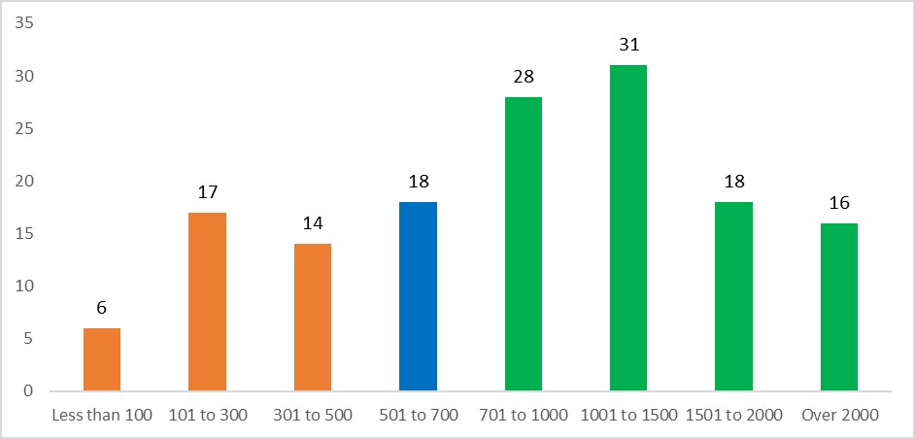

Figure 2
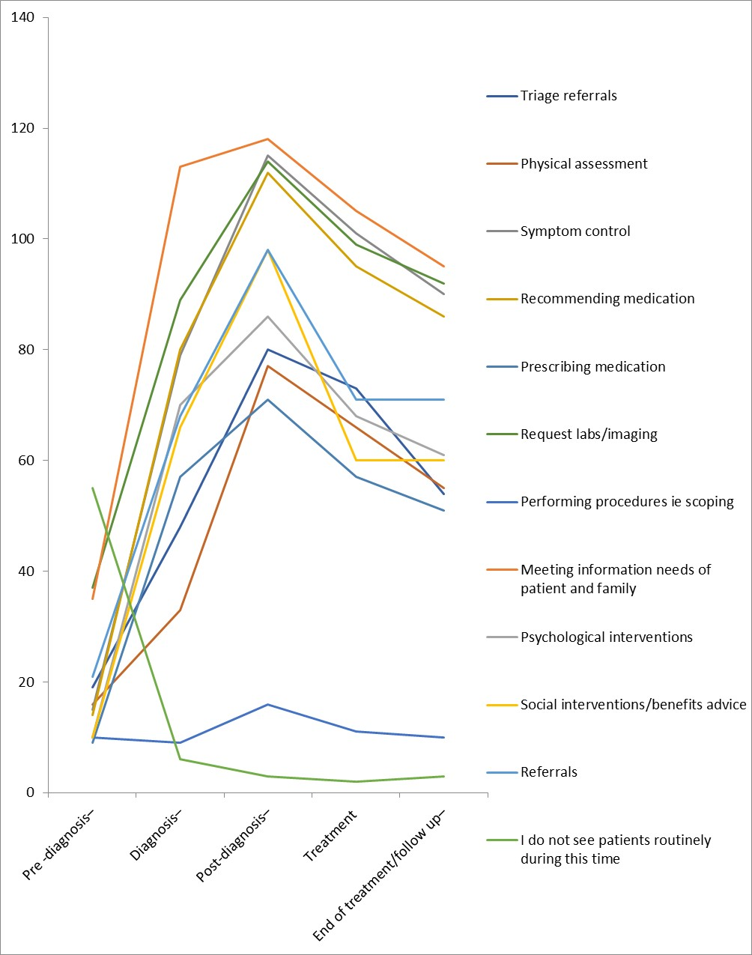

Figure 3
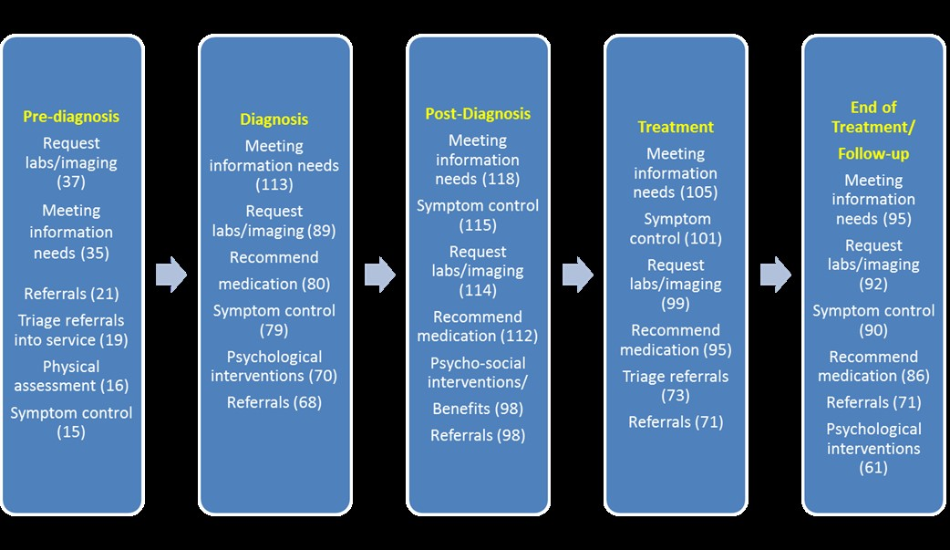
Figure 4
