Supressing Coalescence and Improving Uniformity of Polymer Beads in Suspension Polymerisation using a Two-Stage Stirring Protocol
Mohammad Alroaithi¹, Fatemeh Jahanzad² and Shahriar Sajjadi¹
¹ Faculty of Natural and Mathematical Science, King’s College London, Strand, London, WC2R 2LS, UK.
² Division of Chemical and Petroleum Engineering, London South Bank University, London SE1 0AA, UK.

Abstract
In a typical suspension polymerisation, both emulsification and polymerisation occur simultaneously in a single stirred vessel reactor using a constant stirring speed and stabiliser concentration. This work introduces a novel two-stage stirring protocol for improving the uniformity of polymer beads produced in suspension polymerisation reactions. In the two-stage stirring protocol proposed, the polymerisation stage was carried out at a reduced stirring speed. This policy, confirmed by mathematical modelling, led to the drops coalescence being suppressed and as a result drops average size and size distribution being maintained in the course of polymerisation. The particle size distribution narrowing was more significant if the emulsification stage was carried out at room temperature, the stabiliser concentration was low, and the difference between the stirring speeds used in the two stages was large. The two-stage stirring protocol was extended to include a two-stage stabiliser-addition protocol, which further improved the quality of the beads.

- Introduction
Suspension polymerisation is a well-established process in industry for making polymer beads. In this process, the monomer phase containing an initiator is suspended as drops via mixing in a continuous phase (water) containing a stabiliser or a surface active agent. The monomer drops are transformed into polymer beads via free radical polymerisation initiated by an initiator. A wide variety of commercial products such as polyvinylacetate, polymethylmethacrylate, and polystyrene are manufactured by suspension polymerisation processes. Suspension polymerisation is mostly preferred in industries due to its vast advantages including good temperature control, low level of impurities and low separation cost.
One of the major challenges in suspension polymerisation is the ability to produce polymer beads with a narrow size distribution.¹ Many parameters have been investigated to improve the uniformity of polymer beads in suspension polymerisation including stabiliser type and concentration,, initiator concentration, monomer phase ratio, reaction temperature, and internal design of the reactor like stirrer and reactor geometry. Advanced technologies have also been employed, including membrane emulsification and microfluidic techniques, to generate uniform drops that can deliver uniform polymer beads when polymerised.,,,,Although these technologies have potential to produce polymeric beads with a good control over the bead size and uniformity, they are limited by their high manufacturing cost and difficulties involved in their scale up. To control the size distribution of polymer beads within the means of suspension polymerisation, one would require a better understanding of the main parameters affecting drop/bead size distributions.
Typically, the evolution of average drop size during a suspension polymerisation passes through four characteristic intervals. ¹⁴ The first interval is known as a “transition stage” during which the average size of drops decreases as a result of extensive rate of drop break up. The second interval is the “quasi-steady state stage” during which the average drop size remains constant due to the rate of drop break up being equal to that of coalescence. The most critical stage during suspension polymerisation that leads to the enlargement of drops is the “growth or sticky stage” in which the rate of drop break-up falls behind the rate of drop coalescence due to the increase in the drops viscosity. Finally, in the last interval, the viscous drops resulting from the growth stage reach their “identification point” beyond which they cannot be further ruptured nor undergo coalescence, and therefore remain stable and keep their identity. The sequence of these four intervals often leads to bead size distributions becoming much wider than that of the initial monomer drops. This suggests controlling the rate of drop break up and coalescence during these characteristic intervals is crucial for producing beads of narrow size distribution.
Drop break up and coalescence are strongly influenced by mixing conditions as well as by stabiliser type and concentration. ^{1,2} There has been much work on the effect of stirring speed on the average bead size, but only few used a stirring protocol as a means to improve the uniformity of the drop/bead size distribution. Takahashi et al. adopted a coreverse rotation with different periodic intervals to supress the rate of coalescence during mixing and thus control the bead size distribution. The experimental results showed that the final beads size decreased and the uniformity of beads was improved compared to the steady stirring method., They attributed the PSD narrowing to the formation of oscillatory flow in the reactor, enhanced with decreasing periodic time interval, which decreased the efficiency of drop coalescence.
In this paper, we present a facile methodology to improve the uniformity of polymer beads by employing a two-stage stirring protocol; the emulsification stage was conducted at a high stirring speed (rpm), while the polymerisation stage was carried out using a lower stirring speed. Conventional suspension polymerisation, in which both emulsification and polymerisation stages occurred using the same stirring speed, was also conducted for comparison.
- Experimental
- Materials
Methyl methacrylate (MMA), lauryl peroxide (LPO) and polyvinyl alcohol (PVA) (Mw = 85000- 146000; degree of hydrolysis 87-89%) were purchased from Sigma Aldrich. The monomer was purified with ion-exchange resins (Sigma Aldrich) to remove inhibitors prior to use.
- Set up
The experiments were carried out using a 0.5-L jacketed glass reactor equipped with four 90◦ baffles. A four-bladed flat turbine impeller with diameter and width of 3.8 cm and 1.1 cm, respectively, was installed inside the reactor for stirring. The temperature of the reactor content was controlled at the desired temperature (75.0± 1.0 ºC) by passing water with appropriate temperature through the reactor jacket. Nitrogen purging was carried out for 15.0 min before the monomer phase was added to the aqueous phase. The impeller speed was set at the desired stirring speed before the start of experiments. The setup for the experiment is shown in Figure 1.
- Procedure
A total of 40.0 ml of methyl methacrylate (MMA) containing 1.0 wt% of lauryl peroxide (LPO) as initiator was poured into 200 ml of the continuous aqueous phase (distilled water) containing polyvinyl alcohol (PVA) as stabiliser. The recipe for suspension polymerisation is shown in Table.1.

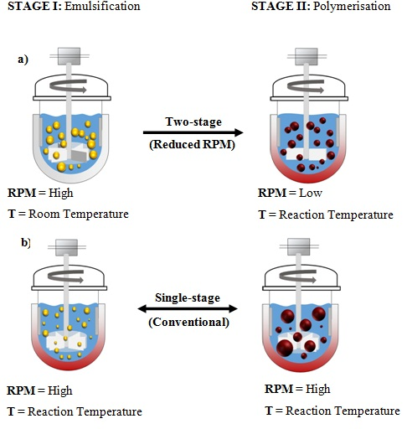

Figure 1 Schematic illustration of the experimental set up for a) The two-stage protocol and b) Corresponding single-stage conventional suspension polymerisation.

The mixture was stirred for a given time during the emulsification stage, which was carried out at room temperature to ensure that viscosity of drops did not change with time due to the polymerisation rate being negligible at low temperatures. The stirring speed was then reduced after 60.0 min and the reaction started by pumping hot water at 75.0ºC through the jacket. The reaction temperature was achieved within 8-9 min from the start of the polymerisation stage. Samples were withdrawn at appropriate times to measure the conversion and size of drops/beads. The monomer and initiator concentrations were kept constants in all experiments. Most experiments were carried out twice to ensure accuracy of results.
Table.1 Recipe for suspension polymerisation.
Ingredients | Quantity
Water (g) | 200
MMA/water (φ) | 0.20
PVA (g l⁻¹) | 0.25-1.0
LPO/MMA (%) | 1.0
LPO (g) | 0.4
Temperature (◦C) | 75 ºC ± 0.5
stirring speed (rpm) | 250-700
- Characterisation of emulsion drops and polymer beads
Conversions were measured gravimetrically. Approximately 3.0 g of the dispersion was withdrawn from the reactor, placed in an aluminium foil dish, left for several hours at room temperature to dry, and were then completely dried in an oven at 75ºC for 24 h. The monomer conversion was calculated as the weight ratio of the polymer produced to the total monomer in the recipe. Drops/beads were sufficiently stable to be visualised by an optical microscope (Kyowa Tokyo, Japan) with a camera (Moticam 2300) connected to a computer. The Sauter mean diameter (D₃₂) of beads and their volume size distributions were measured using a laser diffraction particle sizer (Malvern, Coulter LS130). The breadth of distribution was judged by span s and polydispersity index PDI. Span is similar to coefficient of variation (CV), but is defined as follows:
$$s=\frac{d_{0.90}{-d}_{0.10}}{d_{0.50}}$$
Where d_{0.90}, d_{0.50} and d_{0.1} signify the point or diameter in the volume size distribution, up to and including which, 90%, 50% and 10%, respectively, of the total volume of material in the sample is contained. d_{0.50} is the median of the volume distribution and is equivalent to the average-volume diameter. All these diameters were automatically produced by the particle sizer. Polydispersity index (PDI) of drops/beads were calculated by using the equation
$$PDI=\frac{d_{w}}{d_{n}}$$
where d_{w} is the weight-average diameter $d_{w}=\sqrt{n_{i}d_{i}^{4}}/\sqrt{n_{i}d_{i}^{3}}$ , d_{n} is the number-average diameter $d_{n}=\sqrt{n_{i}d_{i}}/\sqrt{n_{i}}$, and n_{i} is the number of drops with diameter d_{i}. To calculate d_{w} and d_{n}, and hence PDI, the volume distribution generated by the particle sizer was converted to the number distribution.

- Results and discussion
- Theoretical development of the concept
a)
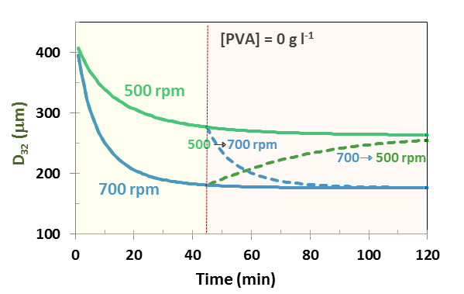
b)
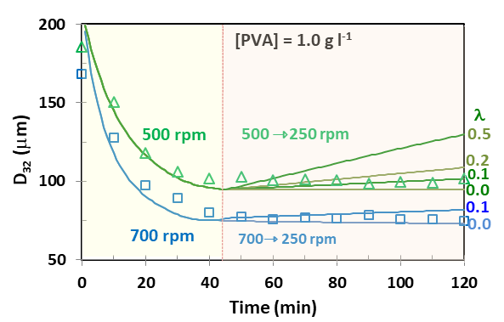
Figure 2 a) The theoretical time evolution of D₃₂ in a MMA-water dispersion at 500 and 700 rpm and when stirring speed was altered from 500 to 700 rpm and vice versa after 45.0 min (T =22ºC, [PVA] = 0 g l⁻¹, φ = 0.2; see ref [14] for modelling parameters). b) Experimental time evolution of D₃₂ (symbols) and the modelling predictions (lines) with coalescence efficiency λ as the adjustable parameter for two emulsification runs started at constant stirring speeds 500 and 700 rpm followed by stirring speed being reduced to 250 rpm after 45.0 min (T =22ºC, [PVA] = 1.0 g l⁻¹).

The size of monomer drops in suspension polymerisation reactors is determined by two opposing factors in the course of reaction, they are the continuous drop break up and coalescence. During the transition period in a typical emulsification stirred-vessel, the rate of break up is much greater than that of coalescence, R_{b} >> R_{c}, as a result drops continuously reduce in size until they reach a so-called “steady-state drop size”. This average size is within the two size limits known for liquid-liquid dispersions in stirred vessels. Above the upper bound, the maximum stable drop size d_{max}, drops are extremely unstable and will rupture immediately. Drops with size below the lower bound, the minimum stable drop size d_{min}, are doomed to coalesce. Both d_{max} and d_{min} depend on the impeller diameter and speed, as well as stabiliser concentration and dispersed phase ratio (φ).
Only drops undergoing coalescence and surpassing the d_{max} can be ruptured again during the steady state. This usually occurs under dynamic steady-state conditions which is predominate when a low concentration of stabiliser is used. ¹⁴ In this case the number of drops experiencing coalescence is almost equal to those experiencing break up, leaving the average drop size constant. If the stabiliser is effective and its concentration is high, then coalescence is prohibited and a static steady state is established, meaning that drops remain intact. ¹⁴ This condition, however, is not suitable for suspension polymerisation due to homogenous and heterogeneous nucleation occurring in the aqueous phase at excessive concentration of stabiliser.
In this research we applied a step decrease to stirring speed after the steady drop size was achieved. Any decrease in the impeller speed, after achieving a steady state, will theoretically increase the average drop size until a new steady state is established after sometime. This is because both R_{b} and R_{c} will decrease with a decrease in stirring speed. R_{b} decreases because the shear stress generated in the reactor, which acts to break up drops, is proportional to the stirring speed. R_{c} is composed of two components, the frequency of drops collision and collision efficiency., The drop–drop collision frequency decreases with decreasing stirring speed. However, the efficiency of drop coalescence, defined by $λ=exp⁡(-\frac{t_{c}}{t_{i}})$ where t_{c} and t_{i} are the contact and film drainage time (coalescence time), respectively, increases with decreasing stirring speed due to a rise in the contact time t_{c}. The net result, however, is a decrease in R_{c} with decreasing stirring speed. ¹⁴
It has been shown that the steady-state drop size in liquid-liquid dispersions is independent of the emulsification path., This means that the average size of drops eventually reaches the steady-state value corresponding to the new stirring speed after going through a transition period. The transition period, which is the time required to reach the new steady state, however, may vary with conditions. The transition time following a rise in the stirring speed, such as switching on agitation at the onset of an emulsification process, is governed by the rate of break up (i.e. R_{b} > R_{c}). However, the transition time following a decrease in the stirring speed is mainly determined by the rate of coalescence being the dominant driving force (i.e. R_{c} > R_{b}).
The concept behind this research is that if drops produced at a high stirring speed are maintained at a low stirring speed during polymerisation, where drops are too small to be further ruptured and then get involved in a cycle of coalescence/break-up events, polymer beads with narrower size distributions will be achieved, compared to the case when both emulsification and polymerisation occur at a constant stirring speed (i.e., conventional suspension polymerisation). As a matter of fact, such policies are already in use, but they are not explicitly recognised. For example, we recently reported membrane-emulsification assisted suspension polymerisation where the uniform monomer drops produced at a high shear stress in a membrane emulsification vessel were polymerised in a low shear stress stirred tank reactor. This methodology, when optimised, delivered polymer beads with the same uniformity as the initial monomer drops.
To theoretically verify this concept, we considered a stabiliser-free emulsification system at the stirring speeds of 500 and 700 rpm as defined in the caption of Figure 2a and used exactly the same modelling parameters explained elsewhere.¹⁴ Figure 2a shows how the Sauter mean diameter of drops responds to an alteration in the stirring speed. It should be mentioned that this numerical analysis is not aimed at the modelling of this process, but just to demonstrate the underlying conceptual design for this research. We then applied a step decrease in the stirring speed from 700 rpm to 500 rpm and vice versa at t = 45 min, when the steady-state drop size was already established. Drops showed a continuous, but slow, growth in size soon after the stirring speed was reduced to 500 rpm. At this stirring speed, drops were less vulnerable to break up because of the reduced shear stress, as stated before, but drop coalescence could still occur. However, we should note that the rate of growth of drops after reduction in the stirring speed is a function of several parameters such as the stabiliser concentration and monomer phase ratio.
An opposite change in the stirring speed, from low to high, resulted in a relatively fast decrease in the size of drops, as shown in Figure 2a, similar to the events occurring during the transition stage of a typical emulsification process where R_{b} is predominant. The time scale of break up is often shorter than that for coalescence. This is mainly because break up is a single-body event but coalescence is a double-body event, which depends on the number of drops (i.e., collision rate). This delayed response provides a time window during which monomer drops can be converted to polymer beads before undergoing too much coalescence. This trend can be further dampened by using a stabiliser.
We now verify the concept developed above for the emulsification stage of MMA. Figure 2b shows the variations in the Sauter-mean diameter of drops with time in emulsions made using two different stirring rates of 700 and 500 rpm. These experiments were conducted in the presence of 1.0 g l⁻¹ PVA, which has been found to be an optimum PVA concentration for suspension polymerisation of MMA under conditions used in this work. ¹⁴ For simplicity, we refer to the impeller speed during the emulsification stage by N_{E} and to that during post-emulsification stage (i.e., polymerisation) by N_{P}. The emulsification process took 45.0 min by then the steady-state drop size was achieved. The steady-state drop size at the stirring speed N_{E} = 500 rpm was larger than that at 700 rpm (see Figure 2b), as expected. We then reduced the stirring speed to 250 rpm and closely monitored the subsequent change in the average drop size with time for further 60.0 min, which is a typical time for a suspension polymerisation to complete. The size of drops only slightly increased with time after the reduction in stirring speed. The continuous lines in Figure 2b show the model predictions for the average drop size at different values of coalescence efficiency λ, which was used as an adjustable parameter. A coalescence efficiency as small as λ = 0.10 was found to predict the experimental data fairly well, implying a supressed coalescence for drops at the reduced stirring speed in the presence of stabiliser. From Figure 2b one could infer that drops identity was almost maintained at the reduced speed, suggesting that the methodology can be extended to the polymerisation stage.
a) | b) T= 22.0 ºC  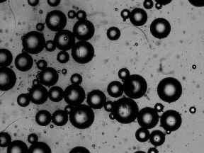  250 rpm | 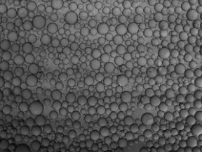  500 rpm | 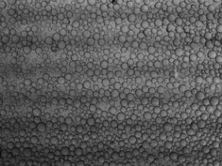  700 rpm
 | c) T= 75.0 ºC  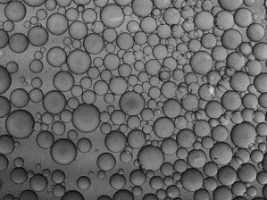  250 rpm | 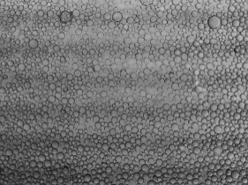500 rpm | 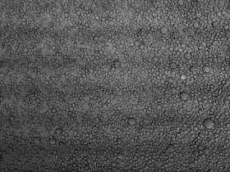  700 rpm

Figure 3. a) Variations in D₃₂ of the final drops sizes with stirring speed N_{E} at two different temperatures T=22.0ºC and 75.0ºC. Micrographs of the corresponding final emulsions obtained using different stirring speeds at b) T=22.0 ºC and c) 75.0 ºC. Scale bar is 100 μm. [Emulsification time = 30.0 min; [PVA] = 0.5 g l⁻¹]
Low-temperature emulsification as the first stage of the protocol
In a typical suspension polymerisation in the presence of PVA, which is commonly used as stabiliser, both emulsification and polymerisation occur at high temperatures (i.e. reaction temperature). The literature has pointed to the PVA efficiency being highly dependent on temperature in addition to its molecular weight and the degree of hydrolysis. In order to comprehend the significance of the emulsification temperature, we conducted the emulsification stage at two temperatures; room temperature and reaction temperature. The final drop sizes (t = 60.0 min), along with their corresponding micrographs, are shown in Figure 3. From Figure 3a one can see that the drops formed at room temperature were much larger than those produced at high temperature, due to low interfacial tension, over a wide range of stirring speeds. The thermal behaviour of different grades of PVA has been well-documented in literature.²⁴ For the PVA used in this study, the interfacial tension decreases with increasing temperature. Interfacial force acts as a cohesive force for drops so a low interfacial tension will assist drop break up and thus decrease the average size of drops. The difference between the average drop sizes at low and high temperatures became significantly less with increasing rpm as the disruptive forces took over. One obvious conclusion is that while drops were larger at room temperature, they were more stable due to having a smaller surface area and higher coverage by the stabiliser molecules. We later show how the increase in stability of drops, despite their size being increased, will eventually reduce the polymer beads size by improving drop stability against coalescence during polymerisation.
The polymerisation stage started when the temperature of the dispersion was raised to 75°C. In order to show the increase in temperature and the associated decrease in interfacial tension at the onset of the polymerisation (second) stage will not affect the rate of break-up, we carried out the following analysis. We chose to discuss the effect on D₃₂, rather than on R_{b}, because of the well-known D₃₂ equation being in place. The Sauter mean diameter in a typical liquid-liquid dispersion in its simplest form is related to Weber number by:
$D_{32} = k_{1}{We}^{-0.6}=k_{1}(\frac{d^{3}N^{2}ρ}{σ})^{-0.6}=k_{2}(\frac{σ}{N^{2}})^{0.6}$ (1)
where d is the impeller diameter, N is the stirring speed, ρ is the density and σ is the interfacial tension. A decrease in N by almost one third from 700 to 250 rpm, as occurred when we shifted from the emulsification to polymerisation stage, would theoretically increase D₃₂ by 87.0%. An increase in temperature from room temperature (22.0 ºC) to the reaction temperature 75.0 ºC, would decrease the interfacial tension by 40.0 % and theoretically decrease D₃₂ by 18.8%.²³ The net effect is that the decrease in σ at the onset of 2nd stage, due to the increase in temperature, is easily compensated by a larger decrease in the shear stress associated with the reduced stirring speed, suggesting that drops remain robust against break up. This conclusion is backed up by the results presented in the next section.
Finding the operational range of stirring speed
Before proceeding with the main aim of the present study, we first investigated the effect of stirring speed on the final bead size in a typical suspension polymerisation. It is important not only to identify the range of stirring speeds where the two-stage stirring protocol can be fully examined, but to be able to extend such ranges.
Figure 4 shows the effect of stirring speed on the final bead size in the presence of 0.5 g l⁻¹ PVA. Normal operation of suspension polymerisation reactors is practically constrained by two stirring speed limits. The low speed, N_{p},_{min}, marks the minimum speed that can be used to disperse the monomer phase in the water phase. We found that the N_{p,min} was around 200 rpm in the current system. At N_{p} < N_{p,min}, a massive coagulation occurred and polymer lumps were created due to the poor mixing, creaming (i.e., phase separation of the drops) and heat transfer issues in the reactor.²³ This is the reason we selected 250 rpm in this work as the target reduced speed. At N_{p} < N_{p,min}, a stratified layer of monomer on the top of the dispersion was formed. Advantage of this monomer layer was taken in conducting in-situ mass polymerisation inside a suspension polymerisation reactor.
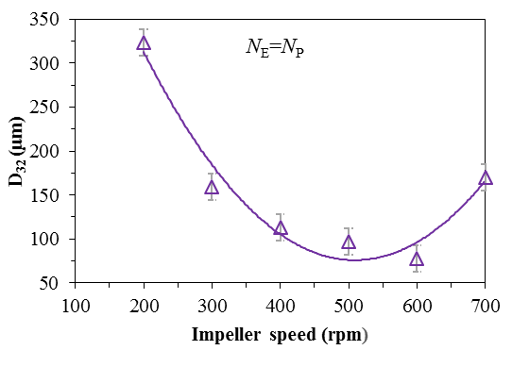
N_{p,max}
N_{p,min}
Figure 4. Variations in D₃₂ of polymer beads with stirring speed N_{E}=N_{P} (conventional suspension polymerisation, T =75ºC, and [PVA] =0.5 g l⁻¹). The error bars indicate the spread of the data around the average.

It is a common practice to increase the stirring speed in suspension polymerisation to achieve smaller beads. However, Figure 4 indicates this relation broke down above a critical rpm, N_{p},_{cri} = 500-600 rpm, beyond which the use of a more intensive mixing became inefficient as the bead size increased displaying a U shape behaviour. The emergence of U-type drop size variations at high stirring speeds has been previously reported in the literature., The N_{p,cri} marks the maximum impeller speed N_{p,max} (i.e., corresponding to the minimum average bead size achievable) that should be used for any polymerisation setting. The reason for such a behaviour beyond N_{p,max} can be attributed to the increased rate of coalescence, R_{c} > R_{b}, because of the formation of many drops.²⁷ The stabiliser concentration plays a critical role in the emergence of this feature. As the stirring speed increases, the interfacial area generated increases and thus the coverage of drops by the stabiliser molecules becomes increasingly less. This facilitates drop coalescence and therefore increases the size of (polymerising) drops.
One may argue that for a given polymerisation system, N_{E,max} = N_{p,max}, suggesting that minimum drop size and minimum particle size occur at the same agitation speed. However, for monomer drops being less viscous and more deformable than polymer-monomer drops encountered in polymerisation, the N_{E,max} could be far more than N_{p,max}. In the next section, we explore the feasibility of polymerisation beyond the critical stirring speed for the two-stage suspension polymerisation.

- Application of two-stage stirring protocol
- Reduction in bead size
Having verified the credibility of the approach for the reaction-free emulsification stage, we extended the work to the polymerisation stage. We used two model stirring speeds; one being N_{E}=500 rpm which represents the normal range of stirring speeds and the second one being N_{E}=700 rpm, which was found to be beyond the normal range of operations for the current polymerisation system. Emulsifications were conducted at the assigned stirring speeds and room temperature until the drops passed the transition stage and reached their steady state size (t = 60.0 min). The stirring speed was then reduced to the desired level (N_{P}=250 rpm) and polymerisation was initiated, by increasing the reactor temperature to 75°C, to convert the discrete drops into polymer beads.
a)  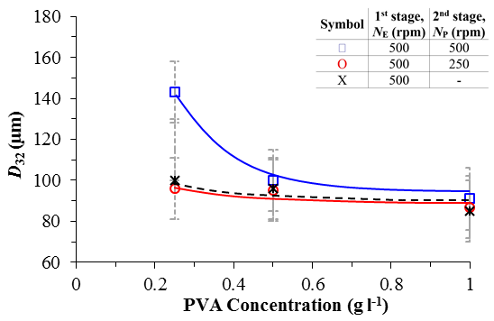 |  | b) 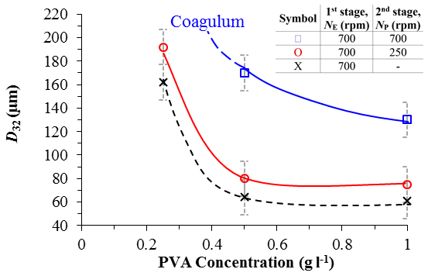
c)  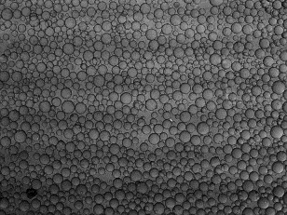t= 0.0 min | 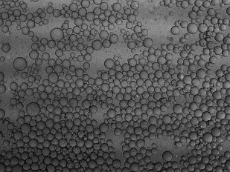15.0 min | 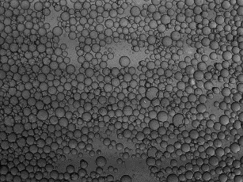30.0 min | 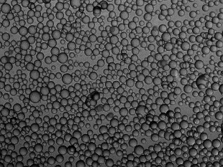60.0 min (Beads)
Figure 5. Variations in the final Sauter mean diameter of polymer beads with PVA concentration for two-stage stirring protocol and corresponding single-stage conventional suspension polymerisation. a) N_{E}=500 rpm, b) N_{E}= 700 rpm. The polymerisation impeller speed is N_{p}=250 rpm for both scenarios. The dotted line represents the average drop sizes at the end of the emulsification stage (T = 22.0ºC). c) Micrographs showing typical variations in the size of drops for two-stage stirring protocol with time during the polymerisation stage. The micrograph at t =0 represents drops at the onset of the 2nd stage ([PVA] = 0.5 g l⁻¹). Scale bar is 100 μm. The bars show the spread of distributions.

Figure 5a and Figure 5b illustrate the Sauter mean diameter of monomer drops (D₃₂) and the corresponding polymer bead diameters at the onset of polymerisation stage and at the end of polymerisation stage, respectively, as a function of PVA concentration for two emulsification stirring speeds N_{E} = 500 and 700 rpm. The size data from corresponding conventional suspension polymerisation featured by N_{p}=N_{E} are also shown for comparison. At both stirring speeds (700 and 500 rpm) the bead size decreased with increasing stabiliser concentration due to the associated decrease in interfacial tension. However, the two-stage stirring protocol produced smaller beads than the conventional single-stage process, regardless of PVA concentration. The advantage, however, became more significant with decreasing PVA concentration. One interesting finding is the average size of drops at the end of emulsification stage being always similar to that of the final polymer beads resulting from the two-stage process. This pattern is evident in Figure 5c that shows little change in the average size of drops during polymerisation. This suggests the two-stage protocol could fairly well supress drops coalescence and tightly control their growth in the course of polymerisation.
The cross examination of Figure 5a and Figure 5b indicates that the size of beads resulting from conventional single-stage suspension polymerisation at 700 rpm is greater than those at 500 rpm. The difference is much greater at low PVA concentration (i.e, [PVA] = 0.25 g l⁻¹) where generation of a large interfacial area in the presence of small concentration of stabiliser led to a gross coagulation of the beads. This is in line with the finding from Figure 4 that the bead size increased with the stirring speed above the critical range of 500-600 rpm. If the same comparison is made for the two-stage protocol, one can see that beads formed at N_{E} = 700 rpm were smaller than those made at N_{E} = 500 rpm, except for the lowest PVA concentration used; 0.25 g l⁻¹. This suggests that the two-stage protocol can be used in suspension polymerisation to extend the operational range of stirring speeds as a means to reduce the size of beads.

- PSD Narrowing via the two stage protocaol
The uniformity of beads obtained using the two-stage protocol can be best reflected by bead size distributions. Figure 6a and Figure 6b illustrate the size of distribution of polymer beads obtained using the two-stage protocol at the conditions previously explained.

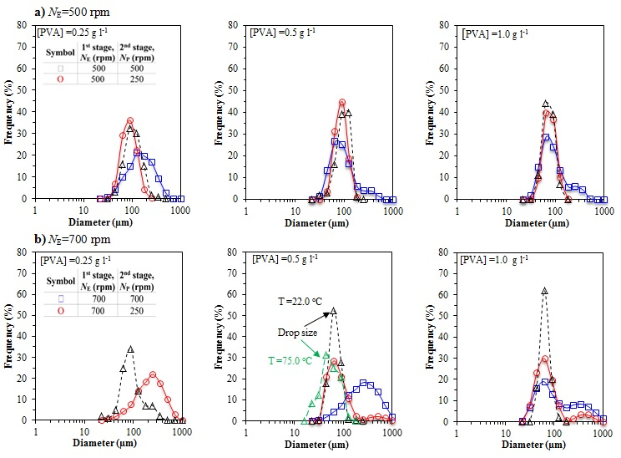
Figure 6 Comparison of bead size distributions obtained using the two-stage protocol at a) N_{E} = 500 rpm, and b) N_{E} = 700 rpm with those from conventional single-stage suspension polymerisation at different PVA concentrations. The reduced impeller speed of N_{p} =250 rpm was used for both series. The dotted lines represent drop size distribution at the end of the emulsification stage (T =22.0ºC) or onset of polymerisation stage (T =75.0ºC). The size distribution of final drops from conventional single-stage polymerisation is also shown in Figure b for PVA = 0.5 g l⁻¹.

Table 2 also shows the PDI(span) of the final polymer beads. The two-stage protocol always produced narrower size distributions, as indicated by smaller PDI(span), compared with those from conventional single-stage suspension polymerisation. The difference, however, widened with decreasing stabiliser concentration, in a very similar way to the change in the average size of the beads with stabiliser concentration (see Figures 5a and 5b). Furthermore, the size distribution of drops at the onset of the 2nd stage (polymerisation stage) changed only little by the end of the 2nd stage, suggesting that the identity of drops was almost maintained during the course of polymerisation. This interesting feature contrasts a well-known drop size increase and particle size distribution broadening encountered in conventional suspension polymerisation, for which a typical result is shown in Figure 6b for [PVA] = 0.5 g l⁻¹. The size average and distribution of the polymer beads are significantly larger and broader, respectively, than that of monomer drops. The difference between the two, however, increased as the maximum (critical) speed was approached.
Table 2. The breadth of particle size distributions as judged by PDI (span).
[PVA] gl⁻¹ | rpm =500
 | Conventional | 2-stage
0.25 | 2.7(1.68) | 1.4(0.90)
0.50 | 2.0(1.62) | 1.3(0.68)
1.0 | 2.0(1.1) | 1.5 (0.76)
 | rpm=700
0.25 | - | 2.0(1.67)
0.50 | 4.5(1.99) | 2.0(1.57)
1.0 | 4.5(NA) | 2.4(NA)

The cross examination of Figure 6a and Figure 6b also indicates that the size distribution of beads from conventional single-stage suspension polymerisation at 700 rpm is broader than those at 500 rpm, which is consistent with the concomitant increase in the average size of beads above the maximum stirring speed range.

- Development of the two-stage hybrid (stirring and stabiliser addition) protocol
While bead size distributions from the two-stage protocol was much narrower than those from conventional polymerisation, they occasionally revealed a positive skewness, particularly when the initial stirring speed was high. This could be due to the flocculation of drops because of their low stabiliser coverage. In this section we show how stabiliser partitioning can be used along with the two-stage stirring protocol to further supress coalescence/flocculation and improve uniformity of beads. In a recent paper, it has been demonstrated that if a part of stabiliser is added to the reactor prior to the onset of the growth stage, where polymerising monomer drops are viscous and cannot be ruptured, polymer beads with smaller size and more uniform distribution may be produced.
Following the same line of thought, we explored if the emulsification stage could be conducted using only a portion of PVA from the main recipe, followed by polymerisation at a reduced stirring speed using the remainder of PVA, in order to produce more uniform beads.
To prove the addition of PVA at the onset of polymerisation stage should not affect the rate of break-up, we carried out a similar analysis to the one given before for the reduced emulsification temperature. We performed the analysis by assuming that the emulsification stage started with 0.25 g l⁻¹ PVA out of 0.5 g l⁻¹ considered for the whole recipe, followed by addition of the remainder 0.25 g l⁻¹ PVA at the onset of the second stage. A sudden increase in the PVA concentration in the continuous aqueous phase by 0.25 g l⁻¹ at the onset of the second stage (from 0.25 to 0.50 g l⁻¹), would decrease the interfacial tension σ by 31.0% (the interfacial tensions at [PVA] = 0.25 and 0.50 g l⁻¹ are 6.05 and 4.12 dyn/cm, respectively) ²³ and D₃₂ by 25.0 %. As we noted before, a decrease in N by almost one third from 700 to 250 rpm at the onset of the polymerisation stage, should theoretically increase D₃₂ by 87.0%. This suggests that the drops in the 2nd stage of the hybrid two-stage protocol should remain robust against break up and thus the additional PVA can only serve to further stabilise them against coalescence. We monitored drop size evolution with time when the secondary PVA addition and the reduction in rpm coincided as seen in Figure.7a for a typical emulsification. There was no sign of reduction in drop size with time. This validated the statement made before and allowed us to put the hypothesis into practice.
Transition time
b) [PVA]_{t} = 1.0 g l⁻¹ | c) [PVA]_{t} = 0.5 g l⁻¹

Figure.7 a) Effect of application of the two-stage hybrid protocol on variations of D₃₂ of drops with time ([PVA]_{t} = 1.0 g l^{-1.}). Comparison of the size distribution of beads formed using the hybrid two-stage at b) [PVA]_{t} = 1.0 g l⁻¹ and c) [PVA]_{t} = 0.5 g l⁻¹ with those from simple two-stage protocol.
Two series of experiments were carried out at total PVA concentration of 0.5 and 1.0 gl⁻¹. The stabiliser was divided into two parts, with the first part (0.25 g l⁻¹) being added in the beginning of the emulsification stage and the second part in one shot at the start of the polymerisation stage when the stirring speed was reduced. Figure.7b and Figure.7c show comparison of bead size distributions obtained using simple and hybrid two-stage protocol at [PVA] = 1.0 and 0.50 g l⁻¹, respectively. The average size of beads is similar but their distribution is narrower when the hybrid two-stage protocol was used, compared with the case of simple two-stage stirring protocol. The use of a small portion of the PVA from the recipe in the initial charge of the emulsification stage produced large drops, because of the associated increase in the interfacial tension, but these drops were more effectively covered by the remainder of PVA during the polymerisation stage. This provided an enhanced stability to growing drops/beads during the growth stage against coalescence and produced beads with a narrower distribution.
We found that the hybrid protocol was unsuccessful at [PVA]_{t} ≤ 0.25 g l⁻¹ (not shown). The reason for this seems to be due to the lack of stability of drops at very low concentration of PVA. In general, the hybrid process was less vulnerable to coalescence due to a smaller interfacial area developed by the reduced amount of PVA used in the initial charge and a better surfactant coverage during the polymerisation stage.²⁸ As a result the hybrid protocol produced more uniform beads.

- Two-stage stirring protocol at reaction temperature (Isothermal)
In the previous section, we decoupled emulsification and polymerisation stages in order to take advantage of the low-temperature emulsification feature of PVA and ensure the underlying foundation of the concept of two-stage protocol was valid. We carried out the emulsification stage (first stage) at room temperature and in the absence of reaction, and the polymerisation stage (2nd stage) at the reaction temperature (75ºC). This allowed drops to be larger and thus better protected by PVA at the end of transition state, before undergoing polymerisation. In a new series, we ran the emulsification at the reaction temperature right from the beginning and reduced the stirring speed sometime, t_{2nd}, during polymerisation. This strategy has previously been reported for styrene suspension polymerisation. This protocol allowed drops to undergo variations in size during their transition period while their viscosity being increased, because of ongoing reaction inside them.
Broad PSD due to significant coalescence | t_{2nd} =

Figure 8 a) Variations in the monomer conversion versus time and b) Comparison of bead size distributions obtained via isothermal two-stage protocols at different stirring speed reduction time t_{2nd} with the corresponding non-isothermal and conventional suspension polymerisation (N_{E} = 700 rpm, N_{P} = 250 rpm, T = 75ºC, [PVA] = 0.5 g l⁻¹).
We carried out the isothermal two-stage protocol with the stirring speed of 700 rpm being reduced to 250 rpm after t_{2nd} = 10.0, 20.0, or 30.0 min from the start of the reaction. Any time longer than t_{2nd} = 30 min, corresponding to the conversion 0.30 which coincides with the onset of the growth stage¹⁴ as seen in Figure 8a, led to an unleashed growth of polymer beads and produced large polymer beads with a high polydispersity, similar to that shown in Figure 8b for the conventional suspension polymerisation with N_{E} = N_{P} = 700 rpm. Any time shorter than t_{2nd} = 10 min was not practical because of formation of drops with a broad size distribution due to diffusion - controlled adsorption of the stabiliser.¹⁴ Furthermore, a short mixing time could allow large drops to survive in the dispersion and contribute to the size distribution broadening. The comparison of bead size distributions obtained via this two-stage stirring protocol carried out at the reaction temperature with the two-stage protocol previously proposed (i.e. emulsification-stage carried out at room temperature followed by the polymerisation reaction at a higher temperature) is shown in Figure 8b. The figure indicates that beads resulting from isothermal two-stage protocol became increasingly smaller and more uniform with decreasing t_{2nd}. All these runs practically produced smaller and narrower bead size distribution than the conventional MMA suspension polymerisation carried out at a single stirring speed of 700 rpm. However, one can easily see from Figure 8b that the two-stage protocol, using decoupled emulsification and polymerisation stages, delivered polymer beads with smallest size and least polydispersity.
The transition stage in a typical suspension polymerisation may take up to 60 min, depending on the polymerisation conditions, during which drops continuously decrease in size (see Figure 7a as an example). It has already been shown that any parameter, such as initiator concentration, that can reduce the extent by which drops are reduced in size during the transition stage, also produce finer polymer beads with a better uniformity.¹⁴ By the same token, the reason for small average particle size and PSD narrowing in the (isothermal) two-stage protocol lies in the fact that drops were not exposed to high intensity shear for long, and therefore did not significantly reduce in size during the transition stage. The longer was t_{2nd}, within the safe range of transition time > 10 min, the smaller and more vulnerable (against coalescence) were the drops at the onset of growth stage, due to a lower stabiliser surface coverage.²⁸ This can explain why beads became larger and their size distribution wider with increasing t_{2nd}. Nevertheless, the results clearly show that the two-stage protocol was more efficient when the emulsification stage was carried out at low temperature (i.e., in the presence of PVA).
Tanaka also found that the sudden reduction in stirring speed for styrene suspension polymerisation produced larger bead size with increasing x_{2nd,} conversion at which stirring speed was reduced. ²⁹ This trend is consistent with our results for MMA. However, it was reported that the polydispersity index of resulting polymer beads increased with increasing x_{2nd}, up to x_{2nd} = 0.40, in line with increase in the average bead size. Then the PDI showed an abrupt minimum at x_{2nd} = 0.45 (corresponding to t_{2nd} = 120 min), followed by an increase and then a gradual decease with increasing x_{2nd}. ²⁹ Unlike MMA polymerisation, styrene polymerisation is relatively a slow reaction for which the conversion 0.45 corresponds to the onset of growth stage. ²⁹ It is not clear why a sudden minimum in polydispersity of polystyrene beads occurred at x_{2nd} = 0.45, against the general trend, nor how a delayed x_{2nd} during the growth stage, where drops are difficult to rupture and mainly undergo coalescence, could lead to an improved beads uniformity. In our work, a decrease in the average size of final polymer beads was always associated with a decrease in the polydispersity. The best result, in terms of finer bead size and improved uniformity, was obtained for t_{2nd} = 10 min, which was long enough to rupture large drops and short enough to avoid excessive rupture of drops (see Figure 8a).

- Conclusion
In this work, we developed a two-stage stirring protocol to supress drop coalescence and improve the uniformity of polymer beads obtained by suspension polymerisation. The concept behind this research was to produce drops using a high stirring speed in the emulsification stage, followed by their polymerisation at a reduced stirring speed. The results showed that the two-stage protocol always produced narrower size distributions than those by conventional (single-stage) suspension polymerisation. The difference, however, widened with decreasing stabiliser concentration, in a very similar way to the change in the average size of beads with stabiliser concentration. Emulsifications using PVA were found to be more efficient at low temperatures, and when combined with a reduced stirring speed. These led to the formation of drops that did not change much in size during polymerisation and produced polymer beads that were one-one copy of initial monomer drops. Another conclusion drawn from this research is that the two-stage protocol can extend the range of operational stirring speeds in suspension polymerisation. The application of the hybrid two-stage (stirring and stabiliser addition) protocol further succeeded to improve the uniformity of polymer beads.

references

Corresponding Author Faculty of Natural and Mathematical Sciences, Kings College London, Strand, London, WC2R 2LS, UK. Email: Shahriar-sajjadi-emami@kcl.ac.uk; Telephone number: +44-(0)20 7848 2322.
[] Vivaldo-Lima, E., Wood, P.E., Hamielec, A.E. and Penlidis, A. An updated review on suspension polymerization. Ind. Eng. Chem. Res. 1997, 36, 939-965.
[] Brooks, B.W. Basic Aspects and Recent Developments in Suspension Polymerisation. Makromolekulare Chemie-Macromolecular Symposia. 1990, 35-6, 121-140.
[] Konno, M., Arai, K., and Saito, S., The Effect of Stabilizer on Coalescence of Dispersed Drops in Suspension Polymerization of Styrene, J. Chem. Eng. Jpn., 1982, 15, 131.
[] Chatzi, E. G., Boutris, C. J., and Kiparissides, C. On-line monitoring of drop size distributions in agitated vessels: 2. Effect of stabilizer concentration. Ind. Eng. Chem. Res. 1991, 30, 1307
[] Chatzi, E. G., and Kiparissides, C. Drop size distributions in high holdup fraction dispersion systems: Effect of the degree of hydrolysis of PVA stabilizer, Chem. Eng. Sci. 1994, 49, 5039-5052.
[] Nikolaeva, V.F., Kazanskaya, V.F., Vinogradskii, V.O., and Usacheva, V.T., Technological Features of Suspension Polymerization of Styrene, Plastmassy, 1980, 6, 11.
[] Langner, F., Moritz, N.-U., and Reichert, K.-H., Reactor Scale-up for Polymerization in Suspension, Chem. Eng. Sci., 1980, 35, 1519.
[] Ni, X., Zhang, Y., and Mustafa, I., Correlation of Polymer Particle Size with Drop Size in Suspension Polymerization of Methylmethacrylate in a Batch Oscillatory- Baffled Reactor, Chem. Eng. Sci., 1999, 54, 841.
[] Wang, R., Zhang, Y., Ma, G. and Su, Z. Preparation of uniform poly (glycidyl methacrylate) porous microspheres by membrane emulsification-polymerisation technology. J. Appl. Polym. Sci. 2006, 102, 5018-5027.
[] Ma, G.H., An, C.J., Yuyama, H., Su, Z.G. and Omi, S. Synthesis and characterization of polyurethaneurea-vinyl polymer (PUU-VP) uniform hybrid microspheres by SPG emulsification technique and subsequent suspension polymerisation. J. Appl. Polym. Sci.. 2003, 89 ,163-178.
[] Nabavi, S.A, Vladisavljevic, G.T., Wicaksono, A., Georgiadou, S., Manovic, V., Production of molecularly imprinted polymer particles with amide-decorated cavities for CO2 capture using membrane emulsification/suspension polymerisation. Colloids & Surfaces A-Physicochemical & Engineering Aspects, 2017, 521, 231-238.
[] Omi, S. Preparation of monodisperse microspheres using the Shirasu porous glass emulsification technique. Colloids Surf., A. 1996, 97-107
[] Vladisavljevic, G.T., Structured microparticles with tailored properties produced by membrane emulsification. Advances in Colloid and Interface Science, 2015, 225, 53-87.
[] Jahanzad, F., Sajjadi, S. and Brooks, B.W. Characteristic intervals in suspension polymerisation reactors: An experimental and modelling study. Chem. Eng. Sci. 2005, 60, 5574-5589.
[] Yang, B., Takahashi, K. and Takeishi, M. Unsteady stirring method staged used in suspension polymerisation of styrene. J. Appl. Polym. Sci. 2001, 82, 1873-1881.
[] Yao, W.G., Sato, H., Takahashi, K. and Koyama, K. Mixing performance experiments in impeller stirred tanks subjected to unsteady rotational speeds. Chem. Eng. Sci. 1996, 53, 3031-3040.
[] Jahanzad, F.; Sajjadi, S.; Brooks, B.W. Comparative Study of Particle Size in Suspension Polymerization and Corresponding Monomer−Water Dispersion, Ind. & Eng. Chem. Res. 2005, 44 (11), 4112-4119.
[] Shinnar, R and Church, J.M. "Predicting particle size in agitated dispersions. Ind. Eng. Chem. Res 1960, 52, 253-256
[] Coulaloglou, CA and Tavlarides, L.L. "Description of interaction processes in agitated Liquid-liquid dispersions. Chem. Eng. Sci. 1977, 32, 1289-1297
[] Liu, S., and Li, D. "Drop coalescence in turbulent dispersions. Chem. Eng. Sci. 1999, 54,5667-5675.
[] Mikos, A. G., Takoudis, C. G., Peppas, N. A., Reaction engineering aspects of suspension polymerization. J. Appl. Polym. Sci. 1986, 31, 2647.
[] Hong, P.O. Lee, J.M. "Changes of the average drop sizes during the initial period of liquid-liquid dispersions in agitated vessels. Ind. Eng. Chem. Res. 1985, 24, 868-872.
[] Alroaithi, M. and Sajjadi, S. Uniform polymer beads by membrane emulsification-assisted suspension polymerisation. RSC Advances. 2016, 6, 79745-79754.
[] Olayo, R., Garcia, E., Garcia-Corichi, B., Sanchez-Vazquez, L. and Alvarez, J.,. Poly (vinyl alcohol) as a Stabilizer in the Suspension Polymerization of Styrene: The Effect of the Molecular Weight. J. Appl. Polym. Sci. 1998, 67, 71-77.
[] Jahanzad, F., Sajjadi, S., Yianneskis, M. and Brooks, B.W. In situ mass-suspension polymerisation. Chem. Eng. Sci. 2008, 63, 4412-4417.
[] Johnson, G. R. Effects of agitation rate during VCM suspension polymerization. Journal of Vinyl Technology, 1980, 2, 138-140.
[] Kelsall, D. G., & Maitland, G. C. The interaction of process conditions and product properties for PVC. In K. H. Reichert, & W. Greiseler, 1983, Polymer reaction engineering (pp. 133-145). Vienna: Hansen Publishers.
[] Jahanzad, F. and Sajjadi, S. Two-stage stabilizer addition protocol as a means to reduce the size and improve the uniformity of polymer beads in suspension polymerization. J. Appl. Polym. Sci. 2017, 134, 1097-4628.
[] Tanaka, M. Effect of Sudden Reduction of Impeller Speed on Particle Size Distribution in Suspension Polymerization of Styrene. J. Chem. Eng. Jpn., 1989, 22, 559-561. For Table of Contents Only

