Optimisation of SrBi₂(Nb,Ta)₂O₉ Aurivillius phase for lead-free electrocaloric cooling

Anna-Karin Axelssonª, Florian Le Goupil^{b}, Matjaz Valant^{c,d}, Neil McN. Alford^{b}

ªSchool of Engineering, London South Bank University, London SE1 00A, UK
^{b}Department of Materials, Imperial College London SW7 2AZ , UK
^{c}Materials Research Laboratory, University of Nova Gorica, Nova Gorica 5000, Slovenia
^{d}Institute of Fundamental and Frontier Sciences, University of Electronic Science and Technology of China, Chengdu 610054, China.

Abstract: The influence of different substitutional mechanisms on the electrocaloric effect of a lead-free SrBi₂(Nb_{0.2}Ta_{0.8})₂O₉ Aurivillius phase was studied for application in electrocaloric cooling systems. The A-site substitution with barium efficiently reduced the temperature of maximum permittivity from about 300°C to 100°C. The A-site substitution induced phenomena that are typical of strong relaxor ferroelectrics such as significant broadening of the permittivity peak and an increase in its frequency dispersion and with a depolarization temperature below room temperature. These features directly influenced the electrocaloric effect. A direct measurement system, based on a modified-differential scanning calorimeter, was used to analyze the EC effect of the dense (Sr_{0.5}Ba_{0.5})Bi₂(Nb_{0.2}Ta_{0.8})₂O₉ ceramics. In accordance with the relaxor characteristics, the EC effect was found to increase continuously over a broad temperature range above the room temperature. This was attributed to the alignment of field induced polar nanodomains. Directions for optimization towards a high-performing EC ceramic were identified.

Keywords: Aurivillius phases; lead-free ceramics; ferroelectric relaxor; electrocaloric materials

- INTRODUCTION

Among lead-free electrocaloric (EC) materials Aurivillius phases have been recognized as promising candidates for mid- and large-scale EC refrigeration [] due to very high values of dielectric strength. It was reported to be around 280 MV/m for SrBi₂Ta₂O₉.[] The dielectric strength has been recognized as one of the key properties that enable achieving the high EC effects.[] For this reason, thin films that can sustain much higher fields than bulk, give much higher EC effects. However, their application potential is limited due to a very low heat capacity and, consequently, a low cooling power. In addition, the Aurivillius phases exhibit a low leakage current and a high resistance to fatigue. [,] This is important for the refrigeration devices where high alternating electric fields are expected to be applied for as much as 10⁹ cycles.

To exploit the benefits of the Aurivillius phases for the EC refrigeration their ferroelectric transition should be moved from as high as 400ºC down towards or even below room temperature. It would also be advantageous to induce a strong relaxor character in order to keep the EC effect high through a broad temperature range around the refrigerator working temperatures. []

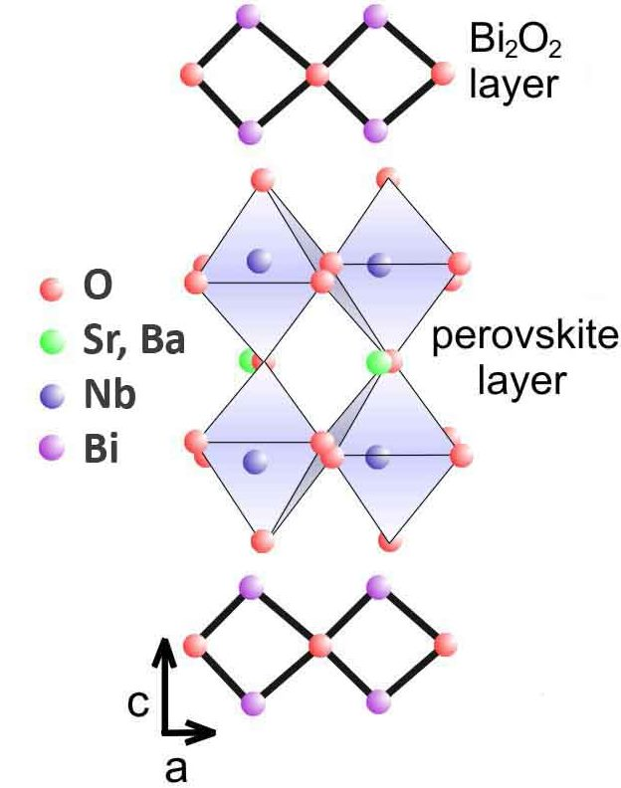
Figure 1: Crystal structure of (Sr,Ba)Bi₂Nb₂O₉ Aurivillius phase seen as a-c projection

The Aurivillius phases are layered perovskites with a general composition of (Bi₂O₂)²⁺ (A_{m}⁻¹B_{m}O_{3m+1})^{2–}, where the (A_{m}⁻¹B_{m}O_{3m+1})^{2–} perovskite-type layer is sandwiched between the layers of bismuth oxide, (Bi₂O₂)²⁺ (Fig. 1) The ferroelectric transition temperature of the Aurivillius phases can be efficiently tuned down towards the working temperatures of the refrigeration devices with a Bi-site substitution. Lone electron pairs of the Bi³⁺ ions apply a compressive stress on the neighboring perovskite layer and altogether contribute to distortion of the BO₆ octahedra. The induced strain in the perovskite layer stabilizes the ferroelectric phase and increases the ferroelectric transition temperatures.[] Therefore, the substitution with ions that do not possess the lone electron pair relaxes the compressive stress and destabilizes the ferroelectric phase. By this, the shift of the phase transition to lower temperatures occurs. In addition, the local variations in the structural distortions and strain fields result in an increase in diffuseness of the phase transition. This approach has been demonstrated for many different substituents like La, Pr, Sm etc.[,,]

There is another mechanism that allows for the downshift of the transition temperature. In the Aurivillius phases, such as SrBi₂Nb₂O₉, there is always some degree of intrinsic aliovalent exchange between the perovskite A-site (e.g. Sr²⁺) and Bi³⁺ in the bismuth oxide layer.[] The presence of the A ion (with no lone electron pair) in the bismuth oxide layer affects the ferroelectric stability in the same way as the extrinsic Bi-substitution described above. It destabilizes the ferroelectric phase and shifts the ferroelectric transition downwards. A degree of this effect can be influenced by an extrinsic A-site substitution (i.e. Ba²⁺ or Ca²⁺ for Sr²⁺).[,] The presence of the substituents changes the degree of the intrinsic exchange and the compressive stress on the perovskite layers. Because the A-site ions in the bismuth oxide layer induce local off-centering, the cation redistribution is the main source of polar nano-domains.[] The cation redistribution is associated with formation of point charges and breaking of the long-range ferroelectric order, which increases the relaxor character of the compound. So, the A-site substitution will also affect the strength of the relaxor ferroelectrics.[]

In our previous study we have investigated a respond of the EC effect on the substitution on the Bi-site in SrBi₂(Nb_{0.2}Ta_{0.8})₂O₉.[] Here we studied how the EC effect responds on the A-site substitution. It is shown an example how the A-site doping of the Aurivillius phase shifts the ferroelectric transition temperature, affects the relaxor characteristics and how this correlates with the measured EC effect. As a model system the same compound as in our previous study, SrBi₂(Nb_{0.2}Ta_{0.8})₂O₉, was used and substituted with Ba on the A-site according to (Sr_{0.5}Ba_{0.5})Bi₂(Nb_{0.2}Ta_{0.8})₂O₉ formula. The properties measured for the A-site substituted compound were compared with the undoped and the Bi-site substituted Sr(Bi_{1.85}Pr_{0.15})(Nb_{0.2}Ta_{0.8})₂O₉ system from Ref. 16 .

- Experimental details
The SrBi₂(Nb_{0.2}Ta_{0.8})₂O₉, and (Sr_{0.5}Ba_{0.5})Bi₂(Nb_{0.2}Ta_{0.8})₂O₉ compounds were prepared by the conventional solid state reaction method. Analytical Grade precursors (SrCO₃, Bi₂O₃, Nb₂O₅, Ta₂O₅ and BaO) were homogenized in a polyethylene bottle with isopropanol and stabilized zirconia milling balls for 24h in a ball mill. The homogenized mixtures were calcined at 900°C for 5h and milled in a planetary mill at 300 rpm for 3h. The milled and dried samples were uniaxially pressed at 100 MPa to form 13mm diameter pellets and sintered in air at 1100°C for 4h, in a sealed alumina crucible to prevent bismuth loss. The density was measured by the Archimedes method and was found to be around 95% of the theoretical density for all the ceramics.
A high resolution X-ray diffractometer (Philips X'Pert Pro) with a CuKa source was used for the phase composition and purity analyses of the calcined powder and the sintered samples. Microstructural studies were performed with Jeol JSM 7001 TTLS scanning electron microscope on thermally etched polished cross-section of the samples. The thermal etching was performed for 7 min at 1100ºC in oxygen flow.
Polarization versus electric field (P-E) and leakage current measurements were carried out using a ferroelectric tester (Radiant LC Precision Unit) with a High Voltage Amplifier (TREK model 609B) over a temperature range of 24°C to 150°C. Dielectric permittivity measurements were performed with a LCR meter (HP 4263B) at a heating/cooling rate of 1°C/min. A 500 mV signal was applied at frequencies of 100Hz, 1kHz, 10kHz and 100kHz.
The direct EC effect measurements were performed between 30°C to 150°C, with a modified differential scanning calorimeter (DSC), described elsewhere.[] The estimated uncertainty of the EC effect measurement was determined to be ±0.05ºC. The thickness of the ceramic pellets was around 0.5mm to allow the application of electric field without electric arcing. For each measurement cycle, the electric field (DC bias) from 20kV/cm to 60kV/cm was applied for 100s periods. The heat capacity measurements were also performed with the DSC.

3. RESULTS AND DISCUSSION

3.1 (Micro)structural characterization
The synthesis of SrBi₂(Nb_{0.2}Ta_{0.8})₂O₉ (SBNT) and (Sr_{0.5}Ba_{0.5})Bi₂(Nb_{0.2}Ta_{0.8})₂O₉ (Ba-doped SBNT) compounds at 900ºC yielded a single phase product. The X-ray diffraction patterns can be indexed in accordance with the known crystal structure of the Aurivillius phases (Fig. 2). The calculated unit cell volume of SBNT is 762.7(1) Å³ while after the Ba-doping, the unit cell expands to 769.7(1) Å³ due to a larger ionic radius of Ba²⁺ in the 8-fold site (1.42 Å) compared to that of Sr²⁺ (1.26 Å).[]

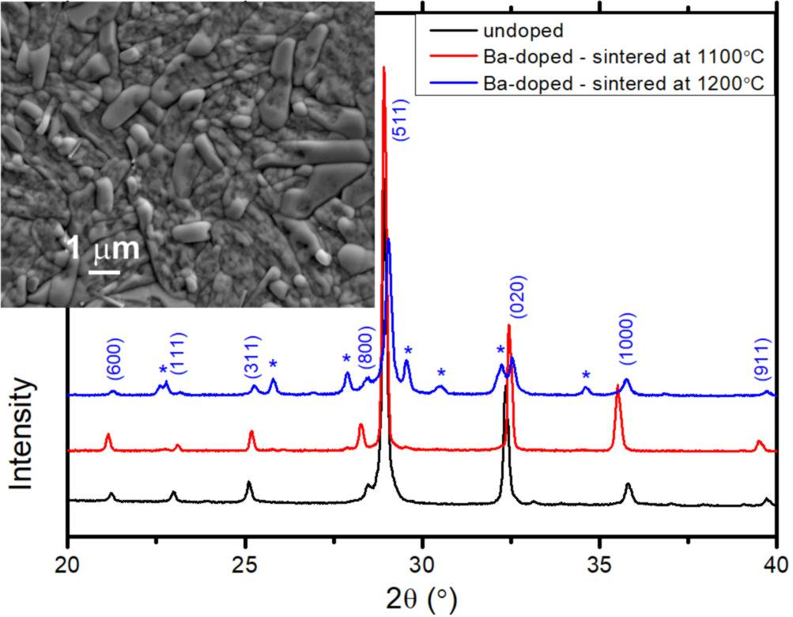
Figure 2: XRD patterns of SBNT and Ba-doped SBNT sintered at 1100ºC and 1200ºC respectively. The diffraction lines of the secondary tungsten bronze Sr_{0.5}Ba_{0.5}Nb₂O₆ phase are marked with asterisks. The inset shows the thermally etched microstructure of a polished cross-section of the Ba-doped SBNT ceramics sintered at 1100ºC

Dielectric strength of the ceramics depends crucially upon the degree of residual porosity.[3] For this reason, we have carefully optimize the powder processing and sintering conditions in order to prepare dense but still single phase ceramics. After sintering at 1100ºC for 4h, the residual porosity was estimated from a thermally etched polished cross-section to be less than 5%. The sintering at a higher temperature resulted in formation of a secondary tungsten bronze phase (Sr_{0.5}Ba_{0.5}Nb₂O₆) due to enhanced evaporation of bismuth. The microstructure of the ceramics shows slightly elongated grains typical for the Aurivillius phases that are known to exhibit a strong crystallographic anisotropy.

  - Dielectric Measurements
The real part of the permittivity for SBNT and Ba-doped SBNT, measured at different frequencies, is given in Fig. 3. It can be seen that the temperature of the permittivity maximum (T_{m}) at 100kHz decreased from 303°C to 105°C after 0.5 mol of Ba was incorporated on the Sr-site. In comparison with the Bi-site substituted system, this shows that the A-site substitution is not so efficient in decreasing T_{m}. When only 0.15 mol of Pr was incorporated on the Bi-site, the T_{m} shifted down to 79ºC. [16]

Relaxation properties of Ba-doped SBNT were found to be very strong. The permittivity peak is much broader than that observed for SBNT and the maxima, T_{m} , is moving to lower temperatures with increasing frequencies. Also the frequency dispersion of the permittivity peak is larger. The frequency dispersion can be quantitatively described as a temperature range, ∆T_{90,}[] that corresponds to a difference between the temperature T_{m} and a temperature corresponding to 90% of maximum permittivity (ε_{m}) on the high temperature side of the peak. The ∆T₉₀ value was found to increase with Ba-doping from 21.2°C to 93.6°C, showing how significantly more diffused the phase transition of Ba-doped SBNT is.

A degree of diffuseness, γ (1 < γ <2), reflects on relaxation strength. γ=1 corresponds to normal ferroelectric behavior and γ=2 refers to a pure relaxor ferroelectric.[] γ can be determined by a modified Curie–Weiss law given by
$$\frac{1}{ε}-\frac{1}{ε_{m}}=\frac{{\left(T-T_{m}\right)}^{γ}}{C}$$
,where C is the Curie-like constant. By fitting the experimental data for Ba-doped SBNT by the modified Curie-Weiss law, γ was found to be 1.82 (Fig 3), which confirms its strong relaxor characteristics. For comparison, γ for SBNT was found to be only 1.05 while the Bi substitution by Pr slightly increased this value to 1.39.[16]

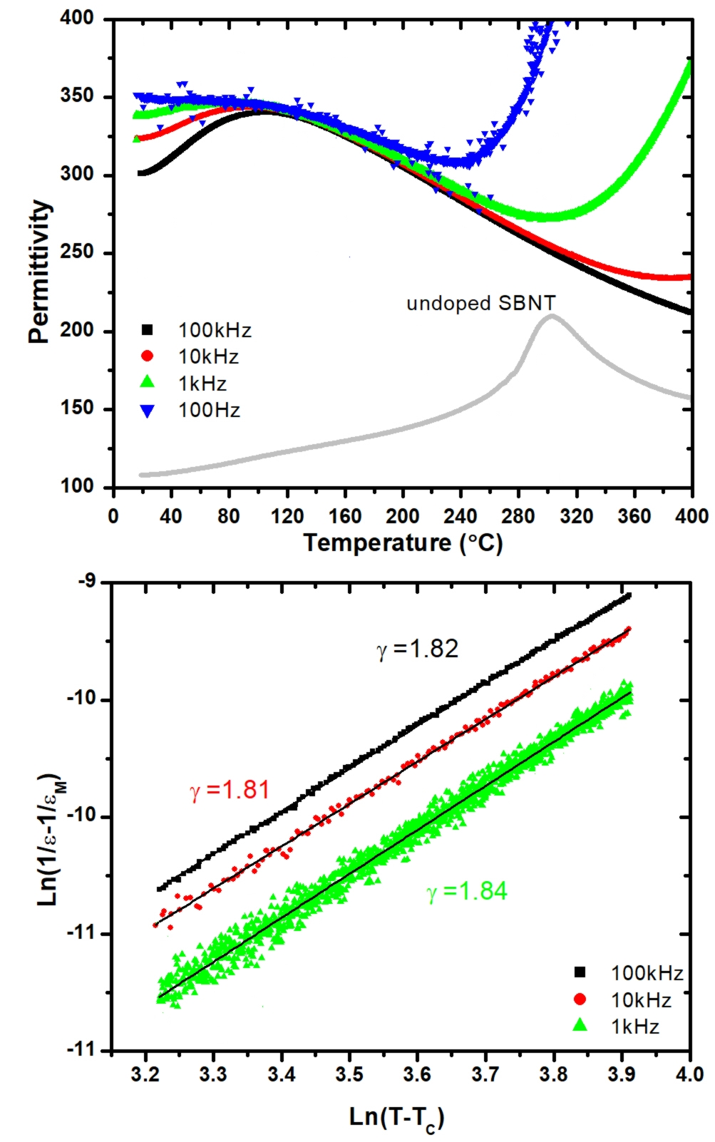

Figure 3: (a): Temperature dependence of the real part of permittivity of the undoped SBNT at 100 kHz and Ba-doped SBNT at four different frequencies, (b): Estimation of the exponent of the modfidied Curie-Weiss law for 100 kHz, 10 kHz and 1kHz.

The polarization loops of Ba-doped SBNT were measured in a temperature range from 18ºC to 140ºC (Fig. 4). It is interesting to notice that the phase transition is very broad and the maximum polarization decreases very slowly with temperature. The remnant polarization is very small even at 18ºC. This is very beneficial for electrocaloric devices as it prevents hysteresis energetic losses during field cycling. These are typical characteristics expected for relaxor ferroelectrics. In addition, the observed decrease in polarization with temperature is smooth with no abrupt changes that would suggest on presence of a depolarization temperature, i.e. a temperature at which the correlation length of the polar domains becomes large enough to create a long-range ferroelectric order. If such temperature exists it should be below 18ºC. In the Bi-site substituted system the depolarization temperature also decreased, but only down to 48ºC.[16] In that study it was recognized that additional increase in the EC effect of this Aurivillius phase can be achieved by further reduction in the depolarization temperature, which is exactly what we have achieved with the A-site substitution.

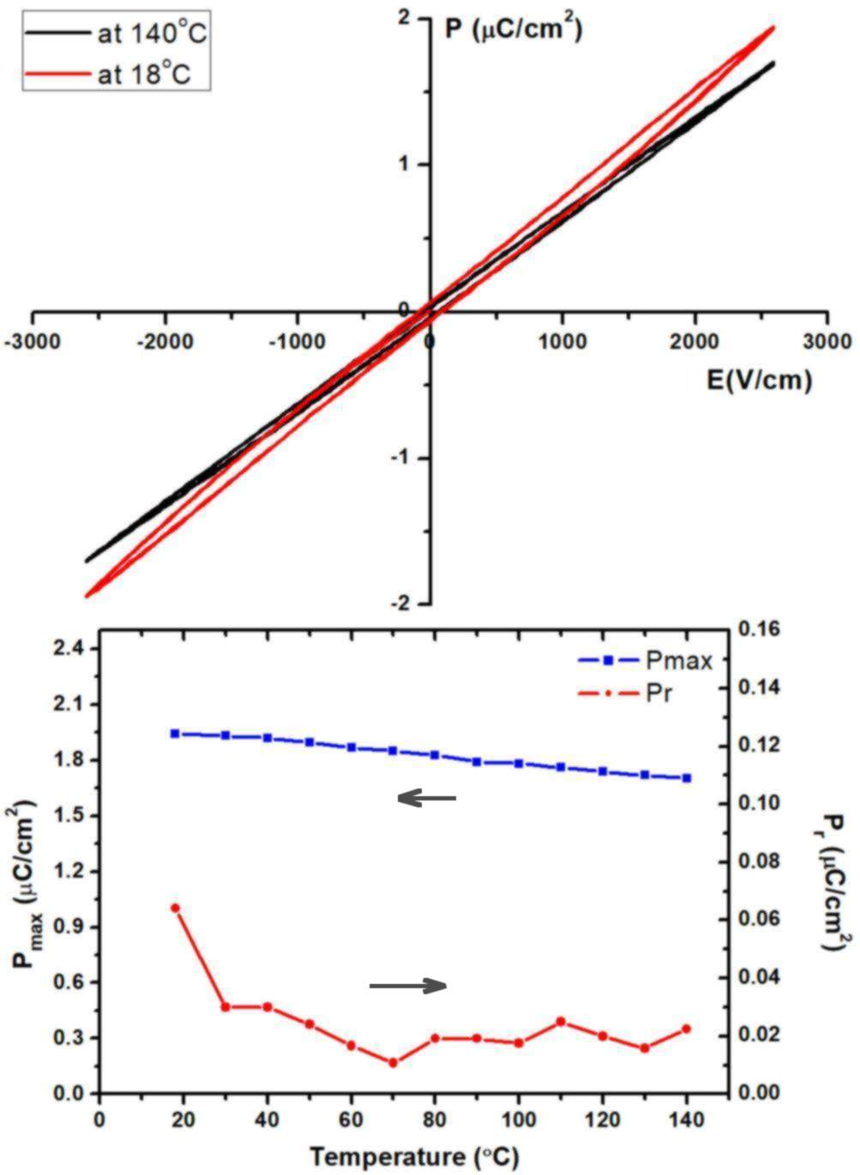

Figure 4: Polarization loop (above) and remanent and maximum polarization (below) measured for Ba-doped SBNT as a function of temperature.

3.3. Electrocaloric effect
The EC effect, measured for Ba-doped SBNT as a function of temperature for different values of applied electric field, is given in Fig. 5. It can be seen that the EC effect follows the increasing trend of the real part of the permittivity below T_{m}. However, instead of decreasing above T_{m}, the EC effect keeps on increasing with temperature. The highest EC effect was measured at 140°C under 50kV/cm and was found to be 0.78K, which is almost twice the EC effect that was measured for the Bi-site substituted system under the similar conditions.

The temperature dependence of the EC effect in the Aurivillius phase perfectly follows the main EC characteristics found for other relaxor systems. The maximum EC effect is not observed at T_{m} but higher. Above the maximum, for low electric fields (20kV/cm) the EC effect starts to slightly decrease with temperature before increasing again. For high electric fields (50kV/cm), the EC effect continuously increases. The origin of this increased contribution to the EC effect is in alignment of the polar nanodomains that are present in this strong relaxor. []

The occurrence of such double peak is very beneficial for practical application of the EC material as it makes the high EC effect spanning over a broad temperature range. In addition, it can be expected for the lead-free Aurivillius phase that even higher EC effect can be achieved at higher temperatures (which are beyond the temperature limit of our measurement system) and for higher electric fields. To realize this ECE values within the working temperatures of the refrigerator systems, the phase transition should be brought further down to lower temperatures by a suitable doping. This should be accompanied by an optimized ceramic processing in order to maximize the dielectric strength.[3]

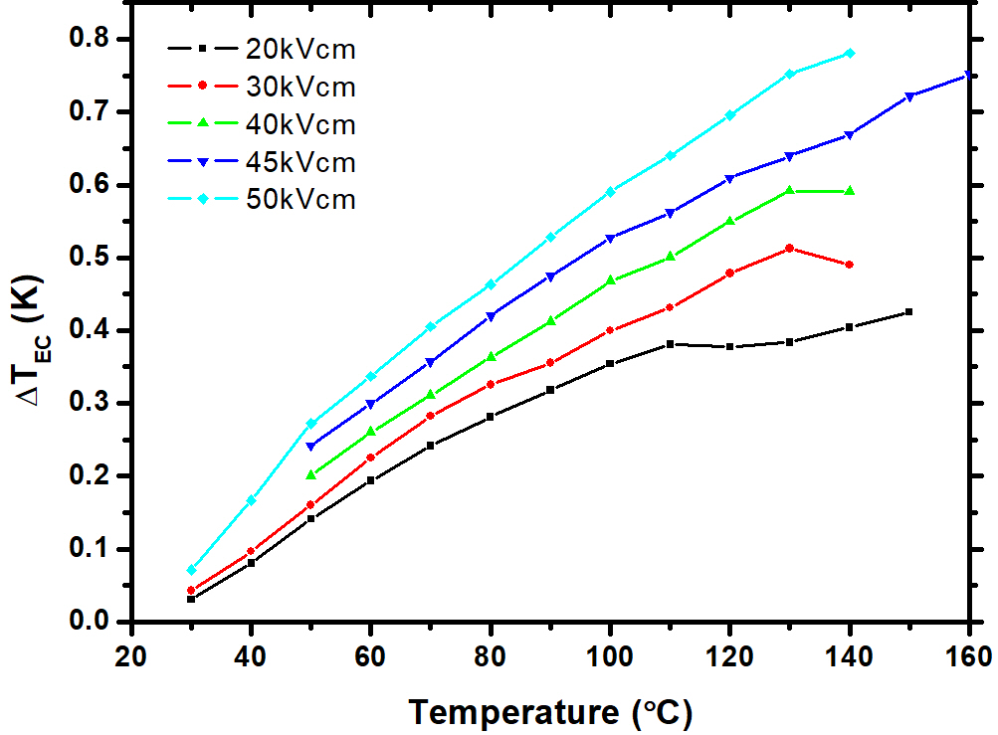

Figure 5: Direct measurement of the EC effect in Sr_{0.5}Ba_{0.5}Bi₂(Nb_{0.2}Ta_{0.8})₂O₉ ceramics as a function of temperature and applied electric field.

CONCLUSIONS
The relaxor-type transition of SBNT was successfully decreased below room temperature by the A-site isovalent substitution. As predicted, the decrease in the depolarization temperature resulted in a downshift of the EC effect peak towards room temperature. Consequently, the measured EC effects within the measuring limit were much higher than that of SBNT or by the Bi-site substituted SBNT, for which the depolarization temperature was at 48ºC. The highest measured EC effect for Ba-doped SBNT was 0.78ºC at 140 ºC. However, the downshift, obtained by Ba doping within this study, is still not sufficient to unveil all the electrocaloric potential of this lead-free Aurivillius phase. The top of the broad EC peak has not been reached yet as it lies above the temperature limit of the measurement system.

It is advantageous that the A-site substitution resulted in a strong relaxor character of the Ba-doped SBNT phase. This shows on a potential of this material to keep the high EC effect over a broad range of working temperatures, which is necessary for an efficient electrocaloric cooling cycle.

Further development should be focused on search for more efficient dopants and/or substitution mechanisms that would bring the depolarization temperature to even lower temperatures, much below the room temperature. At the same time it should not significantly decrease the overall polarization. A focus on aliovalent substitution could be beneficial as it has already been shown to lead to formation of much larger polar nanodomains. [] Such substitution together with optimisation of ceramic processing in order to increase dielectric strength, could be the key for realizing EC effect high enough for commercial applications of the lead-free Aurivillius phases.

[] Electrocaloric Materials – New Generation of Coolers (ed. by T. Correia, Q. Zhang), Springer, Berlin 2014.
[] J. F. Scott, High-dielectric constant thin films for Dynamic Random Access Memories (DRAM), Annu. Rev. Mater. Sci. 28 (1998), 79-100.
[] M. Valant, A.-K. Axelsson, F. Le Goupil,N.M. Alford, Electrocaloric temperature change constrained by the dielectric strength, Mater Chem. Phys., 136, (2012) 277-280.
[] C. A. Paz de Araujo, J. D. Cuchiaro, L. D. McMillan, M. C. Scott, J. F. Scott, Fatigue-free ferroelectric capacitors with platinum electrodes, Nature 374 (1995), 627 –629.
[] F. Nagata, T. Takahashi, Y. Yano, T. Takenaka, Electrical properties of bismuth layer-structured ferroelectrics Sr_{m-3+x}Bi_{4-x}Ti_{m-x}Ta_{x}O_{3m+3}, Ferroelectrics 261 (2001), 883–888.
[] M. Valant, Electrocaloric materials for future solid-state refrigeration technologies, Prog. Mater. Sci. 57, (2012) 980-1005.
[] V. V. Shvartsman, D. C. Lupascu, Lead-free relaxor ferroelectrics, J. Am. Ceram. Soc. 95 (2012), 1-26.
[] S. Huang, C. Feng, L. Chen, X. Wen, Dielectric properties of SrBi_{2-x}Pr_{x}Nb₂O₉ ceramics (x=0, 0.04 and 0.2), Solid State Comm. 133 (2005) 375–379
[] V. Shrivastava, A. K. Jha, R. G. Mendiratta, Structural and electrical studies in La-substituted SrBi₂Nb₂O₉ ferroelectric ceramics, Physica B: Condensed Matter 371, (2006) 337-342.
[] L. Sun, C. Feng, L. Chen, S. Huangz, Dielectric and piezoelectric properties of SrBi_{2-x}Sm_{x}Nb₂O₉ (x=0, 0.05, 0.1, 0.2, 0.3, and 0.4) ceramics, J. Am. Ceram. Soc. 90 (2007) 3875–3881.
[] B. J. Kennedy, Ismunandar Effect of temperature on cation disorder in ABi₂Nb₂O₉ (A = Sr, Ba), J. Mater. Chem. 9 (1999) 541-544.
[] M. J. Forbess, S. Seraji, Y. Wu, C. P. Nguyen, G. Z. Cao, Dielectric properties of layered perovskite Sr_{1-x}AxBi₂Nb₂O₉ ferroelectrics (A=La, Ca and x=0, 0.1), Appl- Phys. Lett. 76 (2000) 2934-2936.
[] Y. Wu, M. J. Forbess, S. Seraji, S. J. Limmer, T. P. Chou, C. Nguyen, G. Cao, Doping effect in layer structured ferroelectrics, J. Appl. Phys. 90, (2001) 5296 – 5302.
[] C. H. Hervoches, P. Lightfoot, Cation disorder in three-layer Aurivillius phases: structural studies of Bi_{2−x}Sr_{2+x}Ti_{1−x}Nb_{2+x}O₁₂ (0<x<0.8) and Bi_{4−x}La_{x}Ti₃O₁₂ (x=1 and 2), J.Solid State Chem. 153 (2000), 66-73.
[] S. Huang, C. Feng, L. Chen, Q. Wang, relaxor behavior of Sr_{1-x}Ba_{x}Bi₂Nb₂O₉ Ceramics, J. Am. Ceram. Soc. 89, 2006, 328-331.
[] A.-K. Axelsson, F. Le Goupil, M. Valant, N. McN. Alford, Electrocaloric effect in lead-free Aurivillius relaxor ferroelectric ceramics, Acta Mater., 124 (2017) 120-126.
[] F. Le Goupil, A. Berenov, A. K. Axelsson, M. Valant, N. M. Alford, Direct and indirect electrocaloric measurements on 001-PbMg_{1/3}Nb_{2/3}O₃-30PbTiO₃ single crystals, J. Appl. Phys. 111 (2012), 24109.
[] R.D. Shannon, Revised effective ionic radii and systematic studies of interatomic distances in halides and chalcogenides, Acta Cryst. A32 (1976) 751-767.
[] A. K. Axelsson, Y. Y. Pan, M. Valant, P. M. Vilarinho, N. M. Alford, Polar fluctuations in Mn substituted KTaO₃ ceramics, J. Appl. Phys. 108 (2010), 064109.
[] K. Uchino, S. Nomura, Critical exponents of the dielectric constants in diffused-phase-transition crystals, Ferroelectrics 44, (1982), 55-61.
[] L. J. Dunne, M. Valant, A. K. Axelsson, G. Manos, N. Alford, Statistical mechanical lattice model of the dual-peak electrocaloric effect in ferroelectric relaxors and the role of pressure, J. Phys. D - Appl. Phys., 44, (2011) 375404.
[] A. K. Axelsson, M. Valant, N. M. Alford, Influence of Point Defects in KTaO₃ on Low-Temperature Dielectric Relaxation, J. Europ. Ceram. Soc. 30, (2010) 941-946.

