RiserSure: Automated Deployment of Digital Radiography for Subsea Inspection of Flexible Risers

A. Kaur, B. Ma, M. Corsar, T. Sattar
London South Bank Innovation Centre,
Granta Park, Great Abington,
Cambridge, UK
michael.corsar@affiliate.twi.co.uk
A. L. Clarke, C. Forrest, P. Ian Nicholson
TWI Technology Centre (Wales)
Harbourside Business Park, Harbourside Road,
Port Talbot, Wales, UK
ian.nicholson@twi.co.uk

Abstract— Flexible pipes are used as risers to carry oil and gas from sub-sea wells to Floating Production Storage and Offloading vessels. Due to the harsh nature of the environment, these risers are subject to fatigue over their lifetime. It is important, as part of their integrity management, that regular in-service monitoring is undertaken to track how the asset ages. Current inspection methods for flexible risers are limited. Only radiography can inspect the multiple layers within a flexible riser to produce a volumetric inspection. Automated underwater digital radiography improves on traditional radiography by allowing a shorter inspection time. This paper presents the design and development of a new automated, underwater digital radiography inspection system prototype to survey flexible risers at depths of 100m. This is a cost effective solution using a commercially available underwater Gamma radiation source holder and a high definition, linear digital radiography detector housed in a submersible vessel. The sub-sea deployment of a linear detector for underwater inspection of flexible risers is reported for the first time. The use of a linear detector array offers greater sea depth capability, in a smaller package, and the ability to cope with the high radiation energy demands of the Gamma source compared to flat panel detector solutions. Deployment has been achieved by implementation of a bespoke robotic scanning system that can accurately control the source and detector motion. The prototype was mounted on a flexible riser during shallow water sea trials. Preliminary results are presented which show that the internal inner and outer tensile armour layers in the riser have been successfully imaged.
Keywords—flexible riser; inspection, asset integrity, digital radiography, robotic scanner

Introduction
The RiserSure project is a collaboration between EU companies and research organisations with the objective of bringing to market a digital radiography (DR) based inspection system for underwater surveying of flexible risers.
Flexible risers are a type of pipework that connect offshore platforms to sub-sea equipment for production and drilling purposes, and can carry a range of fluids such as hydrocarbons, injection and control fluids and gas lift. There are several types of riser widely used by the oil and gas industry, including steel catenary and top tensioned which are constructed from stiff carbon steel pipe, however this research focuses on flexible risers.
Flexible pipeline technology was pioneered in the 1970s and used initially in benign, shallow water conditions such as the Mediterranean. They began to be adopted by industry during the 1980s as the technology developed and matured to the point where they have now become a key enabling technology to provide access to fields in extreme environments. They have been widely adopted for connecting floating equipment (such as FPSOs [Floating Production, Storage and Offloading]) to the sea bed because their inherent flexibility overcomes the challenges posed by dynamic environments [1].
The demand for flexible risers is growing; currently the global market is equivalent to around 1,200km/year of new pipe [2]. However, their adoption is not universal across all markets. Their selection is based upon a number of driving factors defined by the application. They are the preferred choice to connect to high motion vessels, such as FPSOs, in harsh environments. Their flexibility in following the sea’s surface motion has opened up fields that were previously inaccessible. Furthermore, they can be installed more quickly than other types of riser allowing production to be brought forward. Additionally, they often require less seabed preparation prior to installation.
The riser’s inherent flexibility is achieved by employing a number of layers in the construction of the riser wall as shown in Fig. 1. These layers are able to slip past each other, thereby imparting low bending stiffness characteristics. Each layer has a particular function that is configured by the designer. The inner steel carcass acts to prevent collapse of the liner under hydrostatic pressure and prevent fluid pressure leaking into the annulus. Around this, a polymer sheath provides the seal preventing leakage of the bore fluid passing into the annulus. There are several layers of steel wound armour; the pressure armour resists radial hoop stresses and the tensile armour carries the weight of the pipe by resisting axial tension. There can be multiple layers required in high tension applications. The outer polymer sheath is a barrier to sea water but is susceptible to accidental damage. All flexible pipes are designed based on this concept, even if there are variations in material selection for specific operating environments such as high temperature or deep water.
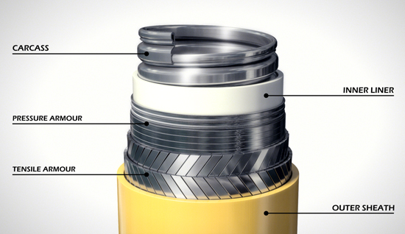
Fig. 1. Riser construction [3].

Present means for detecting flaws
Table 1 lists known flexible riser failure modes. Presently it is difficult for flexible risers to meet the industry’s equipment life expectations of 25 years, which steel risers can achieve, due to in-service failure. There are a wide range of potential failure mechanisms detailed in the American Petroleum Institute (API) Recommended Practise guide [4].
- Flexible riser failure modes
Failure mode | Failure mechanisms | Occurrence
Collapse | Excessive tension, external pressure, aging of polymer | Multiple reports worldwide
Burst | Tensile armour rupture, pressure armour rupture, pressure in annulus | Outer sheath rupture is common. Rupture of tensile wires may be problematic in deep water
Tensile failure | Excessive dynamic movement, large tensile loads combined with corrosion | High risk for corroded armour in deep water
Compressive failure | Radial buckling, upheaval buckling | Bird caging of armour is a problem worldwide
Over-bending | Installation error | Used to be a problem (1990s) due to errors in installation
Torsional failure | Large dynamic loads | Risers in very harsh environments most susceptible
Fatigue | Tensile armour rupture, pressure armour rupture, aging of polymer layers, cracking of carcass | Not common unless corrosion or other factors are present
Erosion | Internal erosion of carcass | Risk when bore fluids contain sand
Corrosion | Tensile armour rupture, pressure armour rupture, corrosion of internal carcass | Common problem linked to damage of the outer sheath

The most common reported failures in flexible risers relate to damage to the external sheath which lead on to other problems such as corrosion. Sheath damage can occur due to accidents during installation, in-service abrasion with other parts of the installation or polymer aging [5]. Examples of damaged risers are shown in Fig. 2.
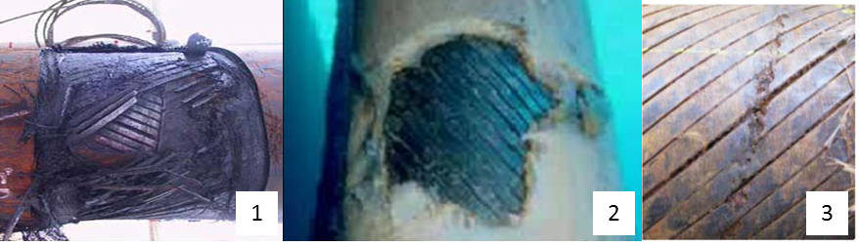
Fig. 2. Riser damage: 1) armour wire breakage, 2) external sheath damage, 3) armour corrosion.
There is a drive within industry to better understand riser degradation and failure mechanisms. For example, the Petroleum Safety Authority (PSA) commissioned a 2014 study to focus on degradation, failure modes, inspection and integrity management [6]. Recent Norwegian data indicates that there is at least a 1.5% probability of riser failure per year in service. As a result, few risers have met their documented service life.
Riser integrity management is a continuous assessment process applied throughout design, construction, installation, operations and decommissioning phases to assure that risers are managed safely. As far as in-service integrity the DNV standards require that design intent is maintained, and the actual state of riser degradation is known, due to operational conditions [7]. Part of the degradation assessment requires periodic asset inspection to be carried out. Table 2 shows the main typical methods used for riser inspections.
- Current inspection methods
Inspection Method | Inspection Capability | Notes
Visual inspection | Outer sheath (splits in layer and bulges) | + Easily deployed by ROV  -External flaw detection only  -Sea life attached to riser can inhibit visibility
Ultrasound | Detection of flooding | -Only detects defects in outer armour layer if riser annular is flooded.
Eddy Current | Outer armour layer | + Rapid inspection  -Difficult to interpret results
Traditional Radiography | Inspect through multiple different layers | + Penetrates all riser layers  -Use of film or phosphor plate requires processing and development topside.  Slow collection of data to topside

Only radiography can offer the capability for volumetric inspection to detect flaws in the areas of most concern. However, traditional radiography using wet film or phosphor plates is not in widespread use in the subsea environment because it is impractical and time consuming, and therefore expensive to execute. This is because, after exposure of the radiography detection media, it is then necessary for the media to be returned topside to be developed and processed [8][9].
The application of DR, whereby a marinised underwater flat panel detector is deployed as the radiography detection media, has been previously researched and demonstrated both by the current authors [10] and subsequently by others [11] in later work.
DR allows for fast acquisition of radiographic images through shorter exposure times and fast transfer of radiographic image data. It is not necessary to return the radiography detection media to the surface in-between each radiographic exposure as the recovery of the radiographic images is achieved through digital communication, via an umbilical, to a remote computer located topside. However, for the widespread uptake of DR in the oil and gas industry, DR deployment needs to be further automated and more cost effective.

Robotic System: Development
The development aim of the robotic system is to facilitate in-situ inspection of the flexible riser without the need to remove it from service. Risers are designed to operate in the oil field for 25 or more years, and therefore require periodic inspections to guarantee their integrity. As removing them from service is prohibitively expensive, RiserSure must be able to deliver high quality inspection data in the field. The conventional methods of deploying inspection systems around a riser are either by diver or remotely operated vehicle (ROV). The intervention of a diver comes with associated operational risks and, particularly in the case of radiography inspection, is not easy as the inspection units are relatively heavy compared to other inspection techniques. The radiography source and detector need to be aligned directly opposite to each other and moved very precisely at very low speed. The option of deploying the inspection system around the riser using an ROV is not favoured on cost grounds. Costs associated with work class ROVs are very high depending on their payload capacity and the time required for operation.
The robotic system has been designed such that divers and ROV’s are not necessary. Therefore the robot capsule can be connected to the riser near a top side hang-off point, and winched down the riser (as shown in Fig 3). This allows inspection in the critical areas where riser damage often occurs; the splash zone down to 50-100m below the surface.
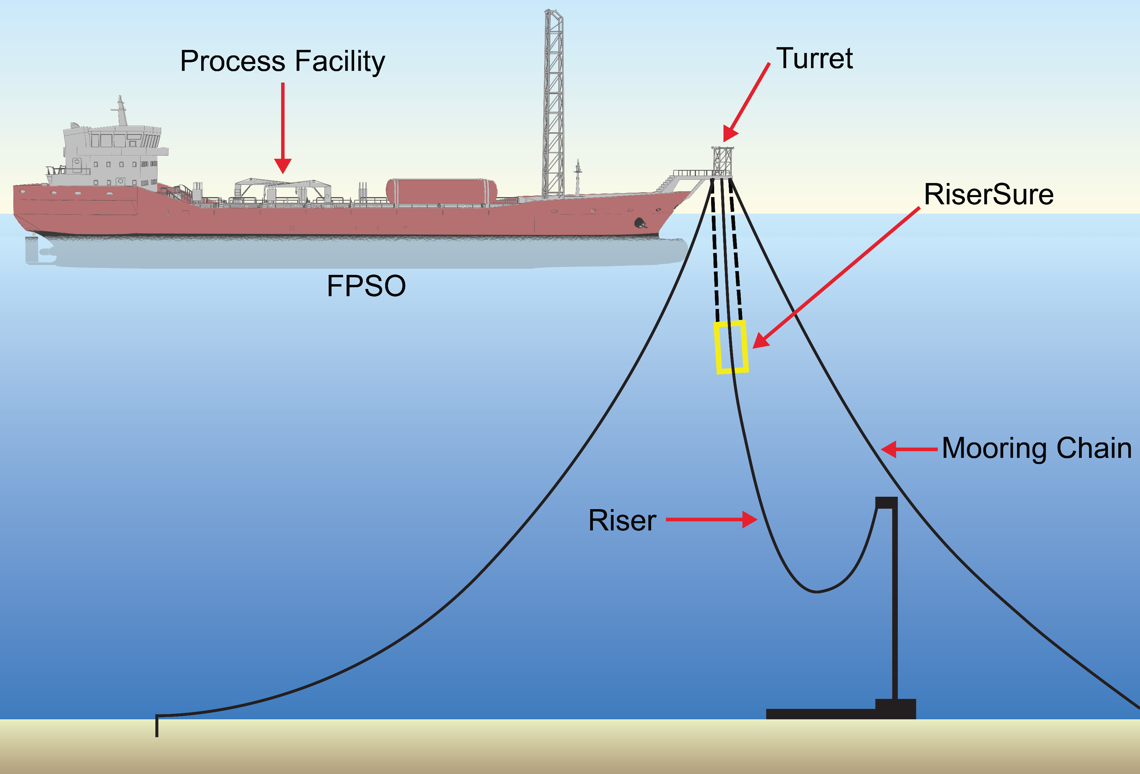
Fig. 3. Typical deployment strategy for the RiserSure capsule.
The main operational requirements of the robotic system include its capability to carry the radiography unit to the point of inspection, securely hold its position around the riser, and complete a 360 degree scan of the riser. The system has the capability to vary the scanning speed to change the exposure time such that it can accommodate a wide range of riser diameters. Specifically, it can manage risers of up to 250mm (the majority of risers are of 250mm diameter or less in the North Sea [5]). In order to build up a detailed radiographic image that will capture small defects, the rotational speed of the drive system on which the radiography system is mounted is very low and precisely controlled.
The core of the prototype robotic system is an open platform that can be positioned around a riser with very little or no manual adjustment. The only part of the capsule that needs to be opened to encircle a riser is the two piece precision rotary ring gear that is used to carry the radiography units. The design approach is such that it can easily be adapted to be deployed using ROVs if desired. The rotary ring is actuated by a motor driven pinion gear, and floats on three thrust bearings fixed permanently on a base plate. A model of the prototype is shown in Fig. 4. To keep the radiography units stable against the wave disturbances during scanning, and to avoid any collisions with the riser surface, a gripper system consisting of linear slides has been incorporated which holds the riser during scanning inspection. The gripper system design parameters are derived from the wave disturbances data and on the assumption that it will be a clean riser surface ensuring the coefficient of friction between the gripper and riser surface used at the design time. Positioning of the scanner along the riser is controlled by the winching system. Using winch the scanner is positioned to area of interest for inspection along the riser. The gripper system is activated to hold the riser and scanning is performed.

Fig. 4. 3D model of prototype of the robotic inspection system.
The gripping and scanning system of the riser has been implemented using customised subsea actuators. Each of the actuators consists of motor, the drive electronics and control circuitry integrated within the stainless steel oil-filled subsea enclosures. Each actuator also includes position feedback, current limit control, internal temperature and status monitoring registers. The low level controls are implemented in the integrated controller, and the supervisory control of the whole system is implemented in the dedicated industrial computer which is operated remotely at the topside. All the robotic subsea units are connected to the topside unit using the controller area network (CAN) bus interface. Each actuator acts as a node with its own unique id, and is configured as shown in Fig. 5. All actuators are connected to the topside unit via a single integrated umbilical. This ensures minimal wiring is required for interconnections and is key to good cable management practice. The umbilical contains a pair of cores for power supply and a twisted pair of cores for communication to the topside controller. This reduced the size and weight of the umbilical helps in reducing drag on the whole robotic system in the subsea conditions, while at the same time providing benefits of CAN bus such as communication error control, bus arbitration and noise immunity.
There are high costs involved for fabrication of subsea enclosures. The robotic electronics hardware configuration has been designed specifically to minimise the size of enclosure units and junction boxes. This is achieved by using dedicated in-built control and drive units of the actuators which are interconnected using a subsea umbilical with splice extensions and subsea connectors.

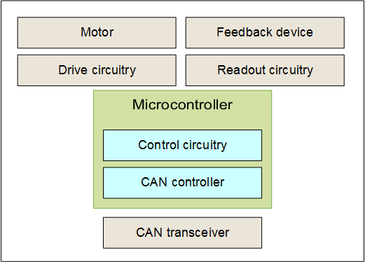
Fig. 5. Configuration of actuator nodes.
The system configuration of the robotic inspection system, consisting of robotic hardware and the radiographic modules, is shown in Fig. 6. The inspection detector consists of the in-built read-out and processing circuitry. The array detector outputs are transferred to the topside dedicated processing software via an Ethernet connection using an umbilical consisting of power supply lines for the detector and four twisted pairs CAT-5E Ethernet interface. The digital detector has a separate DC power supply and controller, which is supplied with the system. The source controller unit contains the hydraulic supply and valve system, which controls to subsea source unit to open or close the shutter for exposure (see section IV).
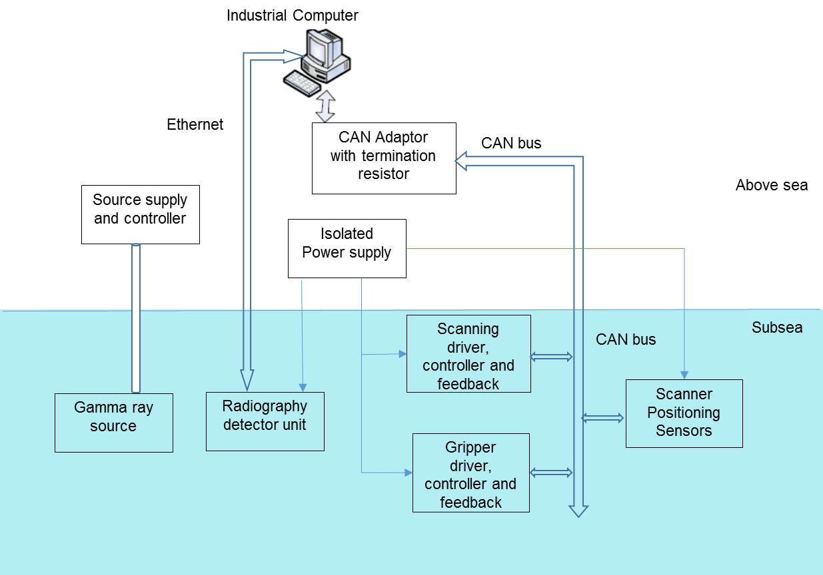
Fig. 6. Robotic inspection system configuration.
The supervisory control on the topside is a GUI (graphical user interface) based system. This includes the control of system operational modes based on user inputs and internal system parameters, monitoring of critical parameters of subsea units, display of system status and warnings of system errors. The guidelines from subsea standards are implemented in the control software. This consists of the timing parameters for sampling of inputs, display updating rate, continuous position monitoring of the robotic system, display of modes being executed, checks on user inputs, provision for stopping execution for any of the operational modes and saving of data as required.
The hardware and software of the robotic system are based on a modular structure that facilitates easy integration of additional hardware units in the system and respective software components. The winch system is a subsea certified commercially available system which is operated independently. The position of the scanner along the riser is encoded using the encoder on the winch and the subsea depth sensor. The depth sensor readings are measured and recorded using the supervisory control system and the winch encoder readings are entered manually for logging. However, for safety purposes, before the execution of any operational modes, except the emergency stop, the user is required to confirm the operation, allowing the verification of external and internal systems’ conditions.
To resist the subsea environment and to withstand the environmental loading, all the mechanical parts and enclosures are manufactured from stainless steel (316L).

Radiographic Inspection Development
Previous work by the authors has shown the deployment of a DR flat panel for underwater inspection of flexible risers [10]. However, the geometry of a flat panel detector is not conducive to a cost effective marinised housing solution for operation of the detector at significant subsea depths. It was subsequently found that the resulting vessel housing the detector was large and heavy and only achieved a limited 25m to 50m sea operation depth. This necessitated deployment by an expensive to hire “heavy work class” ROV to support the total payload of the resulting inspection system.
The RiserSure solution uses a commercially available Linear Detector Array (LDA) housed in a marinised cylindrical vessel. The detector array comprises a 250mm long detection area housed in a 475mm long cylinder. This detector offers greater sea depth capability in a smaller size compared to existing commercially available flat panel detector solutions. The linear detector is also able to withstand higher radiation energy levels since the majority of the detector electronics is shielded by the vessel housing, and the active sensor line array is only directly exposed to the radiation through a narrow 1mm collimated slit. The detector was selected specifically because it incorporates a Cadmium Tungstate crystal scintillator for converting radiation into light. At high energies (equivalent to 20Ci energy) the crystal is 50 to 95% more efficient compared to the Gadox/Lanex crystal scintillators often used in other commercial detectors. A diode array, with 0.4mm pixels, converts the light into an electrical signal. The large size of the pixel contributes to lower signal noise, a wider dynamic range and increased spatial resolution.
The biggest technical challenge for underwater radiography, without excluding the environment by use of a habitat, is that water (unlike air) is highly attenuating to ionisation radiation, even at relatively high radiation energy levels. In terms of radiation absorption it has been calculated that 10mm volume of water is equivalent to approximately 2mm thick steel in terms of radiation absorption [10]. To minimise the water path, the detector and source need to be positioned as close as practically possible to the riser walls. Putting the radioactive source inside the riser is not acceptable as it would mean having to stop production. Therefore, a further challenge is that inspection of flexible risers must be conducted through both walls of the flexible riser. This means that there is more material density to penetrate and thus a requirement for high energy radiation. Furthermore, the risers tend to contain liquid within the internal carcass, contributing to the overall attenuation factor of the radiation beam.
The energy requirement cannot be practically achieved by using X-ray emission due to the size and weight of the equipment, and that is before any marinised housing is produced. For convenience underwater radiography uses a Gamma source (e.g. Ir-192) which produces radiation as the isotope of the material decays. Ir-192 is widely available and offers an optimum working penetration of steel thickness ranging from 18mm up to a maximum of 100mm [12]. It also has a more practical 74 day half-life compared to other types of Gamma source.
A commercially available marinised Ir-192 isotope holder, provided by SXSubsea, has been incorporated in the RiserSure prototype. The holder is rated to carry an Iridium 192 sealed source capsule of up to 200Ci emission activity. However, for inspection of flexible risers with 220 to 250 mm outer diameter 20Ci energy is sufficient.
Protection from accidental exposure is provided because the source capsule is stored in the shielded part of the holder by default. The source is moved from the stored position to the exposed position by a pneumatic or hydraulic actuator (depending on the option selected). The actuation automatically returns the source to the stored position in the event of a pressure failure.
The radiography technique used is double wall double image (DWDI), and the setup is shown in Fig. 7. In this technique the radiation source is positioned as close as practically possible to the near side wall of the flexible riser, resulting in a magnified image of the nearside wall (which is ignored) overlaid with a clear image of the outside wall (the wall closest to the detector). The image of the nearside wall is blurred due to the geometric unsharpness caused by its proximity to the Gamma source. This does not affect the image of the outside wall, which remains clear.
The dimensions shown in Fig. 7 are those of the flexible riser used in the shallow water sea trials. As shown, the radiation path is assuming the riser is not submerged. The riser is open ended, and when it is submerged in the sea, water is therefore present both inside and outside the riser and therefore increases the radiation path. The riser diameter inspected was nominally 220mm in outer diameter, with an equivalent total steel thickness of 50mm in air. Taking into account the source to object, the detector to object, and the water distances in the riser, the total equivalent steel thickness in water can be calculated as 103.9mm. This steel thickness value is within the penetrated steel thickness quoted by British radiography standards. However, should inspection of greater riser diameters be required, even with the same wall thickness, Ir192 will not give the best results. The greater the riser diameter the longer the radiation path. In reality, flexible risers will be filled with oil rather than water. As oil has a lower attenuation compared to water, there is scope for larger diameter or thicker walled risers to be inspected but this has not been investigated in the current work.
Fig. 7. DWDI radiography technique (dimensions in mm).

Shallow water SEA trials
Prior to the seawater trials, the RiserSure system had been subjected to several laboratory based trials which demonstrated that the system had the capability to transition to seawater operation.
The shallow water trials (<10m depth) were performed at the seawater-fed Loch Linnhe in Fort William. By having this first trial at a sheltered sea loch first, before actual sea trials on an FPSO, meant that it was possible to validate the RiserSure system operation in a more controlled environment.
The RiserSure system was managed from the control room on the surface through an umbilical link, allowing the system to remotely image a full 360 degree section of the riser.
A photograph of the submerged system is shown in Fig. 8 where the core functionality of the system was proven. Due to the shallow depth the source container could be pneumatically operated using compressed air. A sealed source Ir192 capsule, with initial activity of 20.8 Ci and a 1.5mm diameter, was used over the three day trial period.
High quality, radiographic images of the riser were captured and tested for different exposures and varying scanning speeds.
A key factor in obtaining a high quality radiographic image with the RiserSure system is the synchronisation between the detector’s image acquisition speed and the rotational speed of the scanner module. For optimal operation, the LDA should acquire a line of the image each time the object moves a distance equal to the LDA’s pixel width (assuming no geometric magnification of the radiographic image). If the detector acquires the line images too fast then the resultant radiograph becomes stretched, a too slow acquisition results in a compressed image, which could lead to image blur and small defects being masked and undetectable.
Fig. 8. RiseSure system deployed underwater (image from monitoring ROV).
In order to validate the synchronisation between RiserSure’s scanner and detector a basic image quality indicator (IQI) was created during the trial comprising a punched hole lead plate containing five 5mm holes for application to the surface of the riser. Measurements of the IQI’s side length and width were taken from the radiographs in order to optimize the detector exposure time versus scanner rotation.
Since there were no known flaws in the riser used in the shallow sea trial, the IQI was also used to provide a measure of the image quality for the acquired radiographic images.
Fig. 9 shows a radiographic image for a 360º scan of the riser which resulted in two impressions of the IQI in the acquired image. The vertical axis of the image corresponds to the detector array length (250mm). It can be observed that one impression of the IQI is relatively in proportion at low magnification when the detector passes the IQI side (right of image), and the other impression (left of image) shows a highly magnified but distorted version where the Gamma source passes the IQI side. This is due to the fact that the radiograph is acquired by the DWDI technique, and the scanner and detector can only be synchronised to accurately image a single distance from the riser at any one time. Using a source activity of 20.8 Ci the radiographic image was acquired in just under 15 minutes.
Fig. 9. Radiographic image showing 360º scan.
The results achieved during trials revealed the riser’s internal structure, proving the robotic inspection system’s suitability to carry out radiographic inspection of the flexible riser and providing reliable images of high accuracy and resolution. Fig. 10 shows a digitally magnified image of the right half the radiographic image previously shown in Fig. 9, and represents a scan area of 180º. When viewed on a high resolution monitor in a dark room all 5 holes punched in the IQI are clearly visible in the radiographic image.
Fig. 10. Digitally magnified radiographic image representing a 180º scan.
The effective operation and performance capabilities of the assembled robotic system under water conditions were also verified during the trial testing. Further improvements in the robotic system are under development as a result of the trials. The system is being made more ruggedized to withstand the aggressive operational environment specifically during inspection in the splash zone. The design needs further improvement to accommodate the riser vertical curvature which was assumed to be straight in the prototype design. Cable management is one of the important aspects in the new development.

Conclusions
The RiserSure consortium is the first to report underwater DR for inspection of flexible risers using a linear digital detector. The active detection area in a linear detector is a single line array. This means that the detector ensemble could be easily accommodated in a cylindrical vessel which is inherently stronger and smaller compared to a flat walled container housing which would be required if using a flat panel digital detector. Deploying a linear detector underwater is not without its challenges. Image quality is dependent on the accuracy of the mechanics. However, the first shallow sea trial results show that sufficient stability and precision using the robotic scanner has been achieved.
The shallow seawater trials were successful in proving that the RiserSure concept works effectively, and this has informed the next step in the system’s development whereby it will undergo an improvement cycle to ensure that it is ruggedised for offshore use and deployment from an FPSO.

Acknowledgment
The RiserSure Project is collaboration between the following organisations: InnoTechUK Innovative Technology & Sciences Ltd., IKnowHow SA, MISTRAS, London South Bank University, TWI Ltd. This project is managed and co-ordinated by InnoTechUK, and is part funded by the European Union’s Horizon 2020 research and innovation program under grant agreement No 730753. Website: www.risersure.eu. The authors wish to express their gratitude to Shawcor Ltd. for manufacture of the underlying detector technology, SXSubsea Ltd for supply of the Nautilus Gamma source container, and together with The Underwater Centre, Fort William, the support given during the shallow sea trials.

References
- J. Remery, C. Silva, O. Mesnage, ‘”The free standing flexible riser: A novel riser system for an optimised installation process”, Offshore Technology Conference 2008, Houston
- G. Gardner, P. Viana, “Flexible Riser Re-use and Life Extension”, AOG 2016
- Courtesy: National Oilwell Varco Rig Systems
- API RP 17B, “Recommended Pratice for Flexible Pipe”, 4th Ed.
- P. O’Brien, E. Meldrum, C. Overton, J. Picksley, K. Anderson, I. MacLeod, “Outcomes from the SureFlex Joint Industry Project – An International Initiative on Flexible Pipe Integrity Assurance”, Offshore Technology Conference, 2011
- 4 Subsea, “Un-bonded Flexible Risers – Recent Field Experience and Actions for Increased Robustness”, 2012
- Directive 2013/30/EU on safety of offshore oil and gas operations, June 2013, Official Journal of the European Union
- C. Marinho, C. Camerini, C. Maia, R Tadeu, and H Rocha H, “Gamma Ray System Operated by Robots for Underwater Pipeline Inspection”, ECNDT 2006, Berlin, Sept 2006
- J. R. McNab, B. Steel, “Computed radiography deployed by a subsea remotely operated vehicle”, March 2008, Insight Journal, Vol. 50(3), pp. 138-145
- P.I. Nicholson, “Development of an underwater radiography system for the in-situ inspection of flexible risers”, Proceedings: 7th International QRM Conference, Quality Reliability and Maintenance, Coxmoor Publishing Company, 2010, p112-123, ISBN: 978-1-9-1892-34-5
- L. Tomasz, "Pipe crawling underwater X-ray machines find leaks before they happen", Anti-Corrosion Methods and Materials, Vol. 61 Issue: 3, 2014, https://doi.org/10.1108/ACMM.12861caa.012
- BSI. “Non-destructive testing of welds – Radiographic testing of welded joints”, BS EN 1435:1997, 2004, ISBN: 0-580-28913-3

