HFE mRNA expression is responsive to intracellular and extracellular iron loading: short communication
Kosha J. Mehta¹, Sebastien Je Farnaud² and Vinood B. Patel^{1*}

¹115 New Cavendish Street, Department of Biomedical Sciences, University of Westminster, London W1W 6UW, UK.
²138 James Starley Building, School of Life Sciences, Coventry University, CV1 5FB, UK.

*Corresponding author and requests for reprints: Dr.Vinood Patel, Department of Biomedical Sciences, University of Westminster, London W1W 6UW, UK, Tel.:0207 911 5000 ext. 64138; Fax: 0207 911 5087; Email: v.b.patel@westminster.ac.uk

Acknowledgements for source of funding
Dr Kosha Mehta was supported by a scholarship from the University of Westminster.

Abstract

Background: In liver hepatocytes, the HFE gene regulates cellular and systemic iron homeostasis by modulating cellular iron-uptake and producing the iron-hormone hepcidin in response to systemic iron elevation. However, the mechanism of iron-sensing in hepatocytes remain enigmatic. Therefore, to study the effect of iron on HFE and hepcidin (HAMP) expressions under distinct extracellular and intracellular iron-loading, we examined the effect of holotransferrin treatment (1,2, 5 and 8 g/L for 6 h) on intracellular iron levels, and mRNA expressions of HFE and HAMP in wild-type HepG2 and previously characterized iron-loaded recombinant-TfR1 HepG2 cells.

Methods and Results: Gene expression was analyzed by real-time PCR and intracellular iron was measured by ferrozine assay. Data showed that in the wild-type cells, where intracellular iron content remained unchanged, HFE expression remained unaltered at low holotransferrin treatments but was upregulated upon 5 g/L (p<0.04) and 8 g/L (p=0.05) treatments. HAMP expression showed alternating elevations and increased upon 1 g/L (p<0.05) and 5 g/L (p<0.05). However, in the recombinant cells that showed higher intracellular iron levels than wild-type cells, HFE and HAMP expressions were elevated only at low 1 g/L treatment (p<0.03) and were repressed at 2 g/L (p<0.03) treatment. Under holotransferrin-untreated conditions, the iron-loaded recombinant cells showed higher expressions of HFE (p<0.03) and HAMP (p=0.05) than wild-type cells.

Conclusions: HFE mRNA was independently elevated by extracellular and intracellular iron-excess. Thus, it may be involved in sensing both, extracellular and intracellular iron. Repression of HAMP expression under simultaneous intracellular and extracellular iron-loading resembles certain iron-excess pathologies.

Keywords: HFE, iron-sensing, holotransferrin, hepcidin
Introduction
Maintenance of cellular and systemic iron homeostasis in the body is a dynamic process involving several signal transduction pathways. The hemochromatosis protein HFE maintains body iron homeostasis by participating in the induction of hepcidin (HAMP), the systemic iron regulator, by a yet incompletely understood mechanism [1–3]. Mutations in iron-related genes such as HFE, HJV, HAMP and TFR2 cause diminished hepcidin production which results in systemic and tissue iron overload, referred as type 1, type 2A, type 2B and type 3 hereditary hemochromatosis, respectively [4]. However, despite the presence of functional wild-type alleles of these genes, low to moderate tissue iron excess is also observed in alcoholic liver disease, hepatitis C infections, non-alcoholic fatty liver disease, non-alcoholic steatohepatitis and type 2 diabetes [5–8]. In these cases, iron loading can exacerbate the pathophysiology via excess-iron-induced oxidative stress [9]. Thus, it is important to fully delineate the iron-sensing mechanisms to formulate therapeutic interventions, particularly for the low-moderate iron-loaded conditions where, unlike hereditary hemochromatosis, phlebotomy is not practiced for removal of excess iron.

The mRNA response of HFE to a range of increasing extracellular iron, elevated intracellular iron and its relationship with HAMP expression has not been studied so far. Hence, in this short study, we investigated the effect of a range of holotransferrin (holo-Tf) concentrations (1 to 8 g/L) on HFE and HAMP mRNA expressions, and intracellular iron content. First, we observed these responses in the wild type (Wt) HepG2 cells, where holo-Tf supplementation represent physiological conditions with extracellular (systemic) iron elevation prior to intracellular/tissue iron loading. Then, we examined the responses in the previously characterized recombinant (rec)-TfR1 HepG2 cells [10]. As these cells can achieve intracellular iron overloading [10], holo-Tf supplementation to these cells represent pathological conditions, which show simultaneously increased extracellular (systemic) and intracellular iron levels. Finally, to understand the exclusive effect of high intracellular iron content, we compared the expression levels between holo-Tf-untreated Wt and recombinant cells. Unlike most previous holo-Tf supplementation studies that were conducted at longer time-points of 24 h, 48 h or 72 h [11–13], here, we studied the effect following 6 h of holotransferrin treatment to examine early responses.

Materials and Methods
Cell culture and treatments
Maintenance and holo-Tf supplementation to the WtHepG2 cells (Health Protection Agency, UK) and rec-TfR1HepG2 cells was as described previously [10]. Cells were treated with holo-Tf (1, 2, 5 and 8 g/L) prepared in serum-free EMEM (0 g/L) for 6 h and assessed for various parameters. As treatment with 8 g/L holo-Tf represent very high holo-Tf concentrations and the rec-TfR1 HepG2 cells had the potential for intracellular iron-overloading following holo-Tf supplementation [10], the effect of this concentration was studied only in Wt cells.

Determination of intracellular iron content
Cellular iron content determined by ferrozine assay [14] was normalized to protein, content, as quantified by Bradford method. Iron levels were expressed as nmoles iron/mg protein.

Gene expression analysis
Primers (Invitrogen, UK) for expression analyses, RNA extraction, cDNA conversion and assessment for mRNA expression via real-time PCR by using Quantifast SYBR green kit (Qiagen, UK), was as previously described [10,15].Data was analyzed by the relative quantification method, Delta-Delta C_{t} (∆∆Ct) and expressed as 2 ^{-∆∆Ct}[16].

Statistical analysis
Data analysis was performed using one-way ANOVA. The level of significance was set at p<0.05. Data was presented as mean ± SEM (n=3).

Results
In the Wt cells, while intracellular iron content remained unaltered following holo-Tf supplementation (Fig.1a), HFE mRNA expression significantly increased by 3.5-fold (p<0.04) upon 5 g/L treatment and further increased by 4.5-fold (p=0.05) upon 8 g/L treatment (Fig.1b). Expression levels remained unaltered at lower concentrations of 1 g/L and 2 g/L (Fig.1b). Differentially, HAMP expression showed a pattern of alternating responses i.e. a significant 1.8-fold (p<0.05) up-regulation upon 1 g/L treatment, unaltered expression upon 2 g/L treatment followed by a significant 2.3-fold up-regulation upon 5 g/L treatment (p<0.05) and then, down-regulation upon 8 g/L treatment (Fig.1c).

Prior to expression studies in the recombinant cells, intracellular iron loading was confirmed. Data showed that following treatment with most holo-Tf concentrations,
intracellular iron content in these cells was higher than Wt cells (Figs. 2a and 1a).In the recombinant cells, over the increasing holo-Tf concentrations, although intracellular iron content decreased at 2 g/L (p<0.01), it increasedat 5 g/L treatment (p<0.03) that restored the high levels, as in untreated conditions (Fig.2a).These cells differed from the Wt cells in HFE and HAMP expression patterns (summarized in Table 1). Here, HFE expression increased upon 1 g/L (p=0.07), but then decreased upon 2 g/L holo-Tf treatment (p<0.03), and remained unaltered at 5 g/L (Fig.2b). Similarly, HAMP expression increased by 3.5-fold at 1 g/L (p<0.03) followed by arepression at 2 g/L (p<0.03) and remained unaltered at 5 g/L treatment (Fig.2c).

Further, to understand the exclusive effect of intracellular iron loading, HFE and HAMP expressions in untreated cells were compared. Data showed that the recombinant cells expressed higher levels of HFE and HAMP mRNA than Wt cells (2.3-fold; p<0.03 and 3.9-fold; p=0.05, respectively) (Figs. 3a and 3b).

Discussion
The genes HFE and HAMP are extremely important for maintaining body iron homeostasis, where the protein HFE modulates HAMP induction [1,2] and the induced peptide hepcidin regulates systemic iron homeostasis upon systemic iron elevation [17,18]. However, the intracellular and extracellular iron-sensing mechanisms remain unclear and the upstream responses of the HFE mRNA to a range of increasing extracellular iron concentrations and elevated intracellular iron levels, and its co-relation with HAMP mRNA have been rarely studied. Therefore, in this short study we aimed to discriminate between the effects of intracellular and extracellular iron-loading. Hence, we examined HFE and HAMP expressions under high extracellular iron levels, high intracellular iron levels, and simultaneously increased intracellular and extracellular iron levels by treating Wt and recombinant HepG2 cells with/without a range of increasing holo-Tf concentrations. Such studies will not only help in elucidating the iron-sensing mechanisms but also in understanding iron-acquisition in different iron-excess pathologies.

Unlike previous studies where the responses of HFE mRNA expression were studied either under a single concentration of holo-Tf [11,19] or in macrophages [19], here, we used a range of holo-Tf concentrations (from 1 g/L to 8 g/L) on HepG2 cells to mimic the gradually elevating extracellular iron loading in different iron-excess pathologies, accounting for the probable different stages of iron loading. Since HFE is the inducer of HAMP expression [1,20–22] and hepcidin is a hormone [23], an early response to treatment was expected. Therefore, unlike most previous studies [11–13], here, the duration of treatments was only 6 h. As expected, alterations were observed in both, Wt and recombinant cells at this time-point (Figs. 1b, 1c, 2b and 2c).
HFE mRNA expression is responsive to excess extracellular and intracellular iron
To our knowledge, no study has yet reported the effect of a range of holo-Tf concentrations or saturation on HFE mRNA levels. We report for the first time, that elevation in extracellular holo-Tf concentration for 6 h causes elevation in HFE mRNA expression in the Wt HepG2 cells (Fig.1b). As this increase occurred in the absence of intracellular iron elevation (Fig.1a), it could be attributed exclusively to the elevated extracellular holo-Tf concentrations, thereby demonstrating the responsiveness of HFE mRNA towards excess extracellular iron. Furthermore, high HFE mRNA expression in the absence of extracellular iron, but presence of high intracellular iron (as observed in untreated recombinant cells) can be attributed exclusively to the high intracellular iron content (Figs. 3a, 1a and 2a). This indicates the responsiveness of HFE mRNA exclusively to high intracellular content. Collectively, HFE mRNA expression showed independent sensitivity to extracellular and intracellular iron loading.

In the Wt cells, lack of significant increase in intracellular iron following holo-Tf treatment (Fig. 1a) was anticipated; partly due to the short 6 h duration of treatment, and partly due to the source of iron (holo-Tf) used in this study. Unlike non-transferrin bound iron uptake, in which the pathways of iron acquisition and the corresponding regulatory mechanisms are unclear, transferrin bound iron uptake, as mediated in this study, is a well-understood and well-regulated mechanism. This concept is supported by previous observations in HepG2 cells where Fe-NTA treatment caused a 4-fold increase in cellular iron content compared to an insignificant 1.2-fold increase by 4.5 g/L holo-Tf [11].
Regulated cellular iron uptake follows the principles of iron-response element (IRE)-iron response element binding protein (IRP) system [24,25] that aims at maintaining cellular iron homeostasis. Accordingly, subtle increments in intracellular iron would be sensed by the IRE-replete TFRC transcripts and lead to decreased transcript levels and eventually, decreased TfR1 protein expression on cell-surface to prevent further iron-uptake [25]. Such increments would be additionally sensed by the IRE-replete SLC40A1 (ferroportin) transcripts, lead to increased expression and mediate iron efflux via this iron exporter to maintain intracellular iron homeostasis [24,25]. This is supported by the data (Supplementary Fig.1), which shows that in the Wt HepG2 cells, both, TFRC and SLC40A1 transcripts were downregulated upon holo-Tf treatment, thereby preventing both, iron uptake and iron efflux. Thus, the Wt cells showed no major increase in intracellular iron content upon holo-Tf treatment, demonstrating cellular iron-homeostatic mechanisms in action (Fig. 1a), resembling data from another study [11] and reflecting physiological conditions where excess cellular iron uptake would be prevented under excess extracellular iron to maintain cellular iron homeostasis.

HAMP mRNA expression and iron
In the Wt cells, elevation of HAMP expression following holo-Tf supplementation (Fig.1c) is an expected response following an iron stimulus [17,26,27].These elevations occurred in the absence of increased intracellular iron, indicating that an increase in extracellular iron was sufficient for the induction and a major increase in intracellular iron content was not necessary. Interestingly, its wavy pattern of expression over the increasing holo-Tf concentrations displayed a typical hormonal characteristic where increased levels of a stimulant (here, holo-Tf) may not lead to a directly proportional mRNA response. This is because, unlike cytokines, hormone-peptides are ‘premade’ and released from vesicles following a stimulus, like incase of insulin [28]. In the absence of extracellular iron (untreated cells), the high HAMP expression in recombinant cells (Fig. 3b), indicated that HAMP could be induced exclusively due to high intracellular iron content (Figs. 2a and 1a).

Interrelationship between HFE and HAMP expression patterns
Since HFE is an inducer of HAMP expression [1,22], a correlation between the mRNA responses of HFE and HAMP over the increasing holo-Tf concentrations was envisaged. The Wt cells showed no co-relation between the patterns of their responses (Figs. 1b and 1c), probably reflecting the hormonal characteristic of hepcidin. Conversely, the recombinant cells showed similarities between the patterns of HFE and HAMP expressions (Figs. 2b and 2c). Data in the recombinant cells showed that under intracellular iron excess, only subtle extracellular iron elevation could increase HFE and HAMP expressions, while further increase in extracellular iron led to either repression or an unaltered effect (Figs. 2b and 2c). This implies that both these genes can be induced by an external iron stimulus to regulate iron homeostasis, but preferably in the absence of intracellular iron loading, as supported by HFE and HAMP elevations observed in Wt cells that did not show intracellular iron loading (Fig.1). Accordingly, it could be extrapolated that once intracellular iron loading is attained in iron-excess pathologies such as alcoholic liver disease and hepatitis C infections, the iron-regulatory functionality of HFE and HAMP is dampened. This could be one of the reasons for deregulated iron metabolism and insufficient hepcidin production in such pathologies that show both, systemic and cellular iron loading along with diminished hepcidin production despite the presence of functional alleles of iron-related genes [5,7,29,30]. Additional experiments and corresponding clinical data will be necessary to provide more evidence to support the resemblance of our findings with such clinical conditions.

Further studies are required to elucidate these mechanisms to better understand the iron-sensing and iron-loading mechanisms; aiming to design therapeutic interventions for iron-excess pathologies other than hemochromatosis.

Conclusion
In this short study, the independent effects of extracellular and intracellular iron on HFE and HAMP expressions were examined. HFE mRNA demonstrated independent responsiveness to elevated extracellular and intracellular iron content, suggesting its involvement in sensing both, extracellular and intracellular iron. Under combined intracellular and extracellular iron loading, HFE and HAMP expressions showed similar patterns and HAMP was induced only by low holo-Tf concentration, a scenario resembling certain iron excess pathologies.

Compliance with Ethical Requirements: This article does not contain any studies conducted on human or animal subjects.

Author contributions
Dr Kosha Mehta: Key researcher; carried out experimental work, performed statistical analyses and wrote the article.
Dr Sebastien Farnaud: Concept of the research.
Dr Vinood B. Patel: Director of studies and final approver for the version of the article to be published.

Abbreviations: EMEM: Eagle’s Minimal essential medium; Holo-Tf: holotransferrin; H: hours

Gene annotations: HAMP, gene encoding hepcidin; HFE, gene encoding hemochromatosis protein HFE.

References
1. D’Alessio F, Hentze MW, Muckenthaler MU. The hemochromatosis proteins HFE, TfR2, and HJV form a membrane-associated protein complex for hepcidin regulation. J Hepatol. 2012 Nov;57(5):1052–60.
2. Rishi G, Crampton EM, Wallace DF, Subramaniam VN. In situ proximity ligation assays indicate that hemochromatosis proteins Hfe and transferrin receptor 2 (Tfr2) do not interact. PloS One. 2013;8(10):e77267.
3. Gao J, Chen J, Kramer M, Tsukamoto H, Zhang A-S, Enns CA. Interaction of the hereditary hemochromatosis protein HFE with transferrin receptor 2 is required for transferrin-induced hepcidin expression. Cell Metab. 2009 Mar;9(3):217–27.
4. Pietrangelo A. Hereditary hemochromatosis: pathogenesis, diagnosis, and treatment. Gastroenterology. 2010 Aug;139(2):393–408, 408.e1-2.
5. Costa-Matos L, Batista P, Monteiro N, Simões M, Egas C, Pereira J, et al. Liver hepcidin mRNA expression is inappropriately low in alcoholic patients compared with healthy controls. Eur J Gastroenterol Hepatol. 2012 Oct;24(10):1158–65.
6. Fujita N, Takei Y. Iron overload in nonalcoholic steatohepatitis. Adv Clin Chem. 2011;55:105–32.
7. Hörl WH, Schmidt A. Low hepcidin triggers hepatic iron accumulation in patients with hepatitis C. Nephrol Dial Transplant Off Publ Eur Dial Transpl Assoc - Eur Ren Assoc. 2014 Jun;29(6):1141–4.
8. Nelson JE, Klintworth H, Kowdley KV. Iron metabolism in Nonalcoholic Fatty Liver Disease. Curr Gastroenterol Rep. 2012 Feb;14(1):8–16.
9. Cichoż-Lach H, Michalak A. Oxidative stress as a crucial factor in liver diseases. World J Gastroenterol WJG. 2014 Jul 7;20(25):8082–91.
10. Mehta K, Busbridge M, Renshaw D, Evans RW, Farnaud S, Patel VB. Characterization of hepcidin response to holotransferrin in novel recombinant TfR1 HepG2 cells. Blood Cells Mol Dis. 2016 Oct;61:37–45.
11. Jacolot S, Férec C, Mura C. Iron responses in hepatic, intestinal and macrophage/monocyte cell lines under different culture conditions. Blood Cells Mol Dis. 2008 Aug;41(1):100–8.
12. Rapisarda C, Puppi J, Hughes RD, Dhawan A, Farnaud S, Evans RW, et al. Transferrin receptor 2 is crucial for iron sensing in human hepatocytes. Am J Physiol Gastrointest Liver Physiol. 2010 Sep;299(3):G778-783.
13. Gehrke SG, Kulaksiz H, Herrmann T, Riedel H-D, Bents K, Veltkamp C, et al. Expression of hepcidin in hereditary hemochromatosis: evidence for a regulation in response to the serum transferrin saturation and to non-transferrin-bound iron. Blood. 2003 Jul 1;102(1):371–6.
14. Riemer J, Hoepken HH, Czerwinska H, Robinson SR, Dringen R. Colorimetric ferrozine-based assay for the quantitation of iron in cultured cells. Anal Biochem. 2004 Aug 15;331(2):370–5.
15. Mehta K, Greenwell P, Renshaw D, Busbridge M, Garcia M, Farnaud S, et al. Characterisation of hepcidin response to holotransferrin treatment in CHO TRVb-1 cells. Blood Cells Mol Dis. 2015 Aug;55(2):110–8.
16. Livak KJ, Schmittgen TD. Analysis of relative gene expression data using real-time quantitative PCR and the 2(-Delta Delta C(T)) Method. Methods San Diego Calif. 2001 Dec;25(4):402–8.
17. Pigeon C, Ilyin G, Courselaud B, Leroyer P, Turlin B, Brissot P, et al. A new mouse liver-specific gene, encoding a protein homologous to human antimicrobial peptide hepcidin, is overexpressed during iron overload. J Biol Chem. 2001 Mar 16;276(11):7811–9.
18. Park CH, Valore EV, Waring AJ, Ganz T. Hepcidin, a urinary antimicrobial peptide synthesized in the liver. J Biol Chem. 2001 Mar 16;276(11):7806–10.
19. Jacolot S, Yang Y, Paitry P, Férec C, Mura C. Iron metabolism in macrophages from HFE hemochromatosis patients. Mol Genet Metab. 2010 Nov;101(2–3):258–67.
20. Bridle KR, Frazer DM, Wilkins SJ, Dixon JL, Purdie DM, Crawford DHG, et al. Disrupted hepcidin regulation in HFE-associated haemochromatosis and the liver as a regulator of body iron homoeostasis. Lancet Lond Engl. 2003 Feb 22;361(9358):669–73.
21. Schmidt PJ, Fleming MD. Transgenic HFE-dependent induction of hepcidin in mice does not require transferrin receptor-2. Am J Hematol. 2012 Jun;87(6):588–95.
22. Schmidt PJ, Toran PT, Giannetti AM, Bjorkman PJ, Andrews NC. The transferrin receptor modulates Hfe-dependent regulation of hepcidin expression. Cell Metab. 2008 Mar;7(3):205–14.
23. Rossi E. Hepcidin - the Iron Regulatory Hormone. Clin Biochem Rev. 2005 Aug;26(3):47–9.
24. Muckenthaler MU, Galy B, Hentze MW. Systemic iron homeostasis and the iron-responsive element/iron-regulatory protein (IRE/IRP) regulatory network. Annu Rev Nutr. 2008;28:197–213.
25. Casey JL, Hentze MW, Koeller DM, Caughman SW, Rouault TA, Klausner RD, et al. Iron-responsive elements: regulatory RNA sequences that control mRNA levels and translation. Science. 1988 May 13;240(4854):924–8.
26. Moretti D, Goede JS, Zeder C, Jiskra M, Chatzinakou V, Tjalsma H, et al. Oral iron supplements increase hepcidin and decrease iron absorption from daily or twice-daily doses in iron-depleted young women. Blood. 2015 Oct 22;126(17):1981–9.
27. Girelli D, Trombini P, Busti F, Campostrini N, Sandri M, Pelucchi S, et al. A time course of hepcidin response to iron challenge in patients with HFE and TFR2 hemochromatosis. Haematologica. 2011 Apr;96(4):500–6.
28. Rorsman P, Braun M. Regulation of insulin secretion in human pancreatic islets. Annu Rev Physiol. 2013;75:155–79.
29. Bridle K, Cheung T-K, Murphy T, Walters M, Anderson G, Crawford DG, et al. Hepcidin is down-regulated in alcoholic liver injury: implications for the pathogenesis of alcoholic liver disease. Alcohol Clin Exp Res. 2006 Jan;30(1):106–12.
30. Fujita N, Sugimoto R, Takeo M, Urawa N, Mifuji R, Tanaka H, et al. Hepcidin expression in the liver: relatively low level in patients with chronic hepatitis C. Mol Med Camb Mass. 2007 Feb;13(1–2):97–104.

Figure Captions and Legends
Fig. 1 Effects of holo-Tf supplementation in Wt HepG2 cells
WtHepG2 cells were treated with holo-Tf for 6 h. Following the treatment, intracellular iron levels were measured and expressed per mg protein (a). HFE (b) and HAMP (c) mRNA expressions was assessed and expressed relative to untreated (0 g/L) cells. Data is presented as mean ± SEM (n=3). *p<=0.05 compared to untreated (0 g/L) controls.

Fig. 2Effects of holo-Tf supplementation in rec-TfR1 HepG2 cells
Rec-TfR1 HepG2 cells were treated with holo-Tf for 6 h. Following the treatment, intracellular iron levels were measured and expressed per mg protein (a). HFE (b) and HAMP (c) mRNA expressions was assessed and expressed relative to untreated (0 g/L) cells. Data is presented as mean ± SEM (n=3). *p<0.03, **p<0.01 and #p=0.07 compared to untreated (0 g/L) controls. ^p<0.03 compared to 2 g/L treatment.

Fig. 3HFE and HAMP mRNA expressions in rec-TfR1 HepG2 cells relative to WtHepG2 cells
The mRNA expressions of HFE (a) and HAMP (b) in the recombinant cells were expressed relative to WtHepG2 cells under untreated conditions at the 6 h time point.Data is presented as mean ± SEM (n=3). *p<=0.05 compared toWtHepG2 cells.

Table 1 Summary of HFE and HAMP expression patterns
 | HFE mRNA expression |  | HAMP mRNA expression
 | Wt cells | Recombinant cells | Wt cells | Recombinant cells
1g/L | -
2 g/L | - |  | -
5 g/L |  | - |  | -
8 g/L |  | N/A |  | N/A
Key to Table 1:
- : unaltered expression
: Increased expression
: decreased expression
N/A: not applicable as the expression was not studied.

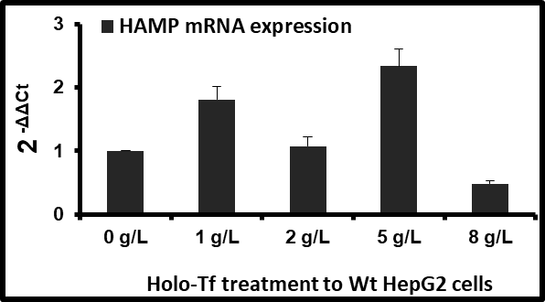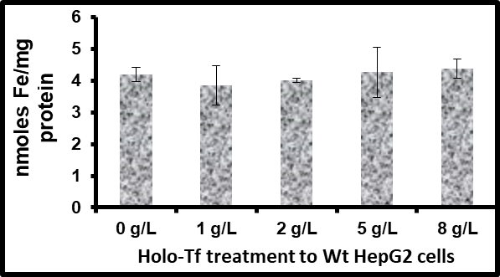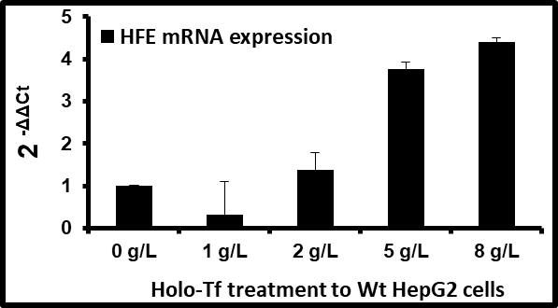
Fig. 1a
Fig. 1b
*
*
Fig. 1c
*
*

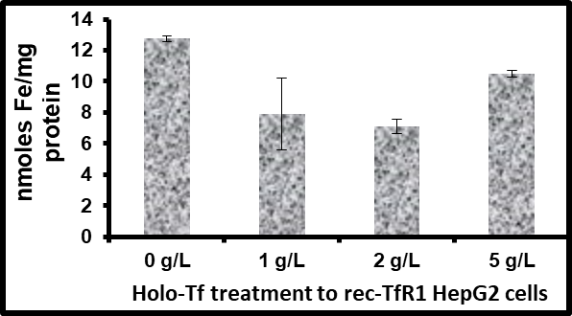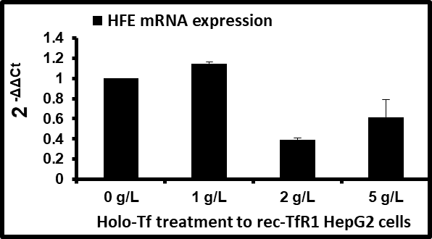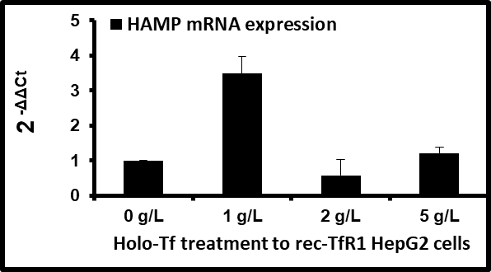
**
^
#
*
*
*
Fig. 2a
Fig. 2b
Fig. 2c

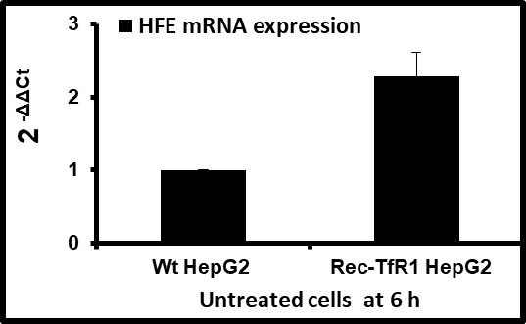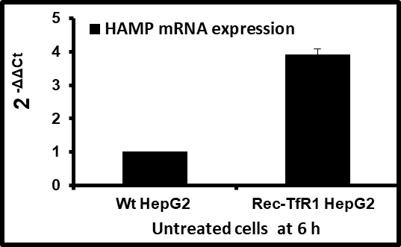
*
*
Fig. 3a
Fig. 3b

HFE mRNA expression is responsive to intracellular and extracellular iron loading: short communication

Supplementary Fig.1.
a) b)
*
*
*
*
Supplementary Fig.1 mRNA expression of iron-uptake and iron-efflux genes in Wt HepG2 cells
Holo-Tf-induced mRNA expression of (a) TFRC (encoding transferrin receptor 1) and (b) SLC40A1 (encoding ferroportin) in the Wt HepG2 cells have been shown. *p<=0.05 compared to untreated (0 g/L) controls. Data is presented as mean ± SEM (n=3).

