Passive elastic contribution of hip extensors to joint moments during walking in people with low back pain

Mark G. Hines PhD1,2, Neale A. Tillin PhD3, Jin Luo PhD1, Raymond Y.W. Lee PhD4

1. London South Bank University, School of Applied Sciences, 103 Borough Road, London, SE1 0AA,UK.

2. British College of Osteopathic Medicine, 3 Sumpter Close, London, NW3 5HR, UK

3. University of Roehampton, School of Life Sciences, Whiteland’s College, Holybourne Avenue, London, SW15 4JD, UK.

4. University of Portsmouth, Faculty of Technology, Winston Churchill Avenue, Portsmouth, PO1 2UP, UK

Correspondence address: Mark Hines, London South Bank University, School of Applied Sciences, 103 Borough Road, London, SE1 0AA. hinesm@lsbu.ac.uk

Manuscript word count: 4199

Abstract word count: 246

Abstract

*Background.* It has been found that alterations in passive muscle properties may be associated with low back pain, and these may be responsible for the altered gait parameters often observed in subjects with back pain. The purpose of the present study was to assess total hip and passive hip extensor moments in people with or without low back pain during the hip flexion component of walking.

*Methods.* 52 subjects volunteered for this study (low back pain group, *n* = 25 (male *n* = 13, female *n* = 12), control group,*n* = 27 (male *n* = 15, female *n* = 12)). Passive hip moments were calculated using an adapted force transducer during supine testing. A biomechanical model and predictive equation were used to calculate passive hip moments during walking. Total hip moments were calculated with the use of a 9 camera, 3-D motion-capture system.

*Findings.* Independent samples t-tests demonstrated no significant differences between groups for gait parameters or hip or knee angles. Results of the ANOVAs demonstrated significant differences in passive hip flexor moments during the second half of hip flexion (P < 0.05).There were also significant differences in hip power and work done during peaks of power absorption and the second peak of power generation (*P* < 0.05).

*Interpretation.* The present data demonstrates that subjects with low back pain have altered passive hip extensor and total power and work done during walking compared with healthy controls. Biomechanical models should include individual measurements of passive joint moments.

Passive elastic contribution of hip extensors to joint biomechanics during walking in people with low back pain

1. Introduction

Low back pain (LBP) is one of the leading causes of disability globally [1]. Clinical assessments of LBP patients often include tests of hip extensor extensibility [2]. Tests can include assessment of knee extension angle and sacral angle, the sit and reach test [3], and the straight leg raise test [3, 4]. However, the relevance of hip muscle extensibility to LBP and any relationship to movement remains unclear [5]. There is a growing interest in including more comprehensive assessments of joint and muscle resistive properties, due to the lack of consensus with assessing extensibility alone [6, 7].

Joint passive resistance is a property of the non-contractile tissues, such as the tendon, sarcolemma, endomysium, perimysium and epimysium [6, 8-10], structural proteins such as titin [11], and inactive muscle fibres. Active resistance is a property of contracting muscle fibres. Some investigators report musculotendinous extensibility being moderately related to passive stiffness, and weakly related to active stiffness [9]. An investigation by Halbertsma *et al*.[7], reported an association between hamstring extensibility and LBP, but no differences in passive stiffness between LBP patients and controls. Overall, there is a lack of agreement in the literature as to whether passive muscle resistance is related to extensibility [9, 12]. Further, any relationship between extensibility, passive and active stiffness and activities of daily living (ADLs) in LBP patients remains to be determined.

It has been reported that muscle resistive properties may be altered in subjects with LBP [6, 13, 14], and these could be responsible for the reduced leg swing, step length and gait velocity often observed in LBP subjects when compared with healthy controls [15-18]. During the late swing phase of walking, the activation of biceps femoris is increased in LBP [18], indicating altered active factors. Identifying alterations to passive or active components may be a useful tool for the clinical assessment of LBP, and the first stage in developing effective physical therapy-based treatment strategies.

The purpose of the present study was to assess total hip and passive hip extensor moments in people with LBP during the hip flexion component of walking, and to compare them with pain-free controls. Passive hip moments were calculated as a product of hip and knee angle using a dynamic biomechanical model. Further comparisons were made of total hip power and work done during hip flexion and the complete gait cycle.

2 Methods

## 2.1 Participants

Fifty-two subjects volunteered for this study. Subjects were excluded if they were pregnant or had any tumours, rheumatological or musculoskeletal disorders, tuberculosis, or an injury or infection of the spine, hips or knees during the 3 months prior to their participation. Subjects were also excluded if they had a history of any dislocation or surgery of the spine or lower limbs. Female subjects were only eligible for testing during the 7 days following the first day of menstruation, to control for any potential effects of the ovarian cycle.

Subjects meeting the inclusion criteria were divided into groups according to if they had suffered with chronic, non-specific low-back pain (LBP group, *n* = 25 (male *n* = 13, age = 34 (SD 8.53) years female *n* = 12 age= 30 (SD 7.96) years) for at least 6 weeks, including at least one episode during the week of the study, or were back-pain-free (NBP group, *n* = 27 (male *n* = 15, age=29 (SD 7.78) years, female *n* = 12, age=33 (SD 8.78) years). Subjects in the NBP group needed to have been without back pain during the 6 months prior to the study.

Following consent to participate, subjects were required to complete a medical screening form and International Physical Activity Questionnaire (short form) (IPAQ-SF). LBP subjects were required to complete a Roland Morris Disability Questionnaire (RMDQ) and to rate their level of pain on a visual analogue scale (VAS). The study was approved by the ethics committees of both the University of Roehampton and the British College of Osteopathic Medicine.

## 2.2 Experimental Setup

Passive hip extensor moments were calculated during leg raising tests using an adapted force transducer, comprising a bi-axial cantilever load cell (QLA263, Futek, Irvine, US), and 2 analogue electro-inclinometers (PTAM27, ASM, Moosinning, Germany). The force transducer was inserted into a custom-built ankle brace designed to house the transducer with minimal friction, whilst maintaining the ankle in neutral. Four knee braces were pre-formed to secure the knee at 180, 170, 160 and 140 degrees, where 180 degrees refers to the knee in full extension. An additional two electro-inclinometers were secured using straps to the thigh and shank, to measure hip angle and angular acceleration, and knee angle, respectively. Two single differential surface electromyography (EMG) electrodes (SX230, Biometrics, Newport, UK), were placed over the biceps femoris and rectus femoris, in accordance with the SENIAM guidelines for electrode placement. The EMG signals were used for real-time feedback to ensure no activity, and not for subsequent analysis.

The analogue signals from the load cell were pre-amplified (CSG110, Futek, Irvine, US) with 15 VDC for each input and analogue-digital converted. All analogue signals from the load cell and inclinometers were acquired at 50 Hz, and from the EMG electrodes at 1000 Hz, using a data acquisition unit (Datalink, DLK900, Biometrics, Newport, UK). Load cell and inclinometer data was digitally filtered at 2 Hz using a low-pass Butterworth filter, and saved to a personal laptop computer (Dell Precision, M4500, Dell, Bracknell, UK) for processing with Matlab programming software (Version 7.3, Mathworks, Natick, US).

Subjects were required to lie supine on a massage table. In accordance with the procedures of Lee and Munn [19], the test leg was passively raised 10 times to precondition the tissues, and to account for variability in activity levels between subjects immediately prior to testing (the test set-up is shown in figure 1). Supine passive leg raises were performed 3 times with each of the 4 knee braces, with 1 minute rest between tests with the same knee brace, and 2 minutes between different braces. During testing the subject was required to verbally indicate if and when they felt an onset of stretch-related pain. Each test would cease upon the onset of pain or deviations in EMG muscle activity above resting baseline level.

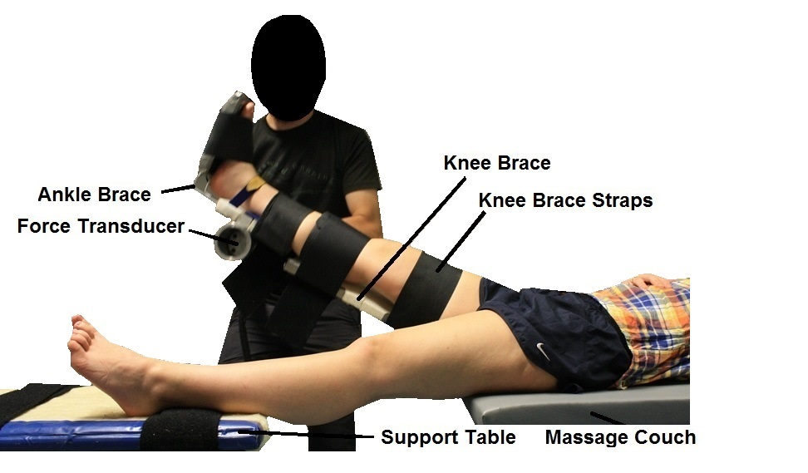

Figure 1. Subject test set-up for passive hip moment assessment, showing placement of force transducer, ankle brace and one of the 4 knee braces used to maintain the knee at a predetermined angle (180 degrees in the example above).

Total hip moments were calculated during level walking with the use of a 9 camera, 3-D motion-capture system (T-series, Vicon, Oxford, UK) and 2 force plates (9281CA, Kistler, Winterthur, Switzerland). 35 retro-reflective markers were placed on each subject in accordance with the placements used by previous researchers [20-22]. Motion capture data was sampled at 100-Hz and force plate data at 1000-Hz. Data was initially assessed via the Nexus software programme (Vicon Nexus version 1.8, Vicon, Oxford, UK), before being transferred to Microsoft Excel (2010, Microsoft, Redmond, US) and Matlab for further processing.

Subjects were required to walk along a 10-metre walkway in view of the motion capture cameras and over the force plates at their normal walking speed. The tester observed foot contact onto the force plates and ensured a minimum of 5 walks contained both left and right clear foot strikes. Walking was at each subject’s normal pace without reasonable likelihood of fatigue during testing.

## 2.3 Data Processing

A data processing pipeline was created in Vicon Nexus to perform standard data modelling of the walking trials. The pipeline included Woltring filtering and gap filling. Following determination of marker trajectories data was smoothed using a low-pass Butterworth filter at 6 Hz. Total moment-angle data for the hip was established for each complete gait cycle, and data was used from the first 5 complete tests on each leg. The coefficient of multiple correlation (CMC) of the moment-angle curves were calculated. The coefficient of variation (CV) was also calculated to assess intra-subject gait cycle variability.

Passive hip extensor moments were calculated based upon the dynamic biomechanical model developed by Lee and Munn [19]:

$$M=F_{x}y_{f}+F_{y}x_{f}+m_{leg}{\ddot{x}}_{cg}y_{cg}-{(m}_{leg}g+m_{leg}{\ddot{y}}_{cg})x_{cg}-m_{leg}k^{2}\ddot{θ}$$

where *Fx*, *Fy*, are the forces applied to the leg to flex the hip joint, *Xf*, *Yf*, are the locations of force application to the leg, *mleg* is the mass of the leg, *g*, is acceleration due to gravity, *xcg*,, *ycg*, refer to the location of the centre of mass of the leg and *k* is the radius of gyration. ${\ddot{x}}_{cg}, {\ddot{y}}_{cg}$ refer to the acceleration of the leg centre of mass, and $\ddot{θ}$ is the angular acceleration of the leg. Dempster [23] body segment parameter ratios were used for both the total and passive moment calculations.

The mean curve from 3 leg raises, smoothed using cubic spline interpolation and fitted with an exponential function, was used for further analysis.

To establish a predictive equation for passive hip extensor moments based upon a combination of hip and knee angles, 3-D surface plots were generated for assessing the changes in hip moments with hip angle, and at different knee angles. In agreement with other researchers [19], passive hip moments were found to increase exponentially as a function of hip angle. By introducing a variable knee angle component, it was found that this contributed a linear component to the equation. A surface fitting programme was written for Matlab, and visual and residual analyses used to determine the most appropriate equation coefficients for the individual datasets. From the present investigation, the following equation was developed to predict passive hip moments (*Mpassive*) during flexion:



where *θknee* is the angle at the knee, *θhip* the angle at the hip, and *a*, *b*, *c*, and *d* are the equation coefficients.

Passive hip moments and 95% confidence intervals were recalculated from hip neutral to maximum hip flexion angle, using the derived predictive equation. Root mean squared error (RMSE) and adjusted r-squared were calculated to assess goodness of fit of each surface-plot.

Hip moments were calculated using the conventional gait model, based upon the Newington-Helen Hayes model. Total hip power was calculated from hip angular velocity and total hip moments. All data was subsequently normalised to body mass and height. Total hip moments were calculated at the peak hip flexor moment (FL), and the two hip extensor peaks (Ext1, Ext2). Total hip power was calculated at the two peaks of power generation (H1, H3) and peak of power absorption (H2). Mechanical work done at H1 and H3 was calculated by integrating the complete positive portions of the corresponding power generation curves. Work done was also calculated for the full negative power absorption curve (H2). Passive hip extensor moments and total hip moments, power and work done were additionally calculated for the portion of the gait cycle corresponding to hip flexion, between hip neutral and maximum hip flexion angle. Scores for the RMDQ were calculated as the sum of ticked statements. Physical activity data was used to ensure matching of subjects in LBP and NBP groups.

## 2.4 Statistical Analysis

A mixed-model analysis of variance (ANOVA) was used to compare within gait cycle peaks and degrees of hip flexion between LBP and NBP group data using SPSS (version 24, IBM Statistics, U.S.). *Post hoc* analyses for between groups comparisons were performed using independent samples t-tests where significant interactions were determined. Passive hip extensor moments and total hip moments, power and work done were compared at 25% increments of hip flexion, between neutral and maximum hip flexion. Total hip moments were additionally compared at FL, Ext1 and Ext2, and total power and work done were compared at H1, H2 and H3. Additional comparisons included age, gender, body mass, physical activity type and duration, walking speed and step length, maximum hip flexion angle, hip extension angle and knee angle, assessed using independent t-tests. CMCs and CVs were used to assess intra-subject gait cycle characteristics. RMSE and the adjusted r-squared were used to assess goodness of fit of the predictive equation coefficients for calculating passive moment contributions. Normality of data was assessed using Shapiro-Wilk tests, and the alpha level for all tests was set at 0.05.

3 Results

Subjects in the LBP group reported occurrence of back pain for 6.97 (SD 5.98) years with a range of 6 weeks to 30 years. RMDQ scores were 3.92 (SD 3.1) and VAS scores were 5.06 (SD 2.27). Independent samples t-tests demonstrated no significant differences between LBP and NBP groups for age, gender, body mass (within gender), walking speed or step length (*P* > 0.05). There were no significant differences (*P* > 0.05) in any of the physical activity parameters calculated, which included walking (13.6 (SD 18.3) hours per week LBP, 9.9 (SD 12.9) hours NBP), moderate intensity exercise (6.9 (SD 11.0) hours per week LBP, 4.1 (SD 5.6) hours NBP) and vigorous exercise (6.7 (SD 8.7) hours per week LBP, 5.1 (SD 3.4) hours NBP).

The CMC means were 0.955 (SD 0.037) for LBP and 0.937 (SD 0.051) for NBP, respectively. The CV means were 21.4% (SD 11.6) and 26.3% (SD 13.9), for LBP and NBP, respectively. The RMSE was 0.016 (SD 0.008) Nm/(kg*m) for LBP and 0.017 (SD 0.07) Nm/(kg*m) for NBP. The adjusted r-squared values were 0.889 (SD 0.081) for LBP and 0.896 (SD 0.075) for NBP. There were no significant differences in hip or knee angles between groups (*P* > 0.05).

There were no statistically significant interaction effects in the total hip flexor (FL) or extensor moment peaks (Ext1, Ext2) (*F(1.571,155)* = 3.019,*P* = 0.065, table 1) or their timings (*F*(1.599,158) = 0.368, *P* = 0.645) (figure 2). There was no main effect of group *F*(1,99)=0.208, *P* = 0.649). During the hip flexion component of the gait cycle, there was no statistically significant interaction effect in total hip moments (*F(2.064,204)* = 0.823, *P* = 0.444) (table 2). There was no main effect of group (*F*(1,99) = 0.012, *P* = 0.913).

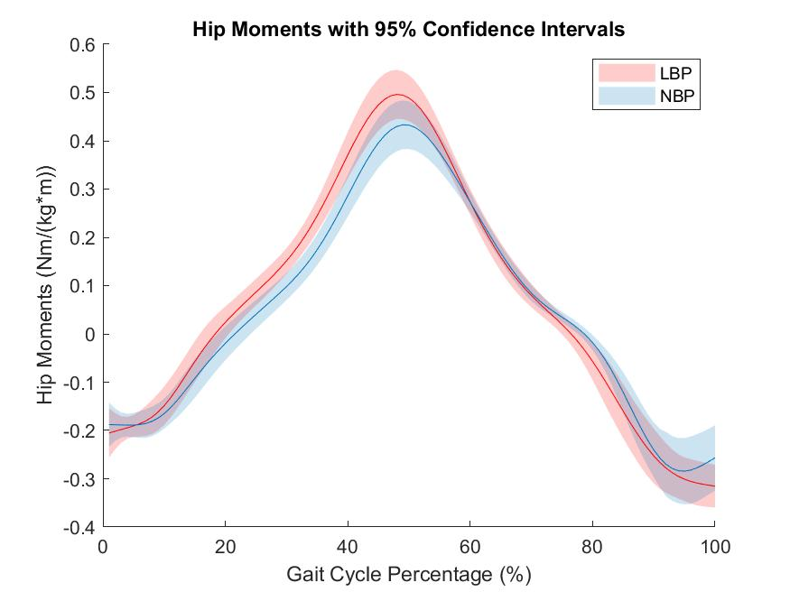

#### Figure 2. Mean total hip moments with 95% confidence intervals in LBP and NBP groups during gait cycle.

For passive hip moments there was a significant interaction effect of group and percentage of hip flexion (*F(1.751,173)* = 9.316, *P* = 0.000) and a statistically significant main effect of group (*F*(1,99) = 6.597, *P* = 0.012). Passive hip moments decreased throughout hip flexion, demonstrating increased extensor moments (figure 3), with no significant differences between groups at hip neutral or 25% (*P* > 0.05). From 50-100% of hip flexion, passive moments were significantly more negative in LBP subjects (*P* < 0.05), demonstrating greater extensor moments. At maximum hip flexion, passive hip extensor moments were 46.6% and 39.4% of total hip moments, for LBP and NBP, respectively. Passive hip extensor and total hip moment mean, standard deviation and results of the independent t-tests are shown in table 2.

##### Table 1. Variable data for complete gait cycle. NS (not significant) indicates ANOVA *P* > 0.05 with *post hoc* tests not indicated. Statistically significant results are denoted with an asterisk(*).



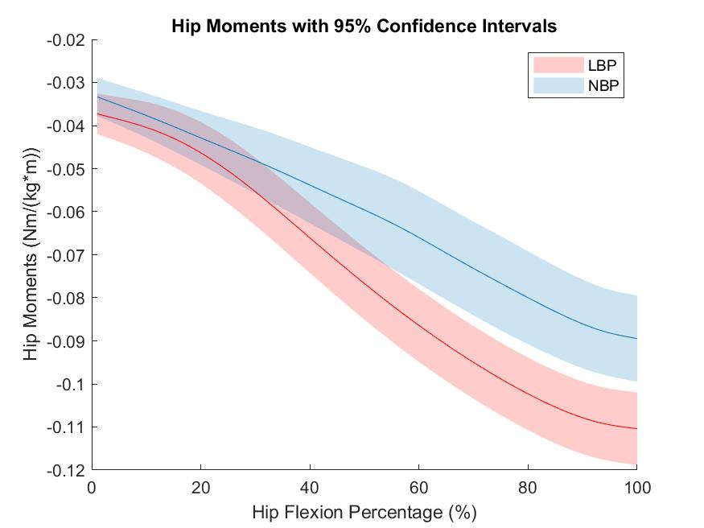

#### Figure 3. Mean passive hip extensor moments with 95% confidence intervals in LBP and NBP groups during hip flexion from neutral to maximum hip flexion

##### Table 2. Passive hip extensor and total hip moments (Nm/(kg*m)) during hip flexion, from neutral to full hip flexion. NS (not significant) indicates ANOVA *P* > 0.05 with *post hoc* tests not indicated. *P*-values included represent results of *post hoc* independent t-tests. Statistically significant results are denoted with an asterisk(*).



There was a statistically significant interaction of group and peak of hip power (*F(1.353,134)* = 4.366, *P* = 0.027) but no main effect of group (*F*(1,99) = 0.06, *P* = 0.807). There were no significant interactions of angle at peak (*F(1.526,151)*= 0.863, *P* = 0.398). The first peak of power generation (H1) occurred at 8.2 (SD 4.5) %, and 10.0 (SD 4.4) % of gait cycle, for LBP and NBP, respectively, with no significant differences in timing or power (*P* > 0.05. table 1, figure 4). The hips then absorbed power, with a peak of power absorption (H2) during mid-stance. The peak of power absorption at H2 was significantly greater in LBP than NBP (-0.520 (SD 0.231) W/(kg*m), -0.429 (SD 0.212) W/(kg*m), for LBP and NBP, respectively, *P* = 0.041), with no difference in timings between groups (*P* > 0.05). Power generation peaked at toe-off and the initiation of swing phase, at approximately 60% GC (H3). H3 was significantly greater in LBP than NBP (0.844 (SD 0.298) W/(kg*m), 0.736 (SD 0.235) W/(kg*m) for LBP and NBP, respectively, *P* = 0.045), with no difference in timings between groups (*F*(1.526,151), = 0.863, *P* = 0.398).

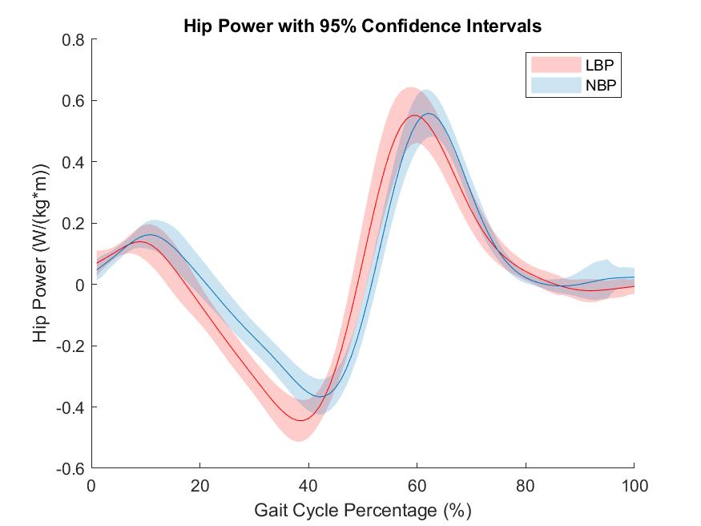

#### Figure 4. Mean total hip power with 95% confidence intervals in LBP and NBP groups during gait cycle.

For power during the hip flexion component of gait (figure 5), ANOVA results demonstrated a significant interaction of group and time (*F(2.264,224)* = 3.228, *P* = 0.036) but no main effect of group (*F*(1,99) = 2.538, *P* = 0.114). *Post hoc* analyses determined that total hip power was significantly greater (*P* = 0.012) in LBP subjects when the hip was in neutral (LBP = 0.717 (0.300) W/(kg*m), NBP = 0.583 (0.22) W/(kg*m). There were no statistically significant differences between groups at any other percentage of hip flexion assessed (*P* > 0.05). Mean, standard deviation and results of the independent t-tests for hip flexion are shown in table 3.

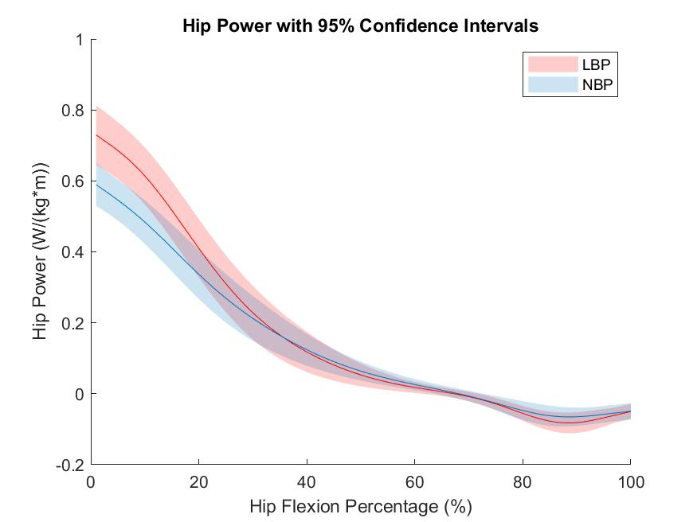

#### Figure 5. Mean hip power with 95% confidence intervals in LBP and NBP groups during hip flexion from neutral to maximum hip angle.

##### 

##### Table 3. Total hip power (W/(kg*m)) during hip flexion, from neutral to full hip flexion. Statistically significant results are denoted with an asterisk(*).



There was a significant interaction of group and peak for work done during gait (*F(1.263,125)* = 6.114, *P* = 0.010), but no main effect of group (*F*(1,99) = 2.538, *P* = 0.114). Negative mechanical work done during the H2 power absorption curve was greater in LBP than NBP (-0.111 (SD 0.059) J/(kg*m), -0.087 (SD 0.054) J/(kg*m), for LBP and NBP, respectively, *P* = 0.034). Positive mechanical work was greater in LBP than NBP during the H3 power generation curve (0.115 (SD 0.033) J/(kg*m), 0.101 (SD 0.026) J/(kg*m), for LBP and NBP, respectively, *P* = 0.017). During H1 and the hip flexion component of the gait cycle there were no statistically significant differences in work done between groups (*P* > 0.05). Total work done mean, standard deviation and results of the independent t-tests for hip flexion are shown in table 4.

##### Table 4. Total hip mechanical work done (J/(kg*m)) during hip flexion, from neutral to full hip flexion in 25% intervals and for overall hip flexion



4 Discussion

The present study found no statistically significant differences in hip and knee angles between groups. Values of passive hip extensor moments, and total hip moments, power and work done for NBP subjects were similar to those reported elsewhere [24]. Other investigators have reported alterations in hip and knee angles during walking in LBP subjects compared with healthy controls [25-27]. The most likely cause of increased passive moments in LBP is an increased passive resistance of the hip extensor and knee flexor muscles, such as the bi-articular hamstrings muscles. However, a previous study using the same subjects demonstrated no significant differences in passive moments between groups. Because passive hip moments increase with hip angle in an exponential manner, it is likely that small increases in hip angle have a considerable influence on passive moments during walking, as observed in the present study. It is also plausible that individual alterations and interactions of joint angles and passive moments may be masked by averaging individual and group leg data. Alternatively, the difference in passive moments equates to a maximum of 3 Nm in absolute rather than normalised figures, which may be statistically significant but of little, if any, clinical relevance. Altered passive moments occurred without differences in total moments.

Power absorption and work done at H2 were significantly greater in LBP than NBP. The H2 power curve occurs during the stance phase of gait, as the hip flexors eccentrically contract to stabilise the pelvis and support the trunk, preventing backwards movement of the trunk relative to the pelvis. Power generation and work done at H3 were also greater in LBP than NBP, and occurs during the late stance (pre-swing) phase of gait, as the hip flexors contract concentrically to pull the leg forward and facilitate toe-off. This coincided with greater power generation and work in LBP than NBP as the hip moved through neutral.

The results of the present study demonstrate increased passive extensor moments in LBP, with no differences in total moments. Whether the passive moments contribute to total moments, thereby reducing the need for active contraction and promoting efficiency, or if values of total moments should be altered due to the influence of greater passive moments, is not currently understood [24].Alternatively, altered joint angles, and therefore passive moments, later in the swing phase may follow the increased total power generation from the hip flexors during early swing, directly following toe-off. In this case, increased passive moments may be due to increased joint angles, resulting from greater momentum of the hip where active power generation is greater in LBP with no differences in passive moments following toe-off. Greater momentum of the swinging limb could cause greater hip flexion angles, contributing to greater passive resistance, and therefore higher passive moments. The lack of difference in total moments may reflect reduced active components late in swing, or be due to total moments being miscalculated due to lack of account of passive influences in inverse dynamic modelling. Despite our lack of understanding regarding the mechanisms and interactions of the passive and active components, it is clear the passive component is considerable, and should not be overlooked in future models of dynamic movements.

LBP subjects in the present study reported RDMQ scores that were low (3.92 (SD 3.1)) compared with other studies, VAS scores were considered moderate (5.06 (SD 2.27)), and similar to those reported elsewhere [28-35]. Although self-reported pain is a subjective measure, subjects in the studies where VAS and RMDQ scores were higher were recruited from physical therapy and rehabilitation clinics [28, 29, 31]. Overall, the findings in the present study remain appropriate to the population assessed. Whilst LBP severity and disability may be lower than in subjects attending rehabilitation clinics, there were clear adaptations in gait to modify passive and active joint biomechanics compared with healthy controls.

The present study indicates that passive moments may be influenced without affecting total joint moments. Specifically, it is plausible that LBP may affect the structural components of muscle tissue, or alternatively results in subtle interactions of joint angle and moments during movement, sufficient to influence passive components without affecting total moment. There may be further interactions between LBP, passive moments, total power and total work done, which affect accelerations and energy efficiency for movement. From a clinical perspective, an assessment of passive biomechanics will be useful to help understand which tissue types are influenced by LBP, on a case-by-case basis. Findings suggestive of structural adaptations will necessitate a muscle-targeted therapy, such as stretching or strengthening exercise. Conversely, if joint kinematics are altered, this indicates the active component of the muscular system may have been affected, necessitating a therapy that targets neuromuscular improvements, such as muscle activation timing and magnitude, and the specific fibres recruited during movement.

A limitation of the current study was the measurement of hip passive moments during hip flexion only. In previous studies [24, 36, 37], researchers averaged hip moments during flexion and extension, and reported only a small underestimation of moments during flexion, and overestimation during extension. However, in the present study it was considered more appropriate to determine accurate values of passive hip extensor moments, for integration into the hip flexion model during walking, rather than over- or underestimating moments. Future studies would benefit from direct measurement of both passive hip extensor and hip flexor moments to model the complete gait cycle accurately in the sagittal plane.

Hip extensor moments were 46.6% and 39.4% of total hip moments for LBP and NBP, respectively, at maximum hip flexion angle. This finding demonstrates that passive structures may interact with active components, have a considerable influence on total hip moments during walking [24], and should be integrated into future biomechanical models. Whether it is appropriate to add passive moments to total moments, or to subtract them, or if there is a more complex interaction between passive and active components to total moments is not currently understood [24] and therefore warrants further investigation.

5 Conclusions

The present data demonstrates that subjects with LBP have altered passive hip extensor moments and total power and work done during walking, compared with healthy controls. Although it is not possible to extrapolate cause and effect relationships, rehabilitation programmes for LBP patients should differentiate between the active, neuromuscular components of movement, and the passive components. Biomechanical models should include individual measurements of passive joint moments. The approach used in the present study may be a useful measurement model for clinicians assessing low back pain.

Acknowledgements

This work was supported by the British Naturopathy and Osteopathy Association, London, UK.

References

1. Buchbinder, R., et al., *Placing the global burden of low back pain in context.* Best Pract Res Clin Rheumatol, 2013. **27**(5): p. 575-89.

2. Ekedahl, K.H., B. Jonsson, and R.B. Frobell, *Validity of the fingertip-to-floor test and straight leg raising test in patients with acute and subacute low back pain: a comparison by sex and radicular pain.* Arch Phys Med Rehabil, 2010. **91**(8): p. 1243-7.

3. Davis, D.S., et al., *Concurrent validity of four clinical tests used to measure hamstring flexibility.* J Strength Cond Res, 2008. **22**(2): p. 583-8.

4. Ylinen, J.J., H.J. Kautiainen, and A.H. Hakkinen, *Comparison of active, manual, and instrumental straight leg raise in measuring hamstring extensibility.* J Strength Cond Res, 2010. **24**(4): p. 972-7.

5. Rebain, R., G.D. Baxter, and S. McDonough, *A systematic review of the passive straight leg raising test as a diagnostic aid for low back pain (1989 to 2000).* Spine (Phila Pa 1976), 2002. **27**(17): p. E388-95.

6. Marshall, P.W., J. Mannion, and B.A. Murphy, *Extensibility of the hamstrings is best explained by mechanical components of muscle contraction, not behavioral measures in individuals with chronic low back pain.* PM R, 2009. **1**(8): p. 709-18.

7. Halbertsma, J.P., et al., *Extensibility and stiffness of the hamstrings in patients with nonspecific low back pain.* Arch Phys Med Rehabil, 2001. **82**(2): p. 232-8.

8. McNair, P.J. and S.N. Stanley, *Effect of passive stretching and jogging on the series elastic muscle stiffness and range of motion of the ankle joint.* Br J Sports Med, 1996. **30**(4): p. 313-7, discussion 318.

9. Blackburn, J.T., et al., *The relationships between active extensibility, and passive and active stiffness of the knee flexors.* J Electromyogr Kinesiol, 2004. **14**(6): p. 683-91.

10. Blackburn, J.T., et al., *Sex comparison of extensibility, passive, and active stiffness of the knee flexors.* Clin Biomech, 2004. **19**(1): p. 36-43.

11. Rassier, D.E., *The mechanisms of the residual force enhancement after stretch of skeletal muscle: non-uniformity in half-sarcomeres and stiffness of titin.* Proc Biol Sci, 2012. **279**(1739): p. 2705-13.

12. Tafazzoli, F. and M. Lamontagne, *Mechanical behaviour of hamstring muscles in low-back pain patients and control subjects.* Clin Biomech, 1996. **11**(1): p. 16-24.

13. Hamill, J., M. Moses, and J. Seay, *Lower extremity joint stiffness in runners with low back pain.* Res Sports Med, 2009. **17**(4): p. 260-73.

14. Gombatto, S.P., et al., *Differences in symmetry of lumbar region passive tissue characteristics between people with and people without low back pain.* Clin Biomech, 2008. **23**(8): p. 986-95.

15. Elbaz, A., et al., *A novel biomechanical device improves gait pattern in patient with chronic nonspecific low back pain.* Spine (Phila Pa 1976), 2009. **34**(15): p. E507-12.

16. Henchoz, Y., et al., *Energetics and mechanics of walking in patients with chronic low back pain and healthy matched controls.* Eur J Appl Physiol, 2015. **115**(11): p. 2433-43.

17. Barzilay, Y., et al., *Patients with chronic non-specific low back pain who reported reduction in pain and improvement in function also demonstrated an improvement in gait pattern.* Eur Spine J, 2015.

18. Ertelt, T., *Walking with chronic non-specific low back pain--a failed strategy: what can we learn from sports?* Med Hypotheses, 2014. **82**(5): p. 601-5.

19. Lee, R.Y. and J. Munn, *Passive moment about the hip in straight leg raising.* Clin Biomech, 2000. **15**(5): p. 330-4.

20. Kadaba, M.P., et al., *Repeatability of kinematic, kinetic, and electromyographic data in normal adult gait.* J Orthop Res, 1989. **7**(6): p. 849-60.

21. Tsushima, H., M.E. Morris, and J. McGinley, *Test-retest reliability and inter-tester reliability of kinematic data from a three-dimensional gait analysis system.* J Jpn Phys Ther Assoc, 2003. **6**(1): p. 9-17.

22. Gorton, G.E., 3rd, D.A. Hebert, and M.E. Gannotti, *Assessment of the kinematic variability among 12 motion analysis laboratories.* Gait Posture, 2009. **29**(3): p. 398-402.

23. Dempster, W.T., *Space Requirements of the Seated Operator: Geometrical, Kinematic, and Mechanical Aspect of the Body with Special Reference to the Limbs.* WADC Technical Report, 1955: p. 55-159.

24. Whittington, B., et al., *The contribution of passive-elastic mechanisms to lower extremity joint kinetics during human walking.* Gait Posture, 2008. **27**(4): p. 628-34.

25. McGregor, A.H. and D.W. Hukins, *Lower limb involvement in spinal function and low back pain.* J Back Musculoskelet Rehabil, 2009. **22**(4): p. 219-22.

26. Cimolin, V., et al., *Effects of obesity and chronic low back pain on gait.* J Neuroeng Rehabil, 2011. **8**: p. 55.

27. Vogt, L., K. Pfeifer, and W. Banzer, *Neuromuscular control of walking with chronic low-back pain.* Man Ther, 2003. **8**(1): p. 21-8.

28. Wong, T.K. and R.Y. Lee, *Effects of low back pain on the relationship between the movements of the lumbar spine and hip.* Hum Mov Sci, 2004. **23**(1): p. 21-34.

29. Shum, G.L., J. Crosbie, and R.Y. Lee, *Movement coordination of the lumbar spine and hip during a picking up activity in low back pain subjects.* Eur Spine J, 2007. **16**(6): p. 749-58.

30. Shum, G.L., J. Crosbie, and R.Y. Lee, *Energy transfer across the lumbosacral and lower-extremity joints in patients with low back pain during sit-to-stand.* Arch Phys Med Rehabil, 2009. **90**(1): p. 127-35.

31. Shum, G.L., J. Crosbie, and R.Y. Lee, *Three-dimensional kinetics of the lumbar spine and hips in low back pain patients during sit-to-stand and stand-to-sit.* Spine (Phila Pa 1976), 2007. **32**(7): p. E211-9.

32. Lamoth, C.J., et al., *How do persons with chronic low back pain speed up and slow down? Trunk-pelvis coordination and lumbar erector spinae activity during gait.* Gait Posture, 2006. **23**(2): p. 230-9.

33. Muller, R., T. Ertelt, and R. Blickhan, *Low back pain affects trunk as well as lower limb movements during walking and running.* J Biomech, 2015. **48**(6): p. 1009-14.

34. Seay, J.F., R.E. Van Emmerik, and J. Hamill, *Low back pain status affects pelvis-trunk coordination and variability during walking and running.* Clin Biomech, 2011. **26**(6): p. 572-8.

35. Song, A.Y., et al., *Three-dimensional kinematic analysis of pelvic and lower extremity differences during trunk rotation in subjects with and without chronic low back pain.* Physiotherapy, 2012. **98**(2): p. 160-6.

36. Silder, A., B. Heiderscheit, and D.G. Thelen, *Active and passive contributions to joint kinetics during walking in older adults.* J Biomech, 2008. **41**(7): p. 1520-7.

37. Silder, A., et al., *Identification of passive elastic joint moment-angle relationships in the lower extremity.* J Biomech, 2007. **40**(12): p. 2628-35.