Modelling of Heat Energy Recovery Potential form Underground Railways with Nearby Vertical Ground Heat Exchangers in an Urban Environment

ABSTRACT
Ground source heat pumps (GSHPs) in urban environments can take advantage of surplus ground heat energy generated by subterranean infrastructures such as underground railways (URs). This paper describes seminal work in this area and a novel 3D numerical investigation into the heat energy recovery from URs with nearby vertical ground heat exchangers (GHEs). The investigation uses the London Underground (LU) as a case study but its results are generic worldwide. The investigation included a number of studies considering different geometrical configurations of the railway tunnels and the nearby GHE array, and the impact of that variation on the GHEs heat extraction rates. The results showed that heat extraction rates of GSHPs installed near UR tunnels can be significantly improved by up to ~ 43%. This will enhance overall GSHP system efficiencies, resulting in substantial savings in both operational costs and carbon emissions. In addition, the outcomes were used to develop a relationship which allows approximating the GHEs heat extraction improvements due to the nearby tunnel(s) heat load(s). This could give guidance to engineers working in fields where thermal interactions between URs and nearby GHEs arise.
Keywords
Modelling, Underground Railways, Ground Source Heat Pumps, Vertical Ground Heat Exchangers, Secondary Heat, London Underground, London, UK
- Introduction
In March 2007, the European Council made a commitment to reduce greenhouse gas emissions by 20% by 2020 (European Commission, 2009). The UK Government went further and established a target to reduce the nation’s CO₂ emissions overall by 80% by 2050 in comparison to the 1990 reference point (The Stationery Office, 2008). Later it was shown that more than 40% of fossil fuels are burnt for low temperature heating of buildings (Nera Economic Consulting, 2009). Therefore, to achieve the 2050 targets, the decarbonisation of the heat sector through the implementation of low carbon heating solutions is essential. Reductions in heating related carbon emissions become a focus of many cities across Europe. For example The Mayor of London supports the greater use of renewable and low carbon generation technologies. The Mayor has also set a target for London to generate 25% of its heat and power requirements through the use of local, decentralised energy systems or also called district heating networks (DHNs) by 2025 (GOV.UK, 2015). Renewable decentralised energy opportunities including the use of energy from secondary sources such as sewers, electricity cable tunnels or underground railways (URs). These urban infrastructure systems, are potent and untapped energy sources, are often in close proximity to areas of high heat demand and could potentially provide a year-round heat supply. In the UK, It was shown that the total heat which could be delivered from secondary sources in London is of the order of 71 TWh/year, which is more than the city’s total estimated heat demand of 66 TWh/yr in 2010 (The GLA and Buro Happold, 2013). Some of these secondary heat sources have the limitation that their location is too far from where the heat is needed or that they are only available at a particular period of the year. However, UR tunnels are often in close proximity to areas of high heat demand and could potentially provide a year-round heat supply (Revesz et al., 2016).
Heat recovery from URs can be achieved using different techniques. For example, embedded tunnel liner heat exchangers could be viable solutions for newly constructed tunnels, which are routinely built as part of city and infrastructure planning. Early examples of this form of heat recovery from URs are reported in Austria, where geothermal energy systems have been installed in tunnels lined with sprayed concrete (Adam and Markiewicz, 2009). An example of an activated floor slab solution is the Messe-Prater metro station of the U2 metro line in Vienna. In Germany, segmental tunnel linings equipped with heat exchangers have been installed to supply a municipal building with heating energy. The CO₂ emission savings compared with gas-fired boilers were estimated at between 25-35% (Franzius and Pralle, 2011). The work of Winterling et al. (2014) provided an overview of a tunnel energy segment system for London’s Crossrail. The proposed heat recovery system included embedded closed-loop water-filled pipework in tunnel segments, to extract heat. It was shown that this could provide both cooling to the tunnels and heating for adjacent buildings.
Heat utilisation through the ventilation system of an UR, has also been a focus of a number of studies. This method uses a heat exchanger built in the railway network’s ventilation shaft which may capture the heat from the air and a water circuit then transfers it to a heat pump. The heat pump may be connected to a third party’s building or small-scale district heating system. The work of Thompson and Maidment (2010) showed that air source heat recovery through the ventilation system of an UR was viable. This was further supported by Gilbey et al. (2011) and by Ninikas et al. (2016). A more recent study by Davies et al. (2017) called Metropolitan Integrated Cooling and Heating (MICAH) proposed a concept for integrating LU cooling systems with a District Heating Network (DHN) in London. The proposed scheme involves the use of a fan coil heat exchanger located close to the head of the railway’s ventilation shaft. The fan is reversible, enabling its use in either: (i) supply mode, whereby ambient air is drawn through the heat exchanger and cooled, with the chilled air generated being supplied to the underground tunnels via the ventilation shaft, (ii) extract mode, whereby heated air exhausted from the tunnels is directed across the heat exchanger. In both cases the heat extracted from the air is transferred to cold water, flowing through the heat exchanger, raising its temperature. This approach is currently being implemented in London Borough of Islington where waste heat from the LU tunnels will help warm hundreds of local homes with cheaper, greener heating (Euroheat & Power, 2017). A similar scheme is currently being implemented within the Bucharest metro, Romania, as part of the H2020 project, ReUseHeat (2017).The project aims to develop an innovative heating network that can recover the waste heat from the ventilation system of the metro network. The heat will be used in either the Bucharest district heating network or a separate heat supply network.
The soil surrounding UR tunnels also contains large amount of heat energy which could potentially be extracted through ground source heat pumps (GSHP). However, the potential for this type of heat recovery has not yet been established, and is the subject of this paper.

- Investigation of heat energy recovery potential from URs with nearby GHEs
2.1 Preliminary investigations
Revesz et al. (2016) have reviewed and identified potential modelling technics which could be implemented for the analysis of the thermal interactions between URs and nearby vertical ground heat exchangers (GHEs). The authors have also introduced a preliminary 2D investigation which had the key objective to establish key phenomena for more comprehensive research (Revesz et al., 2015). The main outcome of that initial investigation was that the interaction between URs and nearby vertical GHEs is a genuine phenomenon. It was therefore worth further research to promote energy efficiency in GSHP installations. Since the operation of the URs and GSHP involves complex, transient, three-dimensional (3D) transport phenomena and extreme geometrical aspect ratios, 3D numerical models of URs and GHEs were independently developed and validated by Revesz et al. (2017). Each of these numerical models were built with the software package COMSOL Multiphysics (COMSOL Muliphysics, 2017). Validations of the numerical models were achieved by comparing simulation results against measured temperature data at the LU network as well as against analytical solutions such as the Finite Line Source (FLS) method. The individual UR and GHE models were then built into the same modelling environment for their combined analysis.
2.2 Geometrical features of the 3D UR-GHE numerical model
For the investigation detailed in this paper, the combined UR-GHE numerical model was used to present 5 of the many different studies. The 3D reference model included a single UR tunnel and 40 vertical single looped GHEs with a depth of 100 m (~8000 m of overall GHE pipe length). This is a medium sized GSHP installation that would usually be found in urban areas. The different ground conditions that typically exist down to 115 m below the surface within the central London area were taken into account in the building of the model. The soil layers are illustrated in Figure 1 and their thermo-physical properties are summarized in the work of Revesz et al. (2015). It is important to note that in most locations in London, UR tunnels run through London clay, a soil of very low permeability. For this reason, the combined model assumes negligible groundwater movement. The width of the soil domain is a function of the number of GHEs in the “x” direction of the model geometry and the depth of the soil is a function of the number of GHEs in the “y” direction with spacing between the individual GHEs set at 6 m in both directions. The overall height of the soil domain is 15 m deeper than the GHEs, i.e. 115 m. The UR tunnel diameter is 4.4 m with a concrete tunnel liner thickness of 0.5 m. The depth of the centre of the UR tunnel is 24 m below the ground surface. The proximity, which is the separation distance between the tunnel wall and the closest line of the GHE array to the tunnel, was set as 3 m. This figure was chosen as it is the minimum distance that LU allows for any structures to be constructed near the tunnels (TfL, 2013). The 3D model geometry and boundary conditions were built in a way that allows to easily modifying the tunnel configurations (i.e. single or multiple tunnels or the number of heat exchangers within the GHE array or the aspect ratio of that array). Modifying the depth and looping configuration (i.e. single or double looped) of the array is also allowed within the model geometry.
The finite element mesh of the soil domain was built using tetrahedral elements. The first two soil layers, Made Ground and Thames Gravels, were more refined than the London Clay. This was because the vertical temperature gradient caused by climatic effects was considered to have a more significant effect within those layers. Free triangular mesh elements were built on the centre of the tunnel inlet surface. These triangular elements were extended with a boundary layer mesh which was built with layered prism elements. Both the triangular and prism elements then were swept along the tunnel from its inlet to its outlet. It can be seen on the right side of Figure 1, that the mesh was more refined in and around the circumference of the GHEs, at the air/concrete interface of the UR tunnel, and within the first two layers of the soil domain. The mesh independency of the model generated results was achieved through an analysis which included comparing temperature values at a specific point using five different mesh density configurations. Two out of five converged towards nearly the same value at the point of interest and the one with the lower number of elements (663,580) was selected in order to achieve a faster simulation time.

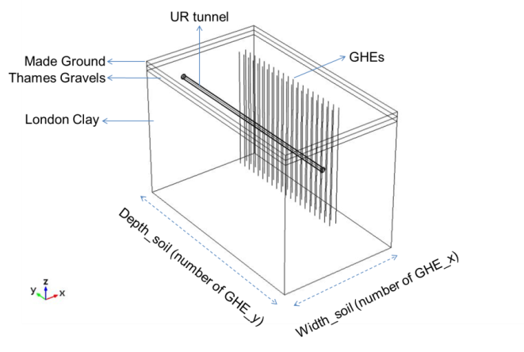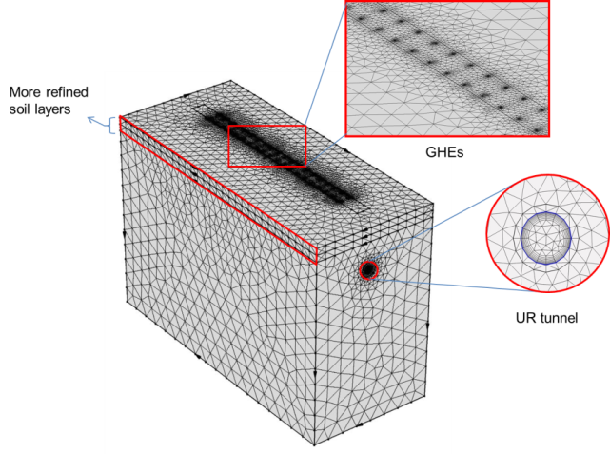
Figure 1: 3D UR-GHE model geometry (left) and mesh (right)

2.3 Modelling objective
The investigation detailed in this paper includes five different studies. The key modelling objective for each study was to investigate the potential improvements on the GHEs heat extraction rates due to the proximity of the UR tunnel(s). When such thermal interactions of URs with GHEs are investigated, it is important to consider the initial effect of the UR operation on its surroundings. Starting a simulation of an UR-GSHP model from a uniform soil temperature profile would not be realistic for a London based case study. This is because the operation of the URs over an extended period would have impacted on the surrounding soil temperature prior to the installation of the GSHP. For this reason the numerical UR-GHE analysis first considered an initial 50 year long simulation period with the operation of the UR only. After that many years of operation the warming effect of the UR on the surrounding soil is almost negligible. This was shown by a preliminary investigation presented by Revesz et al. (2017). The results of that initial study were then used as starting conditions, for a second transient study, which was performed with both the UR and GHE operation over a 2 year long simulation period with a maximum time step of 1 day. Figure 2 illustrates an example where the average fluid temperature at the GHE pipe outlet is shown over a 10 year simulation period whilst circulating fluid at a constant temperature, 5˚C, at the pipe inlet. It can be seen in the figure that this period does not achieve full convergence of the results. However, over 90% of the change does occur in the first 2 years making this a suitable point to consider the impact of any of these changes. Therefore, the results should not be considered as a final steady state response.

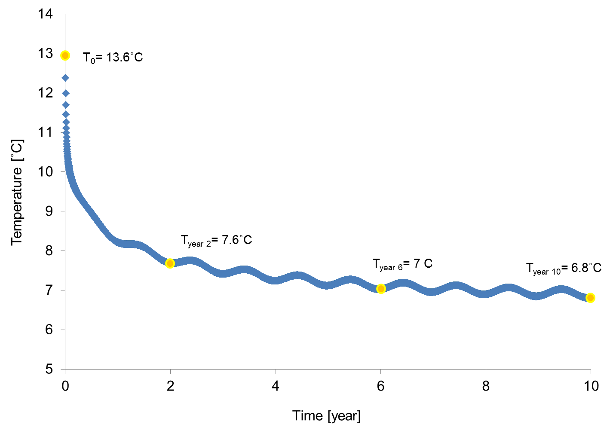
Figure 2: Average GHE fluid temperature at the pipe outlet over 10 year period

The 3D UR-GHE numerical model was then used to investigate the impact of the UR tunnel heat load on the nearby GHEs, based on a number of different geometrical scenarios. The set-ups and results of these 5 different studies are detailed in section 3. During each study the following outputs were monitored and then later analysed:
The GHEs’ average fluid temperature at the pipe outlets [˚C]
The GHEs’ average heat extraction rate [kW]

2.4 Model Characteristics
A simplified temperature boundary condition was applied for the soil surface $T_{S_surf},$which follows Equation 1. The formula represents a periodic annual cycle which starts in the month of May. A similar method was used by Busby et al. (2009) as well as by Lazzari et al. (2010). The initial temperature of the soil domain $T_{S_init}$ was set according to Equation 2 where the average UK geothermal gradient is 0.026°C m⁻¹. The lateral boundary of the domain was assumed to be adiabatic therefore a Neumann boundary condition was applied that can be expressed as Equation 3.

 | $$T_{S_surf}=A_{air}*sin\left(\frac{2πt}{τ}\right)+T_{av_air}$$ | (1)

 | $$T_{S_init}=T_{av_air}-0.026*z$$ | (2)

 | $q"=(-k∇T)=0$ | (3)

Where:
$$A_{air}=amplitude of the outside air temperture variation$$
$$T_{av_air}=average outside air temperature$$
$$τ=1 year=31,536,000 s$$
$$z=depth [m]$$
The fluid flow and heat transfer problems in the GHE pipes were physically modeled using linear pipe elements, reducing the 3D flow problem to 1D. This resulted in a greatly improved computational efficiency over meshing and computing 3D pipes with finite diameter. The boundary conditions which were defined on the inlet point of the linear pipe elements were the volume flow rate and a prescribed temperature. A mixture of water and propylene glycol with a concentration of 20% by volume was used as the heat exchange fluid. The thermal properties of the water-antifreeze solution were taken from the ASHRAE Handbook Fundamentals (ASHRAE, 2009) and are summarised in Table 1. The GHEs operational characteristics were kept the same within the five studies. That is, they had fixed temperature and volume flow rate boundary conditions applied at the inlets of the GHE, 5˚C and 0.1 l/s respectively. The former was used to describe the heating of the fluid, whilst the latter was used to define the flow of the circulation fluid inside the pipes. These are typical operating conditions for a London based GSHP system which is functioning in its heating mode (i.e. cooling the ground). Such a single operating mode (heating only) is often not suitable for GSHPs due to the resulting imbalanced ground temperatures. However, within the modelling scenario which is investigated in this paper, such that the GHEs are installed near an UR tunnel, the soil temperature remains relatively warm due to the operation of the trains. This is because the trains are dissipating GWs of heat into the soil compared to the scale of heat which is being taken out by the GHEs, which is in the range of kWs. In addition, the emphasis of this part of the investigation was to understand how different geometrical configurations of the GHE array in the vicinity of the UR tunnel(s) would work under typical optimum load conditions. It is proposed by the authors that in future work, the operation of the GHEs will be modified based on the ground temperatures surrounding the GHEs and the operation will be matched to the seasonal energy requirements of the building to which the system is connected to.
The pipe flow problem was determined by solving the momentum and continuity equations as described by Barnard et al. (1966). Within these equations, the model makes use of the Darcy friction factor, $f_{D}$ which accounts for the continuous pressure drop along a pipe segment due to viscous shear, and is expressed as a function of the Reynolds number, $Re$ and the ratio of the surface roughness to the hydraulic diameter. The estimation of $f_{D}$ is detailed within the software’s user manual.
The heat transfer in pipes problem is governed by the equation for an incompressible fluid flowing in a pipe as given by Equation 4. The second term on the right hand side corresponds to friction heat dissipated due to viscous shear. The radial heat transfer from the surroundings into the pipe is given by Equation 5. In Equation 5, ${\left(hZ\right)}_{eff}$ is an effective value of the heat transfer coefficient $h$ (W/(m²*K)) multiplied by the wall perimeter $Z$(m) of the pipe and $T_{ext}$ (K) the external temperature outside of the pipe. In the numerical model,$T_{ext}$ corresponds to the temperature field computed in the 3D domains. The heat transfer coefficient per unit length of pipe, including internal film resistance and the wall resistance, are described with Equation 6. The internal film resistance$h_{int}$ can be calculated as Equation 7 where $k_{f}$ is the fluid thermal conductivity,$d_{h}$ is the pipe hydraulic diameter and, $Nu$ is the Nusselt number which defined as the ratio of convective to conductive heat transfers across a boundary.

 | $$ρ_{f}A_{pi}C_{pf}\frac{∂T}{∂t}+ρ_{f}A_{pi}C_{pf}u∙∇T=∇∙A_{pi}k_{f}∇T+f_{D}\frac{ρ_{f}A_{pi}}{2d_{h}}{\left|u\right|}^{3}+{q^{'}}_{wall}$$ | (4)

 | $${q'}_{wall={\left(hZ\right)}_{eff}\left(T_{ext}-T\right) }$$ | (5)
 | $${(hZ)}_{eff}=\frac{2π}{\frac{2}{d_{pi_i}h_{int}}+\frac{\ln\left(d_{pi_o}/d_{pi_i}\right)}{k_{pi}}}$$ | (6)
 | $$h_{int}=Nu\frac{k_{f}}{d_{h}}$$ | (7)
The model inputs related to the operation of the UR system were fixed during the different studies. This is due to the fact that the operational characteristics of the deep level URs in London do not differ significantly. The model takes into account the heat release from the trains. For minimising the computational effort, it uses a 1D linear element for simulating the train as a line heat source within the tunnel. This source, $Q$_{train} is regarded as a general source with a distribution of unit power per unit length [W/m]. The heat dissipation is a highly varying phenomenon due to the high train frequency during normal operating hours. In order to reduce this level of complexity within the model an average continuous heat rate was assumed. This was based on the typical trains per hour (TPH) profile of the LU which is illustrated in Figure 3 (left).
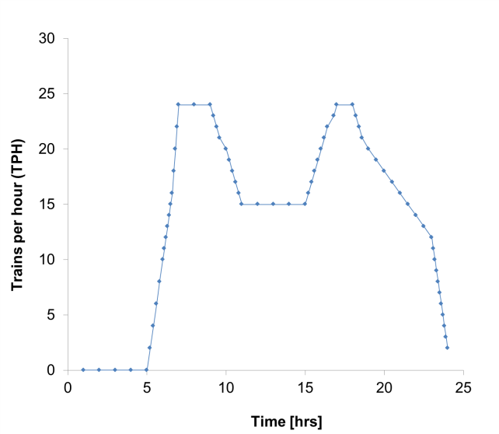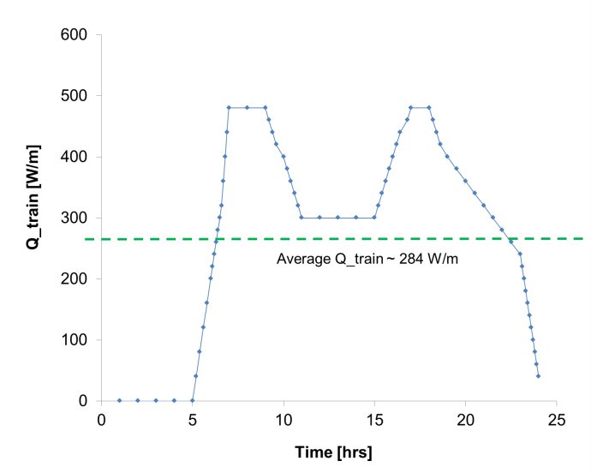
Figure 3: Typical hourly TPH profile of the LU (left) and the resulting hourly averaged heat dissipation values (right)

The TPH values were then converted into hourly averaged heat train heat dissipation rates assuming that the TPH of 10 equates to a typical train heat dissipation rate of 200 W/m. The resulting averaged W/m values are illustrated in the right side of Figure 3. It can be seen that the heat dissipation from the trains shows a similar trend to the train frequency and it peaks at around 480 W/m during the rush hours. Based on these values the average daily train heat load was estimated and implemented into the model. This average daily $Q$_{train} value is 284 W/m, as is highlighted with the dotted line in Figure 3 (right). Removing the short term variation in train heat dissipation rates substantially improved computational efficiencies.
The material that surrounds the line heat source is air. Incorporation of the air domain within the model gives additional flexibility for future analysis in terms of allowing changing the operation of the railway if needed or analysing the mutual impact of the UR tunnels with the nearby GHEs. The air enters at the tunnel inlet at a specified temperature then, flows through the entire tunnel domain with a specified velocity and finally leaves the tunnel at its outlet. The temperature of the air entering the tunnel is time-dependent. This has been set based on the work of Gilbey et al. (2011) who showed that there is a linear relationship between platform and outside air temperatures and it can be expressed as T_{platform} = 0.36 × T_{outside_air} + 19.5. The authors’ work also showed that tunnel temperatures are typically 2 to 3°C cooler than platform air temperatures. This was explained as being a result of the heat produced by the braking mechanism concentrating at the platforms. To reflect this in the model, the time dependent tunnel air inlet temperature boundary within the model was set as shown in Equation 8. To prevent the inclusion of an additional parameter the model assumes that the outside air temperature (ambient as used by Gilbey et al. (2011)) can be approximated as soil surface temperature from Equation 1.

$T_{{Tun_air}_{in}}=0.36*T_{S_surf}+17.5$ (8)

The other condition is a net inflow into the tunnel domain. The single phase air flow was assumed to be turbulent with a high Reynolds number. The velocity of the tunnel air was assumed to be a fixed value of 3.5 m/s, which is an approximate average value of the LU’s air flow for operational and non-operational periods (Ting et al. 2009). The equations solved for the turbulent air flow are the Reynolds-averaged Navier-Stokes (RANS) equations for conservation of momentum, the continuity equation for conversation of mass, and an algebraic equation for the scaled wall distance. The derivation of RANS equations are widely explained within the literature and are therefore not detailed here. Detailed information about how the COMSOL Multiphysics (2017) solves these equations can be found in the tool’s user manual. For solving the transient heat transfer within the air domain the model uses Equation 9. To determine the local heat transfer coefficient at the air-tunnel interface the model uses the Dittus-Boelter equation which is a correlation for internal forced convection in tubes.

 | $$ρC_{p}\frac{∂T}{∂t}+ρC_{p}u∙∇T+q=Q$$ | (9)

In terms of the geometrical parameters of the UR railway, the only variation was to compare a single tunnel scenario with a multiple tunnel one. The 3D model geometry and the main domains such as: (i) Soil; (ii) UR tunnel; (iii) GHEs are illustrated in Figure 4. The governing physics (GP) for each domain as well as some of the applied boundary conditions are also presented in the figure.

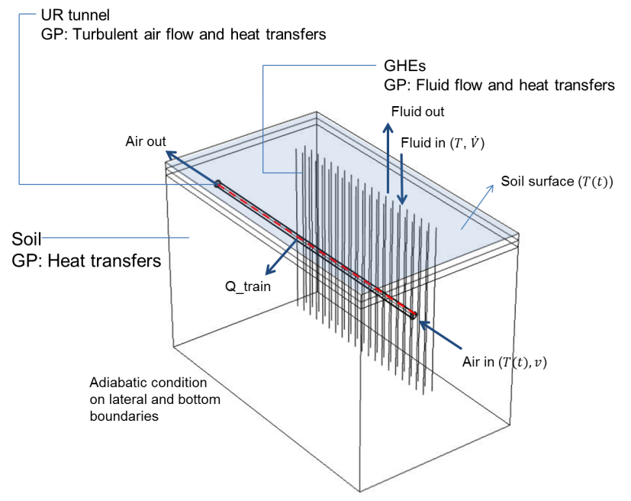
Figure 4: The 3D model geometry: domains and governing physics

The thermophysical properties of the different materials within the numerical model are summarised in Table 1.
Table 1. Thermophysical properties
Material | Value | Unit
Ground: Made Ground, Thames Gravels, London Clay
Thermal conductivity | 2.2, 0.95, 1.3 | W/m*K
Specific heat capacity | 3982, 920, 790 | J/kg*K
Density | 1800, 2000, 1920 | kg/m³
Circulation fluid in GHEs
Dynamic viscosity | 2.02 | mPa∙s
Thermal conductivity | 0.48 | W/m*K
Specific heat capacity | 3962 | J/kg*K
Density | 1020 | kg/m³
Concrete tunnel liner
Thermal conductivity | 1.1 | W/m*K
Specific heat capacity | 880 | J/kg*K
Density | 2400 | kg/m³
Tunnel air | Built in material properties in COMSOL Multiphysics (2017)

3. Results
3.1 Study 1: Single vs multiple tunnels
The aim of Study 1 was to establish whether the heat load from multiple running tunnels would have a larger impact on the nearby GHE array than a single tunnel. The aspect ratio of the GHE array was chosen as 1x40 (i.e. a single line of GHEs at 3 m horizontal separation distance from the wall of the UR tunnel). The 3D model geometries with a single and multiple UR tunnels are illustrated in Figure 5.

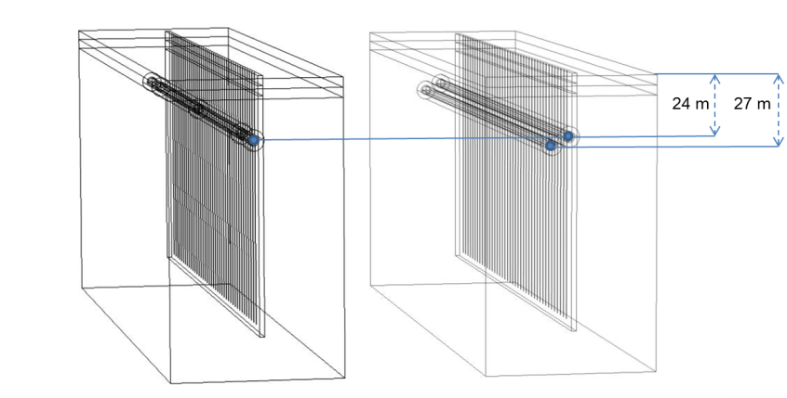
Figure 5: 3D model of geometry of multiple UR tunnels and 1x40 GHEs

All parameters were the same between the two model geometries, however in the multiple UR tunnel option the second tunnel’s centre point was positioned 27 m below the ground surface (3 m below the 1st tunnel’s centre point). This layout was chosen to represent the typical ‘rising’ and ‘falling’ alignment of the tunnels. Within the multiple tunnels model setup the horizontal distance between the centres of the tunnels was set as 7.5 m. In both model geometries the proximity, which is the separation distance between the tunnel wall and the closest line of the GHE array to the tunnel, was set as 3 m. GHE spacing was set as 6 m which resulted in an overall array length of 234 m.

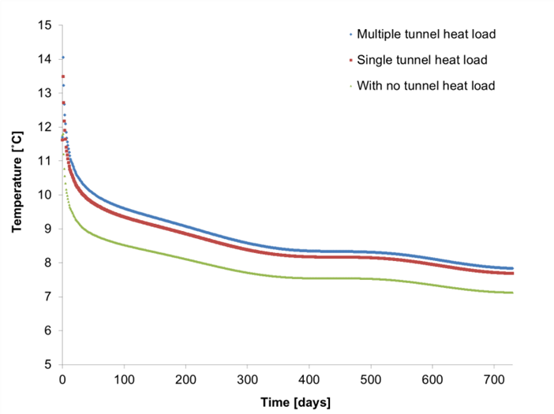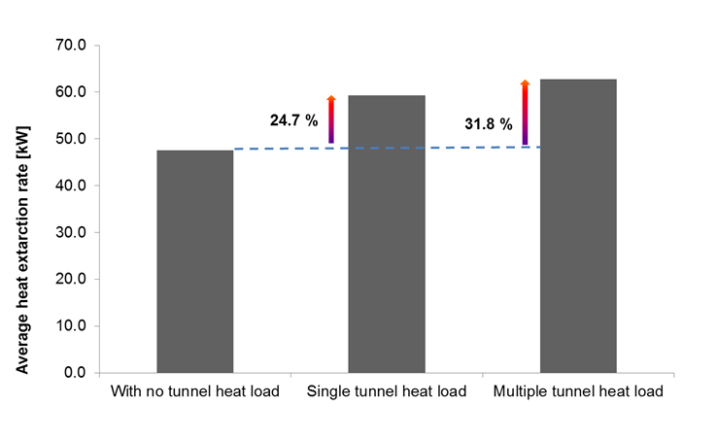

Figure 6: Study 1-Average GHE fluid temperature increment (left) and heat extraction rate (right)

Figure 6 shows the simulated averaged temperatures of the GHEs fluid at the pipe outlets. It can be seen that the fluid temperature increased by an average of 0.7˚C due to the tunnel heat load from a single tunnel and of 0.9˚C when a multiple tunnel heat load scenario was applied in the model. This higher temperature profile was observed from the very beginning and throughout the simulation time. This shows that the initial ground temperature which is affected by the URs is an important characteristic to consider when UR-GSHP interactions are being investigated. The increment of the GHEs’ average fluid temperature in percentage was measured as 8.9% for single and 11.5% for multiple tunnel geometry. On the other hand, the GHEs average heat extraction rate increased by 24.7% when the single and by 31.8% when the multiple tunnel heat load was applied within the model. This is shown in the right side of Figure 6.
3.2 Study 2: GHEs between multiple tunnels
Study 2 considered a geometrical scenario whereby the vertical GHEs are placed between multiple tunnels at 3.5 m horizontal distance from the centre points of the tunnels. This is illustrated in the magnified section of Figure 7. The soil domain parameters, length and depth of the tunnels and the GHE array aspect ratio were kept the same as in Study 1. It was expected that such an arrangement would increase the interactions; although in reality, it would apply to only a small range of places in London and would not be common unless part of an integrated holistic design of new build facilities, for example new UR stations.

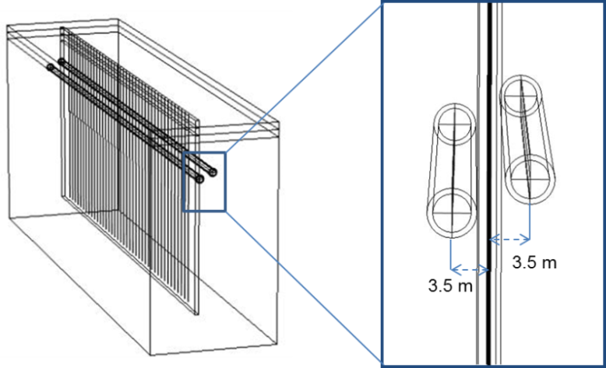
Figure 7: Study 2 model geometry with magnified section

Simulation results showed that the GHEs circulated fluid temperature is higher when the GHE array is built between multiple running tunnels. This is shown in Figure 8. The left side of the figure shows the average fluid temperatures leaving the GHEs with and without the multiple tunnel heat loads. It can be seen that when the tunnel heat loads were applied in the model (both initially and during the two years simulation period), the temperature of the fluid leaving the pipes increased on average by approximately 1.2˚C, which equates to an increment of 14.8% compared to a scenario where the tunnel heat loads were neglected. In addition Figure 8 (right) shows the average heat extraction rates with and without the tunnels heat loads. It can be seen that the GHEs heat extraction rates of the GHEs have significantly increased, by approximately 41% due to the heat loads from the tunnels.

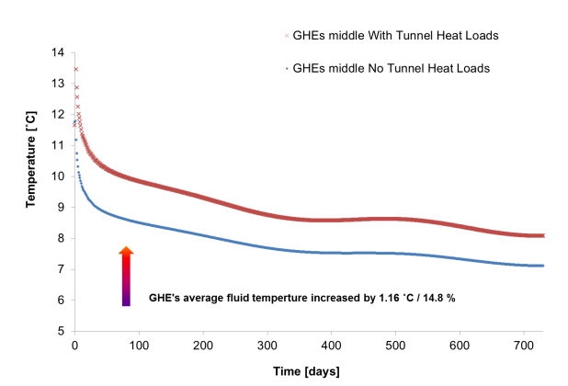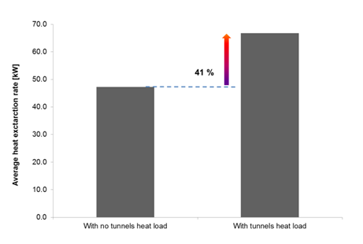
Figure 8: Study 2- Average GHE fluid temperature increment (left) and heat extraction rate (right)

3.3 Study 3: GHEs aspect ratio variation
Studies 1 and 2 considered a single line of GHEs with an array aspect ratio of 1x40. However GHE arrays are often constructed with different geometrical arrangements. In order to explore how UR-GSHP interactions are influenced by the aspect ratio of a rectangular GHE array, two new geometrical options with the same overall pipe lengths (~8000 m) were constructed (i) option b, with GHEs having an aspect ratio of 2x20, and (ii) option c, with 4x10 GHEs. These new geometrical options, alongside the original 1x40 model geometry (option a), are illustrated in Figure 9. The depth of each GHE array option was kept as 100 m. The separation distances between the tunnel wall and the closest line of the GHE array to the tunnel, for each option was kept as 3 m.

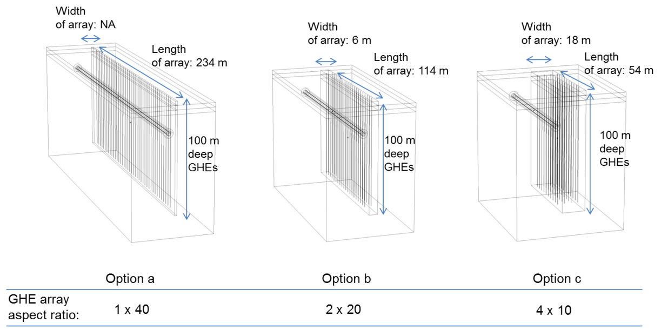
Figure 9: Study 3 model geometry with different aspect ratios

For each option, the GHEs fluid temperature and heat extraction rates were investigated and the results are shown in Figure 10, Figure 11, and Figure 12 respectively. The left sides of these figures show the average GHE fluid temperature increment at the pipe outlets due to the UR heat load. The right sides of the same figures in turn show the average heat extraction increment based on that temperature difference. It can be seen that the highest impact from the UR tunnel on the GHEs was achieved in geometrical option a (Figure 10), where the array has the smallest width and runs the longest distance next to the tunnel. For option a, the average temperature of the GHEs fluid leaving the pipes increased by almost 9% due to the nearby tunnel heat load. This equates to a nearly 25% increment in the average heat extraction rates by the GHEs. For option b and option c the increments were 22.3 and 18.2 % respectively.
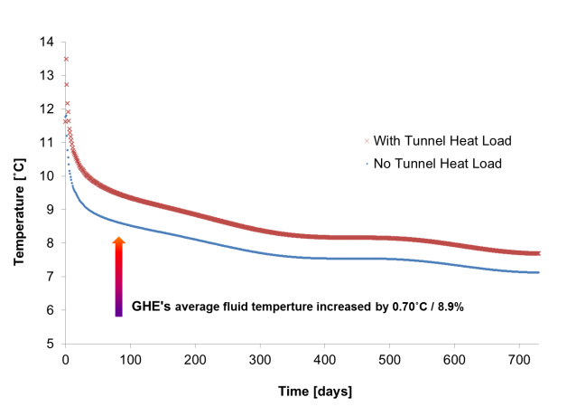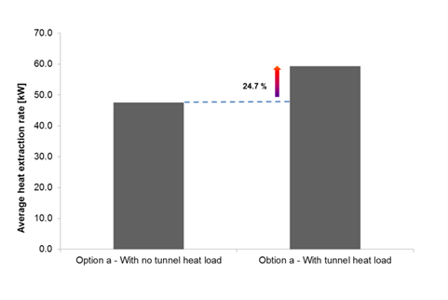
Figure 10: Study 5 - option a – Average GHE fluid temperature increment (left) and heat extraction rate (right)
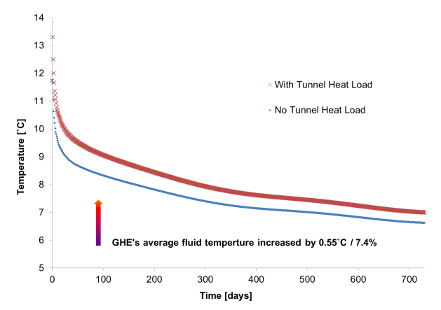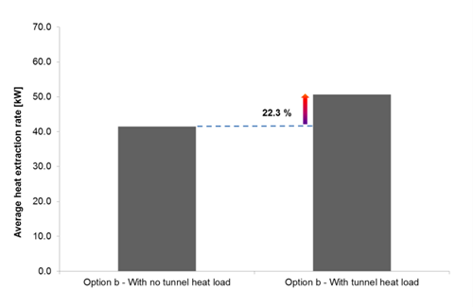
Figure 11: Study 5 - option b – Average GHE fluid temperature increment (left) and heat extraction rate (right)

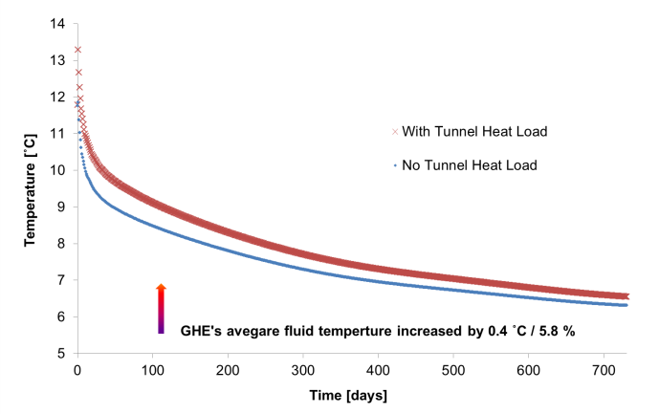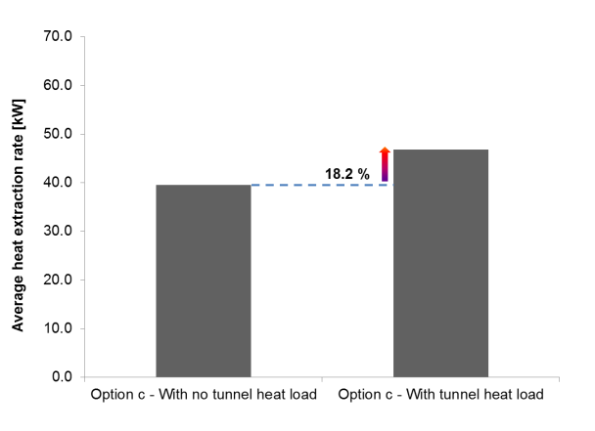
Figure 12: Study 5 - option c – Average GHE fluid temperature increment (left) and heat extraction rate
(right)

3.4 Study 4: Single vs double looped GHEs
Study 4 aimed to investigate how UR-GHE thermal interactions are affected, when the GHEs are constructed in double looped configuration near to a single tunnel. The array aspect ratio and the overall GHE pipe length were kept the same as they were in the previous studies (1x40 and 8000 m). However, double looping the GHE pipes made the depth of the GHEs shorter, to 50 m. The 3D diagram of the model geometry in Study 4 is shown in Figure 13. The diagram also has a magnified section of a double-looped GHE.
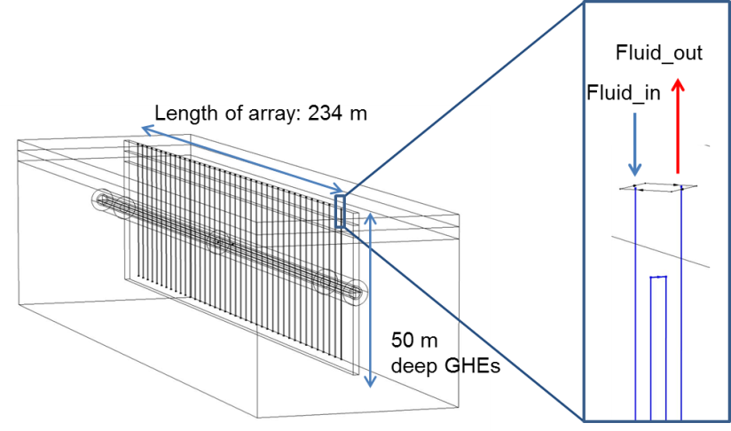
Figure 13: Model geometry in Study 4 with magnified section

Results of Study 4 are illustrated in Figure 14. It can be see that the average fluid temperature leaving the pipes is lower than it was when the deeper single looped GHEs were simulated in the previous studies. This is because the soil temperatures are higher at greater depths as a result of the geothermal gradient condition imposed on the soil domain. On the other hand, when the tunnel heat load was applied, the heat extraction rate of the GHEs increased by almost 43%, compared to the scenario when the tunnel heat load was neglected. This is a substantial increase and it is about 18% higher than the increment observed in Study 1 with a single UR tunnel. The reason for this is that although the length of the GHE pipes were kept the same 8000 m as within the previous studies, the double looped configuration applied in Study 4 reduced the overall depth of the GHE array. This in turn allowed greater interactions between the two systems by having built the majority of the GHE array within the soil regions where the impact of the UR is higher.

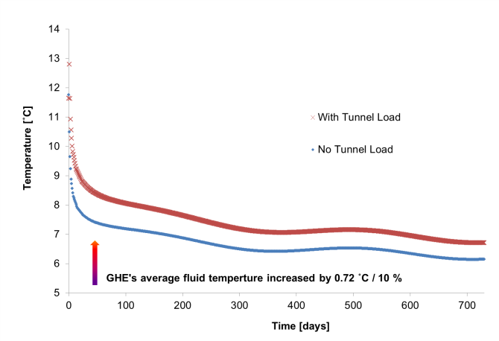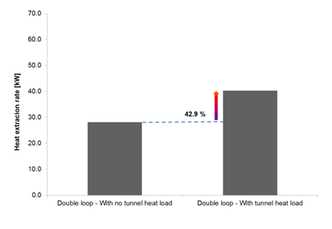
Figure 14: Study 4 - Average GHE fluid temperature increment (left) and heat extraction rate (right)

3.5 Study 5: Proximity variations
Within studies 1 to 4, a fixed UR-GHE horizontal distance of 3 m was used. Therefore these previous studies have explored the improvement in the GHEs heat extraction rates by considering geometrical options with the largest possible thermal interaction potential. Study 5 aimed to explore to what extent the interactions are affected by moving the GHE array further away from the wall of the UR tunnel. The base case scenario, to which the newly built geometrical options were compared, was set as the original 3 m horizontal separation distance. This was then gradually increased in order to investigate how the UR-GHE interactions were affected by horizontally separating the systems. The base case scenario, option a, and the other four horizontal distance options (options b to e) were set at 3, 6, 12, 24 and 35 m respectively between the wall of the tunnel the vertical GHEs. A plan view of these different geometrical options of the 3D UR-GHE model are illustrated in Figure 15.

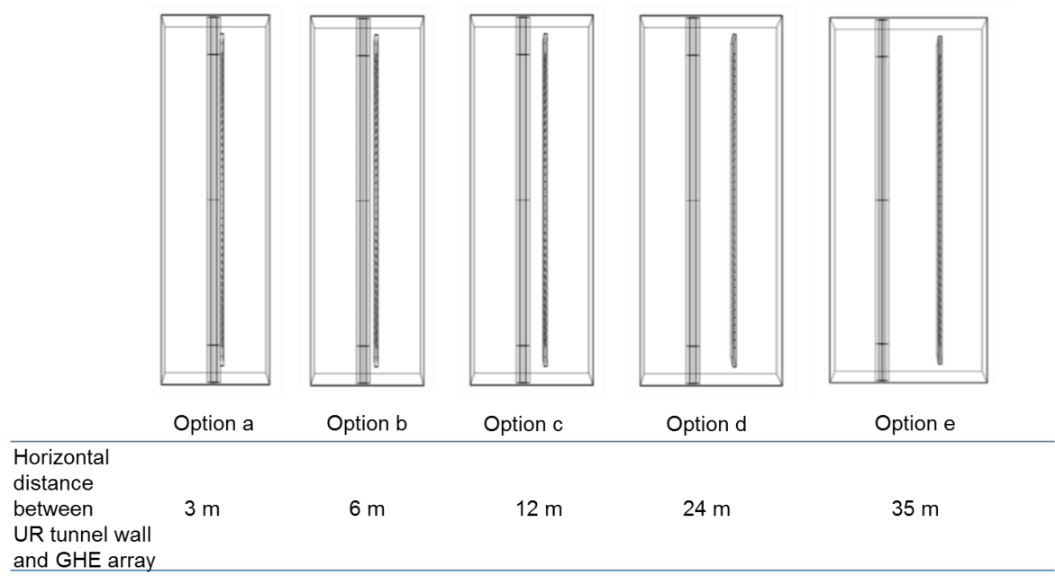
Figure 15: Plan view of the different UR-GHE horizontal distance options in Study 5

Simulated results showed that as the horizontal UR-GHE wall to wall distance increases, the UR impact on the GHE array becomes smaller. This lesser impact was confirmed by the results in the GHEs fluid temperature variation in Figure 16 (left).

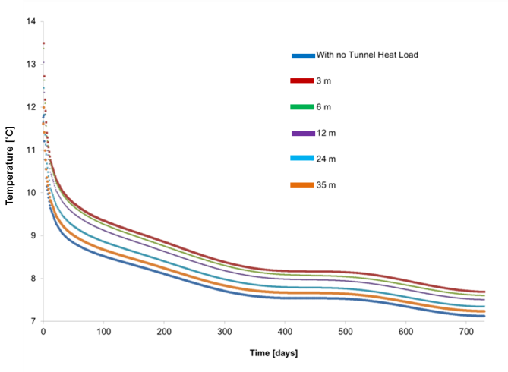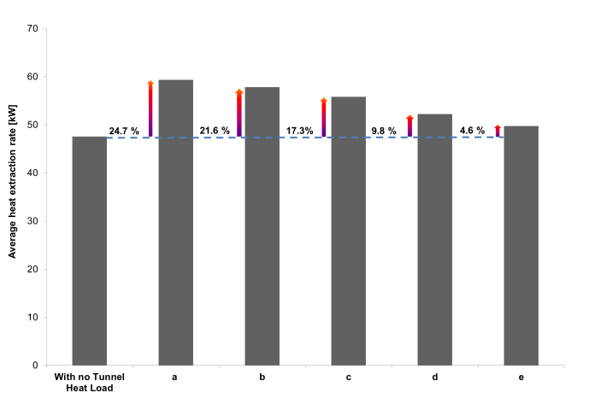
Figure 16: Study 5 - Average GHE fluid temperature increment (left) and heat extraction rate (right)

According to Figure 16 the average temperature of the GHEs fluid leaving the pipes is reduced as the UR-GHE horizontal separation distance increases. However, it can be seen that in option b, the impact from the tunnel was almost as high as it was in option a. This suggests that at a 6 m radial distance from the wall of the UR tunnel the thermal impact from it is still relatively large. The results also show that after about 24 m from the wall of the tunnel the impact on the GHEs is small and after about 35 m it is almost negligible. In the context of the GHEs heat extraction performance, Figure 16 (right) illustrates the average heat extraction rate for each geometrical option studied. It can be seen that the GHEs extract less heat as their horizontal distance increases from the tunnel. The results showed that constructing the GHE array at 6 m distance from the wall of the tunnel would still result heat extraction rate improvement greater than 20%. On the other hand, the results show that at 35 m from the tunnel wall, the GHEs heat extraction rates would only improve by less than 5% compared to a scenario where there was no additional heat source available from a nearby UR tunnel.

4. Summary of results and analysis
The combined UR-GHE numerical model was used to perform five different studies, investigating different geometrical options of URs with nearby vertical GHE arrays. The key aim of these studies was to explore how the waste heat generated in the ground by the operation of URs could potentially enhance the heat extraction rates of the GHEs. The results of these investigations are summarised in Table 2. The Greek Theta symbol ($ϴ$) was used to represent the improvement on the GHEs’ average heat extraction rates in %. It can be seen that the highest $ϴ$ was achieved in Study 4 (~43%) when the GHEs were double looped, where the array’s geometrical centre was closer to the tunnel. This way the thermal interactions between the systems become larger.
Table 2. Results of the numerical investigations
Study | Number of UR tunnel(s) | Improvement on the GHEs’ average heat extraction rates ($ϴ$ )
 |  | [%]
1 | 1/2 | 24.7 / 37.8
2 | 2 | 41
3 | 1 | 24.7 / 22.3 / 18.2
4 | 1 | 42.9
5 | 1 | 24.7 / 21.6 / 17.3 / 9.8 / 4.6

In order to be able to characterise the thermal interactions between URs and the GHEs, a new geometrical variable was introduced. The variable was named as UR-GHE interaction proximity with a symbol of Ω. It was defined as the distance between the geometrical centre of the UR tunnel and the geometrical centre of the GHE array (i.e. the array centre point at the half of the width, length and depth of the array). The values of Ω for each study (which considered a single tunnel in the model geometry) are listed in Table 3. It can be seen from the table that for the number of studies analysed there are several geometrical scenarios which have different GHE array layouts but the same UR-GHE interaction proximity (Ω). For example Study 3: Option b has the same Ω value as Study 5: Option b as well as Study 3: Option c and Study 5: Option c. These values of Ω were compared against the improvement on the GHEs heat extraction rates and were found to be consistent. This is illustrated in Figure 17.

Table 3. Ω for the different studies
Study | Ω
 | [m]
1 | 26.5 / NA
2 | NA
3 | 26.5 / 27.2 / 29.6
4 | 5.4
5 | 26.5 / 27.2 / 29.6 / 36.9 / 45.4

It can be seen from Figure 17, that an almost linear relationship (with an R² of 0.97) can be derived, when Ω, as a single variable, was compared against the improvement in the GHEs average heat extraction rates ($ϴ$) due to the tunnel heat load. This relationship can be described with a formula as shown in Equation 10. It is clear that as Ω becomes smaller the impact of the UR on the nearby GHEs would become larger. For the scenarios which have identical Ω but different GHE array aspect ratio, there are small disparities (+/- 1% difference) between the improvement rates. For better visualisation, these specific points are highlighted with circles in Figure 18. Therefore, Ω can be regarded as a key variable for quantifying the thermal interactions of URs with nearby vertical GHEs.

$ϴ=-0.9×Ω+48.9$ (10)
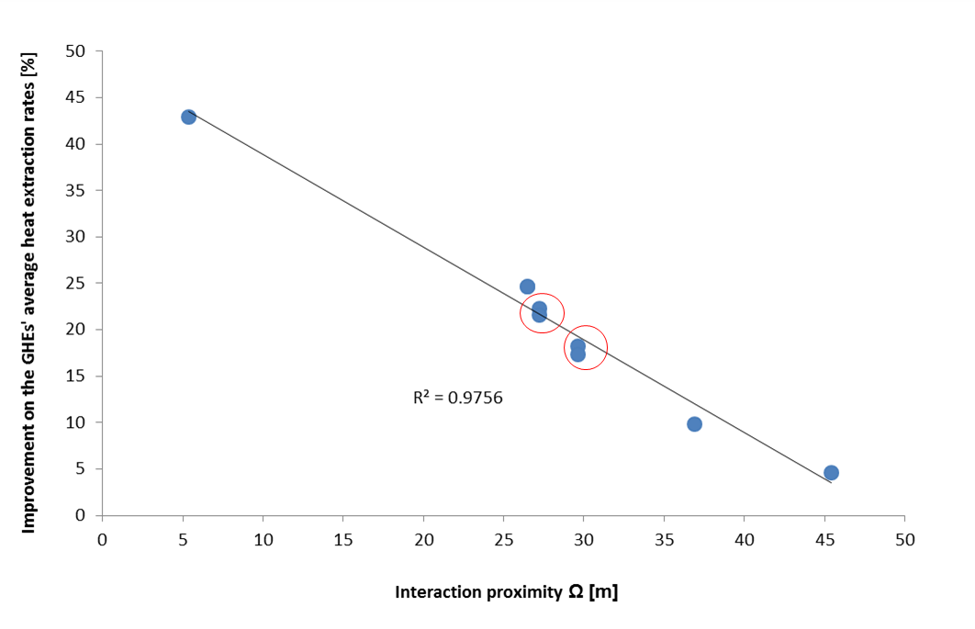
Figure 17: GHEs heat extraction improvement in relation to Ω

- Conclusions
This article has described a seminal study investigating a novel way of capturing waste heat from underground railways (URs). It describes an original numerical investigation into the thermal interactions of URs with nearby vertical GHEs of GSHPs. The motivation for this work was the potential utilisation of waste heat energy generated by urban URs with localised GSHP installations. The modelling objectives were to establish the potential for heat recovery from URs and identify the level of improvements of vertical GHEs due to heat load from an UR tunnel. For minimising the computational effort, the model was built using 1D linear elements for simulating the operation of train in the tunnel as well as the GHE pipes. The investigation included details of five of the many different studies which were conducted to consider alternative geometrical parameter variations of the systems. Within all studies, the model configuration represents the operation of a typical UR in London using time dependent boundary conditions. The emphasis of this part of the investigation was to understand how the different geometrical configurations of the GHE array in the vicinity of the UR tunnel would work under typical optimum load conditions. Thus the inlet temperature of the GHEs assumed to be constant based on an average inlet temperature during the heating season. It is proposed by the authors that in future work, the operation of the GHEs will be modified based on the ground temperatures surrounding the GHEs and the operation will be matched to the seasonal energy requirements of the building to which the system is connected to. Findings of the numerical investigations showed that the impact of the operation of an UR tunnel on nearby vertical GHEs can be substantial. For example, it was shown that the improvement on the GHEs average heat extraction rate due to the heat load from the UR tunnel can be high as ~43%, depending on the size and shape of the array and its proximity to the tunnel. This will enhance overall GSHP system efficiencies, resulting in substantial savings in both operational costs and carbon emissions. The results also showed that in order to achieve a large heating impact from the tunnel(s) on the GHEs, the geometrical centre of the GHE array should be as close as possible to the geometrical centre of the tunnel. This distance was introduced as a variable defined as the interaction proximity (Ω). This single variable was then used to characterise the thermal interactions of URs and nearby vertical GHEs with different geometrical layouts. It was shown that there is a nearly linear relationship between this variable and the average increment of the GHEs’ heat extraction rates due to the UR heat load. Therefore, Ω can be regarded as one of the key variables when the thermal interactions of URs with nearby vertical GHEs are being investigated. The results are generic to many applications worldwide and could give guidance to engineers working in fields where thermal interactions between URs and nearby GHEs arise.
Acknowledgements
The authors would like to express their gratitude for the support by London Underground Ltd and the interdisciplinary centre for Storage, Transformation and Upgrading of Thermal Energy (i-STUTE).
REFERENCES:
Adam, D. and Markiewicz, R. (2009) Energy from earth-coupled structures, foundations, tunnels and sewers, Géotechnique, 59 (3), pp. 229–236. DOI:10.1680/geot.2009.59.3.229.
ASHRAE (2009) ASHRAE Handbook: Fundamentals. American Society of Heating, Refrigeration and Air-Conditioning Engineers.
Barnard, A. C. L., Hunt, W. A., Timlake, W. P. and Varley, E. (1966) A Theory of Fluid Flow in Compliant Tubes, Biophysical Journal, 6 (6), pp. 717–724.
Bourne-Webb, P. (2013) Observed Response of Energy Geostructures, in: Laloui, L. and Donna, A. D. (eds.) Energy Geostructures. John Wiley & Sons, Inc., pp. 45–77.
Brandl, H. (2006) Energy foundations and other thermo-active ground structures, Géotechnique, 56 (2), pp. 81–122. DOI:10.1680/geot.2006.56.2.81.
Busby, J., Lewis, M., Reeves, H. and Lawley, R. (2009) Initial geological considerations before installing ground source heat pump systems, Quarterly Journal of Engineering Geology and Hydrogeology, 42 (3), pp. 295–306. DOI:10.1144/1470-9236/08-092.
COMSOL Muliphysics (Version 5.3) (2017). Available from: http://www.uk.comsol.com/ [Accessed 16 October 2017].
Davies, G., Boot-Handford, N., Grice, J., Dennis, W., Rami, R. and Nicholls, A. (2017) Metropolitan Integrated Cooling and Heating, in: Las Vegas, Nevada, US.
Euroheat & Power (2017, July 18) Bunhill Heat and Power - capturing waste heat from the London Underground, Euroheat & Power. Available from: https://www.euroheat.org/knowledge-centre/bunhill-heat-power-capturing-waste-heat-london-underground/[Accessed 19 October 2017].
European Commission (2009) Decision No 406/2009/EC on the effort of Member States to reduce their greenhouse gas emissions to meet the Community’s greenhouse gas emission reduction commitments up to 2020. Official Journal of the European Union. Available from: http://eur-lex.europa.eu/LexUriServ/LexUriServ.do?uri=OJ:L:2009:140:0136:0148:EN:PDF [Accessed 2 October 2016].
Franzius, J. N. and Pralle, N. (2011) Turning segmental tunnels into sources of renewable energy, Proceedings of the Institution of Civil Engineers - Civil Engineering, 164 (1), pp. 35–40. DOI:10.1680/cien.2011.164.1.35.
Gilbey, M., Thompson, J. and Duffy, S. (2011) The Potential for Heat Recovery from London Underground Stations and Tunnels, in: CIBSE Technical Symposium. Leicester, UK.
Kavanaugh, S. P., Xie, L. and Martin, C. (2000) Investigation of methods for determining soil and rock formation thermal properties from short-term field tests, Final Report for ASHRAE TRP-1118.
Lazzari, S., Priarone, A. and Zanchini, E. (2010) Long-term performance of BHE (borehole heat exchanger) fields with negligible groundwater movement, Energy, 35 (12), pp. 4966–4974. DOI:10.1016/j.energy.2010.08.028.
Nera Economic Consulting, Renewable Heat Technologies for Carbon Abatement: Characteristics and Potential, Final Report to the Committee on Climate Change July 2009 - Google Search (2009). Available from: https://www.google.co.uk/webhp?sourceid=chrome-instant&ion=1&espv=2&ie=UTF-8#q=Nera+Economic+Consulting%2C+Renewable+Heat+Technologies+for+Carbon+Abatement:+Characteristics+and+Potential%2C+Final+Report+to+the+Committee+on+Climate+Change+July+2009 [Accessed 9 January 2017].
Ninikas, K., Hytiris, N., Emmanuel, R., Aaen, B. and Younger, P. L. (2016) Heat recovery from air in underground transport tunnels, Renewable Energy, 96, Part A, pp. 843–849. DOI:10.1016/j.renene.2016.05.015.
ReUseHeat: Recovery of Urban Excess Heat (2017, December 14), Euroheat & Power. Available from: https://www.euroheat.org/our-projects/reuseheat-recovery-urban-excess-heat/.
Revesz, A., Chaer, I., Thompson, J., Mavroulidou, M., Gunn, M. and Maidment, G. (2015) Interactions of ground source heat pumps with nearby underground railway tunnels in an urban environment, The 24th IIR International Congress of Refrigeration, Yokohama, Japan.
Revesz, A., Chaer, I., Thompson, J., Mavroulidou, M., Gunn, M. and Maidment, G. (2016) Ground source heat pumps and their interactions with underground railway tunnels in an urban environment: A review, Applied Thermal Engineering, 93, pp. 147–154.
Revesz, A., Chaer, I., Thompson, J., Mavroulidou, M., Gunn, M. and Maidment, G. (2017) The Potential for Integration of Ground Energy from Underground Railways, 2017 ASHRAE Winter Conference, in: Las Vegas, NV, US.
TfL (2013) Civil Engineering – Common Requirements, Category 1 Standard.
The Greater London Authority and Buro Happold (2013) London’s zero carbon energy resource. Available from: http://www.london.gov.uk/sites/default/files/031250%20GLA%20Secondary%20Heat%20-%20Summary%20Report.pdf [Accessed 12 October 2017].
The Stationery Office (2008) Climate Change Act 2008. Available from: http://www.legislation.gov.uk/ukpga/2008/27/pdfs/ukpga_20080027_en.pdf [Accessed 2 October 2016].
Thompson, J., Gilbey, M. and Maidment, G. (2008) Geothermal cooling of underground railways-the opportunity, in: UK, London: The Institute of Refrigeration, Volume 105.
Thompson, J. and Maidment, G. (2010) Alternative geothermal heating sources, heat pumps and their application, in: 1st IIR International Conference on the Cold Chain and Sustainability. Cambridge, UK.
Ting, Y. S., Gilbey, M. J., Drake, S. N., Missenden, J. F. and BHR Group Limited (2009) CFD estimation of heat transfer enhancement on a cooling pipe in underground railway tunnels, in: pp. 629–644.
Winterling, R., Nicholson, D. P., Winter, A., Chen, Q. and de Silva, M. (2014) The design of thermal tunnel energy segments for Crossrail, UK, Proceedings of the ICE - Engineering Sustainability, 167, pp. 118–134.
Zeng, H. Y., Diao, N. R. and Fang, Z. H. (2002) A finite line-source model for boreholes in geothermal heat exchangers, Heat Transfer—Asian Research, 31 (7), pp. 558–567.

