International conference on engineering and product design education
8 & 9 September 2016, AALBORG UNIVERSITY, DENMARK

talking with experts - from research to objects: using academic research as the basis of collaborative and cross disciplinary projects for design students
Susana SOARES and Deborah ANDREWS
London South Bank University, United Kingdom
abstract
The role of design is changing and after postmodern design, in which design seemed to be more related to production, business and marketing, we are currently looking at ‘the translation of scientific and technological research into tangible objects that change people's lives’ as one of the most fundamental roles of design [1].
In the majority of Higher Education institutions a significant amount of research takes place and there is considerable potential to develop applications from the results of these activities, many of which are not fully exploited. The primary aim of this project was to investigate how design methods can be used to bridge the gap between the abstraction of research and the tangible requirements of everyday life. A project targeted second year students was developed to explore this concept; it was also an opportunity for students to challenge their familiar working methods by being collaborative and interdisciplinary. First they formed teams and identified examples of scientific and engineering research expertise; they then contacted the research active academic staff working in these fields and carried out a video interview. They analysed their findings and gave a presentation outlining their approach and design development for an appropriate context. Finally the teams presented educational videos that explain and promote their design proposals to expert and non-expert audiences.
The paper includes several examples of these design proposals and illustrates the benefits of collaboration for students and to researchers who see how their work can be interpreted and developed into real world tangible applications.
Keywords: Cross-disciplinary, collaborative, design, education, academic research.

1 Introduction
The Talking with Experts project aimed to
- explore how design can be used to increase the impact of academic research
- challenge and expand students’ perceptions of the role of design by using on-going academic scientific and technological research as the starting point of the design process
- communicate their design proposal to audiences who are familiar and unfamiliar with the subject
Second year BSc Product Design students working in groups within the Design Futures and Innovation module had to contact and negotiate with a research-active member of academic staff and carry out a video interview with them. This interview was analysed and the subject matter investigated in order to develop design concepts. The teams then had to demonstrate their spin-off ideas in an embodied form in which features of the product / system could be described coherently. They then prepared and delivered a presentation that outlined their approach and demonstrated the potential of their proposal for an appropriate context; finally they made an educational video to communicate their concept to audiences who were familiar and unfamiliar with the research subject.

2 Scope
The aims and goals of this project derive from two premises. The first refers to the importance stated by governmental institutions to increase the real world impact of research and innovation carried at Higher Institutions in UK and across Europe [2] and the second explores how design, and specifically product design, can support Pathways to Impact [3] and stimulate innovation, new products and processes, knowledge transfer and exchange and skills development.

2.1 Collaborative models of innovation
In the last decade there has been considerable encouragement in the UK to maximise the potential of research carried at Higher Education Institutions [2]. The Research Councils invest around £3 billion each year in research conducted at UK universities [3]. Although it is recognised that UK has an excellent research base, a 2011 report from the House of Commons Science and Technology Committee concluded that the majority of the research conducted fails to bring about positive impact in our society and economy [4]. One of the reasons for such discrepancy was identified in a study conducted at the University of Sussex that states that university research often adopts an inappropriate and misleading ‘linear model of innovation’ and concludes that:
‘the main route by which knowledge generated by the research base is commercialized
is through collaborative and contract research, consultancy, and the provision of
professional training’ [5].
Consequently the aim of the project is to prepare people to work collaboratively across disciplines in order to generate knowledge that can increase innovation, engagement and enhance quality of life.

2.2 Design as catalyst
The second premise stems from emerging disciplines of design, namely critical and speculative design [6], in which design can translate research into objects and product systems that people can engage with and understand; they can also be a catalyst for public engagement with and awareness of science and technology [7]. This is especially relevant since in the Pathways to Impact report researchers are encouraged, amongst other recommendations, to ‘identify and actively engage relevant users and articulate a clear understanding of the context and needs of users’ [3]. These recommendations were initially published in 2000 in a Public Understanding of Science report where it is stated that it is increasingly important that non-experts should be able to talk with experts to understand aspects of science that may impact their lives; similarly experts should be able to engage non-experts to ‘seek understanding of the impact of their work and possible applications on society and public opinion’ [8].
Furthermore in the 2015 Innovation by Design report, the UK Design Council established that design accelerates commercialisation and increases the value of scientific and technological research:
‘Design is the best tool we have for bringing that human perspective into the innovation process and so plays a vital role in delivering outcomes that are more viable, desirable and usable’ [9].

3 design process
The Design Council’s Double Diamond was used as the framework for the Talking with Experts design process. The Double Diamond approach loops from divergent to convergent thinking [10] and in the context of Talking with Experts, the framework was extended and stages were redefined as analyse, speculate, concretise and feasibility.
A given research or emerging technology was analysed and potential applications were considered until the design brief milestone. Final proposals were concretised using a product and / or product system approach and communicated through video. Due to time constraints and limitations the outcomes did not aim for in depth feasibility, production, or commercialisation. Nevertheless students were expected to clearly explain the impact and benefits of their design concept and key attributes as appropriate (e.g. functionality, user interface and experience, materials).

4 The brief

4.1 Overview
The brief was divided in three parts across twelve weeks: part 1 – interviews, part 2 - design proposal and part 3 - video. Each part had points of assessment where students could receive both verbal and written feedback. Along with the brief students were provided with learning outcomes, an overview of how to conduct interviews, a step-by-step project guide, and lectures and workshops on film making.

4.1.1. Learning outcomes
By the end of the project learners were expected to:
- be familiar with academic research activities and develop potential future applications for specific research
- challenge working methods by talking and working with experts, making projects interdisciplinary and collaborative
- start to base design projects on observation, conversation, interpretation and translation
- generate proposals that can increase innovation and public engagement and enhance quality of life.

4.2 Team work
Due to the complexity of the outcomes and the range of skills required (such as project management, communication, primary and secondary research, concept generation, storyboarding, filming and editing), students had to work in teams. Teamwork is recommended in complex projects as it encourages students to develop a supportive environment and fosters creativity and innovation [11]. Students could work in groups with a maximum of three members, totalling an overall of six teams. A self -selecting and shared interest formation was adopted, meaning that students were asked to form teams themselves based on friendship and shared interests in order to capitalise on motivation and control over an unknown process. There were three available research topics to select from: food and nutrition, materials engineering and refrigeration and air conditioning. The allocation of topics and researchers was aleatory to avoid conflict amongst teams when choosing topics.
A reasonable weighting of the overall assessment, (twenty per cent out of one hundred), was given to group dynamics and peer assessment and students were made aware that they had to assess their colleagues’ standards of professionalism and participation. A ‘contract template’ (Nelson et all, 2007) that included allocation of roles and tasks plus project management tools was delineated with the teams in a group session [11] in order to minimise conflict and manage the allocation of tasks.

4.3 The Interview
Part 1: The Interview involved:
- allocating a research subject and a researcher within the University after which students had to contact them via email, introduce the aim of the project and set up an interview. In order to reduce the time spent finding collaborators, both subjects and researchers were pre-selected and pre-contacted about the project by lecturers. This ensured that researchers were willing to participate in and dedicate precious time to the project. Although, this removes the process of selection, negotiation and learning to deal with rejection, it facilitates and accelerates the first part of the project and also prevents research staff members from feeling pestered and becoming less inclined to participate in further or similar projects.
- the interview had to be recorded in video format for no longer than one hour and teams were advised to take footage of both the researcher and research in context (i.e. B roll in the lab etc.).
- for the presentation teams were asked to edit a three-minute video with a coherent narrative that covers the following: the topic and research, the researcher / collaborator, the focus of their work, what students learned about it, potential applications and to reflect upon the experience.
Students had a lead-time of 4 weeks to complete this stage of the project.

4.4 Concept development
Teams were asked to develop concepts based on the conclusions drawn during part one and propose potential applications for the research being developed by the researchers. The applications could be concepts of products and / or product systems for use in the present or near future. The proposals were assessed on the following criteria: utilisation and application of research material; innovation and viability of the design proposals; quality of the design development and quality of the models. Teams had to produce concept sketches, select a concept and develop the proposal through computer-generated renders (see Figure 1) and draft models. The groups prepared a brief digital interim presentation detailing concept rationale, design proposal, how it works guides, special features and innovation and design proposal in context with users.

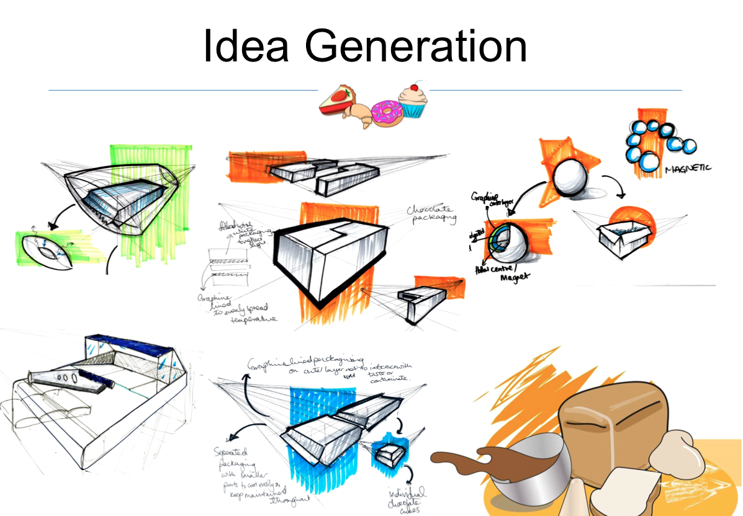
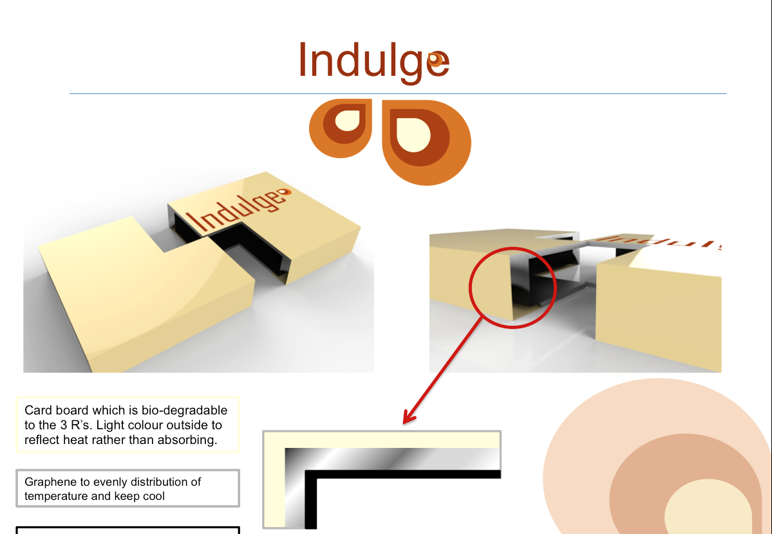

Figure 1. Ideation sketches and final concept development

4.5 Design proposals
Students usually use a static medium and either printed or digital presentation boards created with graphic design software, accompanied by digital presentation tools such as Power Point or Prezi. The presentations frequently comprise four boards that show prescriptive stages of the design project process, namely: research, ideation, and concept development, final proposal, technical details and in context. For this project however time-based media was identified as the most appropriate means of presenting and communicating the final product / product system design proposals; it was also an excellent learning space for students to develop new transferable practical skills. Each team had to create a one to two minute long video; the teams could choose film and/or animation techniques.

4.5.1 Narrative
Talking with Experts gave students the opportunity to investigate different strategies to engage with diverse audiences, in this case fellow students, the researchers, the lecturers and the target users. Although the strategies are not new they are less common in the field of Product Design [12]. One strategy used in the project that is inherent in film and advertising is the use of narrative and scripts. According to Dickey (2005) narrative is both a ‘means of reasoning and a means of representation’ that also provides opportunities for reflection, evaluation, illustration, exemplification, inquiry [13] and aids comprehension [14]. Prior to storyboarding students analysed various video examples and, as a result of in-class discussion, recognised that a strong backstory which contextualises the challenge / problem and an attention to the flow / pace of the video were most effective in conveying the message. Starting with a storyboard and a script outlining what and how they wanted to communicate (see figure 2) about the project they then developed videos that communicated the relevance of their proposals, how they worked, and their target users.
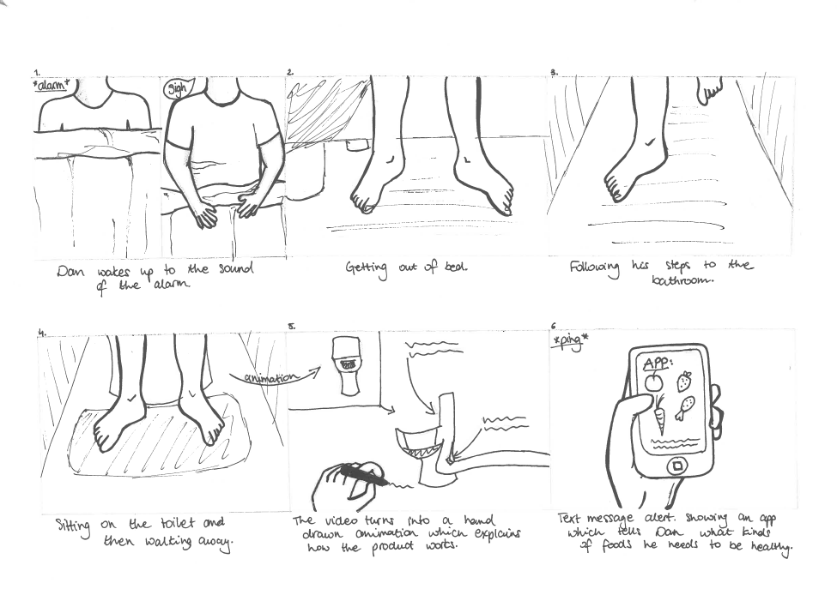
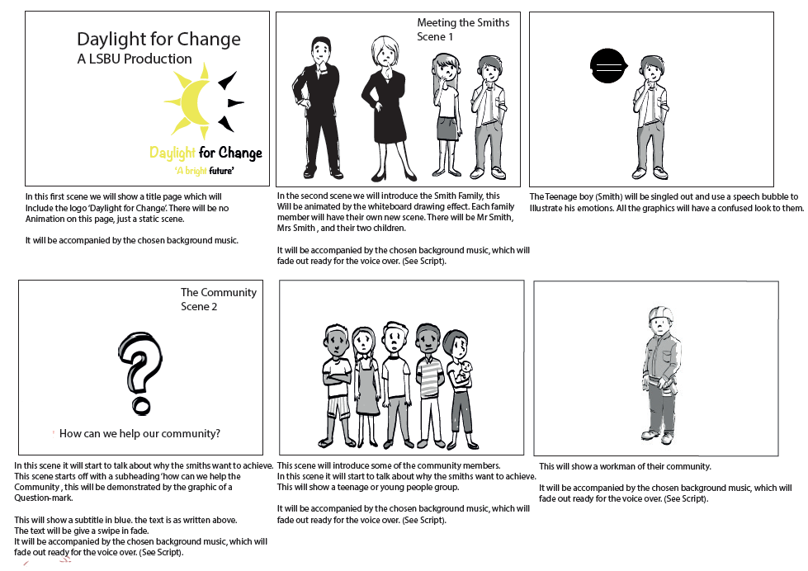

Figure 2. Examples of storyboards with scripts
4.5.2 Proposals
All the six group proposals had a product system approach, meaning that products were contextualised in the bigger picture. This is in line with recent views of teaching product designers where a systems product design approach is advocated to creatively answer complex challenges [15].
The groups were also encouraged to talk with the researchers regarding their proposals and get feedback from them. Three of the projects had taken on the food and nutrition topics (see figure 3). A future orientated smart toilet, Flush, that would tailor diets according to samples taken weekly from faeces, was inspired by a microbiologist’s research on food hygiene. Research into improving bread longevity and structure originated a new brand concept, G Free for gluten free products and a gluten allergy and intolerance awareness campaign. Research looking at preserving chocolate properties in hot (e.g. tropical) environments similarly motivated students to investigate packaging materials and technologies that would preserve the proprieties of chocolate; behavioural change in chocolate consumers in these environments was also considered, all of which led to the development of design proposals for a brand, specialist packaging and shops named Indulge.

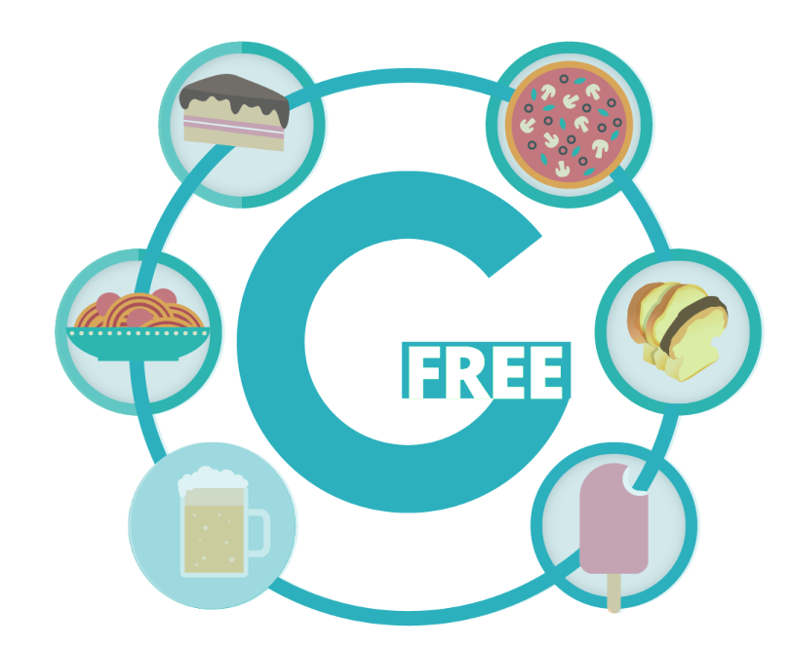
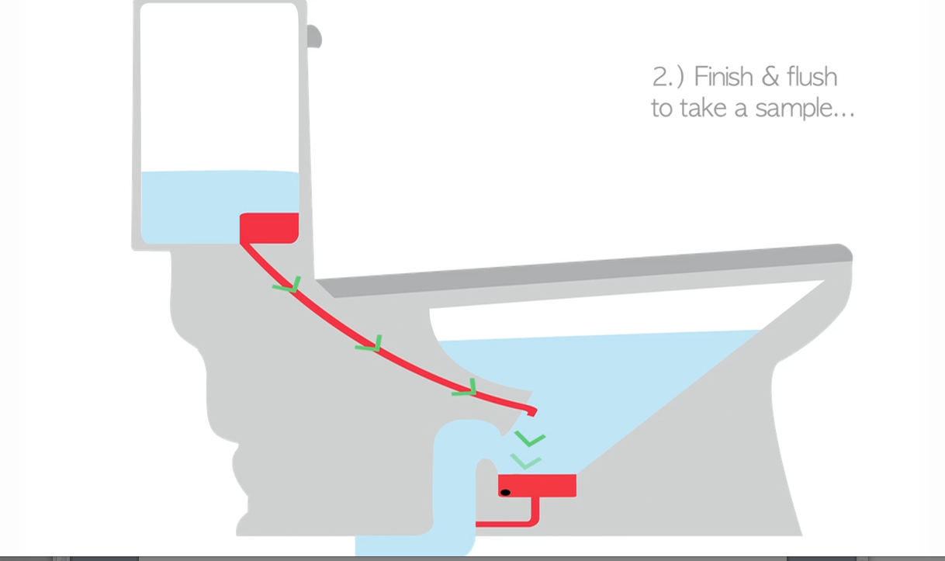

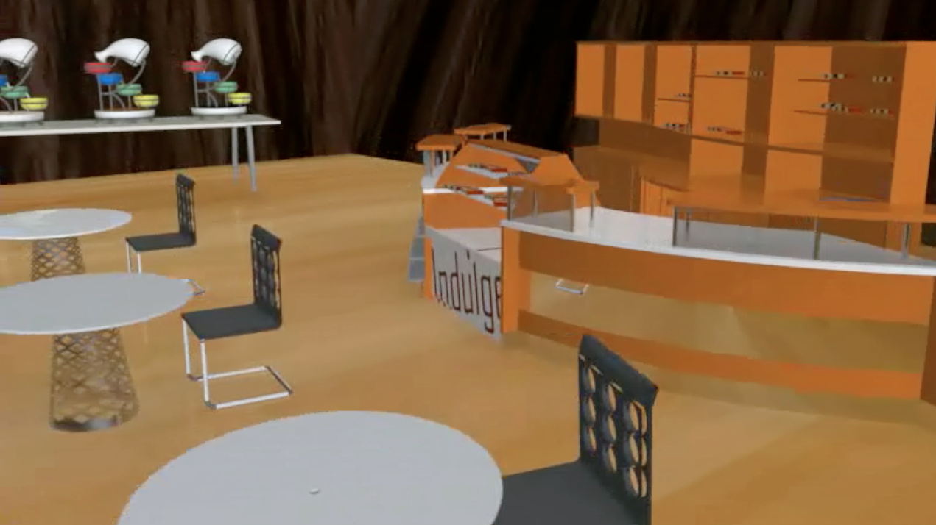

Figure 3. Final proposals Flush, G Free and Indulge

5 Conclusion
The overall quality of the projects was very good and student engagement was very high. The level of critical design thinking and divergent approaches was evident from the research starting points and subsequent project directions and perspectives.
Four out of the six experts involved provided positive feedback, although this was mainly related to the quality of aesthetics and communication. Two of the researchers found the projects had really interesting applications (i.e. the chocolate packaging and the smart toilet), although both recognised the necessity for more extensive development in order to for the design proposals to create real impact and to be commercially viable; however the schedule will have to be extended for this to happen.
Since students took a product system approach they found that making a model was irrelevant and they focussed on narrative and producing design content for the film/animation. Final proposals referred to the research as the backstory but there was not necessarily a direct correlation and none of the interview footage was used in the final proposals. Students had a mixed response to the project and alternative design process; the majority were also challenged when asked to learn new software skills at the same time learning a different design process. Sample feedback included the following:
- Good however felt that the brief was not real enough to prepare for industry (Student 1)
- The assignment stretched many boundaries and opened my knowledge of media and film studies. I have learnt much more about the design process (Student 2)
- Overall this module helped me to research (Student 3)
In general the team members worked quite well together and conflict was limited although they were over-generous with their peer assessment. These factors could be addressed by highlighting teamwork processes and with the addition of a ‘design a brief’ and assessment writing session in which students are encouraged to clearly define and align project outcomes against aims and objectives. In future the project will also benefit from closer collaborations, and by getting more feedback on concept design stages from experts and non-experts through public engagement strategies and by adopting game design techniques for example [12].
In conclusion this has proved to be a very successful project that has benefited students (who have developed new approaches to design, practical and transferable skills) and researchers (who can now see new and diverse ways of creating real world impact from their research). It is evident that design methods can bridge the gap between abstract research and tangible requirements of everyday life and that this can successfully occur when experts and non-experts from different disciplines collaborate.

References
[1] Antonelli P. Design and the elastic mind, 2008 (The Museum of Modern Art, New York).
[2] House of Commons, Science and Technology Committee. Bridging the valley of death: improving the commercialisation of research, Eighth Report of Session 2012–13. Available:http://www.publications.parliament.uk/pa/cm201213/cmselect/cmsctech/348/348.pdf [Accessed on 2014, July], (2013) 13 March.
[3] Research Councils UK. RCUK Review of Pathways to Impact. Available: http://www.rcuk.ac.uk/RCUK-prod/assets/documents/documents/PtoIExecSummary.pdf [Accessed on 2015, December], (2010).
[4] House of Commons, Science and Technology Committee. The impact of spending cuts on science and scientific research, Sixth Report of Session 2009–10. Available: http://www.publications.parliament.uk/pa/cm200910/cmselect/cmsctech/335/335i.pdf [Accessed on 2016, 14 January], (2010) 23 March.
[5] Tidd, Joseph and Hull, Frank M (2006) Managing service innovation: the need for selectivity rather than `best-practice'. New Technology, Work and Employment, 21 (2). pp. 130-161.
[6] Dunne, Anthony. Hertzian Tales: Electronic Products, Aesthetic Experience, and Critical Design, 2008 (MIT Press).
[7] Beaver, J., Kerridge, T. & Pennington, S. Material beliefs, 2009 (Goldsmiths University of London).
[8] House of Lords, Science and Technology Third Report. Public Understanding of Science.Available:http://www.publications.parliament.uk/pa/cm201213/cmselect/cmsctech/348/348.pdf [Accessed on 2009, January], (2000) 23 February.
[9] Design Council UK. Innovation by Design. Available: http://www.designcouncil.org.uk/sites/default/files/asset/document/innovation-by-design.pdf [Accessed on 2016, 10 February], (2015) 24 February.
[10] Design Council UK. A study of the Design Process. Available:http://www.designcouncil.org.uk/sites/default/files/asset/document/ElevenLessons_Design_Council%20%282%29.pdf [Accessed on 2008, September], (2007) 20 January.
[11] Nelson, J., Kift, M., Creagh, A. & Quinn, Carole. Teamwork Protocol: Enhancing Transition at QUT : A Student Centred Approach to Learning. Available: http://eprints.qut.edu.au/42084/1/QUT_Teamwork_Protocol_Compressed%5B1%5D.pdf [Accessed on 2010, November], (2007).
[12] Dickey, M. Engaging by design: How engagement strategies in popular computer and video games can inform instructional. Educational Technology Research and Development June 2005, Volume 53, Issue 2, pp 67-83.
[13] Conle, C. An anatomy of narrative curricula. Educational Researcher April 2003 vol. 32 no. 3 15.
[14] Laurillard, D. Multimedia and the learner’s experience of narrative. Computers in Education, 1998, 31,229–243.
[15] Liem, A. A systems approach in teaching product design. Norwegian University of Science and Technology (NTNU), Department of Product Design. International Conference of Engineering Design, ICDE’07 28-31 August 2007, Cite des Sciences et de L’Industrie, Paris, France.

