**Exact Matrix Treatment of an Osmotic Ensemble Model of Adsorption and Pressure Induced Structural Transitions in Metal Organic Frameworks**

Lawrence J. Dunne a, c, George Manosb*

a School of Engineering, London South Bank University, London SE1 0AA, UK.

b Department of Chemical Engineering, University College London, Torrington Place, London, WC1E 7JE, UK.

c Department of Materials, Imperial College London, London SW7 2AZ, UK

Abstract

Here we present an exactly treated quasi-one dimensional statistical mechanical Osmotic ensemble model of pressure and adsorption induced breathing structural transformations of metal-organic frameworks (MOFs). The treatment uses a transfer matrix method. The model successfully reproduces the gas and pressure induced structural changes which are observed experimentally in MOFs. The model treatment presented here is a significant step towards analytical statistical mechanical treatments of flexible metal-organic frameworks.

*Corresponding author. [g..manos@ucl.ac.uk](mailto:g..manos@ucl.ac.uk) Tel: +442076793810

**1. Introduction**

Metal-organic frameworks (MOFs) are an important well-known group of hybrid organic-inorganic nanoporous materials with exceptional adsorption properties. In MOFs organic units link with metal framework centres and provide flexibility thereby enabling structural transitions to occur under appropriate conditions. MOFs belong to the class of Soft Porous Crystals, a term introduced by Kitagawa et al[1] to describe “porous crystals that possess both a highly ordered network and structural transformability”. Besides temperature and pressure, the cause of structural transitions in MOFs could be also adsorption. Coudert and coworkers[2] classify guest induced structural transitions into gate adsorption and breathing, which they define as two successive transitions, from a large pore (LP) to a narrow pore (NP) state and back again to the LP state.

Here we present an exact one-dimensional statistical mechanical lattice model which mimics adsorption and pressure induced structural changes2 in metal-organic framework (MOF) type structures in the Osmotic Ensemble. It is the first analytical treatment of the Osmotic ensemble which uses a transfer matrix method. However,since we treat a restricted quasi-one dimensional model we do not expect quantitative agreement with adsorption experiments on three dimensional materials. Our emphasis is on a methodology which reproduces the essential adsorption and pressure induced structural changes in MOFs. The model reproduces the trends in the experimentally observed gas and pressure induced structural changes in MOFs and is a step towards analytical statistical mechanical treatments of flexible metal-organic frameworks. The type of behaviour of concern to us is shown schematically below and taken Fig. 4 of Ref.[3].

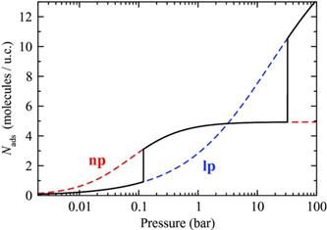

**Fig. 1 Adsorption isotherms computed at T = 300 K with Grand Canonical Monte-Carlo simulations in the np (dashed red) and lp (dashed blue) rigid structures. The full black line is a composite adsorption isotherm, featuring the breathing transitions calculated using an analytical model in the osmotic ensemble. Taken from Ref.3 ( Reproduced with permission of the American Institute of Physics)**

Previously[4] we have presented an exactly solvable statistical mechanical lattice model of a MOF using a transfer matrix method which treats the solid and gas component on an equal footing. Here we give an accurate transfer matrix treatment of a quasi-one dimensional statistical mechanical Osmotic ensemble model of pressure and adsorption and induced structural transitions in MOFs. The matrix eigenvalue problem required in evaluation of the Osmotic Potential is treated numerically which enables more realistic chemical and physical features to be incorporated than previously.

Our approach cannot compete with more computationally based methods which treat three dimensional crystals. However, exactly treated statistical mechanical models may provide novel insights into these phenomena.

It appears that the most useful ensemble to study adsorption in soft expandable materials is the osmotic ensemble2 devised originally by Brennan and Madden [5] and Panagiotopoulos[6]. The osmotic ensemble was developed for molecular simulation of MOF systems by Coudert and coworkers[7], [8],[9], [10], [11], [12], [13], 2,[14]. It is a special case of the Generalized Ensembles discussed by Hill[15]. The independent variables for this ensemble are the temperature, 𝑇, the number of unit cells of the adsorbing species, the mechanical pressure *σ* and the chemical potential of the adsorbed gas, 𝜇g. In this work the Osmotic Potential Ω= (*𝑈 − 𝑇 𝑆 + σ𝑉 – 𝜇g ng*) is proportional to the logarithm of the largest term in the Generalised partition function discussed below which can be equated without detectable error to the logarithm of the Generalised partition function. In our approach we evaluate the logarithm of the Generalised partition function exactly by a transfer matrix method and thereby provide an accurate route to the calculation of thermodynamic properties of the model.

Following others[16] we are assuming that the chemical potential *𝜇g*and mechanical pressure *σ* can be considered as decoupled independent thermodynamic control variables.

2. Matrix Treatment of Adsorption and Pressure Induced Large Pore to Narrow Pore Transition

We have chosen to focus on 4 types of energetically significant clusters, 1, 2, 3, and 4 shown in Fig.2a below**.**

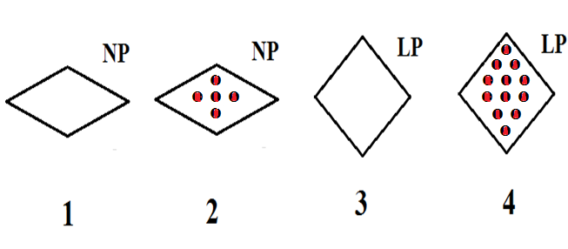

**(a)**

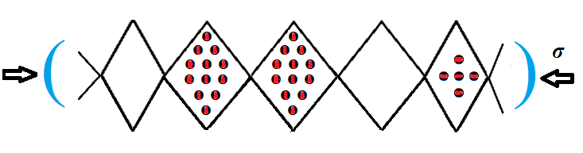

**(b)**

**Fig. 2 (a) Structures 1, 3 are the pure solid in the NP and LP states. As an example, species 4 contains solid and 12 adsorbed gas species in the LP state. Species 1 has undergone a transition to the NP state while species 2 is the NP state with 5 adsorbed gas molecules.**

(b) **An example of a typical configuration of a group of species -1-4-4-3-2- considered in the infinite quasi-one dimensional chain. The structure is subjected to a one dimensional pressure *σ* directed along the x-axis.**

We consider a strip of N groups of unit cells each of which may be in either the large pore (LP) or narrow pore (NP) state. Furthermore each individual NP cell can be occupied by  molecules and the LP unit cell by molecules. We have chosen to focus on 4 types of energetically significant clusters, 1, 2, 3, and 4 shown in Fig.2a below where as an easily depicted example= 5 molecules ,and = 12 molecules. A typical configuration of these is shown in Fig 2 b**.** The structure is subjected to a one dimensional mechanical pressure *σ* directed along the x-axis.

The gas species occupying the cells are assumed to be in equilibrium with a gas reservoir at chemical potentials *g*, and temperature T given by[17]  where the standard chemical potential is given by and where modification for non-ideal behaviour is straightforwardly achieved by replacing pressure by fugacity.***σ*** is set to equalto the gas pressure *P* if no external mechanical pressure is applied.

Matrix methods for statistical mechanical treatment of one-dimensional lattice fluid problems have been reviewed by us previously[18]. The Osmotic Partition function  for the mixture of 1,2,3,4 species along a line with N unit cells may be expressed as

 (1)

The double summation runs over the volume *V* and number of gas molecules *n*. is the Canonical partition function for volume *V* and *n* gas molecules. We will use the method of the maximum term in which the logarithm of the sum in equation (1) is replaced by the logarithm of the maximum term without making detectable error to terms of thermodynamic order of magnitude. Proceeding to identify the logarithm of the maximum term we have

 (2)

where the *V\** and *n\** represent the optimum values of *V* and *n*.

These *V\** and *n\** valuesmust simultaneously satisfy the extremum equations

 (3)

and  (4)

showing that using the method of the Maximum term the Osmotic ensemble has degenerated as expected into a Canonical ensemble and discussed for Generalized Ensembles by Hill15. The Osmotic potential used by Coudert and others discussed above is given by.

Thus we have

 (5)

This gives the thermodynamic relations

 and  (6)

where  will be evaluated by a transfer matrix method which we will now describe.

The Osmotic partition function equation (1) can written as the sum of the products of N factors (unit cells) given by

 (7)

where the sums run over the 4 possible species shown in Fig.2. Cyclic boundary conditions have been assumed where the lattice is folded on to a ring. As is usual in the matrix method[19] we define the terms in (7) as the product of an internal partition function for the cluster and an interspecies interaction term given by

 (8)

where subscripts *i,j* run over the species 1 to 4 and the parameter *Jij* is the interaction energy of nearest neighbour pairs of species *i,j*. The internal partition function for species 1 to 4 are given by









(9)

*Jgas* is the interaction energy between a pair of adsorbed gas molecules and Δ is the energy difference between the LP and NP states whose value is 5.216 k*T* (taken from16 ). are the LP and NP volumes whose values are 1400 and 1200 Å3 taken from Refs.[20],14. Treating methane and carbon dioxide in a spherical molecule approximation, *Jgas*= - 161 k and – 245 k respectively[21] where we have also estimated the number of pair interactions as  for molecules in the NP species and similarly for the LP species. The temperature in all calculations is 300 K.

Using the inner product rule  for matrix multiplication of a pair of conformable matrices **B** and **C** the Osmotic Partition function given in equation (7) can be expressed as:

 (10)

where  are the eigenvalues of the matrix **A** whichisgiven below as

 (11)

The eigenvalues of matrix **A** and subsequent differentiations were evaluated using mathematical software. The Mathcad[22] ‘eigenvals’ routine was used for eigenvalue extraction with finite difference calculation of derivitives.

As is usual in matrix evaluations of partition functions only the largest eigenvalue of **A** concerns us here since for large N equation (9) reduces to

 (12)

where  is the largest eigenvalue of the matrix **A** found using mathematical software.

The number of adsorbed molecules and system volume are given by



 (13)

Thus for a given gas phase pressure adsorption isotherms and pressure/volume relationships can be constructed using mathematical software21 for this exact one-dimensional model.

**3. Results and Discussion**

The only non-zero interaction parameters are *J12, J22*, *J44* defined below which we treat as effective semi-empirical parameters*.* All the remaining *Jij* values are zero while other values are defined above. The model displays the types of isotherm discussed below.

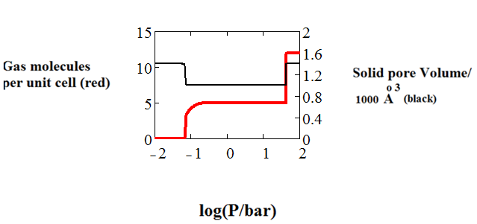

**Fig. 3 Theoretical isotherm calculated using exact matrix method for CO2 adsorption in MIL-53 at 300 K. The shape of the isotherm reflects the structural transitions shown above. *J12* = -10*kT* , *J22* = -15*kT* and *J44* = -30*kT.***

The isotherm in Fig. 2 initially shows adsorption (LP 🡪 NP) where the volume of the solid phase falls due to the gas take-up into the NP structure. This is followed by solid expansion (NP 🡪LP) as shown in Fig. 2. At higher gas pressures the structure reverts to the LP phase so that the structure breathes. The shape of the adsorption isotherm follows the general pattern seen in the results of Coudert and coworkers2 and Ghysels et al.16

The methane isotherm shape for Fig 4 reflects gas adsorption only into the LP structure as the NP structure is statistically insignificant for this isotherm with *J44* = -80*kT.* A further major cause of the differing sensitivities of the isotherms in Figs. 3 and 4 is the difference in the adsorption energy parameters  for CO2 and CH4 respectively. These are -20.5 kJ/mol and -37.9 kJ/mol for CO2 and -18.4 kJ/mol and -30.1kJ/mol for CH4 respectively as taken from ref16.

The shape of the adsorption isotherms reflects the competition between the potential for adsorption and the energy required for structural transformations as a driving force for the features in these two distinct types of adsorption isotherms.

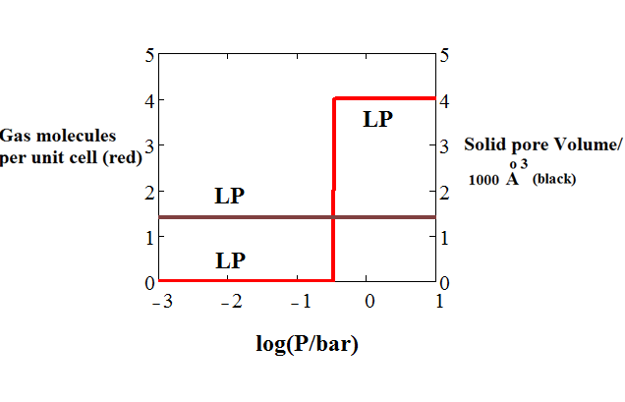

**Fig. 4 Theoretical isotherm calculated using exact matrix method for CH4 adsorption in MIL-53 at 300 K. The isotherm shape reflects gas adsorption only into the LP structure. The NP structure is statistically insignificant for this isotherm.** *J44* = -80*kT*

Intrusion experiments have been performed in which a powder is brought under isotropic stress reflected in the mechanical pressure *σ* in our theory. Beurroies at al.19 and later Neimark et al.14 observed a LP to NP transition at a pressure of 550 ± 150 bar. We have modelled this transition by calculating the solid volume as a function of the mechanical compression. Fig. 5 below shows compression of the structure, which in good agreement with the above results of Beurroies at al.19 and Neimark et al.14

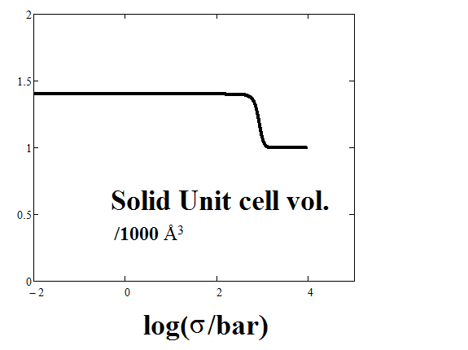

**Fig. 5 Theoretical Compression of MIL-53 calculated using exact matrix method. The transition reflects the LP -> NP transition at about 500 bar mechanical pressure.**

4. Conclusion

In this paper we have presented a one-dimensional statistical mechanical lattice model treated accurately using a transfer matrix method in the Osmotic ensemble. The model mimics adsorption and pressure induced structural changes in MOFs. Our approach is the first analytical treatment of the Osmotic ensemble. The model reproduces the experimentally observed gas and pressure induced structural changes in MOFs and is a step towards analytical statistical mechanical treatments of flexible frameworks.

The model reproduces successfully the breathing behavior upon CO2 adsorption caused by the stabilization of the narrow pore by CO2 molecules as seen in computer simulations. The first step in the adsorption isotherm corresponds to the uptake of CO2 (5 molecules per cell) and the accompanying transition LP 🡪 NP while a further uptake of another 7 molecules per cell (total adsorbed CO2: 12 molecules per cell) reverses the structural transition, NP 🡪 LP. The volume of the solid phase falls during the first step (LP 🡪 NP) followed by solid expansion during the second step at the NP 🡪 LP transition. The CH4 isotherm shape shows no breathing behaviour reflecting gas adsorption only into the LP structure as the NP structure is statistically insignificant for this isotherm with no corresponding solid volume change.

Finally, the model reproduces experimental and computational results of mechanical pressure (compression) induced LP 🡪 NP transition.

Our method is the first analytical treatment of the Osmotic ensemble which degenerates into the Canonical Ensemble using the method of the maximum term. It is a promising methodology towards analytical statistical mechanical treatments of flexible metal-organic frameworks. The model may easily be extended to mixtures and may aid the development of computer simulation studies by cheaply and rapidly giving insights into expected adsorption and mechanical properties.

Graphical Abstract

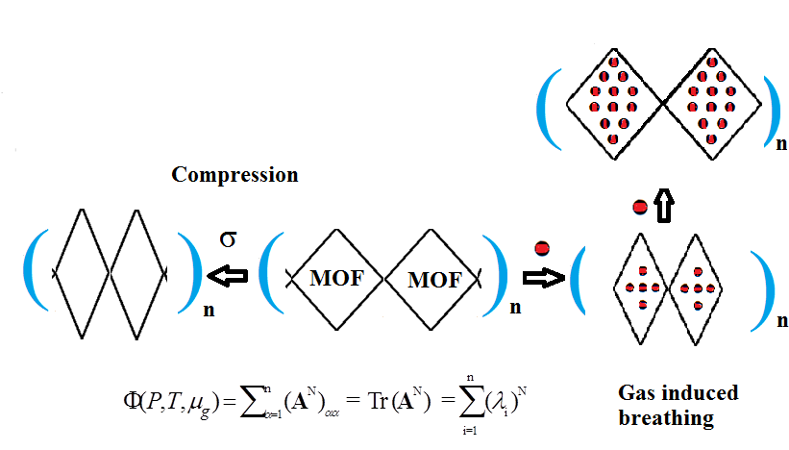

**References**

1. S. Horike, S. Shimomura and S. Kitagawa, *Nat. Chem.*,2009, **1**, 695.
2. D. Bousquet, F.-X. Coudert, A. G. J. Fossati, A. V. Neimark, A. H. Fuchs and A. Boutin, *J. Chem. Phys.*, 2013, **138**, 174706.
3. D. Bousquet, F.-X. Coudert, and A. Boutin J. Chem. Phys., 2012, 137, 044118
4. L. J. Dunne, and G. Manos, *Journal of Statistical Mechanics: Theory and Experiment*, 2015, P05008.
5. J. K. Brennan and W. G. Madden, *Macromolecules*, 2002, **35**, 2827.
6. A. Z. Panagiotopoulos, *Molecular Physics*, 1987, **61**, 813
7. F.-X. Coudert, M. Jeffroy, A. H. Fuchs, A. Boutin, and C. Mellot-Draznieks, *J. Am. Chem. Soc.* 2008, **130**, 14294.
8. F.-X. Coudert, C. Mellot-Draznieks, A. H. Fuchs, and A. Boutin, *J. Am.Chem. Soc.*, 2009, **131**, 3442.
9. F.-X. Coudert, *Phys. Chem. Chem. Phys.,* 2010, **12**, 10904.
10. A. Boutin, M.-A. Springuel-Huet, A. Nossov, A. Gedeon, T. Loiseau, C. Volkringer, G. Férey, F.-X. Coudert, and A. H. Fuchs, *Angew. Chem., Int. Ed.*, 2009, **48**, 8314.
11. A. Boutin, F.-X. Coudert, M. A. Springuel-Huet, A. V. Neimark, G. Férey, and A. H. Fuchs, *J. Phys. Chem. C*, 2010, **114**, 22237.
12. A. Boutin, S. Couck, F.-X. Coudert, P. Serra-Crespo, J. Gascon, F. Kapteijn, A. H. Fuchs, and J. F. M. Denayer, *Microporous Mesoporous Mater.*, 2011, **140**, 108.
13. A. U. Ortiz, M. A. Springuel-Huet, F.-X. Coudert, A. H. Fuchs, and A. Boutin, *Langmuir,* 2012, **28**, 494.
14. A. V. Neimark, F.-X. Coudert, C.Triguero, A. Boutin, A. H. Fuchs, I. Beurroies and R. Denoyel, *Langmuir*, 2011, **27**, 4734.
15. T. L., Hill, *Statistical Mechanics*; McGraw Hill, New York, 1956.
16. A. Ghysels, L. Vanduyfhuys, M. Vandichel, M. Waroquier, V. Van Speybroeck and B.Smit *J. Phys. Chem. C*, 2013, **117**, 11540
17. T. L. Hill, *An Introduction to Statistical Thermodynamics*; Addison-Wesley: New York, U. S. A., 1960.
18. Dunne, L. J.; Manos, G. (Eds), *Adsorption and phase Behaviour in Nanochannels and Nanotubes*, Springer: Dordrecht, The Netherlands, 2010.
19. L. J. Dunne, G. Manos, Z. Du, *Chem. Phys. Lett.*, 2003, **377**, 551.
20. I. Beurroies, M. Boulhout, P. L. Llewellyn, B. Kuchta, G. Ferey, C. Serre, R. Denoyel, *Angew. Chem. Int. Ed.* 2010, **49**, 7526
21. M. Rigby, E. B. Smith, W. A. Wakeham, G. C. Maitland, *The Forces Between Molecules*, Oxford University Press, Oxford, 1986
22. Mathcad 15, Parametric Technology Corporation, 140 Kendrick Street, Needham, MA 02494 USA