Domestic Refrigerator Design – Safety Issues and Opportunities
M Beasley*, PG Holborn**, JM Ingram**, GG Maidment**

*London Fire Brigade
**London South Bank University

Abstract
There are around 300 house fires in Great Britain each year where a fridge or freezer is cited as the cause. This paper describes the examination of evidence of domestic fires in London between 2005 and 2015 where fridges or freezers have been cited as the fire source. It describes the generic reasons for the cause and spread of the fire and potential ways of constructing and using fridges and freezers to significantly reduce the risk, spread and consequences of these fires.

1. Introduction

Over the past decade around 300 domestic fires in Great Britain have occurred each year, where the cause was found to be a fridge or freezer [1]. A number of these incidents have resulted in injuries/fatalities and produced significant levels of property damage. It is therefore extremely important to analyse such incidents and understand the underlying ignition and fire spread mechanisms that have led these fires to occur.

This paper describes the examination of evidence of domestic fires collected via fire investigation in London between 2005 and 2015 where fridges or freezers have been cited as the fire source. A comparison is made between the severity of fridge/freezer fires and fires caused by other comparable types of domestic appliance (washing machines, dishwashers and tumble dryers). The generic reasons for the cause and spread of the fire and potential ways of constructing and using fridges and freezers that could be used to reduce the risk, spread and consequences of these fires are also examined.

2. Method

London Fire Brigade (LFB) attends around 10% of all the fires in the UK [2] and around 20% of the recorded appliance fires. LFB first setup a dedicated fire investigation team in 1983. Since that time specialist fire investigation officers have been available to assist the incident commander in determining the origin and cause of a fire. By their very nature LFB fire investigators tend to attend the most significant and severe fire incidents. They also have a number of criteria that mandate their attendance at a fire incident, including any fire involving an injury or fatality or where the cause is unknown.

The range and usefulness of the data collected by LFB fire investigators was originally recognised during the mid-1990s, which led to the creation of a Real Fire Library (RFL) database. This was used to organise and store the information collected from LFB fire investigations, until 2008, when it was superseded by the Incident Information Management System (IMS). The data collected into the RFL has also formed the basis of a number of research studies into fire safety [3-5].

Through the recording of details from fires over previous years, LFB fire investigation data has provided access to the specific details of many case histories for incidents involving domestic refrigerators. Many of the incidents have resulted in samples being removed and examined by forensic scientists. For example, samples of starter switches have been removed and photographed from over 300 appliances to provide a comprehensive database of compressor switches that can be analysed to obtain information on failure modes and causes of fire in domestic fridges. This information collected over the past decade has been used here to identify possible ignition and fire spread mechanisms occurring in fridge and freezer fires.

Part of the research also involved regular visits to local authority re-cycling yards where permission had been given to examine refrigeration appliances. The condition of a number of appliances - e.g. defrost switches were examined and recorded and used to provide additional insight into possible ignition mechanisms.

3. Results

3.1 Common failures leading to ignition

Based upon an analysis of LFB fire investigation of a larger number of incidents the following common failure modes leading to ignition in domestic refrigeration fires (see Figure 1.) have been identified:

(i) Starter relays

Earlier models of fridge/freezer employ a starter relay attached to the compressor. This allows current to pass to the start windings of the compressor. Once the compressor starts to run, the relay opens, cutting off the current, and the compressor then functions independently. The failure of a start relay typically results in severe heating to the coil assembly and external heat damage to the adjoining cabling. This failure mechanism has been recorded for many years. Since the switch to PTC starters the number of incidents together with the often limited amount of resulting damage means this fire cause is now less common and in decline.

(ii) PTC starter switches

The starter switch normally consists of PTC (positive thermal coefficient) ‘pill’ housed in a plastic body containing the electrical connections. The pill functions as a conductor until it reaches a temperature (around 120°C) above which it becomes a resistor. Hence the pill functions as a temperature switch. Over time degrading of the pill can occur, until it eventually breaks or splits. Arcing can then take place which is sufficient to melt the metal contacts within the switch.

(iii) Mechanical defrost switch failures

The defrost switch is mounted externally, at the rear of the appliance. The defrost timer housing has a small adjusting hole near its base for manually setting/adjusting the timer. Water penetration into the switch casing can produce severe arcing to the switch contacts. The external switch cover is constructed of fire resisting plastic but the cogs within the switch have a high nylon content and will readily burn. Once the cover has distorted and started to melt, the internal components are then exposed to the atmosphere the switch components will burn and spread the fire to the switch cover and to the appliance insulation.

(iv) Capacitor failures

Capacitors have been fitted to almost all modern refrigeration appliances since around the year 2000. Positioned within the same lower section of refrigeration appliances, its function is normally to either provide a start or run facility which smooths out electrical supply imbalances to the compressor. It is usually located to the left of the compressor although it may also be found mounted adjacent to the compressor start switch. During its lifetime the capacitor will be subjected to various types of stress which can cause it to age and eventually fail, including – over-voltages, over-heating, pollution, humidity, radiation, and vibrations. A capacitor failure can range from a simple failure of its circuitry leading to a slow melting and degrading to form char, to a dramatic and violent ignition or pressured eruption.

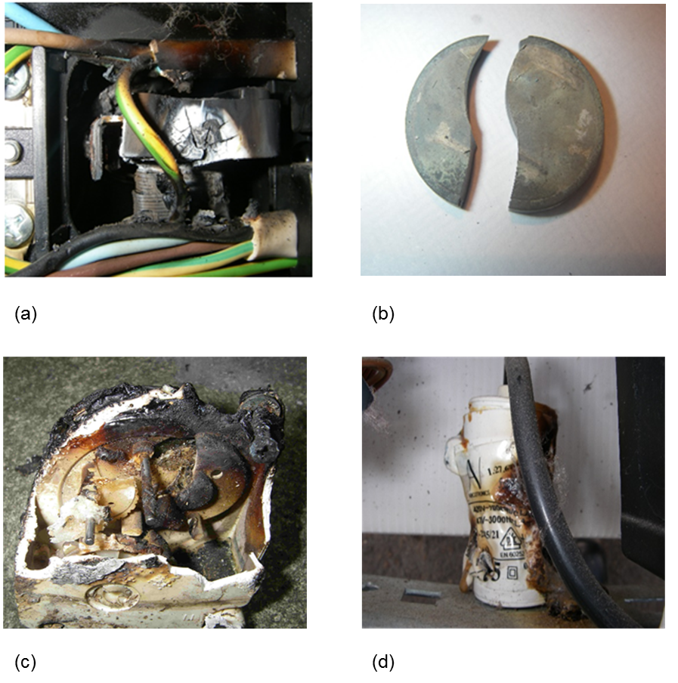
Figure 1. Examples of ignition sources in refrigeration fires: (a) starter relay; (b) PTC switch; (c) mechanical defrost switch; (d) capacitor.

3.2 Degree of fire spread by appliance type

Figure 2 breaks down the number of appliance fires recorded by LFB (2008 – 2015) by appliance type and degree of fire spread. Comparing the four different appliance types, the results suggests that refrigeration fires result in the greatest risk of fire spread following ignition. Thus, although there were more washing machine fires overall, most remained localised to the first item ignited. By comparison a far greater number of fridge/freezer fires spread beyond the first item, to affect the room and floor of origin and the building as a whole.
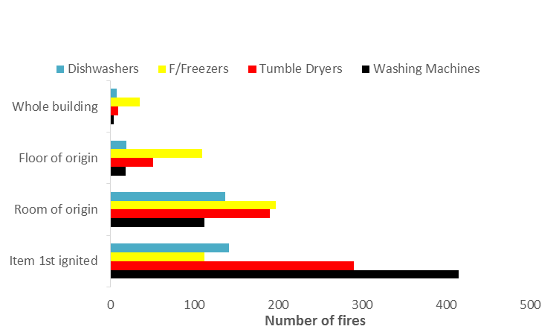
Figure 2. Number of LFB domestic appliance fires categorised by degree of fire spread and appliance type

4. Discussion

The refrigeration appliance is almost unique in its domestic setting as it is one of the few appliances which runs continuously and is not designed to be isolated at night or when left unattended. Hence, it is extremely important that domestic refrigerators be designed and manufactured so that not only the chance of fire is very low, but that should a fire occur it then remains contained within the appliance and not be able to spread. However, the results from section 3 suggest that not only are there a number of potential ignition mechanisms for fridge/freeze fire which are occurring in practice, but that a higher proportion of fires in fridge/freezers spread beyond the first item than is the case for the other types of appliance.

4.1 Escalation and fire spread mechanisms

Why do fires in fridge/freezer appear to escalate and spread more readily? Observations taken from LFB fire investigation would suggest that changes in fridge/freezer construction materials and design with time (in the UK) have resulted in a more flammable construction, where faults or failures are more likely to produce a significant fire. Based upon the results of these investigations, the following fire escalation and spread mechanisms have been identified:

(i) Plastic Drip Trays

For many years, the evaporation tray housed on top of the compressor was made of thin metal. Its function was to retain any condensate water until it evaporated. However these trays would often rust and allow water to be displaced onto the compressor and on to the kitchen floor. The manufacturer’s response was to replace the trays with plastic variants. The problem now is not only do the trays fail as before, but the material is extremely flammable providing both a rapid flame front and burning droplets, that will increase the initial fire loading to and promote flame spread to the appliance insulation.

(ii) Twin Wall Backing Materials

The steel metal backs used in older fridge/freezer designs have slowly been replaced by a silvered cardboard or foil barrier covered by polyurethane or more recently a ‘twin wall’ polyethylene / polypropylene panel. Fire tests have revealed that “twin wall” backing materials become ignited very easily and then promote extremely rapid flame spread to involve insulation panels, whilst producing intense heat and large volumes of toxic smoke [6].

(iii) Polyurethane Foam Insulation Panels

The early slab constructed internal insulation panels have now been replaced by blown hydrocarbon foams. The materials currently in use are officially classified as highly flammable and hazardous waste when sent for disposal. Fire tests have shown that such rigid polyurethane foam insulation offers little resistance to ignition and burns very rapidly, generating high heat release rates. There are also extensive quantities of such materials present in a typical refrigerator creating a high fire load [6].

4.2 Comparison between the UK and USA

Figure 3 shows a comparison between the number of fires and casualties due to refrigeration appliances in the USA [7] and UK from 2006 to 2010. It is evident that, although there was approximately five times the number of refrigeration fires in the USA (to be expected since the population of the USA is roughly five times that of the UK) recorded in that time-period, the number of resulting fire casualties was actually higher in the UK. This data suggests that a significant difference exits between the two countries with regard to the occurrence of severe refrigeration fires. Why?

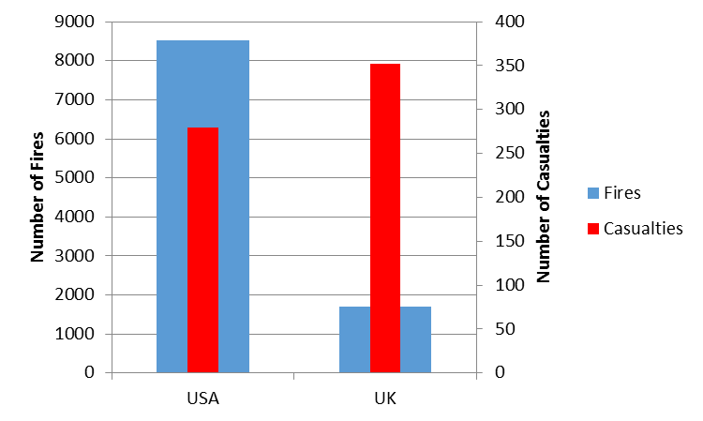
Figure 3. Comparison between the USA and UK – Number of Refrigeration Fires and Casualties from Refrigeration Fires 2006–2010.
A comparison between the two countries suggests that a number of significant differences in refrigerator appliance design and construction have arisen. For example refrigerators in the USA still have a largely steel construction (casing and back wall) and use metal drip trays. They also tend to use high quality components (e.g. capacitors) and have a policy of surrounding potential ignition sources in metal box containments, isolating then from other flammable items.

In the UK (and EU) the only real driver for improving the fire safety design of appliances is to legislate through changes to standards. The failure of electrical components is always a possibility - the resulting fire growth following a failure is also predictable. The solution is often financially achievable, but it falls to standards to determine and set the changes. European standards are largely controlled and set by manufacturers and their representatives, placing a potential impediment to change. In contrast, in the USA design and regulation of refrigerators is driven by the insurance industry (via the Underwriters Laboratory) and threat of litigation. This difference in regulatory system would appear to be the most likely explanation for the the differences in refrigerator appliance design and construction that are seen between the UK and USA.

4.3 Measures for reducing the risk

Consideration of the potential ignition sources and escalation mechanisms observed during LFB fire investigations and the differences in UK and USA fridge/freezer construction suggests that the following design measures could be used by manufacturers to reduce the likelihood and severity of fridge/freezer fires:

- Using high quality standard components (e.g. capacitors)
- Containing potential ignition sources in metal boxes
- Using metal drip trays
- Using fire retardant added to insulation foam or applied to insulation surfaces
- Fitting a non-combustible or fire retardant covering at the back of the appliances

5. Conclusion

The generic reasons for the cause and spread of domestic refrigeration fires have been examined using information obtained from LFB fire investigations over the past decade.

Analysis of these incidents suggests that fires caused by fridge/freezers exhibit a higher degree of fire spread than other types of appliance (washing machine, dishwasher or tumble dryer). There is also evidence to suggest that severity of refrigeration fires in the UK is significantly higher than in the USA. The reason for the severity of these fridge/freezer fires can be attributed to a combination of components that can fail and act as an ignition source, located in close proximity to an extensive source of flammable material which can burn readily and spread the fire.

A number of common failure modes leading to ignition in domestic refrigeration fires have been identified: (i) starter relays; (ii) PTC switches; (iii) mechanical defrost switches; and (iv) capacitor failures. Specific fire escalation and spread mechanisms have also been identified: plastic drip trays, twin wall backing materials and polyurethane foam insulation panels.

Based on information obtained from LFB fridge and freezer fire investigations, and a comparison between the design and construction of refrigeration appliances used in the UK and USA, a number of design measures have been suggested which could be used by manufacturers to significantly reduce the risk of fire e.g. putting a simple non-combustible or fire retardant covering at the back of fridge and freezer appliances.

References

[1] Department for Communities and Local Government, Fire Statistic Great Britain, (2005 – 2015).

[2] Office of the Deputy Prime Minister, Fire Statistics (UK) 2002-2004, 3 year average (2004).

[3] Holborn, PG, Nolan, PF, Golt, J, Townsend, N, Fires in workplace premises, Fire Safety Journal, 37:303-327, (2002).

[4] Holborn, PG, Nolan, PF, Golt, J, An analysis of fatal unintentional fires investigated by London Fire Brigade between 1996 and 2000, Fire Safety Journal, 38:1-42, (2003).

[5] Holborn, PG, Nolan, PF, Golt, J, An analysis of fire sizes, fire growth rates and times between events using data from fire investigations, Fire Safety Journal, 39:481-524, (2004).

[6] Vaughan-Davies A, Refrigeration Appliances – Ignitability, Flammability and Toxicity of refrigeration appliance back panel plastic and its insulation when involved in fire, London Fire Brigade Fire Investigation Research Report, (2012).

[7] Hall, JR, Home structure fires involving kitchen equipment other than cooking equipment, National Fire Protection Association, (2012).

