MODELLING AND DEVELOPMENT OF SUSTAINABLE REFRIGERATED ROAD TRANSPORT SYSTEMS

Christina FRANCIS(*), Gareth DAVIES(*), Judith EVANS (*), Pat MAUGHAN (**), Jed SHERWOOD (**), Graeme MAIDMENT(*)
(*) London South Bank University, 103 Borough Road, London, SE1 0AA, UK
francc17@lsbu.c.uk
(**)Hubbard Products Limited, Hillview, Church Road, Otley, Ipswich, Suffolk, IP6 9NP, UK

ABSTRACT
Refrigerated road transport (RRT) vehicles are large users of energy, and reportedly have relatively high leakage of hydrofluorocarbon refrigerant gases, both of which contribute to global warming. The experience obtained from widespread research in leak reduction in stationary refrigeration systems can be instructive in combatting leakage in RRT systems, which has received less focus to date. This paper will take an integrated approach to develop and describe a preliminary model for sustainable RRT systems. It will first review lessons learned about refrigerant leakage in stationary systems in an effort to identify problematic/leak prone components common to transport refrigeration systems. This will then be followed by a survey of recent studies conducted in modelling transport refrigeration systems to advance energy efficiency. Initial results from the model illustrate the need to improve the efficiency of the refrigeration system, together with preventative maintenance of the box structure and refrigeration system as a whole.
- INTRODUCTION
Primary food distribution by refrigerated road transport (RRT) in the UK uses up to 37% more energy than comparable non-refrigerated vehicles (Tassou et al., 2009), and other published sources imply that RRT vehicle engines alone account for 2 Mtonnes carbon dioxide equivalent emissions (CO₂e) in the UK i.e. equal to 2 % of the total emissions from the UK road sector (AEA Technology, 2005 and McKinnon et al., 2003). Field data provided by Hutchins (2007) revealed that the average fuel consumption of RRT systems varied between 15-25% of the engine fuel consumption irrespective of the vehicle class (cited in Tassou et al., 2009). Heap (2003) considered that up to 50% energy savings could be achieved for chilled goods transport, by means of efficiency improvements.

Annual service charge requirements reported for RRT units were approximately 10-30% of the total refrigerant charge for each system based on refrigerant type (UNEP, 2011). In terms of hydrofluorocarbon (HFC) refrigerant use by mass in the transport refrigeration sector, RRT has the largest segment accounting for 68%, followed by intermodal containers (i.e. combined rail/sea and/or road transport) (19%) and sea vessels (13%) (Öko-Recherche GmbH et al., 2011). RRT was also responsible for 75% of the total annual HFC refrigerant emissions of the transport refrigeration sector (UNEP, 2011). This is significantly higher than the proportion of refrigerant used by sector (i.e. 68%) which suggests higher refrigerant losses than for other refrigerated transport sectors. Furthermore, it is projected that this sector of the industry will continue to grow. The total world fleet of RRT vehicles was estimated at 4,000,000 units in 2010 consisting of vans, small and large trucks and trailers (UNEP, 2011). This is a very large increase of 300% since the 2002 estimate of 1,200,000 units (UNEP 2003). In 2012, it was estimated that approximately 1,100,000 RRT vehicles were operating within 27 countries in the European Union (Michineau et al., 2014). Peters, (2014) indicated that there were more than 80,000 RRT vehicles operating in the UK with an annual growth rate of approximately 10%. Additionally, according to the industry body IGD (The Institute of Grocery Distribution), the online UK food and grocery market was valued at £6.5 million in 2013 and is expected to be worth £14.6 billion by 2018 (Barford, 2014). This implies a rise in demand for last mile refrigerated vehicles which are normally used for tertiary distribution, through “click and collect” and “home deliveries”.

A range of studies have been directed towards modelling RRT systems to improve their performance and reduce energy consumption. Besides the indirect carbon emissions generated through operating the refrigeration unit and its extra weight, there is concern for direct carbon emissions due to leakage of HFC refrigerant gases, which also contributes to global warming and climate change. The revised European F-Gas regulations now require operators of refrigerated trucks and trailers to record refrigerant leakage, and operate leak tight and efficient systems. The experience obtained from widespread research in leak reduction in stationary refrigeration systems can be instructive in combatting leakage in RRT systems, which has received less focus to date. This paper presents recent research and development of a refrigerant leakage analysis tool and a mathematical model for evaluation of the indirect carbon emissions from a RRT system.
- REFRIGERANT LEAKAGE AND ANALYSIS TOOL
It has been suggested that a leak tight stationary refrigeration system typically should not leak more than 10- 20% of its original charge to affect system performance, throughout its lifetime of 20 years (Bostock, 2007). However, large stationary refrigeration systems have been reported to have leak rates of up to 30% per annum (Bostock, 2007) especially if they have not been regularly maintained. The RRT unit lifetime is usually 10-15 years and it is estimated that 10% of the HFC refrigerant charge on average is lost per year. This can result from small leaks, total charge losses due to ruptures, service losses and end of life losses (UNEP, 2011). Refrigerant leakage in transport systems is considered to be more problematic due to the greater vibrations and shocks experienced relative to stationary systems. As such, it may be considered that the published 10% leak rate for HFC gases for RRT systems may not reflect actual experience.

Extensive research by various authors has identified a range of reasons for leakage, and common sites for leaks, in air conditioning and refrigeration systems (Francis, 2010). For example, the UK led REAL Zero Project entailed investigation into the causes and solutions of refrigerant leakage. The study by Francis, (2010) suggested that the most frequently occurring fault locations e.g. flared joints, flanged joints, Schrader valves, and other valves/glands in stationary systems, were generally located in the compressor pack or high pressure liquid line. These components are also found in RRT vehicles with vapour compression (VC) systems.

Using an approach similar to Francis, (2010), an initial model has been developed to analyse historical service maintenance records for RRT systems. Microsoft Excel was used to create a list of pre-defined questions which essentially capture key information from the maintenance incident-record. The Excel spreadsheet tool then appropriately itemizes and maps each fault or refrigerant leakage incident reported according to the type of fault; into one of 4 distinct categories (i.e. compressor, evaporator and expansion valve, condenser and miscellaneous) as well as to the components within the RRT system. As a result the data can be easily sorted to determine where leaks or faults are commonly found. Subsequently, a statistical analysis will be performed to determine frequency (%) and total refrigerant mass added (kg) of the following: per fault category-type; per fault location-refrigeration system level; per fault location-refrigeration component level; and yearly comparison of the refrigerant leakage data. An initial analysis of 365 RRT service maintenance records showed that the bulk of the faults i.e. approximately 40% were located within the refrigeration system condenser. A further analysis of the faults within the condenser was conducted. Figure 1 illustrates a breakdown of the major components fault locations within the condenser.
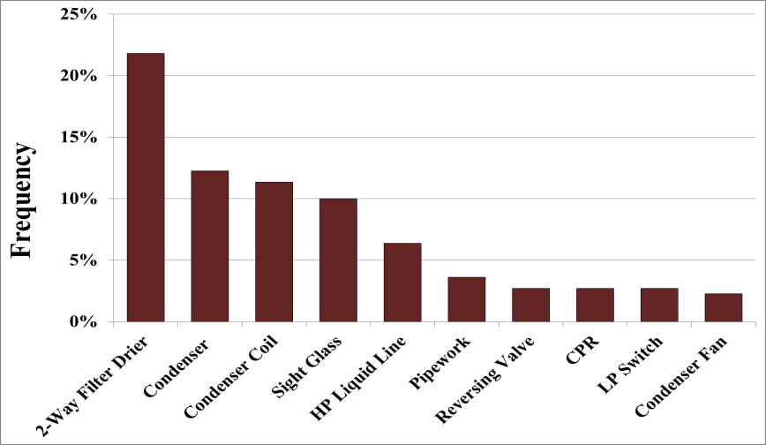
Figure 1: Breakdown of major fault components within condenser

It is anticipated that future results from the study will uncover strategies to reduce refrigerant leakage by examining common leaks associated with RRT systems and building upon the lessons learned from previous leak reduction projects in stationary systems.
- RRT PERFORMANCE MODELS
James et al., (2006) provided a review of various models of food transportation systems. One such model was the CoolVan program which was developed to predict the food temperature inside a refrigerated delivery vehicle during multi-drop deliveries. Simulated results were expressed as the average rate of heat extracted over the total journey time and were verified against measured data from a real delivery round. Rachek et al., (2010) developed a numerical model in the Dymola-Modelica Language that performed dynamic simulation of a truck compartment coupled with a VC refrigeration unit which also included an analysis of the thermal bridges. The predicted results were consistent in determining the compressor power and cooling capacity against time. It also demonstrated that the heat and mass transfer during the door openings were the predominant heat loads.

Thermosys is a MATLAB/Simulink toolbox that models the VC cycle using a moving boundary method which has been applied to transport refrigeration systems (Jain, 2009 and Li, 2009). Thermosys models are capable in simulating the transient behaviour when switching between cooling/heating modes (Li et al., 2012), stop-start cycling operations (Li, 2009) and VC-hybrid configurations for RRT systems (Fasl, 2013). However, these models use a small time step and are mainly used for the development of advanced controllers. As such, they may not be ideal for long term dynamic simulation of refrigeration systems.

Cavalier and Stumpf (2010), highlighted the need for engineers to optimize the refrigeration units in their different operation modes in order to maximize energy savings. They outlined a range of methods to measure and simulate the real energy consumption of a RRT vehicle. These methods included: the evaluation of the refrigeration system’s fluctuating operation modes (i.e. pull-down, start-stop, continuous run, heating and defrost) against the vehicle road profile for a long distance or urban distribution; direct measurement of the fuel consumption of RRT systems under partial load conditions, as opposed to only full-load tests; and development of an energy consumption calculation tool.

Several methods have been used to evaluate the global warming impact of refrigeration systems. Wu et al., (2013) developed a carbon footprint model for RRT vehicles whilst Nasuta et al., (2014) developed a Life Cycle Climate Performance (LCCP) model. Although Wu’s model was capable of analysing the influences of ambient temperature, refrigerant type, refrigeration temperature, lifetime and refrigerator drive mode on the carbon foot print, it did not appear to incorporate direct calculation of the actual energy consumption of the unit during different refrigeration operation modes. However, the model considered the annual vehicle speed distribution and engine efficiency at the given speeds. In contrast, Nasuta’s model included a fuel consumption modelling tool which predicted the energy consumption based on the system operation i.e. vehicle running schedule, weather data, box structure, cooling load, varying heat loads etc. Case study results from Nasuta’s model showed that indirect emissions dominated overall total emission contributions which was similar to the outcomes of Wu et al., (2013). The highest observed percentage of direct emissions was 42% of the total emissions (using a leakage rate of 50%) in Nasuta et al’s study. Nasuta recommended more research to better estimate reasonable refrigerant leakage rates for transport refrigeration applications. Despite the advantages of Wu’s and Nasuta’s models in assessing effective ways of reducing carbon emissions for RRT vehicles; these models are not readily available.

Even though many researchers have made key contributions to the development of methods for evaluating the performance of RRT systems, there has been limited research that offers technical advice to transport fleet operators on sustainable strategies for decreasing the total cost of ownership in relation to carbon emissions. Also, despite the fact that energy labelling was suggested many years ago (Panozzo 1999), it has not been fully implemented by the industry. Fleet owners need guidance in assessing the true energy performance of different transport refrigeration systems before purchase. The present model focuses on estimating the energy consumption of the UK’s last mile refrigerated vehicles. Moreover, it is anticipated that the proposed RRT refrigerant leakage study and analysis described in the last paragraph of section 2 will reveal practical estimates of the annual rate of leakage which will be incorporated in the model.
- PRELIMINARY MODEL OF A RRT SYSTEM
In tandem with the RRT refrigerant leakage study and analysis, a preliminary mathematical model for a typical last-mile RRT vehicle (i.e. small vans to medium rigid refrigerated trucks) used for urban distribution was developed in Microsoft Excel. Steady state calculations of a refrigerated box were executed to determine the relative proportion of the various heat loads that contribute to the indirect carbon emissions of RRT systems. This initiative was conducted in an effort to appreciate the contributing factors affecting the overall system performance, with the main focus on options for energy reduction. A description of the preliminary model and results are outlined below.
  - Preliminary Model Description for Indirect Carbon Emissions
For the preliminary steady state model the following heat loads were considered, in order to approximate the total refrigeration load for a given journey or trip. The corresponding indirect carbon emissions of the refrigeration system were also calculated.

- The transmission load through the walls of the refrigerated box, ${\dot{q}}_{walls}$ was calculated using equation (1)
$${\dot{q}}_{walls}=UA (∆T+T_{s})$$ | (1)
where,
A = surface area of the wall [m²]
ΔT = temperature difference across the refrigerated wall [K]
T_{s} = solar temperature increase [K] (as detailed in Chapter 24 of ASHRAE, 2010)
and
U, the overall heat transfer coefficient was calculated using equation (2)
$$U=\frac{1}{\frac{1}{h_{i}}+\frac{x}{k}+\frac{1}{h_{o}}}$$ | (2)
where,
x = wall thickness [m]
k = thermal conductivity of wall material [Wm⁻¹K⁻¹]
h_{i} = inside surface heat transfer coefficient [Wm⁻²K⁻¹]
h_{o} = outside surface heat transfer coefficient [Wm⁻²K⁻¹]

An average aging rate of 5% per year for the thermal insulation (Tassou et al., 2009) was used in the calculation. A value of 6 Wm⁻²K⁻¹was estimated for h_{i}, while h_{o} was determined by equation (3) Earle, (1983), which is based on the relative wind speed, v in m/s according to the vehicle speed and direction.
$$h_{o}=7.4v^{0.8} for 5<v<30 ms^{-1}$$ | (3)

- The natural infiltration load due to heat leakage through the gaps and cracks of the refrigerated box, ${\dot{q}}_{gaps_cracks}$ was calculated by estimating the latent and sensitive load using equation (4). From previous studies, the infiltration rate through gaps and cracks varies linearly with the transport speed (Gigiel, 1997 and Xie et al., 2011). Empirical values for the infiltration rate of 1.118*10⁻⁵ m³s⁻¹ per kph was used for a new vehicle while 2.236*10⁻⁴ m³s⁻¹ per kph was used for an old poorly maintained refrigerated vehicle (Gigiel, 1997).
$${\dot{q}}_{gaps_cracks}={{\dot{m }}_{air}[(C}_{p_ air}∆T)+{(X}_{inf}{-X}_{r})*(l_{v}+l_{i})]$$ | (4)
where,
${\dot{m }}_{air}$ = mass flow rate of air [kgs⁻¹]
$C_{p_air}$= specific heat capacity of air [Jkg⁻¹K⁻¹]
$X_{inf}$ = humidity ratio of the infiltrated or outside air [kgH₂O (kg air) ⁻¹]
${ X}_{r}$ = humidity ratio of the refrigerated air [kgH₂O (kg air) ⁻¹]
${ l}_{v}$ = latent heat of vaporization for water vapour [Jkg⁻¹]
${ l}_{i}$ = latent heat of fusion for ice [Jkg⁻¹]

- The infiltration load due to door openings of the refrigerated box, ${\dot{q}}_{door}$ was calculated iteratively (using a time step of 1 second) using the Gosney and Olama, (1975) air exchange equation outlined in Chapter 24 of ASHRAE, (2010).

- The product load inside the refrigerated vehicle, ${\dot{q}}_{pr}$ was estimated using equation (5)
$${\dot{q}}_{pr}=\frac{m_{pr}C_{p_pr} (T_{box }-T_{pr_loaded }) }{Operational time (hrs)*3600} + {\dot{q}}_{r}$$ | (5)
where,
$m_{pr}$ = mass of product [kg]
${ C}_{p_pr}$ = specific heat capacity of the food/ product [Jkg⁻¹K⁻¹]
$T_{box }$ = temperature of the box [K]
${ T}_{pr_loaded}$= temperature of the loaded product [K]
${\dot{q}}_{pr}$= rate of heat generation (respiration) for perishable food product [kW]

- Other loads included within the refrigerated box such as the evaporator fan loads. The evaporator fan loads ${\dot{q}}_{e_fans }$were calculated using equation (6)
$${\dot{q}}_{e_fans }=(N*V*I)/μ_{e_fan}$$ | (6)
where,
$N$ = number of fans
$V$ = supply voltage [V]
$I$ = input current [A]
${ μ}_{e_fan}$= evaporator fan motor efficiency, %

Hence the total refrigerated load, ${\dot{Q}}_{T }$was approximated using equation (7):
$${\dot{Q}}_{T }={\dot{q}}_{walls}+{\dot{q}}_{gaps_cracks}+ {\dot{q}}_{door}+{\dot{q}}_{pr}+{\dot{q}}_{e_fans }$$ | (7)

The total refrigeration load was then equated to the evaporator load and the coefficient of performance (CoP) of the refrigeration system was used to calculate the compressor work. The total fuel used for refrigeration was determined by the average journey time and the energy content of the specified fuel. The carbon emission factor of the fuel was subsequently used to estimate total carbon emissions for the journey.
  - General Assumptions and Limitations

For the analysis, a number of assumptions were made in order to compare the heat load distribution of a single temperature frozen refrigerated truck (operating at -20ºC) with that of a chilled refrigerated truck (operating at 5ºC). A medium sized rigid truck with a loading volume of 8.5 m³ was used for the analysis, in each case. It was assumed that the truck was conducting multi-drop deliveries in an urban location with an average speed of 32 kph with 4 door openings per hour. The duration of each door opening was for approximately 4 minutes and a total journey time of 6 hours per day was assumed. It was also assumed that the vehicle was operational for a total of 288 days for the year. Summer and winter weather conditions in London were used for the analysis. A comparison of the heat loads was conducted for a 5 year old poorly maintained refrigerated truck against those for a new truck. In addition, a product mass of 1,200 kg of select beef, at a temperature of 2 ºC higher than that for the refrigerated box was assumed to be initially loaded in the truck. A CoP of 0.5 was used for the frozen RRT system whereas a CoP of 1.5 was used for the chilled RRT system (Tassou et al., 2009). The overall efficiency for the direct drive mechanism was assumed to be 50% and a fuel consumption rating of 10 litres/100 km for the vehicle was used.

The preliminary model is a steady state model and does not account for the variation in the weather conditions throughout the day, the variety of products being loaded and off-loaded as well as whether the vehicle is in traffic or otherwise. Moreover, the added heat load due to to rise in the product temperature after each door opening was not included in the model. These factors will in turn affect the operational mode of the refrigeration system which will depict the actual energy consumption.
- RESULTS AND DISCUSSION
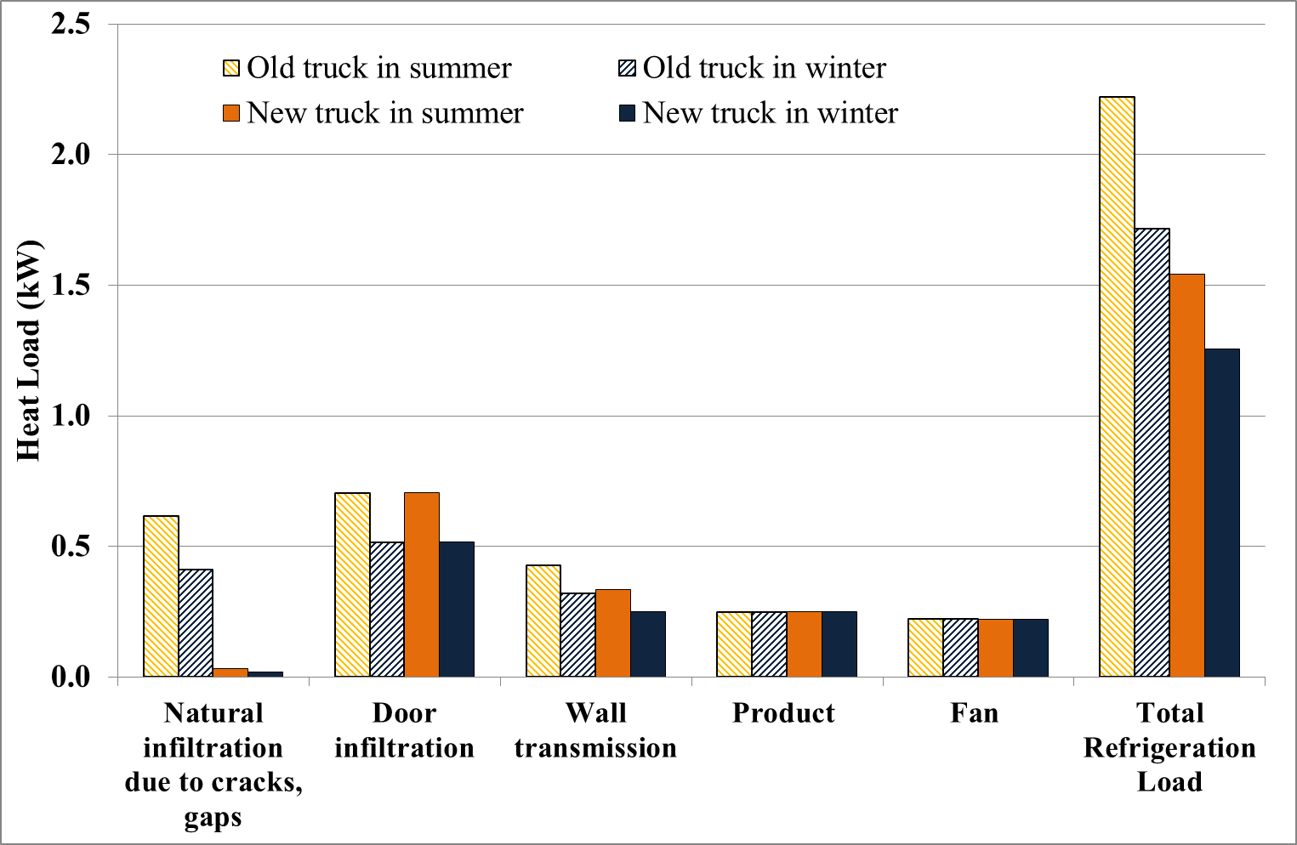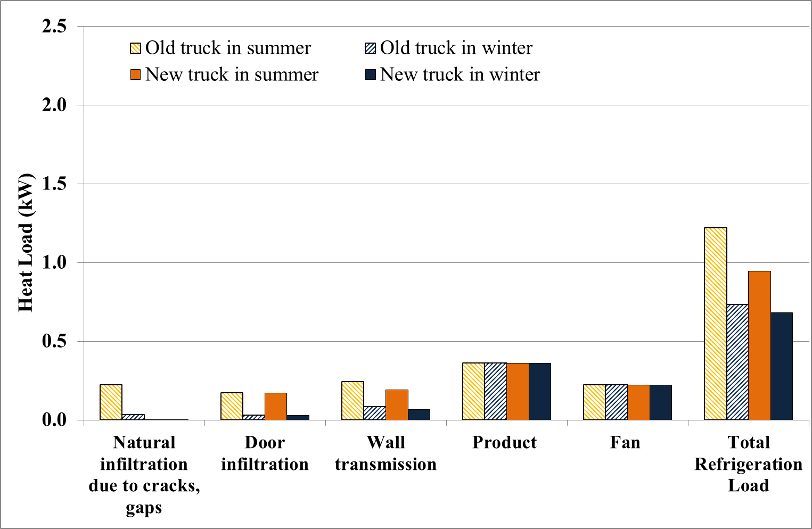
Figure 3: Graph showing heat load distribution for chilled refrigerated truck, multi-drop deliveries
Figure 2: Graph showing heat load distribution for frozen refrigerated truck, multi-drop deliveries

Figure 2 and 3 illustrate the results for the heat load distribution for a frozen and chilled refrigerated truck performing multi-drop deliveries respectively. The graphs also indicate the relative proportion of heat loads during the summer and winter conditions for a 5 year old poorly maintained truck and a new truck. The total heat load for the single temperature frozen refrigerated truck performing multi-drop deliveries is significantly greater than that for the chilled refrigerated truck, as would be expected.

From Figure 2 it can be clearly seen that the door infiltration load is the major heat load for both sets of weather conditions (i.e. winter and summer) for a frozen (single) temperature truck performing multi-drop deliveries. The model performed as expected whereby, the door infiltration load during the winter (i.e. 30% of the total refrigeration load) was lower than that in the summer (i.e. 46%). In addition, the natural infiltration due to heat leakage through the gaps and cracks of the refrigerated box is significantly lower for a new vehicle with good door seals, as compared with that for a poorly maintained older vehicle. Figure 2 also demonstrates that the natural infiltration load during the winter and summer of a poorly maintained 5 year old truck is higher than the wall transmission load for both an old and new truck. This signifies the importance of maintenance of the structure and door seals for the refrigerated box. In contrast, the major heat load for the chilled refrigerated truck for both weather conditions was the product load, accounting, for 16% of the total refrigeration heat load (in winter) and 38% (in the summer), as indicated in Figure 3. This is mainly due to the differences in the thermal properties of beef above and below freezing. It should be clearly understood that the results obtained are only valid for this case study and as the individual loads vary, the overall contribution to the refrigeration load will also vary accordingly.

Using the results from the preliminary model for an older truck, the annual indirect carbon emissions for operating the chilled distribution RRT system was approximately 600 kgCO₂e while the motive work (i.e. energy used for transport) was responsible for emitting 15, 103 kgCO₂e. In contrast, the annual indirect carbon emissions for operating the frozen distribution RRT system was approximately 3, 637 kgCO₂e while the motive work was responsible for emitting 15, 103 kgCO₂e. Thus the chilled distribution refrigeration system accounted for about 4% of the engine fuel consumption while the frozen distribution refrigeration system accounted for about 24% of the engine fuel consumption. It should be noted that both the CoP and the drive mechanism efficiency are critical in influencing the actual fuel consumption of the refrigeration system.

The impact of the direct emissions of a 1.5 kg R404A refrigerant charge RRT system was evaluated by varying the annual leak rate between 10-20%. For both refrigeration applications, the carbon emissions due to energy consumption of the motive work and operating the refrigeration system was responsible for majority of the overall carbon emissions due to refrigerant leakage, motive energy and the refrigeration energy. Interestingly, unlike the frozen distribution RRT system, the direct carbon emissions due to leakage almost doubled the indirect carbon emissions from operating the chilled distribution RRT system (i.e. not including the motive power) when a leak rate of 20% per year was assumed in the model. This highlighted that in order to minimise emissions, it is not only important to improve the efficiency of the RRT system, but also to maintain the leak tightness of the refrigeration system by performing routine maintenance and integrity checks.

Although the present case study results of 4% and 24% of the engine fuel consumption being used for the refrigeration system did not fully agree with the field data which suggested a range of 15-25% (Hutchins, 2007 cited in Tassou et al., 2009), their data did not distinguish between chilled, frozen, or multi-temperature product transportation or the distribution type. In addition, the differences observed may be the result of the assumptions and limitations used in the present model. However, revised assumptions based on real data measurements may be incorporated as the model is developed further in the future.
- CONCLUSIONS
The paper discusses recent research in which a refrigerant leakage analysis tool was developed to investigate the locations and components where leaks are commonly found in RRT systems, contributing to direct CO₂e emissions. The refrigerant leakage analysis tool has been supplemented with a steady state mathematical model for evaluation of the indirect carbon emissions from a RRT system. Preliminary results from the model verified the importance of a high CoP and drive mechanism efficiency. The model also revealed that under some circumstances, the direct carbon emissions from RRT systems can exceed indirect carbon emissions from operating the refrigeration unit, highlighting the need for preventative maintenance for such systems. Future work includes: conducting a statistical analysis of refrigerant leakage data and development of a transient model of the refrigeration system, to account for a wide range of operating modes. Thereafter, the model will be validated against actual data measurements, and different configurations for a multi-temperature RRT vehicle will be developed to determine the optimum design for maximum efficiency.
- ACKNOWLEDGEMENTS
The authors would like to express their gratitude for the support from Hubbard Products Ltd. and the interdisciplinary centre for Storage, Transformation and Upgrading of Thermal Energy (i-STUTE).
- REFERENCES
AEA Technology (2005, July) The validity of food miles as an indicator of sustainable development: final report produced for DEFRA. AEA Technology. Available from: http://statistics.defra. gov.uk/esg/reports/foodmiles/default.asp/ [Accessed 13 December 2013].
ASHRAE (2010) ASHRAE Hanbook Refrigeration. SI Edition. Atlanta, Georgia: American Society of
Heating, Refrigerating and Air-Conditioning Engineers, Inc.
Barford, V. (2014) The rise, fall and rise of the mini-supermarket, BBC New Magazine, 17 January,
Bostock, D. (2007) Designing to minimise the risk of refrigerant leakage, in: IOR Annual Conference.
Institute of Refrigeration,.
Cavalier, G. and Stumpf, A. (2010) Measurement and simulation of energy consumption of transport
refrigeration equipments, in: 1st IIR Conference on Sustainability and the Cold Chain. Cambridge: International Institute of Refrigeration (IIR),.
Earle, R. L. (1983) Unit operations in food processing. Second Edition. U.K.: Pergamon Press.
Fasl, J. M. (2013) Modeling and control of hybrid vapor compression cycles (Masters of Science in
Mechanical Engineeering). University of Illinois, Urbana-Champaign. Available from : http://hdl.handle.net/2142/45429
Francis, C. (2010) Investigation of refrigerant leakage within UK major supermarkets (Master’s degree in
the Faculty of Engineering Science and the Built Environment). London South Bank University, London.
Gigiel, A. (1997) Predicting food temperatures in refrigerated transport, in: Institute of Refrigeration Session
1996-1997. The Institute of Marine Engineers, 76 Mark Lane, London EC3,.
Gosney, W. B. and Olama, H. A. . (1975) Heat and enthalpy gains through cold room doorways, in: Institute
of Refrigeration. U.K.,72, pp. 31–41.
Heap, R. (2003) Refrigerated transport: progress achieved and challenges to be met (16th Informatory Note
on Refrigerating Technologies). Paris: The International Institute of Refrigeration (IIR). Available from: http://www.iifiir.org/userfiles/file/publications/notes/NoteTech_16_EN.pdf
Jain, N. (2009) Dynamic modeling and validation of a commercial transport refrigeration system (Master of
Science in Mechanical Engineering). University of Illinois at Urbana-Champaign, Urbana, Illinois. Available from :
http://web.mechse.illinois.edu/media/uploads/web_sites/104/files/jain_ms_thesis.20091221.4b2fac0c538276.21071120.pdf
James, S. J., James, C. and Evans, J. A. (2006) Modelling of food transportation systems – a review,
International Journal of Refrigeration, 29 (6), pp. 947–957. DOI:10.1016/j.ijrefrig.2006.03.017.
Li, B. (2009) Dynamic modeling and control of vapor compression cycle systems with shut-down and start-
up operations. University of Illinois at Urbana-Champaign, Illinois. Available from : http://web.mechse.illinois.edu/media/uploads/web_sites/104/files/li_ms_thesis.20091221.4b2fa9110bd552.59660714.pdf
Li, B., Jain, N., Mohs, W. F., Munns, S., Patnaik, V., Berge, J., et al. (2012) Dynamic modeling of
refrigerated transport systems with cooling-mode/heating-mode switch operations, HVAC&R Research, 18 (5), pp. 974–996. DOI:10.1080/10789669.2012.670685.
McKinnon, A., Ge, Y. and Leuchars, D. (2003) Analysis of transport efficiency in the UK food supply chain
(Full report of the 2002 key performance indicator survey). Edinburgh, UK: Logistics Research Centre, School of Management an Languages Heriot-Watt University. Available from: http://www.sml.hw.ac.uk/downloads/logisticsresearchcentre/efficiency/Analysis.pdf
Michineau, T., Cavalier, G. and Devin, E. (2014) F-Gases in refrigerated transport, in: Twickenham Lonon,.
Nasuta, D., Srichai, R. and Martin, C. (2014) Life cycle climate performance model for transport
refrigeration/ airconditioning systems, in: London: International Institute of Refrigeration (IIR),.
Öko-Recherche GmbH, Öko-Institut e.V., HEAT International GmbH, Danish Technological Institute, Re-
phridge, Karlsruhe University of Applied Sciences, et al. (2011) Preparatory study for a review of Regulation (EC) No 842/2006 on certain fluorinated greenhouse gases Final Report (No. Service Contract No 070307/2009/548866/SER/C4). Available from: http://ec.europa.eu/clima/policies/f-gas/docs/2011_study_en.pdf
Peters, T. (2014) : Liquid air on the highway findings / ‘clean and cool’ summit / Hubbard Products
announcement.
Rachek, A., Sartre, V. and Bonjour, J. (2010) Dynamic simulation of the refrigerated compartment of a truck
coupled with its refrigeration system, in: 1st IIR Conference on Sustainability and the Cold Chain. Cambridge: International Institute of Refrigeration (IIR),.
Tassou, S. A., De-Lille, G. and Ge, Y. T. (2009) Food transport refrigeration – approaches to reduce energy
consumption and environmental impacts of road transport, Applied Thermal Engineering, 29 (8–9), pp. 1467–1477. DOI:10.1016/j.applthermaleng.2008.06.027.
UNEP (2011) 2010 Report of the refrigeration, air conditioning and heat pumps technical options
committee: 2010 assessment. Nairobi: United Nations Environment Programme (UNEP). Available from: http://ozone.unep.org/teap/Reports/RTOC/RTOC-Assessment-report-2010.pdf
Wu, X., Hu, S. and Mo, S. (2013) Carbon footprint model for evaluating the global warming impact of food
transport refrigeration systems, Journal of Cleaner Production, 54, pp. 115–124. DOI:10.1016/j.jclepro.2013.04.045.
Xie, R., Sun, Y., Foster, A. and Liu, G. (2011) Dynamic performance of infiltration from a refrigerated
container, in: The 23rd International Congress of Refrigeration. Prague, Czech Republic,.

