Amount of words: 5717

Life cycle assessment of salmon cold chains:

Comparison between chilling and superchilling technologies

H.M. Hoang a[1]*, T. Brown b, E. Indergard c, D. Leducq a, G. Alvarez a

a Irstea, UR GPAN, 1 rue Pierre-Gilles de Gennes, 92761 Antony, France

b, School of the Built Environment and Architecture, London South Bank University, Churchill Building, Langford, North Somerset, BS40 5DU, UK

c SINTEF Energy Research, Kolbjørn Hejes vei 1D, NO-7465 Trondheim, Norway

Abstract

The cold chain is defined as a set of refrigeration steps that maintain the quality and safety of food product. Refrigerant leakage and the use of fossil fuels to produce electrical power for refrigeration equipment contribute greatly to ozone depletion and global warming. Thus, new and emerging refrigeration technologies are developed to provide better energy efficient and environmentally friendly alternatives to current technologies. Superchilling is a concept where the temperature is reduced 1-2 °C below the initial freezing point of the product. The small amount of ice formed within the product (10-15%) serves as a heat sink, eliminating the need for ice during storage and transport. In this work, Life Cycle Assessment (LCA) is applied to the chilling and superchilling salmon cold chains. The superchilling cold chain presents an important improvement compared to the chilled one: diminution of about 20% of the environmental impacts. This improvement is mainly due to the augmentation of available volume for transportation. Other solutions to increase the environmental performance (replacement/reduction of packaging material, reduction of transport distance and diminution of electricity consumption in the display cabinet) are also studied.

*Keywords*: LCA, environmental impact, cold chain, superchilled

**Nomenclature**

|  |  |
| --- | --- |
| COP | Coefficient of performance |
| CP | Corrugated plastic |
| EPS | Expanded polystyrene |
| LCA | Life cycle assessment |
| LCI | Life cycle inventory |
| LCIA | Life cycle impact assessment |
| SEC | Specific energy consumption |

1. **Introduction**

Worldwide it is estimated that 15% of the electricity consumed is used for refrigeration (Coulomb 2008). Direct emissions from refrigerant leakage and indirect CO2 emissions from combustion of fossil fuels to generate power for refrigeration equipment contribute greatly to ozone depletion and global warming. Maykot et al. (2004) estimated that indirect emissions contribute up to 95-98% of the Total Equivalent Warming Impact (TEWI) in both light commercial (i.e. integrals and vending machines) and household applications (refrigerator and freezer). New and emerging refrigeration technologies providing energy efficient and sustainable alternatives to current technologies have recently been developed for cold chain application. However, it’s important to evaluate the environmental performances of these new technologies and their gain of performances compared to conventional technologies.

Superchilling is a concept where the temperature is reduced 1-2°C below the initial freezing point of the product (Claussen 2011). The salmon is crust frozen in a blast freezer (Kaale et al. 2013). This crust will then equalize to give 10-15% ice throughout the product which serves as a heat sink so that the additional ice normally added to chilled salmon is not required during storage and transport. Superchilled product presents improved quality such as extended shelf life, higher yield and reduced microbiological risk (Duun and Rustad 2007). Drip loss was significant lower in superchilled samples of Atlantic salmon compared to chilled and frozen samples (Kaale et al. 2014). Compared to conventional technology, the superchilling process needs more energy to attain lower product temperature and some degree of freezing but the energy used to produce additional ice is saved.

Life cycle assessment (LCA) is a standardized methodology (ISO_14044) for assessing the environmental aspects associated with a product, technology or activity based on the compilation of an inventory of material and energy inputs and outputs for each stage over a life cycle. A review of the main developments of LCA over the past 30 years in the domain of energy analysis was given by Udo de Haes and Heijungs (2007). The LCA can be applied to compare two (or more) products and technologies. For example, Ardente and Mathieux (2014) used a LCA based approach for environmentally assessing the durability of energy-using products in order to identify when the potential extension of the product's lifetime could have life-cycle benefits. The method is based on the comparison of two scenarios of different lifetimes of a target product and its potential substitution with better performing alternatives. The life cycle environmental impacts of ready-made meals manufactured industrially was compared with meals prepared at home by Schmidt Rivera et al. (2014). The comparison of the carbon footprint of food transport refrigeration systems using different refrigerants (R404A, R410A and R744) were performed by Wu et al. (2013). In this study, the carbon footprint was calculated as the sum of direct emissions (by various greenhouse gas emissions and leakage in each process) and indirect emissions (the CO2 equivalent emissions due to the energy consumption in each process). Their result showed that the CO2 emissions caused by the energy consumption are a large part of the total CO2 emissions thus increasing the coefficient of performance (COP) of the refrigerator and of other equipment can significantly reduce the energy consumption and CO2 emissions.

Recently, LCA were applied to study the environmental impacts of the seafood industry. Denham et al. (2015a) have analyzed and identified the most effective cleaner production strategies for improved environmental performance of the supply chain in the seafood industry. Many stages of the seafood supply chain were studied: production, transport, processing and packaging, storage and retails. They suggested that in order to ensure the greatest reduction in environmental impact, a whole of supply chain management system that incorporates life cycle assessment modelling is recommended. The cumulative energy use, biotic resource use, and greenhouse gas, acidifying, and eutrophying emissions associated with producing farmed salmon in Norway, the UK, British Columbia (Canada), and Chile were reported by Pelletier et al. (2009). The greenhouse gas (GHG) emissions from two Western Australian finfish supply chains, from harvest to retail outlet, were measured using streamlined life cycle assessment methodology by Denham et al. (2015b). A comparative LCA study between chilled and superchilled haddock from production to wholesaler was carried out by Claussen et al. (2011).

In the present work, the LCA approach is applied to compare the chilled and superchilled salmon cold chain; more stages (i.e. distribution centre, display cabinet, domestic fridge which were not studied by Claussen et al. (2011)) are considered. The objectives of this study are to identify:

* the steps of the cold chain that have the most important environmental impacts
* the steps of the cold chain that the superchilled cold chain have a better (or worst) performance than the chilled cold chain
* the solutions (other than the use of superchilling technology) that can reduce the environmental impacts of the cold chain

1. **Materials and methods**

According to ISO 14044’s framework, an LCA study consists of four steps:

1. Defining the goal and scope.

2. Life cycle inventory (LCI): modelling of product life cycle with environmental inputs and outputs (data collection)

3. Life cycle impact assessment (LCIA): understanding the environmental relevance of all the inputs and outputs.

4. Interpretation of the results.

* 1. Goal and scope of the study

1. Goal of the study

The goal of this study is to compare the environmental impacts of chilled and superchilled salmon cold chains. The traditionally chilled fish is packed in boxes filled with approximately 25 % ice to keep the temperature low during transport and storage. Superchilled fish contains 10-15 % ice and does not need ice for transport and storage.

1. Geographical and time limits

The salmon is supposed to be produced in Norway and transported to European countries. According to van der Sluis et al. (2012), a duration of 36h is reported for the 1st refrigerated transport (right after the production step) which corresponds to a distance of about 2160 km (considering an average velocity of 60 km/h). The salmon is then stored in a distribution storage center during 12h before being despatched to supermarket. A duration of 3h is reported for the 2nd refrigerated transport (between distribution storage center and supermarket). The salmon are kept during 4 days inside the display cabinet. After the purchase, the salmon is transported inside the consumer’s car (1h) and stored in the domestic refrigeration (2 days). The total duration of the reference salmon cold chain is 223h (9 days and 7h).

1. Reference chilled and superchilled salmon cold chain

The reference cold chains of chilled and superchilled salmon were reported in van der Sluis et al. (2012) and shown in the Figure 1. The cold chain is presented as the succession of blocks, the common blocks (orange) are the same for chilled and superchilled cold chains; the blocks which correspond exclusively to chilled cold chain are in dotted green; the superchilled blocks are in black and white patterns. The information about the temperature, duration and refrigerant in each block is also given.

* The cold chain is composed of 7 steps: production, 1st refrigerated transport, distribution centre storage, 2nd refrigerated transport, supermarket display cabinet, non - refrigerated transport (consumer’s car) and domestic fridge. One step may correspond to a cold chain block (refrigerated transport, distribution center storage, supermarket display cabinet, non-refrigerated transport and domestic fridge) or is the combination of many blocks as in the case of the production step (combination of 4 blocks: harvesting, processing, packaging and storage). *All of these steps are taken into account in the present study.* However, the salmon rearing and the by-product treatment are not considered in this study, more information concerning these processes can be found in Pelletier et al. (2009) and (Denham et al. 2015b).
* Among these steps, the chilled and superchilled salmon are processed differently (in terms of technology or temperature level) in the packaging and storage in the production step, in the 1st transport by refrigerated vehicle and the distribution centre storage. Compared to chilled cold chain, the superchilled cold chain has an extra block in the production step: the “superchilling” block in which a contact blast chiller is used to cool down the salmon to the superchilling storage condition of temperature (-1.7°C).

1. Functional unit

In the present study, the functional unit is defined as 1 kg of processed salmon (after the processing/filleting block in the production step). It is assumed that the weight loss along the cold chain is negligible so that the same 1 kg of salmon can be found at the consumer.

* 1. Life cycle inventory (data collection)

One of the most challenging tasks in a LCA analysis concerns the data gathering; it is the step that defines the precision and the limits of the analysis. In this section, the data of the input material and energy in each step per kg of salmon was collected.

1. Production

The production step involves 4 main processes in which the farmed salmon is harvested, filleted, packed and stored before despatch. It is assumed that the harvesting and filleting processes are the same for chilled and superchilled salmon (van der Sluis et al. 2012).

* Harvesting (data from Winther et al. (2009))

This process uses drum chilling and bleed chiller (both using refrigerated sea water). The inputs and outputs of this process are presented in Table 1. As shown in this table, the by-product (about 18%) is sent to ensilage and can be used later to produce protein powders, fertiliser and animal feeds. While reusing the fish waste can potentially reduce the environmental impacts of the salmon cold chain, the supplement needed energy/materials can diminish this benefit (Denham et al. 2015b). The ensilage process is not considered in the present study.

* Filleting

As the filleting is manual work, the energy consumption of this process is assumed to be negligible.

* Packaging

*For chilled salmon*, the salmon is chilled and packed with ice inside expanded polystyrene (EPS) boxes. Each box (0.66 kg of EPS) can contain 20kg fillets and about 5 kg ice (0.25 kg/kg salmon). Part of this ice (0.05kg/kg salmon) is used in cooling the fillets back down after some warming during preceding processing, but the remainder (0.2 kg/kg salmon) is available to keep the fillets cool during initial distribution and transport.

* + The needed amount of EPS for 1 kg of chilled fillet is:

0.66/20= 0.033 kg/kg salmon

* + The needed amount of ice for 1 kg of chilled fillet is: 0.25 kg/kg salmon
  + Based on cooling of water from 10°C to 0°C, assuming the ice machine has a COP of around 2.5, production of ice at these ratios requires:

0.25 * (Cp_water * 10) + L_water) / 2.5 = 37.6 kJ /kg salmon (Brown 2014).

with Cp_water = 4.187 kJ/kg.K and L_water = 334 kJ/kg.K

*For superchilled salmon,* the salmon is cooled down by the contact blast chiller and also packed inside the same EPS boxes (0.66 kg EPS for 25 kg fillet), no ice is needed.

* + The needed amount of EPS for 1 kg of superchilled fillet is: 0.66/25= 0.0264 kg
  + The needed amount of energy for 1 kg of superchilled fillet (in the contact blast chiller) is 72 kJ/kg salmon (Claussen et al. 2011).
* Storage

*For chilled salmon,* the product is stored for 24h at 0°C before despatch (van der Sluis et al. 2012). Two published sources of typical energy use were compared. The first, Thrane (2004), gave the average energy use for a chilled storage facility at 0°C as 0.44 kJ/kg for the 24h. The second source (Evans et al. 2014) presented average values for Specific Energy Consumptions (SEC) for chilled and frozen cold stores, which are based on the volume of the stores. For chilled the average SEC was 56.1 kWh/m3.year. Assuming the store is 75% full and that the packing density for salmon is 0.5, the SEC figure can be attributed across all products in the store as 1.48 kJ/kg for the 24 hour storage period. Taking an average of the two figures gives a rounded up figure of 1.0 kJ/kg salmon.

*For superchilled salmon,* the storage prior to despatch is very similar to that in the chilled chain, but temperature is kept slightly lower at -1.7°C. This results in somewhat higher heat loads on the storage room and in a slightly lower COP for the fridge plant. Brown (2014) estimated that 1.2 kJ/kg is needed for the 24 hour superchilled storage.

1. 1st transport by refrigerated vehicle (data from Claussen et al. (2011) and Tassou et al. (2007))

After leaving the producer, the salmon is transported by lorry for 36 h. The salmon is maintained at +2°C (chilled) or -1.7°C (superchilled) in the vehicle. The SimaPro background process ‘Operation, lorry 28t, full/CH S’ was used. This process takes into account the additional diesel required (kg/h) and exhaust gases emitted due to refrigeration.

*For chilled salmon:*

* + Each lorry can transport 18 000 kg chilled salmon. So the transport time attributes for 1 kg salmon is: 36 h / 18 000 kg = 0.002 h (or 7.2 s) / kg salmon.
  + Tassou et al. (2007) suggested a part-load diesel use of 0.5 to 1.0 litres per hour, as the diesel density is 0.832 kg/l, the average of these figures would be 0.62 kg/h.

*For superchilled salmon:*

* + Each lorry can transport 23 400 kg superchilled salmon (the quantity is bigger than in chilled process because there is no ice to be transported). The transport time attributes for 1 kg salmon is: 36 h / 23 400 kg = 0.0015 h (or 5.5 s) / kg salmon.
  + The cold production is provided by a diesel machine which consumes a little more than that of chilled salmon: 0.64 kg/h.

1. Distribution centre storage

The salmon is stored for 12h in the distribution centre. Although there may be scale factors, it was assumed for this comparative study that distribution centre cold stores are similar to the storage facilities in the production stage, so that for a duration of 12 hours, the energy use would be approximately 0.5 kJ/kg *for chilled salmon*, and 0.6 kJ/kg *for superchilled salmon*.

*Note: After the distribution centre storage step, the superchilled salmon is assumed to have the same treatment as the chilled one.*

1. 2nd transport by refrigerated vehicle

After leaving the distribution centre storage, the salmon is transported by lorry for 3 h at +2°C:

* + Each lorry can transport 18 000 kg chilled salmon. So the transport time attributes for 1 kg salmon is: 3 h / 18 000 kg = 0.0002 h (or 0.6 s) / kg salmon.
  + The cold production is provided by a diesel machine which consumes 0.62 kg/h

1. Display cabinet

A method for estimating typical retail display cabinet energy use was developed by Brown (2014) based on published Eurovent test data for various cabinet types and different temperature classifications. The energy values at these different temperatures were regressed to give a value at 5°C and a typical open-fronted multi-deck cabinet was selected for chilled foods. This type had a daily energy consumption of 10.4 kWh/m2, with a total display area of 5m2 and a gross volume of 5m3. It was assumed that 65% of the gross volume was usable (based on measurements of several common models) and that 50% of the remaining net volume would actually be stocked with food. Using a packed salmon density of 500kg/m3, this results in each cabinet holding 812.5 kg. The duration of display specified in the reference cold chain is 96 hours, during which energy consumption would be 208 kWh. This is equivalent to 921.6 kJ/kg.

1. Transport by consumer

Representing the journey from the supermarket to the consumer’s home, this block is unrefrigerated and therefore has no energy impact form a cold chain energy perspective. However, it would result in varying degrees of warming which would then have to be addressed by the domestic refrigerator.

1. Domestic fridge

A method for estimating typical domestic refrigerator energy use based on the thresholds for Energy Efficiency Indices used in the Energy Labelling Scheme (see EU Directive 2010/30/EU and Commission Delegated Regulation Number 1060/2010) was developed by Brown (2014). A typical A+ rated domestic refrigerator with a net volume of 150 litres was chosen, which would have a threshold energy (i.e. the maximum allowed under A+) of 123.2 kWh/year. Assuming the appliance was on average 50% full, and that the packed salmon density was again 500kg/m3, and as chilled salmon is a relatively short shelf-life commodity, a domestic storage duration of 48 hours was chosen, during which 0.67kWh of energy would be used, equivalent to 64.8kJ/kg.

* 1. Making of the cold chain

The salmon cold chain was built using the collected data in LCI, its flowchart is presented in Figure 2: the lower step becomes one of the inputs of the higher step. In general, the chilled and superchilled cold chains use the same processes but with different quantity of materials and energy consumption. The table 2 presents the comparison of material and energy inputs (for 1 kg salmon) between chilled and superchilled cold chain: the superchilled cold chain needs more electricity (mostly because of the use of contact blast chiller to cool down the salmon to superchilling condition) but less packaging material (EPS) and less diesel (for cooling during the transport).

The detailed electricity consumption in each step is reported in the table 3. The two steps that consume the most electricity are the production and the display cabinet. In the storage step, the merchandise is kept in huge quantity so that it has a low demand in electricity per 1 kg of product. The refrigerant leakage is also considered in this study. The refrigerant type and % of leakage per year (data from Winther et al. (2009) and van der Sluis et al. (2012)) are also presented in Table 2. According to these data, only the production and distribution center storage steps use a natural refrigerant (NH3). The steps that have the highest percentage of leakage/year are transport (10%) and display cabinet (12%).

The LCA study was performed using SimaPro (version 7.3) with the CML 2 Baseline 2000 V2.05/ World 1990, one of the most widely used and acknowledged LCIA methods, developed by the Centre of Environmental Science of Leiden University (SimaPro 2012). The impact category indicators, included in this method, were: abiotic depletion, ozone depletion potential, global warming potential, marine aquatic ecotoxicity, fresh water aquatic ecotoxicity, terrestrial ecotoxicity, human toxicity, photochemical oxidation, acidification, and eutrophication.

1. **Results and discussion**

The LCA calculations are based on the compilation of the amounts of materials and energy used and the emissions associated with processes. The latter are multiplied with characterisation factors proportional to their power to cause environmental impact. One specific emission is chosen as the reference and the result is presented in equivalents with regard to the impact of the reference substance.

* 1. Comparison between chilled and superchilled salmon cold chain

The impact of chilled and superchilled salmon cold chain was assessed and compared. The results (Table 4 and Figure 3) show a net improvement in term of environmental impacts of superchilled cold chain compared to chilled one, with a diminution of about 20% in most of the categories: abiotic depletion, global warming (GWP100), ozone layer depletion (ODP), photochemical oxidation, acidification and eutrophication.

* 1. Impact of cold chain steps

The contribution of each step on different categories of impact is presented in Figure 4. It is noted that the downstream steps (2nd transport, display cabinet and domestic fridge) are assumed to be the same for the chilled and superchilled cold chains, they present the same impact. Compared to other steps, the 1st transport has the most important influence on 3 categories: global warming, ozone layer depletion and acidification because of the use of diesel. The production step has the greatest impact on the human toxicity and photochemical oxidation because of the use of many natural and technical inputs, the expanded polystyrene EPS for packaging in particular. The display cabinet which consumes the most electricity (Table 3) has the greatest influence in marine aquatic ecotoxicity, terrestrial ecotoxicity and fresh water aquatic ecotoxicity (the same level as the 1st transport). In general, the distribution centre, the 2nd transport and the domestic fridge have small impacts.

Compared to the chilled cold chain, the superchilled one presents an important diminution of the environmental impact in both production and 1st transport steps. This diminution is mainly due to the augmentation of available volume for transportation and the reduction of the quantity of needed EPS for packaging. It is to be emphasized that the production and 1st transport steps have the greatest environmental impact and energy consumption in the cold chain. As shown in Table 5, they represent from 36.2 to 90.2% of the cold chain total impact for chilled salmon and from 30.8 to 87.9% for superchilled salmon. It is observed that the categories in which the production and 1st transport steps present the less impact are also the categories in which the display cabinet has the greatest influence, i.e. marine aquatic ecotoxicity, terrestrial ecotoxicity and fresh water aquatic ecotoxicity.

* 1. **Other solutions for cold chain improvement**

The results of the section 3.2 show that the 3 steps that have the greatest environmental impacts are: production, 1st transport and display cabinet. Thus, some solutions to reduce these impacts can be proposed as follows.

1. Reducing the quantity of EPS in the production step or using more environmentally friendly materials

However, this solution can be applied only if the “new” box can assure the insulation of the product during transport. Margeirsson et al. (2012) have compared the use of EPS box and a more environmentally friendly corrugated plastic (CP) box and observed that although better insulating performance of EPS than of CP was confirmed, similar storage life was observed for fish stored in the two box types under variable temperature. Thermal insulation of different types of EPS boxes and a box-in-box type cardboard prototype for chilled seafood transport were studied by Navaranjan et al. (2013). They suggested that lower insulation properties than standard EPS boxes (40% diminution of mass for the same volume) could be used for fish transport. In order to evaluate the potential of this solution, two scenarios are studied:

* S1: in this scenario, the quantity of EPS is reduced of 40%
* S2: in this scenario, the EPS is replaced by the CP, the same quantity is used (the EPS and CP boxes in the study carried out by Margeirsson et al. (2012) had the nearly same mass: 171 g and 178 g respectively for 3 kg of fish).

1. Reducing the distance of the 1st transport

In the reference cold chain (section 2), the first transport corresponds to a distance of about 2160 km and a duration of 36h. This distance is close to the distance between Oslo and Monaco for example. In the third scenarios, shorter distance is considered:

* S3: in this scenario, the distance is reduced of 40%, a distance of 1296 km is considered.

1. Reducing the electricity consumption of the display cabinet

In the reference cold chain (section 2), the type of the display cabinet is an open-fronted one. It was shown by Evans et al. (2007) that the energy consumption of the display cabinet can be significantly reduced by using the cabinet equipped with doors: 35% of reduction was observed.

* S4: in this scenario, the electricity consumption is reduced of 35% for the display cabinet which corresponds to 599 kJ/kg salmon.

In order to compare these solutions, the environmental impacts obtained from each scenario are compared to the results of the reference superchilled cold chain in Figure 5. For each scenario, only one parameter is changed, the others are taken from the reference superchilled cold chain. Except the scenario 2 (replacement of EPS by CP) in which the impacts concerning terrestrial ecotoxicity, photochemical oxidation and acidification are increased, all the three other scenarios present a better performance in all categories compared to the reference superchilled cold chain. This result showed that the corrugated plastic (CP) is not totally more environmentally friendly than the EPS but further study is needed to confirm this. The scenario 1 (reduction 40% of EPS) allows a diminution of more than 20% of the impacts concerning abiotic depletion and human toxicity. The scenario 3 (reduction 40% of the 1st transport distance) presents the best performance (around 20% of reduction) concerning the reduction of global warming, ozone layer depletion, acidification and eutrophication. The scenario 4 (reduction 35% of the electricity consumption in the display cabinet) allows the greatest diminution of fresh water aquatic ecotoxicity, marine aquatic ecotoxicity and terrestrial ecotoxicity. It can be expected that the combination of the solutions (S1, S3 and S4) can produce an even greater reduction of environmental impacts.

1. **Conclusions**

Life Cycle Assessment (LCA) was applied to the chilling and superchilling salmon cold chains in order to compare these two processes and study their environmental impact. The superchilling cold chain presents an important improvement (diminution of about 20% in most of the categories) compared to the chilled one. This improvement is mainly due to the reduction of the quantity of needed EPS for packaging and the augmentation of available volume for transportation in superchilled case since no ice is needed. The three steps that have the most important impacts are: production, 1st transport and display cabinet. Furthermore, 4 solutions to improve the environmental performances of the salmon cold chain are studied. While the replacement of EPS by the corrugated plastic (CP) does not show improvement in all categories, the reduction of the quantity of EPS, of the 1st transport distance and of the electricity consumption of the display cabinet are good solutions to reduce the cold chain environmental impacts.

**ACKNOWLEDGEMENTS**

The research leading to this result has received funding from European Community's Seventh Framework Programme (FP7/2007-2013) under the grant agreement n° 245288.

**References**

EU Directive 2010/30/EU and Commission Delegated Regulation Number 1060/2010; <http://eur-lex.europa.eu/legal-content/EN/TXT/?uri=CELEX:32010R1060>

Ardente, F.,Mathieux, F. 2014. Environmental assessment of the durability of energy-using products: method and application.Journal of Cleaner Production. 74.0, 62-73.

Brown, T. 2014. Report on quality and energy use of proposed technologies - superchilling.Frisbee European Project Deliverable D.5.1.1.4.

Claussen, I. C. 2011. Superchilling Concepts Enabling Safe, High Quality and Long Term Storage of Foods.Procedia Food Science. 1.0, 1907-1909.

Claussen, I. C., Indergård, E.,Grinde, M. 2011. Comparative Life Cycle Assessment (LCA) of production and transport of chilled versus superchilled haddock (Melanogrammus aeglefinus) fillets from Norway to France.Procedia Food Science. 1.0, 1091-1098.

Coulomb, D. 2008. Refrigeration and cold chain serving the global food industry and creating a better future: two key IIR challenges for improved health and environment.Trends in Food Science & Technology. 19.8, 413-417.

Denham, F. C., Biswas, W. K., Solah, V. A.,Howieson, J. R. 2015b. Greenhouse gas emissions from a Western Australian finfish supply chain.Journal of Cleaner Production.0.

Denham, F. C., Howieson, Janet R., Solah, V. A.,Biswas, W. K. 2015a. Environmental supply chain management in the seafood industry: past, present and future approaches.Journal of Cleaner Production. 90.0, 82-90.

Duun, A. S.,Rustad, T. 2007. Quality changes during superchilled storage of cod (Gadus morhua) fillets.Food Chemistry. 105.3, 1067-1075.

Evans, J. A., Foster, A. M., Huet, J. M., Reinholdt, L., Fikiin, K., Zilio, C., Houska, M., Landfeld, A., Bond, C., Scheurs, M.,van Sambeeck, T. W. M. 2014. Specific energy consumption values for various refrigerated food cold stores.Energy and Buildings. 74.0, 141-151.

Evans, J. A., Scarcelli, S.,Swain, M. V. L. 2007. Temperature and energy performance of refrigerated retail display and commercial catering cabinets under test conditions.International Journal of Refrigeration. 30.3, 398-408.

ISO_14044. 2006. Environmental Management – Life Cycle Assessment – Requirements and Guidelines.International Organisation for Standardisation (ISO), Geneva (2006).

Kaale, L. D., Eikevik, T. M., Rustad, T.,Nordtvedt, T. S. 2014. Changes in water holding capacity and drip loss of Atlantic salmon (Salmo salar) muscle during superchilled storage.LWT - Food Science and Technology. 55.2, 528-535.

Kaale, L. D., Eikevik, T. M., Rustad, T., Nordtvedt, T. S., Bardal, T.,Kjørsvik, E. 2013. Ice crystal development in pre-rigor Atlantic salmon fillets during superchilling process and following storage.Food Control. 31.2, 491-498.

Margeirsson, B., Lauzon, H. L., Pálsson, H., Popov, V., Gospavic, R., Jónsson, M. Þ., Sigurgísladóttir, S.,Arason, S. 2012. Temperature fluctuations and quality deterioration of chilled cod (Gadus morhua) fillets packaged in different boxes stored on pallets under dynamic temperature conditions.International Journal of Refrigeration. 35.1, 187-201.

Maykot, R., Weber, G. C.,Maciel, R. A. 2004. Using the TEWI methodology to evaluate alternative refrigeration technologies. International Refrigeration and Air Conditioning Conference. Purdue, USA

Navaranjan, N., Fletcher, G. C., Summers, G., Parr, R.,Anderson, R. 2013. Thermal insulation requirements and new cardboard packaging for chilled seafood exports.Journal of Food Engineering. 119.3, 395-403.

Pelletier, N., Tyedmers, P., Sonesson, U., Scholz, A., Ziegler, F., Flysjo, A., Kruse, S., Cancino, B.,Silverman, H. 2009. Not All Salmon Are Created Equal: Life Cycle Assessment (LCA) of Global Salmon Farming Systems.Environmental Science & Technology. 43.23, 8730-8736.

Schmidt Rivera, X. C., Espinoza Orias, N.,Azapagic, A. 2014. Life cycle environmental impacts of convenience food: Comparison of ready and home-made meals.Journal of Cleaner Production. 73.0, 294-309.

SimaPro. 2012. <http://www.pre-sustainability.com/>.

Tassou, S. A., De-Lille, G.,Lewis, J. 2007. Food trasport refrigeration.part of Defra LINK project report, available online at <http://www.grimsby.ac.uk/documents/defra/trns-refrigeenergy.pdf>, accessed March 2014.

Thrane, M. 2004, Environmental impacts from Danish fish products, hot spots and environmental policies, Doctoral dissertation, Dept. of Development and Planning, Aalborg University, Aalborg, Denmark.

Udo de Haes, H. A.,Heijungs, R. 2007. Life-cycle assessment for energy analysis and management.Applied Energy. 84.7–8, 817-827.

van der Sluis, S. M., Wissink, E.,Hendriksen, L. 2012. Definition of reference cold chains using general assumptions, refined towards EU situation.Frisbee European Project Deliverable D3.1.1.

Winther, U., Ziegler, F., Skontorp Hognes, E., Emanuelsson, A., Sund, V.,Ellingsen, H. 2009. Carbon footprint and energy use of Norwegian seafood proucts.SINTEF report ISBN 978-82-14-04925-1.

Wu, X., Hu, S.,Mo, S. 2013. Carbon footprint model for evaluating the global warming impact of food transport refrigeration systems.Journal of Cleaner Production. 54.0, 115-124.

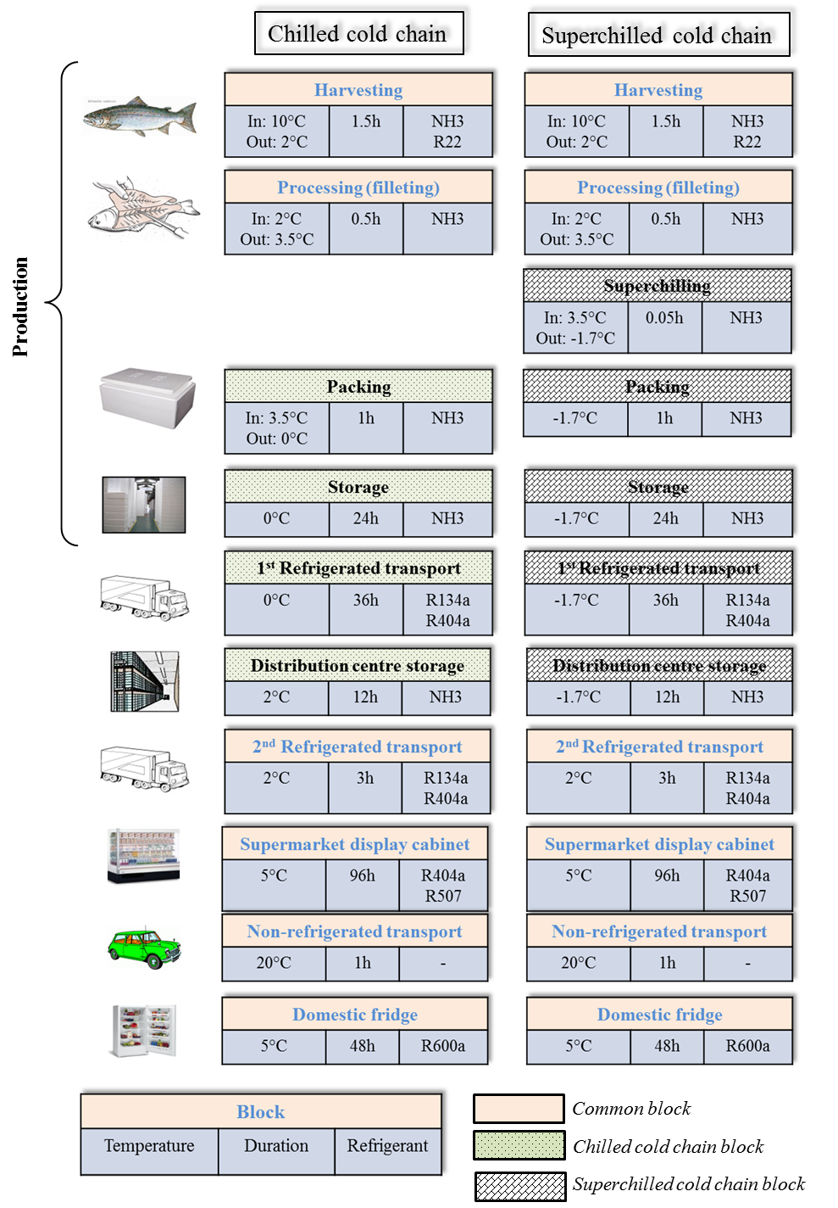

Figure 1: Scope of the study - chilled and superchilled salmon cold chain

(data from van der Sluis et al., 2012)



Figure 2: Flowchart of salmon cold chain

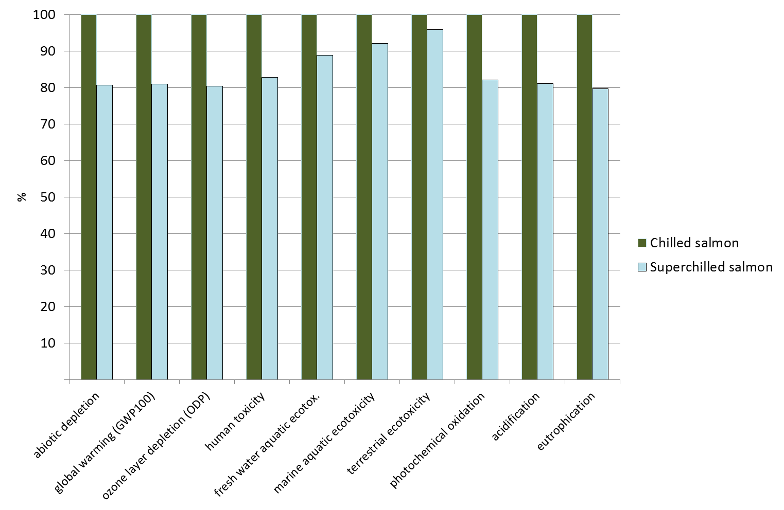

Figure 3: Relative comparison between chilled and superchilled salmon cold chain

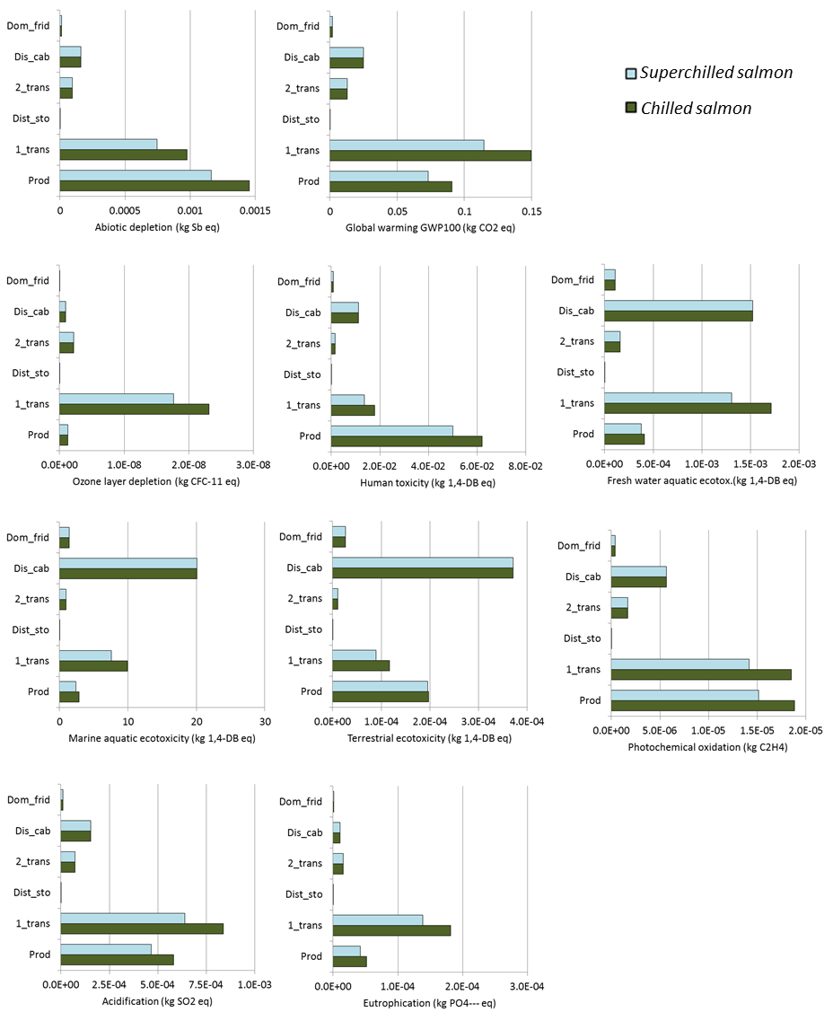

Figure 4: Impact of cold chain steps, comparison between chilled and superchilled cold chain

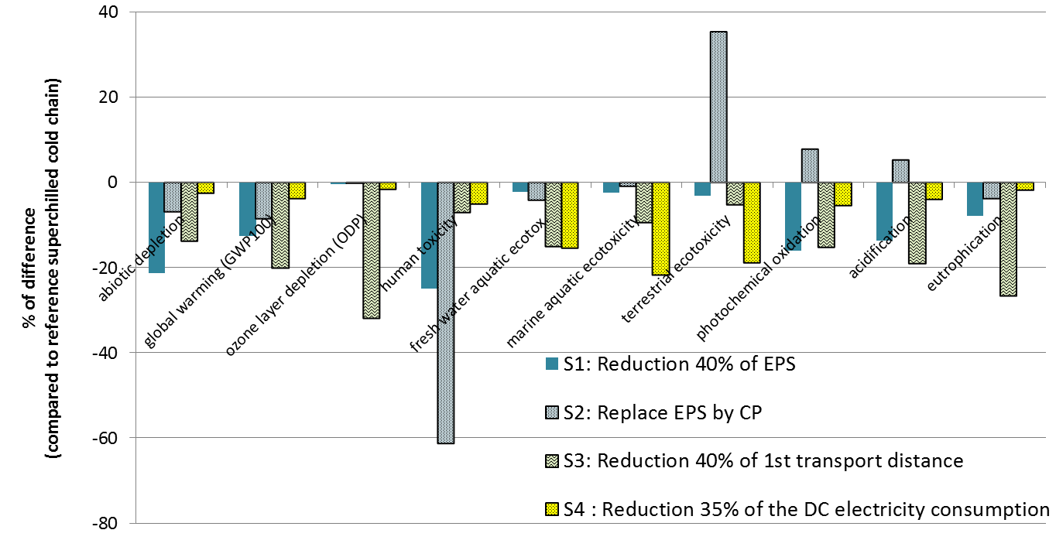

Figure 5: Comparison of the results of 4 scenarios to reference superchilled cold chain

Table 1: In - and outputs in salmon harvesting process

|  |  |  |  |
| --- | --- | --- | --- |
| Input | Amount | Output | Amount |
| Live-weight salmon | 1 kg | Salmon, head-on, gutted | 0.822 kg |
| Electricity | 291.6 kJ | Salmon by-products to ensilage | 0.178 kg |
| Carbon dioxide | 0.15 g |
| Water | 3.5 litres |  | |
| Refrigerant R22 | 0.45mg |
| Refrigerant NH3 | 7.4mg |
| Ice | 207 g |

Table 2: Material and energy inputs for 1 kg of salmon

|  |  |  |  |
| --- | --- | --- | --- |
| Material/Energy Inputs | Step | Chilled | Superchilled |
| Electricity (kJ) | all steps | 1364.8 | 1399.5 |
| R22 (µg) | production | 450 | 450 |
| EPS (g) | production | 33 | 26.4 |
| Ammonia (mg) | production, distribution center | 7.4 | 7.4 |
| Diesel (g) | 1st and 2nd transport | 1.8 | 1.6 |

Table 3: Electricity consumption and refrigerant use for 1 kg of salmon

|  |  |  |  |  |  |
| --- | --- | --- | --- | --- | --- |
| N° | Step | Electricity consumption  (kJ/kg salmon) | | Refrigerant | Ref. leakage  (%/year) |
| Chilled | Superchilled |
| 1 | Production |  | |  |  |
| * *Harvesting* | 339.3 | | NH3/ R22 | 5 |
| * *Filleting* | - | | NH3 | 5 |
| * *Packaging* | 37.6 | 72.0 | NH3 | 5 |
| * *Storage* | 1.0 | 1.2 | NH3 | 5 |
| 2 | 1st transport | use diesel | | R134a/R404a | 10 |
| 3 | Distribution centre storage | 0.5 | 0.6 | NH3 | 5 |
| 4 | 2nd transport | use diesel | | R134a/ R404a | 10 |
| 5 | Display cabinet | 921.6 | | R404a/ R507 | 12 |
| 7 | Domestic fridge | 64.8 | | R600a | 2.5 |

Table 4: Environmental impact of chilled and superchilled salmon cold chain

|  |  |  |  |  |
| --- | --- | --- | --- | --- |
| Impact category | Unit | Chilled salmon | Superchilled salmon | Superchilled vs Chilled (%) |
| abiotic depletion | kg Sb eq | 2.69E-03 | 2.17E-03 | -19.3 |
| global warming (GWP100) | kg CO2 eq | 2.80E-01 | 2.27E-01 | -19.0 |
| ozone layer depletion (ODP) | kg CFC-11 eq | 2.76E-08 | 2.22E-08 | -19.7 |
| human toxicity | kg 1,4-DB eq | 9.36E-02 | 7.75E-02 | -17.3 |
| fresh water aquatic ecotox. | kg 1,4-DB eq | 3.91E-03 | 3.48E-03 | -11.1 |
| marine aquatic ecotoxicity | kg 1,4-DB eq | 3.52E+01 | 3.24E+01 | -7.9 |
| terrestrial ecotoxicity | kg 1,4-DB eq | 7.24E-04 | 6.94E-04 | -4.1 |
| photochemical oxidation | kg C2H4 | 4.52E-05 | 3.71E-05 | -17.9 |
| acidification | kg SO2 eq | 1.66E-03 | 1.34E-03 | -18.9 |
| eutrophication | kg PO4--- eq | 2.61E-04 | 2.08E-04 | -20.4 |

Table 5: Impact of the production and 1st transport steps against the total impact of the cold chain (in %)

|  |  |  |
| --- | --- | --- |
| Impact category | Chilled salmon (%) | Superchilled salmon (%) |
| abiotic depletion | 90.2 | 87.9 |
| global warming (GWP100) | 85.9 | 82.6 |
| ozone layer depletion (ODP) | 88.3 | 85.4 |
| human toxicity | 85.4 | 82.3 |
| fresh water aquatic ecotox. | 54.2 | 48.5 |
| marine aquatic ecotoxicity | 36.2 | 30.8 |
| terrestrial ecotoxicity | 43.5 | 41.1 |
| photochemical oxidation | 82.8 | 79.0 |
| acidification | 85.7 | 82.4 |
| eutrophication | 89.6 | 86.9 |

1. * Corresponding author: Tel: 33 1 40 96 65 02 Fax: 33 1 40 96 60 75 E-mail: hong-minh.hoang@irstea.fr